

Oral & Maxillofacial Surgery Referral
Strong Memorial Hospital – AC-4
Silver Elevators to 4th Floor
601 Elmwood Ave, Box 705
Rochester, NY 14642
Phone: (585) 275-5531 (Option #3) | Fax: (585) 461-5420
The patient must call the office to schedule appointment (first appointment is a consultation).
Please email x-rays and referral to omfs@urmc.rochester.edu
Include patient name and date of birth in the subject line.
X-rays must have patient identifiers on them.
Please fill out all patient demographic and referring provider information.

Patient’s Information
Patient Name:
Patient Date of Birth: / /
Parent/Guardian Name:
Parent/Guardian Date of Birth: / /
Address:
Primary Phone #: ( )
Secondary Phone #: ( )
Dental Insurance:
Dental Insurance ID #:
Medical Insurance:
Medical Insurance ID #:
Date of Last Panoramic/CBCT X-ray: / /

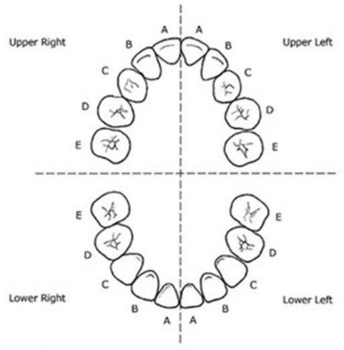
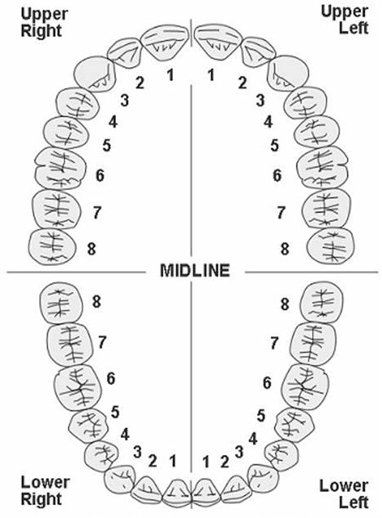
Reason for Referral
☐ Extract Indicated Teeth
☐ Surgical Exposure of Teeth
☐ Evaluate Pathology/Biopsy
☐ Placement of Implant
☐ Orthognathic Surgery
☐ TMJ Surgery
☐ Other:

Teeth numbers or site/area to be addressed:

IMPORTANT
☐ Treatment is for medical clearance
(Patient will be required to provide documentation of medical diagnosis/assessment from treating physician)

Referring Provider’s Information
Name:
Facility Name:
Phone #: ( )
Fax #: ( )
Signature:
Date: / /
Eastman Institute for Oral Health

