
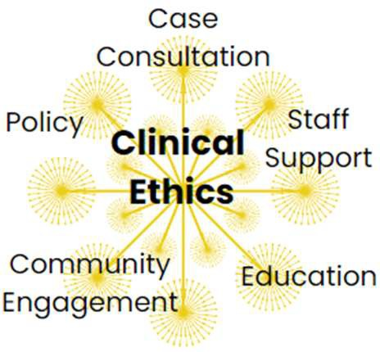
every clinical encounter is a moral encounter

ADVANCED CERTIFICATE IN CLINICAL BIOETHICS

REQUIRED COURSES FOR ADVANCED CERTIFICATE

FEATURES AND BENEFITS

The Advanced Certificate in Clinical Bioethics is a multidisciplinary graduate credential administered by the University of Rochester’s Department of Health Humanities & Bioethics in the School of Medicine and Dentistry that prepares students to identify, analyze, and discuss the ethical considerations and/or conflicts that arises in the context of health care decision-making.
This program addresses stated priorities in the University of Rochester School of Medicine and Dentistry and University of Rochester Medical Center strategic plans. This program reinforces the biopsychosocial approach to patient care and develops clinical skills, knowledge, and attitudes consistent with health care professional core competencies.

Clinical Skills include:

- Ethical & humanistic patient care
- Interpersonal & communicative skills
- Professionalism

This program can be completed in 2 semesters (fall & spring) or 3 semesters (fall, spring & fall).

Required Courses
MHB 482: Clinical Ethics & the Law
MHB 472: Philosophical Foundations of Bioethics
MHB 410: Clinical Bioethics

WHO SHOULD APPLY?

This program is open to all graduate students at the University of Rochester, all faculty and staff at the University of Rochester Medical Center, and all faculty and staff at all UR Medicine affiliated institutions.*

*Employee tuition benefits apply

CONTACT INFORMATION
Bryanna Moore, PhD
Director, Advanced Certificate in Clinical Bioethics University of Rochester School of Medicine & Dentistry 601 Elmwood Ave, Box 676, Rochester, NY 14642
(585) 275-5800

Email: Bryanna_moore@urmc.rochester.edu

*$1970 per credit hour ($5910 per course) and tuition benefits may reduce the costs up to 95% depending upon your salary band.
SCHYVE support: All University of Rochester and URMC employees and housestaff in the Certificate program who submit an abstract to attend the American Society of Bioethics and Humanities conference within 1 year of participating in the program will have their registration paid for by the Paul M Schyve Center for Bioethics (value of $250). Those who have an abstract accepted will have airfare and 2 hotel nights covered (value of $800). The Schyve Center will also cover University of Rochester and URMC employees and housestaff who sit for the HEC-C exam within 1 year of participating in the Advanced Certificate program (value of $695)

