Off-Site/VPN Access for E-mail and HRMS

Enrolling in Duo Mobile Security
In order to log into your e-mail and/or HRMS from an off-site connection (this includes your phone, generally), you must have a smart phone with access to the Duo Mobile security application.

To begin, visit https://tech.rochester.edu/enroll-in-duo/
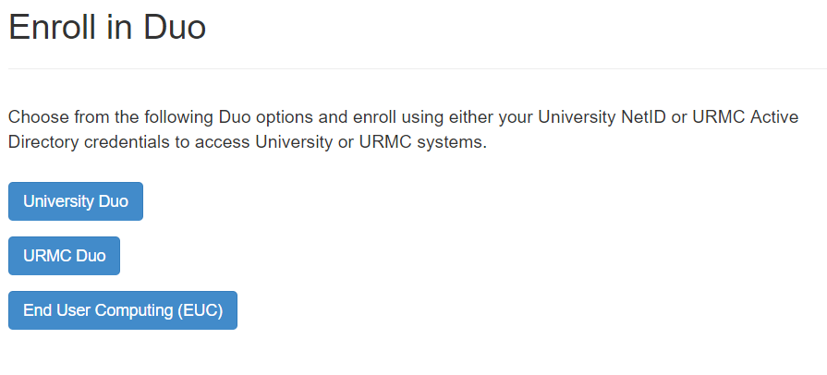
In order to access HRMS and your e-mail, you will have to do the set-up for both University Duo as well as URMC Duo.
- University Duo will have you set things up using your NetID and password, so make sure you have that ready; this will allow you to access HRMS
- URMC Duo will have you use your AD (domain) username – this will be the same username you use to log into a computer (this will sometimes be the same as your NetID, depending on your name length, but not always); this will allow you at access your e-mail
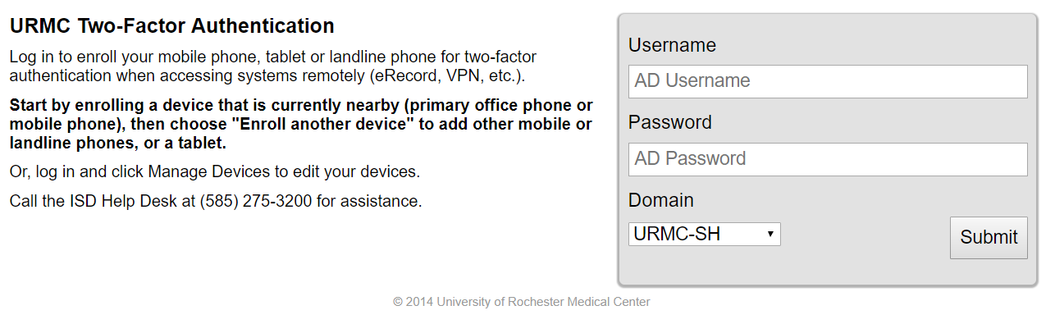

Once you log in, you can start the set-up – both set-ups look slightly different, however, they work the same way. The URMC authentication has a few more steps than the University authentication.
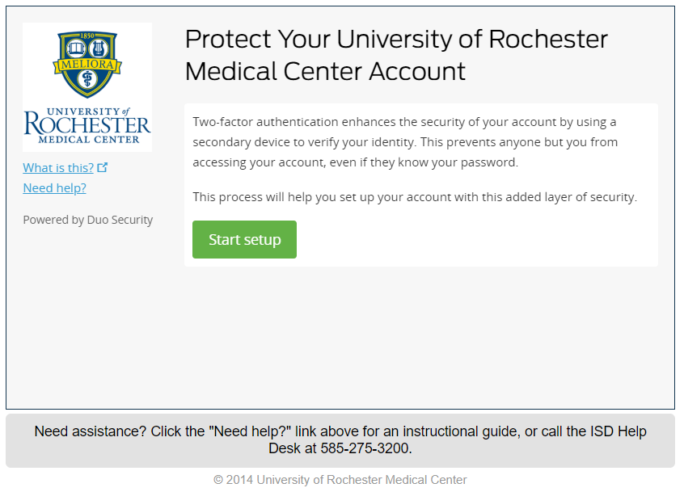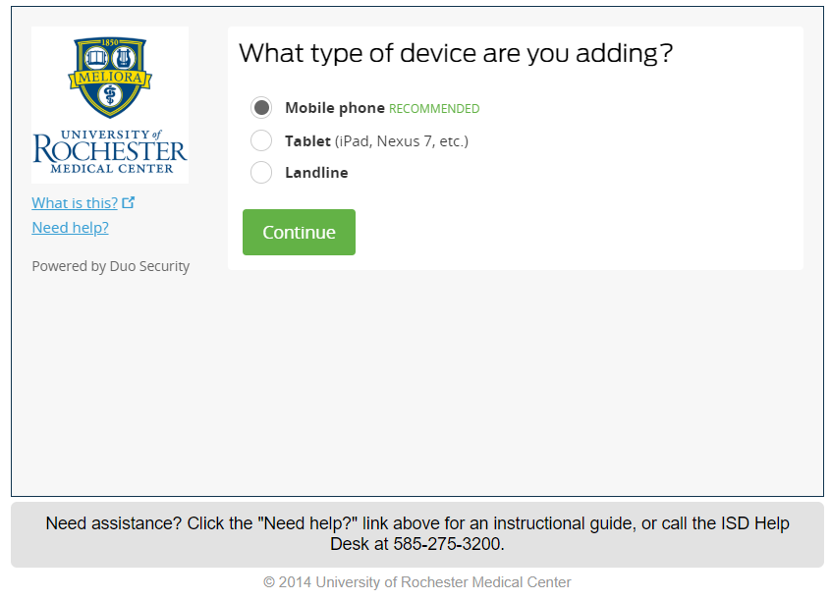
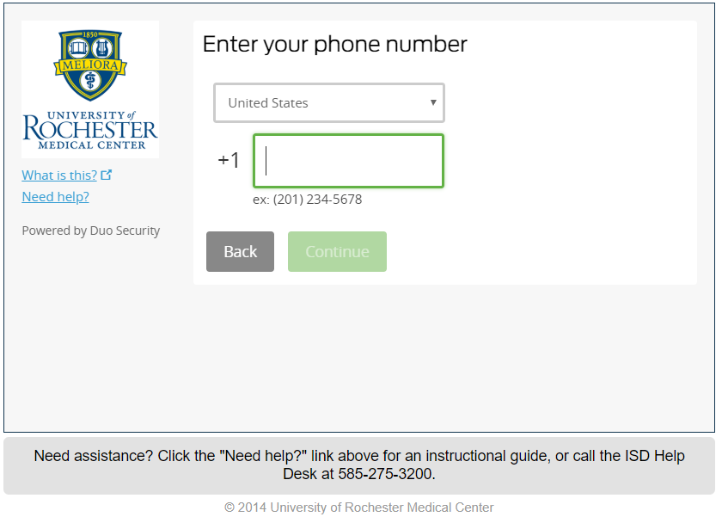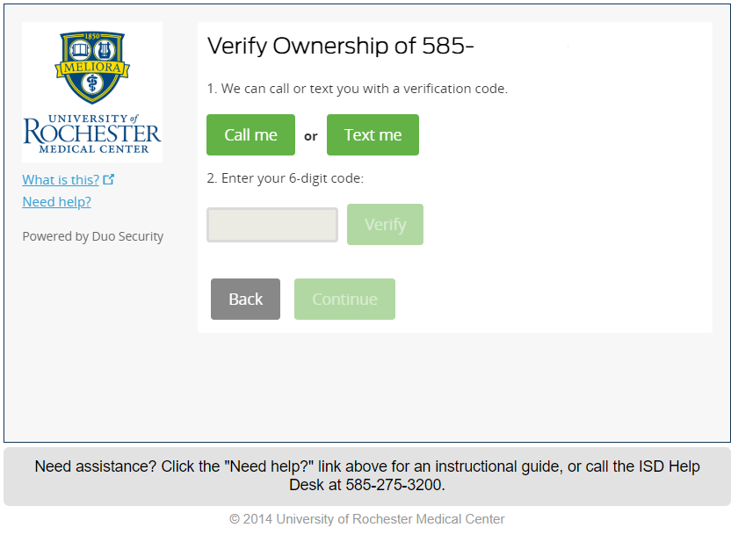
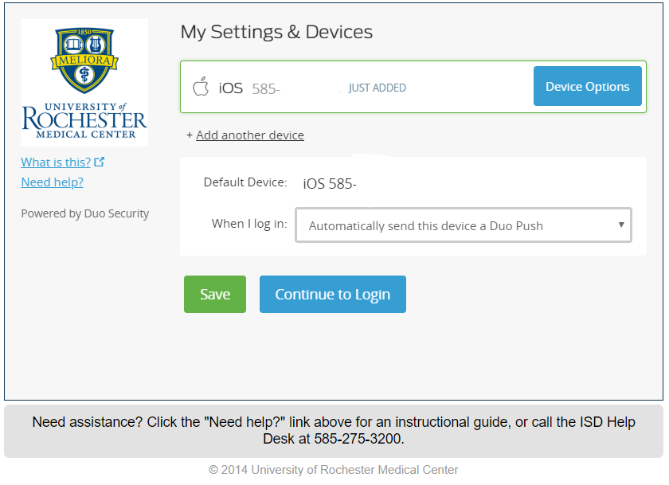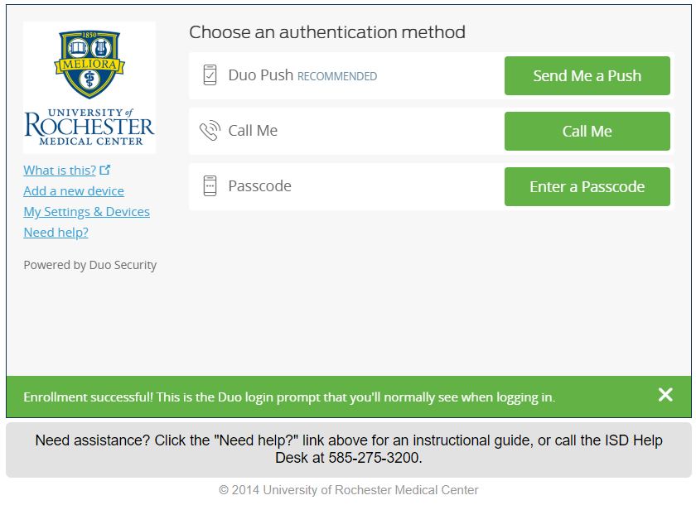
** Make sure you change it to “Automatically send this device a Duo Push” when you log in – you will receive a notification to approve the connection, and then it will log you in***

Once Duo Mobile is set up on your phone, it should look like this (it may look a bit different on an Android phone, however, the app should look the same):
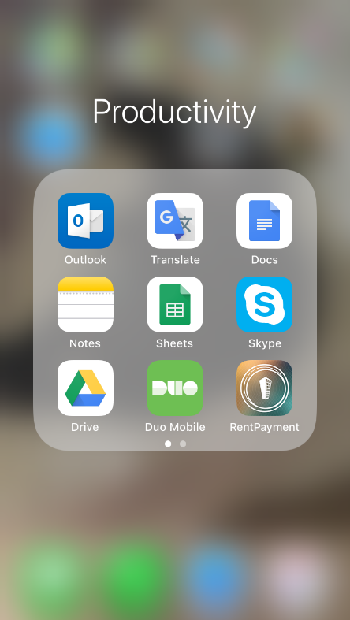
When you try to log in and receive a push notification to approve, it should look like this:
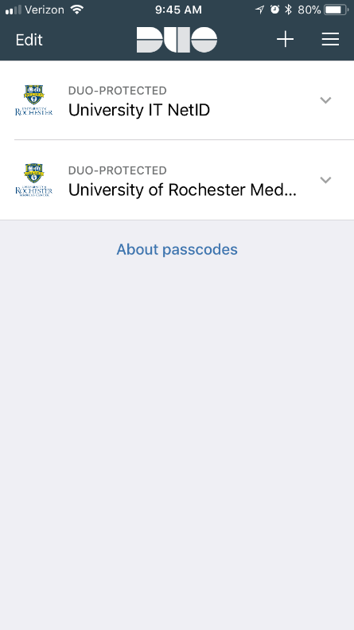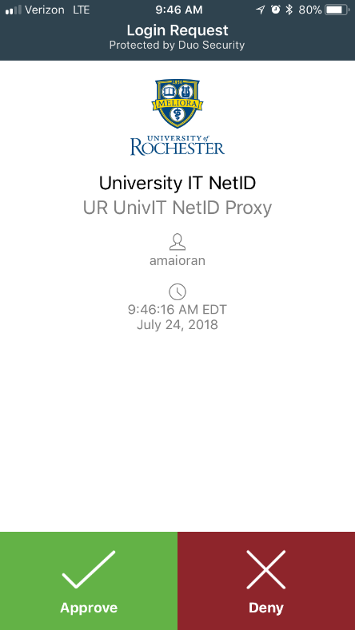
Once you approve it, the site will log in!
If you have any issues, please don’t hesitate to give the ISD Helpdesk a call at (585) 275-3200!

