PhD in Translational Biomedical Science Program Tracker
Information on Research Rotations, Pre-Qualifying Examination, and Qualifying Examination

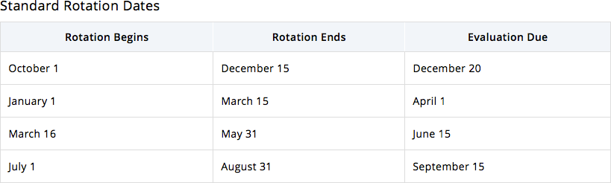

Research Rotation #1 (October 1-December 15, Fall first year in program):
** Note: dates may be different if student began first rotation July 1

Rotation Advisor(s):

Project Description:

Research Rotation #2 (Jan 1- March 15, Spring first year in program):
** Note: dates may be different if student began first rotation July 1

Rotation Advisor(s):

Project Description:

Research Rotation #3 (March 16 - May 31, Spring first year in program):
** Note: dates may be different if student began first rotation July 1

Rotation Advisor(s):

Project Description:

Note: under some circumstances, the third rotation may be waived.

