OVERVIEW
The Master’s Program in Health Humanities & Bioethics prepares students to achieve success in the interdisciplinary fields of humanities, bioethics, and healthcare. Whether you are a clinician, budding bioethicist, a humanities or social science professional or an enthusiast - at entry-level or have years of experience - this program will provide you with knowledge & skills to use in your career and life.
The University of Rochester is the home of the biopsychosocial approach to healthcare. The Health Humanities & Bioethics MS Program teaches students to apply the methods and materials of the humanities and bioethics-- from disciplinary areas such as history, visual arts, ethics, and narrative-- to health care issues and clinical practice. Graduates of this programs will gain the skills to critically evaluate and attend to the social, cultural, contextual, and ethical needs of patients as persons and as partners in health.
All learners will gain from the opportunity to expand their skills in critical thinking, cultural awareness and self-reflection.

CURRICULUM
- The MS Program in Health Humanities & Bioethics consists of 30-36 credit hours and can be completed in one year (two semesters) of full-time study. Part-time options are available.
- Students can choose to explore broadly or to focus on either clinical & translational ethics or a medicine, history & culture concentration.
- Students will study research methods relevant to the health humanities and bioethics focused on designing an independent scholarly research, or creative capstone project. The aim is to apply knowledge and methods from the humanities and bioethics to a question or issue in contemporary health care. Students pursuing a concentration will focus their capstone project in the area of concentration.
- Classroom discussions will emphasize key philosophical, historical, clinical, and cultural issues in Western medicine. Students will apply skills and concepts learned to contemporary issues in health care.



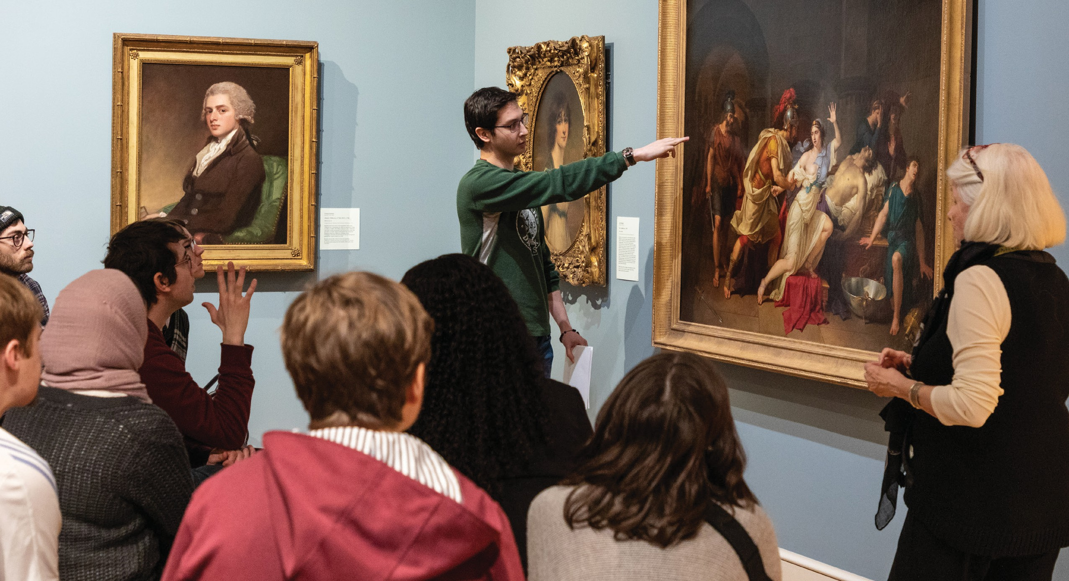
CONTACT US
(585) 275-5800
hhbe@urmc.rochester.edu
urmc.rochester.edu/education/graduate/masters/medical-humanities Health Humanities and Bioethics URMC

Health Humanities & Bioethics

PROFESSIONAL OPPORTUNITIES
The MS program in Health Humanities & Bioethics will prepare you to:
- Position yourself to be a successful applicant for continuing education programs, such as PhD graduate training, medical school, and other professional programs.
- Work collaboratively with patients, families, and interprofessional teams.
- Integrate health humanities and bioethics learnings related to medicine and healthcare into your academic work.
- Develop new skills and perspectives to improve your clinical practice.

PROGRAM ELIGIBILITY
Candidates for admission to the program must have earned a baccalaureate degree or its equivalent.
The master’s program in Health Humanities & Bioethics is intended for:
- Health care professionals
- Humanities professionals
- Bridging year students going into the health sciences, humanities, and the arts

Learn more and apply:
hhbe@urmc.rochester.edu
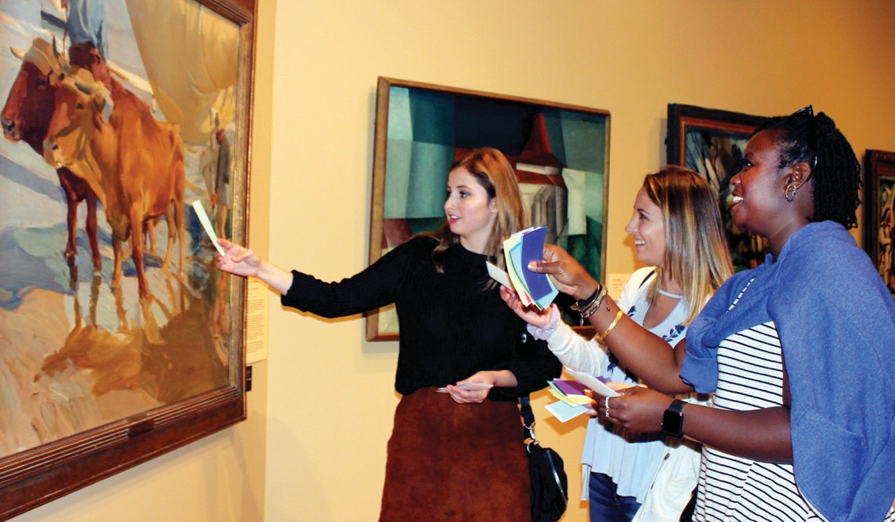

Application Deadlines
- May 1st for fall admission (with application fee waiver)
- June 15th for fall admission

ADMISSION CHECKLIST
Online application.
Personal statement addressing your reasons for pursuing a master’s degree in Health Humanities & Bioethics, and how you see this degree program enhancing your personal, intellectual, and professional growth.
Transcripts from all previous college and graduate programs attended (can be unofficial transcripts).
Minimum 3.25 Undergraduate GPA.
Three letters of recommendation from former instructors or employers.
One writing sample. This sample can be academic, narrative or creative writing.
We encourage applicants to include other samples of their work (e.g., visual arts, poetry, digital media, etc.) that support their statement of purpose and demonstrates their work in the humanities.
$60 application fee.



