Before the Interview
- Review the documents you sent with your application as these will be the primary resource interviewers use to learn about you.
- Review basic information about the program as this will show that you have some invested interest in the program.
- Practice for the interview: Many universities offer mock interviews to both current students and alumni through student services or a career center.
- Dress for success: Make sure to dress in appropriate attire (business casual/smart casual) that is comfortable.
- If participating in a virtual interview, several additional steps should be considered:
  - Test and ensure you have a strong Wi-Fi connection.
  - Make sure the video platform works with your electronic device and that you know how to use the platform.
  - Choose a quiet, well-lit space for the interview. Keep the lighting and background environment as professional as possible. If unavoidable, consider using a professional background filter.

During the Interview
- Introduce yourself to your interviewer: First impressions can influence the mood of the entire interview.
- Make eye contact and engage with your interviewer: This shows the interviewer that you are interested and paying attention in what they have to say.
- Do not fiddle with clothing or objects. A trick to avoid this would be to bring a small notebook and pen that you can hold. This not only gives your hands something to do but also allows for some notetaking.
- Stay calm: From the pool of applicants, YOU were chosen by the faculty to enter the interview phase. Although cliché, the faculty you will be meeting were once in your shoes, so they understand feeling nervous.

After the Interview

- After the interview, send an email thanking each interviewer for taking the time to talk with you. Within this email, you could ask any follow-up questions as well.

Places to Live
- Common Housing for Toxicology Students – 1600 Elmwood Apartments*, Clintwood Apartments, Elmwood Manor Apartments & Townhouses*, Elmwood Terrace Apartments & Townhomes*, Goler House*, Imperial South Apartments*, Mount Hope Lofts at College Town*, Rustic Village Apartments, and University Park*
- University Housing Options – Goler House, University Park, and Whipple Park Apartments
- For Housing Assistance – contact University of Rochester Office for Residential Life & Housing Services Off-Campus Housing or the Toxicology Training Program Coordinator
*Within walking distance to URMC

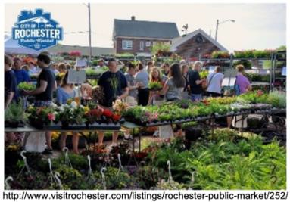
Activities in Rochester
- Food
Try a Rochester famous garbage plate!
Rochester’s local craft breweries: Swiftwater Brewing Company, Roc Brewing Co., and Genesee Brewing Company.
- If you prefer wine, head down to the Finger Lakes Region for a wine tour, such as the Seneca Lake Wine Trail.
The Pittsford Dairy offers great homemade ice cream year-round.
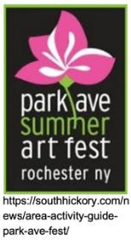
The Neighborhood of the Arts (NOTA) and Park Ave Neighborhood are great places to shop and dine.
- For groceries, try the Rochester famous grocery chain Wegmans or head to the Rochester’s Public Market for some fresh, seasonal, and local produce.
- Events
From summer festivals to music and sports, check out the continually updated list of upcoming events in Rochester at www.rochesterevents.com/.
- Recreation
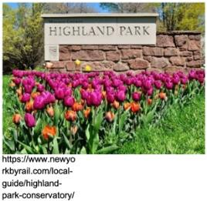
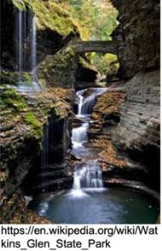
www.daytrippingroc.com/ is a great resource for Rochester day trip ideas! Local museums: the Kodak/Eastman Museum, the Memorial Art
Gallery (free with a UR Student ID), the Strasenburgh Planetarium, the Strong National Museum of Play, and the Rochester Museum and Science Center.
- To explore or expand your artistic side, try classes at Flower City Arts Center or the Rochester Brainery.
- Rochester contains many parks and trails that are perfect for
running, biking, hiking, and cross country skiing. Some local favorites are Highland Park, Mount Hope Cemetery, Cobb’s Hill Park, Erie Canal, Genesee Valley Park. Plus, just a short drive away are several great New York State Parks, including Niagara Falls State Park, Letchworth State Park, Watkins Glen State Park, and Taughannock Falls State Park.

