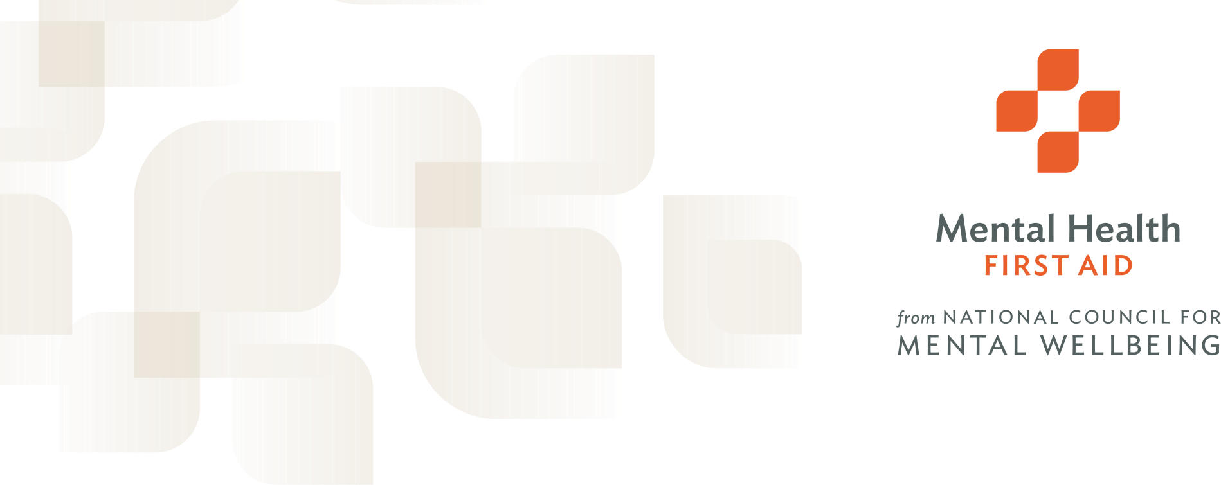

Mental Health First Aid Training Info Session

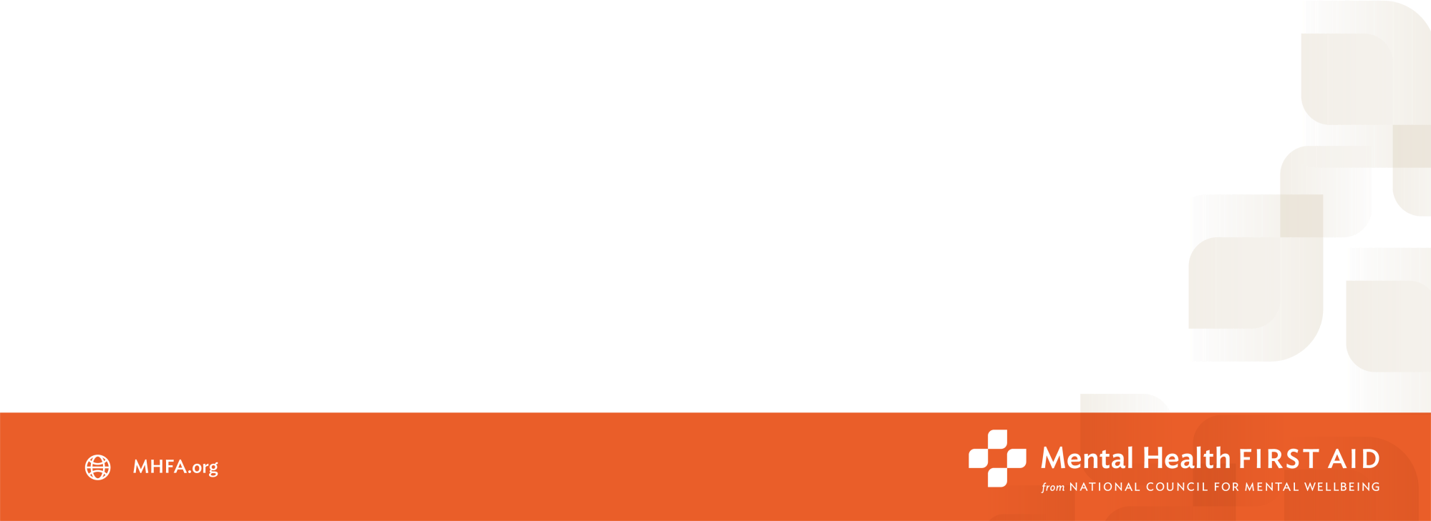
Mental Health in the US

Approximately 1 in 5 adults in the United States are diagnosed with a mental disorder in a single year.
Almost half of all U.S. adults will experience a mental health challenge at some point over the course of their lifetime.

Mental Health in the US
Many people with common mental disorders do not seek

professional help.
More than 40% of people with mental disorders sought no treatment in the prior year.

Barriers to care:
- Stigma about mental health challenges.
- A negative experience with a therapist.
- Lack of access and availability.
- The financial burden.

Mental Health First Aid
Mental Health First Aid is a program of the National Council for Mental Wellbeing. It was brought to the United States in 2008 with the aim to make it as common as physical First Aid and CPR. Since the National Council brought MHFA to the U.S. in 2008, MHFA has established itself as a trusted, evidence-based training program.

Through MHFA, more than 3 million people in the U.S. have been trained by thousands of certified Instructors to identify, understand, and respond to signs and symptoms of mental health and substance use challenges.

Mental Health First Aid training gives people knowledge and confidence
when it comes to identifying and helping an individual in distress.

How do we know MHFA is effective?
Many people know to call 911 or administer CPR for a physical health emergency but hesitate to start conversations about mental health and substance use. MHFA provides the tools a layperson needs to take action.
MHFA is proven to be effective in teaching adults how to recognize and respond to signs and symptoms of mental health and substance use challenges. Peer-reviewed studies from around the world show that individuals trained in MHFA:
» Expand their knowledge of signs, symptoms and risk factors of mental health and substance use challenges.
» Can identify appropriate types of professionals and self-help resources for
individuals with a mental health or substance use challenge.
» Have increased confidence in and likelihood to help an individual in distress.
» Show increased mental wellbeing themselves.

Mental Health First Aid Training
Mental Health First Aid is a skills-based training course that teaches participants about mental health and substance-use challenges.
- Create a new path of resilience and wellbeing.
- Reduce stigma and discrimination.
- Improve overall psychological safety.
- Address mental health and substance use challenges.

What it covers:
- Common signs and symptoms of mental health challenges
- Common signs and symptoms of substance use challenges
- How to interact with a person in crisis.
- How to connect a person with help

What Mental Health First Aiders Learn
- Risk factors and warning signs of mental health and substance use challenges.
- Information on depression, anxiety, trauma, psychosis and substance
use.
- A 5-step Action Plan to help someone developing a mental health or substance use challenge.
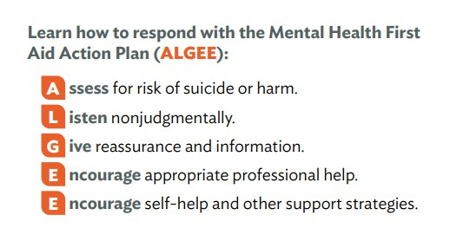

What To Expect at MHFA Training
- Manual and workbook that are yours to keep. No laptop or electronic devices necessary – all materials are printed.
- In-person delivery with a total of 7.5 hours of content, plus extra time
for breaks and refreshments.
- Interactive sessions with small group discussions/breakouts.
- 3-year certification that needs to be renewed through the National Council for Mental Wellbeing, or by repeating a MHFA training course.
- Email signature and downloadable certificate – display either one
wherever you choose, in as many settings as you’d like.
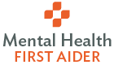
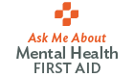

MHFA Training at the School of
Medicine and Dentistry
- Training is available for everyone: SMD graduate students, postdocs, staff, and faculty can all attend Mental Health First Aid training conveniently on-site at SMD
- MHFA Certified Instructor Amber Rivera, Director of Learner Life and Wellness in the SMD Graduate Education and Postdoctoral Affairs Office will offer the training several times per year.
- Interested in Mental Health First Aid Training? Contact Amber Rivera to find out more and to register for an upcoming training session. Email: amber_rivera@urmc.rochester.edu
Phone: 585-275-7288

