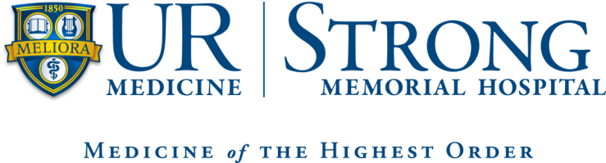

Urgent Care Medicine

Advanced Practice Provider

Fellowship Program Application

2026-2027
About UR Medicine
- Serves over 80,000 patients annually from the greater Rochester area.
- NP/PA will work with faculty with a wide variety of expertise in Urgent Care Medicine and Emergency Medicine. Fellows will be on the cutting edge of health care delivery as they train to work within the University of Rochester Medical Center and our Urgent Care centers.
Goal of the Fellowship Program
- It is anticipated that the Fellows will show clinical growth, improved clinical confidence and increased preparedness to care for patients in all of these settings, by the completion of the Fellowship.
- Our post graduate NP/PA Fellowship will provide additional skills training, as well as independent mentorship experience in the Urgent Care and Emergency Department for the duration of 10 months.
- This will be an intensive clinical program which will prepare NP's and PA's to meet the needs of culturally diverse and clinically complex adult and pediatric patients that are typical of our Urgent Care Centers.
- Fellows will be employees of URMC and will comply with all patient care policies.
Training Methods
- Hands on training in all of the following areas:
  - Multiple Urgent Care centers
  - Adult Emergency Department
  - Pediatric Emergency Department
  - Radiology
  - Orthopedics
  - EMS
  - Multiple other subspecialty experiences
Training Methods
- Simulation Lab Experiences
- Procedure Lab Experiences
- Cadaver Lab Experiences

Certifications Provided during Program
- BLS (required upon start of program)
- ACLS
Program Outline
- Applications will begin to be accepted after January 1st, 2026
- Applications due March 1st, 2026
- Interview will begin late March – early April 2026
- Application acceptance notification mid-late April 2026
- Anticipated program start date: Fall 2026 (pending NYS licensing and credentialing process)
- 10-month program
Benefits
- Competitive Fellowship salary
- Health insurance coverage
- Dental insurance coverage
- Life insurance policy
- Disability insurance coverage
- 5 weeks of vacation/year
- 1 week CME time/year
- $1000 CME annually
- $300 book stipend
- DEA coverage
- EMRA resource guides provided
- EM Boot camp independent learning provided
- EM Scrub Allowance

The APP Fellow MUST meet the following qualifications:
- Family Nurse Practitioner
  - Master’s degree in Nursing
  - Active New York State licensure as Registered Nurse and in good standing
  - New York State Nurse Practitioner licensure and national certification as a Family Nurse Practitioner (required to start program)
- Physician Assistant
  - Completion of an AMA approved Physician Assistant program
  - New York State Physician Assistant licensure and national certification as a Registered Physician Assistant (required to start program)

Applicants for the Urgent Care APP Fellow position should demonstrate clinical competence as well as excellent verbal and written communication skills. The APP Fellow should have excellent customer relation skills, a passion for Urgent Care Medicine and an active desire to learn.
Application Process:
- Please send the following items, via the mail, to the Emergency Medicine APP Director, Heidi Springer, FNP.
  - Current Resume or Curriculum Vitae
  - Official academic transcript to date
  - Submit 2 professional confidential references. Recommendations should be placed in a sealed envelope with their signature across the seal of the envelope.
    - Request a confidential recommendation from a Nurse Practitioner/Physician Assistant/Physician clinical preceptor during your academic program.
    - Request a confidential recommendation from a Faculty member from your academic program.
  - Letter of Interest:
    - Provide a letter of interest which reflects on your interest in the Urgent Care Medicine APP Fellowship program, your passion for Urgent Care Medicine, and how this opportunity will impact your future as an Urgent Care Medicine APP. Please also comment on why you think this program will be a good fit for you.

- Applications for consideration for the 2026-2027 Fellowship program are due by March 1st, 2026. Please mail all required items together in one envelope. Incomplete applications will not be considered after the deadline.
- Candidates will be contacted in mid-March 2026 to arrange for interview
- Return complete application to:
  - Heidi Springer, FNP
  - Mail to:
Strong Memorial Hospital
Emergency Department
601 Elmwood Avenue
Box 655A
Rochester, NY 14642
- Please note that in addition to this supplemental application, all applicants must also apply on the University of Rochester Medical Center’s on-line Recruitment system.
  - https://rochester.wd5.myworkdayjobs.com/UR_Nursing
  - Job Description: University of Rochester Urgent Care – APP Fellowship – Nurse Practitioner/Physician Assistant
- Please e-mail Heidi Springer at Heidi_Springer@URMC.Rochester.edu with any questions or concerns about this application and the application process.

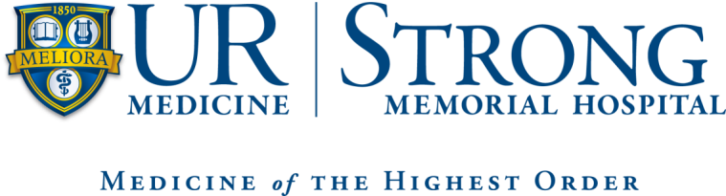

Urgent Care Medicine Advanced Practice Provider

Fellowship Program

Reference Form
Nurse Practitioner/Physician Assistant Program: ________________________________________________
Date:________________________
_________________________________ (name of applicant) has applied for a position in the Urgent Care Medicine APP Fellowship Program at Strong Memorial Hospital in Rochester, NY.
We would appreciate your evaluation of this applicant’s general ability and professional proficiency in academic and clinical practice. We would like to know what you consider the applicant’s strengths and weaknesses to be. You can be assured that all information will be treated confidentially.
Please be advised that all recommendations are to be completed confidentially and recommender should be provided an envelope to enclose their recommendation which must have a signature across the seal of the envelope and can be submitted with the application.
I hereby authorize the release of my academic/clinical record to Strong Memorial Hospital, Emergency Medicine Department.
Applicant Signature: _________________________________________
Applicant Printed Name: ______________________________________
******************************************************************************************
The above APP was a student in your academic/clinical setting during what period of time? ________________________
In comparison with the other students in the class, how would your rank this student academically?
Upper 10% ( ) Upper 25% ( ) Middle ( ) Lower 25% ( ) Lower 10% ( ) N/A ( )
In comparison with the other students you have worked with clinically, how would you rank this student clinically?
Upper 10% ( ) Upper 25% ( ) Middle ( ) Lower 25% ( ) Lower 10% ( ) N/A ( )

Page 1/3

Please Rate the Applicant on the Following:

 | Above Average | Average | Below Average | N/A | Comments
Critical Thinking Skills

Organizational Skills

Leadership Potential

Flexibility/Adapts to Change

Professional Attitude

Clinical Competence

Appropriately selects and interprets diagnostic testing findings

Medical Decision Making Process

Demonstrates therapeutic communication with patients & families
Demonstrates professional communication with other professionals
Works in a collaborative fashion with health care team

Appropriate documentation

Procedural skills

Appearance/Grooming

Attendance/Punctuality

Overall Recommendation

Page 2/3
Supplemental Statement/Letter: REQUIRED for consideration
Please include a statement below (or attach a letter separately) about the applicant’s strengths, areas for growth, potential for success as an Advanced Practice Provider and whether you feel this applicant will be a good fit for our Urgent Care Medicine APP Fellowship program.

Recommender Name (print): ___________________________________________________________
Recommender Signature: _________________________________________________________
Recommender Title: _____________________________________________________________
Contact Information (E-mail): ______________________________________________________________
Date: ____________________ Page 3/3

Urgent Care Medicine Advanced Practice Provider

Fellowship Program

Reference Form
Nurse Practitioner/Physician Assistant Program: ________________________________________________
Date:________________________
_________________________________ (name of applicant) has applied for a position in the Urgent Care Medicine APP Fellowship Program at Strong Memorial Hospital in Rochester, NY.
We would appreciate your evaluation of this applicant’s general ability and professional proficiency in academic and clinical practice. We would like to know what you consider the applicant’s strengths and weaknesses to be. You can be assured that all information will be treated confidentially.
Please be advised that all recommendations are to be completed confidentially and recommender should be provided an envelope to enclose their recommendation which must have a signature across the seal of the envelope and can be submitted with the application.
I hereby authorize the release of my academic/clinical record to Strong Memorial Hospital, Emergency Medicine Department.
Applicant Signature: _________________________________________
Applicant Printed Name: ______________________________________
******************************************************************************************
The above APP was a student in your academic/clinical setting during what period of time? ________________________
In comparison with the other students in the class, how would your rank this student academically?
Upper 10% ( ) Upper 25% ( ) Middle ( ) Lower 25% ( ) Lower 10% ( ) N/A ( )
In comparison with the other students you have worked with clinically, how would you rank this student clinically?
Upper 10% ( ) Upper 25% ( ) Middle ( ) Lower 25% ( ) Lower 10% ( ) N/A ( )

Page 1/3

Please Rate the Applicant on the Following:

 | Above Average | Average | Below Average | N/A | Comments
Critical Thinking Skills

Organizational Skills

Leadership Potential

Flexibility/Adapts to Change

Professional Attitude

Clinical Competence

Appropriately selects and interprets diagnostic testing findings

Medical Decision Making Process

Demonstrates therapeutic communication with patients & families
Demonstrates professional communication with other professionals
Works in a collaborative fashion with health care team

Appropriate documentation

Procedural skills

Appearance/Grooming

Attendance/Punctuality

Overall Recommendation

Page 2/3
Supplemental Statement/Letter: REQUIRED for consideration
Please include a statement below (or attach a letter separately) about the applicant’s strengths, areas for growth, potential for success as an Advanced Practice Provider and whether you feel this applicant will be a good fit for our Urgent Care Medicine APP Fellowship program.

Recommender Name (print): ___________________________________________________________
Recommender Signature: _________________________________________________________
Recommender Title: _____________________________________________________________
Contact Information (E-mail): ______________________________________________________________
Date: ____________________ Page 3/3

