A Healthy Homes Needs Assessment for Rochester, NY

October 14, 2015
Katrina Smith Korfmacher, PhD Valerie Garrison, MS

Please contact Dr. Katrina Korfmacher with questions or comments about this report:
Katrina Smith Korfmacher, PhD University of Rochester Medical Center
Director, Community Outreach and Engagement Core, Environmental Health Sciences Center
Associate Professor, Department of Environmental Medicine katrina_korfmacher@urmc.rochester.edu

Acknowledgements
This effort would not have been possible without the help of City of Rochester Bureau of Inspection and Compliance Services staff, who produced inspection data sets and advised on field selection and data interpretation. Other contributors to this effort include faculty in the Environmental Health Sciences Center, staff from the NYS Department of Health and Monroe County Department of Public Health, housing professionals from PathStone and Neighborworks, and the Rochester Healthy Homes Partnership. This needs assessment was funded through the University of Rochester Department of Environmental Medicine’s NIEHS Center Grant (P30 ES001247) Pilot Program. The views expressed in this report are those of the authors, and do not reflect the views of these contributors or their organizations.

Introduction
Home environmental health hazards are widely recognized as significant health concerns, particularly for low-income children. Children at greatest risk are those living in older, poorly maintained housing that may have lead, air quality, pest infestation, safety, carbon monoxide, or other hazards. Many of these hazards can be addressed, mitigated, or avoided through parent education, appropriate referral to community resources (e.g. housing, inspection, or legal services), or low-cost home-based interventions. However, systems, policy, and practice changes may be needed to efficiently and sustainably reduce home hazards in a community. Developing such systems-level changes requires understanding the nature, extent, and distribution of home hazards in that particular community.
Rochester, New York, is a city which is characterized by older housing (93% was built before 1980)(U.S. Census Bureau, 2009-2013b). Rochester has the 5th highest overall poverty rate in the country, and a child poverty rate (50%) more than double that of New York State (22%)(Doherty, 2013; U.S. Census Bureau, 2009-2013a). More than 60% of Rochester residents are renters (over 90% in many of the poorest neighborhoods)(U.S. Census Bureau, 2009-2013b). Not surprisingly, many Rochester children live in low-value rental housing in poor condition. In addition, with a median housing value of
$75,800, many low-income families own their homes, but may not be able to afford adequate maintenance.
These characteristics contributed to childhood lead poisoning rates in some neighborhoods that were nearly 20 times the national rate in 2000. The number of children with blood lead levels over 10 µg/dL has declined by 89% since 2000, in part because of Rochester’s 2005 lead law that required inspection for and repair of deteriorated paint in rental units. This law built on the findings of a 2002 Needs Assessment for Lead Poisoning Prevention that characterized local, state, and national approaches to lead poisoning prevention and characterized the neighborhoods likely to have the highest lead risks (Boyce & Hood, 2002). Since that time, community groups have increasingly recognized that in addition to lead, many other home environmental health hazards (asthma triggers, carbon monoxide, toxic chemicals, etc.) may pose threats to residents’ health. However, there is no systematic surveillance system for most of these home environmental health hazards. Therefore, the prevalence of such hazards is more difficult to characterize than lead.
It is also more difficult to directly connect these housing conditions to health outcomes.
Research in other cities has shown that multiple environmental hazards frequently co-occur in low-value older housing in poor condition (Krieger and Higgins, 2002). There is a well-developed evidence base that home environmental hazards contribute to health problems (Hoppin, Jacobs, & Stillman, 2010; Jacobs & Baeder, 2009; The Guide to Community Preventive Services, 2009). Although this research was not conducted in Rochester, there are some local health data, such as the higher rates of asthma in low-income neighborhoods, which suggest that home hazards other than lead are adversely affecting
children’s health here as well.

In order to develop targeted, efficient, and effective strategies for improving home health in Rochester, we first need to characterize the nature, extent, and distribution of such hazards. The primary goal of this Needs Assessment was to analyze existing data to identify key home environmental health issues in Rochester, determine additional data needs, and guide future healthy housing efforts. Additionally, characterization of home hazards in Rochester could facilitate future research on housing-health connections that inform additional hazard reduction strategies. Development of this Needs Assessment had two sub-aims:
- Provide an evidence base for a community-based approach to develop policy, programmatic and systems change efforts to advance home-related health in Rochester.

- Establish new partnerships as a foundation for community-based environmental health research.
The University of Rochester Environmental Health Sciences Center Community Outreach and Engagement Core (COEC) partnered with the Rochester Healthy Homes Partnership (RHHP) to conduct this Needs Assessment. The RHHP is a group of about 20 local organizations involved in housing, health, and environmental issues. In 2010, the RHHP identified three actions needed to advance healthy homes in Rochester: 1) educate residents, community groups, and government officials; 2) conduct a Needs Assessment to characterize and prioritize the most critical healthy homes issues in Rochester; and 3) develop a strategy to address the identified needs. RHHP members have made significant contributions to the first goal (education), including training programs by the COEC, the RIT Pollution Prevention Institute, the American Lung Association, and the Child Care Council. The RHHP noted that a comprehensive, science-based characterization of home health hazards in Rochester is needed as a foundation for the third step: developing and implementing a strategic plan to improve home health.

Background: Home health risks, research, and solutions
Americans spend most of their time indoors. It is well established that exposure to poor indoor air quality, lead, and many other toxicants (including chemicals in cleaners, pesticides, air fresheners, etc.) can pose significant environmental health risks (Jacobs & Baeder, 2009; Wu, Jacobs, Mitchell, Miller, & Karol, 2007). Because children spend so much time in the home, and because of their unique susceptibility, home environmental hazards are particularly significant for children’s health.
The National Center for Healthy Housing recently compiled an overview of the evidence for connections between housing interventions and health. The review emphasizes the complexities of integrating research on housing interventions, housing conditions, and clinical outcomes.¹ The literature

¹ The authors of the NCHH review noted: “In assessing the scientific evidence, we used two broad categories of evidence: clinical evidence and environmental or housing measurements. Each of these sources of evidence has strengths and weaknesses. Clinical evidence (or other health data such as self-reported health) is likely to be the most direct measure of health status. Yet many health conditions do not have adequate biomarkers, or have long time horizons before an adverse health event occurs, making clinical evidence problematic. For example, lung cancer from radon exposure may not be clinically observable for many years, yet there is good evidence that radon environmental measurements can be linked reliably to risk of lung cancer. Similarly, asthma is a complex set of

review concluded that there is good evidence for housing interventions that improve health in all categories of hazards they examined (interior biological agents, interior chemical agents, external exposures, structural deficiencies, and neighborhood-level factors), but that more research is needed to determine the efficacy of additional interventions.
The Seven Principles of Healthy Homes
http://www.nchh.org/WhatWeDo/HealthyHomesPrinciples.aspx

- Dry: Damp houses provide a nurturing environment for mites, roaches, rodents, and molds, all of which are associated with asthma.
- Clean: Clean homes help reduce pest infestations and exposure to contaminants.
- Pest-Free: Recent studies show a causal relationship between exposure to mice and cockroaches and asthma episodes in children; yet inappropriate treatment for pest infestations can exacerbate health problems, since pesticide residues in homes pose risks for neurological damage and cancer.
- Safe: The majority of injuries among children occur in the home. Falls are the most frequent cause of residential injuries to children, followed by injuries from objects in the home, burns, and poisonings.
- Contaminant-Free: Chemical exposures include lead, radon, pesticides, volatile organic compounds, and environmental tobacco smoke. Exposures to asbestos particles, radon gas, carbon monoxide, and second-hand tobacco smoke are far higher indoors than outside.
- Ventilated: Studies show that increasing the fresh air supply in a home improves respiratory health.
- Maintained: Poorly-maintained homes are at risk for moisture and pest problems. Deteriorated lead-based paint in older housing is the primary cause of lead poisoning, which affects some 240,000 U.S. children.
Because of the complexity and overlap among these hazards, NCHH developed “Seven Principles of Healthy Housing” (see text box) to guide healthy homes interventions. These principles serve as a common-sense guide to the kinds of housing interventions and maintenance that are likely to reduce health hazards.
As these descriptions suggest, most home environmental health hazards involve both a physical and behavioral element. Pest control may be the best example: in order to address infestations, the home must be secure (i.e. no cracks in walls or foundation) and dry. In addition, however, residents must store food properly, clean up spills, and remove clutter that can harbor pests. Similarly, controlling mold requires adequate ventilation, which includes both system installation and use (such as installing and using bathroom fans). For this reason, effective healthy housing interventions should include both addressing physical problems in the home and educating residents to support behavioral change as needed. When
addressing hazards in rental housing, the property owner-tenant relationship is important. Many healthy homes programs emphasize one or the other (physical or behavioral). Since the goal of this

symptoms for which a single, reliable biomarker has yet to be identified. Thus, an intervention that successfully reduces environmental exposures for which there is good evidence of a dose-response relationship may be judged successful. Ideally of course, both clinical and environmental data can make the most compelling case for a given intervention. In this review, we analyzed studies that contained clinical, health, or environmental measurements, or a combination of these” ((Jacobs & Baeder, 2009), p. 8).

Needs Assessment is to inform systems change, our focus is on physical characteristics of homes that can affect health; however, any successful approach must also address resident behaviors.

Approach and Methods
We integrated multiple data sources in order to identify and characterize hazards in Rochester housing. These included: Data from the Monroe County Healthy Neighborhoods Program, American Housing Survey, and City of Rochester Certificate of Occupancy (CofO) inspections, as well as interviews with key stakeholders. A range of approaches has been used to develop ‘indicators’ of healthy housing and to target housing where hazards are likely to occur. Below, we describe our efforts to analyze available data on housing in Rochester to 1) paint an overall picture of housing hazards in Rochester in comparison with other cities, 2) identify areas within Rochester that should be targeted with limited housing resources, and 3) identify future data needs.
Key Informants:
Throughout the project, we consulted with members for the Rochester Healthy Homes Partnership (RHHP) and key informants. At the outset of the project, we solicited input from EHSC researchers, RHHP members, City of Rochester inspections staff, NYS Health Department and Monroe County Department of Public Health Healthy Neighborhoods Program staff, and National Center for Healthy Housing staff about housing characteristics that would be useful indicators of home health, available data sources, and approaches to assessing home health developed by groups in other cities. We also shared preliminary results and the draft report with these groups for feedback and input on recommendations.
Monroe County Healthy Neighborhoods Program (HNP):
The HNP is part of a statewide network of targeted efforts to assess, educate, and promote healthy homes interventions in high-risk housing. HNP offers healthy home assessments and interventions for residents of high-risk communities throughout New York State. The Monroe County Department of Public Health conducts home visits through this program in five Rochester zip codes: 14605, 14609, 14608, 14611, and 14621. The Monroe County HNP program was first funded from 1993-1997. Funding was restored in 2004 and will continue through 2019. As of September 1, 2015, HNP staff have visited over 4,800 homes. The summary data from this program is available on the New York State Department of Health (NYSDOH) website.^{2,3} In addition to information about housing conditions, the HNP data includes resident information such as smoking behaviors, use of scented products, and whether any of the occupants have asthma.
NYS publishes aggregate HNP data annually (excluding health information); these are summarized in this report (see Tables 11-15). HNP indicators that correspond to the selected CofO

² https://www.health.ny.gov/environmental/indoors/healthy_neighborhoods/
³ https://health.data.ny.gov/en/browse?q=healthy+neighborhoods+program, accessed 6/11/2015

violations are included in Table 1; other available HNP data (data recorded by HNP that does not match up with selected CofO violations) is listed in Table 2. Because participation in the HNP is voluntary and targets high-risk neighborhoods, its database cannot be interpreted as representative of housing in Rochester. However, compared with more systematically collected data, such as the American Housing Survey and the City of Rochester Certificate of Occupancy Inspections database, it provides a window into what kinds of hazards may be more problematic in high-risk housing in Rochester. In addition, the HNP data is the only existing dataset that connects housing, behavior, and health data. Finally, because HNPs collect the same data in all 15 cities, it is possible to compare data from Rochester with other New York communities. Because of the convenience sample approach of the HNP, this data must be interpreted with caution; however, it may be useful to suggest key hazards to focus on in future studies.
American Housing Survey (AHS)
The AHS is a national phone survey conducted with a representative sample of households in major cities. Survey results are used to calculate population-wide estimates.⁴ The AHS National Sample is surveyed every other odd-numbered year; the Metropolitan Sample survey occurs in selected areas on a rotating basis (American Housing Survey, 2015). Prior to the 2013 survey, Rochester was last surveyed in 1998.
Although the AHS data is based on self-report by property owners and occupants and does not involve physical inspections, the standardized protocol means that AHS data can be used to compare housing conditions between cities. However, the sampling methodology (survey rather than inspection-based) and variable timing (e.g., a 15 year gap between the most recent and prior survey for Rochester) limits the AHS’ usefulness for informing or evaluating targeted housing interventions.
The AHS includes questions ranging from general housing information to property and neighborhood conditions, community involvement, and public transportation options. Subsets of the housing questions relate to home health hazards (Table 1) and were integrated by the National Center for Healthy Housing into twenty indicators for the State of Healthy Housing Report.
State of Healthy Housing Report (SHHR)
Using data from the American Housing Survey, the National Center for Healthy Housing developed a State of Healthy Housing report. This document was designed to increase awareness of “housing-related health hazards” (National Center for Healthy Housing, 2013a). The SHHR compares 20 categories of problems in 46 cities across the US, using American Housing Survey data.⁵ As discussed below, we used the SHHR indicators to help select which CofO violations to analyze and to develop our “Healthy Housing Index.” Appendix I summarizes variables selected for the SHHHR and their connections to health.

⁴ Exterior data is only reported for single family units.
⁵ http://www.nchh.org/Policy/2013StateofHealthyHousing.aspx

Poor Quality Index
The Poor Quality Index (PQI) was developed for the U.S. Department of Housing and Urban Development Office of Policy and Research by Econometrica (Eggers & Moumen, 2013).
The index ranks 35 housing quality indicators by “weight,” which the researchers assigned based on severity. For example, indicators that automatically qualify a dwelling as “inadequate” are ranked a 10. Other indicators are ranked lower than 10 according to severity. We used PQI
indicators weighted as a 4 or higher (the “most important” indicators of poor quality housing) to help select which CofO violations to analyze.
City of Rochester Housing Inspection Database
The City of Rochester Bureau of Inspection and Compliance Services inspects all rental units every six years (single family or duplex) or every three years (buildings with three or more dwelling units or mixed use structures). Over 60% of homes in the City of Rochester are renter-occupied (U.S. Census Bureau, 2009-2013b); in some neighborhoods, the rental rate is more than 80%. This proactive code inspection system has been in place for rental housing with two or more units since the mid-1970s and since 1998 for single family rentals. Qualifying housing in the City of Rochester should not be occupied without passing an inspection and having a current Certificate of Occupancy (CofO)(B. o. I. a. C. S. City of Rochester). Between CofO inspections, additional inspections may be triggered by a resident or neighbor complaint, an outside agency referral or by City inspectors surveying their assigned areas.
Rochester’s inspections are based on both local and state codes, which in turn are based on the International Property Maintenance Code (IPMC) as implemented by the state of New York (International Code Council Inc. & New York State Department of State, 2010). Rochester’s inspection process incorporates additional provisions related to lead paint (visual inspections for deteriorated paint and bare soil, and dust wipe tests for units in high-risk areas that pass the visual inspections)(City of Rochester, 2006).
When violations are found in the course of an inspection, the property owner is cited and must address the violations before a CofO is issued. All violations are recorded in the city’s Building Information System database. If the violations are not cleared within a specified period of time, the city may assess fines or take other appropriate enforcement action. ⁶ This system of proactive inspection of all rental units is one of the most thorough and comprehensive in the country.
During CofO inspections, inspectors check compliance with a list of over 280 potential violations. Below, we describe the process we went through to select a manageable number of violations to extract from the database as indicators of home health and safety. The resulting database provides a comprehensive picture of home health hazards in rental housing in Rochester.

⁶ The city maintains an online database of “rental properties within the City of Rochester that have a current Certificate of Occupancy and no outstanding violations.” http://www.cityofrochester.gov/app.aspx?id=8589953471

Indicator Selection
The CofO inspection addresses over 280 potential violations. We met with stakeholders to identify a subset of these violations that were most likely to indicate a potential health hazard. City code enforcement and inspection staff identified the violations that they most commonly associated with unhealthy homes. We also spoke with energy efficiency and rehabilitation agency staff who identified additional indicators of an unhealthy home and data that may be useful in their work. We sent the resulting list of indicators to National Center for Healthy Housing staff to review the data selection process and key indicators as they related to previous healthy homes indicators efforts.
Next, we compared the suggested “CofO healthy home violations” with the indicators used by the AHS, SHHR and PQI. As noted above, we used the PQI weights to identify a subset of 10 “most important” SHHR indicators to focus on (Appendix II).
We compared this list of 10 SHHR indicators to the list of Rochester CofO inspection violations and identified 34 that fit within them (Table 1). Seven additional violations were included in the list of CofO violations at the recommendation of stakeholders. These included:
- Immediate hazards
- Broken or missing handrails
- Interior deteriorated paint - 10%
- Interior deteriorated paint - 2 sq ft
- Poor housekeeping
- Carbon monoxide alarms
- Smoke alarms
This yielded a total of 41 CofO violations. For this needs assessment, we requested only a single year of inspection data (2013) to demonstrate proof of concept.⁷ The complete list of CofO violations we selected is in column one of Table 1.
The City of Rochester provided an Excel database consisting of the records of all CofO cases opened and properties inspected for CofO in 2013 and which, if any, of these 41 violations were cited. Each property was listed by address with fields including date of construction, property type (number of units), and property value, in addition to the selected violations. After data cleaning, there were 4,627 unique property records. Refer to Appendix III for information about how the data were cleaned.
The addresses were geocoded in ArcGIS 10.1 using the New York State Street Address Mapping Program.⁸ Appendix IV details the geocoding process and how the housing data was linked to geographic boundaries.

⁷ For several of these conditions, the CofO database included multiple related violations. In such cases, we selected the most commonly cited of these related violations. For example, there are seven violations related to smoke alarms; therefore, we only requested information on the most commonly cited violation “alarm req
smoke.”

Table 1 – City of Rochester housing code violations and their related indicators in other national datasets
⁸ https://gis.ny.gov/streets/
9
City of Rochester Housing Code Violation | NCHH State of Healthy Housing Indicators | AHS indicator(s) | (Poor) Housing Quality Index (weight) | HNP Indicator(s)
Infestation interior | Signs of mice/rats | Signs of mice in past 12  months |  | Mice (evidence or reported)
Rodents | Signs of mice/rats | Signs of rats in past 12  months |  | Rats (evidence or reported)
Pipes are leaking | Water leaks from inside | With leakage from inside structure |  | Plumbing leaks
Water heater leaking
P sewage (raw) cellar
Roof leaking | Water leaks from outside | With leakage from outside structure |  | Any roofing or structural leaks
Walls repair/point
Gutters/dnspt miss/repair
H thermostat missing/rep | Heating equipment breakdown | Equipment breakdowns | Unit was uncomfortable cold for 24 hours (4)
Heat inadequate | Heating equipment breakdown | Equipment breakdowns | Each heating equipment breakdown (2)
 | Heating equipment breakdown | Equipment breakdowns | Unit cold due to utility interruption (2)
Heating system inoperable | Heating equipment breakdown | Equipment breakdowns | Unit cold due to inadequate heating capacity (2)
Heating system inoperable | Heating equipment breakdown | Equipment breakdowns | Unit cold due to inadequate insulation (2)
 | Heating equipment breakdown | Equipment breakdowns | Unit cold due to other reason (2)
H Flue not conn/seal | Room heater without flue | Room heaters without flue | Main heating equipment is unvented kerosene heater(s) (4)
Heater (kerosene) unappv'd
Circuits are exposed | Exposed wiring in unit | Exposed wiring | Unit does not have electricity (10) | Electrical hazards found
E junction box open | Exposed wiring in unit | Exposed wiring | Unit has exposed wiring (4) | Electrical hazards found
E svc box need k-o seals | Exposed wiring in unit | Exposed wiring | Each occurrence of a blown fuse or thrown circuit  breaker (1) | Electrical hazards found
Outlet/switch req plate | Exposed wiring in unit | Exposed wiring | Unit does not have electric plugs in every room (3) | Electrical hazards found
Elec svc ent cabl repair
Wires exposed encl/rem
Pch roof detr'd
Roof eaves deteriorated | Roofing problems | Sagging roof | Roof’s surface sags or is uneven (5)
Roof deteriorated | Roofing problems | Missing roofing material | Roof missing shingles/other roofing materials (5)
Roof has holes
Roof shingles need repair | Roofing problems | Hole in roof | Roof has holes (5)
Siding brkn/missing | Siding problems | Missing bricks, siding or other outside wall material | Outside walls missing siding/bricks/and so on (5)
Masonry wall needs repair | Siding problems | Missing bricks, siding or other outside wall material | Outside walls missing siding/bricks/and so on (5)
Att chimney pointing req'd | Siding problems | Missing bricks, siding or other outside wall material | Outside walls missing siding/bricks/and so on (5)
Brickwk (ext) - repair req'd | Siding problems | Sloping outside walls | Outside walls slope/lean/slant/buckle (5)
Chimney has holes | Siding problems | Sloping outside walls | Outside walls slope/lean/slant/buckle (5)
Chimney point or repair | Siding problems | Sloping outside walls | Outside walls slope/lean/slant/buckle (5)
Door boarded | Window problems | Broken windows | Windows broken (5)
Storm wndw pane brkn/miss | Window problems | Broken windows | Windows broken (5)
Window boarded | Window problems | Boarded up windows | Windows broken (5)
Window panes brkn/missing | Window problems | Boarded up windows | Windows broken (5)
Foundation point/repair | Foundation problems | Foundation crumbling or  has open crack or hole | Holes/cracks or crumbling in foundation (5)
Hazard - correct immed.
Handrail broken/miss
Paint det int - 10% |  |  |  | Chipping, peeling, deteriorated, chalking paint found indoors
Paint det int - 2 sq ft
Poor housekeeping |  |  |  | *, **Evidence of effective  housecleaning
Alarm req CO exist bldg. |  |  |  | *Residence has a working carbon  monoxide detector
Alarm req smoke |  |  |  | *Residence has functional smoke detector(s) on every floor with  living space
*Smoke detector audible from
sleeping space

*Positive home health indicators
**HNP has multiple indicators related to housekeeping. These include significant dust accumulation, significant clutter in the dwelling, improperly stored garbage or rubbish in the dwelling, and food or harborage for cockroaches in the dwelling. Improperly stored garbage in or near the building may indicate other housekeeping-related hazards that may not be connected to the visited unit. We report evidence of effective house cleaning here because that likely encompasses many of these and other conditions, and a lack of effective housekeeping is more commonly reported than other hazards.

⁸ https://gis.ny.gov/streets/

Table 2 – HNP Indicators not related to requested city inspection data
Smoker(s) in the home
Smoking allowed in home (among dwellings with smokers)
Smoking limited to certain rooms (among dwellings with smokers and where smoking is allowed in the home)
*Residents have taken US EPA Smoke Free Home Pledge
*Residence has a functional fire extinguisher
*Exits function properly
Improperly stored flammables found
*Residents practice exit drills in the home (EDITH)
*Tenant received Protect Your Family from Lead in Your Home
Chipping, peeling, deteriorated, chalking paint found outdoors
Malfunctioning appliances that could result in an indoor air hazard found
Furnace or heat source filter is dirty or missing
Humidifier or vaporizer is used
*Every room has ventilation (windows open and bathroom is ventilated)
Chemical smell indoors is present
Odor from scented home products is present
*Building has been tested for radon
Cockroaches (evidence or reported)
Wall-to-wall carpeting or large rugs
*Walls, ceilings, doors, floors, and stairs in good repair
Evidence of mold or mildew (observed or musty smell)
*Indicators of good home health (positive indicators).
Note: Several of these conditions are cited by the city, but were not requested for this needs assessment. Many are included in the larger data request that was recently submitted.

Results
City of Rochester Certificate of Occupancy (CofO) Inspections
Of the 4,627 properties inspected for Certificates of Occupancy (CofO) in 2013, 69% (3,182) were cited for at least one of the 41 selected “healthy home” violations. About 90% of all properties inspected have at least one violation overall (City of Rochester Assessment Bureau, 2015). However, due to our interest in housing conditions with health implications, throughout this Needs Assessment we focus on properties that were cited for one or more of the 41 healthy home violations.

CofO violations data were summarized by property type (number of units), value and age (Tables 3-5).⁹ Because inspection data for only one year is included, there are low numbers in some categories (e.g., there were only 95 homes built between 1960 and 1979 cited for a healthy home violation during a 2013 CofO inspection). Nonetheless, these data are useful to generate initial hypotheses and questions that may be investigated in a larger dataset (e.g., multiple years of inspection data) in the future.

⁹ A limited number of housing characteristics (year built, property type [number of units, residential/commercial/mixed, etc.], and assessed value) are listed for each property in the inspections database. Categories for each of these housing characteristics were initially based on census categories for ease of comparison to state and national data. In some cases, these were split or combined in order to have a more even distribution in each category.

Not surprisingly, older, lower-value housing appeared to have more home health hazards than homes that were built more recently or are of higher value. There appear to be fewer hazards in homes built after 1980 (Table 5). Two-unit properties appeared to have a higher incidence of certain violations, particularly those related to the physical structure of the home, and plumbing and electrical systems (Table 3).

However, there were a few violations that appear at similar rates in all housing types. For example, the rate of smoke or CO alarm violations did not vary greatly across property type, value or age.
Table 3 – Percent of total City of Rochester inspections cited for the specified housing problem(s) - by property type
 | Total  (N=4,627) |  | 1 Unit  (N = 2,112) |  | 2 Unit  (N = 1,334) |  | 3+ Units  (N = 898) |  | Mixed Use  (N=283)
 | #  cited | %  cited | #  cited | %  cited | #  cited | %  cited | #  cited | %  cited | #  cited | %  cited
Infestation | 225 | 5% | 72 | 3% | 88 | 7% | 51 | 6% | 14 | 5%
Rodents | 100 | 2% | 27 | 1% | 42 | 3% | 25 | 3% | 6 | 2%
Interior Paint Deteriorated -  10% | 119 | 3% | 51 | 2% | 51 | 4% | 15 | 2% | 2 | 1%
Interior Paint Deteriorated - 20  sq ft | 205 | 4% | 83 | 4% | 77 | 6% | 40 | 4% | 5 | 2%
Water Leaks from Inside | 157 | 3% | 65 | 3% | 53 | 4% | 32 | 4% | 7 | 2%
Water Leaks from Outside | 1031 | 22% | 525 | 25% | 327 | 25% | 154 | 17% | 25 | 9%
Heating Equipment Breakdown | 189 | 4% | 78 | 4% | 60 | 4% | 36 | 4% | 15 | 5%
Room Heater without Flue | 382 | 8% | 171 | 8% | 131 | 10% | 64 | 7% | 16 | 6%
Exposed Wiring in Unit | 969 | 21% | 425 | 20% | 327 | 25% | 164 | 18% | 53 | 19%
Porch Roof Deteriorated | 48 | 1% | 24 | 1% | 14 | 1% | 10 | 1% | 0 | 0%
Roofing Problems | 689 | 15% | 312 | 15% | 230 | 17% | 116 | 13% | 31 | 11%
Siding Problems | 777 | 17% | 358 | 17% | 257 | 19% | 118 | 13% | 44 | 16%
Window Problems | 856 | 18% | 373 | 18% | 305 | 23% | 141 | 16% | 37 | 13%
Foundation Problems | 321 | 7% | 159 | 8% | 97 | 7% | 54 | 6% | 11 | 4%
Immediate Hazard | 144 | 3% | 64 | 3% | 47 | 4% | 21 | 2% | 12 | 4%
Broken Handrail | 551 | 12% | 296 | 14% | 175 | 13% | 75 | 8% | 5 | 2%
Poor Housekeeping | 146 | 3% | 44 | 2% | 42 | 3% | 48 | 5% | 12 | 4%
CO Alarm Needed | 1677 | 36% | 633 | 30% | 572 | 43% | 365 | 41% | 107 | 38%
Smoke Alarm Needed | 2178 | 47% | 872 | 41% | 742 | 56% | 432 | 48% | 132 | 47%

Table 4 – Percent of total inspections cited for the specified housing problem(s) - by property value
 | Total (N=4,627) |  | <$25,000 (N= 388) |  | $25,000 -  $49,000  (N= 1,730) |  | $50,000 -  $99,000  (N=1,426) |  | $100,000 -  $149,000  (N=458) |  | >$150,000 (N=625)
 | #  cited | %  cited | #  cited | %  cited | #  cited | %  cited | #  cited | %  cited | #  cited | %  cited | #  cited | %  cited
Infestation | 225 | 5% | 24 | 6% | 127 | 7% | 50 | 4% | 11 | 2% | 13 | 2%
Rodents | 100 | 2% | 5 | 1% | 62 | 4% | 22 | 2% | 5 | 1% | 6 | 1%
Interior Paint Deteriorated -  10% | 119 | 3% | 9 | 2% | 72 | 4% | 32 | 2% | 1 | 0% | 5 | 1%
Interior Paint Deteriorated -  20 sq ft | 205 | 4% | 12 | 3% | 94 | 5% | 71 | 5% | 13 | 3% | 15 | 2%
Water Leaks  from Inside | 157 | 3% | 20 | 5% | 82 | 5% | 40 | 3% | 8 | 2% | 7 | 1%
Water Leaks  from Outside | 1031 | 22% | 155 | 40% | 487 | 28% | 276 | 19% | 57 | 12% | 56 | 9%
Heating Equipment  Breakdown | 189 | 4% | 30 | 8% | 97 | 6% | 44 | 3% | 9 | 2% | 9 | 1%
Room Heater  without Flue | 382 | 8% | 48 | 12% | 206 | 12% | 89 | 6% | 25 | 5% | 14 | 2%
Exposed Wiring  in Unit | 969 | 21% | 103 | 27% | 478 | 28% | 273 | 19% | 55 | 12% | 60 | 10%
Porch Roof  Deteriorated | 48 | 1% | 8 | 2% | 23 | 1% | 9 | 1% | 2 | 0% | 6 | 1%
Roofing  Problems | 689 | 15% | 81 | 21% | 318 | 18% | 196 | 14% | 46 | 10% | 48 | 8%
Siding Problems | 777 | 17% | 105 | 27% | 371 | 21% | 195 | 14% | 46 | 10% | 60 | 10%
Window  Problems | 856 | 18% | 111 | 29% | 422 | 24% | 242 | 17% | 36 | 8% | 45 | 7%
Foundation  Problems | 321 | 7% | 55 | 14% | 163 | 9% | 65 | 5% | 16 | 3% | 22 | 4%
Immediate  Hazard | 144 | 3% | 18 | 5% | 70 | 4% | 39 | 3% | 5 | 1% | 12 | 2%
Broken Handrail | 551 | 12% | 81 | 21% | 276 | 16% | 144 | 10% | 23 | 5% | 27 | 4%
Poor  Housekeeping | 146 | 3% | 14 | 4% | 51 | 3% | 35 | 2% | 16 | 3% | 30 | 5%
CO Alarm  Needed | 1677 | 36% | 138 | 36% | 671 | 39% | 510 | 36% | 177 | 39% | 181 | 29%
Smoke Alarm  Needed | 2178 | 47% | 190 | 49% | 890 | 51% | 645 | 45% | 225 | 49% | 228 | 36%

Table 5 – Percent of total inspections cited for the specified housing problem(s) - by construction year
 | Total (N=4,627) |  | 1909 or Earlier  (N= 1,643) |  | 1910-1939  (N= 2,477) |  | 1940-1959 (N=238) |  | 1960-1979 (N=95) |  | 1980 or later (N=174)
 | #  cited | %  cited | #  cited | %  cited | #  cited | %  cited | #  cited | %  cited | #  cited | %  cited | #  cited | %  cited
Infestation | 225 | 5% | 93 | 6% | 122 | 5% | 5 | 2% | 3 | 3% | 2 | 1%
Interior Paint Deteriorated -  10% | 119 | 3% | 44 | 3% | 69 | 3% | 4 | 2% | 2 | 2% | 0 | 0%
Interior Paint Deteriorated -  20 sq ft | 205 | 4% | 67 | 4% | 128 | 5% | 8 | 3% | 2 | 2% | 0 | 0%
Water Leaks  from Inside | 157 | 3% | 78 | 5% | 75 | 3% | 2 | 1% | 2 | 2% | 0 | 0%
Water Leaks  from Outside | 1031 | 22% | 450 | 27% | 531 | 21% | 34 | 14% | 10 | 11% | 6 | 3%
Heating Equipment  Breakdown | 189 | 4% | 86 | 5% | 98 | 4% | 1 | 0% | 1 | 1% | 3 | 2%
Room Heater  without Flue | 382 | 8% | 168 | 10% | 197 | 8% | 13 | 5% | 3 | 3% | 1 | 1%
Exposed Wiring  in Unit | 969 | 21% | 369 | 22% | 539 | 22% | 36 | 15% | 13 | 14% | 12 | 7%
Porch Roof  Deteriorated | 48 | 1% | 25 | 2% | 22 | 1% | 1 | 0% | 0 | 0% | 0 | 0%
Roofing  Problems | 689 | 15% | 290 | 18% | 368 | 15% | 22 | 9% | 7 | 7% | 2 | 1%
Siding Problems | 777 | 17% | 327 | 20% | 425 | 17% | 16 | 7% | 7 | 7% | 2 | 1%
Window  Problems | 856 | 19% | 338 | 21% | 482 | 19% | 24 | 10% | 9 | 9% | 3 | 2%
Foundation  Problems | 321 | 7% | 172 | 10% | 138 | 6% | 10 | 4% | 1 | 1% | 0 | 0%
Immediate  Hazard | 144 | 3% | 47 | 3% | 87 | 4% | 5 | 2% | 4 | 4% | 1 | 1%
Broken Handrail | 551 | 12% | 223 | 14% | 314 | 13% | 6 | 3% | 4 | 4% | 4 | 2%
Poor  Housekeeping | 146 | 3% | 50 | 3% | 86 | 3% | 5 | 2% | 4 | 4% | 1 | 1%
CO Alarm  Needed | 1677 | 36% | 624 | 38% | 920 | 37% | 77 | 32% | 29 | 31% | 27 | 16%
Smoke Alarm  Needed | 2178 | 47% | 806 | 49% | 1191 | 48% | 114 | 48% | 38 | 40% | 29 | 17%

We requested the inspection comment field for infestations in order to separate by type of pest (Table 6).¹⁰ Only 5% of the inspected properties were cited for pests. This rate is much lower than qualitative reports by home visitors or, as noted below, in Healthy Neighborhoods Program data. The unexpectedly low number of pest infestation violations may be attributable to the CofO inspection process, in which property owners have an opportunity to correct violations before the inspection. Of the 225 infestation citations, a majority were for mice or rats (44%) and cockroaches (38%)(Table 6).
Mice were the most commonly cited rodent (28% of all infestations). Mice are associated with increased morbidity and sensitivity in asthmatics (Phipatanakul et al., 2012). Cockroaches are common asthma triggers and are associated with asthma development (Portnoy et al., 2013; Wu & Takaro, 2007).

Table 6 – Infestation citations by type of pest – City of Rochester inspection data
 | Cockroaches | Mice  or Rats | Bed Bugs | Other  Insects | Other Non-  Insects | Multiple  Infestations
Number with specified pest | 86 | 100 | 4 | 18 | 31 | 15
Percent of all inspections with specified pest (N=4,627) | 2% | 2% | 0% | 0% | 1% | 0%
Percent of all infestations with specified pest (n=225) | 38% | 44% | 2% | 8% | 14% | 7%

The incidence of infestation does not appear to be strongly correlated to property type, value or age (Tables 7-9). This is surprising since national data show that rodent infestations are more common in homes with one or more exterior hazards, which appear to be most prevalent in older, lower-value housing (National Center for Healthy Housing, 1998, 2011). This unexpected result may simply be due to small sample size and should be explored further with multiple years of data. Also, as noted above, owners have opportunities to prepare for CofO inspections. CofO inspections focus on structural/visible hazards and do not always involve discussions with the tenants who might be more likely to identify pest infestations (see discussion of HNP data below). For all these reasons, CofO data is likely to underestimate the true prevalence of pests in Rochester rental housing.

¹⁰ The CofO database records citations for all infestations in a single “infestations” field. The type of pest (most commonly mice, rats, cockroaches, pigeons, or squirrels) is listed in a separate “comment” field. These pest types have different implications for health. Mice, rats and cockroaches
are significant for asthma; bed bugs may have negative effects on mental health. Therefore, any efforts to analyze these violations with respect to health should separate out the type of pest noted. It is important to note that these counts of pest type based on the comment field may not represent
accurate totals for each pest because some comments were incomplete or too generic (e.g., “insect”) to identify the specific type of pest observed.

Table 7 – Percent of total inspections cited for the specified pest - by property type
 | Total  (N=4,627) |  | 1 Unit  (N = 2,112) |  | 2 Unit  (N = 1,334) |  | 3+ Units  (N = 898) |  | Mixed Use  (N=283)
 | # | % | # | % | # | % | # | % | # | %
Cockroaches | 86 | 2% | 24 | 1% | 36 | 3% | 20 | 2% | 6 | 2%
Mice or Rats | 100 | 2% | 27 | 1% | 42 | 3% | 25 | 3% | 6 | 2%
Bed bugs | 4 | 0% | 0 | 0% | 1 | 0% | 2 | 0% | 1 | 0%
Other insects | 18 | 0% | 11 | 1% | 6 | 0% | 1 | 0% | 0 | 0%
Other non-insects | 31 | 1% | 13 | 1% | 10 | 1% | 7 | 1% | 1 | 0%
Multiple infestations | 15 | 0% | 4 | 0% | 7 | 1% | 4 | 0% | 0 | 0%

Table 8– Percent of total inspections cited for the specified pest - by property value
 | Total (N=4,627) |  | <$25,000 (N= 388) |  | $25,000 -  $49,000  (N= 1,730) |  | $50,000 -  $99,000  (N=1,426) |  | $100,000 -  $149,000  (N=458) |  | $150,000+ (N=625)
 | # | % | # | % | # | % | # | % | # | % | # | %
Cockroaches | 86 | 2% | 13 | 3% | 51 | 3% | 16 | 1% | 3 | 1% | 3 | 0%
Mice or Rats | 100 | 2% | 5 | 1% | 62 | 4% | 22 | 2% | 5 | 1% | 6 | 1%
Bed bugs | 4 | 0% | 0 | 0% | 0 | 0% | 4 | 0% | 0 | 0% | 0 | 0%
Other insects | 18 | 0% | 5 | 1% | 8 | 0% | 3 | 0% | 1 | 0% | 1 | 0%
Other non-insects | 31 | 1% | 2 | 1% | 13 | 1% | 8 | 1% | 4 | 1% | 4 | 1%
Multiple infestations | 15 | 0% | 1 | 0% | 7 | 0% | 4 | 0% | 2 | 0% | 1 | 0%

Table 9 – Percent of total inspections cited for the specified pest - by construction year
 | Total (N=4,627) |  | 1909 or Earlier  (N= 1,643) |  | 1910-1939  (N= 2,477) |  | 1940-1959 (N=238) |  | 1960-1979 (N=95) |  | 1980 or later  (N=174)
 | # | % | # | % | # | % | # | % | # | % | # | %
Cockroaches | 86 | 2% | 36 | 2% | 45 | 2% | 2 | 1% | 1 | 1% | 2 | 1%
Mice or Rats | 100 | 2% | 35 | 2% | 62 | 3% | 2 | 1% | 1 | 1% | 0 | 0%
Bed bugs | 4 | 0% | 1 | 0% | 3 | 0% | 0 | 0% | 0 | 0% | 0 | 0%
Other insects | 18 | 0% | 10 | 1% | 7 | 0% | 0 | 0% | 1 | 1% | 0 | 0%
Other non-insects | 31 | 1% | 14 | 1% | 16 | 1% | 1 | 0% | 0 | 0% | 0 | 0%
Multiple infestations | 15 | 0% | 3 | 0% | 12 | 0% | 0 | 0% | 0 | 0% | 0 | 0%

Healthy Neighborhoods Program Data
We compared Monroe County HNP data to the CofO violations data for eight conditions for which both datasets had corresponding information (Table 10). Some hazards were noted more frequently during HNP visits than CofO inspections, including pest infestations, deteriorated paint, plumbing leaks, poor housekeeping, and missing carbon monoxide (CO) alarms. Structural hazards in the home – including leaks from outside and electrical hazards – were more commonly recorded during

CofO inspections than in HNP visits. Missing smoke alarms were also more commonly cited in CofO inspections.

There are many possible reasons for these differences. For one, the types of hazards more frequently noted during HNP visits are relatively low-cost fixes that may be corrected by property owners prior to having a CofO inspection. Also, HNP staff may be more focused on resident reports and less on visually inspecting for structural issues in the home, and may therefore identify electrical or other structural hazards less frequently than do city inspectors. As noted above, the HNP conducts home visits in a limited number of high-risk city zip codes as identified by a high concentration of low-income residents. Low-income residents often face greater home environmental health challenges than do higher income communities, in part because they are more likely to live in poorly maintained older housing. Additionally, the HNP sample includes both renters and owner-occupants; as suggested by the AHS data for Rochester (see below), several of these hazards (particularly roof problems) are more common in owner-occupied than rental housing. Thus, HNP visits might be expected to identify higher rates of home environmental health hazards than CofO inspections because they intentionally target the highest risk housing under “normal” conditions (i.e. not following preparation for an official CofO inspection).

Because the HNP data is collected from a convenience sample of willing volunteers in high risk zip codes, this data needs to be interpreted with caution. However, it does suggest that relying on citywide CofO data alone may significantly underestimate the prevalence of hazards in high-risk housing. Future analysis of HNP data by individual property (location, value, age, etc.) or type (rental versus owner-occupied; single family versus multifamily, etc.) might provide additional insight into the distribution of home hazards in units that have not been recently prepared for a CofO inspection.

Table 10 – Percent of total inspections cited for the specified housing problem(s) – compared to HNP visits*
CofO Violation | City CofO inspections - properties cited (N=4,627) |  |  | HNP Indicator | HNP – Monroe County** (N=2,577)
CofO Violation | # cited | % cited |  | HNP Indicator | # found | % found
Infestation |  |  |  | Evidence of rats | 180 | 7.0%
Infestation | 225 | 4.86% | < | Evidence of mice | 660 | 25.7%
Infestation |  |  |  | Evidence of cockroaches | 457 | 17.7%
Interior Paint Deteriorated -  10% | 119 | 2.57% | < | Chipping, peeling, deteriorated, chalking paint found indoors | 1,043 | 47.6%
Interior Paint Det. - 20 sq ft | 205 | 4.43%
Water Leaks from Inside | 157 | 3.39% | < | Plumbing leaks | 286 | 11.1%
Water Leaks from Outside | 1031 | 22.28% | > | Any roofing or structural leaks | 158 | 6.1%
Exposed Wiring in Unit | 969 | 20.94% | > | Electrical hazards found | 113 | 4.4%
Poor Housekeeping | 146 | 3.16% | < | No evidence of effective house cleaning | 432 | 16.8%
CO Alarm Needed | 1677 | 36.24% | < | No working CO detector | 1,720 | 66.7%
Smoke Alarm Needed | 2178 | 47.07% | > | Smoke alarms not present on every  floor | 825 | 32.0%
*Aggregate HNP data is posted annually, beginning in January 2008. Data was most recently updated in March 2015. Monroe County’s HNP initially covered three zip codes, but expanded in 2014 to 5: 14605, 14609, 14608,
14611, and 14621.
**Percent based on total number who answered this question, not total number of visits; this data is based on “initial visits” by the HNP to each house; follow-up (second visit) data was collected on a subset of houses.
As noted above, the Healthy Neighborhood Program operates in 13 counties in New York State (Table 11). There is great variation among the 13 HNP programs with respect to how their participants are recruited. Most programs use a combination of a door to door approach, referrals from programs (such as sanitation) and outreach in response to complaints; the proportion recruited from each approach varies by county. There is also likely some variability in how different HNP staff record different conditions (inspection protocols are not fully standardized). In interpreting the data, it is important to remember that it is collected in the course of outreach and education efforts, rather than as a research resource with a focus on consistency. Nonetheless, with these caveats in mind, comparing HNP data between different cities provide insight into which health hazards may be particularly
problematic in certain areas, and whether local initiatives (such as Rochester’s lead law, Buffalo’s pest program, or Syracuse’s fire safety efforts) are reflected in conditions observed in these visits to houses in high-risk zip codes.
Table 12 includes greater and less-than symbols to indicate for which conditions Rochester has a higher rate than the statewide mean (“smokers in the home” or “smoking limited to certain rooms,” “deteriorated paint,” “significant dust accumulation,” “mice,” “cockroaches,” “wall to wall carpeting,” “plumbing leaks,” and “evidence of mold”). The two conditions which were noted less frequently than the statewide mean were positive (“tested for radon” and “walls, ceilings, doors, floors, and stairs in

good repair”). Thus, Rochester’s HNP sample appears to have a higher proportion of hazards related to health than the statewide HNP data.

However, this is not surprising given that many of the HNP programs visit housing that might be expected to have fewer hazards than Monroe County’s (Rochester) HNP sample. As Table 11 shows, most HNP programs included fewer homes on public assistance, more owner-occupants, and fewer pre-1978 homes) than did Monroe County’s. Therefore, it may be more meaningful to compare the Monroe County HNP data to the programs within the HNP that have the most similar sample to Monroe’s.

We noted that among the 13 cities that comprise the HNP, the sample of homes visited in Erie (Buffalo), Oneida (Utica), Onondaga (Syracuse), Orange, and Schenectady counties are the most similar to Monroe’s (Rochester) with respect to percent renter-occupied, percent pre-1978 housing, and proportion of households receiving public assistance. Of the limited housing/demographic data reported by the HNP, these factors are most likely to be associated with home hazards, based on the literature and past experience. In Table 12, we compare the 36 home conditions recorded in the HNP for these six counties. Note that due to the small sample size in Oneida County (Utica, N = 552), which only recently joined the HNP, results from this may not be as representative as others. Conditions that are higher than Monroe’s are indicated in red; those that are lower are colored green (note that some of these conditions are ‘positive’ factors, such as the percent tested for radon, rather than ‘hazards’).
Compared with these five “peer” county HNPs, Rochester appears to have markedly:

- Fewer residents who have taken the “EPA Smoke Free Home Pledge” (with the exception of Erie)
- Fewer homes with functional fire extinguishers (11.1%, less than half the rate in most other peer counties)
- Fewer residents who practice exit drills in the home (EDITH)(with the exception of Orange)
- More homes with deteriorated paint (with the exception of Oneida)
- More homes with “scented home products” than others (with the exception of Oneida)
- Fewer homes tested for radon (only 0.3%; compared with 7.1% statewide)
- More significant dust accumulation (38.8%, three to nearly ten times as often as in peer counties)
- Higher evidence of mice (25.7%, more than double the statewide rate and higher than all peer counties)
- More evidence of cockroach (17.7%) than Erie (2.7%), Onondaga (11.2%), and Schenectady (11.8%) but fewer than Orange (20.8%) or Oneida (23.6%)
- More homes with wall-to-wall carpets (with the exception of Erie)
- More plumbing leaks (11.1%, double the statewide mean) or evidence of mold (14.9%) than any peer county (with the exception of mold in Schenectady (16.7%))

Healthy Homes Needs Assessment for Rochester, NY September 22, 2015

Table 11 – Healthy Neighborhood Program – County Demographics, Percent of Visited Dwellings

 | All Counties | Albany | Clinton | Erie | Monroe | Niagara | Oneida | Onondaga | Orange | Rensselaer | Rockland | Schenectady | Tompkins | Westchester
Demographic characteristic | n = 29070 | n = 657 | n = 2138 | n = 4950 | n = 2577 | n = 4607 | n = 552 | n = 3418 | n = 2668 | n = 447 | n = 2004 | n = 1127 | n = 1134 | n = 2791
Renter | 66.0 | 64.6 | 48.2 | 63.0 | 78.8 | 46.2 | 79.5 | 64.7 | 91.9 | 50.2 | 47.0 | 81.8 | 53.8 | 95.3
Rental assistance | 28.8 | 19.9 | 38.2 | 22.6 | 57.3 | 21.9 | 46.2 | 21.9 | 33.3 | 18.5 | 41.6 | 38.7 | 50.3 | 3.9
Owner-occupied | 39.1 | 48.6 | 53.7 | 42.7 | 23.2 | 57.0 | 32.8 | 40.1 | 14.1 | 57.0 | 59.2 | 24.6 | 50.5 | 5.9
Multiunit dwelling | 55.4 | 77.4 | 27.7 | 57.7 | 35.5 | 33.6 | 84.9 | 51.3 | 83.5 | 53.6 | 52.7 | 79.7 | 35.7 | 96.7
Built pre1978 | 90.6 | 96.4 | 59.4 | 97.8 | 98.3 | 95.7 | 96.4 | 96.8 | 96.5 | 89.3 | 85.4 | 93.1 | 49.6 | 95.7
Built pre1950 | 66.1 | 92.4 | 22.7 | 94.3 | 92.8 | 76.7 | 84.6 | 80.4 | 73.8 | 48.1 | 8.1 | 70.0 | 26.5 | 21.1
Race nonwhite | 51.2 | 36.3 | 2.4 | 70.2 | 66.1 | 35.7 | 45.1 | 53.9 | 66.9 | 24.6 | 40.2 | 45.1 | 18.7 | 83.0
Ethnicity Hispanic | 15.7 | 7.4 | 1.6 | 7.7 | 26.6 | 2.5 | 11.2 | 7.4 | 43.0 | 2.4 | 15.9 | 17.6 | 5.4 | 43.9
HS graduate | 78.5 | 83.9 | 71.9 | 83.2 | 64.6 | 83.7 | 61.6 | 93.2 | 62.1 | 93.6 | 82.5 | 70.9 | 82.1 | 79.3
Public assistance | 51.6 | 33.2 | 91.3 | 56.5 | 64.4 | 40.4 | 69.0 | 45.7 | 65.8 | 15.4 | 29.6 | 67.0 | 48.6 | 24.5

September 22, 2015

Table 12 – Healthy Neighborhood Program – Home Conditions, Percent of Visited Dwellings in Counties Similar to Monroe (based on proportion of renters, pre-1978 housing, and public assistance)
Home condition | All Counties  n = 29070 |  | Monroe  n = 2577 | Erie  n = 4950 | Oneida  n = 552 | Onondaga  n = 3418 | Orange  n = 2668 | Schenectady  n = 1127
Smoker(s) in the home | 34.5 | < | 45.9 | 32.4 | 53.5 | 50.4 | 30.7 | 42.8
Smoking allowed in home (among dwellings with smokers) | 75.8 |  | 73.4 | 82.7 | 72.4 | 73.6 | 77.5 | 58.4
Smoking limited to certain rooms (among dwellings with  smokers and where smoking is allowed in the home) | 33.1 | < | 41.3 | 24.1 | 64.2 | 9.2 | 35.2 | 58.5
Residents have taken US EPA Smoke Free Home Pledge | 16.3 |  | 16.1 | 2.2 | 24.2 | 23.4 | 22.2 | 35.9
Residence has functional smoke detector(s) on every floor  with living space | 71.5 |  | 68.0 | 66.9 | 68.2 | 77.1 | 85.0 | 81.7
Smoke detector audible from each sleeping space | 69.2 |  | 72.4 | 61.9 | 65.3 | 70.3 | 84.4 | 83.8
Residence has a functional fire extinguisher | 26.3 | > | 11.1 | 27.0 | 18.3 | 34.7 | 50.9 | 20.2
Exits function properly | 97.1 |  | 97.2 | 98.6 | 95.4 | 97.2 | 95.4 | 96.9
Electrical hazards found | 5.1 |  | 4.4 | 0.6 | 10.1 | 1.4 | 3.1 | 8.7
Improperly stored flammables found | 0.9 |  | 1.2 | 0.2 | 1.1 | 0.2 | 0.5 | 1.4
Residents practice exit drills in the home (EDITH) | 43.3 | > | 26.1 | 35.4 | 37.5 | 58.4 | 23.7 | 36.8
Tenant received Protect Your Family From Lead in Your  Home | 37.8 |  | 42.1 | 12.4 | 30.1 | 59.1 | 42.5 | 30.5
Chipping, peeling, deteriorated, chalking paint found indoors | 20.0 | < | 47.6 | 9.3 | 49.4 | 15.4 | 39.4 | 37.1
Chipping, peeling, deteriorated, chalking paint found  outdoors | 25.7 | < | 55.1 | 17.0 | 56.3 | 24.4 | 51.3 | 27.1
Residence has a working carbon monoxide detector | 33.1 |  | 33.3 | 24.2 | 15.2 | 35.8 | 49.2 | 42.3
Malfunctioning appliances that could result in an indoor air  hazard found | 3.5 |  | 2.0 | 1.5 | 25.4 | 1.2 | 3.3 | 11.2
Furnace or heat source filter is dirty or missing | 10.2 |  | 9.4 | 10.3 | 14.3 | 5.4 | 2.2 | 6.3
Humidifier or vaporizer is used | 10.0 |  | 12.7 | 0.6 | 30.3 | 3.1 | 6.2 | 27.6
Every room has ventilation (windows open and bathroom is  ventilated) | 96.4 |  | 97.3 | 99.2 | 92.2 | 94.6 | 92.7 | 92.0
Chemical smell indoors is present | 3.6 |  | 0.7 | 0.2 | 1.8 | 3.5 | 1.0 | 1.5
Odor from scented home products is present | 10.0 |  | 11.4 | 2.9 | 14.5 | 4.0 | 1.3 | 5.5
Building has been tested for radon | 7.1 | > | 0.3 | 3.7 | 4.6 | 26.8 | 13.8 | 40.7
Significant dust accumulation | 10.1 | < | 38.8 | 7.7 | 12.7 | 12.3 | 4.8 | 8.7
Significant clutter in the dwelling | 10.9 |  | 7.3 | 10.5 | 15.2 | 18.0 | 11.1 | 15.9
Evidence of effective housecleaning | 87.6 |  | 83.2 | 90.3 | 82.9 | 84.5 | 91.2 | 80.4
Improperly stored garbage or rubbish in the dwelling | 3.4 |  | 3.8 | 1.8 | 9.6 | 7.0 | 3.4 | 4.7
Improperly stored garbage or rubbish in or near the building | 5.2 |  | 3.5 | 2.1 | 10.9 | 15.1 | 5.0 | 7.7
Rats (evidence or reported) | 2.5 |  | 7.0 | 4.2 | 2.2 | 1.7 | 5.4 | 0.9
Mice (evidence or reported) | 12.4 | < | 25.7 | 4.3 | 14.0 | 18.7 | 17.0 | 12.2
Cockroaches (evidence or reported) | 8.3 | < | 17.7 | 2.7 | 23.6 | 11.2 | 20.8 | 11.8
Food or harborage for cockroaches in the dwelling | 4.8 |  | 5.1 | 1.9 | 7.8 | 5.7 | 2.6 | 6.7
Wall-to-wall carpeting or large rugs | 69.2 | < | 76.5 | 85.1 | 59.5 | 59.0 | 47.4 | 59.4
Walls, ceilings, doors, floors, and stairs in good repair | 89.0 | > | 83.5 | 94.7 | 76.1 | 91.4 | 77.6 | 83.0
Any roofing or structural leaks | 5.9 |  | 6.1 | 3.7 | 14.5 | 3.0 | 10.3 | 9.4
Plumbing leaks | 5.5 | < | 11.1 | 3.6 | 9.7 | 4.4 | 8.3 | 10.4
Evidence of mold or mildew (observed or musty smell) | 9.4 | < | 14.9 | 8.4 | 13.7 | 5.3 | 13.5 | 16.7
> = Monroe County is lower than state
< = Monroe County is higher than state
Red text indicates higher than Monroe County (≥5% difference) Green text indicates lower than Monroe County (≥5% difference)

Table 13 – Indoor air quality hazards that may contribute to asthma development or exacerbation – HNP Data*
 | New York State (N=29,070)** |  | Monroe County (N=2,577)**
 | # Observed | % Observed | # Observed | % Observed
Pests
Mice (evidence or reported) | 3,579 | 12.4% | 660 | 25.7%
Rats (evidence or reported) | 724 | 2.5% | 180 | 7.0%
Cockroaches (evidence or reported) | 2,406 | 8.3% | 457 | 17.7%
Tobacco Smoke
Smoker(s) in the home | 9,973 | 34.5% | 1,183 | 45.9%
Smoking allowed in home (among dwellings with smokers) | 7,471 | 75.8% | 863 | 73.4%
Dust mites
Significant dust accumulation | 2,875 | 10.1% | 999 | 38.8%
Furnace or heat source filter is dirty or missing | 2,273 | 10.2% | 237 | 9.4%
Wall-to-wall carpeting or large rugs | 19,840 | 69.2% | 1,972 | 76.5%
Other
Chemical smell indoors is present | 1,022 | 3.6% | 17 | 0.7%
Odor from scented home products is present | 2851 | 10.0% | 294 | 11.4%
Evidence of mold or mildew (observed or musty smell) | 2,689 | 9.4% | 382 | 14.9%
*Aggregate HNP data is posted annually, beginning in January 2008. Data was most recently updated in March 2015. Monroe County’s HNP initially covered three zip codes, but expanded in 2014 to 5 zip codes: 14605, 14609, 14608, 14611, and 14621.
**Percent based on total number who answered each question, not total number of visits; this data is based on “initial visits” by the HNP to each house; follow-up (second visit) data was collected on a subset of houses.

Table 14 – Lead hazards – HNP Data*
 | New York State (N=29,070)** |  | Monroe County (N=2,577)**
 | # Observed | % Observed | # Observed | % Observed
Chipping, peeling, deteriorated, chalking paint found  indoors | 4,189 | 20.0% | 1,043 | 47.6%
Chipping, peeling, deteriorated, chalking paint found  outdoors | 5,458 | 25.7% | 1,208 | 55.1%
Tenant received Protect Your Family from Lead in Your Home*** | 5,803 | 37.8% | 912 | 42.1%
*Aggregate HNP data is posted annually, beginning in January 2008. Data was most recently updated in March 2015. Monroe County’s HNP initially covered three zip codes, but expanded in 2014 to 5: 14605, 14609, 14608,
14611, and 14621.
**Percent based on total number who answered each question, not total number of visits; this data is based on “initial visits” by the HNP to each house; follow-up (second visit) data was collected on a subset of houses.
***”Positive indicator” (i.e. receiving lead information may help residents avoid lead hazards).

Table 15 – Home safety factors – HNP Data*
 | New York State** (N=29,070) |  | Monroe County** (N=2,577)
 | # Observed | % Observed | # Observed | % Observed
Hazardous conditions
Electrical hazards found | 1,432 | 5.1% | 113 | 4.4%
Significant clutter in the dwelling | 3,102 | 10.9% | 188 | 7.3%
Malfunctioning appliances that could result in an indoor air hazard found | 996 | 3.5% | 52 | 2.0%
Improperly stored flammables found | 250 | 0.9% | 30 | 1.2%
Protective factors
Residence has a working carbon monoxide detector | 9448 | 33.1% | 857 | 33.3%
Residence has functional smoke detector(s) on every floor with living space | 20,404 | 71.5% | 1,751 | 68.0%
Smoke detector audible from sleeping space | 19,674 | 69.2% | 1,862 | 72.4%
Residence has a functional fire extinguisher | 7,478 | 26.3% | 287 | 11.1%
Exits function properly | 28,029 | 97.1% | 2,496 | 97.2%
Residents practice exit drills in the home (EDITH) | 12,087 | 43.3% | 667 | 26.1%
*Aggregate HNP data is posted annually, beginning in January 2008. Data was most recently updated in March 2015. Monroe County’s HNP initially covered three zip codes, but expanded in 2014 to 5: 14605, 14609, 14608,
14611, and 14621.
** Percent based on total number who answered each question, not total number of visits; this data is based on “initial visits” by the HNP to each house; follow-up (second visit) data was collected on a subset of houses.

Rochester’s HNP data for safety measures (e.g., fire, carbon monoxide, etc.) appear comparable to the statewide means (Table 15), which is particularly notable given the likelihood that Monroe’s HNP sample includes more high-risk housing than most other counties (Table 11). However, several of the five peer counties, which have similar housing and demographic characteristics, appear to do much better with respect to safety than does Monroe County (Table 12). Overall, these data suggest that fire safety measures in high-risk Rochester homes could be significantly improved, perhaps looking to Orange, Oneida, and Schenectady counties for models. It is also interesting to compare the Monroe HNP data to the CofO data. Nearly twice as many HNP homes lack a CO detector than do those inspected for a CofO. This rate is higher than the highest risk category of CofO inspected homes (by age, value, and size). Perhaps this is because property owners install or check CO detectors in advance of the CofO, in which case this suggests that the CofO mechanism is effective in increasing the prevalence of CO detectors (at least temporarily). However, HNP homes were less likely to lack a smoke detector than were CofO inspected homes (Table 10).

Rochester is well known for having a high awareness of lead hazards, so it is surprising that nearly half of HNP homes (46.7%) had deteriorated paint. It would be very helpful to explore whether the high rate of deteriorated paint is reflected in both owner-occupied and rental homes in the HNP sample since the Rochester lead law applies only to rental housing. On the other hand, it is also possible that the HNP staff are so well-attuned to lead hazards that they note them more frequently than do the HNP staff in other counties (Tables 12 and 14).

Perhaps most alarmingly, Rochester fares worse than nearly all of its peer counties – and much worse than statewide – for triggers related to asthma, including presence of smokers in the home, scented products, pests, wall-to-wall carpets, and moisture or mold (Tables 12 and 13). Again, this could

be because of how the Monroe HNP sample was recruited, or the focus of the local HNP inspectors. However, it does warrant further exploration of the prevalence of these hazards and approaches that may be mitigating them in the ‘peer’ city HNP samples (Table 13). Table 13 highlights the HNP conditions relevant to asthma for Monroe and the statewide HNP results.

American Housing Survey

American Housing Survey data for the Rochester Metropolitan Statistical Area (MSA), which was used by the National Center for Healthy Housing to develop the State of Healthy Housing Report (SHHR), is summarized in Table 16. One strength of the AHS is that, because the data are collected the same way throughout the country, it allows for inter-city comparisons. Of the MSAs surveyed in the AHS, we identified four recently surveyed (2009-2011) cities from our region with similar size, demographics, and housing stock to Rochester (Buffalo, Cleveland, Detroit, and Pittsburgh).¹¹ Table 16 compares the most recently available AHS data between Rochester and these four MSAs. The rate of healthy housing problems in the Rochester MSA AHS data appears to be comparable to or less than that in these cities, with the notable exception of “signs of mice” (Table 16). The AHS data also show that the rates of all SHHR indicators in the Rochester MSA decreased between the 1998 and 2013 surveys, with the
exception of “signs of mice,” “room heater without flue,” and “exposed wiring in unit.”

However, comparing Rochester to all 45 cities in the SHHR shows that the Rochester MSA (1998 survey) ranked in the top 5 in the country for “holes in floors,” “water leaks from outside,” “siding problems,” and “window problems” (National Center for Healthy Housing, 2013b). Rochester is also among the top 10 for “water leaks from the inside,” “lacking complete plumbing,” “heating equipment breakdowns,” and “rooms without working electrical outlets” (National Center for Healthy Housing, 2013b). Note that these comparisons are based on Rochester AHS data is from 1998, represent the entire MSA and include both rental and owner-occupied housing. Nonetheless, it suggests that Rochester housing has higher rates of certain housing hazards than many other cities. Problems related to siding, windows, water leaks from outside, and heating equipment breakdowns may be particularly problematic in Rochester.
The AHS website only reports aggregate data by MSA (U.S. Census Bureau, 2013). We submitted a request to the Census to provide the 2013 Rochester data broken down by City of Rochester only and with separate rates for rental and owner-occupied housing (Table 17).
In general, interior hazards including rodent infestations and water leaks from the inside were reported at higher rates in rental housing. However, structural and other exterior hazards such as water leaks from the outside and roofing, siding, window and foundation problems were reported more commonly in owner-occupied housing (Table 17). In fact, with the exception of window problems, these hazards were reported over twice as commonly in owner-occupied home than in rental units within the City of Rochester. This pattern of higher rates of interior hazards in rental housing is similar (but not consistently so) in the comparison cities (Table 18). However, Rochester is the only one of these five cities with markedly higher rates of roofing, siding, window and foundation problems in owner-occupied homes than rented.

¹¹ Detroit was resurveyed in 2013; summary data is not yet available.

Healthy Homes Needs Assessment for Rochester, NY September 22, 2015

Table 16 – City† Comparisons of National Center for Healthy Housing's State of Healthy Housing Indicators for Renter-Occupied Housing (AHS Data)
MSA | Holes in Floors | Open Cracks or Holes in Walls | Broken Plaster/ Peeling Paint | Signs of Rats | Signs of Mice | Water Leaks from Inside | Water Leaks from Outside | Heating Equipment Breakdown | Room Heater without Flue | Exposed Wiring in Unit | Rooms without Working Electrical Outlets | Roofing Problems | Siding Problems | Window Problems | Foundation Problems
Buffalo 2011 | 2.00% | 8.70% | 5.10% | 1.30% | 6.00% | 10.30% | 12.90% | 4.20% | 1.10% | 2.50% | 2.10% | 9.90% | 9.00% | 14.00% | 13.20%
Cleveland  2011 | 2.00% | 7.90% | 2.50% | 0.80% | 9.50% | 10.60% | 13.10% | 4.40% | 0.40% | 2.50% | 1.20% | 2.70% | 4.20% | 8.20% | 13.70%
Detroit 2009 | 1.40% | 9.50% | 4.20% | 0.60% | 5.30% | 16.60% | 13.70% | 8.00% | 0.00% | 1.00% | 2.20% | 16.60% | 9.00% | 7.70% | 9.80%
Pittsburgh 2011 | 1.10% | 8.70% | 5.90% | 1.60% | 7.80% | 10.90% | 17.20% | 4.20% | 0.50% | 1.90% | 1.30% | 8.50% | 4.50% | 5.00% | 6.30%
Rochester  1998 | 1.90% | 8.90% | 4.20% | 1.90% | 7.80% | 13.60% | 13.10% | 4.70% | 0.10% | 0.40% | 3.00% | 12.00% | 9.30% | 10.80% | 3.40%
Rochester MSA 2013* | 1.38% | 6.99% | 2.85% | 1.14% | 11.46% | 9.02% | 10.41% | 4.03% | 0.24% | 2.44% | 1.71% | 3.09%** | 2.20%** | 3.09%** | 2.20%
Rochester City 2013* | 1.77% | 10.04% | 4.13% | 2.36% | 17.72% | 10.04% | 12.40% | 7.11% | -- | 3.74% | 2.76% | 3.35%** | 1.77%** | 3.35%** | 2.76%
National Average 2013* | 1.45% | 6.25% | 2.57% | 1.14% | 8.33% | 9.44% | 7.45% | 3.16% | 1.00** | 2.02% | 2.00% | 1.69%** | 1.33%** | 2.08%** | 2.02%
† For all 1998-2011 data, NCHH calculated based on “central city,” or a “METRO” value ≤6 in the AHS database. This includes homes within the primary and all secondary central cities in the municipality, and excludes all homes in the MSA suburb or homes outside the MSA. “Rochester MSA 2013” references the publicly available summary MSA data rather than central city. “Rochester City 2013” data is based on the actual City of Rochester boundary.
Red text indicates significantly higher than the national average compared to the closest available year Green text indicates significantly lower than the national average compared to the closest available year
*Statistical significance has not yet been calculated by NCHH for 2013 data; update of SHHR indicators expected in near future
** The SHHR includes multiple conditions for these categories (e.g. “roofing problems” includes properties that have “sagging roof,” “missing roofing material,” or “hole in roof”). However, because the study team only has access to summary data (the publicly reported AHS tables), we selected the largest category in each set to represent the larger set of problems. These are “missing roofing material,” “missing bricks, siding, or other outside wall material,” and “broken windows.”
-- n too small. NOTE CONCERNING SMALL ESTIMATES (U.S. Census Bureau): Because of the large standard errors involved, there is little
chance that estimates containing a small number of records will reveal useful information. Also, the nonsampling error in one or more of the small number of cases providing the estimation can cause large relative error in the particular estimate. Care must be taken in the interpretation of small differences since even a small amount of nonsampling error can cause a borderline difference to appear significant or not, thus distorting a seemingly valid hypothesis test.

Healthy Homes Needs Assessment for Rochester, NY October 14, 2015
Table 17 – City of Rochester National Center for Healthy Housing's State of Healthy Housing Indicators (2013 AHS Data)
MSA | Holes in Floors | Open Cracks or  Holes in Walls | Broken Plaster/ Peeling Paint | Signs of Rats | Signs of Mice | Water Leaks from Inside | Water Leaks from Outside | Heating Equipment Breakdown | Room Heater without Flue | Exposed Wiring in Unit | Rooms without Working  Electrical Outlets | Roofing Problems | Siding Problems | Window Problems | Foundation Problems
Rochester City 2013 | 1.07% | 8.58% | 4.41% | 1.55% | 15.38% | 8.58% | 17.16% | 4.76% | -- | 3.10% | 2.26% | 5.01%* | 3.58%* | 4.05%* | 4.89%
Rochester City Renters 2013 | 1.77% | 10.04% | 4.13% | 2.36% | 17.72% | 10.04% | 12.40% | 7.11% | -- | 3.74% | 2.76% | 3.35%* | 1.77%* | 3.35%* | 2.76%
Rochester City Owner-Occupants  2013 | -- | 6.04% | 4.53% | 0.30% | 12.08% | 6.34% | 24.47% | 1.53% | -- | 2.11% | 1.51% | 7.55%* | 6.34%* | 5.14%* | 7.85%
National Average for MSAs  2013 | 0.92% | 4.40% | 1.58% | 0.89% | 9.15% | 6.84% | 8.16% | 2.09% | 0.89% | 1.63% | 1.40% | 2.48%* | 1.62%* | 2.53%* | 2.97%
-- n too small. NOTE CONCERNING SMALL ESTIMATES (U.S. Census Bureau): Because of the large standard errors involved, there is little chance that estimates containing a small number of records will reveal useful information. Also, the nonsampling error in one or more of the small number of cases providing the estimation can cause large relative error in the particular estimate. Care must be taken in the interpretation of small differences since even a small amount of nonsampling error can cause a borderline difference to appear significant or not, thus distorting a seemingly valid hypothesis test.
* The SHHR includes multiple conditions for these categories (e.g. “roofing problems” includes properties that have “sagging roof,” “missing roofing material,” or “hole in roof”). However, because the study team only has access to summary data (the publicly reported AHS tables), we selected the largest category in each set to represent the larger set of problems. These are “missing roofing material,” “missing bricks, siding, or other outside wall material,” and “broken windows.”

25

September 22, 2015

Table 18 - City Comparisons of National Center for Healthy Housing's State of Healthy Housing Indicators by Housing Tenure (AHS Data)
 | City of Rochester (2013) |  | Detroit MSA (2013) |  | Buffalo-Niagara Falls MSA (2011) |  | Cleveland-Elyria-Mentor MSA (2011) |  | Pittsburgh MSA (2011)
 | Owner | Renter | Owner | Renter | Owner | Renter | Owner | Renter | Owner | Renter
Signs of rats | 0.3% | 2.4% | 0.1% | 0.6% | 0.5% | 1.3% | 0.2% | 0.8% | 0.6% | 1.6%
Signs of mice | 12.1% | 17.7% | 5.2% | 5.3% | 8.6% | 6.0% | 10.1% | 9.5% | 13.9% | 7.8%
Water leaks from inside | 6.3% | 10.0% | 10.7% | 16.6% | 6.8% | 10.3% | 8.8% | 10.6% | 6.7% | 10.9%
Water leaks from outside | 24.5% | 12.4% | 19.3% | 13.7% | 17.2% | 12.9% | 16.8% | 13.1% | 18.2% | 17.2%
Roofing problems | 7.6%* | 3.4%* | 7.6% | 16.6% | 5.8% | 9.9% | 4.8% | 2.7% | 4.5% | 8.5%
Siding problems | 6.3%* | 1.8%* | 4.7% | 9.0% | 3.5% | 9.0% | 2.8% | 4.2% | 3.7% | 4.5%
Window problems | 5.1%* | 3.4%* | 4.0% | 7.7% | 3.6% | 14.0% | 3.8% | 8.2% | 3.7% | 5.0%
Foundation problems | 7.9% | 2.8% | 3.0% | 9.8% | 7.7% | 13.2% | 5.4% | 13.7% | 3.5% | 6.3%
* The SHHR includes multiple conditions for these categories (e.g. “roofing problems” includes properties that have “sagging roof,” “missing roofing material,” or “hole in roof”). However, because the study team only has access to summary data (the publicly reported AHS tables), we selected the largest category in each set to
represent the larger set of problems. These are “missing roofing material,” “missing bricks, siding, or other outside wall material,” and “broken windows.”

The AHS data differs dramatically in some aspects from the CofO violations data (Table 19).
With the exception of a few interior conditions (pests, water leaks from the inside, and heating equipment breakdowns), hazardous conditions were identified less often by AHS respondents than city inspection staff during CofO inspections.

However, several of these differences were striking – 17.72% of AHS rental property respondents reported mice, versus 2.16% of CofO inspections (mice or rats), and interior leaks were reported more than three times as frequently in the AHS (10.04% versus 3.39%). Only one interior condition – exposed wiring – was reported more often in CofO inspections (20.94%) than in the AHS (3.74%). Exterior problems were reported more frequently in CofO inspections than by the AHS, ranging from more than twice as common in rental housing (foundation problems) to nearly ten times as frequently reported (siding problems).
Several of these CofO categories include multiple citations and may include more types of problems than the specific AHS condition for which public data is available. We were unable to calculate the full categories using only summary data. In addition, differences in how the CofO and AHS data are collected must be borne in mind when comparing these data. Because the AHS is a phone survey of residents and property owners rather than an inspection by trained staff, certain home health hazards are likely to be underreported (e.g., renters may be less aware of exterior conditions of their homes). In addition, as noted above, property owners have the opportunity to prepare for CofO inspections, whereas the AHS aims to capture typical living conditions. Nonetheless, these dramatic differences merit further investigation.

Table 19 – Percent of total inspections cited for the specified housing problem(s) – compared to State of Healthy Housing report

CofO Inspections (N=4,627) |  | City of Rochester SHHR indicators 2013 (derived from 2013 AHS data)
 |  |  | Owner-occupied (N_{estimate} = 33,100)* | Renter-occupied (N_{estimate} = 50,800)*
 |  | Signs of rats | 0.30% | 2.36%
Signs of mice/rats | 2.16% | Signs of mice | 12.08% | 17.72%
Signs of mice/rats | 2.16% | Signs of rodents, not sure  which kind | 0.60% | 1.57%
Water leaks from inside | 3.39% | Water Leaks from inside | 6.34% | 10.04%
Water leaks from outside | 22.28% | Water Leaks from outside | 24.47% | 12.40%
Heating equipment  breakdown | 4.08% | Heating equipment  breakdown | 1.53% | 7.11%
Room heater without flue | 8.26% | Room heater without flue | -- | --
Exposed wiring in unit | 20.94% | Exposed wiring in unit | 2.11% | 3.74%
Roofing problems* | 14.77% | Missing roofing material | 7.55% | 3.35%
Siding problems* | 16.95% | Missing bricks, siding, or  other outside wall material | 6.34% | 1.77%
Window problems* | 17.66% | Broken windows | 5.14% | 3.35%
Foundation problems* | 7.53% | Foundation problems | 7.85% | 2.76%
*The AHS estimates are calculated based on a representative sample of surveyed units. Note that exterior conditions are not recorded for multiunit buildings; percents for exterior conditions represent single family housing. CofO inspection data for single family homes is reported for these conditions for better comparison.
** The SHHR includes multiple conditions for these categories (e.g. “roofing problems” includes
properties that have “sagging roof,” “missing roofing material,” or “hole in roof”). However, because the study team only has access to summary data (the publicly reported AHS tables), we selected the largest category in each set to represent the larger set of problems. These are “missing roofing material,”
“missing bricks, siding, or other outside wall material,” and “broken windows.” The CofO inspection data still reported here still represents the combined categories as shown in Table 1.
-- n too small. NOTE CONCERNING SMALL ESTIMATES (U.S. Census Bureau): Because of the large standard errors involved, there is little chance that estimates containing a small number of records will reveal useful information. Also, the nonsampling error in one or more of the small number of cases providing the estimation can cause large relative error in the particular estimate. Care must be taken in the interpretation of small differences since even a small amount of nonsampling error can cause a borderline difference to appear significant or not, thus distorting a seemingly valid hypothesis test.

Anecdotal and Qualitative Data

It is important to note that the data available do not address all types of home-based health hazards. Staff in health or housing related programs, community groups, and residents may have additional important information. For example, bed bugs are also of local interest. Because they are not considered a public health hazard, there are few resources to assist residents address bed bug infestations. In 2014, there were 472 bed bug complaints made to the Monroe County Department of Public Health. Insect complaints, primarily for bed bugs, account for nearly one third of all housing complaints. Bed bug complaints in 2013 (481) marked the first decrease in 5 years. According to MCDPH staff, bed bug complaints have begun to plateau in the past few years (down from 646 in 2012)(Monroe County Department of Public Health, 2015). . It is difficult to know the reason for the reduction, since city inspections and MCDOPH calls are currently the only way to track bed bugs in Rochester. For example, the reduction in calls may signify a drop in bed bug infestations, or it may indicate that residents or property owners now have an action plan for addressing bed bugs and no longer need assistance. Owner-occupants may also be less likely to report infestations due to concerns about stigma, or an inability to afford the necessary interventions. These factors indicate a local knowledge gap; increasing local knowledge about the extent to which bed bugs are a problem in Rochester could help local government and outreach organizations better protect the health of residents.
City inspectors cited only 4 properties for bed bugs in 2013. It is possible that bed bugs are simply not observed during CofO inspections (city staff noted that bed bugs are primarily identified on a complaint basis), that a bed bug infestation was dealt with or hidden during the inspection, or that property owners and tenants are not aware or do not discuss infestations with inspectors. For these reasons, the CofO violations data alone cannot be used to inform local knowledge and bed bug interventions. However, additional years of CofO violations data may be useful if combined with County and other data sources to identify trends in bed bug infestations in Rochester.
Because of such limitations to existing data, we sought feedback and input from the Rochester Healthy Homes Partnership and other local stakeholders. Future efforts to share the available data and get feedback from additional stakeholders, including community residents and neighborhood groups, are important to ‘ground truth’ the available data, identify gaps, and elicit additional information.
Summary of Available Data Sources
Based on informal conversations with home visiting staff throughout Rochester, we expected a higher rate of some CofO violations (e.g., infestations and deteriorated paint). City CofO inspections are thorough, code-based inspections by trained staff persons, and therefore may be more likely to catch structural hazards than are home visiting staff. However, property owners are able to prepare for the scheduled visit, so violations such as deteriorated paint may be corrected before the inspection.
Proactive inspection (CofO) data can therefore highlight the worst properties in Rochester, but may not represent the full extent of environmental home health hazards in Rochester. Conversely, regular, proactive inspections may drive property owners to make repairs that may otherwise go uncorrected.

HNP visits are voluntary and based on invitation by the resident, and include both tenants and owner-occupants. These visits involve a visual inspection by a Community Health Worker or other professional and an extensive interview with the resident. The American Housing survey, on the other hand, is a phone survey conducted with the current resident or property owner; homes are not inspected as part of this survey.
As noted above, City of Rochester CofO violations data provide information on many physical characteristics of rental housing, including foundation, plumbing, roofing and electrical conditions.
However, it lacks information on some key contributors to home health such as heating system/fuel type, a feature described by inspectors as an important indicator of indoor air quality. Inspector observations and housing grant staff indicate that most homes have forced natural gas heating systems; there is no systematic way to identify the age or condition of furnaces and other fuel sources (such as oil, wood, or propane).

Environmental Health Hazard Indicators and Assessment Indices
The data presented above provide an overview of the nature and extent of home environmental health hazards in Rochester. However, in order to analyze patterns in health hazards in meaningful ways (i.e. by age or value of housing) or in relationship to other data (health, economic, etc.), it is useful to identify key indicators or combinations of violations that connect to health concerns. As described above, a number of national efforts have attempted to develop indicators or indices to express the degree or severity of hazards in an individual housing unit. However, the CofO violations data did not allow us to utilize these existing indices. Instead, we chose key violations based on input from city inspection staff and these pre-existing indices and created our own “healthy homes” and “asthma hazard” indices using the CofO data.

Discussion with healthy home stakeholders suggested several individual violations or conditions that they associated with unhealthy housing, particularly roofing, window, and siding problems. They also noted that buildings with stone foundations tended to have problems, but since these are most common in pre-1920 housing, age of housing may be a good way to identify homes likely to have stone foundations.
City inspectors also report that when there are roofing, window and siding problems, there are likely to be other hazards as well. Thus, an index using one or more of these conditions may help identify the least healthy housing in Rochester. Of the inspected properties, 33.6% (1,556) had at least one roofing, window or siding problem. We created a matrix to assess whether roofing, widow, or siding problems are associated with each other (Table 20).

Of the 689 properties cited for roofing problems, 21% also had one or more window problems, 17% also had siding problems, and nearly a quarter had all three (Table 20). Thus, while association among these violations should be explored in future analyses, this descriptive summary suggests that selecting a single violation as an indicator of home health would miss a large proportion (75%) of homes with one of the three key indicators (roofs, windows, or siding problems) identified in CofO inspections.

We have also heard from inspection staff and local housing partners that homes with roofing problems are likely to have interior moisture problems. To quantify this, we compared properties with roofing problems to properties cited for having leaks from the outside. While water leaks from the outside were cited more frequently than roofing problems (14% and 7% of inspected properties, respectively), 55% of the properties cited for roofing problems also had leaks from the outside (Table 21). Again, this correlation merits further analysis, but roofing problems do not appear to be a good predictor of leaks from outside.

Table 20 – Matrix of Frequency of Roofing, Window and Siding Problems in CofO data

 | # | % of any with roof problems | % of any with window  problems | % of any with siding problems | % of those with one or more of R/W/S  problems | % of total cited | % of total inspected
 | # | n = 689 | n = 856 | n = 777 | n = 1,556 | n = 3,182 | n = 4,627
No R/W/S* | 3,071 |  |  |  |  | 52%  (n=1,626) | 66%
Any R, W, S | 1,556 |  |  |  |  | 50% | 34%
R** | 263 | 38% |  |  | 17% | 8% | 6%
W** | 369 |  | 43% |  | 24% | 12% | 8%
S** | 322 |  |  | 41% | 21% | 10% | 7%
RW *** | 147 | 21% | 17% |  | 9% | 5% | 3%
RS*** | 115 | 17% |  | 15% | 7% | 4% | 2%
WS*** | 176 |  | 21% | 23% | 11% | 6% | 4%
R&W&S + | 164 | 24% | 19% | 21% | 11% | 5% | 4%
R/W/S ++ | 954 |  |  |  | 61% | 30% | 21%
*No roof, window or siding problems
** Properties with this problem only (and not the others)
***Properties with both listed problems
+Properties with all of these problems (roof AND window AND siding)
++ Properties with just one of these problems (roof OR window OR siding)

Table 21 – Roofing Problems (R) and Water Leaks from Outside (LO)
 | # | % of any with R | % of any with  LO | % of those with  R and/or LO | % of total cited | % of total  inspected
 | # | n = 689 | n = 1,028 | n = 1,338 | n = 3,182 | n = 4,627
No R/LO* | 3,289 |  |  |  | 59%  (n=1,844) | 71%
Any R/LO | 1,338 |  |  |  | 43% | 29%
R** | 307 | 45% |  | 23% | 10% | 7%
LO** | 649 |  | 63% | 49% | 21% | 14%
R&LO+ | 382 | 55% | 37% | 29% | 12% | 8%
R/LO++ | 956 |  |  | 71% | 31% | 21%
*No roof problems or water leaks from the outside
** Properties with this problem only (and not the other)
+Properties with roof problems AND water leaks from outside 30
++ Properties with roof problems OR water leaks from outside

Asthma is one of the health conditions commonly associated with home health hazards (National Center for Healthy Housing, 2011). Therefore, we developed an “asthma hazards index” (AHI) for each home in the CofO database. In the AHI, we included the following CofO violation categories: “leaks from outside,” “leaks from inside,” “pests,” and “poor housekeeping.” We focused on water leaks (both from the outside and inside) because moisture in the home contributes to many asthma triggers (mold, presence of pests, dust mites, etc.)(Appendix I). It was estimated in 2007 that dampness and mold are attributed to about 21% of asthma cases (Jacobs & Baeder, 2009). In addition to water leaks, other violations that can contribute to asthma include pests (including rodents and cockroaches) and significant dust accumulation (we used the “poor housekeeping” citation as an indicator of dust accumulation).

Each home’s AHI was based on the total number of AHI categories for which the property received one or more citations. The index includes five CofO code violation categories – rats or mice, cockroaches, water leaks from outside, water leaks from inside, and poor housekeeping – and tallies the total for each property (1 point per category), giving each home an AHI between 0 and 5 (Table 22). One third of homes inspected in 2013 had one asthma-related violation cited. Very few homes (less than 10%) had citations in two or more AHI conditions. Water leaks from the outside were the most common asthma-related violation (1,031 of the 1,266 properties with an AHI of 1 or more). This suggests that
“water leaks from the outside” does nearly as well at identifying homes with one or more asthma hazards as using our AHI; these two approaches should be further explored using additional years of data.

Table 22 – Asthma Hazards Index
 | # | % of Cited Properties (N=3,182) | % of All Inspected Properties  (N=4,627)
No asthma-related violations | 3,361 | 60.2%  (n=1,916) | 72.6%
1 category cited | 1,062 | 33.4% | 22.9%
2 categories cited | 164 | 5.2% | 3.5%
3 categories cited | 31 | 1.0% | 0.7%
4 categories cited | 8 | 0.3% | 0.2%
All 5 categories cited | 1 | 0.0% | 0.0%
1 or more categories cited | 1,266 | 39.8% | 27.4%

As noted above, the CofO violations do not address all the categories included in pre-existing indices, such as the SHHR and PQI. Therefore, as described above we created our own Healthy Housing Index based on the 10 SHHR conditions using CofO data:

- Signs of mice/rats
- Water leaks from inside
- Water Leaks from outside
- Heating equipment breakdown
- Room heater without flue
- Exposed wiring in unit
- Roofing problems
- Siding problems
- Window problems
- Foundation problems

We calculated a Healthy Housing Index (HHI) score for each home in the database to provide a general picture of the most hazardous homes in Rochester. Homes received one point per SHHR indicator category in which they have one or more hazards (e.g., a home cited for rats and mice would receive a single point for “signs of mice or rats”)(Table 23). Thus, each home received a “healthy
housing index” (HHI) between 0 and 10. About a quarter of the cited properties included in our citations list were not cited for any of the 10 index categories. Nearly a fifth of the inspected properties (19.9%) were only cited for one of these categories (though may have had multiple city code violations within the category). Another fifth were cited for two or three. Very few (around 5%) were cited for more than 5.

Table 23 – Healthy Housing Index
 | # | % of Cited Properties (N=3,182) | % of All Inspected Properties  (N=4,627)
None of the 10 SHHR indicators | 2,275 | 26.1%  (n=830) | 49.2%
1 or more categories cited | 2,352 | 73.9% | 50.8%
1 category cited | 919 | 28.9% | 19.9%
2 categories cited | 573 | 18.0% | 12.4%
3 categories cited | 400 | 12.6% | 8.6%
4 categories cited | 231 | 7.3% | 5.0%
5 categories cited | 134 | 4.2% | 2.9%
6 categories cited | 66 | 2.1% | 1.4%
7 categories cited | 19 | 0.6% | 0.4%
8 categories cited | 8 | 0.3% | 0.2%
9 categories cited | 1 | 0.0% | 0.0%
All 10 categories cited | 1 | 0.0% | 0.0%

Mapping Home Environmental Health Hazards
One of our primary goals was to characterize the geographic distribution of hazards within the city. Geographic analysis could inform targeting grant, rehabilitation, and educational efforts at neighborhoods where certain hazards are most likely to exist. Based on stakeholder input and development of the indices described above, we focused on a subset of violations and indicators for initial geographic analysis: roofing problems, window problems, deteriorated paint, and the asthma hazards and healthy housing indexes. We also mapped the percentage of homes that were cited for any of the 41 healthy home violations.

We chose to base our initial geographic analysis at the census tract level. City staff, key informants and COEC staff all agreed that geographic analysis would be most useful at the lowest possible geographic level. Block groups would be ideal (so that needs could be assessed at the street level). However, with only one year of data, some tracts had too few inspections to justify dropping

below the tract level (e.g., one tract had only 4 inspections in 2013). Future analyses of multiple years’ data might yield useful results at the block group level.

In addition, most housing and demographic data from the census are only available at the census tract level. Again, future analysis (including partnering with the health department or other institution to link with address-specific health data) might explore this data at a finer scale. ¹² We also explored displaying the information by neighborhood and zip code. These boundaries are less meaningful from a program and policy standpoint because they are too large to reveal important local differences in risks (for example, one neighborhood may have a single street with several unhealthy homes, and the rate of hazards may be “hidden” by healthier homes in surrounding areas). However, these boundaries are more familiar to community residents and may help people understand the distribution of housing problems overall. We do not include zip code or neighborhood maps in this report, but may provide them to individual stakeholders by request.

A brief description of each condition we mapped follows: Roofing Problems
A majority of the identified home environmental health hazards are indirectly related to health outcomes. For example, roofing problems themselves may not cause any health issues, but may contribute to increased mold/moisture in the home, increased access for pests, more extreme temperatures in a home, and cause stress for the occupant, all of which are associated with poor health outcomes (Appendix I). Therefore, roofing problems were identified as a key set of violations for further analysis.
Window Problems

Window problems were identified by key informants as an important healthy home indicator. Broken windows can be an access point for pests and moisture as well as a safety issue (Appendix I). Additionally, windows in need of repair can affect the energy efficiency of a home, decreasing comfort for residents and in some cases increasing stress (higher energy bills). Window problems were also the most commonly cited among the exterior problems (18% compared to 15%, 17% and 7% respectively for roofing, siding, and foundation problems). Window problems are mapped in Figure 2.
Asthma Hazards Index (AHI)

As described above, the AHI assigns a point to properties for each category of violations related to asthma. The categories include 1) presence of rats or mice, 2) cockroaches, 3) water leaks from outside, 4) water leaks from inside, and 5) poor housekeeping. Each property was assigned an AHI between 0 and 5. Figure 3 shows the percent of inspected properties that have an AHI of 1 or higher.

¹² Census data are recorded at the block, block group, tract, and zip code levels (increasing order of size). However, most health data are only reported publicly at the zip code or county level.

Healthy Housing Index (HHI)

As previously described, the HHI assigns a point for properties cited for one or more violations within each of the assessed SHHR categories; each property received an HHI between 0 and 10. Figure 4 shows the percent of inspected properties that have an HHI of 3 or higher.

Interior Lead Hazards

Despite a remarkable reduction in lead poisoning in Rochester, this environmental health hazard remains a threat to children in older homes. Figure 5 depicts the percent of inspected properties found with interior deteriorated paint. Note that “deteriorated exterior paint” and “bare soil” – both of which are indicators of potential lead hazards – were not included in the dataset for this project. We will include these exterior lead hazards in a future data request for a better sense of local lead hazards.

All Citations
Figure 6 shows the percent of properties inspected in 2013 that were cited for any of the 41 CofO violations included in the dataset for this project. Note that this does not include all properties that were cited for any of the 280+ City housing code violations during the CofO inspection. City staff estimate that at least 90% of properties are cited for at least one violation during the CofO inspection; 69% were cited for one of the 41 healthy home violations.

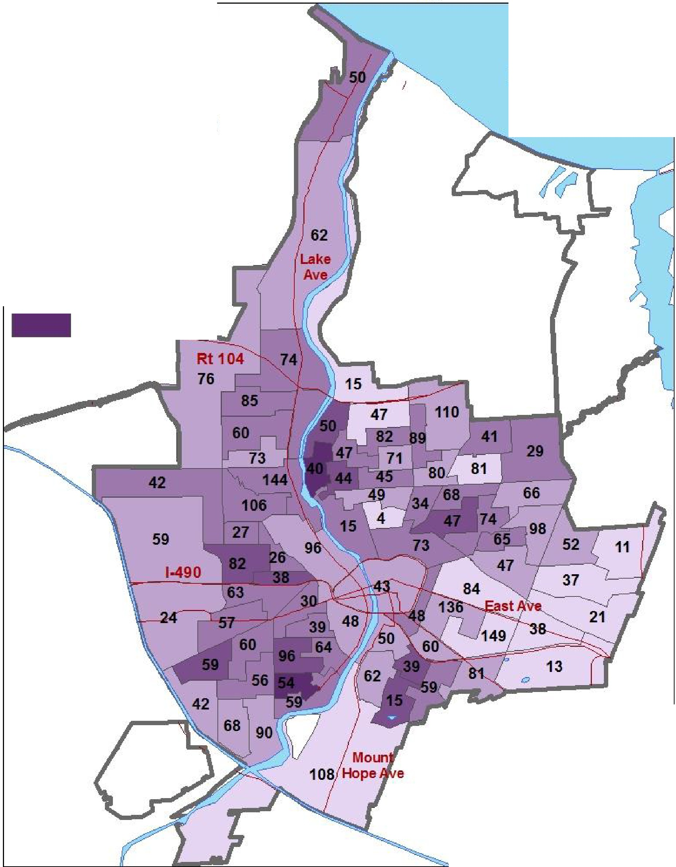
Percent of Properties with a Roofing Problem in 2013

Legend A
N

Percent of inspected properties with a CofO violation for one or more roofing problems by tract
□
Lake Ontario

0%-8%

. .I 9% - 15%

- 16%-22%

- 23%-30%
31% - 38%

Numbers displayed on the map represent the total number
of inspections per tract_

0 0-475 0_95 1-9Miles

Figure 2

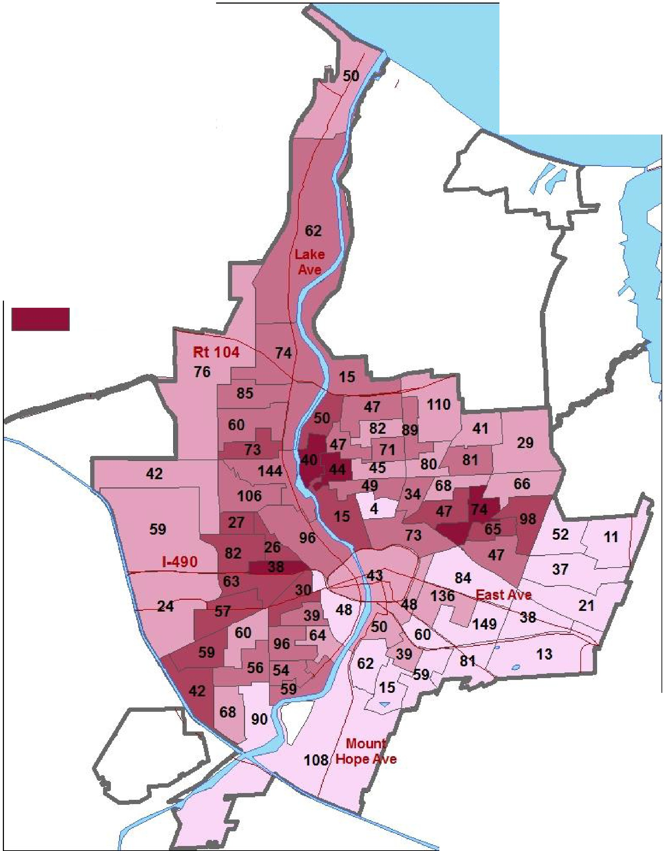
Percent of Properties with a Window Problem in 2013
N

Legend

Percent of inspected properties with a CofO violation for one or more window problems by tract
□

0%-9%

1 | 110% - 1s%
- | 19%-27%
- | 28%-36%
 | 37% -45%

A
Lake Ontario

Numbers displayed on the map represent the total number
of inspections per tract.

0 0.475 0.95 1.9 Miles

Figure 3
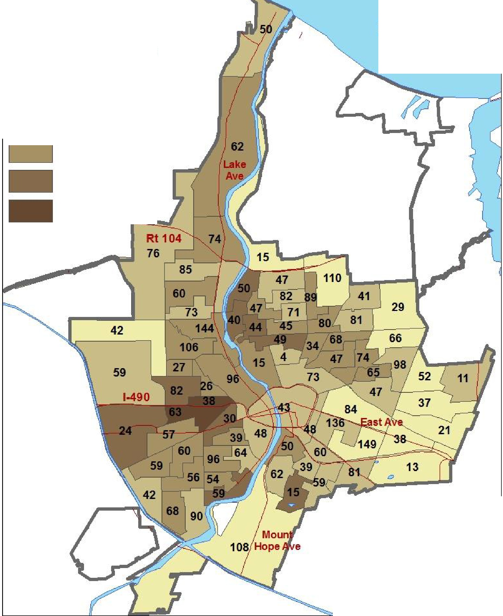
Percent of Properties with an Asthma Hazards Index �1 in 2013 Legend AN

Percent of inspected properties with a CofO violation for one or more asthma hazards by tract
□

Lake Ontario

0%-14%

. .I 15% - 28%
29% -43%

44% - 57%

58% - 71%

Numbers displayed on the map represent the total number
of inspections per tract.

0 0.475 0.95 1.9 Miles

Figure 4
Percent of Properties with a Healthy Housing Index �3 in 2013

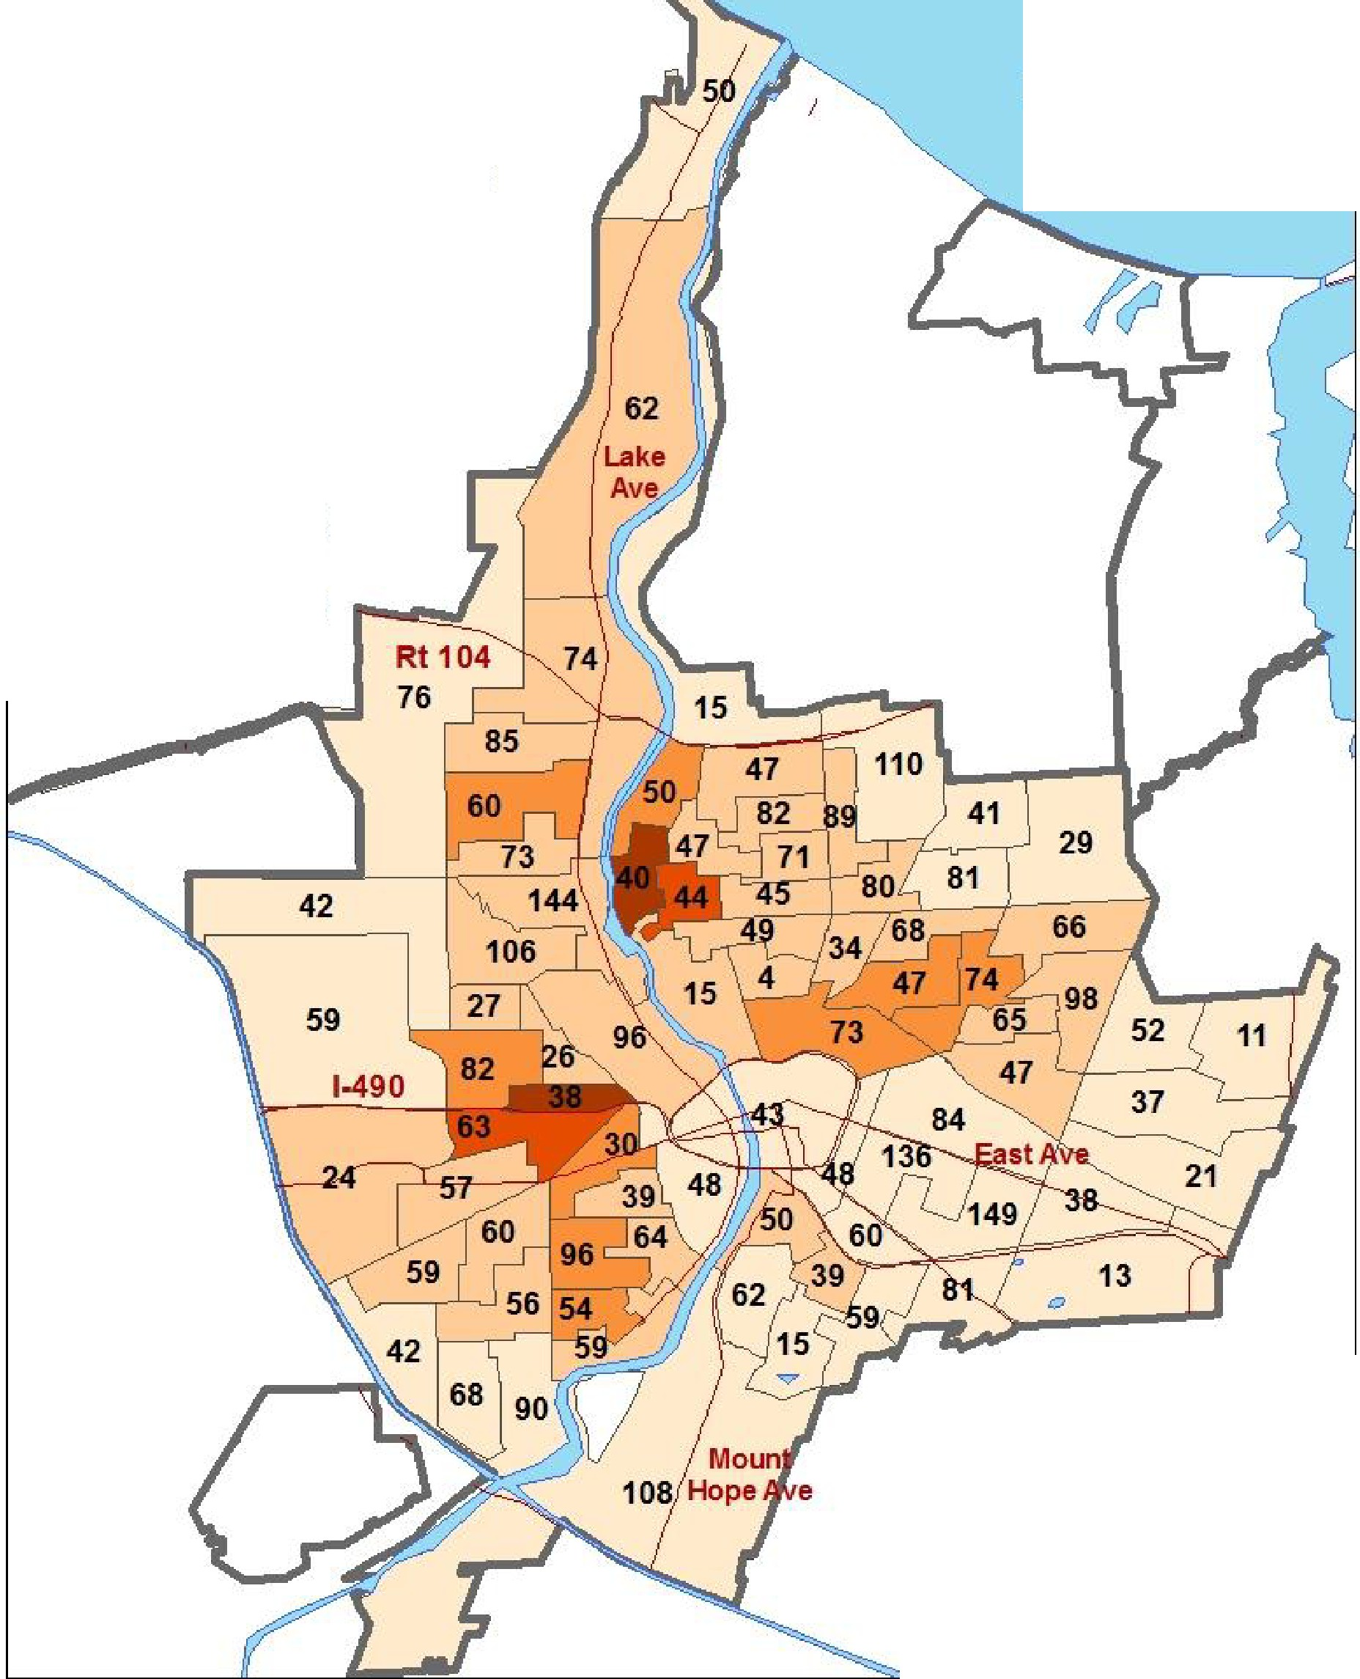
Legend

Percent of inspected properties with a CofO violation for three or more
Healthy by tract  □  □ | Housing Index fields  0%-14%  15%-27%  28%-41%
- | 42%-55%
- | 56%-68%

□

AN
Lake Ontario

Numbers displayed on the map represent the total number
of inspections per tract.

0 0.475 0.95 1.9 Miles

Figure 5

Percent of Properties with a Deteriorated Paint Violation in 2013
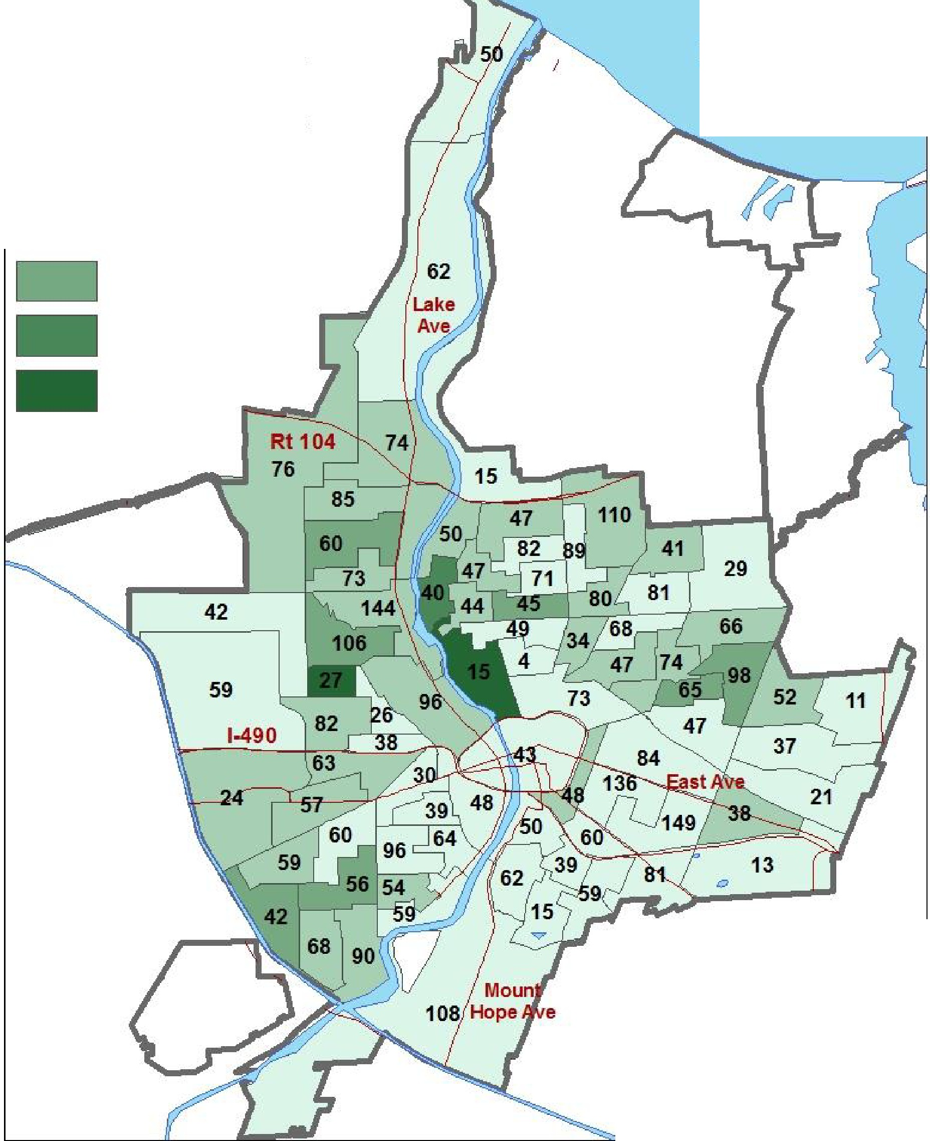
Legend AN

Percent of inspected properties with an interior CofO violation for deteriorated paint by tract
□
Lake Ontario

---
0%-5%

1 6% - 11%
12% -16%

17% - 21%

22% - 27%

Numbers displayed on the map represent the total number
of inspections per tract.

0 0.475 0.95 1.9 Miles

Figure 6

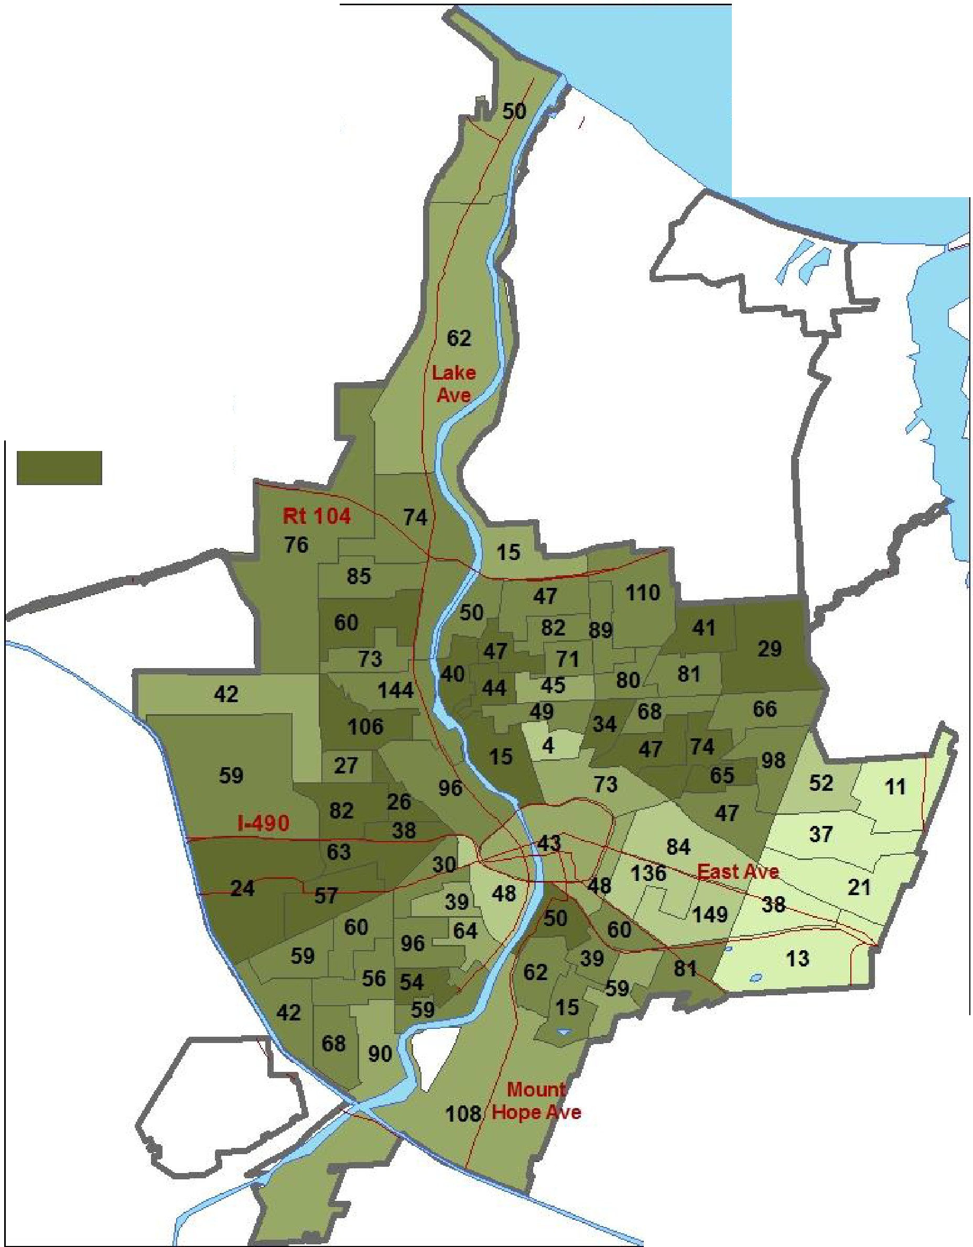
Percent of Properties With a CofO Violation in 2013
N

Legend

Percent of inspected properties with one or more of the 41 requested CofO violations by tract
□
23%-37%

A
Lake Ontario

---
1 38% - 51%

--�I 52%- 64%
- 65%-78%
79% - 92%

Numbers displayed on the map represent the total number
of inspections per tract.

0 0.475 0.95 1.9 Miles

These maps reflect the well-known pattern of higher rates of hazards in low-income neighborhoods with older homes. It is important to note that these maps represent only a single year of CofO inspection data and therefore have small numbers of inspections in certain tracts. However, they highlight geographic areas which may have higher rates of certain kinds of hazards and raise questions for future analysis.
For example, Figure 4 suggests three “healthy homes hot spots” in the northeast and southwest areas of the city, based on homes with three or more of our key indicators. However, deteriorated paint is cited most frequently in one of these areas (Figure 5). This area also demonstrates one of the highest rates of roofing problems. The fact that areas with the highest rates of roofing problems seem to also have the top Healthy Housing Index tracts (as well as additional areas) suggests that roofing problems may be a good indicator of interior hazards; this could be explored with statistical modeling in the future.
As noted above, these analyses were primarily conducted as a proof-of-concept and to help identify hypotheses, questions, and analyses to explore with future data. For example, the Poor Quality Index weights heating equipment breakdowns, siding problems and window problems as greater than 4 out of 10 for severity (Eggers & Moumen, 2013). Thus, these three hazard categories are potentially important local intervention targets; identifying areas of the city with high rates of these hazards could help focus resources for greatest impact.
Multiple years of data should paint a more comprehensive picture of hazards in different areas, since in theory every rental unit will be inspected at least once in every six year period. This may also allow for time-series analysis, for example to see if targeted housing grant programs have reduced hazards in surrounding rental housing. These and other future opportunities are discussed in greater detail below.

Discussion
The data sources outlined above were all collected using different methods. Thus, each has limitations, and comparisons between them must be qualified based on these characteristics. For example, the SHHR allows us to compare housing quality in Rochester to similar municipalities and provides the only systematic data on owner-occupied housing, but may not be accurate due to sampling limitations (sample size and self-report). CofO violations data only include rental housing that has been prepared for inspections, and HNP data is a convenience sample of volunteers from high-risk neighborhoods. However, considering these data together helps illustrate the broader picture of healthy housing in Rochester and may be useful to inform local housing interventions and needs for additional information. Below, we highlight several of our key observations based and implications for future action.

Key Findings
American Housing Survey data show that home hazards associated with health problems are more prevalent in the City of Rochester’s housing stock than the national means for all 20 indicators. In some cases (presence of mice, heating equipment breakdown, roofing problems), these hazards occur double the national means. Compared to similar cities (Buffalo, Cleveland, Detroit, and Pittsburgh), Rochester does better on some indicators, and worse on others (Table 16).
Compared with high-risk housing in 13 communities in New York State assessed through the Healthy Neighborhoods Program, Rochester has similar or higher rates of most hazards. Compared with the most similar of these HNPs, Rochester appears to have higher rates of fire safety, lead, and asthma-related hazards (moisture, pests, smoking, dust and fragrant chemicals). The frequency of ‘deteriorated paint’ in Rochester HNP housing is particularly surprising given the city’s strong lead inspection program for rental housing.
Within the City of Rochester, there is little data on how home health hazards differ between rental and owner-occupied housing. However, AHS data suggest that interior home health hazards are more common in rental units, whereas exterior hazards (roofing, siding, foundation, and window problems) are more prevalent in owner-occupied housing (Table 17). This data is supported by anecdotal reports by City of Rochester inspectors. This pattern is unique to Rochester (compared to similar cities included in the AHS - Buffalo, Cleveland, Detroit, and Pittsburgh, where these hazards (with the exception of roofs in Cleveland) are more common in rental housing). This pattern is particularly significant because initial analysis of Rochester data and experiences in other cities suggest that exterior problems (such as roof, gutter, siding, window, or porch problems) are good indicators of internal hazards (National Center for Healthy Housing, 2009).
Within City of Rochester rental housing, the majority of healthy home indicators are, as expected, cited more frequently in older, low-value rental housing. However, there are several exceptions. A surprisingly high number of rental units lack of smoke (47%) and CO detectors (36%); these rates are fairly consistent across all property types, ages and values (Tables 3-5). As noted above, Rochester has higher rates of fire safety hazards than most of its ‘peer’ cities in the HNP, suggesting that improvements in this area may be feasible.
After smoke and CO detectors, the most commonly cited hazards are structural, including
“water leaks from the outside” (22%), “exposed wiring in unit” (21%), “window problems”(19%), “siding problems” (17%), and “roofing problems” (15%). Based on our categorical data summaries, these problems appear markedly more common in the lowest value housing (e.g., for homes valued at under
$25,000, 40% were cited for “water leaks from outside,” and nearly a third were cited for window, siding, and exposed wiring problems (Table 4)). However, statistical modeling using variable indicators for age and housing might reveal different patterns.
Unfortunately, these most commonly cited problems are frequently expensive to repair. With the exception of “broken handrails,” which is cited five times as frequently in the lowest value housing

(14% in housing valued at $25,000), none of the commonly cited health hazards may be remedied with low-cost repairs.
There is very limited data on resident behaviors that may contribute to home hazards. The CofO records do cite severe housekeeping deficiencies using various categories, including “poor housekeeping,” “unsanitary condition,” and “trash and debris.” For this needs assessment, we
requested citation data for “poor housekeeping,” but added the other fields in our second data request. Interestingly, “poor housekeeping” is cited most frequently in the highest value (over $150,000) housing (Table 4). Similarly, lack of CO and smoke alarms, which are often attributed to residents removing batteries, is cited at a similar rate across all housing values. The Healthy Neighborhoods Program data suggest that Rochester has more problems than peer cities with several hazardous behaviors (smokers in the home, dust accumulation, use of scented products, and practicing exit drills). Others (pest infestations and mold/mildew) may have a component of resident behavior but usually require structural/physical solutions as well. Thus, while resident education might improve a few health-related housing conditions, the majority of hazards for which Rochester has higher rates require some kind of housing solution.
The geographic distribution of hazards (Figures 1-5) in rental housing appears to reflect known patterns in low-value older homes in Rochester. However, these maps suggest that there may be important geographic differences in the prevalence of different home health hazards. Because these maps only reflect one year of data, tract-level analysis must be treated with caution. However, these maps suggest that tract-level analysis with multiple years of data may be useful for targeting and evaluating housing interventions over time. They also suggest that different indicators (e.g. windows, deteriorated paint, roofing problems) and indices (Asthma Hazards Index versus Healthy Housing Index) may result in different target areas.
Gaps in Information
In the course of reviewing available data, it became clear that additional information would be needed to address several of the key questions related to home health hazards in Rochester. There may be additional sources of data that we have not accessed (e.g., fire/emergency data, county deed records, energy efficiency program databases, and non- CofO city inspection data (e.g., complaints, etc.)) or that we are not aware of. Anecdotal or expert knowledge of other hazards may be sufficient to inform future programmatic choices. However, we identify several key information needs that may be worthwhile to address with new data collection efforts. These include additional information on owner-occupied housing, resident characteristics (demographics, behaviors, and exposures), and indoor air quality hazards.
Owner-Occupied Housing

The most significant gap in home hazard data is the lack of information on owner-occupied houses. As noted above, results from the American Housing Survey indicate that owner-occupants may experience higher rates of hazards such as water leaks and roofing problems than renters (Table 18).
The elevated rates of hazards such as deteriorated paint in the Healthy Neighborhoods Program may

reflect problems in owner-occupied housing (this question could be addressed by analyzing the HNP data for renters and owner-occupants separately).
Because of the low cost of housing in Rochester, a higher proportion of low-income residents own their homes than in many other municipalities. These owners may be less able to maintain healthy homes than wealthier owners, and may therefore be at greater risk from home environmental health hazards. Additional information on the prevalence and distribution of health hazards in owner-occupied housing may be needed to better meet the needs of low-income owner-occupants.
Better understanding of hazards in owner-occupied homes will likely require a new data collection effort. City inspectors cite owner-occupied homes when they are made aware of problems (e.g. by complaint or observation of exterior characteristics during regular inspections) and therefore have extensive documentation of exterior issues in owner-occupied homes; future efforts could investigate this data source as a potential surveillance mechanism for identifying high-risk owner-occupied housing. There is limited information about interior hazards in owner-occupied housing because these are only inspected in response to outside agency referrals.
Resident Characteristics: Demographics, Behaviors, and Exposures
There is limited data on resident behaviors, and exposures. The HNP records extensive information about occupants, smoking in the home, etc. However, the Monroe County HNP only works with 600 families each year, and these are self-selected from only five city zip codes. More systematic information about these factors would require surveys of individual households. However, it may be possible to estimate overall prevalence of certain behaviors and choices (e.g. having pets, smoking, presence of rugs, etc.) from research in other cities.
Demographic and economic data is available from the U.S. Census Bureau.¹³ Block group level data is available for several demographics, including age, race, income and housing tenure. Specific programs, such as the Healthy Neighborhoods Program and certain grant programs may have this information by specific address. We were unable to use block group level data for this needs assessment because there were too few inspections in each block group.
Environmental health research suggests connections between many home-based exposures that may result from consumer products ranging from cleaning chemicals to air fresheners to upholstered furniture and carpets. With the HNP exceptions noted above, none of the existing data sources capture information on such potential chemical exposures in the home.
Pests
The available data on pest infestations is particularly puzzling. Both the AHS and HNP data identify Rochester as having unexpectedly high prevalence of mice. HNP data indicates cockroaches are twice as common in Rochester as in the statewide dataset. There is no regular surveillance for bed bugs.

¹³ http://factfinder.census.gov

Monroe County Department of Public Health also collected data on the number of pest complaints each year, but again there is no surveillance mechanism. There is a strong association between cockroaches, rodents, and asthma. In addition, there are potential health impacts of improper pesticide use to control any kind of infestation. Therefore, additional information on the prevalence and nature of infestations – and current efforts to address them – in low-income housing in Rochester is needed to inform future intervention strategies.
Indoor Air Quality Hazards
Indoor air is a key exposure for many home-based health hazards. Because they focus on structural health and safety, CofO inspections check the condition, safety and ventilation on heating sources, but do not record information such as the type (fuel source) or age of combustion appliances, the presence/use of fireplaces or wood stoves, or the condition of filters and ducts. Additional information about heating sources in the home can indicate the nature of air quality hazards in the home (e.g., ultra-fine particles from burning wood). Home energy efficiency audit programs record some of this data; however, these programs are voluntary and do not reflect prevalence of these appliances in different types of housing. Due to the significance of particulates and carbon monoxide for respiratory health, any future surveillance efforts should include documentation of combustion sources in addition to their condition. The city’s online Property Information Application includes this information for some properties but not all.¹⁴

Remaining questions and future analyses
A primary goal of this project was to explore the usefulness of existing home hazard datasets, needs for additional data collection, and potential ways of using this information. In particular, we aimed to determine whether it was feasible to extract, clean, analyze, and draw conclusions from the City’s CofO database. Our initial geographic analysis suggested that tract-level analysis of multiple years of data would be useful. Accordingly, we have requested CofO inspections from 2000 through 2014.¹⁵ This will allow us to conduct a more robust assessment using a larger data set. Importantly, each six year time period should include at least one inspection for every rental unit in the City.
After consultation with stakeholders, we included additional violations/indicators in this data request to better capture the breadth of potential home hazards. Because the code names used by the City changed significantly in 2006, it was also necessary to add additional codes to the data request.
Once this data is extracted and cleaned, it may be possible to conduct geographic and time series analyses, and statistical modeling to inform future policy and program decisions. Linking to additional

¹⁴ www.cityofrochester.gov/propinfo/
¹⁵ We also made small changes to the format of the data request. For example, since we received both opened and inspected cases, some of the properties on our list may not have been inspected in 2013. This means the total number of properties is higher than it should be which changes the overall citation rates. We therefore requested inspected cases only in the second data request.

datasets (such as health conditions) may also provide a powerful tool to inform health-promoting housing interventions.
Identifying Critical Home Health Indicators
We identified 41 violations relevant to home health hazards and explored several approaches to summarizing these violations to characterize overall home health risks. We experimented with using individual variables (deteriorated paint, window problems, roofing problems) and indices (an Asthma Hazard and Healthy Housing Index) to characterize “hazardous housing.” We also produced descriptive tables to explore whether housing age, value, or size might predict particular violations. Future statistical modeling could identify the best predictors of home health. For example, the HHI might identify a subset or single violation that is a good predictor of overall hazards. It would be particularly useful to find an exterior violation (e.g., roof problems), readily available housing characteristic (e.g., year built), or link an index to specific health outcomes (see below).
Linking Exterior and Interior Hazards
Previous studies have linked exterior hazards, such as roofing, window, and siding problems, to interior hazards (National Center for Healthy Housing, 2009). Determining whether (and if so which) exterior hazards predict interior hazards might facilitate identifying hazardous housing from exterior surveys. Particularly if it can be established that these relationships hold for owner-occupied housing, non-CofO city inspections data documenting exterior violations that can be observed from the street may be helpful, since systematic interior inspection of owner-occupied housing is not feasible.
Identifying key exterior violations might also ‘trigger’ more frequent or intensive inspections in single-family rental houses, which are otherwise inspected only every six years.
Associating Home Hazards with Health Outcomes
Research in other cities has linked presence of mold and moisture hazards with asthma (Breysse et al., 2004). Presence of deteriorated paint is a well-established indicator of lead poisoning risk. Future research could link the CofO data to address-specific health outcomes data (e.g. emergency department visits) to explore which violations best predict health risks. These analyses could also be done on an aggregate basis (for example, by census block group or tract) to identify geographic areas to target prevention programs.

Evaluating Housing Initiatives
Many city rehabilitation grant programs are frequently targeted at specific types of housing (e.g., low-income owner-occupied) in discrete geographic areas. Research in other cities has suggested that such targeted investments lead to overall neighborhood improvement. Changes in the prevalence of certain CofO violations in a geographic area surrounding such interventions might be one way of measuring the success or impact of these programs.

Conclusion
An evidence-based needs assessment can help inform ongoing projects to provide resources for home environmental health, for example by helping organizations identify key areas that could benefit most from financial assistance. It can also highlight gaps in information and resources. By analyzing
existing data from the City’s Certificate of Occupancy, the State of New York’s Healthy Neighborhoods Program, and the American Housing Survey, we have taken the first step toward informing strategies to efficiently and effectively address housing problems that have health implications for people in Rochester.
Overall, Rochester’s housing reflects expected patterns of hazards associated with low-value, older housing. However, the strikingly high prevalence of structural problems in owner-occupied housing distinguishes Rochester from other similar cities in the American Housing Survey. Similarly, the city has high rates of home hazards associated with asthma and deficits in fire safety compared to peer communities in the state’s Healthy Neighborhood program.
This needs assessment conducted a limited analysis of several data sources in order to get insights into 1) what health-relevant housing data already exists; 2) what is the potential of this data for further analysis; and 3) what additional data is needed. Based on our initial analysis of the City of Rochester’s CofO inspection data, we believe this is a powerful tool for evaluating past and informing future decisions that affect housing quality and health in Rochester. Based on stakeholder input, we expanded the list of 41 healthy home-relevant citations to 148 and have requested annual CofO inspection data from 1998 through 2014. We expect this will be a rich resource for researchers, agency staff, and community groups who wish to explore a wide range of housing and health issues in Rochester. Future projects utilizing raw data from the Healthy Neighborhoods Program and the American Housing Survey (through data sharing agreements) could yield valuable insights. We also note that there are additional housing data sources – including records of grant programs, fire/emergency
departments, and the City of Rochester’s Property Information Application, that could provide additional variables of interest. Perhaps most significantly, address- or block-group specific health data could be linked with the housing data to directly analyze health-housing characteristic relationships over time. We look forward to exploring these future possibilities and welcome input about additional data sources or analyses that might be useful.
Given the data limitations of this assessment, additional analyses are important to inform future policy and program directions. However, based on these initial analyses, it appears that exploring strategies for addressing asthma hazards (particularly pests and moisture), fire safety, and the particular needs of low-income owner-occupants will be important for Rochester. In addition, while resident and owner education is an important part of any healthy housing solution, the prevalence of structural problems in the lowest-value housing suggests that education alone is unlikely to significantly improve home health in Rochester. Highlighting the health implications of structural housing hazards may help inform, target, and promote ongoing efforts to improve the health and well-being of low-income residents.

References
American Housing Survey. (2015). American Housing Survey (AHS): Methodology. Retrieved August 11, 2015, from http://www.census.gov/programs-surveys/ahs/about/methodology.html
Boyce, S., & Hood, K. (2002). Lead poisoning among young children in Monroe County, NY : A needs assessment, projection model, and next steps (Vol. http://www.cgr.org/reports/02_R-1342_MonroeLeadPoisoning.pdf): Center for Governmental Research.
Breysse, P., Farr, N., Galke, W., Lanphear, B., Morley, R., & Bergofsky, L. (2004). The relationship between housing and health: children at risk. Environmental Health Perspectives, 1583-1588.
City of Rochester Property Code, Article III: Lead-Based Paint Poisoning Prevention § 90-54 (2006). City of Rochester Assessment Bureau (2015).
City of Rochester, B. o. I. a. C. S. Certificate of Occupancy. Retrieved July 21, 2015, from http://www.cityofrochester.gov/article.aspx?id=8589935004
Doherty, E. (2013). Poverty and the Concentration of Poverty in the Nine-County Greater Rochester Area: Rochester Area Community Foundation and ACT Rochester.
Eggers, F., & Moumen, F. (2013). American housing survey: A measure of (poor) housing quality.
Bethesda, MD: Econometrica, Inc.
Hoppin, P., Jacobs, M., & Stillman, L. (2010). Investing in best practices for asthma: A business case: Asthma Regional Council of New England.
International Code Council Inc., & New York State Department of State, D. o. C. E. a. A. (2010). Property Maintenance Code of New York State.
Jacobs, D., & Baeder, A. (2009). Housing Interventions and Health: A Review of the Evidence: National Center for Healthy Housing.
Monroe County Department of Public Health, H. a. S. (2015, September 4, 2015). [Bed bug surveillance data].
National Center for Healthy Housing. (1998). Relationship Between Interior Problems and Exterior Problems - City of Rochester, NY.
National Center for Healthy Housing. (2009). American Housing Survey: Basic Statistics for Healthy Housing. Retrieved August 18, 2015, from http://nchh.org/training/healthyhomestrainingcenter/ahsdata.aspx
National Center for Healthy Housing. (2011). Relationship Between Interior Problems and Exterior Problems.
National Center for Healthy Housing. (2013a). State of Healthy Housing.
National Center for Healthy Housing. (2013b). State of Healthy Housing. Retrieved July 30, 2015, from http://www.nchh.org/Policy/2013StateofHealthyHousing.aspx
Phipatanakul, W., Matsui, E., Portnoy, J., Williams, P. B., Barnes, C., Kennedy, K., . . . Khan, D. (2012).
Environmental assessment and exposure reduction of rodents: a practice parameter. Annals of allergy, asthma & immunology: official publication of the American College of Allergy, Asthma, & Immunology, 109(6), 375.
Portnoy, J., Chew, G. L., Phipatanakul, W., Williams, P. B., Grimes, C., Kennedy, K., . . . Blessing-Moore, J. (2013). Environmental assessment and exposure reduction of cockroaches: A practice parameter. Journal of Allergy and Clinical Immunology, 132(4), 802-808. e825.
The Guide to Community Preventive Services. (2009, 2015). Asthma control: Home-based multi-trigger, multicomponent environmental interventions. Retrieved August 11, 2015, from http://www.thecommunityguide.org/asthma/multicomponent.html
U.S. Census Bureau. (2009-2013a). 5-Year American Community Survey - Table DP03 - Selected Economic Characteristics. Retrieved from: http://http://factfinder.census.gov/

U.S. Census Bureau. (2009-2013b). 5-Year American Community Survey - Table DP04 - Selected Housing Characteristics. Retrieved from: http://http://factfinder.census.gov/
U.S. Census Bureau. (2013). American Housing Survey (AHS) Data. Retrieved August 28, 2015, from http://www.census.gov/programs-surveys/ahs/data.html
Wu, F., Jacobs, D., Mitchell, C., Miller, D., & Karol, M. H. (2007). Improving indoor environmental quality for public health: impediments and policy recommendations. Environmental Health Perspectives, 115(6), 953-957. doi: 10.1289/ehp.8986
Wu, F., & Takaro, T. K. (2007). Childhood asthma and environmental interventions. Environmental Health Perspectives, 115(6), 971-975. doi: 10.1289/ehp.8989

