Who Can Help?
Lead may hurt you even if
you don’t feel sick
Levels of lead once thought harmless are now shown to be toxic

Health Dangers

Your Employer or Union
Follow your employer’s recommendations for safe cleaning, personal protective equipment and ventilation systems.

Your Doctor or other Medical Health Care Provider
It is important for your doctor to know about your possible lead exposure even if you do not have symptoms. He or she will determine if lead testing is necessary.

New York State Department of Health (NYSDOH)
www.health.ny.gov
NYSDOH’s Bureau of Occupational Health and Injury Prevention can provide guidance, information and technical assistance to you on many occupational health issues.
Industrial hygiene services are provided free of charge and can include:
  - consultation by phone or on-site visit
  - technical assistance in controlling workplace hazards
  - worker protection and hazard communication programs
  - guidance on personal and respiratory protective equipment
Inquiries can be made to:
(518) 402-7900.
- Occupational Health Clinic Network http://www.health.ny.gov/ environmental/workplace/clinic_ network.htm
The New York State Network of Occupational Health Clinics provides medical and educational services for workers exposed to workplace hazards. Inquiries about the Clinic Network can be made to: (518) 402-7900.

U.S. Occupational Safety and Health Administration (OSHA)
www.osha.gov/
If you feel that your employer does not adequately address a safety or health hazard, you have the right to request an inspection by OSHA. To find the OSHA office nearest you call:
1-800-321-OSHA (6742).
- New York State Department of Labor www.labor.ny.gov/home
If you are a public employee (work for State, county or city offices), OSHA standards are enforced by the New York State Department of Labor Public Employee Safety and Health (PESH) program. Inquiries can be made to:
(518) 457-9000.


Department of Health
Follow us on:
health.ny.gov facebook.com/nysdoh twitter.com/HealthNYGov

from Lead on the Job

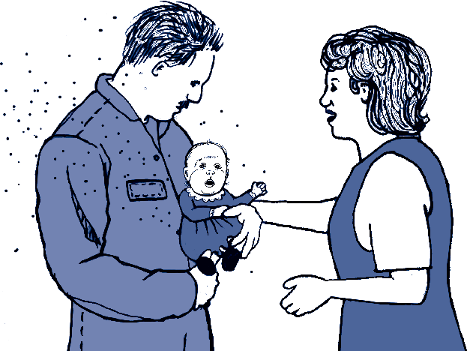
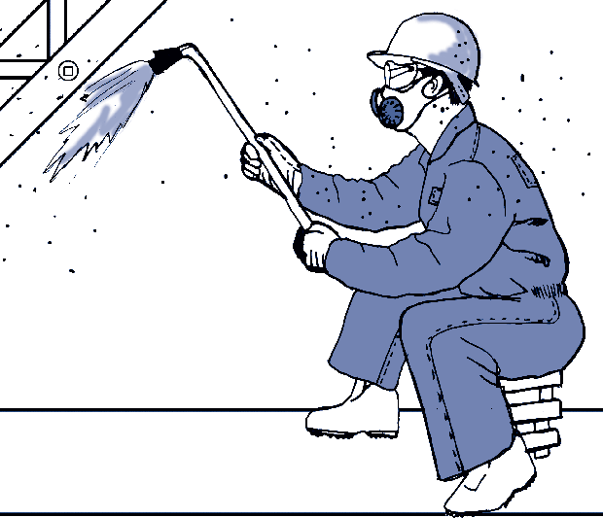
2543
What is
“Take Home” Lead?
Lead dust can be brought into your home on work clothes and equipment.
This is called “take home” lead and it can harm anyone who comes in contact with it.

If young children live in your home and you work with lead, launder your work clothes separately.
Young children are more susceptible to the toxic effects of lead. Even very small amounts can cause learning problems and serious illness.
Lead dust can get in your car, on furniture, floors and carpets. Your child can swallow this lead dust and be poisoned.
A child with lead poisoning usually does not look or feel sick. A blood test is the only way to know how much lead is in
the body.
youtube.com/nysdoh
4/15

Even low levels of lead can cause health damage

Studies in recent years have shown it can:
- Decrease brain function
- Decrease kidney function
- Increase blood pressure and increase your chance of having a heart attack or stroke
- Harm the development of your baby before its born
- Increase chances of having a miscarriage
Once lead gets in the body, it stays there!

Exposure to Lead

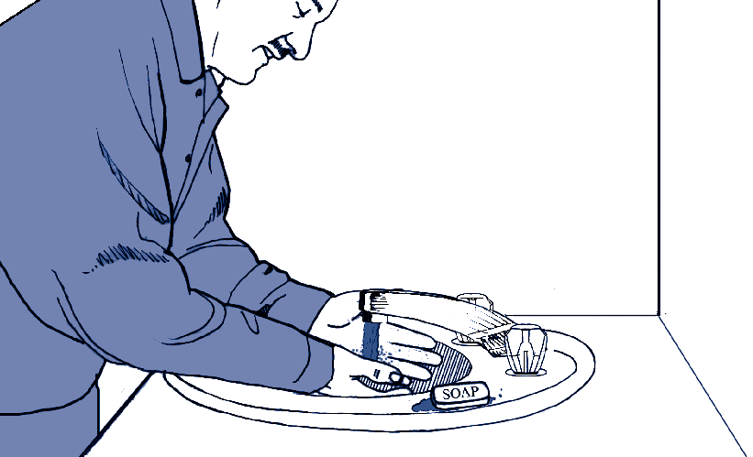
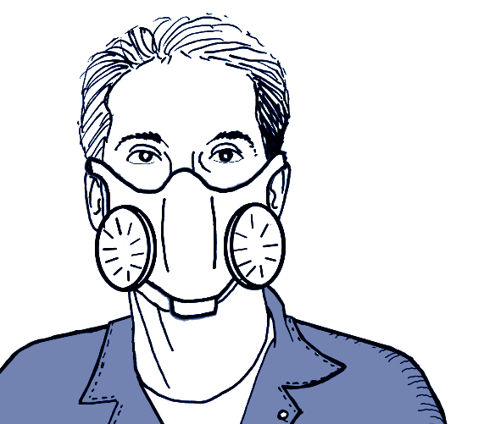
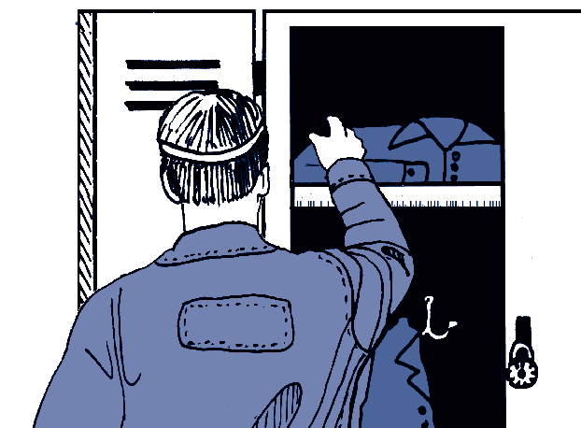
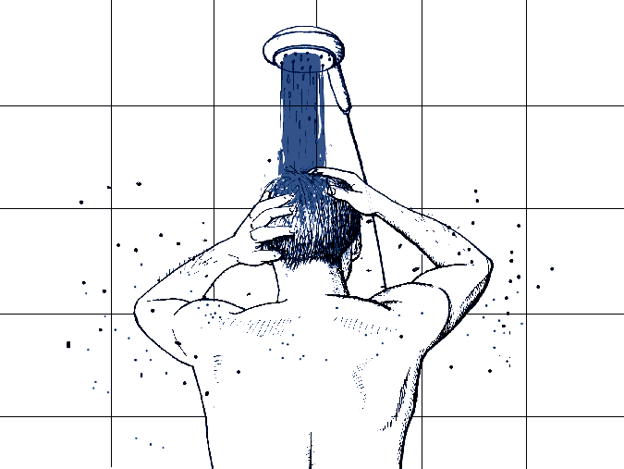
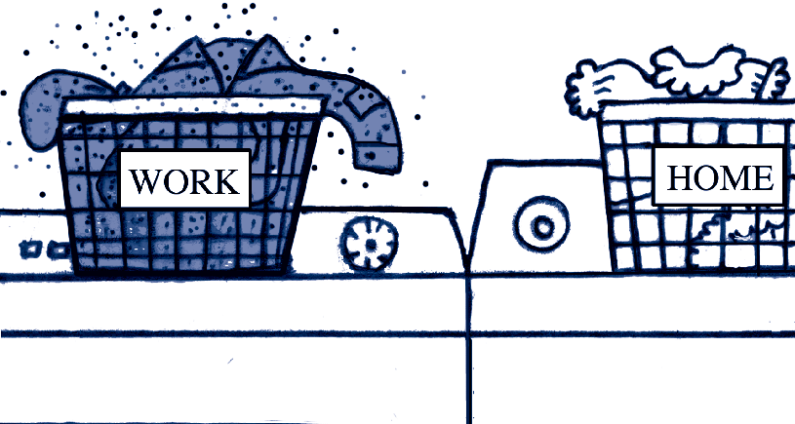
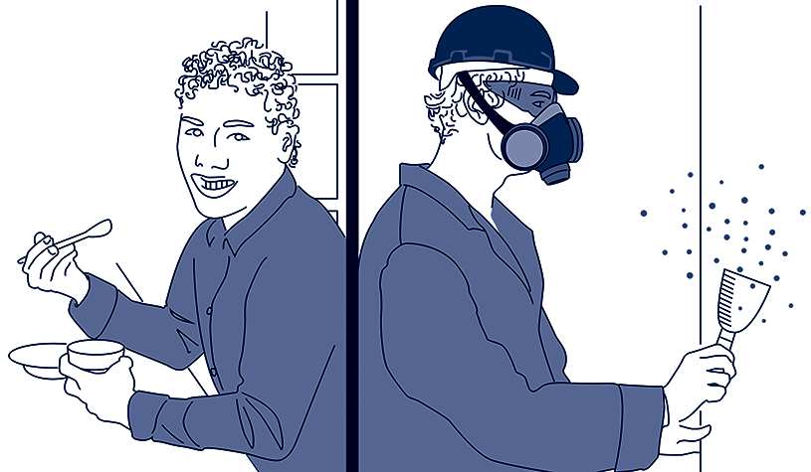
Workers can be exposed to lead by creating dust or fumes during every day work activities. Fumes are easier to breathe in than dust and may be more dangerous.
How Can You Reduce Your Exposure to Lead?
Launder your clothes at work if possible. If you must take clothes home, wash and dry them separately from other family members’ clothes.
Shower at the end of the day, before you go home.
Eat, drink or smoke and store food, drink, cigarettes or cosmetics in areas away from lead dust and fumes.
Wash your hands and face before you eat, drink or smoke.
Wear a clean, properly fitted air purifying respirator equipped with P100 filters
(purple) as a minimum level of protection, in all work areas that have lead dust or
fumes. Shave to get the required fit.
Change into work clothes and shoes before beginning work each day. Consider at minimum changing your shoes.

You could be exposed to lead dust if you:
- Grind, cut, drill, sand, scrape or blast surfaces that are coated with lead paints
- Tear down structures that have been painted with lead based paints
- Work on leaded cables or wires
- Pour powders that contain lead pigments
- Do remodeling and renovation work
- Handle scrap metal
- Shoot in and/or clean indoor firing ranges
- Handle artist pigments
- Break up old lead batteries

You could be exposed to lead fumes if you:
- Use heat guns to remove paint from doors, windows, and other painted surfaces
- Weld or solder lead containing materials such as electronics, stained glass or radiators
- Torch cut coated and uncoated metal
- Work in smelting operations such as bronze, brass, copper or iron foundries

You can be also exposed to lead if you participate in the following hobbies:
- Shoot in an indoor firing range
- Make your own bullets or fishing sinkers
- Make stained glass or pottery
- Remove lead based paint (e.g., home renovation)

