NEW YORK STATE OCCUPATIONAL HEALTH CLINICS



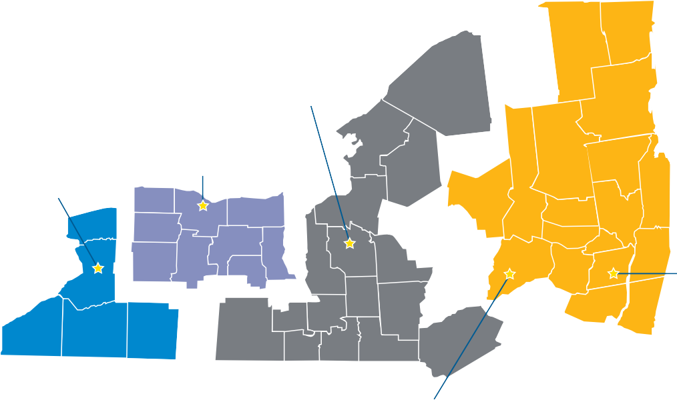
Central Region Occupational Health Clinical Centers

Western Region
Center for Occupational and Environmental Medicine
Finger Lakes Region
Finger Lakes Occupational Health Services

Western

Specialty Agricultural Clinic New York Center for Agricultural Medicine and Health
Eastern Region Occupational and Environmental Center of Eastern New York

Mid Hudson Valley
Mount Sinai/Selikof Centers for Occupational Health

For more information, contact your local
Occupational Health Clinic, or the
New York State Department of Health at:
1-866-807-2130
http://www.health.ny.gov/environmental/ workplace/clinic.htm

New York City
Mount Sinai/Selikof Center for Occupational Health

New York City
Bellevue/NYU Occupational and Environmental
Medicine Clinic

Long Island
Occupational and Environmental Medicine of Long Island




PROTECTING THE WORKERS OF NEW YORK STATE
P R O T E C T I N G T H E W O R K E R S O F N E W Y O R K S T A T E
NYS Occupational Health Clinic Network
For Workers, Retirees, and Residents...
http://www.health.ny.gov/environmental/workplace/clinic.htm

2722 9/18

Each year, thousands of workers in New York get sick or are injured on the job. Since
1987, the New York State Occupational Health Clinic Network (OHCN) has assisted
New Yorkers by helping
them to return to work safely and by preventing disease and injuries.
They have a proven record of assisting the working population in New York.
The OHCN clinics are located throughout the State, including a clinic specializing in farm worker health and safety.

What can the Occupational Health Clinic Network offer you?
Experts in occupational medicine can help you achieve the best possible recovery
if you are sick or injured on the job by:
- taking a complete work history to determine if your illness or injury is related to work
- identifying appropriate medical tests
- working with your other doctors
- developing a specialized treatment plan
- providing a disability assessment
- assisting with rehabilitation services
- identifying ways to prevent you from being sick or injured on the job, in the future
Experts in health and safety can help prevent you and your co-workers from becoming sick or injured on the job by:
  - talking to you about your job and workplace
    - visiting your workplace to assess potential hazards
      - assisting your employer in reducing unhealthy or
dangerous work conditions
        - working with your employer or union
to make your workplace safer
- helping you recognize and avoid hazards at work
- recommending the right protective equipment
Trained staff can assist both you and your family with the stress caused by being sick or injured on the job by:
- answering your questions
- supporting you throughout your diagnosis, treatment and recovery
- filing the necessary paperwork for your insurance or Workers’ Compensation claims
- talking to you about sources of income and other services you may be eligible to receive
- providing support groups for you to discuss problems with other workers
- offering training in relaxation techniques
- helping with job retraining

Who can use the Occupational Health Clinic Network?
The Occupational Health Clinics are available to all workers, retirees and residents in New York State. No worker will be turned away because of an inability to pay and the OHCN clinics can bill directly to most major health insurance carriers.
You could benefit from a visit to an OHCN clinic if:
- your wrists, hands or arms ache or feel numb, especially at night
- you work with asbestos, solvents, lead or other dangerous materials
- you have a hard time breathing when on the job
- you have been told you have asbestosis,
carpal tunnel, occupational asthma, occupational hearing loss, work-related muscular skeletal problems or other
work-related conditions

If your co-worker, friend or family member has been sick or injured on the job, please share this brochure with them.
Your medical information is confidential and will not be shared without your consent unless required by law, including the Health Information Portability and Accountability Act (HIPAA) and OSHA regulations.


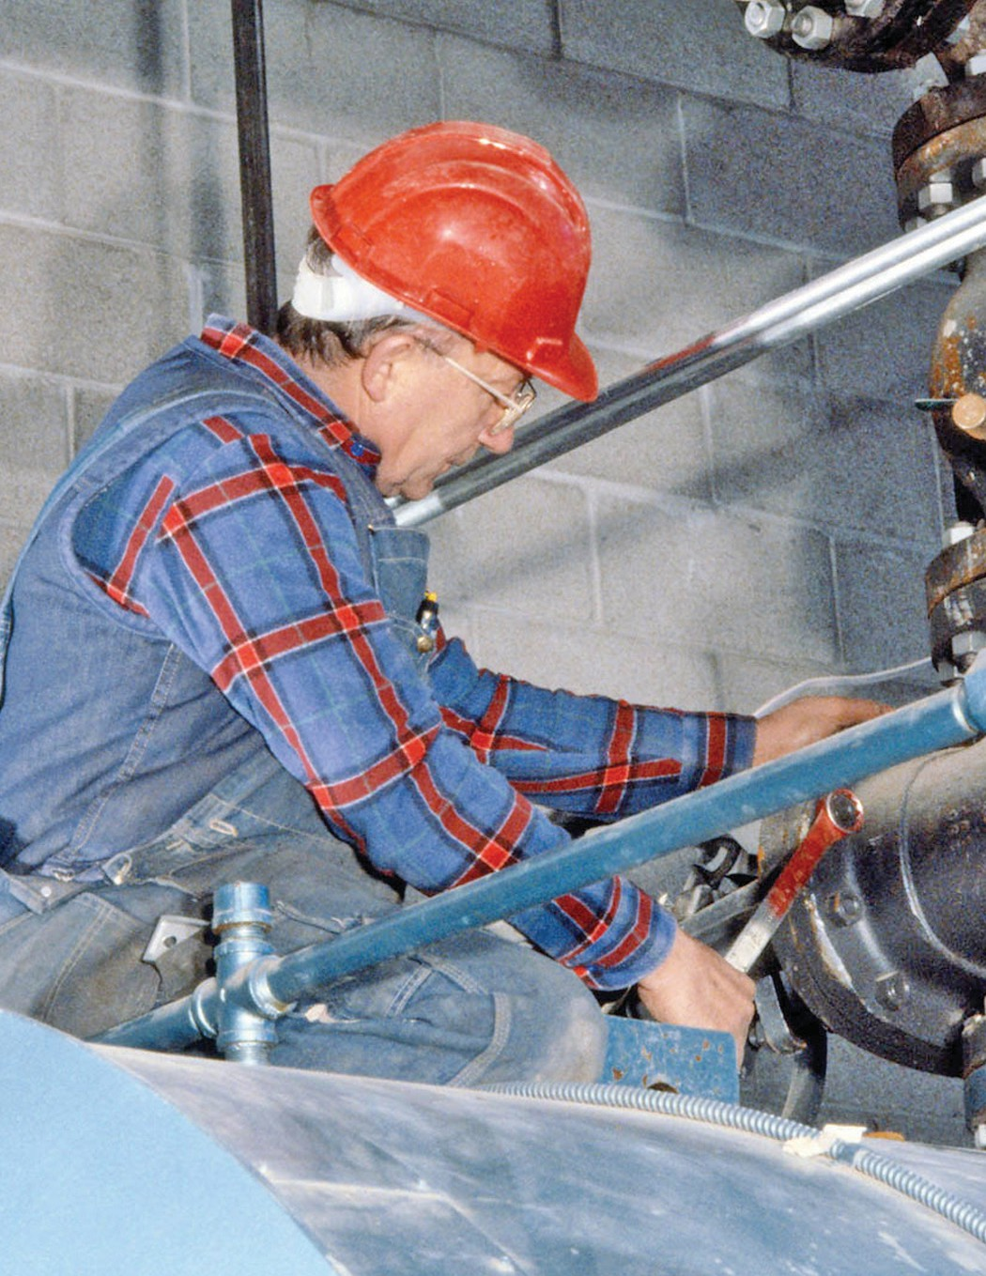

N Y S O c c u p a t i o n a l H e a l t h C l i n i c N e t w o r k

