 | Tele-I-CARE
 | Connecting individuals to vision-saving care.
5/23/18 | Training & User Manual
 | Using the Tele-I-CARE service. Rochester Area Tele-I-CARETM (Tele-I-CARE) is a store and forward telemedicine service owned by the Flaum Eye Institute at University of Rochester Medical Center.

Table of Contents
Introduction 3
How to Use this Manual 4
Training Overview 6
Training Phases 6
Phase 1: On-Site Training 6
Phase 2: Three Volunteers 7
Phase 3: First Patient 7
Follow-Up 7
The Eye and Retina: Camera & Film 8
Eye Anatomy 8
Close Up: The Retina 9
Introduction to Retinal Photography 12
Workflow: Typical Visit 14
Instructions 16
Primary Care Clinic: Patient Encounter 17
Patient and Room Set Up 17
A. Patient Set Up 17
B. Room Set Up 17
Visual Acuity Screening 17
Camera Set Up 18
A. Patient Set Up 18
B. Camera and Computer Set Up 18
Data Entry 19
Capture Photos 19
A. Capture Fundus Photos of Right Eye 19
B. Capture: Anterior Photo of Right Eye 20
C. Capture Fundus Photos of Left Eye 20
D. Capture Anterior Photo of Left Eye 20
E. Save Photos to Computer 20
Send Photos 20
Document Encounter 21
A. Update electronic medical record 21
B. Diabetic Screening: Tracking Sheet 21
Camera Shut Down 21
Eye Care Provider 23
Read Images 23
Generate Report 23
Primary Care Clinic: Next Steps 24
Document Report 24
Contact Patient 24
Trouble? 26
Photos Not Uploaded 26
Tele-I-CARE Website Malfunctioning 26
Need More Help? 27
Appendix 28
Sequence Sheet 28
Patient Quick Screening 29
Diabetic Screening: Tracking Sheet 30
References 31
Contributors 31

Tele-I-CARE

Training & User Manual

Introduction
The Tele-I-CARE service is a store and forward system. The images captured in the primary care setting will be analyzed and read by an eye care provider in order to check for the presence of diabetic eye disease and other abnormalities. Since these images are taking the place of a live visit, the quality of these images is tantamount to the eye care provider’s ability to determine the level and severity of eye disease.
An overview of the Tele-I-CARE service is as follows:
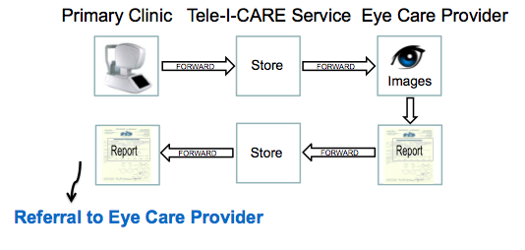

Further details at each step are diagrammed below:

The purpose of this document is to provide support to photographers performing retinal fundus photography for the Tele-I-CARE service.
The goals of this document are to provide:
- The photographer with a basic understanding of eye anatomy and eye photography.
- An easy-to-read guide of the steps the photographer needs to use the Tele-I-CARE service at the primary care clinic.
- Advice for troubleshooting any issues with the Tele-I-CARE service.
Your participation in the Tele-I-CARE service is vital to its success, and we are committed to work with you to take the best possible photographs while still managing your other responsibilities in your clinical environment.
We want to take this opportunity to thank you again for your interest and participation in the Tele-I-CARE service. Together, we can work to ensure that patients are provided with the best possible ocular imaging in order to support their health.

How to Use this Manual
If you are just starting out, read this manual up until “Instructions.” This will help orient you to the structures of the eye and basics of photography.
If you are working on Phase 2 of training, refer to the “Instructions” for a step-by-step guide to performing a patient encounter.
If you are having difficulty in any steps of the camera use, refer to the “Trouble?” section of this manual.
If you do not find your answer in this manual, contact your Tele-I-CARE trainer.

Training Overview

Training Phases
Training:
Phase 1: On-Site Training
Phase 2: Image Quality Assessment: Three Volunteers
Phase 3: First Patient

Phase 1: On-Site Training
In three training sessions that last two hours each, a member from Tele-I-CARE team (trainer) will train the Clinical Champion (you, the trainee) at the primary care clinic to complete a patient encounter. Training will cover all aspects of the Tele-I-CARE service, including camera and website navigation. Volunteers from the primary care clinic will be required to simulate patient encounters at each of the three sessions. These volunteers should be the photographers that the Clinical Champion has selected to use the Tele-I-CARE service.
The first session involves the trainer first explaining the Tele-I-CARE service. Then, the Clinical Champion will observe the trainer leading the volunteer through a simulated patient encounter. The second session involves the trainer guiding the Clinical Champion leading a volunteer through a simulated patient encounter. The third session involves the trainer observing the Clinical Champion performing two simulated patient encounters with the volunteer. Between patient encounters, the trainer will provide feedback.

Session 1
In Session 1, the trainer will explain the overview of the process and show the Clinical Champion how to perform a screening on a volunteer from the primary care clinic. The Clinical Champion will observe the trainer screening the volunteer while following along with the step-by-step instructions (“Detailed Instructions”) in this manual. When photographing a volunteer, enter the “Patient Information” as “Volunteer 1.”

Session 2
In Session 2, you will perform a simulated patient encounter on a volunteer (Volunteer 2) with the trainer’s guidance. This gives both the Clinical Champion and the volunteer a chance to become familiar with the service and to ask the trainer any questions.

Session 3
In Session 3, the Clinical Champion will lead volunteers through two complete patient encounters (Volunteer 3, Volunteer 4). The trainer will provide guidance during the patient encounters and give feedback after each encounter.

Phase 2: Three Volunteers
Over the following week, the Clinical Champion will complete three more patient encounters using volunteers and receive feedback on image quality. Once the eye care provider approves the image quality, the Clinical Champion is certified to screen patients. At this point, the Clinical Champion can begin to train the volunteers/selected photographers to use the Tele-I-CARE service.

Phase 3: First Patient
Your trainer will observe the Clinical Champion’s first patient encounter. You will lead the patient through the entire encounter. Once the encounter is complete, your trainer will give you feedback on your performance. You may also ask your trainer any further questions.
Once the images are reviewed, you will receive a final image quality assessment. Now, you are ready for independent patient encounters!

Follow-Up
Every six months, your trainer will contact you to check in with your use of the Tele-I-CARE service. If you are interested, the trainer can schedule a follow-up session to ensure that your clinic is taking the highest quality photographs.

The Eye and Retina: Camera & Film

Eye Anatomy
The retina is a several layer thick sandwich of vessels, nerves, and light sensitive cells comprising the inner back lining of the eye. Much like film in a camera, the retina is what actually senses and translates light entering the eye into nerve impulses that are sent to the brain to be processed into vision.
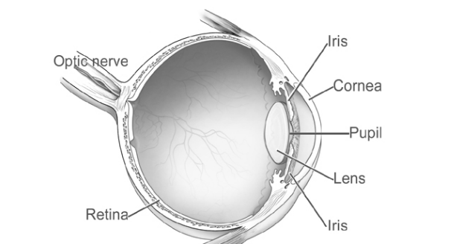

Figure 1: Cross-section of the Eye.¹
The eyeball is called the globe, its structure and toughness being due to the sclera, the tough white fibrous outer tissue that maintains the shape. Inside the globe, filling the cavity within is the vitreous, a semi-solid clear gel that does not have any blood vessels. Occasionally, pieces of vitreous can break off and float around; these are called floaters. You may recognize these as those little shadows or paramecium-looking things that show up in your vision from time to time.
If the retina is the ‘film’, the lens operates similarly to a camera lens in that its job is to focus a portion of the light entering the eye onto the proper plane (the retina).
The iris, the colored muscular tissue easily visible in the mirror, controls the amount of light entering the eye to maximize vision. The iris constricts and dilates in direct response to the amount of light striking the retina; the brighter the light, the more the iris constricts. The opening of the iris is called the pupil.
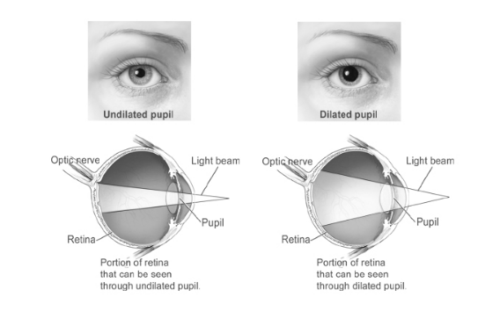

Figure 2: Undilated Pupil and Dilated Pupil.¹
Note: The advantage of a non-mydriatic camera is in allowing the photographer to capture the retina without dilating the patient’s pupil. The amount of retina captured by the camera is represented by the amount of retina that lit by the light beam.
In front of the iris is the cornea, the clear window type structure at the front of the eye, is responsible for focusing most of the light rays in conjunction with the lens. Contact lenses are placed on the cornea.

Close Up: The Retina
While all retinas will look a little bit different based on an individual’s ethnicity and pigmentation, every retina will have the same structure. The conduit from the eye to the brain, the optic nerve, ends at an entry point to the retina called the optic disc. Since there are nerve fibers instead of retinal cells in the optic disc, it is an anatomical blind spot.
The fundus is the entire back of the eye, covered by retina. The fundus contains blood vessels, supplying the retinal cells.

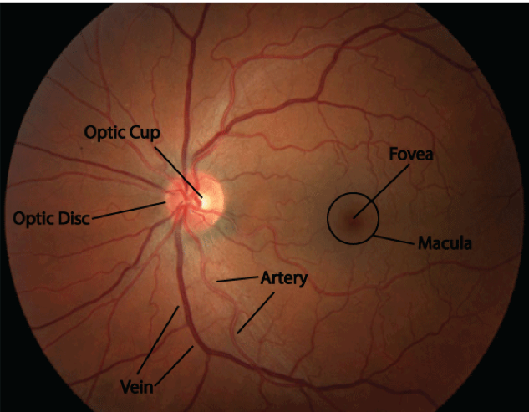

Figure 3: Normal Fundus of Left Eye (OS).²
Just adjacent to the optic disc is the center of vision, called the macula. In the center of the macula is the fovea (darkly pigmented area in retinal photograph), which is the central point of focus for the lens and cornea, and is responsible for high-resolution vision, or central acuity. Blood vessels stop short of the fovea, as they would interfere with high-resolution vision. The fovea contains a high concentration of specific light-sensing structures, or photoreceptors, called cones. Cones are best at acute vision and differentiating color. Cones function best in bright light. All other areas of the retina are dedicated to peripheral vision, and include another set of photoreceptors, called rods. Rods are designed to sense movement and function best in dim light (darkness). The difference is that light preference between rods and cones is why you cannot see color, or read, when its dark. Cones require more light than rods to function.
When photographing the retina, it’s important to know where structures are located in order to photograph each patient consistently. As such, there are a series of directional cues designed to navigate the retina without having to resort to left/right/up/down. Toward the center of the face is considered nasal, because the direction is toward the nose. Away from the center, toward the outside of the ear, is considered temporal, because the direction is towards the temple. Learning and using these directional cues will minimize confusion, as cues are always based on anatomical relationships in the eye.
The fovea is always on the temporal side of the disc, regardless of the eye. Conversely, the optic disc is always on the nasal side. The location of the fovea and optic disc allows you know which eye you are viewing; if the disc is to the right of the fovea, then you are viewing the right eye, and if the disc is to the left of the fovea, you are viewing the left eye. In medical terms, the left eye is oculus sinister, or OS, and the right eye is oculus dexter, or OD. Together, the eyes are oculus unitas, or OU.
In appearance, the fovea seems to be in shadow, due to a higher concentration of pigment in that area. In addition to the macula being the center of vision, it is also typically the center of attention in photographic study. Since you are only able to photograph a small portion of the retina at one time, it is easy to get “lost”, or be viewing an area that doesn’t have recognizable landmarks, such as the disc and fovea. A trick to find your way back is to have the patient look straight down the camera’s lens – this will automatically give you the fovea in the center of your frame.

Introduction to Retinal Photography
In order to successfully photograph the retina, the iris must be relaxed enough to allow light to enter the eye, illuminate the retina, and reflect back, exiting the pupil. When using the non-mydriatic camera, be sure to switch the lights off in the exam room. You have likely already taken retinal photographs without being aware of it; if you’ve ever photographed red eye, you have taken an image of the retina, albeit not a focused one.
There are a few ways to ensure the pupil is large enough for photography. The most common approach in ophthalmology is to dilate the pupil using pharmaceutical drops called mydriatics. While this provides a great advantage for the more extensive testing and evaluation done in the ophthalmologist’s office, it takes time and lasts for several hours. The alternative (and the approach used by Tele-I-CARE) is to use a non-mydriatic camera, which uses light just outside the visible spectrum to focus and compose the picture. Since the eye is not sensitive to this type of light, the pupil does not constrict. However, once the photograph is taken, the flash uses visible light, and the pupil will close, at least temporarily. In other words, with a non-mydriatic camera, the first image captured will often be the best one, because the iris has not had the chance to constrict with the bright first flash.
Fundus cameras have specially designed light sources to optimize the retinal reflection (red eye in photos). This means the light source comes out of the same lens you use to compose and focus. The shape of the light, when focused, resembles a donut, with an outer ring of light with a hole in the middle. This is commonly and logically referred to as the donut of light. This light source is also designed to enter the pupil at a very specific point in space, in order to minimize reflection off of the cornea and maximized the amount of light reflected back. This is known as working distance.
This light from the camera enters the eye as follows; it passes through the cornea, through the pupil, and through the lens in a fairly focused way. After passing through the lens, it spreads to cover the retinal area viewed. The light is then reflected off of the retina, and reverses course, going back through the lens, pupil and cornea respectively to form an image in camera. This is the purpose of the donut of light; at the proper working distance, the outer ring of the donut provides the illumination to the retina passing through the dilated pupil, while the center hole provides an exit point for the reflected light. This is what makes the working distance so critical – the donut of light is sharp at a particular point in space, and if the pupil is in front or behind this point, you will encounter artifacts, or other forms of image degradation that will compromise the quality of the photograph.
The fundus camera is designed to capture a portion of the retina at a time; these segments are known as fields. There are standardized fields in ophthalmology, designed to provide the most consistency across different cameras, photographers and practices. The amount of retina captured is measured in degrees; in this case, fundus camera can capture a 45˚ field of view. This represents only a portion of the entire retina.
The standard photographic fields are centered on the structures of vision and the adjacent areas. For the Tele-I-CARE service, photographs of three fields are required; disc centered (field 1), with the optic disc directly in the center of the frame, and macula centered (field 2), placing the macula in the center of the frame, and temporal to the macula (field 3), showing part of the outer edge of the retina on the temporal side. These three photos will ensure a greater probability of detecting retinopathy by imaging more of the central retina. In addition, Tele-I-CARE requests a photo of the anterior part of the eye. Therefore, four photos will correspond to each eye screened for DR with the Tele-I-CARE service.
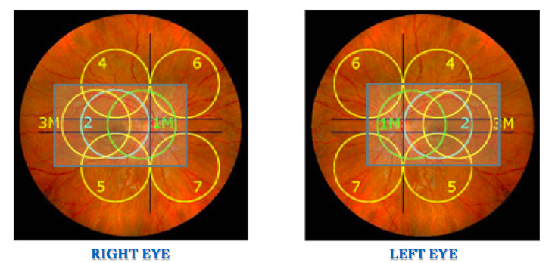
Figure 4: Diagram of three fields: 1) disc 2) macula 3) temporal.³

Workflow: Typical Visit
Consider a typical diabetic patient visit to the primary care clinic. The DR screening should add just 10-15 minutes to a typical diabetic visit without placing any extra burden on the physician’s time because photographs can be taken by any HIPAA trained clinic staff member.

A typical visit for a diabetic patient includes several steps. The patient must first check in with the front desk. Then, a nurse will take a patient through intake, collecting vital signs, height, and weight. After intake, the nurse will lead the patient to wait in the exam room for the physician. The physician will examine the patient, being sure to heed requirements of diabetic patients. The physician reviews the most recent lab values and urinalysis to quantify the patient’s control of his diabetes. The physician must check for ailments common to diabetic patients, paying close attention to signs of peripheral neuropathy and health of the feet.
In addition to these parts of the diabetic visit, the Tele-I-CARE service would ensure that the nurse or doctor asks about the diabetic patient’s most recent dilated eye exam. DR screening is indicated for diabetic patients who have:
- Never had an eye exam
- Cannot remember the date of the last eye exam
- Not had an eye exam in over a year.
If DR screening is indicated, the nurse or physician notifies the clinic’s photographer. Before the photographer sees the patient, certain information must be collected from the patient’s chart. Information includes the most recent HbA1c and the most recent blood pressure. After the physician’s exam is complete, the photographer will lead the patient to the designated eye exam room. In that room, the photographer will take the photos and send them to the eye care provider. Finally, the photographer will lead the patient to check out with the front desk.
ProTip: It is recommended that the nurse reviews the diabetic patient’s chart the day before the patient’s scheduled visit. This way the photographer is prepared with time and the relevant patient information to perform the Tele-I-CARE screening at that visit.

Instructions
The Tele-I-CARE service uses a non-mydriatic retinal camera designed to take fundus, or retinal photos, without requiring dilation. These instructions follow the sequence of the Typical Visit for a diabetic patient, as outlined above.
ProTip: Print these instructions and keep them with your camera for easy reference.
Note: For further instruction refer to the user manual specific to your camera.
Overview of Steps for Screening with Tele-I-CARE:

Primary Care Clinic: Patient Encounter

Patient and Room Set Up
Before taking photographs of the patient, you should first prepare the patient, the room, the camera, and the computer in that order. As with all medical procedures, you have the best chance of success with a relaxed, informed patient.

A. Patient Set Up
1. When the patient’s visit with physician is complete, lead patient from exam room to designated eye exam room.
2. Explain procedure. Following is an example script:
“Hello, my name is Jane, and I’m going to be checking your vision and taking some photographs of the back of both of your eyes. This is to provide the doctors with a close-up view of your retinas. It will not hurt, and I will explain what I want you to do before we do anything. You will be placing your chin in the rest, forehead up against the bar, and I will be on this side driving the camera. You will see a green light inside the camera in different locations; I just ask that you follow the green light to the best of your ability, and blink when you need to. There will be a small flash when we take each picture, and I will let you know when that will happen. I need to get three good photos on each eye. Do you have any questions for me before we get started?”
As you gain practice, you will develop your own script. You will find that if the patient is comfortable and relaxed, you will be much more likely to take quality photographs. Remember, their eye is the other half of your imaging system. Conversely, if the patient is tense, anxious, or uncooperative, the chances are slim that you will get the photographs you need.

B. Room Set Up
ProTip: Successful clinics have dedicated an exam room to visual screening. This way, the camera and privacy is available when a patient needs to be screened.
At the start of the encounter, the lights should be on in the designated visual screening exam room.

Visual Acuity Screening
Note: If patient wears glasses or contact lenses, make a note in the chart. Let patient wear glasses or contacts when checking vision.
1. If using a 20-foot eye chart, stand patient 20 feet away from the eye chart.
2. Ask patient to cover one eye with a spoon occluder and read the lowest line on the eye chart.
Note: If spoon occluder is not available. Patient can use his hand to cover one eye at a time. But be sure that patient does not peak through his fingers.
3. If patient can read half the letters (3 letters) in a line, count the line.
Note: If patient cannot read the eye chart, then record “cannot read chart” in the patient chart.
4. Record information on patient chart.
Note: If the spoon occluder has pinhole attachment, check vision again in same eye using pinholes. Record in patient chart.
5. Then, have patient cover other eye (without pinholes) and read the lowest line.
6. Record information on patient chart.
Note: Use pinholes on this eye, record in patient chart.
7. Ask patient to use both eyes to read the lowest line.
8. Record information in patient chart.
Note: Later in the visit, you will enter this information Patient Quick Screening form on Tele-I-CARE website.

Camera Set Up

A. Patient Set Up
1. Seat patient on chair in front of camera. Say, “Let me clean the camera before you put your head on the chinrest.”
2. Clean chinrest and forehead rest with alcohol swab. (You want the patient to see you do this.)
3. Take a seat behind the camera.

B. Camera and Computer Set Up
Note: Click = computer. Tap = camera.
1. Turn on laptop.
2. Once laptop has turned on, turn on laptop.

Data Entry
ProTip: Save a link to the Tele-I-CARE website on the desktop screen of the computer.
- Navigate to the Tele-I-CARE website: For the ‘’live site” the URL is https://prc.urmc.rochester.edu/. For the demo site, the URL is https://prc.urmc.rochester.edu/Portal/DEMO.
2. Enter Login.
3. Click, “Quick Screen.”
4. In "Patient Quick Screening,” fill out as much information as possible.
5. Click “Enter Screening Data”
6. In pop up, click “OK.”
7. Click “Save”
8. Click “Complete.”
ProTip: Make sure you spell patient’s name correctly, otherwise the computer software will not sync with the website software and the eye care provider will not receive the images.

Capture Photos
1. Turn the room lights down as far as possible while still allowing enough light for you to walk back the camera.
2. Sit behind the camera
3. On computer, enter patient information.
ProTip: Make sure spelling exactly matches patient information added to Tele-I-CARE website (or else the photos will not be sent to the ophthalmologist).
4. Ask patient to rest chin on chinrest and forehead on forehead rest (seen below).
Note: If patient is wearing glasses ask patient to remove them.

A. Capture Fundus Photos of Right Eye
ProTip: You must do right eye before left eye. Take 3 fundus photos and 1 anterior photo before switching to the left eye.
ProTip: Print the Sequence Sheet (in the Appendix of this manual), and place next to the camera for quick reference of fields to photograph in each eye.
1. Take photo of macula field (field 2).
ProTip: Tap the camera lightly because the patient can feel any tapping on the camera screen.
2. Save photo on camera.
3. Take photo of optic nerve field (field 2).
4. Save photo on camera.
5. Take photo of temporal field (field 3).

B. Capture: Anterior Photo of Right Eye
1. Ask patient to tilt forehead away from forehead rest. (This allows you to take a photograph of the entire eye.)
ProTip: If patient is unsure how far to tilt his head back, tell him to place hands in front of forehead and then rest hand against forehead rest.
2. Take anterior photo of right eye.
ProTip: Ask patient to open eyes really wide.
3. Save photo on camera.

C. Capture Fundus Photos of Left Eye
1. Ask patient to bring forehead back to forehead rest.
2. Take three fundus photos of left eye.

D. Capture Anterior Photo of Left Eye
1. Ask patient to tilt head away from the forehead rest.
2. Take anterior photo of left eye.

E. Save Photos to Computer
When you are satisfied with the eight photos you have taken on the camera, save them to the computer.

Send Photos
In these steps, you will send photos to the eye care provider.
1. On computer, select photos.
ProTip: Be sure you are connected to the Internet before the next step.
2. If you are connected to the Internet, export photos to the Tele-I-CARE website.
3. End of patient encounter, lead patient to check out. An example script is as follows:
“We’re all set here. The photos have been sent to the eye doctor to screen for eye disease. We will contact you if you need a further eye exam.”
ProTip: To be sure that photos have been sent to the eye care provider, navigate to Tele-I-CARE website. See that there is a “Yes” in the column titled “Photos” (far right).

Document Encounter

A. Update electronic medical record
1. Make progress note in electronic medical record that the photographs were sent to ophthalmology for review.
Note: This provides a workflow that billing can track.

B. Diabetic Screening: Tracking Sheet
ProTip: Print the “Diabetic Screening: Tracking Sheet” (in Appendix) and store in the designated eye exam room.
1. Record patient information.
2. Check box “Images Sent.”
3. When receive report, check “Interpretation Received.”
4. Update patient’s electronic medical record, check “EMR Updated.”
5. If referral for follow-up required, write “FU” and date you received report.
ProTip: Care manager should make a note in the patient’s electronic medical record to check in with patient to encourage scheduling and attending the follow-up visit with the ophthalmologist.

Camera Shut Down
1. Clean chin rest and forehead rest with wipe.
2. Turn off camera, cover with dust protector.
ProTip: If you need to clean camera lens, only use an eyeglass cloth. This prevents scratching of the lens.
3. Turn off computer, close computer.

Eye Care Provider

Read Images
A qualified eye care specialist will read the photos to check for signs of eye disease.

Generate Report
The specialist will generate a report of the findings and recommendations for the patient. The report will be uploaded to the Tele-I-CARE website.

Primary Care Clinic: Next Steps

Document Report
When the eye care provider has read the images and uploaded the report to the Tele-I-CARE website, the Clinical Champion will receive an email notification that the report is ready.
1. Navigate to Tele-I-CARE website: https://prc.urmc.rochester.edu/
2. Click on row with patient’s name.
Note: The rows in the Tele-I-CARE website is color-coded:
Red: incomplete; primary care clinic did not send photographs
Blue: photographs ready to be read by specialist
Yellow: specialist has read photographs; report ready for primary clinic
Orange: follow up needed (click to add date of appointment with specialist)
White: Patient refuses to get screened.
Green: Incomplete; screening sheet complete, but no pictures.
3. Print report
4. Add report to patient’s electronic medical record.

Contact Patient
If follow up is indicated in the report, contact the patient to encourage patient to schedule an eye exam with an eye care provider.
Example script for patient’s voicemail:
“Hello, this is Jane from Dr. Smith’s office and this message is for Mr. Jones. Please call 585-555-5555 to get the results from your recent visit.”
Example script if contact patient:
“Hello, Mr. Jones, this is Jane from Dr. Smith’s office. We have received the eye report from the eye doctor. The eye doctor sees signs of early stage eye disease in the photographs we took at your last visit to our office. The eye doctor would like to schedule a follow up visit with you at his office. Please call the eye doctor’s office at 585-111-1111 to make an appointment as soon as possible.

Trouble?
Despite our best efforts, there occasionally will be those patients that you just can’t seem to photograph. Even professional ophthalmic photographers have difficulty capturing quality images from every patient.
Some troubleshooting issues are relatively easy to solve; if the image has a quality problem, see the manual specific to your camera. Take a minute break and have the patient sit back. Take a deep breath, and walk yourself through the steps to make sure you didn’t set something incorrectly. If after a recheck of your equipment and approach, you are still unable to get a quality image, see if another trained imager at your clinic can get a better outcome.
There are some physiological issues you may encounter that make it difficult, if not impossible, to photograph. Some medications cause the pupils to be unnaturally constricted, such as glaucoma medications or even some decongestants. If a patient is monocular, or has poor vision, they may not be able to fixate (though sometimes, having them look straight ahead will get you at least in the ballpark). Some may have tremor, or be otherwise unable to hold still in the headrest. Media opacities may make imaging of the retina very difficult to impossible. Still other patients may be just plain uncooperative.
If you cannot capture a quality photograph after troubleshooting, thank the patient for his time and end the session. Remember, with time you will gain confidence and skill, and you will have more quality photographs.
If you cannot capture a quality photograph or if patient complains of vision loss, refer the patient to an ophthalmologist for an in-person eye exam.

Photos Not Uploaded
When Tele-I-CARE website does not have “Yes” under the “Photos” column, there could be 2 main problems:
1. Name misspelled.
The computer program and the Tele-I-CARE website can only sync photos to patient information if the patient name is spelled the same in both the computer program and the Tele-I-CARE website. Be sure that the patient data is correctly entered before sending photos.
2. Not connected to the Internet. If you are not connected to the Internet, the photos cannot be uploaded to the Tele-I-CARE website. An Internet connection is required for successful uploading.

Tele-I-CARE Website Malfunctioning
If Tele-I-CARE website is malfunctioning, print “Patient Quick Screening” sheet (in Appendix). Then, fill in patient information and store securely. Contact your Tele-I-CARE trainer to inform them of the malfunction. When the website is functional again, enter the patient information into the Tele-I-CARE website.

Need More Help?
Refer to the specific user manual for your camera.
Contact your trainer at Tele-I-CARE.
Contact your camera sales representative.

Appendix

Sequence Sheet
OD
2. OD Optic Nerve | 1. OD Macula | 3. OD Temporal

OS
3. OS Temporal | 1. OS Macula | 2. OS Optic Nerve

Patient Quick Screening
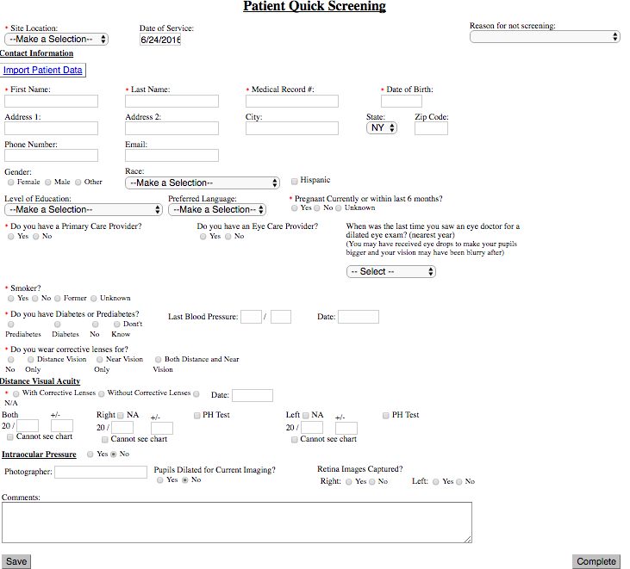

Diabetic Screening: Tracking Sheet
Patient Screened | Images Sent | Interpretation Received | EMR Updated | Referral Needed

References
1. “Normal Eye Anatomy.” New York State Optometric Association. NYSOA. Accessed 21 June 2016.
2. “Fundoscopic/Ophthalmoscopic Exam.” Stanford Medicine. 2016. Accessed 21 June 2016.
3. Fundus Photograph Reading Center. University of Wisconsin System, 2016. Web. 22 July 2016.

Contributors
Rajeev S. Ramchandran, MD, MBA
Christye Sisson, MS, CRA
Jennifer Tingley
Pavel Linares
Taylor Parnell
Vanessa M. Desmore
A Special Thanks to Culver Medical Group

