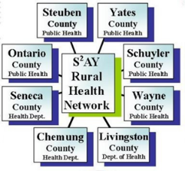
FLPHA MOU Operational Plan
Appendix 4.1: Incident Command System (ICS) Order of Succession

ICS Position | Primary LHD Position | LHD Successor | FLPHA Successor | Responsibilities
Incident Commander |  |  |  | Sets the incident objectives, strategies, and priorities and has overall responsibility for the incident.
Operations Section Chief |  |  |  | Conducts operations to reach the incident objectives. Establishes the tactics and directs all operational resources.
Planning Section Chief |  |  |  | Supports the incident action planning process by tracking resources, collecting/analyzing information, and maintaining documentation.
Logistics Section Chief |  |  |  | Provides resources and needed services to support the achievement of the incident objectives.
Finance & Administration Section Chief |  |  |  | Monitors costs related to the incident. Provides accounting, procurement, time recording, and cost analyses.
Public Information Officer |  |  |  | Advises on information dissemination and media relations. Obtains information from and provides information to the community and media.
Safety Officer |  |  |  | Advises on issues regarding incident safety. Works to ensure safety of field and all incident personnel.
Liaison Officer |  |  |  | Serves as a point of contact for representatives from other response organizations. Provides briefings to and answer questions from supporting organizations.

Incident Command System (ICS) Chart
Public Information Officer
______________________
Safety Officer
______________________
Liaison Officer
______________________
Incident Commander
______________________
Operations Section Chief
______________________
Planning Section Chief
______________________
Logistics Section Chief
______________________
Finance & Administration Section Chief
______________________

