Albany Medical Center PRESENTS: DISASTER Response Training

Basic Disaster Life Support (BDLS) v3.X
June 5th, 2018 – Welcome and Registration 7:30am – Class starts promptly at 8:00am
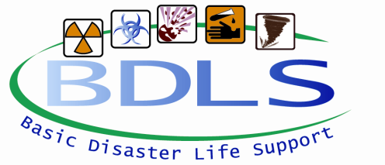
The Basic Disaster Life Support™ (BDLS®) course is a seven hour competency-based, awareness-level course that introduces concepts and principles to prepare health professionals for the management of injuries and illnesses caused by disasters and public health emergencies. The course builds upon, applies, and reinforces information presented in the Core Disaster Life Support® (CDLS®) course. This includes application of core principles and concepts in emergency management and public health as introduced in the CDLS course through the PRE-DISASTER Paradigm™ and DISASTER Paradigm™. The primary focus of the BDLS course is incorporation of an “all-hazards” approach to mass casualty management and population-based care across a broad range of disasters. Measures to ensure and enhance health workforce readiness are emphasized throughout the course. This includes a consistent and scalable approach to workforce protection and casualty management, as well as, mass casualty triage and fatality management.
Training Location:
Albany Medical College - ME300, 47 New Scotland Ave., Albany, NY 12208
Continuing Education Credit for multiple disciplines will be provided for successful completion of this event
Advanced Disaster Life Support (ADLS) v3.0
June 6th and June 7th Welcome and Registration 7:30am – Class starts promptly at 8:00am
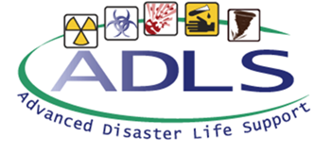
ADLS® is an advanced practicum course for the trained BDLS® provider. It is an intensive, 2-day course that allows students to demonstrate competencies in casualty decontamination, specified essential skills, and mass casualty incident information systems/technology applications. Using simulated, all-hazards scenarios and mass causality incidents, ADLS® makes use of four interactive sessions in which participants treat simulated patients in various disaster drills and situations. Training is focused on the development of hands-on skills to allow participants to apply the knowledge learned in BDLS®.
ADLS is an active, hands-on course. Students should dress comfortably and be prepared for outdoor activities.
Training Location:
Hudson Valley Community College Respiratory Care and Paramedic Program, 400 Jordan Road, Troy, NY 12180
Continuing Education Credit for multiple disciplines will be provided for successful completion of this event
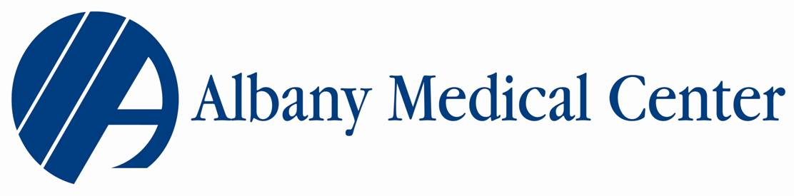
Christopher A. Smith, BS, EMT-P
Emergency Management, Regional Training Center Coordinator
Albany Medical Center
43 New Scotland Ave.
Albany, NY 12208
(518) 262-1070
Smithc12@mail.amc.edu

