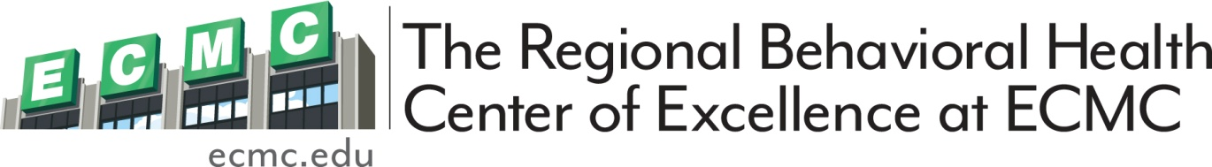

**Registration Limited - see closed registration dates**

**NOTE: If you successfully register you will receive a return e-mail; if you do not get a return e-mail you are NOT registered and you will NOT receive a certificate. Make Checks payable to ECMC Foundation, use credit card information below or use link at bottom to use Pay-pal. All spaces must be completed.**

***Send completed registration form for each attendee* & payment to:**

The Adult, Child, and Family Clinic Attn: Debra Riter

462 Grider St. Buffalo, NY 14215

**Print Name as you wish it on your certificate**: ________________________________________________________

Degree/License: _______________________________Job Title:_____________________________________________

Agency Name/Location:______________________________________________________________________________

**PRINT YOUR Email**:________________________________________________ Phone #/Extension_______________

CC#_____________________________________________ EXP Date___________________________________

CVB:_____________________________________________ Billing Zip code__________________________________

To Register Online go to: [www.ecmc.edu/health-services-and-doctors/behavioral -health/](http://www.ecmc.edu/health-services-and-doctors/behavioral%20-health/) --you must still complete and forward a Registration form for every attendee even if you pay this way through Pay-pal.

**For more information on training sessions offered by ECMC’s Regional Behavioral Health Center of Excellence---- email driter@ecmc.edu**

Continuing Education Training

**REGISTRATION**

**Title: Disaster Mental Health--Assisting Children and Families**

**Presented by:** Bonita S. Frazer MS, CTS, FAAETS, Daniel P. McCartan RN, MS, CNS & Elisabeth Mann LCSWR

**Date: December 8, 2017 Live Training Hours: 3 CEU SW/CASAC/LMHC approved**

**Cost:** $25 ECMC Employees

$35 All others

**Location:** ECMC, 462 Grider St., Buffalo, NY 14215 – 3nd floor (Smith Auditorium)

**Time: 12:30 – 3:45 pm** (registration begins at 11:45 am)

**Overview: The purpose of this live-training course is to serve as an introductory training for social workers, mental health professionals, first responders, spiritual care workers, and hospital staff on working with child survivors of disaster-related trauma and their families. In-class exercises will give you an opportunity to practice skills needed to work with children (target population up to age 12) and families in the immediate aftermath of disasters.**

**Learning Objectives:**

* Describe the basic developmental tasks, issues and behaviors associated with childhood
* Identify a range of behavioral, emotional, and cognitive reactions that children may experience after a disaster
* Identifying key components of informal and formal assessments of children’s post-disaster functioning
* Describe the typical presentation of posttraumatic stress disorder in children
* Understand and describe several developmentally appropriate interventions to use with children and their caregivers
* Use a general understanding of cultural differences between survivors to provide culturally appropriate interventions to children and their families
* Use knowledge about how working with child survivors of disaster related trauma may affect you as a helper in order to provide yourself self-care

You must arrive on time and attend the entire training for CEU certificate; no partial credit is awarded

**CEU Registration Closes:** **Friday December 1st, 2017**

**Erie County Medical Center** is recognized by the **New York State Education Department** as an approved provider of continuing education for licensed social workers #0075 and licensed mental health counselors #MHC-0050. **New York State Office of Alcoholism and Substance Abuse Services (OASAS)** Education and Training Provider Certification # 817. Training under a New York State OASAS Provider Certification is acceptable for meeting all or part of the CASAC, CPP, CPS education and training requirements.