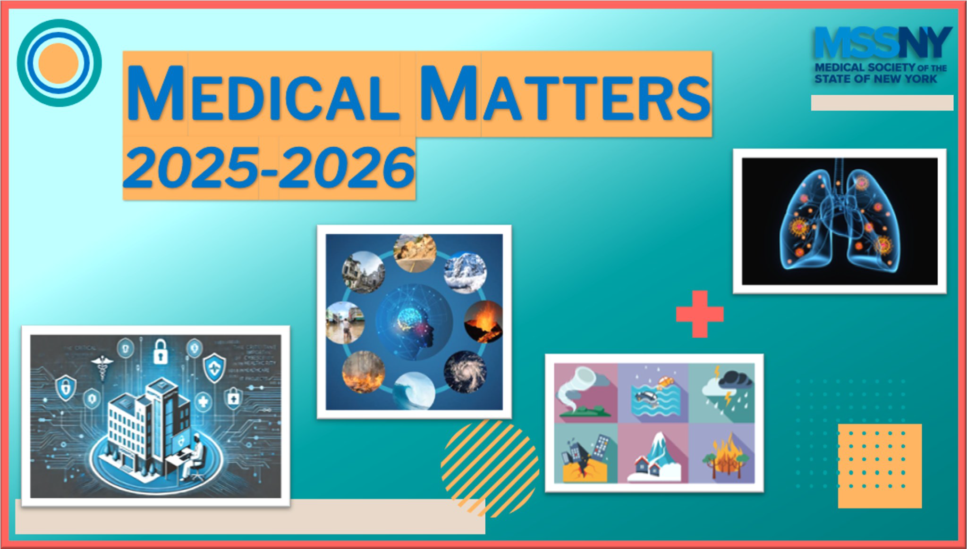

Sponsored by the Medical Society of the State of New York
Beyond the Diagnosis:

Lessons in Vaccine-Preventable Diseases from a
Survivor’s Perspective
Live Webinar

Wednesday May 20, 2026 @ 7:30a.m.
Faculty: Jamie Schanbaum, Director of Legislative Affairs & Strategic Partnerships, The J.A.M.I.E. Group
Educational Objectives:
- Communicate the importance of timely vaccination to patients and families using evidence-based strategies and personal narrative integration, while recognizing the early clinical signs and rapid progression of meningococcal
septicemia to support timely diagnosis and intervention.
- Analyze the long-term physical and psychosocial impact of vaccine-preventable diseases through the lens of patient lived experience.

Click here to register
For more information, contact: Melissa Hoffman at mhoffman@mssny.org or call (518) 465-8085
Funding provided by the New York State Department of Health
The Medical Society of the State of New York is accredited by the Accreditation Council for Continuing Medical Education (ACCME) to provide continuing medical education for physicians.
The Medical Society of the State of New York designates this live activity for a maximum of 1.0 AMA PRA Category 1 credits Physicians should claim only the credit commensurate with the extent of their participation in the activity.

