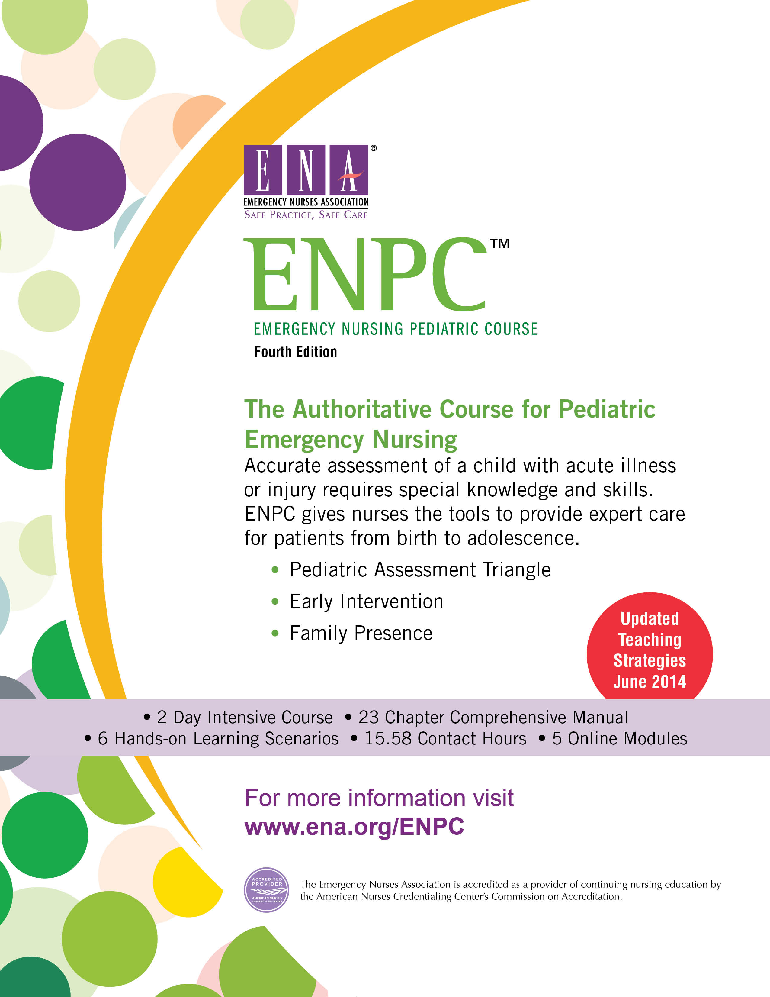
Course Director:
Joanne Fadale 716-574-7336
40tjjmf@gmail.com
Course Dates: Nov 8,9 2017

Registration Instructions: Registration fee due by Oct 1

Location: Erie County Fire Training. 3359 Broadway
Cheektowaga NY 14225

Price: $ 285 ENA member Name________________________________
$ 340 non-member Address______________________________
City/zip_______________________________

Checks: Western NY ENA Hospital_____________________________
c/o Joanne Fadale email _______________________________
4026 Sheldon Rd ENA # __________________________
Orchard Park NY 14127include copy of card

URMC FIngerlakes Regional Training Center has made some scholarships available. You may call us or ask your emergency preparedness co-ordinator if the funds are available. Your uncashed check will be returned class day #2.

Pre-course preparation is essential. Includes online modules /text
Cancellation Policy: No refunds after Oct 27. If you withdraw before Oct 27, a $100 fee for books and postage.

