Albany Medical Center PRESENTS: DISASTER Response Training
ONLINE

Basic Disaster Life Support (BDLS) v3.0 Online

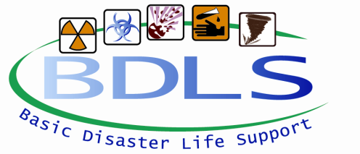
The Basic Disaster Life Support™ (BDLS®) course is a seven hour competency-based, awareness-level course that introduces concepts and principles to prepare health professionals for the management of injuries and illnesses caused by disasters and public health emergencies. The course builds upon, applies, and reinforces information presented in the Core Disaster Life Support® (CDLS®) course. This includes application of core principles and concepts in emergency management and public health as introduced in the CDLS course through the PRE-DISASTER Paradigm™ and DISASTER Paradigm™. The primary focus of the BDLS course is incorporation of an “all-hazards” approach to mass casualty management and population-based care across a broad range of disasters. Measures to ensure and enhance health workforce readiness are emphasized throughout the course. This includes a consistent and scalable approach to workforce protection and casualty management, as well as, mass casualty triage and fatality management.

Continuing Education Credit for multiple disciplines will be provided for successful completion of this event

4 Sessions Via ZOOM
Monday August 10 1pm-3:40pm
Tuesday August 11 1pm-3pm
Wednesday August 12 9am-12:10pm
Thursday August 13 9am-11am
Pose course exam & evaluation – online

***BE ADVISED, THIS IS NOT AN AT YOUR OWN PACE COURSE, YOU MUST PARTICIPATE IN ALL 4 SESSIONS AND HAVE ACCESS TO ZOOM
Click here to request registration information
Jenette White – RTC Coordinator
Albany Med
43 New Scotland Ave
Albany, NY 12208
(518) 262-1070
Whitej4@amc.edu

