Healthcare Professionals Psychological First Aid Mobile https://mobile.va.gov/app/pfa-mobile
PFA Mobile was designed to assist responders who provide psychological first aid (PFA) to adults, families, and children as part of an organized response effort. This app provides responders with summaries of PFA fundamentals, PFA interventions matched to specific concerns and needs of survivors, mentor tips for applying PFA in the field, a self-assessment tool for readiness to conduct PFA, and a survivors' needs form for simplified data collection and easy referral. PFA Mobile was created by VA's National Center for PTSD in partnership with the National Child Traumatic Stress Network (NCTSN) and DoD's National Center for Telehealth & Technology.
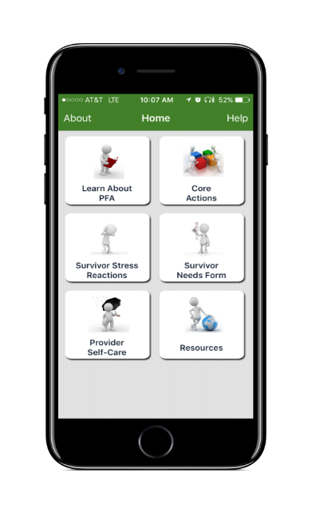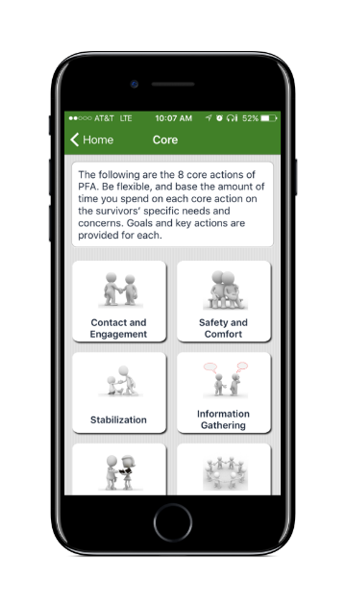
University of Minnesota Psychological First Aid TUTORIAL Mobile App
http://license.umn.edu/technologies/20140244_psychological-first-aid-tutorial-for-iphone-and-android
The Psychological First Aid (PFA) Tutorial app provides information on site for persons who have been trained in PFA procedures. The PFA mobile app is available for Apple and Android devices making it very accessible and easy to use while in the field following a traumatic event, natural disaster, public health emergency, act of terrorism, or personal crisis. First responders, health care providers, mental health providers and Medical Reserve Corps volunteers are able to practice scenarios that provide valuable opportunities to check individuals’ readiness and understanding. The app also reviews self-care actions appropriate for PFA providers and responders before, during, and after responding to an emergency event.
