ICS-200 Test Study Guide

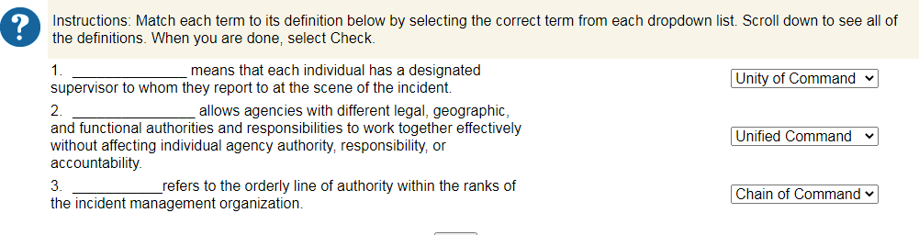

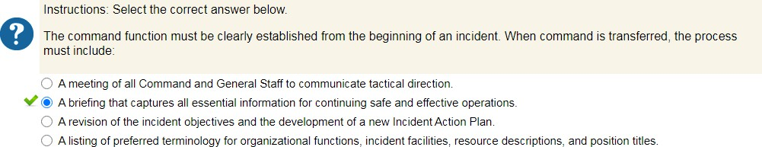

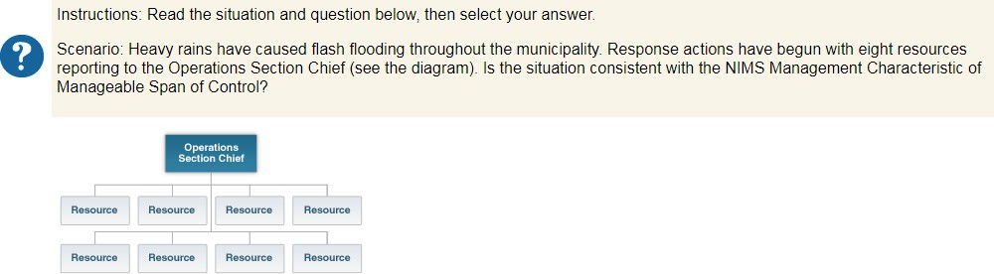

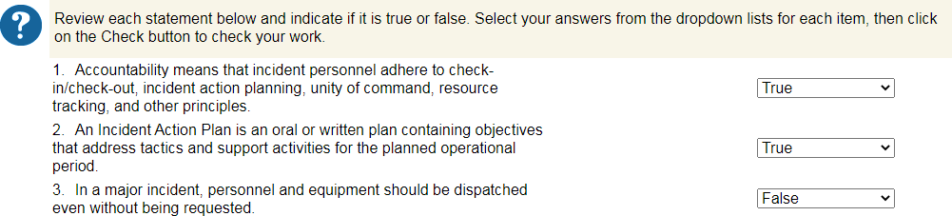

G Instructions: Read all of the statements below and then select the TRUE statement.
0 The ICS intelligence function is limited to national security or other types of classified information.
0 In ICS, modular organization means that the Incident Commander must activate complete, intact teams to staff the different functional areas.
"'@ Resources include personnel, tools, and equipment available, or potentially available, for assignment to incidents.
0 The use of radio codes (10-codes) is the most efficient means of communicating within an ICS organization.

Instructions: Select who would be responsible for the task described below.

Who is the point of contact for representatives of other governmental agencies, nongovernmental organizations, and/or private entities?

0 Publlic Information Officer
V@ Liaison Officer
0 Safety Officer

Instructions: Select the Section that is responsible for the task described bellow.

Which Section collects, evalluates, and disseminates incident situation information and intelligence?

0 Operati1ons Section
V@ Pl.anning1Section
0 Logistics Section

Instructions: Select the Section that is responsiblle fm the task described below.
Which Section iis responsible for all support requirements needed to facillitate effective and efficient incident management, including ordering resources from off-incident locations?

0 Operations Section
0 Finance1Admi1nistration Section
V@ Logistics Section

� Instructions: Select the Section that is responsible for the task described below.
U' Which Section would perform cost analysis and contracting services?

V@ Finance/Administration Section
0 Planning Section
0 Logistics Section

Instructions: Select who would be responsible for the task described below.

Who handles media and public inquiries, emergency public information and warning,s, rumor monitori1ng and rnsponse, and media monitoring, and coordinates the dissemination of information in an accurate and timely manner?

V@ Public Information Officer
0 Planning Section Officer
0 Safety Officer

Instructions: Select who would be responsiible for the task described below.
Who is responsiblle for monitoring incident operatiIons and advising the Incident Commander on all matters relating to operational safety, including thie health and safety of emergency responder personnel?

0 Operations Section Chief
0 Medical Unit Leader
V@ Safety Officer

Instructions: Review the scenario and then sellect the organizatiional strategy you would use to maintain span of control.

0 Scenario The Command Staff consists of a Safety Officer and Public Information Officer Which1organizational structure for the Generali Staff uses correct IICS principles, positi10n titles, and features?
0 Four Strike Teams that combine different types of law enforcement and medical resources und!er the supervision of a Leader.
0 Separate Divisions thal are assigned to accompli1sh different incident objectives under the supervision of a leader.
V@ Two B�an,ches that manage Medical (ElvlS and Life Support) and Investigative (Police) resources under the supervision of a Director.

0 Instructions: Select the TRUE statement from below

Each time an incident is managed using ICS, it is necessary to have a written delegation of authority_ An Incident Commander's scope of authority must be stated in existing laws_
0
0
0 The granting official is relieved of the ullimate responsibili1ty for the incident after delegatingiauthority.
V@ Adelegalion of authority is needed when an incident scope is complex or beyond existing authorities.

Instructions: Review the situation below and select the tactics that support the objective and strategy

Heavy rains are threatening to cause a dam break_One incident objective and its strategy and tactics are as follows

o Objective: Decrease the probability of fllooding by reducing the reservoir level to 35 feet by 0800 tomonrow Strategy: Pump water from reservoir.
Tactics:

V@ Use truck-mounted purnps working from the road into spillway, and portable pumps on the east side discharging into Murky Creek_
0 Inform the comrmmity of the potential risks and evacuate the downstream residents who are closest to the diam_
lr-'-- ,.1..I

Review each statement below and indicate if it iIs true or false Scroll down to see all of the statements When you are done, click on the Check button_

- Emergency Operations Plans should be consistent with the National Incident Management System (NIMS)_
- The operational period is a fixed 12-hour period within which tactics must be completed
- MulU!al aid is the mandatory provision of resources by agencies or organizatiions to assist each other when existing resources are inadequate
- All 50 states, the District of Columbia, Puerto Rico, Guam, and the U s_Virgin Islands can participate in mutual aid through the Emergency Management Assistance Compact (Er,,,1AC)
I True vi
I False vi
I False vi
I True vi

Instructions: The below case study is based on actual events Read the case study and then select the recommended course of actio11_
On Juliy 18, 2001, a train carrying hazardous chemicals derailed and caught fire in a downtow11Baltimorn tunnel, causing a 11ear shutdown of the city and burning so hot that firefighters couldn't reach the flames for 8 hours_
At one poi11t, all major highways i11to the city were bllocked off, a Balltimore Orioles game at nearby Camden Yards was canceled, and the Inner Harbor was closed to boat traffic A water-main break near the tu11nel added to the chaos, causing !hie collapse of part of a major thoroughfare and power outages_
Select your strategy

Given the criticality of public information, the Incident Commander should not delegate the media and liaison functions
0
0 Given that this is a Hazardous Materials Accident, assign!he Safety Officer to work in the Operations Section.
V@ Given the magnitude of this incident, assign all Command Staff immediately to support the Incident Commander_

Instructions: Read the question below and then select the correct answer.
An agency or mganization providing1personnel, services, or other resources to the agency with direct respo11sibility for incident management is called a(n)

V@ Assisting agem;y
0 Cooperating agency

Instructions: Read the question below and then select the correct answer.
An is an individuall assig11ed to an incident from an assisti11g or cooperating agency

0 Assistant
V@ Agency Representative

Instructions: Review the scenario below, select the best course of action, then select Check.
You have been asked to assist Emerald City in its response to increasing floodi11g_The Natio11al Weather Service (NWS) reports ii has been raining heavily for the past 7 days, averaging 1.3 inches of rain each 24-hour period_
The areas of concerns are as follows:

- The Rapid River, which runs north and south through Emerald City, is experiencing slow-rise flooding
- The flooding is being ag,gravated by debris catching on the low bridge dow11stream from lower Lake Emerald_Located near the bridge is the Lake Emerald Independent Living Complex, which includes a skilled nursing facility
- Residents are being1asked to evacuate their homes in anticipation of the rising floodwaters.

It is 1200 hours, and the NWS has just informed the County Emergency Management office that the flooding is expected to crest at 1800 today It is expected that this flood crest will cause flooding as indicated on �i;,rojected floodglain mar;,_,

V@ Divide the Operations Section into three Divisions, each assigned to a different geographical area to evacuate.
0 Divide Ule Operations Section into three Groups, each assigned to a different geographical area to evacuale.
0 Divide tlhe Operations Section into seven Task Forces, each assigned to a different geographical area to evacuate.

Instructions: Review the scenario below, select the best course of action, then select Check.
G

Rain is continuing1and response resources are being ordered to address tile needs of ffllood victims and restore essential services Select tile lbest course of action•
0 Establish th,eLogistics Section to manage a Staging Area wm1resources ready for deployment.
0 Request that the Safety Officer manag:e the Stagiing Area to ensure responder safety.
V@ Assian a Staa1ina Area Mlanaaer who will report to the Ooerati1ons Section Chief.

lnstrnctions: Review the scenario below, select the best course of action, then select Check.

With the additiion of the Staging Area, the Operations Section Chief has the following subordinate leaders reporting directly lo him Staging Area Manager, Division A Supervisor, Division B Supervisor, Division C Supervisor, Flood Control Group SuperviIsor, and Nursing Home Task Force Leader.
After the river crests, the Operations Section will need lo perform additional functions such as controlllhe perimeter, perform search and rescue operations, and restore u1tililies.
The Operations Sectiion Chief should:

0 Combine the evacuatiion resources into one large Division under the supervisor of a Leader
0 Assign a Deputy to assist in the management of tactical resomces.
V@ Add Branciles to alllow for another level of supervision for the expanding resources.

Instructions: Review the scenari:o below, select the best course of action, then select Checlk.

As predicted, the river crested al 3 feet above flood level. Search and resrne operations are underway. There is increasing concern about the nuclear power plant in the downstream area. Three people llost their lives and numerouIs people suffered inJuries. Mutual aid resources are arriving from three surrounding jurisdictions. Incident response is expected lo continue for the next 36 hours.
After expanding the Operations Section, what addition lo the organization would you make?

V@ Establish a Planning Section and begin producing written Incident Acti1on Plans.
0 Use a Technical Specialist in the logistics Section to perform cost accounting functions.
0 Appoint three Deputy Incident Commanders from each of the cooperating agencies providing resources.

0 Additional resources are reporting to the incident Who is responsible for tracking the status of the resources?

0 L.iaison Officer Assistant
0 Stagi111g Manager
V@ Planning Section Resources Unit

0 A decision is made to add a LogiIstics Section. Select lhie responsibility that would be assigned to the Logistics Section.

V@ Ensuring !hat responders can communiicate with one another.
0 Providing medical care of injured flood victims.
0 Establishing mass care facililiies for displaced residents.

Instructions: Review the scenario below aind select the oest course of action.

Before establishing the Planning Sedion, the Incident Commainder diid not have sufficient resources to develop a written Incident Action Plan_
What should the Incident Commander do?

0 Forgo the incident pllanning processing until a formall written plan can be developed and disseminated_
V@ Use the Incident Bri:efing, ICS Form 201, as the initial Incident Action Plan (IAP) until a Planning Section has been established_
0 Assign the Public Information Officer the task of documenting and circulating the incident objectives, strategies, and tactics_

Instructions: Review the information that has been developed to tie enfiered on fihe Emerald City Incident ICS Form 201. After reviewing the excerpt, scroll down to indicate your assessment

Summary of Current Actions
Status See map for projected inundation zone and impacted facilities Floodwaters are projected to crest by 1800 3/15_ Current Actions Command Post establi1shed in parking lot at Fire Station in Tactical Mobile Command Vehicle. Di1visions A, B, C
assigned to alert and warni1ng in projected i1nundation zone; estimate completion by 1330. American Red Cross contacted to open
shelter at Lafayette Miiddle School l:iy 1400-briefed on evacuees from Lake Emerald Living Genter Nursing:Home and Lake Emerald Independent Living notified to implement evacuaition plans not laiter than 1400_lake Emerald confirms adequate transportation_City Water Authority notified to proled water treatment plaint by 1600. Rapid River Nuc Iear Power Plant staff notified and implementing flood SOP by 1600. PIIO has prepared pul:ilic service announcement, awaiting: approval by Ci1ty Mainager; press conference scheduled for 1330 at Cify HaIL Emerald City EOC in the process of being activated. County EOC in the process of l:ieing activated. Emerald City Hospital notified and prepared to receive Nursing Home evacuees by 1600. Resources ordered to support Waler Treatment Plant Group and Nursing Home Evacuation Group. Edison Electric, Commonweailth Gas Co_, and City Iransit notified.

Weather Current weather pattern continues through midnigiht, then partial clearing Highs in the mid 40s, lows in the high 30s. Ch:ance of precipitation 60% through midnight, reducing to 40% after midnight Expected precipitation next 24 hours _75 inches_ Winds from the west 10-15 mph_

Safety Message: Avoid skin contact with:noodlwaters. Drive with lights on_Walch:for downed power lines in nood vicinity_Camy personal flotation devices. Monitor City radio frequency F2 for safety updates
Whal iinformation would you add lo this summary of current aictions?
0 Resources Ordered
- Incident Facility Locations
V@ Incident Objectives

Instructions: Read each l:iri1effing description_From the dropdown list next to each description, select the type of briefing described. Scroll down to see all of fihe descriptions When you are done, click on Check_

- _ It's the beginning of an DDerational period_The Operations Section Chief is meeting with all tactical resources to present the plan for the next operational period to all tactical resources.
2_ A supervisor withiin the Logistics Section iis meeting with personnel to clairi1fy tasks and scope ot the work as welll as define the reporting schedule, subordinate responsibilities and delegated authority, and the supervisor's expectations
3_ A Task Force Leader is meeting with team meml:iers at a work site to discuss tactics and safety issues

ISection-level Briefing ...,I

IStaff-Level Bri1efing "'I IField-Level Briefing "'I

Instructions: Review the statement from the Emerald City Incident Operational!Period Briefing_After reviewing the statement, click or who would present this information, then click on Check.

''First, a brief overview of our incident. II is 1200 hours, and the National Weaifiher Service has just informed the County Emerg1ency Management office that the flooding is expected to crest at 1800 today The Command Post has been established in the parking lot at the Fire Station in the Tactical!Mobile Command Vehiclle. Divisions A, B, and C are assigned to alert and warning in the proJected inundation zone; estimate completion by 1330."

Who would present this information during the Operational Period Briefing?
0 Public Information Officer
V@ Operations Section Criief
0 Liaison Officer

Instructions: Review the statement from the Emerald City Incident Operational Period Briefing. After reviewing the statement, dick on who would present this information, then cllick on Check.

'The objedives for the next operati1onal period are

1 Ensure safety of responders and publlic in impact arna.

- Ensure effective public information.

- Evacuate vulnerable populations and areas of the city that may be cufioff by floodwaters. 4 Protect builldings and infrastructurn from floodwaters"
Who woul!d present U1iis information du�ing the Operational Period Briiefing?
V@ Incident Command!er FinancefAdministration Section Chief
0
0 Task Force Leader

Instructions: Review the statement from the Emerald City Incident Operational Period Briefing. After reviewing the statement, click on who would present this information, then click on Check.

"Everyone should avoid skin contact with floodwaters. Drive with lights on. Watch for clowned power lines in flood vicinity. Wear personal flotation devices when near/around water. Monitor City radio frequency F2 for safety updates"

Who would present this information during the Operational Period Briefing?
0 Public Information Officer
V@ Safety Officer
0 Logistics Section Chief

Instructions: Review the statement from the Emerald Ci1ty Incident Operational Periiod Briefing. After reviewing the statement, click or who would present this information, then click on Check.

'The next Operational Period Briefing is scheduled for today at 1400. Right after this briefing, we will have a quick Plannin,gi Meeting_ At the next Operational Period Bri1efing, I will distribute a written Incident Action Plan. Any questions? If not, we're adjourned."

Who would present this information during the Operati10nal Period Briefing?
V@ Planning Section Chief
0 Operations Branch Director
0 Agency Representalive

0 Instructions: Choose "true" or "false" for each of the following statements, and then click on th1e Check button.

- An ICS organizational structure should incllude only the �unctions and posililons needed to achieve the incident objecti1ves
- ICS positions may be combined in order to save on staffing or achieve
a higher level of efficiency_
- ICS encour.ages the use of unique position titles in order to better meet the specific incident needs.
- A Resources Unit may be activated without activating the Planning Section Chief

- Instructions: Select the correct response bellow.
I True vi
I False vi
I False vi
I True vi

Pat Jones is the Resources Unirt:Leader. No Planning Section Chief is assigned Who does Pat Jones report to?
0
Operati1ons Section Chief
0 L1iaison Officer
V@ Incident Commander
0 No direct supervisor

Instructions: Review the statement below. Click to indicate if the resource being1ordered is a kind or type Ordering a bus with seating for more than 40 aclullts is an example of a resource
•
0 Kind
V@ Type

- Instructions: Review the statement below. Click lo indicate if tile resource being ordered is a kind or type

Ordering a canine team is an example of a resource _
V@ Kind
0 Type

Instructions: The tactical resources below have been request fio respond to a landslide incident. Review the request, click on the correct title of the resources, then click on Check. Remember, you may use the glossary!
One Type I ambulance and crew compllement.
V@ Single Resource Task Force
0
0 Strike Team

Instructions: The tactical resources below and on the following two screens have been request to respond to a landslide incident. Review the request, cllick on the correct title of the resources, then cliIck on Cheek. Remember, you may use the glossary!
•
Five Type II ambulances and crew complements with a leader.

Single Resource Task Force
0
0
V@ Strike Team

Instructions: The tactical resources below h1ave been request lo respond to a landslide incident. Review the request, click on the correct tiitle of the resources, then click on Check. Remember, you may use the gllossary!
0
One Type Ill Helicopter, one Urban Search & Rescue Team, and one Emergency Medical TechniIcian with a leader.

0 Single Resource
V@ Task Force
0 Strike Team

Instructions: Read the scenario below and U1e11select the appropriate incident type
Remember, Type 5 is the least complex and Type 11the most complex. Scenari10
0
A multivehicle accident has occuirred with fatalities and numerous critical!injuries, and there are possible structural integrity cancer with the road. Local resources are on the scene_The rescue, investigation, and engineering operations are expected to go into multiple operational periods_Operational briefings are being1documented; a written Incident Action Pllan has been develloped_

0 Type 5 lnciident
0 Type 4 lnci1dent
V@ Type 3 lnciident
0 Type 2 lnciident
0 Type 1 lnciident

Scenario:
0

Ongoing flooding is occunring in a tri-Stale area Local and regional resources are overwhelmed, and there are numerous missing and injured persons Additional rain and wind is forecasted for thie tri-State area The President has declared all counties in the affected region as disaster areas under the Stafford Act

Type 5 lncide11t
0
0 Type 4 Incident
0 Type 3 Incident
0 Type 2 Incident
V@ Type 1 Incident

Scenario
0

A cargo jet has crashed with injuries oniboardl and on the ground_Additionally, possible hazardous materials are aboard the jet State and local resources are managing the incident All Command positions are filled and the Operations and Planning Sections have been activated.

0 Type 5 lnci1dent
0 Type 4 lnci1dent
0 Type 3 lnciIdent
V@ Type 2 lnciident
0 Type 1 lnci1dent

Scenario

A three-car accident has occurred in a small residential area Two of the drivers and several passengers have sustained minor injuries. Ihe r,esponse will be completed witlhin a single operational period.

V@ Type 5 Incident
0 Type 4 Incident
0 Type 3 Incident
0 Type 2 Incident
0 Type 1 Incident

Scenario

A bank robber is hollding staff and patrons hostag1e An Operations Section has been activated with a Perimeter Control! Group, Investigation Group, and SWAT Unit. The Command Staff includes the Incident Commander and a Public Information Officer, and the incident may extend into murniple operational periods

0 Type 5 Incident
0 Type 4 Incident
V@ Type 3 Incident
0 Type 2 Incident
0 Type 1 Incident

0 lnstrnctions: Choose "true" or "false" for each of the following statements, and then click on lh,e Check burtton.

- The arrival of a more qualified person means that a change in incident command must occur.
- The effective time and date of the transfer should be commurnicated to all personnel who need to know, both at the scene and elsewh,ere
- The transfer should take pllace face-lo-face and include a complete briefing,_
- A formal transfer of command is unnecessary when the Deputy Incident Commander is relieving the Incident Commander for an extended rest period.
I False vi
I True vi
I True vi
I False vi

lnstrnctions:
Let's return lo the Emerald City llncident It is now 1800 and the water level is still rising You are relieving tlhe current Incident Commander fm the next operational period Review the list below and check the 4 items that should be included in the transfer of command briefirng When you ar,e finished, click on Check.

V � Situation Status
V � Current Organization
0 News Releases and Media Monitoring Reports
V � Resource Assignment
V � Incident Objectives and Prio�itires
0 Special Requests fromAgen,cy Representatives

