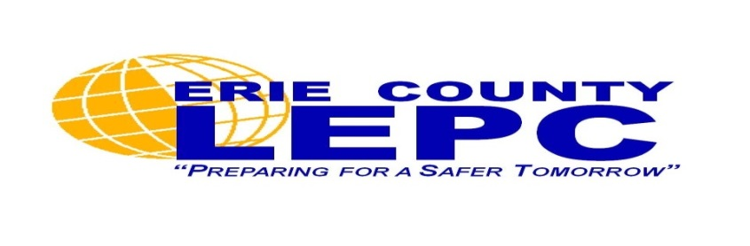

September is National Preparedness Month

Air Quality and the Community: Public Information Forum

The Erie County Local Emergency Planning Committee (LEPC) is hosting its annual
Public Information Forum to discuss emergency preparedness and response
in Erie County. Come learn how the County is preparing communities and agencies to respond to emergency incidents and learn how you can prepare!

Speakers include representatives from:
Erie County Emergency Services
NYS DEC Air Resources Division
Buffalo Fire Department Hazmat Team
National Weather Service

Wednesday, September 14, 2016
6:00pm – 8:00pm

Erie County Department of Emergency Services
Training and Operations Center Auditorium
3359 Broadway, Cheektowaga, NY 14227

Light refreshments will be served!

