[Hospital Name]

Staff Medication Management During an Emergency Event

Contents

A. Disclaimer 2
B. Assumptions 2
C. Preparedness 2
D. Response 2
1. Staff Alerted to a Potential Stay 2
2. Staff Stay in Effect 3
E. Recovery 3

Attachments
Attachment 1… Personal Disaster Plan
Attachment 2… Patient Log

- Disclaimer
In preparing this document we acknowledge that providing needed medication to staff members during an emergency event may pose additional issues not considered at this time. It will be important for staff members to be proactive and plan for their own emergency needs; however, in the event that staff members have not preplanned, the information included here may be a useful tool to assist in a response.

- Assumptions
Although most emergency events are of limited duration, and it is not unusual to be able to miss a dose of a medication, this plan considers a worst case scenario.

- Preparedness
Staff members have been provided information to assist them in development of a personal disaster plan that includes consideration for any personal medication needs (Attachment 1).

Staff members who choose to bring their medication(s) to their worksite have been instructed to keep it in a secure location.

- Response
Initiating this response will require administrative approval and may require revisions to current policy(ies).

Management of staff needs during an emergency event falls under the responsibility of the Logistics Section – Service Branch.

- Staff Alerted to a Potential Stay
When alerting staff of the potential for a stay, leadership should instruct them to bring the following, or have these items brought in to them:
- Any medications or medical equipment that may be needed
- Change of clothing
- Personal hygiene items
- Non-perishable food items
- Blanket or sleeping bag

Depending on the emergency event, staff members may not be able to leave the hospital but may be able to have family or friends drop off their medication.

Options for staff members once alerted to a potential stay:
- Have medication with you – staff member is responsible for storing in a secure location.
- Ask a friend or family member to bring your medication to you – in the original pharmacy packaging.
- Ask your supervisor if you can temporarily leave the facility to pick up your medication.
- [If the hospital has an outpatient pharmacy] Have your provider call in a prescription to the hospital pharmacy – or call in a refill. This may mean that insurance won’t pay, and the hospital or the employee may have to cover the cost.

Medications that may cause drowsiness
Staff members that cannot be without a medication that causes drowsiness, which they typically take when off duty, are responsible for bringing this to the attention of their supervisor. Staff members should not be taking any medication that causes drowsiness when on duty, or on call.

- Staff Stay in Effect
In the event that staff members cannot leave the hospital and there is no way for them to receive their medication, the Hospital Command Center (HCC) may initiate a clinic response. Initiating this response will require administrative approval and may require suspension of current regulations.

Employee Records
Employee Health may have employee records that include a list of medications. Employees who are not sure of what they are taking may be able to access this information.

Clinic Response
This response would include a practitioner along with a pharmacist (if available) setting up an area to screen concerned staff members. Those staff members that wish to be seen would be screened by the practitioner. A pharmacist may be present as that individual is aware of current pharmacy inventory. If a pharmacist is not available, there will be a contact number or radio assigned to allow the practitioner rapid access to the pharmacy/pharmacist.

The practitioner will determine if the staff member should receive medication and will prescribe as appropriate. It is assumed that any medication prescribed will be limited to the expected duration of the event and the hospital will incur the cost.

The practitioner will ensure that all required documentation is completed according to current legal requirements. Attachment 2 may be used to provide a log of staff members seen.

Recovery
Following the emergency/disaster event that required activation of this CEMP Attachment, and as part of the recovery phase, the pharmacy will compile a list of medications and quantity of medications dispensed to staff members (Attachment 2 may be used). This list will be forwarded to the HCC.

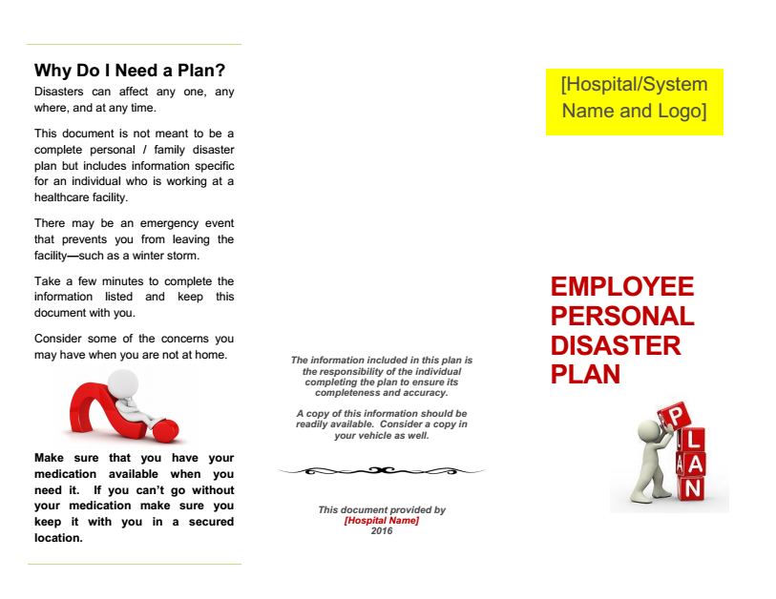
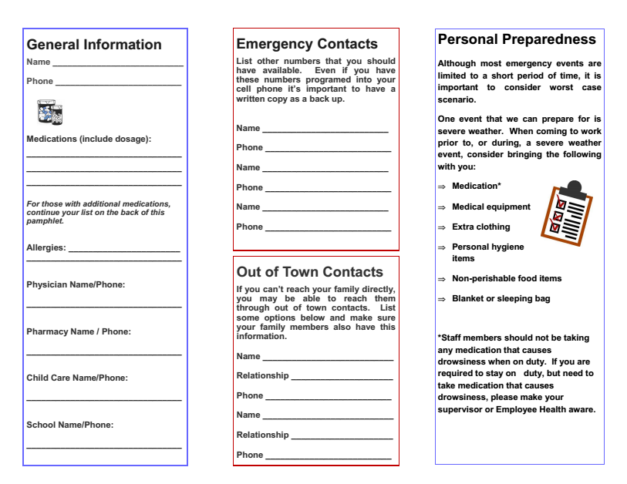
Name of Practitioner __________________________ Contact Info _______________________
Name of Pharmacist __________________________ Contact Info _______________________
Date _____________
Staff Name | DOB | Primary Care Provider | Medication | List of Medication Provided and Amount | Comments

