TRAUMA NURSING CORE COURSE
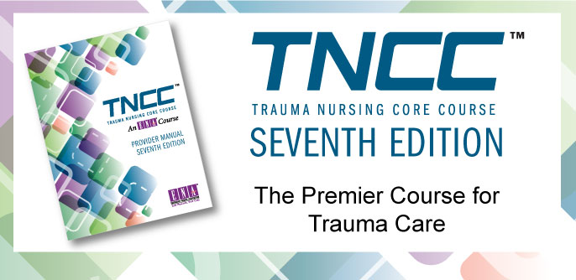\
September 12 & 13, 2015

TNCC, widely recognized as the premier course for hospitals and trauma centers worldwide, empowers nurses with the knowledge, critical thinking skills, and hands-on training to provide expert care for trauma patients.
This seventh edition course combines interactive learning with scenario-based assessments to give nurses a comprehensive learning experience.

The Emergency Nurses Association is accredited as a provider of continuing nursing education by the American Nurses Credentialing Center’s Commission on Accreditation

REGISTRATION REQUIRED

Fees: ENA members…………….$250

Non-ENA members………$285
Make checks payable to: MARK TWAIN CHAPTER ENA.
Refunds will be made according to the following schedule:
4 weeks before……………Full refund
2 weeks before……………$150
(No refund will be given when cancellations are made less than two weeks prior to the start of TNCC.)

Topics
Trauma Nursing and the Trauma Nursing Core Course | Spinal Cord and Vertebral Column Trauma
Teamwork and Trauma Care | Musculoskeletal Trauma
Epidemiology | Surface and Burn Trauma
Biomechanics, Kinematics, and Mechanisms of Injury | Special Populations: The Pregnant Trauma Patient
Initial Assessment | Special Populations: The Pediatric Trauma Patient
Airway and Ventilation | Special Populations: The Older Adult Trauma Patient
Shock | Special Populations: The Bariatric Trauma Patient
Pain | Special Populations: The Interpersonal Violence Trauma Patient
Brain, Cranial, and Maxillofacial Trauma | Psychosocial Aspects of Trauma Care
Ocular Trauma | Disaster Management
Thoracic and Neck Trauma | Transition of Care for the Trauma Patient
Abdominal and Pelvic Trauma | Post Resuscitation Care in the Emergency Department
------------------------------------------------------------------------------------------------------------------------------------------------
Registration Form: Trauma Nursing Core Course: 9/12/15-9/13/15. Please register immediately, due to limited available space.

Registration Deadline: MONDAY, August 10, 2015

Detach and complete this form: Make checks payable to MARK TWAIN CHAPTER ENA, and mail to:
Mary Ann Teeter FNP-C, TNCC Course Director, Arnot Ogden Medical Center, 600 Roe Ave., Elmira, NY 14905
Name_____________________________________________________ ENA #______________________
Address_____________________________________ Affiliation__________________________________
City________________________ State_________ Zip____________ Phone________________________
E-mail________________________________________________________________________________
In accordance with the American Disabilities Act, please advise Course Director if you have any disability that requires special materials and/or services so that appropriate personnel can be advised.

