P.E.A.R.S.

This course is set up for healthcare providers who
see critically ill children infrequently and any healthcare
provider who might encounter pediatric patients. This
course is not intended for those credentialed for
advanced pediatric skills that routinely provide pediatric care.
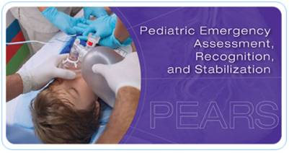
@ Women & Children’s Hospital of Buffalo

Course description: Students develop skills in recognizing certain pediatric distress signs and symptoms using several unique visual cues and work at learning stations. Because typical PEARS students do not regularly treat critically ill children, the course includes video-based simulation so they can actually see and hear critically ill children. In addition, a SIM baby will be used for teaching hands on scenarios.

Register: https://www.nylearnsph.com
Course: FLRTC-PEARS-01
Location:
Women & Children’s Hospital of Buffalo,
140 Hodge, Buffalo N.Y.
Basement Clinical Education Classroom
Specific Instructions will arrive with your PEARS books
Cost $120.00

You will need to include your Name, Address, Contact phone # so we can send out your course instructions and materials 2 weeks in advance.

If you have any questions regarding the PEARS course, you can call 878-7602 or email
Pat Volker@ pvolker@kaleidahealth.org or
Elise Grandits @ egrandits@kaleidahealth.org

P.E.A.R.S.
2015 WNY Fall Courses

September 30, 2015 8:30am – 1:30pm
October 14, 2015 8:30am- 1:30pm
October 22, 2015 8:30am- 1:30pm
November 19, 2015 8:30am – 1:30pm

Women and Children’s Hospital of Buffalo Kaleida Health
219 Bryant St.
Buffalo, New York 14222
878-7602
