SAVE THE DATE
9/17/2016: 8:45AM-4:00PM
Erie County Fire Training Academy
3359 Broadway, Cheektowaga NY

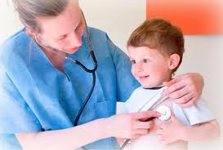

PEDIATRIC BEST PRACTICES WORKSHOP

JOIN US AS SPEAKERS FROM WOMEN & CHILDREN’S HOSPITAL OF BUFFALO AND OTHER PEDIATRIC EXPERTS PRESENT A DAY FULL OF PEDIATRIC TOPICS GEARED FOR FIRST RESPONDERS.

TOPICS INCLUDE: Pediatric Airway Management & Workshop, How Disasters Impact a Child’s Brain & Behavior, Pediatric Assessment, Differences between Children & Adults as Patients, Pediatric Medication Administration & Recognition, Child Abuse Recognition & Reporting, Jumpstart Triage, Trauma Care for Pregnant Women, CDC Trauma Triage Guidelines and Approach to Pediatric Trauma for the EMS Professional.
COST: FREE TO ALL PARTICIPANTS
PLEASE REGISTER AT ECMRC@ERIE.GOV , AND BE SURE TO LEAVE YOUR NAME, ORGANIZATION & CONTACT PHONE NUMBER
**SPACE IS LIMITED - Early registration is advised**

