# P.E.A.R.S.

[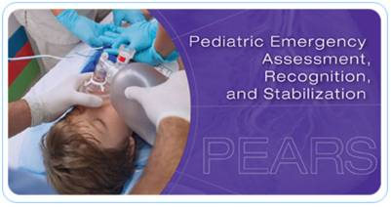](http://www.google.com/url?sa=i&rct=j&q=&esrc=s&frm=1&source=images&cd=&cad=rja&uact=8&ved=0CAcQjRw&url=http://littletonhealthcare.org/education_comm.php&ei=gTCQVbXsFYq1ggS6yYIw&bvm=bv.96783405,d.eXY&psig=AFQjCNHTAlIlmF3ax5uIHis9z_8D4B69wg&ust=1435598986392076)

This course is set up for healthcare providers who infrequently see critically ill children and any healthcare provider who might encounter pediatric patients. This course is not intended for those credentialed for advanced pediatric skills that routinely provide pediatric care.

**Course description**:  Students develop skills in recognizing certain pediatric distress signs and symptoms using several unique visual cues and work at learning stations. Because typical PEARS students do not regularly treat critically ill children, the course includes video-based simulation so they can actually see and hear critically ill children. In addition, a SIM baby will be used for teaching hands on scenarios.

**Cost: $120.00 (made payable to WCHOB on course day)**

A limited number of FLRTC scholarships are available on a first come first serve basis. Please email [FLRTC](mailto:eileen_spezio@urmc.rochester.edu;%20anne_dangelo@urmc.rochester.edu?subject=PEARS%20Scholarship) to see if you qualify. Include hospital name, course date and copy your hospital EP coordinator and supervisor in the request.

**Register:**  [**https://www.nylearnsph.com**](https://www.nylearnsph.com)**Course:** [**FLRTC-PEARS-01**](https://www.nylearnsph.com/Personal/Catalog/Description.aspx?u=kM6WW0gCRpm64tO9vetda2YKyVY61BtAB3xIDheHlssZ%2bjEt%2bnTMlGuo5bTSjQGPsazZ%2bUt8V7A%3d)

### **P.E.A.R.S. 2015 WNY Fall Courses**

September 30, 2015 8:30am - 1:30pm

October 14, 2015 8:30am - 1:30pm

October 22, 2015 8:30am - 1:30pm

November 19, 2015 8:30am - 1:30pm

Women and Children’s Hospital of Buffalo Kaleida Health – Nursing Education Department Classroom

219 Bryant St.

Buffalo, New York 14222

878-7602

@ Women & Children’s Hospital of Buffalo

