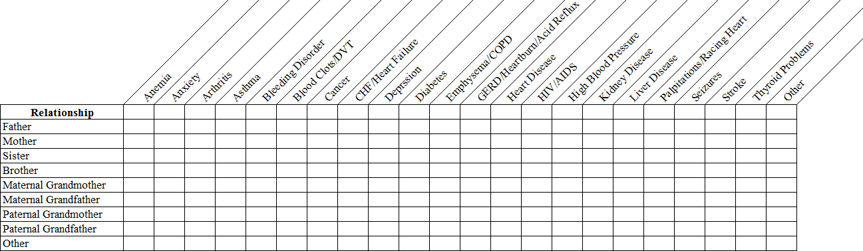
Name (Last, First, M.I.)
Date of Birth (Month, Day, Year)
If you have completed sections 1-4 since your last birthday, please proceed to section 5.
Check all that apply.
- Medical History
  - Anemia
  - Anxiety
  - Arthritis
  - Asthma
  - Bleeding Disorder
  - Blood Clots/DVT
  - Cancer
- CHF/Heart Failure
- Depression
- Diabetes
- Emphysema/COPD
- GERD/Heartburn/Acid Reflux
- Heart Disease
- HIV/AIDS
- Hypertension/High Blood Pressure
- Kidney Disease
- Liver Disease
- Palpitations/Racing Heart
- Seizures
- Stroke
- Thyroid Problems
- Other

2. Surgical History
□ No Surgery
- Coronary Artery Bypass
- Hernia Repair
Location:
- Hip Replacement
- Hysterectomy
- Knee Replacement
- Prostate Surgery
- Spine Surgery
- Organ Transplant
- Anesthesia Complications
- Appendectomy
- Breast Surgery
- Colonoscopy
- Coronary Artery Stent
- Eye Surgery
- Other

- Gallbladder Surgery (Cholecystectomy)
- Social History
Alcohol Use
□ Yes □ No □ Never
  - Wine
  - Beer
  - Liquor
Street Drug Use
- Yes □ No □ Never
- Marijuana
- Methamphetamines
- Cocaine
- Heroin
- Other
Tobacco Use
- Yes □ No □ Never
Type
- Current Smoker
Packs per day
Sexually Active
- Yes □ No □ Not Currently Partners (check all that apply)
- Female □ Male
Birth Control/Protection
- Yes □ No
Method
- Former Smoker
4. Family Medical History (Check all that apply)
- I have no family history
- I have unknown family history
Health History Questionnaire

Name (Last, First, M.I.)
Date of Birth (Month, Day, Year)
- Primary Care Network
  - Allergies to Medications/Latex – Please indicate type of reaction
B. Medications: Please list current medications. Include herbal & over-the-counter medications, dose & how many times a day you take the medication.
Medication
Dose
How many times per day

Health History Questionnaire

