Paragangliomas of the Head and Neck: A Pictorial Essay
Authors: Jerry C. Lee, MD; Ajay Malhotra, MD; Henry Wang, MD, PhD; Per-Lennart Westesson, MD, PhD, DDS
Affiliation: Division of Diagnostic and Interventional Neuroradiology, Department of Imaging Sciences, University of Rochester Medical Center, Rochester, New York
Purpose
Learn the common locations of paragangliomas of the head and neck and where they originate. Learn the common imaging findings of paragangliomas using CT, MRI, and angiography.
Introduction
Paragangliomas of the head and neck originate most commonly from the paraganglia within the carotid body, vagal nerve, middle ear, and jugular foramen. Also called glomus tumors, they arise from paraganglion cells of neuroectodermal origin frequently located near nerves and vessels. The function of most paraganglia in the head and neck is obscure; one exception is the carotid body, which is a chemoreceptor.
Paragangliomas account for 0.6% of all neoplasms in the head and neck region, and about 80% of all paragangliomas are either carotid body tumors or glomus jugulare tumors. The classic manifestation of a carotid body tumor is a nontender, enlarging lateral neck mass that is mobile, pulsatile, and associated with a bruit. Jugulare and tympanicum tumors commonly cause pulsatile tinnitus and hearing loss and may cause cranial nerve compression. Vagal paragangliomas are the least common and present as a painless neck mass that may result in dysphagia and hoarseness.

Common Locations of Head and Neck Paragangliomas
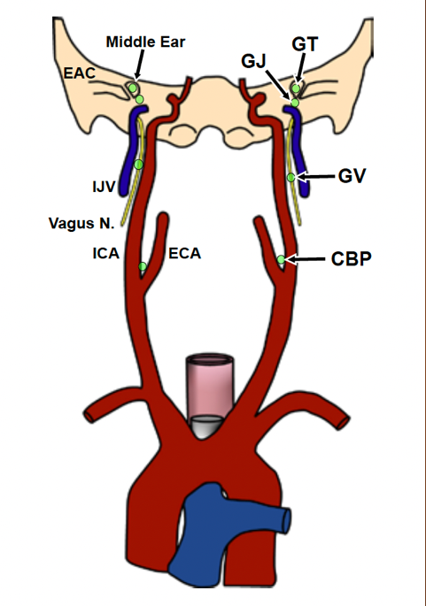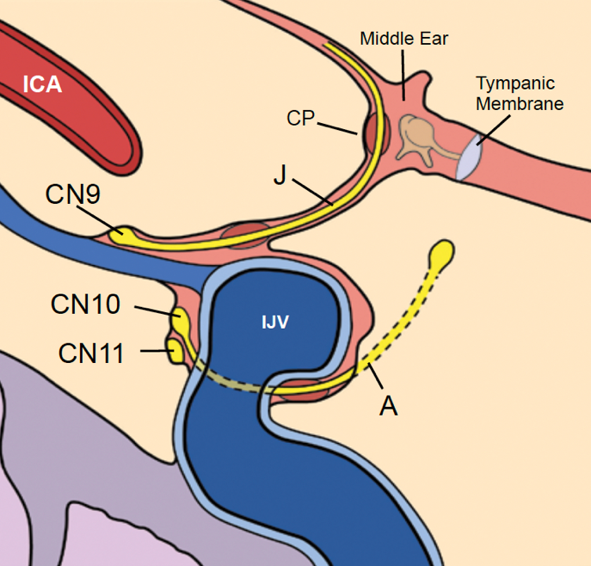

Figure 1. Common location diagrams
Diagram set showing common sites of head and neck paragangliomas. The first diagram maps glomus tympanicum, glomus jugulare, glomus vagale, and carotid body paraganglioma relative to the middle ear, carotid arteries, jugular vein, and vagus nerve. The second diagram shows the jugular fossa next to the middle ear and labels Jacobson nerve, Arnold nerve, cochlear promontory, internal carotid artery, internal jugular vein, and nearby cranial nerves.
Abbreviations used in the original figure:
- GT = Glomus tympanicum
- GP = Glomus jugulare
- GV = Glomus vagale
- CBP = Carotid body paraganglioma
- ICA = Internal carotid artery
- ECA = External carotid artery
- IJV = Internal jugular vein
- CP = Cochlear promontory
Glomus tympanicum occurs along Jacobson nerve in the middle ear adjacent to the cochlear promontory. Glomus jugulare occurs along Jacobson or Arnold nerves within the jugular fossa.

Glomus Tympanicum

Key Points
- Most common tumor of the middle ear.
- Mass arising from the middle ear and not involving the jugular foramen.
- Benign tumor arising from glomus bodies found along the inferior tympanic nerve, also called Jacobson nerve, a branch of the glossopharyngeal nerve on the cochlear promontory.
- Common presentation is a middle-aged woman, roughly 40 to 60 years old, with pulsatile tinnitus, conductive hearing loss, and occasionally facial nerve paralysis, along with a retrotympanic vascular mass.
- Treatment is tympanotomy for smaller lesions and mastoidectomy for larger lesions.

Imaging Characteristics
- CT demonstrates a round mass with a flat base on the cochlear promontory projecting into the mesotympanum.
- A larger lesion may resemble “New Jersey” on coronal imaging when it fills the middle ear cavity.
- Imaging shows a focal enhancing mass on the cochlear promontory.
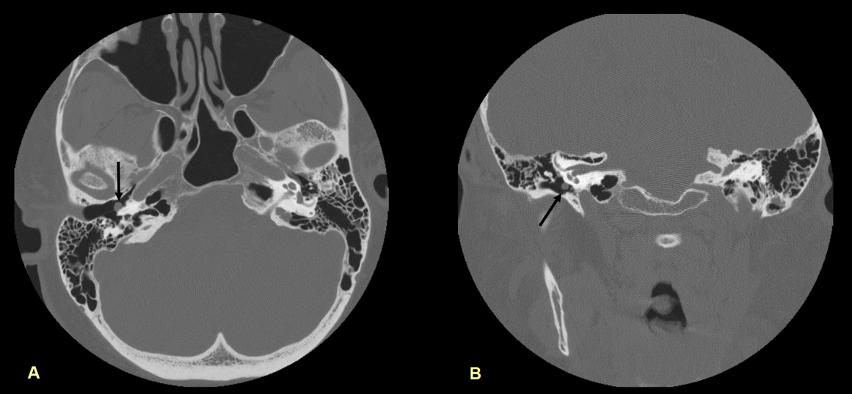

Figure 2. Glomus tympanicum CT example
- Two CT images of the right temporal bone in a 59-year-old woman with tinnitus. The axial image shows a 3 mm soft tissue mass abutting the cochlear promontory and projecting into the middle ear cavity. The coronal reformat shows the same small right middle ear mass without adjacent bone erosion.
- Two CT images of the right temporal bone in a 59-year-old woman with tinnitus. The axial image shows a 3 mm soft tissue mass abutting the cochlear promontory and projecting into the middle ear cavity. The coronal reformat shows the same small right middle ear mass without adjacent bone erosion.
Case summary: 59-year-old female presenting with tinnitus.

Carotid Body Paraganglioma

Key Points
- Most common location for head and neck paragangliomas, accounting for about 60% to 67%.
- Benign vascular tumor arising in glomus bodies in the carotid body between the external and internal carotid arteries at the carotid bifurcation.
- Most common in the fourth and fifth decades of life and often presents as a pulsatile, painless mass at the angle of the mandible.
- Catecholamine-secreting carotid body paraganglioma is rare.
- Treatment is surgical removal.
- Multifocal paragangliomas may occur with glomus jugulare or glomus vagale paragangliomas.
- Imaging review should include a search for multiplicity and a possible second lesion.

Imaging Characteristics
- Vascular mass splays the internal carotid artery posterolaterally and the external carotid artery anteromedially as it extends upward from the carotid bifurcation.
- The lesion enhances intensely.
- On T1-weighted MRI, larger tumors may show a “salt and pepper” appearance, with salt from subacute hemorrhage and pepper from flow voids.
- On T2-weighted MRI, the lesion is hyperintense with flow voids.
- Angiography shows prolonged intense tumor blush between the internal and external carotid arteries, usually fed by the ascending pharyngeal artery, a branch of the external carotid artery.

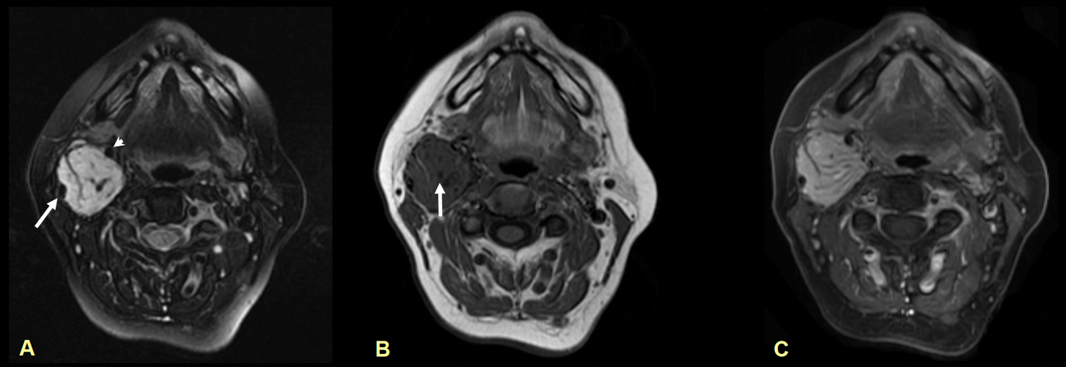
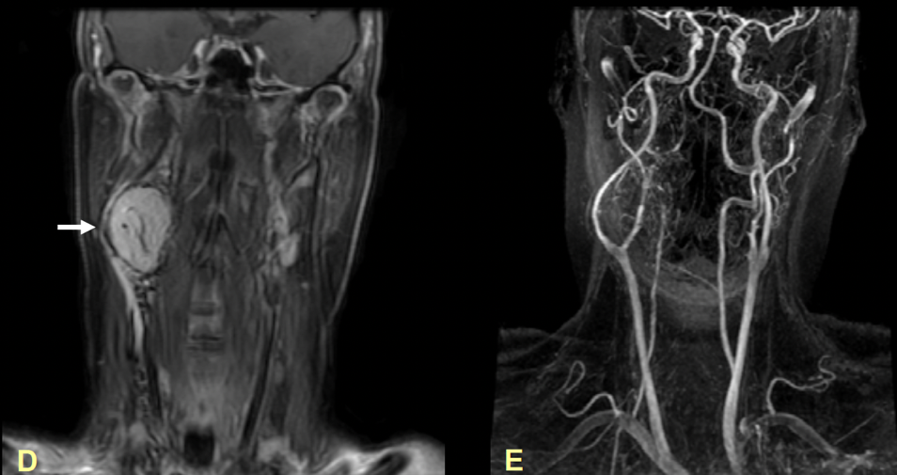

Figure 3. Carotid body paraganglioma MRI example
Case summary: 54-year-old female with a history of right neck mass.
- Axial T2WI shows hyperintense mass with flow voids situated between the ICA (arrow) and ECA (arrowhead).
- Axial T1WI shows low signal isointense mass with “pepper” (arrow) due to flow voids.
- Axial T1WI post gadolinium demonstrates avid enhancement of the right carotid body mass.
- Coronal T1WI post gad demonstrates the enhancing mass situated at the carotid bifurcation deviating the ICA posterolaterally (arrow).
- Coronal 3D time of flight SPGR demonstrates splaying of the right ICA and ECA at the bifurcation.
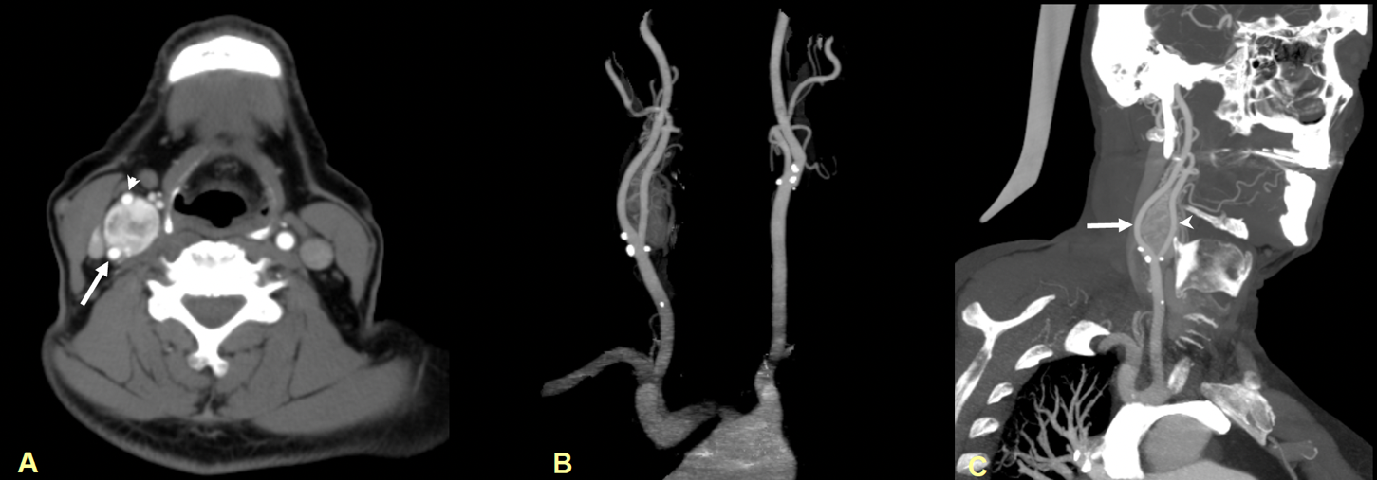
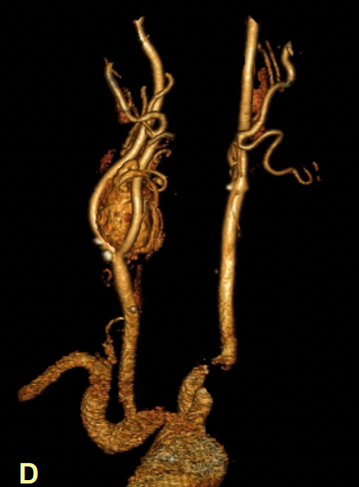

Figure 4. Carotid body paraganglioma CT and vascular reconstruction example
Case summary: 65-year-old male with clinical suspicion of right carotid stenosis.
- Axial CECT demonstrates an avidly enhancing mass situated between the ICA (arrow) and ECA (arrowhead).
- Projection image shows patency of the right ICA and ECA with the mass situated at the bifurcation.
- Coronal oblique MIP shows the mass splaying the ICA (arrow) and ECA (arrowhead).
- Volume rendering better depicts the right carotid body mass with splaying of the ICA and ECA.

Glomus Vagale

Key Points
- Rarest of the major head and neck paragangliomas, accounting for about 2.5%.
- Benign vascular tumor arising from glomus bodies associated with the nodose ganglia of the vagus nerve.
- May present as a painless, pulsatile posterolateral pharyngeal mass and can be associated with vagal neuropathy, hoarseness from vocal cord paralysis, and Horner syndrome.

Imaging Characteristics
- Avidly enhancing ovoid carotid space mass.
- Causes anteromedial displacement of the internal carotid artery and posterolateral displacement of the internal jugular vein.
- Does not widen the carotid bifurcation.
- MRI findings are otherwise similar to those of carotid body paraganglioma.
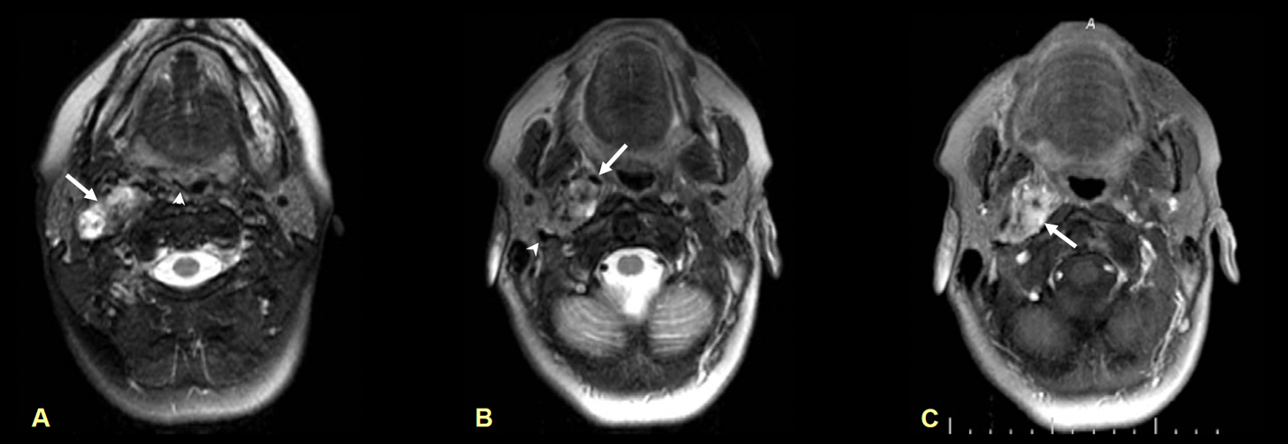
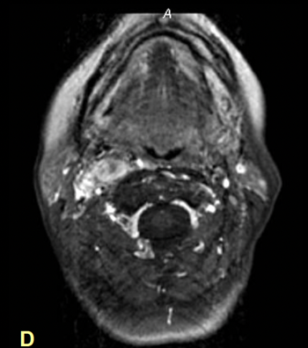

Figure 5. Glomus vagale MRI example at right skull base
Case summary: 54-year-old female with dysphasia.
- Axial T2WI demonstrates a heterogeneously hyperintense mass in the right carotid space (arrow). Also note deviation of the right pharyngeal space medially (arrowhead).
- Axial T1WI demonstrates the heterogeneous mass situated in the right carotid space at the skull base displacing the right internal carotid artery anteromedially (arrow) and the right jugular vein posterolaterally (arrowhead). The mass has a “pepper” appearance due to the flow voids.
- Axial T1WI post gadolinium demonstrates avid enhancement of the right carotid space mass (arrow).
- Axial T1WI post gadolinium at a lower level shows the enhancing mass.
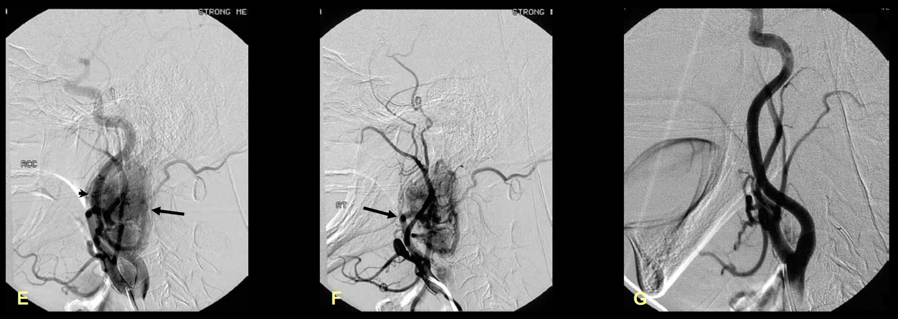
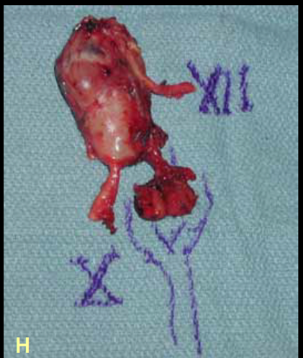

Figure 6. Glomus vagale angiography and gross specimen
Case summary: 54-year-old female with dysphasia, continued.
- Axial T2WI demonstrates a heterogeneously hyperintense mass in the right carotid space (arrow). Also note deviation of the right pharyngeal space medially (arrowhead).
- Axial T1WI demonstrates the heterogeneous mass situated in the right carotid space at the skull base displacing the right internal carotid artery anteromedially (arrow) and the right jugular vein posterolaterally (arrowhead). The mass has a “pepper” appearance due to the flow voids.
- Axial T1WI post gadolinium demonstrates avid enhancement of the right carotid space mass (arrow).
- Axial T1WI post gadolinium at a lower level shows the enhancing mass.
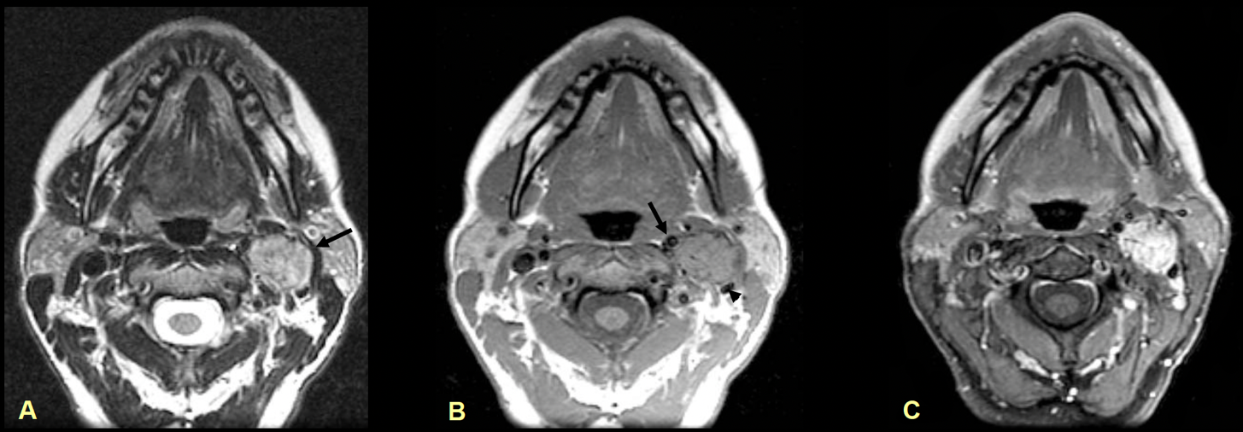
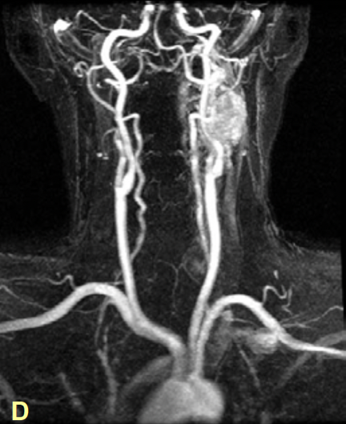

Figure 7. Glomus vagale MRI example at left skull base
Case summary: 44-year-old female with enlarging left neck mass.
- Axial T2WI demonstrates a heterogeneous mass situated in the left carotid space at the skull base (arrow).
- Axial T1WI demonstrates intermediate signal intensity of the left carotid space mass displacing the left internal carotid artery anteromedially (arrow) and the left jugular vein posterolaterally (arrowhead).
- Axial T1WI post gadolinium demonstrates avid enhancement of the left carotid space mass.
- Coronal MRA demonstrates the left carotid space mass with displacement of the left ICA medially.

Glomus Jugulotympanicum

Key Points
- Glomus jugulotympanicum describes a paraganglioma involving both the jugular foramen and the middle ear cavity.
- The jugular foramen mass extends superolaterally into the floor of the middle ear cavity.
- The direction of tumor spread is superolateral.

Imaging Characteristics
- Bone CT demonstrates a mass in the jugular foramen with permeative destructive changes along the superolateral margin of the jugular foramen.
- The mass invades the adjacent middle ear.
- MRI findings are similar to those of glomus jugulare.
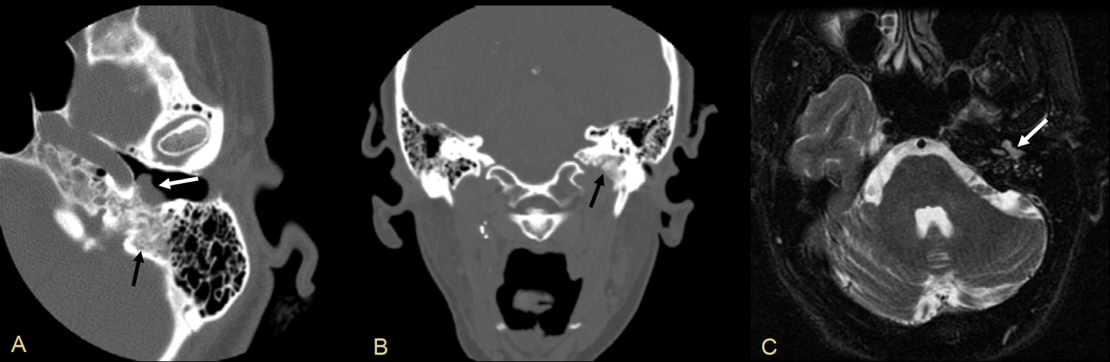

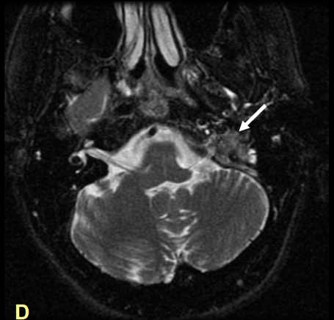

Figure 8. Glomus jugulotympanicum CT and MRI example
Alt text: Four images from a 55-year-old woman with a known right carotid space paraganglioma and a second lesion on the left. CT and MRI show a soft tissue mass in the left middle ear and jugular foramen with adjacent petrous bone erosion and superolateral extension from the jugular foramen into the middle ear.
Case summary: 55-year-old female with known right carotid space paraganglioma; second lesion.
- Thin section axial CT of the left temporal bone demonstrates a soft tissue mass (white arrow) within the middle ear cavity abutting the tympanic membrane. There are surrounding erosions of the petrous bone (black arrow).
- Coronal reformat CT shows expansion of the left jugular foramen with erosions of the petrous bone (arrow).
- Axial T2WI shows an intermediate signal mass (arrow) in the left middle ear which correlates with the findings on the axial CT.
- Axial T2WI shows a heterogeneous mass (arrow) arising from the left jugular foramen and extending superolaterally into the left middle ear.
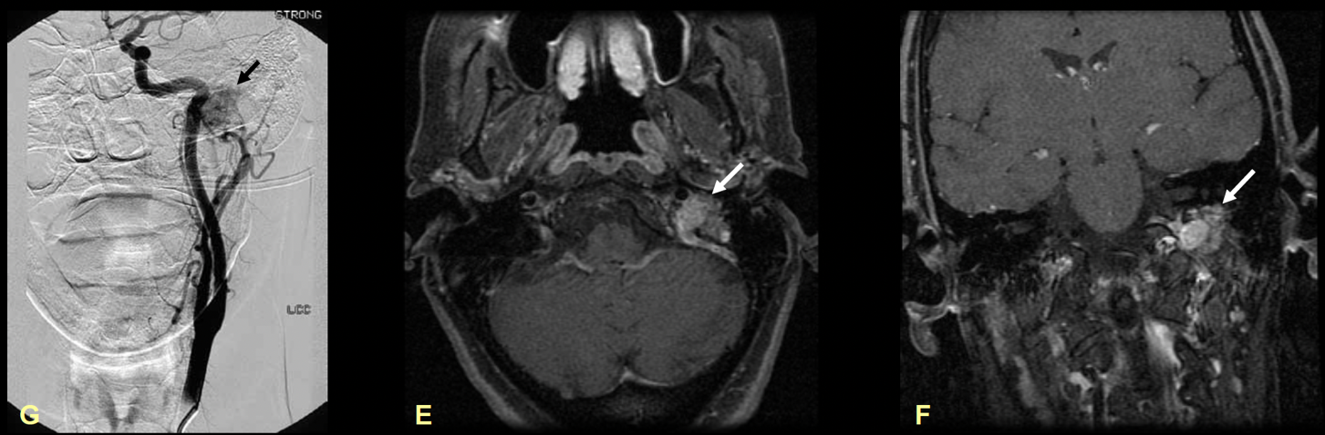

Figure 9. Glomus jugulotympanicum post-contrast MRI and angiography
Case summary: 55-year-old female with known right carotid space paraganglioma; second lesion, continued.
- Axial T1WI post gadolinium demonstrates enhancement of the left jugular foramen mass (arrow).
- Coronal T1WI post gadolinium shows the enhancing mass (arrow) within the left jugular foramen.
- Conventional angiogram of the left common carotid artery demonstrates a blush (arrow) representing the vascular glomus jugulotympanicum in the region of the left middle ear/petrous temporal bone.

Glomus Jugulare

Key Points
- Considered the second most common head and neck paraganglioma.
- Mass arises from the jugular foramen and does not involve the middle ear.
- Origin may be from the tympanic branch of the glossopharyngeal nerve, called Jacobson nerve, or the auricular branch of the vagus nerve, called Arnold nerve.
- Common presentation is a middle-aged woman, roughly 40 to 60 years old, with pulsatile tinnitus and a retrotympanic vascular mass.
- Cranial neuropathy may involve cranial nerves IX, X, and XI.

Imaging Characteristics
- Bone CT demonstrates a mass in the jugular foramen with permeative destructive adjacent bone changes.
- T1-weighted MRI lesions larger than 2 cm may demonstrate the characteristic “salt and pepper” appearance.
- T2-weighted MRI shows a mixed hyperintense mass with flow voids.
- The lesion enhances intensely.
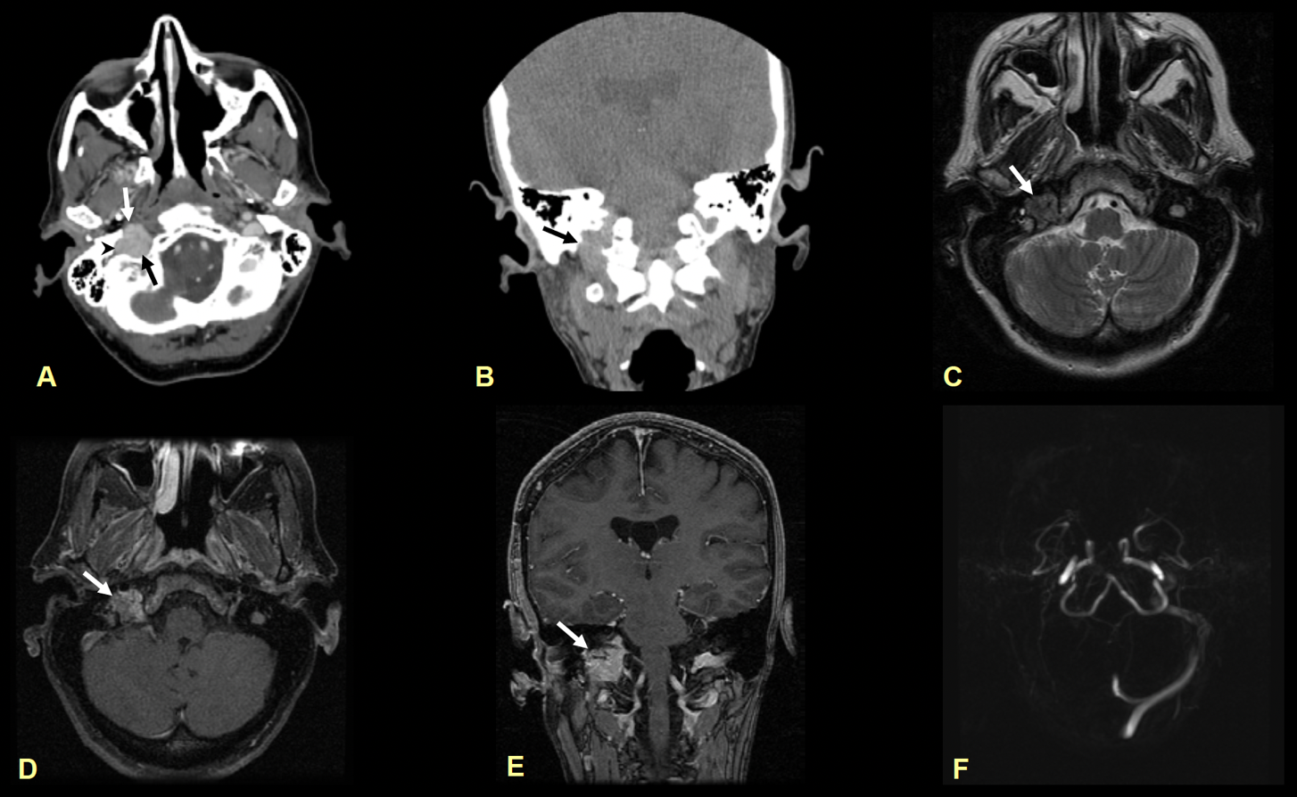

Figure 10. Glomus jugulare multimodality example
Case summary: 55-year-old woman presenting with pulsatile tinnitus in the right ear.
- Axial CECT shows enhancing mass (black arrow) within the right jugular foramen which expands and erodes the adjacent petrous bone. Adjacent right jugular vein compressed laterally (arrowhead). Right carotid artery intact (white arrow).
- Coronal reformat NECT shows the mass (arrow) expanding the right jugular foramen when compared to the left.
- Axial T2WI shows a heterogeneous isointense mass (arrow) within the right jugular foramen.
- Axial and coronal gadolinium enhanced T1WI shows the enhancing mass (arrow) in the right jugular foramen.
- 2D axial phase contrast image does not demonstrate signal in the right transverse and sigmoid sinus. This represents slow flow as contrast images demonstrate flow.

Take-Home Points
- Carotid body paraganglioma and glomus jugulare account for about 80% of head and neck paragangliomas.
- The classic MRI appearance is “salt and pepper”; salt reflects hemorrhage, which is rare, and pepper reflects flow voids.
- Paragangliomas are hypervascular masses and therefore enhance avidly.
- Carotid body masses splay the internal carotid artery posterolaterally and the external carotid artery anteromedially at the carotid bifurcation.
- Glomus vagale displaces the internal carotid artery anteromedially and the internal jugular vein posterolaterally.
- Glomus tympanicum is classically found at the cochlear promontory and arises from Jacobson nerve.
- Glomus jugulare arises from Jacobson nerve or Arnold nerve within the jugular foramen and does not involve the middle ear.

References
- Rao AB, Koeller KK, Adair CF. From the archives of the AFIP: Paragangliomas of the head and neck: radiologic-pathologic correlation. Radiographics. 1999;19:1605-1632.
- Lee KY, Oh YW, Noh HJ, et al. Extraadrenal paragangliomas of the body: imaging features. AJR. 2006;187:492-504.
- Weissman JL, Hirsch BE. Beyond the promontory: the multifocal origin of glomus tympanicum tumors. American Journal of Neuroradiology. 1998;19:119-122.
- Harnsberger R, Hudgins P, Wiggins R, et al. Diagnostic Imaging: Head and Neck. 2004. Amirsys.

Acknowledgment
The original presentation thanks Eddie Lin, MD, and Virendra Kumar, MD for providing cases, and Margaret Kowaluk, Irma Abu-Jumah, and Katie Tower for assistance with the presentation. The jugular fossa diagrams are credited to Katie Tower and Irma Abu-Jumah.

Accessibility Notes
This version has been restructured with a logical heading hierarchy for screen-reader navigation. Each figure from the original pictorial essay has been converted into descriptive alt text so the key educational content of the images is preserved in accessible form. Decorative footer material, repeated copyright notices, and slide pagination from the original file have been omitted to reduce repetition.

