Sleep, A Necessity of Life or a Waste of Time
Answer Sheet

Study Summary Table (Fill this in as your teacher asks you to)

 | Metabolism of Sugar (3A) | Memory (Synapse number and organization, 3B) | Cellular Waste Removal (3C) | Secretion of Growth Hormones (3D)
Summarize introduction
What did the study compare?
Vote! Do you think sleep affects this (Metabolism of sugar, etc)?
What was the conclusion of the study?

1.1) What do you think are the real-life benefits of not needing any sleep?

_______________________________________________________________________________

_______________________________________________________________________________

1.2) What do you think would be the disadvantages of not needing any sleep?

_______________________________________________________________________________

_______________________________________________________________________________

2.1) How many hours a night do you sleep on weeknights?

____________________________

2.2) How many hours do you sleep on weekends or vacations?

____________________________

2.3) Do you wish you could sleep more sometimes?

____________________________

2.4) Do you take naps?

____________________________

2.5) Are you a short sleeper? Why not?

_______________________________________________________________________________

_______________________________________________________________________________

3.1) Are you interested in training yourself to sleep less?

____________________________

3.4) Do you think you get “enough sleep?”

____________________________

3.5) Do you think there are any health effects to not getting “Enough sleep?”

____________________________

3.6) How much sleep do you think is “Enough sleep” for you?

____________________________

3.A.1) Name three organs that take up glucose when insulin is present in the body.

_______________________________________________________________________________

_______________________________________________________________________________

3.A.2) When a person is insulin resistant, will they have higher than normal blood sugar after eating or lower than normal blood sugar after eating?

____________________________

3A.HYPOTHESIS
What do you think the results of a glucose tolerance test would be for a volunteer who had slept for 10 hours a night (sleep normal) compared to someone who slept for 5 hours a night (sleep restricted)? Draw two graphs like the ones below that shows your hypothesis. Are they the same? Different?
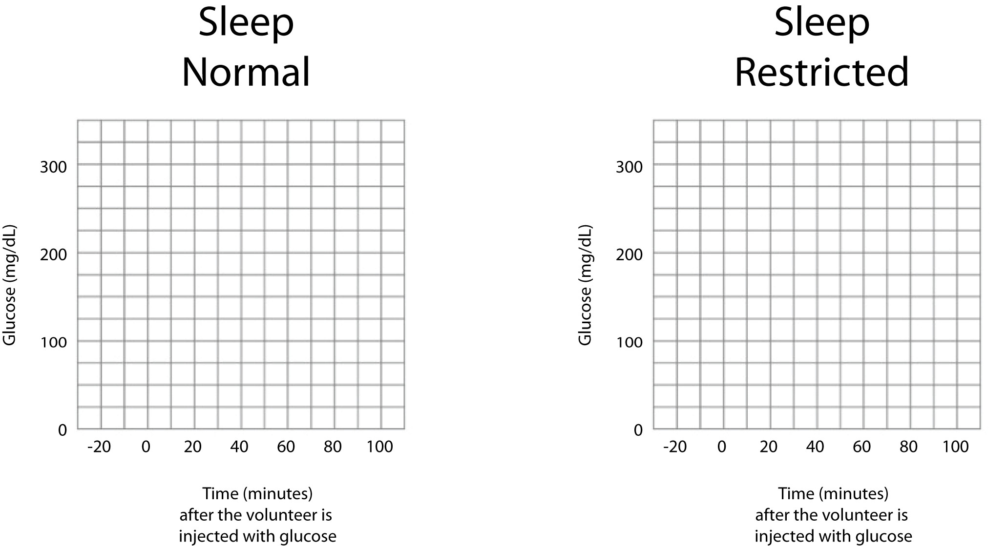

3.A.DATA TABLE

 | Normal Sleep (10 hours) | Sleep Restricted (5 hours)
10 minutes
40 minutes
100 minutes

3.A.3) Does the sleep restricted volunteer have normal, increased, or decreased sensitivity to insulin?

____________________________

3.A.4) What kind of health effects might this have on a person who is regularly getting 5 hours of sleep?

_______________________________________________________________________________

_______________________________________________________________________________

3.B.1) When you learn something, does the number of your synaptic terminals increase or decrease?

____________________________

3.B.2) What is one way your brain organizes synaptic terminals?

_______________________________________________________________________________

_______________________________________________________________________________

3B.HYPOTHESIS
Shown below is a picture of a neuron with lots of synaptic terminals, after learning has occurred. What do you think happens to this neuron when the animal who owns it goes to sleep or doesn’t sleep? Draw the two other neurons that illustrate your hypothesis: one neuron after the animal has slept. The second picture of a neuron if the animal has not slept. Will they look the same? Will one have fewer or more synaptic terminals?
After learning  9 synaptic terminals | After sleeping?  ________ synaptic terminals | After not sleeping?  ________ synaptic terminals
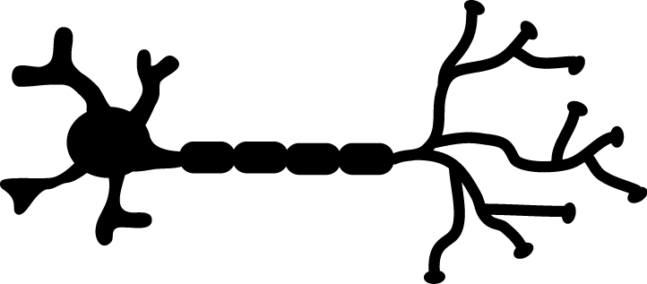 | Draw a neuron | Draw a neuron

3.B.DATA TABLE
Control 1  Fly mall | Control 2  Vial | Group 1  Fly mall, sleep | Group 2  Fly mall, awake

3.B.3) Did the flies that spent 12 hours in the fly mall have a greater number of active synaptic terminals when compared to flies that spent 12 hours in the vial?

____________________________

3.B.4) Did the flies that spent 12 hours in the fly mall and then slept (group 1) have fewer active synaptic terminals after they slept?

____________________________

3.B.5) Did the flies that spent 12 hours in the fly mall and then were kept awake (group 2) have fewer active synaptic terminals after they slept?

____________________________

3.B.6) A fly that goes from having a lot of active synaptic terminals during an interesting experience (like a fly mall) to very few active synaptic terminals has probably done a good job of remembering its experience. Is sleep important for a fly to remember an interesting experience?

_______________________________________________________________________________

_______________________________________________________________________________

3.B.7) What kind of health effects might this have on the fly?

_______________________________________________________________________________

_______________________________________________________________________________

3.C.1) Name a type of waste that is produced by normal chemical reactions in your body.

____________________________

3.C.2) Name an enzyme that your body uses to get rid of these wastes.

____________________________

3.C.HYPOTHESIS)
A mouse that is producing a lot of cellular waste should have a lot of SOD activity. Otherwise, those wastes could become toxic to cells. Do you think a mouse that was sleep deprived would produce more or less SOD than a mouse that slept normally? Why?

_______________________________________________________________________________

_______________________________________________________________________________

3.C.DATA TABLE

 | Control Mice  (Normal Sleep) | Experimental Mice  (No sleep)
SOD Activity (Number of drops of brain sample it took to make the NBT/ROS solution yellow)

3.C.3) Was there more or less SOD activity in mice that were sleep deprived? (Remember, the more sample you had to add, the LESS SOD activity there is)

____________________________

3.C.4) What kind of health effects might this have on the mouse?

_______________________________________________________________________________

_______________________________________________________________________________

3.D.1) Name two things that influence (affect) the amount of Growth Hormone (GH) secreted in a person.

_______________________________________________________________________________

_______________________________________________________________________________

3.D.2) Name one thing that GH does in the human body.

_______________________________________________________________________________

3.D.HYPOTHESIS
Rats that sleep normally show a large spurt of growth hormone (GH) released about an hour after they fall asleep. What do you think happens during the same nighttime hours for a rat that does not sleep? Would the rat have higher or lower levels of GH at the times shown? Write some possible levels of growth hormone down in the column for the “no sleep” rat that reflect your hypothesis.
 | Control (Sleep) | Experimental (No Sleep)
7:00pm | 0 ng/ml GH
9:00pm | 500 ng/ml GH
11:00pm | 0 ng/ml GH
1:00am | 0 ng/ml GH
3:00am | 0 ng/ml GH
5:00am | 0 ng/ml GH

3.D.DATA: Fill in your results for the sleep deprived rat.

 | Control (Sleep) | Experimental (No Sleep)
7:00pm | 0 ng/ml GH
9:00pm | 500 ng/ml GH
11:00pm | 0 ng/ml GH
1:00am | 0 ng/ml GH
3:00am | 0 ng/ml GH
5:00am | 0 ng/ml GH

Did your positive control work? ______________

3.D.3) Did the sleep deprived rat produce the same, more, or less growth hormone than the rat that slept normally?
____________________________

3.D.4) What kind of health effects might this have on the rat?

_______________________________________________________________________________

_______________________________________________________________________________

4.1) How might not getting enough sleep affect your metabolism of sugar?

_______________________________________________________________________________

_______________________________________________________________________________

4.2) How might not getting enough sleep affect your ability to learn new things?

_______________________________________________________________________________

_______________________________________________________________________________

4.3) How might not getting enough sleep affect the amount of toxic cellular wastes in your body?

_______________________________________________________________________________

_______________________________________________________________________________

4.4) How might not getting enough sleep affect a person’s growth?

_______________________________________________________________________________

_______________________________________________________________________________

4.5) Think out of the box: Researchers aren’t yet sure whether or not short sleepers suffer any of the health effects that people do, when they don’t get enough sleep…but if they do NOT, why do you think they don’t? What do you think makes them different?

_______________________________________________________________________________

_______________________________________________________________________________

_______________________________________________________________________________

_______________________________________________________________________________

4.6) How much sleep does the Mayo Clinic think you should have?

____________________________

4.7) What do you think is “Enough sleep?”

____________________________

Now let’s go back to some of the questions we answered before and see if your answers have changed…

4.8) Are you interested in training yourself to sleep less?

____________________________

4.9) About how much sleep do you get on weeknights?

____________________________

4.10) About how much sleep do you get on weekends and holidays?

____________________________

4.11) Do you think this is “Enough sleep?”

____________________________

4.12) Do you think there are any health effects to not getting “Enough sleep?”

____________________________

4.13) Did any of your answer change? Why?

_______________________________________________________________________________

_______________________________________________________________________________

4.14) If you feel you are not getting enough sleep, describe 2-3 things you could do to get more sleep.

_______________________________________________________________________________

_______________________________________________________________________________

_______________________________________________________________________________

_______________________________________________________________________________

