Using this Interactive Paper
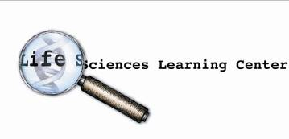

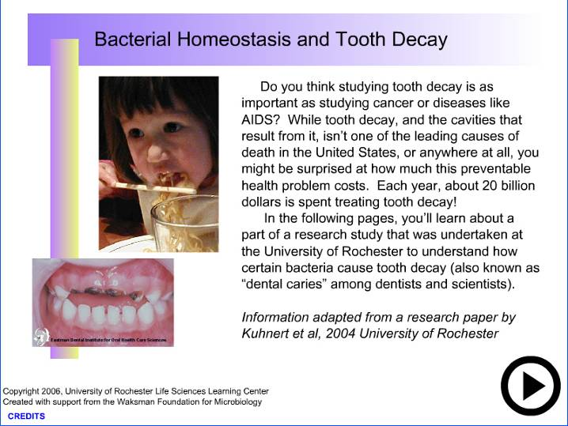
The introduction page contains a short introduction to the content of the paper. Clicking on the arrow button in the lower right hand corner leads you to the “main menu.” This page is used to navigate the entire Interactive Paper.

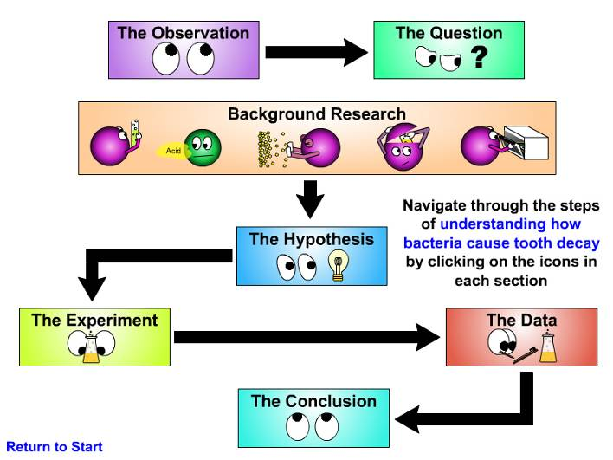
Clicking on the icons will lead you to each section. For example, students can start by learning about the observation that led to this particular inquiry by clicking on the “Observation” icon.

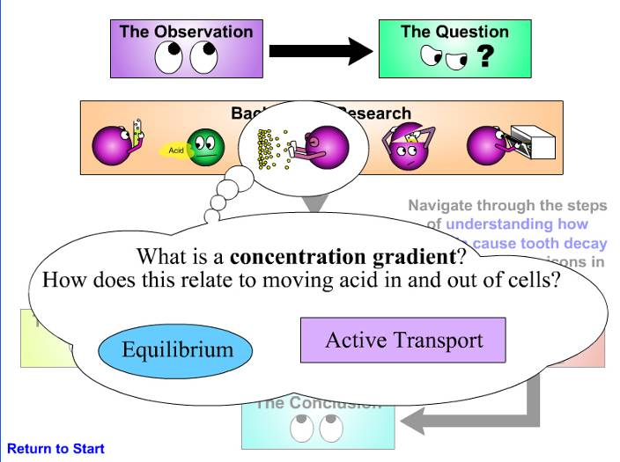
Moving the cursor over the icons in the background section will give you a better idea of what is in that particular background research section
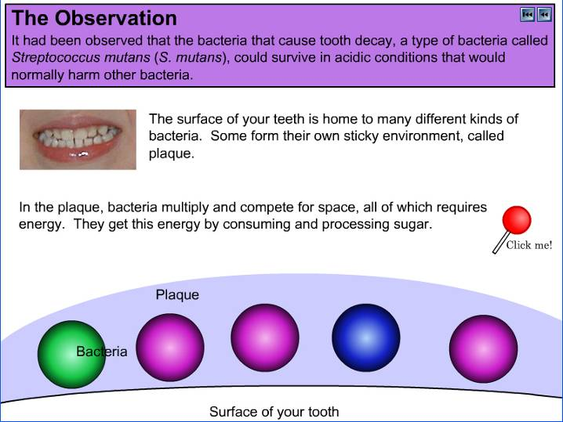
Each section has a series of animations that are activated by different icons that say “click me!”
This button returns you to the main menu
This button returns you to the previous frame in the section
This corner of the page contains a hidden “fast-forward button.” Moving your cursor over this area should result in the cursor becoming a hand icon. Clicking on this area will take you to the next step in the animation.

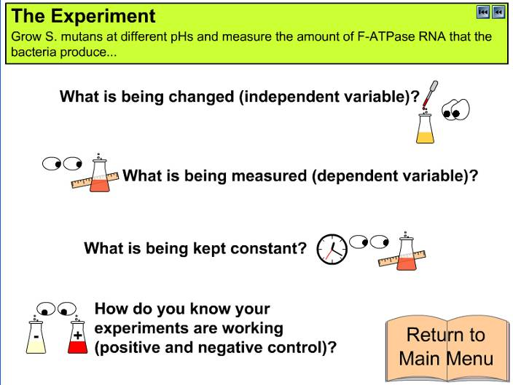
The “Experiment” section contains a sub-menu that breaks the experiment down into a description of the different variables, constants, and positive and negative controls. Clicking on the icons takes you into each sub-section.

Outline
(Text taken from each section)

In 1981 AIDS (Acquired ImmunoDeficiency Syndrome) was first documented in the United States. More than 900,000 cases of AIDS have been reported in the United States since that time. AIDS is caused by a virus, called a Human Immunodeficiency Virus (HIV). By killing or damaging cells of the body's immune system, HIV slowly destroys the body's ability to fight infections that usually do not make healthy people sick. In 1995, HIV infection was the number one cause of death in the United States. Since then, the availability of various drug treatments has reduced the number of HIV related deaths, but these treatments are extremely expensive and need to be taken on a regular basis by an HIV infected person. The following pages describe work done at the University of Rochester Medical Center to understand how HIV works and how to stop it.]


HIV is a virus that has to replicate its genetic material in a human host cell. Since its genomic material is in the form of RNA, it first has to convert its own RNA to DNA. It does this using a complicated replication process that requires a human tRNA.

- HIV, like all viruses, can not replicate on its own. It hijacks resources from host cells by slipping its genetic material into the host's own genetic material
- Since HIV's genetic material is single stranded RNA, to sneak into the host, it has to convert its RNA into double stranded DNA. To do this it requires a human tRNA
- You are about to see how HIV converts its RNA into double stranded DNA. It is amazingly complicated and may seem very inefficient. Just remember that this is how HIV has evolved to take advantage of its host, and it is troublingly (for humans) good at it...
- Human T-cells contain a tRNA (a special single stranded RNA used in the translation of RNA to proteins) that starts the replication process
- The tRNA is called tRNA-Lys (there are many different tRNA's in the cell!), and it has a region of RNA that is complementary to the HIV RNA.
- Once tRNA-Lys attaches to its complementary sequence, a polymerase called Reverse Transcriptase (brought by HIV) starts copying HIV RNA to DNA.
- The RNA degrades (breaks down), leaving a single strand of DNA with an attached tRNA
- Reverse Transcriptase can copy DNA as well as RNA, but it needs to start from a double stranded region. It can not sit down on single stranded DNA or RNA. There is a small piece of DNA called a primer that is complementary to the new DNA strand, but sits down in the middle of this DNA strand.
- Now things get interesting. As Reverse Transcriptase copies the DNA, it approaches the tRNA. It can easily copy the RNA, but this tRNA-Lys has a chemical group attached one of its nucleotides. This chemical group tells the polymerase to stop and cut the tRNA off.
- Now it may look like Reverse Transcriptase can just come in and finish copying those single stranded regions of DNA, but it can not. Reverse Transcriptase, like all polymerases, is directional. To make a simple comparison, nucleotides have a "right and left" side, and polymerases can only go from right to left. You can learn more about this in the Background Research section.
- In order to finish making this into a double stranded piece of DNA, some crazy looping has to happen. There are regions of this piece of DNA that are complementary to each other that allow this looping to happen...

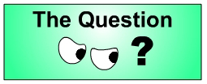
If a mutant tRNA-Lys that did not have the chemical "stop" sign were in a host cell, would HIV be able to replicate? Would putting this mutant tRNA into a cell hurt the cell?

- What would happen if you could make a tRNA that had a different nucleotide here, one that did not have the chemical stop sign?
- Do you think you could you inject this tRNA into cells and have it interfere with HIV replication? Would that harm the cell?

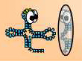 Background Research: What is a tRNA?
- tRNAs have complementary regions that enable them to fold into three dimensional shapes. This shape is very important for its function (like proteins).
- There are many different tRNAs in a human cell.
Each tRNA recognizes a different set of three RNA nucleotides and carries a different amino acid...
- tRNA's carry amino acids on one end... ...and recognize complementary mRNA sequence on the other end.
- Along with proteins called ribosomes, tRNA's are responsible for translating mRNA sequence into amino acid sequence
- tRNAs attach to the RNA if they have the proper complementary sequence.
- Ribosomes make the chain of amino acids by transferring amino acids from one tRNA to another.

 Background Research: What is this “stop sign?
- The "stop sign" is a chemical group called a "methyl group." A methyl group looks like this:
- The methyl group (which we will continue to illustrate as a stop sign) is put onto one of the "A" nucleotides by an enzyme. This enzyme only puts methyl groups on "A's." This particular "A" happens to be the 58th nucleotide of the tRNA.
- When Reverse Transcriptase sees this methyl group, it stops copying and cuts the tRNA off.

 Background Research: How do polymerases work?
- Polymerases must start from double stranded DNA; they can not sit on single stranded DNA and just start copying.
- Polymerases only go in one direction. This is because of the chemical structure of each nucleotide, which we will not discuss here.
- As a simple illustration, the polymerase has a side that has to read the strand it is copying (the "template")
- The polymerase can not copy this single stranded region. When it is properly lined up with the double stranded region it is not reading the single stranded template DNA
- Polymerases can also recognize "nicks" in the DNA. These are regions in double stranded DNA where two nucleotides are not connected by a chemical bond.
- When a polymerase sees a nick in double stranded DNA, it moves aside one of the double strands and copies a new strand.

 Background Research: What is a virus?
- Viruses are essentially bags of genetic material. This genetic material can be DNA or RNA.
- In order to replicate their genetic material, viruses slip their genetic material into the host and utilize the host's resources (nucleotides, polymerases, amino acids...)
- Once inside the host, the viral genetic material can be transcribed and translated, producing the proteins that the virus needs to re-create itself in a form that allows it to infect other cells
- At this point, the virus can break out of the host cell. This damages, and more likely destroys, the host cell

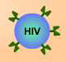 Background Research: How does HIV cause disease?
- HIV infects cells of the immune system. One of these types of cells is called Helper T-Cells. One of the jobs of a Helper T-Cell is to increase the immune response by signaling to other immune cells.
In this example, invading bacteria are recognized by an immune cell called a macrophage...
- Once a bacterium is eaten by a macrophage, the bacterium is broken down into pieces. These pieces are displayed on the surface of the macrophage.
- Helper T-Cells recognize these pieces, which leads to the "activation" of the Helper T-Cell
- If an activated Helper T-Cell sees a B-cell that has recognized and engulfed the same kind of bacteria, it will send signals to that B-Cell that tell it to multiply.
- B-Cells can divide into more B-Cells and Plasma Cells. Plasma Cells make free-floating antibodies, which can attach to bacteria and prevent the bacteria from multiplying.
An increased number of B-Cells and antibodies in the body can effectively stop a bacterial infection
- HIV interferes with the immune system by infecting and damaging Helper T-Cells.
HIV can recognize a protein on the surface of the Helper T-Cell, and uses this protein to insert its genetic material into the Helper T-Cell
- Without Helper T-Cells, the immune response to an infection is much weaker than in an uninfected person. Bacteria or viruses that normally only cause a week's worth of uncomfortable symptoms can be fatal for a person infected with HIV.

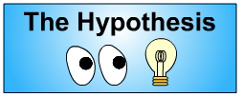
Adding a mutant tRNA that does not have the chemical "stop sign” will prevent the "looping” required to complete the double stranded DNA version of the HIV genetic material. This will prevent HIV from replicating and infecting more cells. This mutant tRNA should only affect HIV replication, not normal translation.

- If we go back to what we know about how HIV converts single stranded RNA to double stranded DNA, we could see that the chemical stop sign results in Reverse Transcriptase stopping and cutting the tRNA off. This is important, because it leaves two complementary ends that attach to each other to complete the replication process
- These two complementary regions attach to each other, forming a loop. Then Reverse Transcriptase is able make a complete double stranded DNA version of the HIV genetic material, which gets put into the genetic material of the host cell. What would happen if the tRNA never got cut off?
- Without the stop sign, scientists at the University of Rochester hypothesized that Reverse Transcriptase would continue to replicate the tRNA...... and there would not be any complementary ends to attach to each other. Therefore, HIV could not completely convert its single stranded RNA into double stranded DNA
- Scientists believed that if they changed the 58th "A" into a "U" nucleotide, then the enzyme that put the chemical stop sign on would not do so.
- Because changing the A to a U should not affect the normal function of tRNA in translation, scientists hypothesized that if this mutant tRNA is added to a cell, it would not affect the normal process of translation, but would stop HIV RNA from becoming double stranded DNA

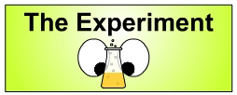

Independent Variable:
- To determine if having a mutant tRNA can affect HIV replication, it is necessary to compare cells with the mutant tRNA and cells without the mutant tRNA
- Instead of injecting tRNA into cells, scientists put in a gene that codes for mutant tRNA (tRNA-58U). Once the gene is in the cell, it will be transcribed into the tRNA. They put the gene in by giving the cells an electric shock.
- The electric shock makes the cell membranes weak, and the plasmids can slip inside. Afterwards, the cell membranes heal, and the plasmid is trapped inside.
- As with all procedures, this does not work 100% of the time. As shown here, some of the cells have the plasmid now, and others do not. To get rid of the ones that do not, the cells are treated with neomycin.
- If you compare the ability of HIV to replicate in cells with and without tRNA-58U, you can determine if tRNA-58U can stop HIV replication

Dependent Variable:
- To test this hypothesis, it is necessary to measure how many cells are infected with HIV. If HIV is unable to replicate, there should be fewer infected cells.
- If you want to measure the number of infected T-Cells, you have to be able to tell the difference between infected and uninfected cells.
- To do this, scientists use a special strain of HIV that was created in the laboratory called HIV-Thy1. HIV-Thy1's genetic material contains a gene for a protein called Thy-1
- If HIV-Thy1 is able to successfully infect the cell, the Thy-1 gene will be inside the host cell genetic material. The host cell will transcribe and translate Thy-1, which is a protein that gets placed into the cell membrane.
- Scientists use a technology called Flow Cytometry to count cells that have the Thy-1 protein on their membranes (and therefore have been infected with HIV).
- Flow cytometry can not actually see the Thy-1 proteins, the first thing scientists have to do is add a fluorescent antibody that attaches to Thy-1
- A flow cytometer machine detects cells using a laser. When cells with no antibodies pass through the laser, they break up the laser light in a certain pattern that the detector recognizes as an “unmarked” cell. A computer that is attached to the Flow Cytometer counts that cell as “No Thy-1.”
- When a cell that has antibodies on it passes through the laser, the fluorescent antibody creates another signal, which the detector recognizes as a “marked” cell. The computer then counts this cell as “Thy-1 positive”
- Using the flow cytometer and HIV-Thy1, scientists can get an idea of how many cells are capable of being infected with HIV
- The more cells that are infected, the more likely it is that HIV is replicating.

Constant:
- To compare the ability of HIV to infect T-cells with and without tRNA-58U, it is important to compare the same number of T-cells and infect them with the same number of viruses.

Positive and Negative Control
- Positive and negative controls help you to interpret your results correctly. Sometimes you may come to an incorrect conclusion because your experiment didn't work and you didn't know it!
- Positive Control
This should be something that you KNOW should work. In this case, infecting T-Cells with HIV
- Positive Control: Normal T-cells infected with HIV-Thy1 should have the Thy-1 protein on their cell membranes. If you infected normal T-Cells with HIV and did NOT see Thy-1 on their cell membranes, you would know that something went wrong; perhaps your HIV was all destroyed.
- Negative Control
This should be something that you KNOW should not work. In this case, using a type of cell that HIV can NOT infect.

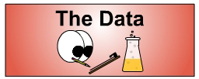
- All T-Cells were grown and infected with a concentration of HIV-Thy1 equal to 1 HIV per 100 T-Cells. Normal T-Cells were infected five separate times. Three groups of T-Cells with tRNA-58U were infected with HIV. (Each group of cells was grown from a single cell that had been electroporated with the tRNA-58U plasmid.) Each group was infected three separate times. On various days after infection, cells were analyzed for the presence of the Thy-1 protein on their cell surfaces using flow cytometry.

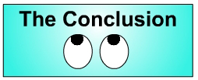
- When normal cells are infected with HIV, the number of infected cells increases steadily. However, in all groups of cells that contain tRNA-58U, there is almost no increase in the number of infected cells. This suggests that tRNA-58U is preventing HIV from replicating and infecting more cells. However, the hypothesis was that tRNA-58U could prevent HIV from replicating without affecting normal translation. We still do not know if this is the case. It is possible that tRNA-58U is making the cells weak because they can not translate proteins properly. Perhaps this is why HIV can not infect the cells.
- One of the goals of research such as this is to develop methods of preventing disease. If HIV was unable to replicate in the human body and infect and kill T-Cells, people who were exposed to HIV would not develop the symptoms of AIDS. It is possible that the plasmid containing tRNA-58U could be inserted into human T-cells (using Gene Therapy), thus preventing HIV from replicating in humans. HOWEVER, it is important to first determine without a doubt that tRNA-58U has no effect on normal cell function.

