Handout #1: Canada Map Assignment

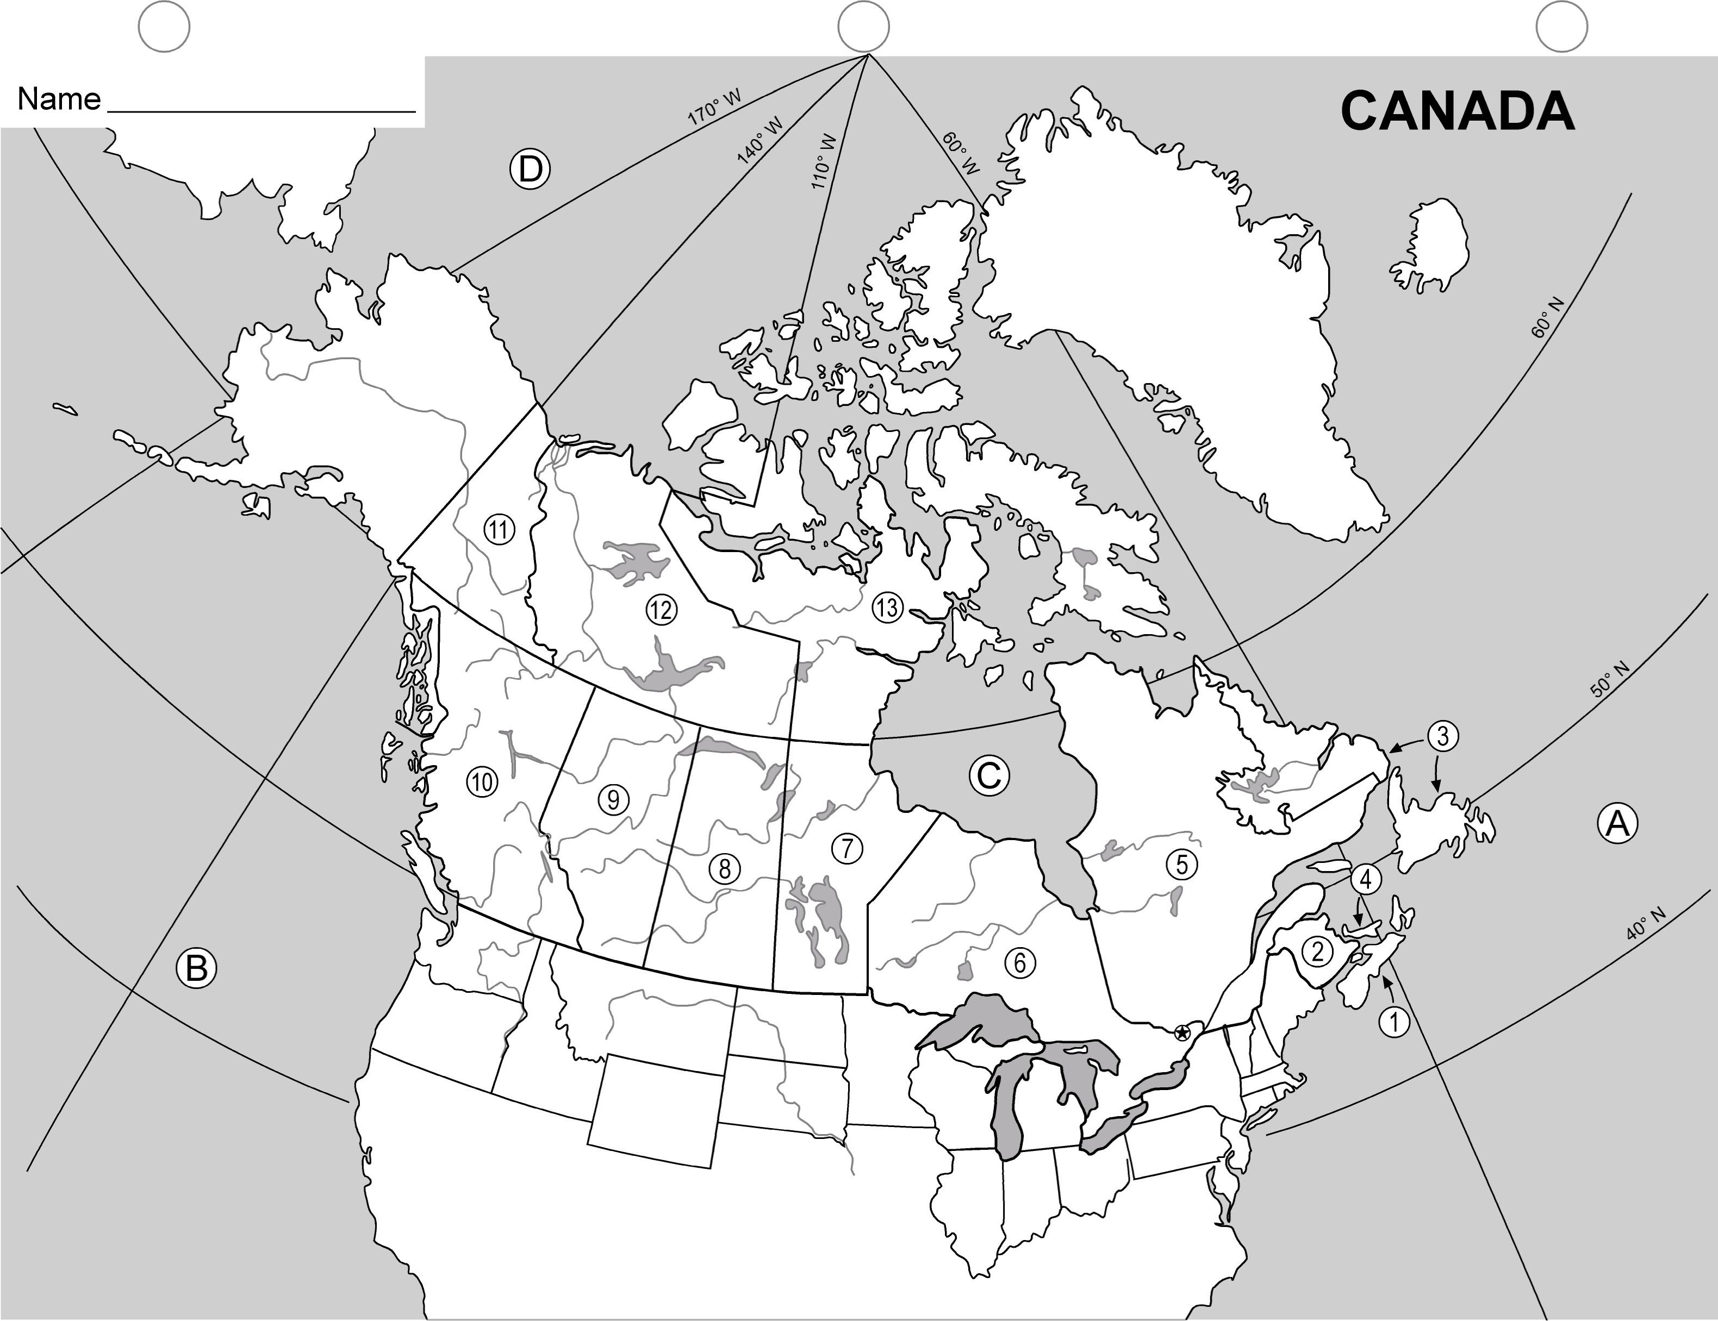

Handout #1: Canada Map Assignment (page 2)

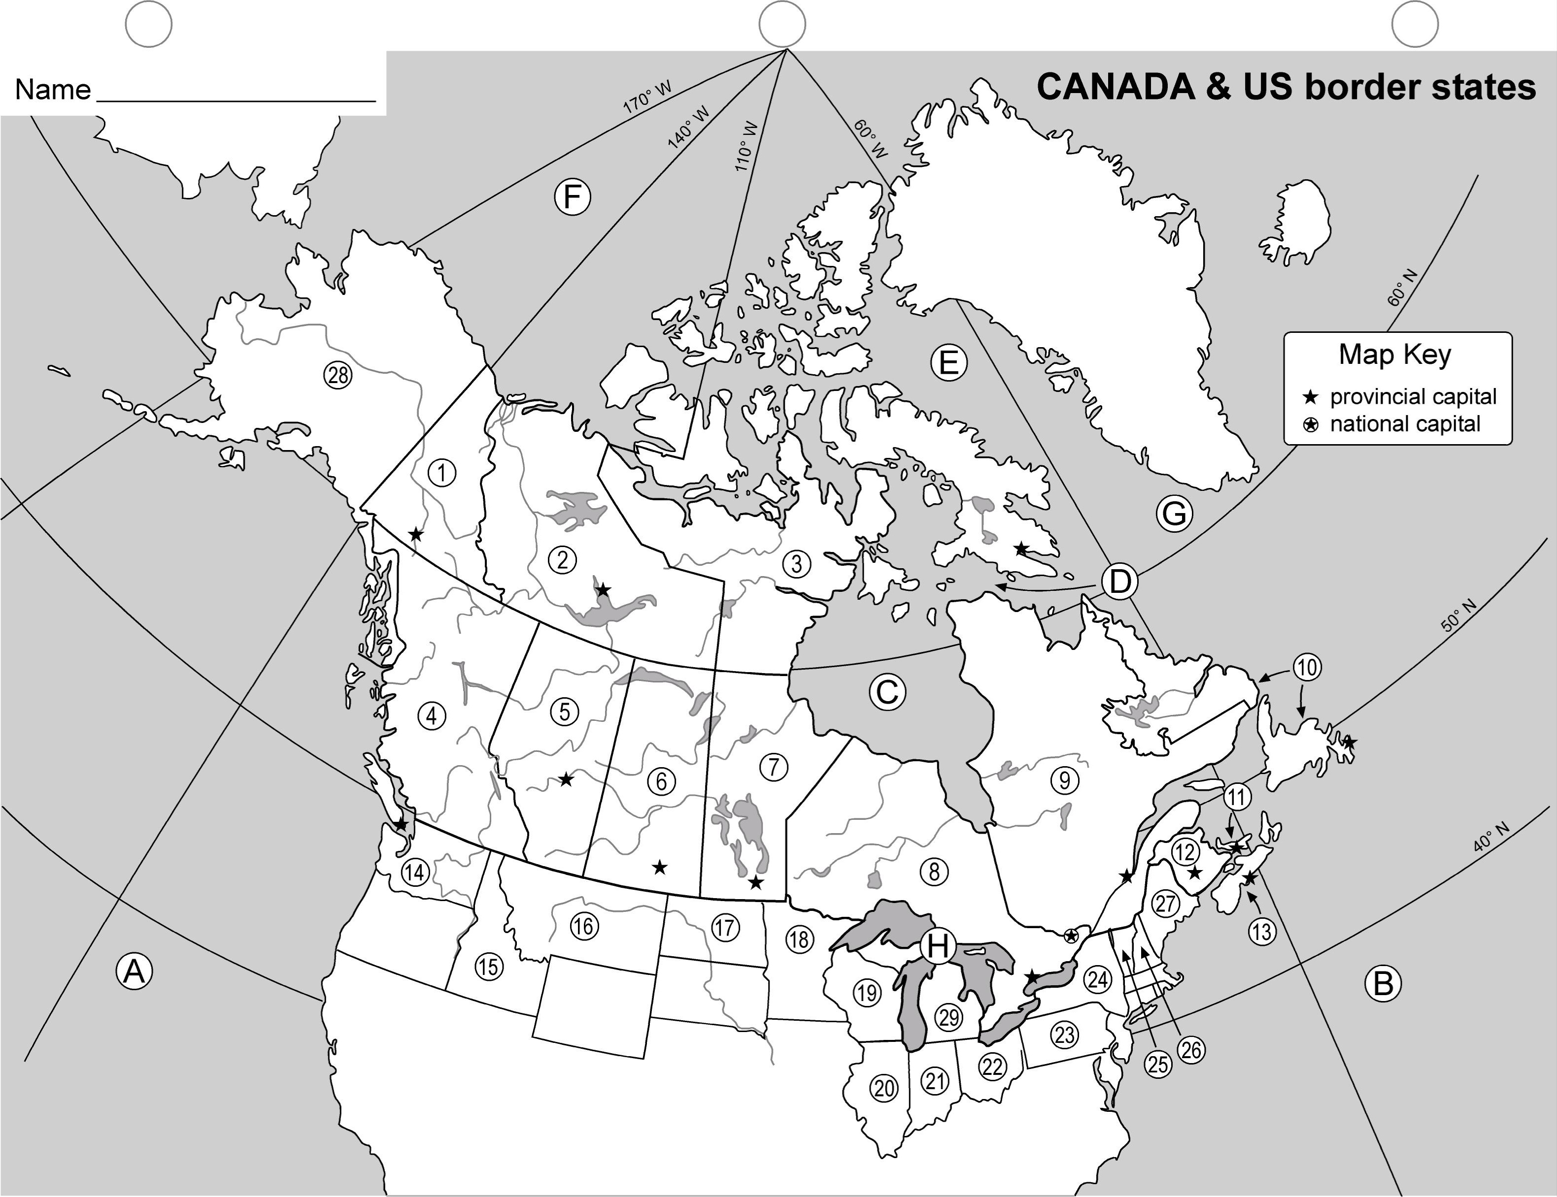

Handout #2: Canada Geo Game

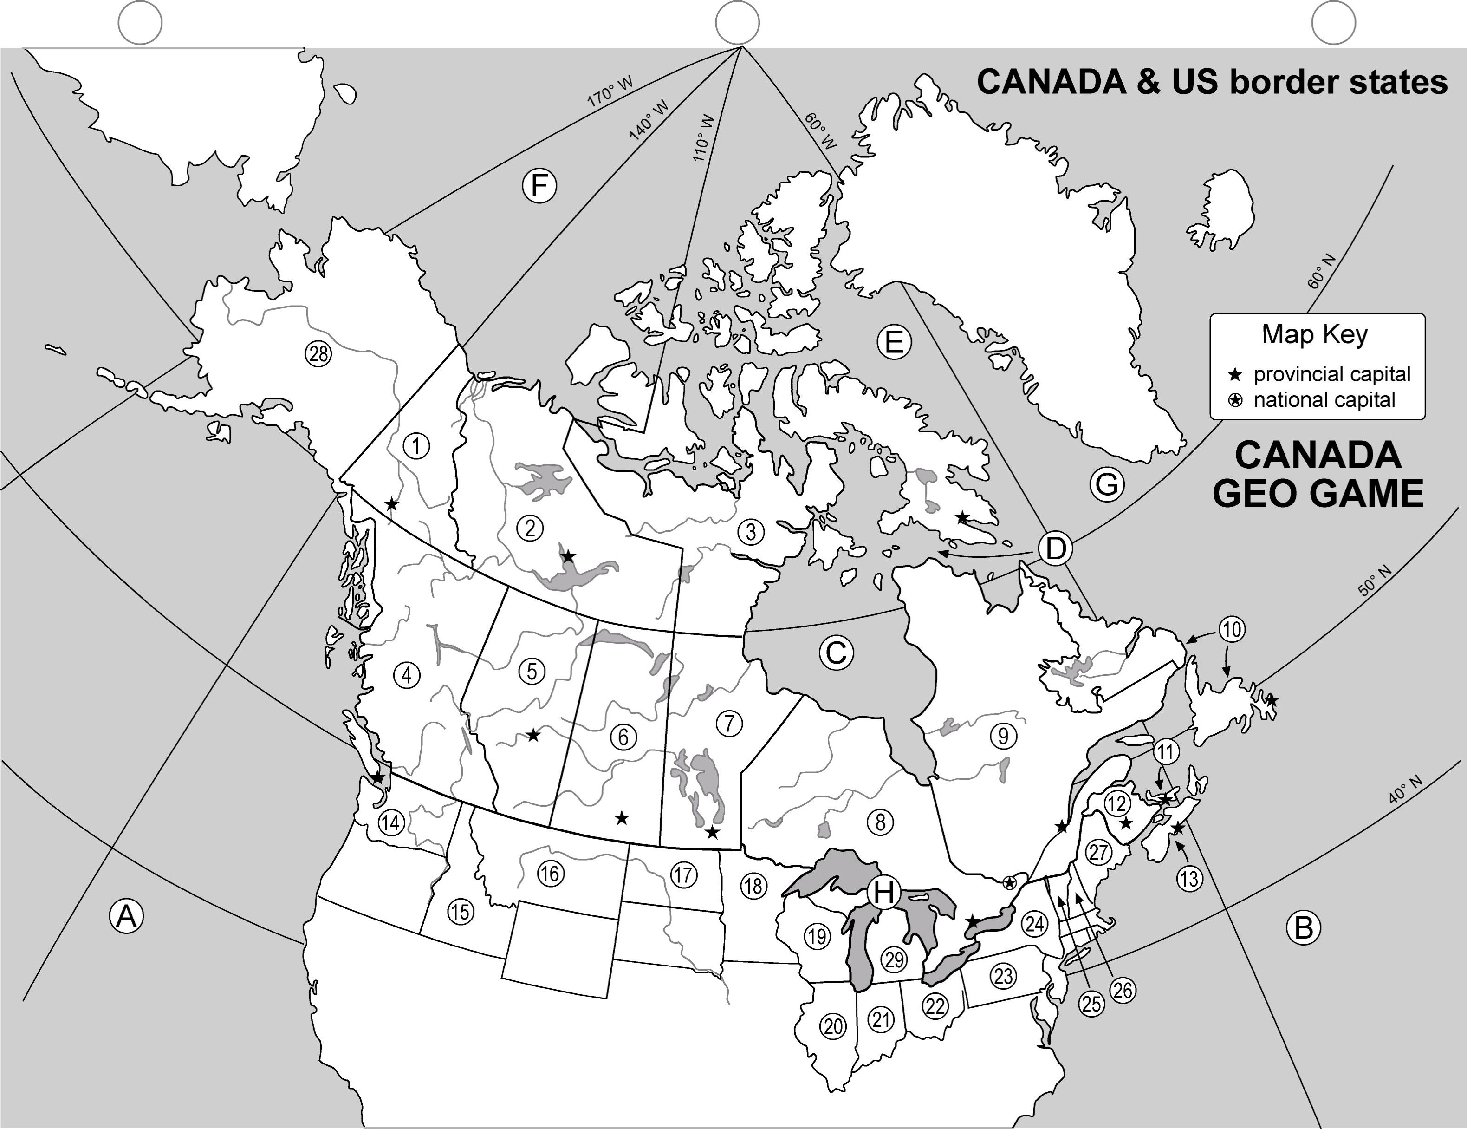

Handout #2: Canada Geo Game (Answer Key)

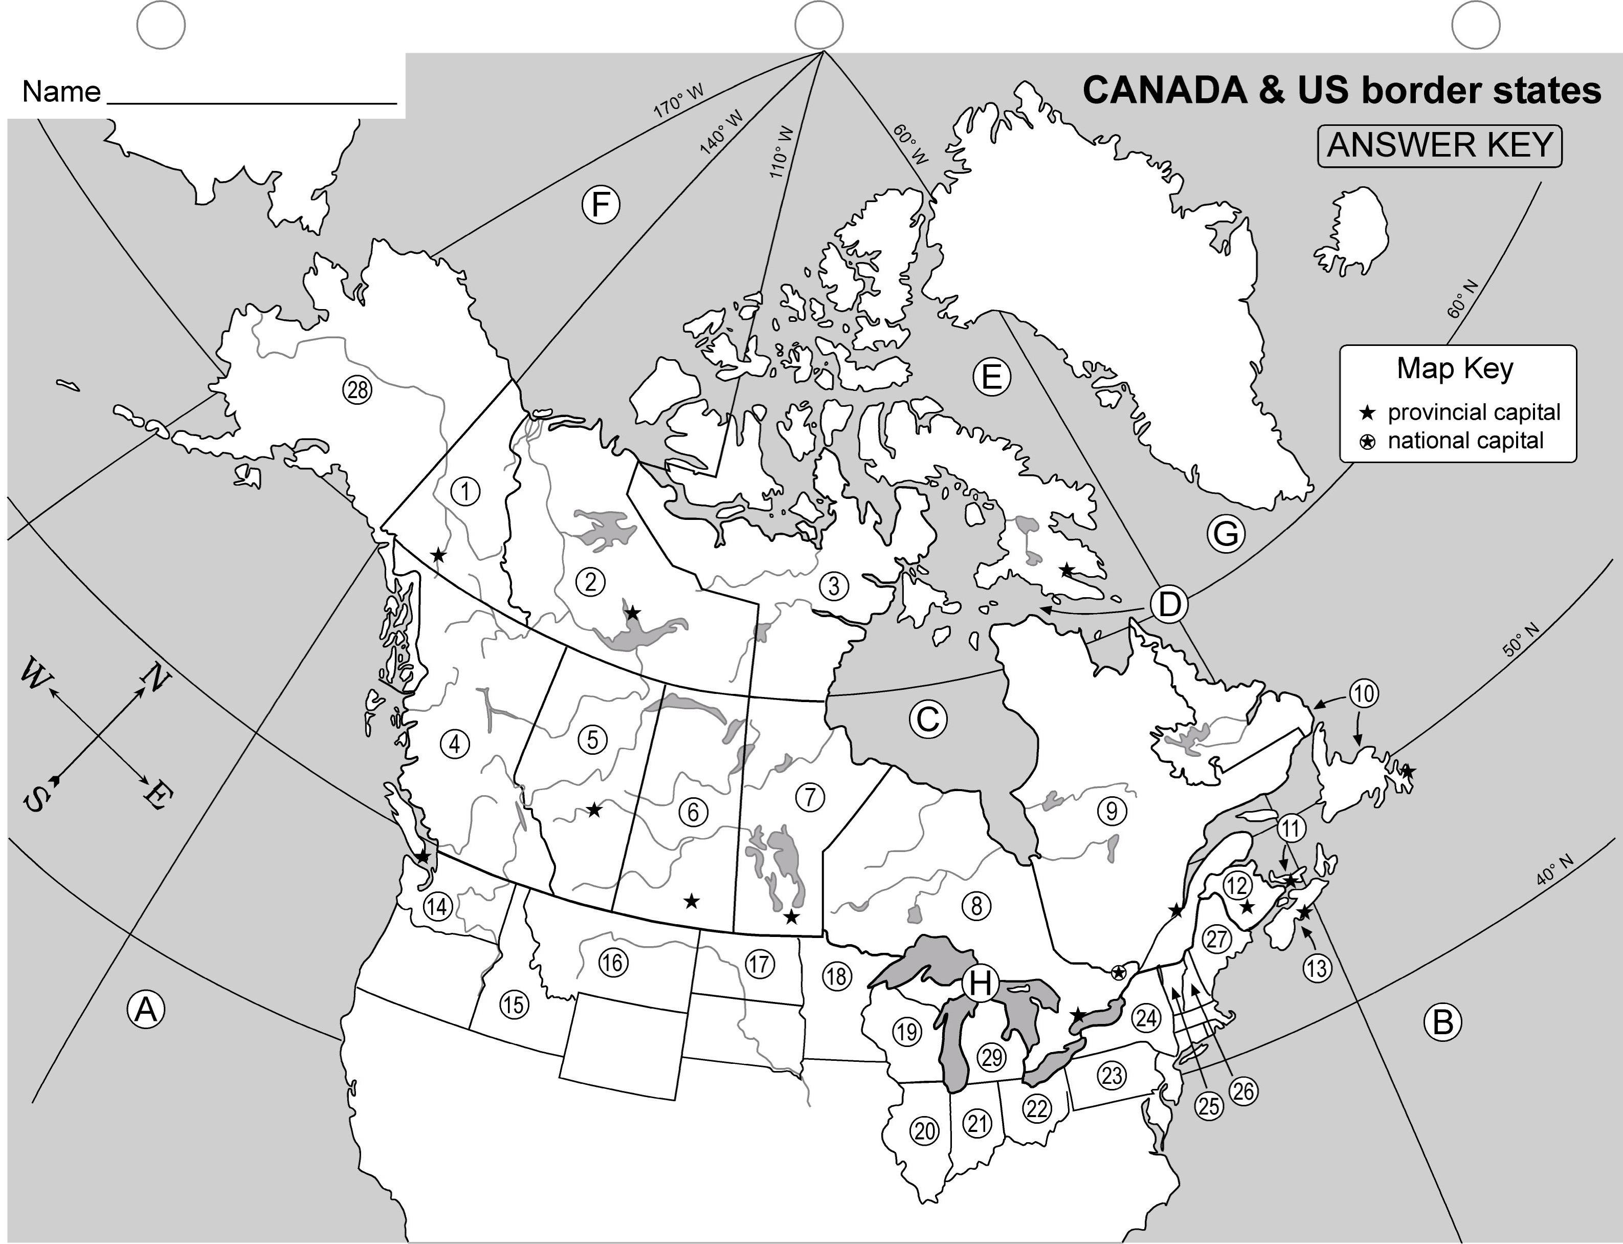

Handout #2: Canada Geo Game (page 2)

Group Name: ________________________________

1. Match the numbers in the first column below with the numbers on the map. Fill in the blanks with the appropriate names of Canada’s provinces and territories. Fill in the second column with the capital that corresponds to the province or territory. Sorry, no word bank for this activity.

 | Provinces & Territories of Canada |  | Capitals
1) |  | 1)
2) |  | 2)
3) |  | 3)
4) |  | 4)
5) |  | 5)
6) |  | 6)
7) |  | 7)
8) |  | 8)
9) |  | 9)
10) |  | 10)
11) |  | 11)
12) |  | 12)
13) |  | 13)

2. The capital of Canada is indicated on the map by a star surrounded by a circle. What is the capital of Canada?

In what province is the capital of Canada ?

3. Match the numbers in the column below with the numbers on the attached map and fill in the blanks with the appropriate names of the U.S. states nearest to Canada.. Sorry, no word bank for this activity.

U.S. States nearest to Canada:

14) |  | 22)
15) |  | 23)
16) |  | 24)
17) |  | 25)
18) |  | 26)
19) |  | 27)
20) |  | 28)
21) |  | 29)

4. Match the letters below with the letters on the attached map and fill in the blanks with the appropriate names. Sorry, no word bank for this activity.

Major water bodies bordering Canada:

A) |  | E)
B) |  | F)
C) |  | G)
D) |  | H)

Handout #2: Canada Geo Game (ANSWER KEY)

Group Name: ________________________________

1. Match the numbers in the first column below with the numbers on the map. Fill in the blanks with the appropriate names of Canada’s provinces and territories. Fill in the second column with the capital that corresponds to the province or territory. Sorry, no word bank for this activity.

 | Provinces & Territories of Canada |  | Capitals
1) | Yukon | 1) | Whitehorse
2) | Northwest Territories | 2) | Yellow Knife
3) | Nunavut | 3) | Iqualuit
4) | British Columbia | 4) | Victoria
5) | Alberta | 5) | Edmonton
6) | Saskatchewan | 6) | Regina
7) | Manitoba | 7) | Winnipeg
8) | Ontario | 8) | Toronto
9) | Quebec | 9) | Quebec City
10) | Newfoundland | 10) | St. Johns
11) | Prince Edward Island | 11) | Charlottetown
12) | New Brunswick | 12) | Fredericton
13) | Nova Scotia | 13) | Halifax

2. The capital of Canada is indicated on the map by a star surrounded by a circle. What is the capital of Canada? Ottawa

In what province is the capital of Canada ? Ontario

3. Match the numbers in the column below with the numbers on the attached map and fill in the blanks with the appropriate names of the U.S. states nearest to Canada.. Sorry, no word bank for this activity.

U.S. States nearest to Canada:

14) | Washington | 22) | Ohio
15) | Idaho | 23) | Pennsylvania
16) | Montana | 24) | New York
17) | North Dakota | 25) | Vermont
18) | Minnesota | 26) | New Hampshire
19) | Wisconsin | 27) | Maine
20) | Illinois | 28) | Alaska
21) | Indiana | 29) | Michigan

4. Match the letters below with the letters on the attached map and fill in the blanks with the appropriate names. Sorry, no word bank for this activity.

Major water bodies bordering Canada:

A) | Pacific Ocean | E) | Baffin Bay
B) | Atlantic Ocean | F) | Arctic Ocean
C) | Hudson Bay | G) | Labrador Sea
D) | Hudson Strait | H) | Great Lakes

Handout #3: Killing the Killer Rain

All of the students in Ms. Borden’s 7th grade history class had stories about surviving the Great Power Blackout during the Summer of 2003. Steve Buker’s family played Monopoly by candlelight. Joanne Green got stuck at the top of a Ferris wheel. Alex Farina’s parents, who own a restaurant downtown, cooked a barbeque for the whole block so they wouldn’t have to trash refrigerated food. And Colby Stone was up in Toronto waiting to see The Lion King. The show never happened, but her family was entertained by U.S. and Canadian politicians blaming each other in the press for the power breakdown.

“My mom says we better get used to walking around in the dark, because this won’t be the last big blackout,” said Melissa Harris. “She says the electric grid is a mess.”

“Can somebody please explain to me what an electric grid is?” asked Barry Brown. “Sounds like something you fry pancakes on.”

“Good point, Barry,” said Ms. Borden. “The electric grid is the system of power lines, transformers, and switching stations that move electricity from power plants to places around the country. I’ve read that the grid wasn’t designed to handle all the electricity people need today. Some people say it needs to be completely “rewired” with new technology. Others say we need new power plants to go along with a new electric grid.”

“I don’t think my uncle would like that idea,” said Mike Morgan.

“Why not, Mike?” asked Ms. Borden.

“Well, he’s a guide up in the Adirondack state park, and he’s in this group that’s always protesting stuff like power plants and acid rain and how the fish are dying.”

“Who would build a power plant in a park?” said Joan. “You can’t do that.”

“No, no. The power plants aren’t in the park,” said Mike. “Most are really far away. And they cause acid rain that kills fish and trees and stuff all the way in the Adirondack Mountains. I’ve seen it. My uncle showed us these crystal clear lakes out in the middle of nowhere without a speck of life in them, not even a pollywog.”

“I’ve seen lakes like that, too, when I went fishing with my Dad in Canada,” said Jerry Burns. “He blamed that on acid rain, too, and he said most of it was coming from the United States.”

“Hold it,” said Brian. “My grandpa works for a big power company in Ohio, and when he visited this summer, he got really mad about an article in the newspaper. It said New York was suing power plants that burn coal in Ohio and other states because of acid rain. I can still hear him yelling: ‘A lot of those lakes were dead before there ever were power plants! Mother nature kills its own lakes all the time! With pine needles!’”

“I don’t get why acid rain is such a big deal,” said Jessica. “So you can’t fish in a few lakes. Go fish somewhere else, then. It seems like only a few places are really affected.”

“I’ve got a question,” said Barry Bright. “If acid rain is doing all that damage to fish and frogs, what’s it doing to people? I mean, what if we get caught in a rainstorm, and it’s all acid rain. Maybe we should be shutting down those power plants.”

Brian stood up. “My grandfather says if you start shutting down coal-burning power plants like his, a lot of people would be out of work, and not just the plant workers. He says using coal here helps our country, too, because it means we don’t have to buy so much oil and gas from other countries to keep us powered up. And coal-burning plants make electricity cheaper for everyone.”

“Can’t somebody figure out how to make the coal burn cleaner?” asked Larry Lunn. Larry is always playing with the latest electronic gadget.

“These are all good points and interesting questions,” said Ms. Borden, “and both the U.S. and Canadian governments have been dealing with them. “In fact, some people seem to favor plans to increase the use of coal. Others say that’s a bad idea.”

Ms. Borden got a certain look in her eye. “Sounds to me as if we need to find out what’s really going on with these power plants and the acid rain situation,” she said. “Maybe with a bit more information, and some good logical thinking, we could come up with some recommendations for the U.S. and Canada about how to deal with all this.”

You should know that Ms. Borden is really big on two things: One is getting the facts straight about whatever issue she’s investigating. The other is sending letters to government officials about what’s on her mind. “You can’t change anything if you don’t do anything,” is one of her favorite lines. “And there sure are enough things that could use a bit of changing.”

Handout #4: Canada Map Quiz

Name:

1. Match the numbers in the first column below with the numbers on the Canada map. Fill in the blanks with the appropriate names of Canada’s provinces and territories. Fill in the second column with the capital that corresponds to the province or territory. Word banks below. (26 pts)
 | Provinces & Territories of Canada |  | Capitals
1) |  | 1)
2) |  | 2)
3) |  | 3)
4) |  | 4)
5) |  | 5)
6) |  | 6)
7) |  | 7)
8) |  | 8)
9) |  | 9)
10) |  | 10)
11) |  | 11)
12) |  | 12)
13) |  | 13)

2. Place a “T” in front of the numbers above that name territories (rather than provinces). (3 pts)

Provinces and Territories (word bank):
British Columbia New Brunswick Nova Scotia Manitoba Nunavut
Alberta Saskatchewan Quebec Prince Edward Island
Ontario Newfoundland Yukon Northwest Territories

Capitals (word bank):
St. John’s Winnipeg Quebec City Iqualuit Victoria
Yellowknife Fredericton Halifax Toronto
Whitehorse Charlottetown Regina Edmonton

3. Use colored pencils to LIGHTLY color the provinces and territories on the attached map. As with all political maps, each province or territory should be a different color. (5 pts)

4. The capital of Canada is indicated on the map by a star surrounded by a circle. What is the capital of Canada? _________________

In what province is the capital of Canada ? ________ (2 pts)

5. Match the numbers in the column on the next page with the numbers on the attached map. Fill in the blanks with the correct names of the U.S. states nearest to Canada. See word bank. (16 pts)

U.S. - Canada Border States:

14) |  | 22)
15) |  | 23)
16) |  | 24)
17) |  | 25)
18) |  | 26)
19) |  | 27)
20) |  | 28)
21) |  | 29)

U.S. - Canada Border States (word bank) :

Wisconsin New York Washington New Hampshire
Pennsylvania Michigan Vermont Illinois
Montana Maine Indiana Minnesota
Alaska North Dakota Ohio Idaho

6. Name the eight states that share ONLY land borders with Canada. (8 pts)

1)
2)
3)
4)
5)
6)
7)
8)

7. Name the four Great Lakes states that share ONLY a water border with Canada. (4 pts)

1)
2)
3)
4)

8. Name the two Great Lakes states that share land AND water borders with Canada. (2 pts)

1)
2)

9. Name the two Great Lakes states that share neither a land border nor a water border with Canada. (These two states border the only Great Lake that is completely within the U.S.)
(2 pts)

1)
2)

10. Use ONE colored pencil to LIGHTLY color all parts of the U.S. The U.S. should be only one color, since the focus of this political map is Canada. (3 pts)

11. Match the letters below with the letters on the attached map and fill in the blanks with the appropriate names. See the word banks below. (8 pts)

Major water bodies bordering Canada:

A)
B)
C)
D)
E)
F)
G)
H)

Major water bodies (word bank):

Baffin Bay Great Lakes Arctic Ocean Hudson Bay Atlantic Ocean Pacific Ocean Labrador Sea Hudson Strait

12. Draw a compass rose, pointing North, in the Pacific Ocean. (1 pt)

13. In the “Map Key” box on the map, show that a plain “star” indicates a provincial or territorial capital. Also show that a star with a circle around it indicates a national capital. (2 pts)

14. Be sure to print your name in spaces provided on your map and this answer sheet. (2 pts)
Handout #4: Canada Map Quiz Answer Key (total points = 84)

Name:

1. Match the numbers in the first column below with the numbers on the Canada map. Fill in the blanks with the appropriate names of Canada’s provinces and territories. Fill in the second column with the capital that corresponds to the province or territory. Word banks below. (26 pts)
 | Provinces & Territories of Canada |  | Capitals
T 1) | Yukon | 1) | Whitehorse
T 2) | Northwest Territories | 2) | Yellow Knife
T 3) | Nunavut | 3) | Iqualuit
4) | British Columbia | 4) | Victoria
5) | Alberta | 5) | Edmonton
6) | Saskatchewan | 6) | Regina
7) | Manitoba | 7) | Winnipeg
8) | Ontario | 8) | Toronto
9) | Quebec | 9) | Quebec City
10) | Newfoundland | 10) | St. Johns
11) | Prince Edward Island | 11) | Charlottetown
12) | New Brunswick | 12) | Fredericton
13) | Nova Scotia | 13) | Halifax

2. Place a “T” in front of the numbers above that name territories (rather than provinces). (3 pts)

Provinces and Territories (word bank):
British Columbia New Brunswick Nova Scotia Manitoba Nunavut
Alberta Saskatchewan Quebec Prince Edward Island
Ontario Newfoundland Yukon Northwest Territories

Capitals (word bank):
St. John’s Winnipeg Quebec City Iqualuit Victoria
Yellowknife Fredericton Halifax Toronto
Whitehorse Charlottetown Regina Edmonton

3. Use colored pencils to LIGHTLY color the provinces and territories on the attached map. As with all political maps, each province or territory should be a different color. (5 pts)

4. The capital of Canada is indicated on the map by a star surrounded by a circle. What is the capital of Canada? __Ottawa________

In what province is the capital of Canada ? ____Ontario_ (2 pts)

5. Match the numbers in the column on the next page with the numbers on the attached map. Fill in the blanks with the correct names of the U.S. states nearest to Canada. See word bank. (16 pts)

U.S. - Canada Border States:

14) | Washington | 22) | Ohio
15) | Idaho | 23) | Pennsylvania
16) | Montana | 24) | New York
17) | North Dakota | 25) | Vermont
18) | Minnesota | 26) | New Hampshire
19) | Wisconsin | 27) | Maine
20) | Illinois | 28) | Alaska
21) | Indiana | 29) | Michigan

U.S. - Canada Border States (word bank) :

Wisconsin New York Washington New Hampshire
Pennsylvania Michigan Vermont Illinois
Montana Maine Indiana Minnesota
Alaska North Dakota Ohio Idaho

6. Name the eight states that share ONLY land borders with Canada. (8 pts)

1) | Washington
2) | Idaho
3) | Montana
4) | North Dakota
5) | Vermont
6) | New Hampshire
7) | Maine
8) | Alaska

7. Name the four Great Lakes states that share ONLY a water border with Canada. (4 pts)

1) | Wisconsin
2) | Michigan
3) | Ohio
4) | Pennsylvania

8. Name the two Great Lakes states that share land AND water borders with Canada. (2 pts)

1) | Minnesota
2) | New York

9. Name the two Great Lakes states that share neither a land border nor a water border with Canada. (These two states border the only Great Lake that is completely within the U.S.)
(2 pts)

1) | Illinois
2) | Indiana

10. Use ONE colored pencil to LIGHTLY color all parts of the U.S. The U.S. should be only one color, since the focus of this political map is Canada. (3 pts)

11. Match the letters below with the letters on the attached map and fill in the blanks with the appropriate names. See the word banks below. (8 pts)

Major water bodies bordering Canada:

A) | Pacific Ocean
B) | Atlantic Ocean
C) | Hudson Bay
D) | Hudson Straight
E) | Baffin Bay
F) | Arctic Ocean
G) | Labrador Sea
H) | Great Lakes

Major water bodies (word bank):

Baffin Bay Great Lakes Arctic Ocean Hudson Bay Atlantic Ocean Pacific Ocean Labrador Sea Hudson Strait

12. Draw a compass rose, pointing North, in the Pacific Ocean. (1 pt)

13. In the “Map Key” box on the map, show that a plain “star” indicates a provincial or territorial capital. Also show that a star with a circle around it indicates a national capital. (2 pts)

14. Be sure to print your name in spaces provided on your map and this answer sheet. (2 pts)

Handout # 5: Killer Rain Assignment

The Situation:

The U.S. and Canadian governments are considering building new power plants to help solve the two nations’ energy needs. Some officials want these power plants to be fueled by coal, since so much is available in North America and using it lessens our dependence on foreign sources of energy. The United States is also considering whether to relax requirements that older power plants install costly anti-pollution devices. Others say other sources of energy, or added conservation, should be used instead.

YOUR TASK:

Advise U.S. and Canadian officials about whether to build new coal-burning power plants and whether to ease anti-pollution requirements for older plants.

To make a wise recommendation, you must educate yourself. You should work in groups to find and summarize the necessary information to answer the questions on the list for your group’s assigned topic.

Students in each group are responsible for equally dividing responsibilities. That is, each student within the group should research a specific question or questions on the group’s list. Group members may share sources of information with other members in order to help the whole group.

To get you started, each group will be given a list of suggested sources for finding information. Later, your group will present its information to the whole class. These presentations should each be 5 to 10 minutes long. The information presented will include the group’s recommendations based on the information gathered to answer its questions. Plan your group’s presentation so that each member of the group addresses the class and hands in his or her own “summary report.” See details below.

Be sure your group’s report addresses this larger question: Based on the information you researched, what will your group recommend to government leaders in Canada and the U.S. regarding the building of new coal-burning power plants and the relaxation of anti-pollution requirements on older plants? Why?

Handout # 5: Killer Rain Assignment (page 2)

Working Time and Deadline:
- For two days you will work with your group in the computer lab or library to research your group’s topic and the answers to the questions assigned to your group. You must use both print sources and the Internet.
- You will then have one day to work with your group members to organize your group’s information and to develop your individual report.
- Reports should be completed by (day) and will be presented next week.

What Each Student Must Prepare and Hand In:
- At least 10 note cards on which you record information from at least two Internet sites and at least one printed source. I encourage you to use more than these three required sources. Use the format for citation taught to you in English class. I will collect the note cards.
- A one page typewritten summary (report) addressing the question or questions you answered for your group.
- A bibliography for your summary (report) that lists of your sources typed in the proper bibliographic format taught to you in English class.

Handout #6: Killer Rain Group Questions

Group 1: Sources, Geography, and Geology

Members: (name of students)
Questions for the topic “What are the sources, geography, and geology of acid rain?”
In addition to the questions developed during the class discussion, you should answer the following questions:
  - How is acid rain, snow, or fog formed?
  - What are the sources of acid rain, snow, or fog? Where does acid rain come from?
  - Who creates acid rain? Who is responsible for most of the acid rain in the U.S. and Canada?
  - Why is acid rain a more serious problem in some areas than in other areas? Is acid rain responsible for all acidified water bodies? Does it all come from industry? If not, where else does acid rain come from?
  - Where and when was acid rain first noticed as a problem, and why?
  - How does acid rain get to where it falls? Why does it fall where it falls?
  - What regions in North America are hardest hit by acid rain, or experience the worst effects of it? Can you describe and show on a map how the acid rain gets to these places?
  - Is acid rain a problem in the Western parts of North America? Why or why not?
  - Two places can receive the same amount of acid rain, and yet one of those places may be affected far more seriously than the other. Why?
  - What are the differences between Canadian power sources and U.S. power sources?

Group 2: Environmental Impact

Members: (name of students)

Questions for the topic “Why is acid rain a problem for the environment?”
In addition to the questions developed during the class discussion, you should answer the following questions:
  - Is acid rain really a problem? That is, what’s so bad about acid rain? Why should we even worry about it?
  - Is acid rain really the problem? Or is the problem more with the sources of acid rain?
  - What specific problems can acid rain or its sources cause?
  - What effects does acid rain have on animal or plant species?
  - How might these problems for plants and animals affect humans?

Group 3: Economics
Members: (name of students)
Questions for the topic “What are the economics of acid rain?”
In addition to the questions developed during the class discussion, you should answer the following questions:
- What are some ways that acid rain negatively affects the economy? That is, who loses money because of acid rain, and why?
- What are some ways that allowing acid rain to continue benefits the economy? Who would save or make more money as a result of not trying to stop acid rain?
- How much would it cost society, the government, and corporations to control or try to stop acid rain?
- How would Americans or Canadians be affected economically by laws or programs designed to cut down on acid rain?
- How would Americans or Canadians be affected economically if no laws or programs were created to control acid rain?

Group 4: Potential Solutions
Members: (name of students)
Questions for the topic “Can we reduce acid rain or repair the damage caused by acid rain?”
In addition to the questions developed during the class discussion, you should answer the following questions:
- Can acid rain be prevented?
- Are their alternatives to coal-burning power plants for generating electricity? Can we produce power in ways that do not produce acid rain?
- How does coal burning compare to other ways of generating electricity? Are the alternatives really better? What are their advantages and disadvantages?
- Aside from other ways to produce power, are there other ways to help cut down on the emissions that cause acid rain? (Examples: pollution trading credits, conservation of resources, technologies to burn coal more cleanly.)
- Can we repair the damage caused to nature after acid rain has fallen? (Hint: This would be called post-acidification fixes.) Are such fixes a good approach for solving acid rain problems in the long-term?
- One government program allows power companies to “trade” pollution credits as a way to solve air pollution and acid rain problems. How does this program work? Is it working?
- What is the United States doing to reduce acid rain? Is it working? What is Canada doing to reduce acid rain? Is it working?

Group 5: Politics
Members: (name of students)
Questions for the topic “What are the politics of acid rain?”
In addition to the questions developed during the class discussion, you should answer the following questions about what each nation is doing to address the problem, and how do their approaches differ?
- What does Canada say about the U.S. and acid rain? What does the U.S. say about Canada and acid rain?
- Are Canada and the United States working together in any ways to tackle acid rain? Are there any agreements or treaties?
- What actions have the state of New York and other states taken to battle acid rain?
- What laws, policies, and regulations currently protect citizens from air pollution that leads to acid rain? What laws, policies, and regulations have been proposed for future protections?
- What is the position of different political groups and ecological action groups on government policies and regulations such as the 1977 “Clean Air Act” and the “Clear Skies Initiative”?

Group 6: Health
Questions for the topic “How does acid rain affect human health?”
In addition to the questions developed during the class discussion, you should answer the following questions:
- Can acid rain or its sources cause human health problems in the short-term?
- Can acid rain or its sources cause human health problems in the long term?
- What actions have Canada and the United States taken to conduct research on the effects of acid rain on human health?
- What has scientific research shown about the effects of acid rain on human health?
- What harmful chemicals besides acid rain are found in emissions from coal-burning power plants?
- What are the long-term health effects from living in areas affected by power-plant emissions?
- Are certain groups of people affected by acid rain more than others? Is this fair?

Handout # 7: Sources of Information about Acid Rain

Internet Sources

- U.S. Environmental Protection Agency-Acid Rain
http://www.epa.gov/airmarkets/arp/
http://www.epa.gov/region4/topics/air/acidrain.html

- Environment Canada
http://www.ec.gc.ca/acidrain/

- Clean Air: Ontario
www.cleanair.web.net/whatsnew/emissionlimits.pdf

- Environmental Science & Engineering Magazine (Canada)
www.esemag.com/0601/pollution.html

- New York State’s Department of Environmental Conservation
http://www.dec.state.ny.us/index.html (Search for “acid rain”)

- Darrin Fresh Water Institute: search under “acid rain”
http: //www.rpi.edu/dept/bio/fwi/index.htm

- CNN.com - Acid rain still endangers Adirondacks - April 19, 2000
http://www.cnn.com/2000/NATURE/04/19/acid.rain.adirondacks/

- Adirondack Mountain Club: Acid Rain
http://www.adk.org/html/acid_rain.htm

Print Sources
- Acid Rain, Acid Snow by John Slade, Woodgate International, © 2000
- “Blackout: Can it happen again?” Time Magazine, August 25, 2003
- “Blackout: Could the Lights Go Out Again?” Junior Scholastic Magazine, September 15, 2003
- Acid Rain: A Continuing National Tragedy, The Adirondack Council, © 1998
- “The Continuing Saga of Acid Rain,” by Howard Simonin, Bureau of Habit, in Wild in New York, Spring, 1998
- “How Many More Lakes Have to Die?” Canada Today, Canadian Embassy, February, 1981

Handout #8: Citations for Sources

All citations are in the MLA style
MLA Style, 9 July 1998. Modern Language Association of America. 6 Dec. 1999. http://www.mla.org/main_stl.htm#sources

Book:
Author or editor. Title. Place of publication: Publisher, copyright date. Page numbers (if necessary).

An entire book by one author:
Ex: Rowling, J.K. Harry Potter and the Sorcerer’s Stone. New York: Scholastic, 1998.

An entire book by one editor:
Ex: Arnold, H.J.P., ed. Man in Space: An illustrated History of Space Flight. New York: Smithmark, 1993.

Unsigned article in an encyclopedia.
Ex: “Alice Walker.” The Grolier Library of Women’s Biographies. Vol. 10. Danbury, CT: Grolier, 1998. 38-39.

Signed article in an encyclopedia by more than two editors.
Ex: Smith, Elaine M. “Mary McLeod Bethune. “Black Women in America.” Eds. Darlene Clark Hine, et. Al. Bloomington, IN: Indiana University, 1993. 113-127.

Hints: If it’s a well-known city like New York or Boston you do not need to add the state. When in doubt, add the abbreviation for the state. If more than one city is listed, use the one with the largest type. Copyright Date: If more than one is listed, use the most recent year.

Magazine Article:
Author. “Title of Article.” Name of Magazine Date of issue: Page numbers.

Ex: Murphy, Cullen. “Women and the Bible. “ Atlantic Monthly. 3 Aug. 1993: 39-64.

Hints: Date of Issue (the date that a magazine or newspaper is published) should be listed as day month (abbreviated) year.

Newspaper Article:
Author. “Title of article.” Name of newspaper Date of issue, edition (if named on the front page): page numbers.

Ex: Feder, Barbara J. “For Job Seekers, a Toll-Free Gift of Expert Advice.” New York Times 30 Dec. 1993, nat’l. ed: C1+.

CD-ROM:
Author: “Title of section used.” Title of the product. Publication medium. Publisher, Year of Publication.

Ex.: Bedau, Hugo A. “Capital Punishment.” Grolier Multimedia Encyclopedia. CD-ROM. Grolier Electronic Publishing, 1995.

Internet – Reference Database (a collection of articles written for the database):
Author. (if avail.) “Title.” Title of Publication. Name of the database. Name of the library where the database was accessed, City, State, Date of Access. <URL of database’s main page>

Ex.: Antiterrorism Polices and Civil Liberties.” Issues and Controversies on File. FACTS.com. Allendale Columbia Library, Rochester, NY. 12 Dec. 2001. <http:www.2facts.com>

Internet – Periodical Database (A collection of articles from print sources):
Author. “Title.” Title of Publication. Publication information from the print version. Name of the database. Name of the library where the database was accessed, City, State, Date of access. <URL of database’s main page>.

Ex.: Kjerasote, Ted. “Halfway Protection.” Audubon Nov/Dec 1997: 140+. Proquest. Allendale Columbia Library, Rochester, NY. 12 Dec. 1999. http://proquest.umi.cojm/pqdweb.

Ex.: Kerasote, Ted. “Halfway protection.” Audubon Nov/Dec 1997: 140+ LIBRA – InfoTrac – General Reference Center. Fairport Public Library, Fairport, NY. 21 January 1999. http://infotrac.galegroup.com/itweb/mcls_main.

Internet – Electronic Periodicals (Magazines or newspapers published online):
Author. “Title.” Title of Publication. Any version or edition numbers or other identifying information (if applicable). Date of publication. Date of access. <URL>.

Rand, Ben. “Kodak R and D Turns Sharply to Digital.” Democrat and Chronicle. 2 Dec. 1999. http://www.RochesterNews.com/1202kodak.html 2 Dec. 1999

Internet – Electronic Text (A complete book or poem online):
Author. Title. Publication information for the printed source. Publication medium. Name of the repository of the electronic text. Name of the computer network. Date of access. <URL>.

Ex. Hardy, Thomas. Far from the Madding Crowd. New York: Oxford University Press, 1993. Online. University of Toronto English Library. Internet. 6 Dec. 1998. http://jefferson.village.virginia.edu/lists_archive/Humanist/v07/0175.html

Internet – Web Site (Information not part of a database or published in a print source):
Author. “Title of article.” (if available) Title of the site. Date of the document or latest update (if available). Name of any institution or organization sponsoring the web site. Date of access. <URL>.

Ex.: Levi, Michael. Economy at a Glance, 20 June 1996. Bureau of Labor Statistics. 6 Dec. 1999. http://stats.bls.gov/eag.table.html.

How to Evaluate a Web Site:

- What? What does the article of information say? Does it answer any question (or part of a question) you started with?

- Where? Where is the source of the information? Does it have an organization name and what kind of organization it is? Does the URL provide any information about the organization? (.edu for educational institutions, .gov for government sites.)

- Who? Who is the author? Can you get in touch by phone or e-mail? Or is there at least a contact person if you have questions?

- Why? Why did the author write this information? What is the purpose? Is there a clear point of view? Any bias? Any important omissions (missing information)?

- How? How is the website presented? Is it organized and designed well? Be careful: Very slick websites may be propaganda.

- When? When was this information written? Is it current?

- Really? Is there any way to check the accuracy of the information using other sources?

Handout #9: Killer Rain Summary Report Assessment
Student Name: ________________________________

Punctuality (5 points):
- Oral presentation on time?
- Written work on time?

Oral Presentation (15 points):
- Eye contact with audience?
- Vocal clarity and volume?
- Posture and energy?
- Too brief or too long?

Understanding of Subject (20 points):
- Recognizes complexity of the issues?
- Provides sufficient detail?
- Clarity of explanation?

Organization (15 points):
- Introduction and conclusion?
- Information flows logically?

Note cards and Bibliography (15 points):
- At least 10 note cards?
- Note cards formatted properly?
- Correct number and types of sources?

Writing, Spelling, and Grammar (15 points):
- Spelling
- Punctuation
- Capitalization
- Sentence Completion
- Other grammatical errors?

Group Work (15 points):
- Participation in group discussions
- Participation in creating reports and visuals
- General cooperation with other group members

Overall Project Grade (out of 100 points):

Handout #10a: Assignment: Write a Letter!

First draft due:
Final draft due:

Using what you have learned about acid rain, coal-burning power plants, and air pollution during the last two weeks, write a 1 or 2 page letter to a local, state, or national politician. The purpose of your letter is to state your opinion regarding the kind of power plants that should be used in the future:
- Should the United States continue using coal-fired plants? Should new sources of power be developed?
- Should the government focus on conservation efforts?
- Are there environmental health concerns you would like to bring to the attention of your elected officials?
- Is there current legislation related to power plants that you would like to comment upon?

Other points to consider:
  - Whether the Environmental Protection Agency (EPA) should continue to require older power plants and other existing industrial polluters to install modern air pollution controls when they are modified (changed or fixed in a major way). The EPA has announced it is relaxing such rules.
  - The Clear Skies Initiative, announced in 2002, also relaxes rules (such as the Clean Air Act of 1970) requiring older power plants and factories to install modern pollution controls. The Bush Administration argues that if all polluting industries are given an air pollution limit, they will successfully meet those limits by working among themselves, as many have done since the early 1990s under the Clean Air Act. (This system is called “cap and trade.”) As long as the new limits are reached, the President argues, it makes no sense to require older plants to add expensive air-cleaning technologies that increase the cost of electricity for all Americans.

Note: Remember to use information from your research and the reports of your classmates to help support your argument.

Addresses for Public Officials:

President George Bush (or current President)
The White House
1600 Pennsylvania Avenue, NW

Washington, DC 20500

These web sites will assist you with identifying your Congressperson in the U.S. House of Representatives and providing contact information:

http://www.house.gov/writerep/

http://www.visi.com/juan/congress/

http://www.senate.gov/general/contact_information/senators_cfm.cfm

Handout #10b: Assignment: Write a Letter!

Reading:

It is important to understand that laws such as the Clean Air Act (1970) can be challenged and amended (changed) by the U.S. President and congress. Please read the following articles and websites that address the challenges of the Clean Air Act and proposed new initiatives.

- White House Summary of the Clear Skies Act (from the White House web site)

- Two press releases from the New York State Attorney General entitled:

“States Sue Federal Government to Protect Clean Air Act” and “States Seek to Block Harmful New Air Rule”

- PBS NOW program’s summary of President Bush’s Clear Skies Initiative

- Media responses to the Clear Skies Initiative

Writing:

After reading the above articles, use the information from these readings, as well as what you have learned about acid rain, coal-burning power plants, and air pollution during the last two weeks, to write a 1 or 2 page letter to two U.S. Senators, and your congressional representative. The purpose of your letter is to state your opinion.

Your opinion must be supported by the evidence/data you have read and researched and the reports of your classmates.

Here are some discussion points you might address:
- Should the United States continue using coal-fired plants? Why or why not?
- Should new sources of power be developed? If so, what would they be?
- Should the U.S. government focus on conservation efforts? How?
- Are there environmental health concerns you would like to bring to the attention of your elected officials?
- Is there current legislation related to power plants that you would like to comment upon?

Other points to consider:
- Whether the Environmental Protection Agency (EPA) should continue to require older power plants and other existing industrial polluters to install modern air pollution controls when they are modified (changed or fixed in a major way). The EPA recently announced it is relaxing such rules.

- An EPA ruling (2005), under the Clear Skies Initiative, also relaxes rules (Clean Air Act, 1970) requiring older power plants and factories to install modern pollution controls.

The current administration argues that if all polluting industries are given an air pollution limit, they will successfully meet those limits by working among themselves, as many have done since the early 1990s under the Clean Air Act. This system is called “cap and trade”, which means as long as the new limits are reached, or “capped,” then industry can “trade” off additional requirements that they add expensive air-cleaning technologies. The current administration argues that such expensive technology increases the cost of electricity for all Americans.

Note: Remember to use information from your research, the reports of your classmates, speakers, and field trips to help support your argument and use citations.

Addresses for Public Officials:

President George Bush (or current President)
The White House
1600 Pennsylvania Avenue, NW

Washington, DC 20500

See the web-links below for your congressional representatives and senators:

http://www.house.gov/writerep/

http://www.visi.com/juan/congress/

http://www.senate.gov/general/contact_information/senators_cfm.cfm

http://www.whitehouse.gov/news/releases/2002/02/20020214.html

Fact Sheet:
President Bush Announces Clear Skies & Global Climate Change Initiatives (February 2002)
President Announces Clear Skies & Global Climate Change Initiatives…

Today's Presidential Action
Today the President will unveil the most aggressive initiative in American history to cut power plant emissions, as well as a bold new strategy for addressing global climate change.
The Clear Skies Initiative: Cuts power plant emissions of the three worst air pollutants -- nitrogen oxides, sulfur dioxide, and mercury -- by 70 percent. The initiative will improve air quality using a proven, market-based approach.

Global Climate Change: Commits America to an aggressive strategy to cut greenhouse gas intensity by 18% over the next 10 years. The initiative also supports vital climate change research and ensures that America's workers and citizens of the developing world are not unfairly penalized.

The Clear Skies Initiative
Dramatically & Steadily Cuts Power Plant Emissions of Three of the Worst Air Pollutants:
- Cuts sulfur dioxide (SO₂) emissions by 73 percent, from current emissions of 11 million tons to a cap of 4.5 million tons in 2010, and 3 million tons in 2018.
- Cuts emissions of nitrogen oxides (NOx) by 67 percent, from current emissions of 5 million tons to a cap of 2.1 million tons in 2008, and to 1.7 million tons in 2018.
- Cuts mercury emissions by 69 percent -- the first-ever national cap on mercury emissions. Emissions will be cut from current emissions of 48 tons to a cap of 26 tons in 2010, and 15 tons in 2018.

Uses a Proven Market-Based Approach
- Protects Americans from respiratory and cardiovascular diseases by dramatically reducing smog, acid rain, fine particles, regional haze, nitrogen and mercury deposition.
- Protects our wildlife, habitats and ecosystem health.
- Cuts pollution further, faster, cheaper, and with more certainty, using a 'cap-and trade' program, replacing a cycle of endless litigation with rapid and certain improvements in air quality.
- Saves as much as $1 billion annually in compliance costs that are passed along to American consumers, and improves air quality and protects the reliability and affordability of electricity.
- Uses the model of our most successful clean air law -- the 1990 Clean Air Act's acid rain program -- and encourages use of new and cleaner pollution control technologies.

A New Approach on Global Climate Change: The President has committed America to an aggressive new strategy to cut greenhouse gas intensity by 18% over the next 10 years. The initiative also supports vital climate change research and ensures that America's workers and citizens of the developing world are not unfairly penalized. The President's initiative puts America on a path to slow the growth of greenhouse gas (GHG) emissions, and -- as the science justifies -- to stop, and then reverse that growth.

Cutting Greenhouse Gas Intensity by 18 Percent Over the Next 10 Years: Greenhouse gas intensity is the ratio of greenhouse gas emissions to economic output. The President's goal seeks to lower our rate of emissions from an estimated 183 metric tons per million dollars of gross domestic product (GDP) in 2002, to 151 metric tons per million dollars of GDP in 2012. By significantly slowing the growth of greenhouse gases, this policy will put America on a path toward stabilizing GHG concentration in the atmosphere in the long run, while sustaining the economic growth needed to finance our investments in a new, cleaner energy structure. America is already improving its GHG intensity; new policies and programs will accelerate that progress, avoiding more than 500 million metric tons of GHG emissions over the next ten years -- the equivalent of taking nearly one out of every three cars off the road. This goal is comparable to the average progress that nations participating in the Kyoto Protocol are required to achieve.

A New Tool to Measure and Credit Emissions Reductions. The U.S. will improve its GHG registry to enhance measurement accuracy, reliability and verifiability, working with and taking into account emerging domestic and international approaches. These improvements will give businesses incentives to invest in new, cleaner technology and voluntarily reduce greenhouse gas emissions.

Protect and Provide Transferable Credit for Emission Reductions: The President will direct the Secretary of Energy to recommend reforms to: (1) ensure that businesses that register voluntary reductions are not penalized under a future climate policy, and (2) give credit to companies that can show real emissions reductions.

Reviewing Progress on Climate Change and Taking Additional Action if Necessary in 2012: which may include a broad, market-based program, as well as additional initiatives to accelerate technology. If, in 2012, we find that we are not on track toward meeting our goal, and sound science justifies further policy action, the United States will respond with additional measures that may include a broad, market-based program as well as additional incentives and voluntary measures designed to accelerate technology development and deployment.

Unprecedented Funding for Climate Change-Related Programs: The President's budget in Fiscal Year 2003 provides $4.5 billion for global climate change-related activities -- a $700 million increase. This includes the first year of funding for a five-year, $4.6 billion commitment to tax credits for renewable energy sources.

A Comprehensive Range of New and Expanded Domestic and International Policies, including:
- Expanded research and development of climate-related science and technology
- Expanded use of renewable energy
- Business sector challenges
- Improvements in the transportation sector
- Incentives for sequestration
- Enhanced support for climate observation and mitigation in the developing world.

A Better Alternative to the Kyoto Protocol: Rather than making drastic reductions in greenhouse gas emissions that would put millions of Americans out of work and undermine our ability to make long-term investments in clean energy -- as the Kyoto Protocol would have required -- the President's growth-based approach will accelerate the development of new technologies and encourage partnerships on climate change issues with the developing world.

Reprinted from: http://www.whitehouse.gov/news/releases/2002/02/20020214.html

http://www.oag.state.ny.us/press/2003/oct/oct27b_03.html
Press Release: October 23, 2003
Office of New York State Attorney General Elliot Spitzer

STATES SUE FEDERAL GOVERNMENT TO PROTECT CLEAN AIR ACT

From the New York State Attorney General

Acid Rain and Respiratory Disease Will Increase if New Rule is Not Blocked

A coalition of 12 states (NY, CT, ME, MD, MA, NH, NJ, NM, PA, RI, VT, WI), the District of Columbia and local governments today sued the Environmental Protection Agency to block changes it is making to the regulations that implement key aspects of the federal Clean Air Act. The states argue that the new regulations will sharply weaken national air pollution protections and result in damage to the environment and public health.

"This is an attack on the Clean Air Act by the Bush Administration," said New York Attorney General Eliot Spitzer. "The President is taking the nation in the wrong direction on environmental policy. We should not be relaxing emission control standards when air pollution continues to cause such devastating health and environmental problems."

In the lawsuit filed today the states and localities argue that only Congress has the authority to make sweeping changes in the Clean Air Act.

The new rules by the Environmental Protection Agency undermine Congressional intent in passing this pioneering environmental legislation. Specifically, the new rules will allow coal-fired power plants, oil refineries and other large industrial sources to release more pollution into the nation’s skies.

The Clean Air Act requires existing industrial sources of air pollution to install modern air pollution controls when they are modified. While Congress intended pollution controls to be added for any modification that increases pollution, EPA long ago allowed exemptions for "routine maintenance" to exclude routine work that would not be expected to increase pollution.

For many years, including under the Reagan Administration and the first Bush Administration, EPA interpreted this "routine maintenance" exemption in a common sense fashion. EPA looked at the nature, purpose, cost and frequency of the modification to determine if it was "routine". Courts upheld this approach. In a dramatic change, however, the new regulation states that any modification costing up to 20 percent of the replacement cost of the unit will be considered routine maintenance - and therefore exempt from pollution controls, even if the plant modification results in much higher levels of air pollution. Labeling such a project as "routine maintenance," the new regulation would turn a blind eye to any air pollution increases caused by the project.

For instance, if a power plant was built for $25 million 35 years ago -- before pollution controls were required under the Clean Air Act -- but replacement cost (of a new unit) would cost $100 million, the power plant operator could spend up to $20 million on any project to upgrade and extend the life of the plant without installing any air pollution controls. Even if the plant actually polluted more than it had, it would not be required to install modern pollution controls under the new rule.

The revisions to the New Source Review program were signed by the EPA Acting Administrator on August 27, 2003 but did not become final until they appeared in the Federal Register today.

The new regulation guts the very provision of the Clean Air Act that states and the EPA have successfully used in lawsuits targeting dirty power plants, oil refineries and other polluting facilities. This year alone, those lawsuits have resulted in major settlements with Virginia Electric Power Company and Mirant Corporation that will substantially reduce air pollution. In addition, the EPA and the states of New York, Connecticut and New Jersey scored a major victory for clean air against Ohio Edison on August 7, 2003 when a federal judge in Ohio ruled in their favor under this provision.

Today’s action was filed in United States Court of Appeals for the District of Columbia Circuit, where a currently pending challenge to the first round of Clean Air Act rollback regulations was filed Dec. 31, 2002.

Reprinted from: http://www.oag.state.ny.us/press/2003/oct/oct27b_03.html

http://www.oag.state.ny.us/press/2003/nov/nov17a_03.html
Press Release: October 23, 2003
Office of New York State Attorney General Elliot Spitzer

STATES SEEK TO BLOCK HARMFUL NEW AIR RULE

Rule Sharply Weakens Clean Air Act; Violates Intent of Congress
2003
------------------------------------------------------------------------
New York Attorney General Eliot Spitzer
California Attorney General Bill Lockyer
Connecticut Attorney General Richard Blumenthal
District of Columbia Corporation Counsel Robert Spagnoletti
Illinois Attorney General Lisa Madigan
Maine Attorney General G. Steven Rowe
Maryland Attorney General Joseph Curran, Jr.
Massachusetts Attorney General Thomas Reilly
New Hampshire Attorney General Peter Heed
New Jersey Attorney General Peter Harvey
New Mexico Attorney General Patricia Madrid
Pennsylvania Environmental Secretary Kathleen Mcginty
Rhode Island Attorney General Patrick Lynch
Vermont Attorney General William H. Sorrell
Wisconsin Attorney General Peg Lautenschlager
------------------------------------------------------------------------

A coalition of 14 states, the District of Columbia and numerous local governments today filed papers in federal court seeking to block implementation of a change to Clean Air Act regulations that will allow vast amounts of additional industrial pollution into the nation's skies.

The new rule written by the federal Environmental Protection Agency (EPA) is scheduled to take effect December 26. In their request for a stay, the states argue that the new rule violates the plain language of the Clean Air Act, conflicts with Congressional intent, and contradicts long-standing court rulings.

New York Attorney General Eliot Spitzer said: "It is a sad day in America when a coalition of states must go to federal court to defend the Clean Air Act against the misguided actions of the federal agency created to protect the environment. But in this matter, the EPA is standing with polluters instead of with the people it is supposed to protect, and the states have no choice but to take this action."

California Attorney General Bill Lockyer, President of the National Association of Attorneys General, said: "This case provides the latest reminder of the Administration's disturbing modus operandi: adopt policies that increase air pollution and try to gussy them up as ‘Clear Skies.' We're not fooled by the Orwellian clothing. This rule turns the Clean Air Act on its head. For the sake of the public's health, we cannot afford to let the EPA succeed."

Connecticut Attorney General Richard Blumenthal said: "This rollback means more smog and acid rain, more asthma, respiratory disease and even death for Connecticut and the nation. Given the dire threat to public health and the environment, and the strength of our case, the court should call a time out until we have the opportunity to show that these changes are illegal. The Bush Administration seeks to repeal the Clean Air Act by dictatorial edict, which it can't legally do. In doing so, the Administration is sacrificing public health and the environment to advance the financial interests of its friends in the energy industry."

District of Columbia Corporation Counsel Robert Spagnoletti said: "This rule change is a step backward. It threatens the air quality in our nation's capital, presenting a potential health threat not only to our citizens, but also to the millions of visitors who come to Washington from across the country and around the world each year. We can do better, and, under the Clean Air Act, we must do better."

Illinois Attorney General Lisa Madigan said: "When it comes to major roll-backs of provisions that protect public health and the environment, the Bush Administration is clearly a repeat offender. We will continue to go to court as long as it takes to protect people who walk to work every day, children who play in parks and the environment from massive weakenings of common sense protections."

Maryland Attorney General Joseph Curran, Jr. said: "While the rule does not immediately take effect in Maryland, the stay is necessary to prevent further degradation of the air that could be caused by upwind sources."

New Hampshire Attorney General Peter Heed said: "New Hampshire is bombarded with pollution from upwind states and, despite its strict air laws, needs improvements from upwind industries to protect public health and the environment. We are determined to challenge this new loophole designed to allow major polluters to avoid installing modern pollution controls. It is not only illegal, it is bad public policy."

New Jersey Attorney General Peter Harvey said: "With this request for a stay, we are calling on the federal court to apply the brakes before the EPA deliberately drives the train of environmental enforcement off the tracks. The plain language of the Clean Air Act and common sense interpretation by the courts had us on track to achieve cleaner, healthier air. The EPA's new rule, if permitted to take effect, will derail our efforts and result in more pollution, more acid rain and more asthma and respiratory disease."

New Mexico Attorney General Patricia Madrid said: "The Clean Air Act is vital to the health of New Mexicans as well as the entire country. We cannot allow the federal government to weaken this law. Public health and the integrity of the environment will be the losers should the EPA be permitted to move in such a harmful direction."

Rhode Island Attorney General Patrick Lynch said: "This holiday season will bring lumps of coal to our citizens who yearn to breathe clean air, courtesy of President Bush, Big Business, and, sadly, the very agency that exists to protect our environment. The motion we filed today aims to stop EPA from making changes to the Clean Air Act that will line the pockets of the energy industry but will certainly not improve the quality of our air."

Vermont Attorney General William Sorrell said: "It should be an embarrassment to EPA that so many states have had to go to court to protect themselves from the harm that these new regulations will cause. Instead, EPA seems to wear this dismemberment of the Clean Air Act as a badge of honor. We will not sit idly by and let this happen."

The Clean Air Act requires existing industrial sources of air pollution to install modern air pollution controls when they are modified. While Congress intended pollution controls to be added for any modification that increases pollution, the EPA has allowed exemptions for "routine maintenance" to exclude routine work that would not increase pollution. From 1978 until earlier this year, EPA and the courts narrowly interpreted this exemption to cover work at a facility that, under common sense understanding, were truly maintenance projects.

However, in a rule announced just before Labor Day and published on October 27, the Bush Administration radically departed from this consistent interpretation. The new rule allows any modification to be classified as routine maintenance if it does not exceed 20 percent of the replacement cost of the unit -- even if it creates more pollution. As a result, the facility would not need to add pollution controls, which can reduce air pollution by as much as 95 percent.

For example, at a typical 1000 megawatt power plant with a replacement cost of $800 million, the new rule would exempt as routine maintenance any equipment replacement, upgrades and modifications that each cost less than $160 million - - no matter how many projects are undertaken - - regardless of whether the work results in increased air pollution.

The provision of the Clean Air Act affected by the new rule has been the basis of a series of enforcement actions taken by EPA and the states against dirty power plants and refineries. Settlements of these cases have required the installation of pollution controls, resulting in hundreds of thousands of tons of emission reductions annually. EPA's new routine maintenance rule, however, would exempt almost all of the 20,000 factories and power plants potentially covered by the rule from having to reduce their air pollution. Indeed, EPA's own analysis of the new rule indicates that at least 95 percent of the violations at issue in the enforcement cases would no longer trigger the need to add pollution controls.

In their motion for a stay, the states demonstrate that hundreds, perhaps thousands, of industrial facilities will be allowed under the new rule to undertake plant modifications that increase emissions, without installing pollution controls. Both EPA and industry sources have asserted that there is a backlog of projects as manufacturers have been holding back on upgrades until this rule goes into effect in order not to build pollution controls into their facilities. Even if the court later throws out the new rule, there will be no way of undoing the harm that will occur when, in the interim, plant owners modify, upgrade, or extend the service life of their facilities without adding pollution controls, resulting in increased pollution for the rest of the life of the plant.

Additional air pollution permitted by the new rule will contribute to higher rates of premature mortality, respiratory disease, asthma attacks, acid rain, smog and other public health and environmental damage.

This case is closely related to another lawsuit filed by a similar coalition of states that challenged an earlier EPA rule, published December 31, 2002, that created other exemptions to the New Source Review (NSR) program of the Clean Air Act. The states have moved to consolidate the challenges to both rules and have also moved to stay the earlier set of exemptions. Those motions are under consideration by the U.S. Court of Appeals for the District of Columbia Circuit, which will also hear the underlying challenge to the two rules.

The Clean Air Act is the cornerstone of federal law designed to protect public health and the environment from the ill effects of air pollution. Although it has historically been strengthened since it was signed into law by President Nixon in 1970, the Bush Administration's NSR reforms significantly weaken one of the few tools available to control air pollution from older, dirtier industrial facilities.

The case was filed today in United States Court of Appeals for the District of Columbia Circuit.

The states participating in the stay motion are California, Connecticut, Illinois, Maine, Maryland, Massachusetts, New Hampshire, New Jersey, New Mexico, New York, Pennsylvania, Rhode Island, Vermont and Wisconsin.

Reprinted from: http://www.oag.state.ny.us/press/2003/nov/nov17a_03.html
http://www.pbs.org/now/science/clearskies05.html
April 15, 2005

The Clear Skies Initiative
PBS’s NOW Science & Health Program

As covered in NOW's story "Clearing the Air," a new EPA rule weakens the "New Source Review" provision (1977) of the Clean Air Act. This means that when industrial facilities make upgrades to plants that increase air pollution…the plant doesn't have to install modern pollution controls. According to one study, the failure to install modern pollution controls at 51 plants (involved in enforcement cases) is responsible for 5,000 to 9,000 premature deaths and 80,000 to 120,000 asthma attacks every year.

Meanwhile, the Bush administration's Clear Skies Initiative has promised to "help alleviate our nation's major air pollution-related health and environmental problems including fine particles, ozone, mercury, acid rain, nitrogen deposition, and visibility impairment." Clear Skies claims to be "a simple cost-effective way of improving air quality over broad multi-state areas in a way that makes sense for everyone." The administration called it "the most significant step America has ever taken to cut power plant emissions" and said it would "aggressively reduce air pollution from electricity generators and improve air quality throughout the country." But many environmentalists oppose Clear Skies, arguing that it weakens the standards of the Clean Air Act.

Reprinted from: http://www.pbs.org/now/science/clearskies05.html

http://www.pbs.org/now/science/clearskies05.html
April 15, 2005

Media Responses to the Clear Skies Initiative

This controversial topic has gotten a lot of attention from activists, environmentalists, industries, and the press. For every advocate of the new clean air policy or the Clear Skies Initiative, there is a staunch opponent. Read what people on all sides of the issue have been saying about Clear Skies since its introduction in 2002.

Washington Post editorial, March 2, 2003:
"The good things about this bill: A cap-and-trade system could reduce emissions faster and more cheaply than the cumbersome, lawsuit-prone regulatory system. When used to impose meaningful standards, emissions trading could broaden the significant achievements of the air quality regulatory regime in this country, at a lower cost to electricity consumers. The bad things about this bill? This legislation, if and when it ever emerges from Congress, is unlikely to do all of this, and it may not do any of it."

OMB (Office of Management and Budget) Watch, July 14, 2003:
"The Bush administration recently attempted to hide an analysis showing that a rival Senate plan would achieve greater public health and environmental benefits than the president's Clear Skies Initiative, at only a slightly higher cost…. Meanwhile, electric power utilities have begun mobilizing support for the polluter-friendly Clear Skies plan. Edison Electric Institute, in particular, recently established a web site and sent an e-mail to power company officials in support of the administration's air pollution plan, according to the Cincinnati Enquirer."

Sierra Club, February 22, 2002:
"Instead of reducing air pollution, the President's plan will actually result in more air pollution than currently allowed under current law. At the same time, the Administration is considering weakening New Source Review; an important Clean Air Act program that requires antiquated power plants and factories to install modern pollution control equipment when they expand."

Foundation for Clean Air Progress, February 27, 2003:
"The Clean Air Act has produced substantial improvements in air quality over the last three decade. The question is whether there's a better way to reduce power plant emissions even further — an approach that guarantees continued air quality improvements while maintaining a reliable and affordable supply of electricity. We think the Clear Skies Initiative is headed in the right direction." - Edison Electric Inst. Pres. Thomas Kuhn

National Mining Association (NMA):
"While the Clear Skies proposal is a strong start, there are a number of improvements that must be made to assure that coal-fired generation is not adversely affected… Properly structured, and with the changes suggested by NMA, the Clear Skies proposal would provide for further emissions improvements, have a minimal impact on coal based generation, preserve America's most reliable and affordable energy source, and encourage the construction of new coal capacity using advanced clean coal technologies."

Competitive Enterprise Institute, August 19, 2003 (Executive Summary of the study, "The Clear Skies Initiative is Hazy"):
"Proponents of the Clear Skies Initiative claim that it will avert thousands of deaths annually by reducing emissions from coal-fired power plants. Environmental activist groups counter that Clear Skies will kill tens of thousands annually because it does not go far enough to curb emissions. This paper counsels skepticism on the root epidemiological premise behind the claims of both proponents and opponents of Clear Skies — the assumption that fine particulate pollution kills people at any level of exposure."

Atlantic Salmon Federation, November 27, 2002:
"The Atlantic Salmon Federation (ASF), like the rest of New England, is outraged by the Environmental Protection Agency's (EPA) announcement on Friday of regulatory changes to the Clean Air Act that will allow thousands of coal-burning power plants, steel mills, and incinerators to continue unabated to spew great quantities of poisonous gases and chemical residues into the air."

"Bush's Clear Skies Initiative," by A. Danny Ellerman and Paul L. Joskow in the New York TImes:
"It is unfortunate that many environmentalists and some legislators have opposed this plan. It provides for a huge reduction in emissions and uses innovative strategies to fight air pollution… In the administration's plan, plant owners would get both the incentive to reduce emissions and the flexibility to find the cheapest cleanup strategies for key pollutants without regard to a plant's age. The nation is more likely to reduce air pollutants faster by scrapping the new-source strategy, increasing the use of cap-and-trade, and moving away from a system that requires regulators to make too many plant-by-plant decisions."

Reprinted from: http://www.pbs.org/now/science/clearskies05.html

Handout #11: Write a Letter! Homework Grading Rubric

Student Name: ______________________________________

- On Time? (5 points):

- Neatness? (5 points):

- Spelling/Grammar corrections? (5 points):

- Clearly states a position? (5 points):

- Supports the position with relevant facts from your research (5 points):

- Support the position with relevant facts from other students’ reports (5 points):

Total Homework Points out of 30:

