As The Scale Tips:
Phthalates and Reproductive Health

Developed by
Sandra Latourelle
State University at Plattsburgh
Plattsburgh, New York

For the

My Environment, My Health, My Choices project



University of Rochester

Rochester, NY

Abstract:

This problem based learning experience encourages students to investigate opposing sides when considering the effects of chemical phthalates on reproductive health. The experience provides guided practice in the exploration of informed decision making and separation of fact from opinion while weighing risks and benefits associated with everyday product use. Student teams apply what they have learned by creating a media campaign to present their position to voters.

Table of Contents

Pre/Post Test | 3-4
Pre/Post Test Answer Key | 5-6
Learning Context | 7
Teacher Procedure and Timeline | 7-10
Teacher Graphic Overview | 11
Teacher Background Information | 12
New York State Learning Standards | 13
Appendix A: Word Splash | 15
Appendix B: Graphics for Word Splash | 16-29
Appendix C: Word Splash Typical Paragraph | 30
Appendix D: Word Splash Strategy | 31-32
Appendix E: Pass Along Word Splash Paragraph | 33
Appendix F: Phthalates—Balancing Risks and Benefits | 34-35
Appendix G: Teacher Only - Ano-genital Distance | 36
Appendix H: Phthalates Student Record Sheets | 37-38
Appendix I: Brainstorming Guidelines | 39
Appendix J: Problem Solving and Teamwork Rubric | 40-42
Appendix K: Websites for Background Information | 43
Appendix L: Media Blitz Activity | 44-48
Appendix M: Risks and Benefits Chart | 49-50
Appendix N: Student Articles | 51-53
Appendix O: Weekly Reports | 54-55
Appendix P: Rubric for Media Blitz | 56-57

Teachers, we would appreciate your feedback. Please complete our brief, online Environmental Health Science Activity Evaluation Survey after you implement these lessons in your classroom.
The survey is available online at: www.surveymonkey.com/s.asp?u=502132677711
(Student Pre/Post Test)

Name _________________________________ Class _____

1. Which of these products are most likely to contain the highest concentrations of phthalates?
1. metal products
2. lumber products
3. ceramic products
4. beauty products

2. What is the most common procedure used to detect phthalates in an individual?
1. microscope analysis
2. paper chromatography
3. a urine test
4. protein gel electrophoresis

Base your answers to questions 3 through 5 on the information below:

In one research study on phthalates, Dr. Swan found that when pregnant women had higher levels of certain phthalates in their urine, their baby boys had abnormalities in their sex organs.

3. Dr. Swan’s research showed that phthalates have effects on the
1. reproductive system
2. circulatory system
3. nervous system
4. muscular system

4. Phthalates may interfere with the production or action of testosterone. If this is true, phthalates would appear to affect the functioning of what body system?
1. immune
2. endocrine
3. nervous
4. excretory

5. According to this research study, which individuals did Dr. Swan determine are affected by phthalate exposure?
1. men aged 25-62
2. elderly women (over age 65)
3. male fetuses
4. female fetuses

6. By adding phthalates to commercial products, humans have possibly
1. created unplanned consequences to human health
2. provided a way to increase metabolism
3. destroyed a vital part of the ecosystem
4. increased the rate of global warming

7. If you were doing a risk assessment of the effects of phthalates, you should
consult with
1. neurobiologists and microbiologists
2. cardiologists and immunologists
3. geneticists and physiologists
4. toxicologists and epidemiologists

8. Before scientists conclude that malformed sex organs in boys is due to the mother's exposure to phthalates while she was pregnant, research should be done to determine whether
1. phthalates cause malformed sex organs in laboratory animals
2. pregnant women are exposed to phthalates in their environment
3. other environmental or genetic factors might explain the cause of malformed sex organs in boys
4. phthalates affect the development of other body systems

9. Some people have stated that the use of phthalates should be banned. Opponents of this position argue that
1. there is evidence that phthalates use is hazardous to human health
2. phthalates are present in the environment, but are not absorbed by humans
3. decision-makers must weigh the risks, benefits, and trade-offs associated with phthalate use
4. the ban should only be applied to pregnant women

10. "If exposure to a chemical or use of a product might cause harm to human health or the environment, you should prevent exposure to that chemical or product, even if scientists are not totally sure that this chemical or product is harmful.”
This statement is known as the
1. Precautionary Principle
2. Physician’s Principle
3. Endocrinologist’s Principle
4. Phthalates Principle

Teacher
Pre and Post Test Questions Answer Key

1. Which of these products are most likely to contain the highest concentrations of phthalates?
1. metal products
2. lumber products
3. ceramic products
4. beauty products

2. What is the most common procedure used to detect phthalates in an individual?
1. microscope analysis
2. paper chromatography
3. a urine test
4. protein gel electrophoresis

Base your answers to questions 3 through 5 on the information below:

In one research study on phthalates, Dr. Swan found that when pregnant women had higher levels of certain phthalates in their urine, their baby boys had abnormalities in their sex organs.

3. Dr. Swan’s research showed that phthalates have effects on the
1. reproductive system
2. circulatory system
3. nervous system
4. muscular system

4. Phthalates may interfere with the production or action of testosterone. If this is true, phthalates would appear to affect the functioning of what body system?
1. immune
2. endocrine
3. nervous
4. excretory

5. According to research study, which individuals did Dr. Swan determine are affected by phthalate exposure?
1. men aged 25-62
2. elderly women (over age 65)
3. male fetuses
4. female fetuses

6. By adding phthalates to commercial products, humans have possibly
1. created unplanned consequences to human health
2. provided a way to increase metabolism
3. destroyed a vital part of the ecosystem
4. increased the rate of global warming

7. If you were doing a risk assessment of the effects of phthalates, you should
consult with
1. neurobiologists and microbiologists
2. cardiologists and immunologists
3. geneticists and physiologists
4. toxicologists and epidemiologists

8. Before scientists conclude that malformed sex organs in boys is due to the mother's exposure to phthalates while she was pregnant, research should be done to determine whether
1. phthalates cause malformed sex organs in laboratory animals
2. pregnant women are exposed to phthalates in their environment
3. other environmental or genetic factors might explain the cause of malformed sex organs in boys
4. phthalates affect the development of other body systems

9. Some people have stated that the use of phthalates should be banned. Opponents of this position argue that
1. there is evidence that phthalates use is hazardous to human health
2. phthalates are present in the environment, but are not absorbed by humans
3. decision-makers must weigh the risks, benefits, and trade-offs associated with phthalate use
4. the ban should only be applied to pregnant women

10. "If exposure to a chemical or use of a product might cause harm to human health or the environment, you should prevent exposure to that chemical or product, even if scientists are not totally sure that this chemical or product is harmful.”
This statement is known as the
1. Precautionary Principle
2. Physician’s Principle
3. Endocrinologist’s Principle
4. Phthalates Principle

As The Scale Tips: Phthalates and Reproductive Health

Learning Context:

Subject Area: Biology

Overall Purpose:
This learning experience (LE) allows students to investigate opposing sides when considering the effects of chemical phthalates on reproductive health. The experience provides guided practice in the exploration of informed decision making and separation of fact from opinion while weighing risks and benefits associated with everyday product use. The LE also permits students to engage in problem based learning.

Learning Objectives:
- Students will analyze information to make informed decisions.
- Students will explain the function of reproductive hormones and their receptors.
- Students will create a product that demonstrates understanding of:
    - Reproduction and development are influenced by factors such as gene expression, hormones, and the environment.
    - Gamete development may be influenced by environmental factors.
    - The embryo may encounter risks from faults in its genes and from its mother’s exposure to environmental factors such as inadequate diet, use of alcohol/drugs/tobacco, other toxins, or infections throughout her pregnancy.
    - Fetal development is a highly regulated process which may be influenced by environmental toxicants.
4. Students will objectively defend/support a position taken on the risks and benefits of product use.

Procedure:

Day 1

- At the beginning of this learning experience prepare a table somewhere in the classroom. Position the table to allow students to pass by to make observations. Items on the table should contain a selection of the following:

perfume | soap | hairspray | shampoo
nail polish | moisturizers | plastic, vinyl toys | shower curtains
wallpaper | vinyl mini-blinds | solvents | pacifiers
wood finish | detergents | adhesives | PVC plumbing pipe
lubricants | medical tubing | medical fluid bags
insecticides | vinyl flooring | Teething rings

Explain to students that they should observe the array of products and formulate a hypothesis as to what the items have in common. Allow a few minutes (2-3) for viewing time. Do not tell them the commonality. Use their curiosity as a motivator. (~5 minutes)

- Provide students with a copy of Word Splash items or write the words on the blackboard, or post word/graphic signs (see Appendix A and B) or make Power Point® slides for viewing access. Direct students to use the vocabulary on the Word Splash to write a ‘storyline’ of one or two paragraphs which include all items in text. Allow 3-5 minutes for this activity. You may choose to show the students a ‘typical’ paragraph (see Appendix C) or keep them in suspense and reuse the activity at the end of the project for a ‘mini-assessment.” Word splash directions are further explained in Appendix D. OR Use the Pass Along Word Splash Paragraph activity explained in Appendix E. This activity will take longer. (~10 minutes)

- Distribute copies of the Phthalates- Balancing Risks and Benefits Problem Based Learning activity to each student (see Appendix F). Choose a narrator, Mr. Curwood, and Dr. Swan to read the PBL aloud to the class. For teacher edification, a photo of the anal-genital measurement spoken of in S. Swan’s interview is located in Appendix G. (~5-7 Minutes)

- Establish groups of five students. Think about your class dynamics when establishing groups. Provide each student with the Phthalates--Record of Individual and Team Work- Facts/Questions (see Appendix H). Assign groups of five to use the PBL and Brainstorming guidelines (see Appendix I) to fill in the charts with facts and questions. Potential PBL rubrics are available in Appendix J. (~15 minutes).

- Distribute copies of the required background information to each student. Students should read required background information article(s) for homework. You may wish to have students summarize such to assure work is completed. Article reference(s) are located in Appendix K. See top of page for suggestions.

Day 2

- Show students the Power Point® entitled Risk Assessment and located in the website folder for this project. This Power Point introduces students to the basic principles of risk assessment. Please note the suggested script on the note pages. (~20 minutes)

- Provide students with the Media Blitz: Dewey, Sellum, Allign & Howe assignment found in Appendix L. Begin by going over the assignment and addressing any questions that may arise. Tell students they will be given additional resources with which they can build on the information they have already received. Appendix N (~20 minutes)

Day 3 and 4

- Explain to students that they will need to research both the risks and benefits of phthalate use so that they can analyze information can help Senator Gould be informed on both the pros and cons of phthalate use.

- Assign teams to represent the PRO phthalate and CON phthalate sides of the issue of phthalate use. Point out that creating a persuasive media campaign will require that they understand both the risks and the benefits of phthalate use. Students will have to make choices.

- Hand out copies of the Risks and Benefits charts located in the Appendix M. The number of charts per team will be dictated by the annotated articles chosen.

- Provide students with copies of the Pro or Con articles located in Appendix N, (especially useful are the articles marked with asterisks). Allow ~30 minutes for students to fill in their charts. (This may vary with reader ability.)

- Discuss components of the full media campaign promoting the determined the PRO or CON side of the issue, including:
- A script for a 30 second PSA (Public Service Announcement) suitable for audio and video, complete with accompanying storyboard. (If possible, enlist the school audio/visual department to assist with the PSA.)
- A press release giving cogent information about their research topic and about the “Science Day” event.
- A feature article for the school’s newspaper about their research project (including images, if at all possible).
- A large poster denoting the action plan. Limit size?
- A PowerPoint® presentation detailing the research and culminating action plan presented by the team. Limit slides?
- In addition you may want to consider bumper stickers, kitchen magnets, single page brochures, letters to the editor, etc.

- Ask students to identify team members who will be responsible for each of these roles:
- A Project Coordinator, to gather all the threads of the research project.
- A Lead Researcher, who determines and assigns paths of research and avoids duplication and/or omission.
- A Lead Graphic Artist, who, through input from the full team, makes final determination of the overall “look” of the project.
- A Lead Writer, to keep the overall written style of the project similar
- A Media Specialist, to coordinate the implementation of the various media (PowerPoint®, video, audio, etc.) required for successful completion of this project.
NOTE: If you have a class of more than 25 students, you may add such roles as “Proof Reader,” “Production Assistant,” etc. If you have a class smaller than 25, just combine some of the duties listed above.

- Allow class time for work on the Media Blitz or have students complete the Media Blitz for homework. Discuss the overall project deadlines and the expectations for the groups. Note the information in Appendix O, Weekly Group Work Evaluation Report and Weekly Progress Report. These are specifically designed for longer project time intervals.

- Decide and discuss with students how they will present their media blitz (authentic assessment) and make the necessary arrangements. An example of a rubric for Media Blitz presentations located in Appendix P. Examples of groups to present the Media Blitz to include:
- A school assembly program
- Other biology classes
- At least one class other than their own (maybe a chemistry class)
- A Parent-Teacher (PTA/PTO) meeting
- A Parents’ Night (A way to get community involved)
- School Superintendent or Principal
- A District Science Fair
- To their existing class. Author’s Note: The author feels this is the least effective scenario. In order to meet the standards-based criteria of authentic assessment, students should present their findings to an audience other than themselves.

Classroom Timeline:

Four in-class days and a fifth or sixth (day) for Media Blitz presentations. Additional class time could be provided for students to develop their media campaign in class.

Equipment and Supplies:

Technology Equipment
- access to computer(s)
- a presentation system for presentations
- audio equipment
- video equipment: camera, use of personal cell phone’s picture-taking capabilities, tri-pod
OR

- appropriate paper formats to allow students to explain exactly how they would accomplish the project (tasks) in a step-by-step manner

Other Materials
- chart paper for PBL brainstorming
- copies of handouts described in the procedure
- appropriate copies of articles selected by the teacher
- multiple copies of the weekly group work evaluation report, if project is extended
- colored pencils
- paints/brushes
- poster board
- charcoal/drawing pencils
- additional materials as needed

7 E Model - Teacher Overview of Project:

A concept map illustrating how to use the learning experience, As The Scale Tips: Environment and Reproductive Health.
Teacher Background Information:

Gender-Bending Chemicals This article provides suggestions to journalists on how to provide balanced and accurate news articles on endocrine disrupting chemicals. Recommended reading for higher level classes. (10 pages) http://www.facsnet.org/tools/nbgs/a_thru_h/g/genderben.php3

- Living Earth Phthalates*** Interview with Dr. Shanna Swan used for developing PBL activity. http://www.loe.org/shows/segments.htm?programID=05-p13-00021&segmentID=2

- Decrease in Anogenital Distance among Male Infants with Prenatal Phthalate Exposure. Original research article by Dr. Shanna Swan. http://www.ehponline.org/members/2005/8100/8100.pdf

- Reproductive Endocrinology Learning Guide developed by Abbott Diagnostic Fertility Educational Services. Excellent source of detailed lesson plans and resources for introducing students to reproductive hormones http://www.abbottdiagnostics.com/Science/pdf/learning_reproductive_endocrinology.pdf

- Widespread Pollutants with Endocrine-disrupting Effects*** This site contains a table of endocrine disrupting compounds, the hormone systems affected, mechanism (if known) and references for the primary literature. Pages 5 and 6 are the pages pertinent to this learning activity. (8 Pages) http://www.ourstolenfuture.org/Basics/chemlist.htm

- A benchmark investigation of industrial chemicals, pollutants and pesticides in umbilical cord blood The article discusses research on pollution of our bodies. (7 pages) http://www.ewg.org/news/story.php?id=5262

- Not Too Pretty: Phthalates, Beauty Products & the FDA*** Detailed information on beauty products that contain phthalates listed by brand name. Consider posting one copy in the classroom so that students can see if the beauty products they use contain phthalates. http://www.nottoopretty.org/images/NotTooPretty_final.pdf

- Paralysis through Analysis This is an essay certain to catch kids’ interest with the first sentence: “ Measuring the size of an alligator’s penis is not an easy job.” Pages 43 through 50 from The Fly in the Ointment by Dr. Joe Schwarcz, ECS Press, 2004.

- Our Stolen Future A contemporary version of ecology classic similar to Rachel Carson’s Silent Spring. This highly readable book traces the history developing understanding of the threat from endocrine disrupting chemicals. Our Stolen Future: Are We Threatening Our Own Fertility, Intelligence, and Survival? A Scientific Detective Story by Theo Colborn, John Peterson Myers, and Dianne Dumanoski

*** These resources are especially recommended.

New York State Learning Standards and Performance Indicators:

Standard 4
Students will understand and apply scientific concepts, principles, and theories pertaining to the physical setting and living environment and recognize the historical
development of ideas in science.

Key Idea 4: The continuity of life is sustained through reproduction and development.

Performance Indicator 4.1
Explain how organisms, including humans, reproduce their own kind.

Major Understandings
4.1e Human reproduction and development are influenced by factors such as gene expression, hormones, and the environment. The reproductive cycle in both males and females is regulated by hormones such as testosterone, estrogen, and progesterone.

4.1f The structures and functions of the human female reproductive system, as in
almost all other mammals, are designed to produce gametes in ovaries, allow for internal fertilization, support the internal development of the embryo and fetus in the uterus, and provide essential materials through the placenta, and nutrition through milk for the newborn.

4.1g The structures and functions of the human male reproductive system, as in other mammals, are designed to produce gametes in testes and make possible the delivery of these gametes for fertilization.

4.1h In humans, the embryonic development of essential organs occurs in early stages of pregnancy. The embryo may encounter risks from faults in its genes and from its mother’s exposure to environmental factors such as inadequate diet, use of
alcohol/drugs/tobacco, other toxins, or infections throughout her pregnancy.

Key Idea 5: Organisms maintain a dynamic equilibrium that sustains life.

Performance Indicator 5.1
Explain the basic biochemical processes in living organisms and their importance in maintaining dynamic equilibrium.

Major Understanding
5.1g Enzymes and other molecules, such as hormones, receptor molecules, and antibodies, have specific shapes that influence both how they function and how they interact with other molecules.

Prerequisite Knowledge and Skills:
It is expected that students have a basic understanding of the structure and function of the male and female human reproductive system.

Appendices
spina bifida
Appendix A:
Word Splash

ESTROGEN

HORMONE
FOLIC ACID

Appendix B:
Graphics for Word Splash activity

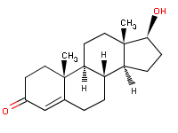

http://www.mesomorphosis.com/images/steroid-structure/testosterone.gif

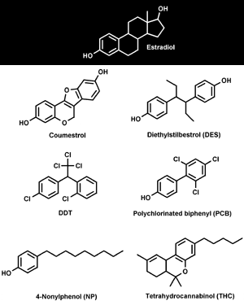

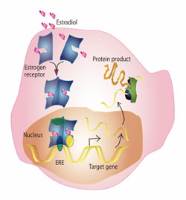

http://www.llnl.gov/bio/groups/food_mutagens/images/estrogen_formation_1.jpg

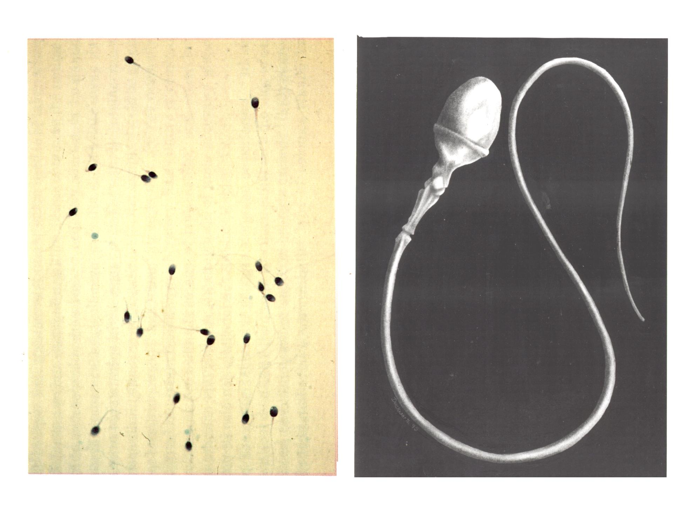

Sperm

http://www2.unescobkk.org/eubios/BetCD/Bet8sp.jpg

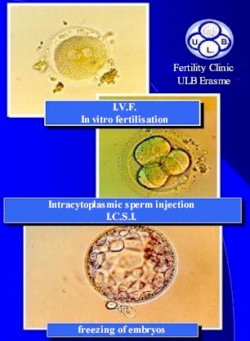
http://www.ulb.ac.be/erasme/edu/FIV/en/cover.htm

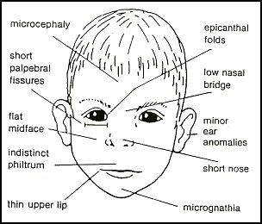
http://www.fetalalcohol.com/images/face-thm.gif
Syndrome

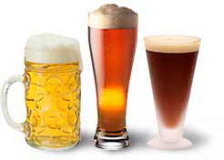

http://www.happinessonline.org/images/img-beer-menupic1.jpg

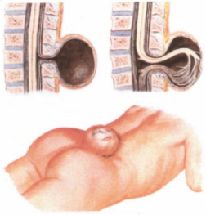

http://www.paritaet.org/asbh/wasist/b3.jpg

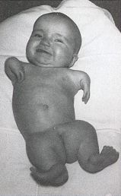



Flipper-like limbs
http://engineering.cua.edu/biomedical/faculty/kirtley/synergy/pamimg.jpg

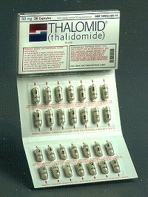

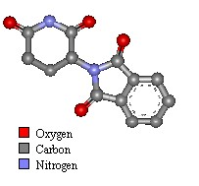

http://www.chm.bris.ac.uk/motm/thalidomide/effects.html

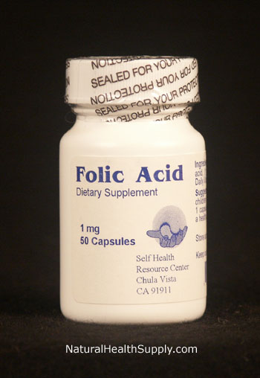

Folic Acid
http://www.naturalhealthsupply.com/products/folic-acid.jpg

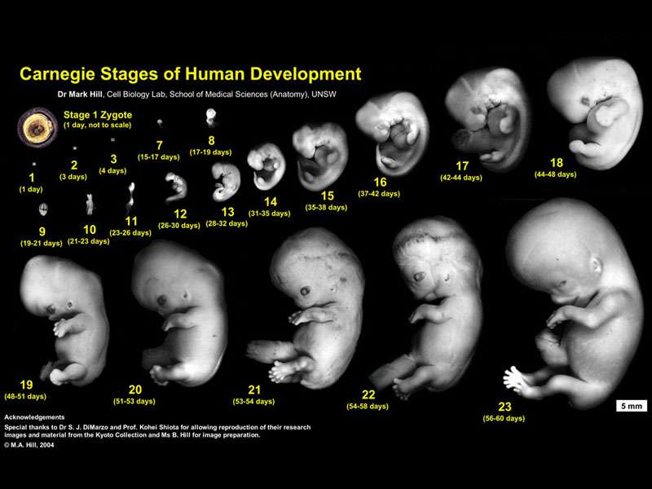

Fetal
http://embryology.med.unsw.edu.au/wwwhuman/Stages/Images/Cst800.jpg

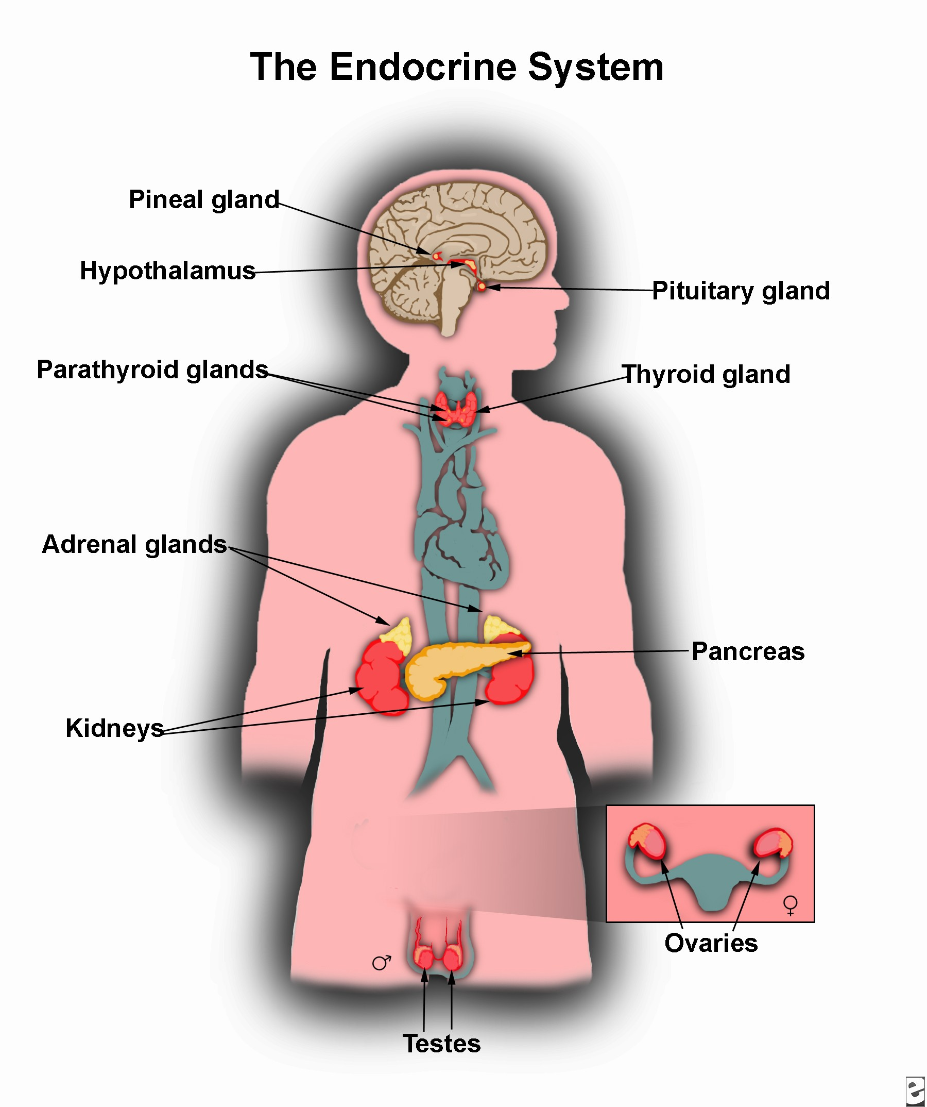

http://www.emedicinehealth.com/images/4453/4453-13250-37539-37611.jpg

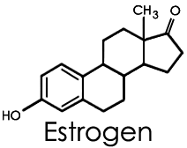

http://hcs.harvard.edu/~wishr/estrogen.gif

(Appendix C: Student)
Word Splash Typical Paragraph

History records many examples of the impacts of environmental factors on reproductive health. In the late 1950s and early 1960s, thalidomide was given to pregnant women suffering from severe morning sickness. Many of these women had babies born with flipper-like limbs. Research has also shown that women not receiving enough folic acid in their diet have an increased risk of having babies with spina bifida. Pregnant women ingesting alcohol risk having babies born with fetal alcohol syndrome. Recently there is growing evidence that some chemicals act as hormone mimics that block such hormones as estrogen or testosterone from coupling with their receptors to turn on genes necessary for normal reproductive development. Finally, fertility clinics are seeing more and more couples having difficulty conceiving due to problems with sperm cell production. Scientists suspect environmental influences may be responsible.
(Appendix D: Teacher)

Word Splash Strategy

“Splash” refers to random arrangement of key terms around a topic. Students examine the words posted in disarray and are directed to construct meaning from seemingly unrelated terms. Words are splashed visually to students in any manner convenient for a classroom, e.g., whiteboard, overhead, wall, power point presentation, or on student desks. This strategy can be used anytime during the instructional “flow” of a lesson or laboratory activity.

Three word splash choices follow:

1. The Ordered Word Splash:
Place 6-10 words that you want ordered sequentially or in some form of hierarchy. Students will do this in written format such as a graphic organizer template. Below is a possible example for the living world hierarchy.

organ
cell
community
system
tissue
ecosystem
population

2. Directed Word Splash:
The words in this splash are targeted to answer a focus question. For example, “How would you use the following terms in discussing evolution with a team member?”
homologous structures
vestigial
Geology

(In this example we would hope students would focus on using these as lines of evidence supporting the theory of evolution.)

3. Engaging Word Splash
This splash may be useful in assessing prior knowledge or in the Engaging phase of the 5 E model. There is no suggested limit for the number of words/phrases as it is dependent on the task or reading passage used. Individual students mentally compose a story or scenario in which the words have meaning. Timing is important in this task and usually limited to 4 minutes. A variety of ‘report out’ techniques can be employed such as pair-share, a graphic representation, writing the story, or general class discussion. The activity concludes with the actual story/scenario being given to students who are then asked to find and underline the splashed words/phrases.

50% chance
loosen
voyage
in bed
vinegar
oranges
teeth

scurvy
limeys

Passage:
Two hundred years ago, men setting out on a long sea voyage had a 50% chance of returning. Major causes of death were not pirates, sharks or being washed overboard. In the 1740’s a crew of 400 British sailors was reduced to 200 primarily as a result of scurvy. Approximately 250 years ago a British physician set out to learn what caused scurvy. The symptoms of the disease he described as follows: large, discolored spots over the body, “swelled” legs, “putrid” gums, no energy, ulcers on legs, rotten bones, and fungus flesh. One of the fascinating symptoms, and perhaps the most telling, is that old scars would break open just as if the wound had recently been inflicted. He reported that people with the ailment could eat and drink well but, because they had no energy, they would stay in bed all day. If called out of bed, they would attempt to stand and bones in their legs would break. In an attempt to learn the cause of scurvy, the physician designed a well controlled experiment. He selected one group of sailors to eat as usual. Then he established five other groups that each day ingested the following: (1) sea water (2) vinegar (3) sulfuric acid (4) oranges (5) lemons. Those consuming the citrus fruit did not develop the symptoms of scurvy.

Using this information, each British sailor consumed a daily ration of lime juice to prevent scurvy. Hence, British sailors became known as “limeys.”

Vitamin C, also known as ascorbic acid, can be synthesized by most vertebrates from the nutrients they ingest. Humans and monkeys are the only exceptions to this and must eat vitamin C in order to have adequate amounts. Ascorbic acid is necessary in the synthesis of hydroxyproline which is necessary in connective tissues and synthesis and repair. Without it, connective tissue slowly breaks down…the teeth loosen, gums degenerate, scar tissue and blood vessels break down. In advanced stages, sufferers usually hemorrhage.
(Appendix E: Student)

Pass Along word splash Paragraph

What will you do: Work as a team to write a paragraph that uses all the words in the word splash.

- Observe the words on the word splash and develop a hypothesis about what those words might have in common.

- Select the oldest person on the team to begin the pass along paragraph. The oldest person on the team should:
- Write your team’s hypothesis at the top of a sheet of paper.
- Select two words from the word splash and write one sentence that includes both of these words.
- Pass the sheet of paper to the next person on his/her right.

- The next person should:
- Read the sentence written by the person before him/her aloud to the team.
- Select one or two new words from the word splash and write a second sentence that uses these words and logically relates to the previous sentence.
- Pass the sheet of paper to the next person on his/her right.

- Continue this process until your team has used all of the words on the word splash.

- The last person should read the paragraph aloud to the entire team.

- Work as a team to develop one sentence that could be used as a theme sentence to begin or end the paragraph. The oldest member of the team should record this theme sentence and indicate whether it would be best placed at the beginning or the end of the paragraph.

- Does your paragraph relate to your word splash hypothesis? Explain why or why not.
(Appendix F: Student)

Phthalates - Balancing Risks and Benefits

(Narrator)
Senator Matt Gould was gearing up for re-election. Balancing all the preparation for pre-election events was taking its toll. He was trying to juggle family, job, and maintain his political image. The public relations firm that he was going to today would hopefully ease some of the pressure he was feeling.

He thought about his wife, Marge’s, promotion to senior vice president of the EA Cosmetics firm on Lake Clear Highway. Her ten years as a cover girl model had made Marge even more recognizable than he was when they traveled. He’d really miss having her available on the campaign trail but she would be needed at work. Community members had approached the Town Board expressing concerns and requesting an environmental statement for the proposed addition to the EA Cosmetics manufacturing site. The company had been picketed for two weeks straight and Marge was asking him for help.

Matt shifted his thoughts to his daughter Callie. She had a toddler and now a new baby on the way. Next time she visited he would lay down the law! No more teething rings, baby bottles, and squeaky toys in his den.

Seeing Callie and her toddler was really tough on his son Mark and his wife, Jody. Matt considered how to provide support for the couple. They were desperately trying to have a family. Visits to the New Hope Fertility Clinic had shown that Mark’s sperm count was extremely low. His work load at Plasticizer’s, Inc., combined with finding the source of the couple’s inability to conceive was pushing Mark over the edge. He was showing signs of serious depression.

Matt tried to bring his focus back to his problems. He remembered that his aide, Larry, had given him his CD player. Larry’s parting words were, “Senator, there’s an issue you’re going to have to be prepared to handle. I googled phthalates and found an audio interview I think you need to hear.” Matt put in his ear buds and here is what he heard:
CURWOOD: Today I am interviewing Dr. Shana Swan, a professor of obstetrics and gynecology at the University of Rochester. Her research study on the effects of phthalates on male reproductive health was recently published in the Environmental Health Perspectives journal. Thanks for taking this time with me today, Dr. Swan.
CURWOOD: “Studies by the Centers for Disease Control show that most people in the United States carry in their bodies concentrations of a family of synthetic chemicals known as phthalates. Phthalates are commonly found in plastics, pesticides, and personal care products like shampoos, soaps, and makeup. Phthalate exposure has been linked to malformed sex organs in male lab animals. Now, for the first time, there is a human study linking mothers’ exposure to phthalates to genital birth defects in male infants. The research is in the journal, Environmental Health Perspectives and its' lead author, Doctor Shanna Swan, of the University of Rochester Medical School, joins me now. Dr. Swan, what exactly did you find?
SWAN: Well,” … “we found that when the mother had higher levels of certain phthalates in her urine while she was pregnant, the boys produced had incomplete masculinization. Specifically, we found that a measurement that we call ‘anal-genital distance’ was shorter when the mother was exposed to higher levels of certain phthalates. So, what is that? Well, the anal-genital distance can be measured pretty easily in young baby boys. It is the distance between…” … “the anus and the penis.” “In addition, the boys were more likely to have less fully descended testicles and also shorter or smaller penis size as measured by the volume. And their scrotums were smaller and less distinct.
CURWOOD: Now, just because this distance was shorter and the genitals were smaller doesn't necessarily mean that this is a bad thing, does it? I mean, some people are shorter than others, that’s not necessarily a bad thing. Or is it a bad thing?
SWAN: Having a shorter anal-genital distance is a reflection of less virilization– pushes the boy toward the direction of the feminine. And,” … “this is something that, in rodents, has led to a lot of problems later in the rodents' lives such as decreased fertility, decreased sperm count, and eventually testicular cancer.
CURWOOD: Now you're study says that as many as a quarter of the women in this country have levels of phthalates in their bodies higher than the levels you found in your research. Tell me, uh, to what extent do these chemicals accumulate in body tissue? And what's the pathway for exposure to them, in adults?
SWAN: Right. Well, actually, for most of the phthalates we studied, and particularly the four that we found associated with genital development in boys, they are present in almost every female of reproductive age in the United States. So they're extremely common. And the pathway is really unclear. They can come in through dermal exposure, through cosmetics, for example, putting on hand cream and so on. They can come in through your food or through your water. So we have ingestion, we have dermal exposure. And inhalation is probably the least likely, although they are in hairsprays and perfumes as well. So we have multiple routes of exposure and, um, multiple sources as well.”
Matt headed to his first meeting with Dewey, Sellum, Allign & Howe. Today’s meeting with this public relations firm would be an important one.
(Appendix G: Teacher)

This photo indicates how the “ano-genital” distance is measured.
Figure courtesy of Shanna Swan, Ph.D., University of Rochester

Provided for teacher reference only.

(Appendix H: Student)

Phthalates - Record of Individual and Team Work

Name: Class:

FACTS
What are the facts of the case?

Phthalates - Record of Individual and Team Work

Name: Class:

Questions
What questions do you have, or think others might have, about the case?

(Appendix I)


Take turns calling out ideas
Record ideas as stated
Strive for quantity
Resist evaluation or discussion
Encourage all ideas
Piggy-back on other ideas
Brainstorming Guidelines
(Appendix J)

#1: PROBLEM SOLVING RUBRIC

Student: | 1  Limited | 2  Developing | 3  Proficient | 4  Advanced | 5  Exemplary | Self | Team
Identifies Relevant Facts (“What do we know?”) | Cannot identify facts, or mixes facts with opinions. |  | Identifies most relevant facts. |  | Helps distinguish facts from opinions/inferences.
Asks Relevant Questions (“What more do we want to know?”) | Asks no questions or ones unrelated to script. |  | Asks basic kinds of “who, what, where, when” questions. |  | Asks higher-level questions which reflect depth of thought.
Organizes Questions for Research | Is unable to organize questions into categories. |  | Organizes questions into appropriate categories. |  | Identifies questions that fit into multiple categories.
Selects Useful Information from Appropriate Sources | Cannot locate information to answer research questions. |  | Obtains relevant information from key sources provided. |  | Obtains reliable and wide-ranging information from sources beyond those provided.
Organizes and Presents Information Effectively | Does not organize information to clearly present answers to research question(s). |  | Organizes information to clearly present answers to research question(s) |  | Summarizes information from many sources; presentation is concise accurate, and insightful.
Identifies Major  Problem(s) and Stakeholders | Cannot state a major problem or identify important stakeholders. |  | Identifies major problem and major stakeholders. |  | Distinguishes between major & minor problems; identifies direct & indirect stakeholders.
Develops Multiple Solutions to Major Problem(s) | States only one (obvious) course of action to major problem. |  | Develops two or more solutions to the major problem(s) |  | Develops multiple solutions based on pros/cons and stakeholder perspectives.
Chooses a Course of Action and Supports Choice | Cannot select or support a course of action. |  | Selects and supports a course of action based on ethics or risks/benefits to one stakeholder |  | Selects a solution based both ethics and risks/benefits to multiple stakeholders

#2: PBL TEAMWORK AND TEAM PROCESSING RUBRIC

Team  Members: | 1  Limited | 2  Developing | 3  Proficient | 4  Advanced | 5  Exemplary | Self | Team
Distribute  Tasks | Do not distribute tasks equally. |  | Distribute tasks equally. |  | Distribute tasks based on team members’ skills.
Collaborate  & Contribute Equitably | Let one or two team members do most of the work. |  | Ensure that all team members contribute fully. |  | Know and encourage each other’s strengths to do quality work.
Manage  Conflict | Do not recognize or take action to reduce conflict |  | Resolve conflicts to continue to stay “on task.” |  | Identify and actively use “win-win” solutions to manage conflict.
Use Brainstorm  “Rules” | Do not use brainstorm “rules”; allow others to block the process. |  | Follow brainstorming “rules” and contribute ideas equally. |  | Develop new “rules” as needed to facilitate the brainstorming process.
Effectively Reflect on Teamwork | Do not contribute to discussions about their work as a team. |  | Use the results of this rubric to suggest ways to improve teamwork. |  | Regularly monitor and assess teamwork of individuals and group as a whole.
Build Consensus | Do not attempt consensus process. |  | Use consensus process to work effectively. |  | Seek out feedback and process this information to improve teamwork.
Manage  Time | Do not monitor their progress or recognize time constraints. |  | Use time efficiently and complete all tasks on time. |  | Regularly monitor and assess progress to exceed task expectations.
Produce Quality Work | Show no, or limited, attention to making quality products. |  | Create high school products that meet expectations |  | Create products that resemble practicing professionals “in the field.”
Stay on Task | Are easily distracted or frequently go “off task.” |  | Use time in focused & productive ways. |  | Create work-plan agenda and monitor progress.
Come Prepared | Are not consistently prepared with needed materials. |  | Are consistently prepared with needed materials. |  | Take time daily to assure that materials are ready for next work session.
Maintain Positive Attitude | Exhibit negative behaviors; use “put down” expressions. |  | Exhibits positive attitudes/behaviors towards work and others. |  | Assist others in maintaining positive attitudes and behaviors..

PBL Problem Solving and Teamwork Reflection Questions:

1. Describe a specific example of something you learned from your PBL team (e.g., information or a problem solving or teamwork skill) that you probably would not have learned on your own.

2. Describe a specific example of something that your team members learned from you (e.g., information or a problem solving or teamwork skill) that they probably would not have learned without you on their team.

3. Suggest one specific, practical change the team could make that would improve the team’s learning, problem solving or teamwork skills.
(Appendix K)

Web Sites for Background Information

It is suggested that teachers either select two of these articles for all students or assign each student to read different articles. All students should read the multi-asterisk selection at the bottom of the listing.
- Tox Town- Phthalates This site provides answers to the following questions: What are phthalates? How might I be exposed to phthalates? How can phthalates affect my health? Lists locations where phthalates may be found and provides a well selected list of credible internet links. (2 pages) http://toxtown.nlm.nih.gov/text_version/chemical.php?name=phthalates
- Phthalates This overview article discusses uses, toxicity, and human exposure to phthalates. (5 pages) http://website.lineone.net/~mwarhurst/phthalates.html
- Chemical Profile Phthalates This overview article provides a chemical profile of phthalates, toxicity, MSDS information, significant statistics, health effects, how exposures occur, how to detect phthalates, minimize exposure, and alternatives to use. It also provides multiple resources.*** http://www.checnet.org/healthehouse/chemicals/chemicals-detail2.asp?Main_ID=281\
- The Ugly Side of Beauty Products This article focuses on the controversy surrounding phthalate use and emphasizes risk assessment. *** (1 page) http://www.ehponline.org/docs/2005/113-1/EHP113pa24PDF.PDF
- Are hormone mimics affecting our health? This 1998 article from the World Resources Institute is a must for information on hormone mimics. **** (5 pages) http://population.wri.org/pubs_content_text.cfm?ContentID=1319
(Note: Instructors may choose to use excerpts from this article rather than the article in its entirety.)

(Appendix L)

DEWEY, SELLUM, ALLIGN & HOWE
Advertising & Public Relations Agency
1876 Madison Avenue

New York, NY

You have just changed your address to Madison Avenue! The words “Madison Avenue” have been synonymous with advertising and public relations. Great books, movies, and products have relied on advertising and public relations firms and the power they hold. Now politicians are beginning to use public relations firms.

You are now the leading creative team of the agency, Dewey, Sellum, Allign and Howe. You have an important client. Senator Matt Gould is running for re-election and must make an informed decision about an issue that will certainly affect his campaign. He wants your firm to assist him with selecting the appropriate stand on this issue and put together a campaign — in other words, a media blitz — to educate the public on a group of chemicals called phthalates.

Your creative team should include:
- A Project Coordinator, to gather all the parts of the research project and keep track of all of the different media.
- A Lead Researcher, who determines and assigns paths of research and avoids duplication and/or omission.
- A Lead Graphic Artist, who, through input from the full team, makes final determination of the overall “look” of the project.
- A Lead Writer, to keep the written style of the project similar.
- A Media Specialist to coordinate the implementation of the various media (PowerPoint®, video, audio, etc.) required to complete this project successfully. (If some media are not available at your location, simply plan out the project as if to ready them for production.)

If your creative team contains fewer than five members, you will have to “job out” the tasks between the members of the team. If your creative team contains more than five members, add a proofreader, a production assistant, and whatever additional roles are needed.

You have four weeks to produce a top-notch campaign. At the end of the four-week period, a seminar/symposium will be held offering each team the chance to present its component of the overall campaign. An audience will be present to evaluate your team’s performance and provide authentic assessment.

Your combined presentations are expected to boost the firm’s ability to provide clients with exactly what they need - Dewey, Sellum, Allign and Howe. In addition to your research questions, you will also receive guidelines (also known as a rubric) for what the client wishes to accomplish with his campaign. If you want this firm to receive the contract in order for you to be paid (read: graded well), it is strongly suggested that you adhere to the following guidelines to the best of your ability. Please note the due dates for weekly progress reports and final project. Your weekly progress reports should discuss what is done, what needs doing, questions that you have, problems you have encountered, and your group dynamics survey.
“Re-Elect Thornton” PROJECT GUIDELINES

Senator Thornton has asked that the Campaign include:

- A 30 second television Public Service Announcement (PSA)

PSA Script:
- timed to 30 seconds
- must promote major understanding of the issue
- typed, double-spaced, all CAPS for better readability
- include client name, team name(s), project name

PSA Storyboard:
- a shot-by-shot description of what video and audio will be in a :30 television spot

Storyboards: HELPFUL WEB SITES

Studio 1151: Production Storyboard Examples
http://www.mcli.dist.maricopa.edu/authoring/studio/guidebook/storyboard_example.html
Excellent site explaining the importance of storyboarding, what storyboards are used for, and step-by-step instructions for creating them.

This is Our School (Analog Video)
http://www.horizon.ab.ca/onlinecourses/videoourschool.htm
This site is a step-by-step instruction on creating a videotaped piece.

Printable Storyboard Blank Sheet
http://www.horizon.ab.ca/onlinecourses/storyboardg.htm
One example of a storyboard blank.

Sample Storyboards
Sample Storyboard: “Effigy Mound Portfolio on Tape”
http://www.nps.gov/efmo/parks/7009b.htm

- A Press Release

Press Releases: HELPFUL WEB SITES

What You Need to Know Publishing: Press Release Pointers
http://publishing.about.com/library/weekly/aa072598.htm?once=true&

Press Release Writing Tips and Press Release Distribution
http://www.press-release-writing.com/

- A Feature Article
- Target audience’s school newspaper, or even local newspaper’s education desk. Include images if at all possible.

- PowerPoint® Presentation
- A minimum of six screens to support a 5- to 8-minute presentation detailing the research and culminating action plan presented by the team.
- Storyboard, as outlined earlier

- Poster Campaign
- A large poster denoting the positive action plan.

Senator Thornton has asked that you keep him informed about your team’s status on this project through weekly progress reports. He has also emphasized that it is critical that you meet his deadline for project completion. Your boss has reminded you that you also must submit your group work evaluation forms on a weekly basis.

WEEKLY PROGRESS REPORT DUE DATES

1:________________ DEADLINE

2:________________ DEADLINE

3:________________ DEADLINE

FINAL PROJECT DUE DATE: ________________

(Appendix M)
Risks and Benefits Chart

Using the format shown below, fill in the appropriate information from your research source. As you read, jot down your ideas on the risks of phthalates and the benefits of phthalates. See example on the bottom of the next page.

Internet Resource:

___________. ___________. ______________________________________
Author*** (date) Title of full work (underlined).

Retrieved _______________, from _____________________________
Retrieval date, name of web site
______________________________________________
URL (No additional punctuation at the end)

***If author is unknown, put Unknown. Note that all lines below the first are indented five spaces. The retrieval dates for your work should be located on the articles.

Benefits/Pros of phthalate use | Risks/Cons of phthalate use

What questions do you have from your reading?

Do you think this internet resource is credible? Why? Why Not?

Example: A quote - “Sure it sounds bad. But is it really serious enough to make me give up golf, Evian®, and safe sex?”

Walker, J. (1996, October). Gender-bending chemicals. Retrieved July, 26, 2006 from
FACSNET News Backgrounder site
http://www.facsnet.org/tools/nbgs/a_thru_h/g/genderben.php3
(Appendix N)

Student Articles
Articles for Pros/Benefits Teams:
It is suggested that each “Pro” team be given one copy of each of these articles. Each student in a team can then read and report on two of these articles. Articles that are especially recommended are indicated by a ***
- CPSC Validates Use of DINP in Vinyl Toys On this site there is synopsis of the Consumer Safety Commission’s vote on banning vinyl from products used by children 5 years and under. (2 pages) http://www.phthalates.org/mediacenter/panelstatement.asp?ID=42
- Phthalates and Your Health—Endocrine Disruptors This site gives background, issues, and evidence associated with the endocrine system and phthalates. *** (3 pages) http://www.phthalates.org/yourhealth/endocrine.asp
- Phthalates and Your Health—Bioaccumulation Phthalate biomagnification, accumulation, issues and evidence can be found at this site. (2 pages) http://www.phthalates.org/yourhealth/bioaccumulation.asp
- Save plastic IV-bags so they can save you An excerpt from this site states, “Chemical companies have helped Americans attain the highest standard of living in history. But one would never know it from the industry. The least credible accusation against its products can send manufacturers into panicked retreat. That's a fact that anti-chemical activists have learned all too well and exploit unmercifully, to the great detriment of consumers who might otherwise have benefited from these products.” (2 pages) http://www.junkscience.com/mar99/ivbags.htm
- Safe Plastics, Poisonous Journalism This site covers the opinions of a senior fellow at the Hudson Institute and was written in response to a Time magazine article on the dangers of phthalates. (~2 pages) http://www.fumento.com/safeplastic.html
- Claims that study shows sexual development of boys at risk from phthalates is a serious misinterpretation of the facts say experts. Industry refutes scientific research done by Dr. Swan. (3 pages) http://www.phthalates.com/upload/documents/document35.pdf
- Phthalates and Your Health: Food Containers & Packaging This site discusses phthalates, food packaging and your health. (2 pages) http://www.phthalates.org/yourhealth/food_packaging.asp

Phthalates and Your Health: Personal Care Products Article discusses phthalates and personal care products. “Of the many phthalates used in different ways today, three in particular -- DMP, DEP, and DBP -- are used in cosmetics and personal care products because they deliver benefits that are difficult to otherwise achieve.” (3 pages) http://www.phthalates.org/yourhealth/personal_care.asp

Outside Panel Finds Swan Study Hypothesis "Not Supported" by Her Published Study. A Statement by the Phthalate Esters Panel, American Chemistry Council, January 27, 2006 (3 pages) http://www.phthalates.org/mediacenter/panelstatement.asp?ID=66
- Health Scare Alert: Consumers Union, ABC News to Alarm about Plastic Baby Bottles. A report about the plan of Consumers Union and the ABC News program "20/20" plan to use "junk science" to launch a scare about the safety of plastic baby bottles. (1 page) http://www.prnewswire.com/cgi-bin/stories.pl?ACCT=104&STORY=/www/story/04-19-1999/0000912636&EDATE= combined with JPMA Supports Safety of Plastic Baby Bottles The leading paragraph at this one page site says, “The Juvenile Products Manufacturers Association (JPMA) announced today that it stands by the scientific research indicating that plastic baby bottles are safe.” (1/2 page) http://www.plasticsinfo.org/babybottles/jpm_article.html ***

Articles for Cons/Risks Teams:
It is suggested that each “Con” team be given one copy of each of these articles. Each student in a team can then read and report on two of these articles.
- Ingredients in cosmetics, toys a safety concern This Wall Street Journal article discusses the phthalate debate. The opening paragraph states, “In the 12th week of a human pregnancy, the momentous event of gender formation begins, as X and Y chromosomes trigger biochemical reactions that shape male or female organs. Estrogens carry the process forward in girls, while in boys, male hormones called androgens do.” http://www.post-gazette.com/pg/05277/582410.stm
- About Phthalates This article is a particularly good one for general information. It also cautions readers to consider who is publishing the information on the health risks/benefits of phthalates. (5 pages) http://www.mindfully.org/Plastic/Plasticizers/About-Phthalates.htm
- Study Demonstrates Exposure of People to Phthalates An excerpt from this document says, “For the first time, scientists from the Centers for Disease Control and Prevention's (CDC's) National Center for Environmental Health have been able to measure, in humans, the presence of metabolites of seven phthalates, chemicals used in plastics, solvents, detergents, and many other products (4 pages). http://www.niehs.nih.gov/oc/news/cdcphth.htm
- Take Action Now + More About Phthalates These articles encourage consumers to take action against the use of phthalates in products being marketed to women. (3 pages) http://www.nottoopretty.org and http://www.nottoopretty.org/more.htm
- Chemicals: Phthalates The two page summary discusses common names and health effects of phthalates. (2 pages) http://www.checnet.org/healthehouse/chemicals/chemicals-detail2.asp?Main_ID=281
- Girls May Face Risks from Phthalates This article appeared in Science News September 9, 2000. It discusses the risks faced by young girls exposed to phthalates. (4 pages) http://www.sciencenews.org/articles/20000909/fob3.asp
- Coming Clean: Are Your Household Products Harmful? “They are not conclusive studies showing phthalates harm people, only animals. However, scientists have found high concentrations of the chemicals in people, and among some environmental and health groups that's reason to send a warning. “ (1 page) http://www.kcbd.com/glbal/story.asp?s=851806&ClientType=Printable
- Panel Ranks Risks of Common Phthalate Additional research underscores concerns about DEHP that were first expressed in 2000 report This article is taken from the CHEMICAL & Engineering News Journal (7 pages) http://pubs.acs.org/cen/coverstory/83/8346specialtychem5.html

New Research Explores How Chemicals Effect Reproduction A feature story on phthalates, published in 2006. (11 pages) http://www2.envmed.rochester.edu/envmed/ehsc/outreach/winter2006/Your_Health-winter2006.html#phthalates

Our Stolen Future This article provides a summary of research done by Dr. Shanna Swan. “For the first time, researchers have demonstrated a highly significant relationship between a mother's exposure during pregnancy to phthalates—a family of compounds used widely in plastics and personal care products—and changes in the ways that baby boy’s genitals develop.” (8 pages) http://www.ourstolenfuture.org/NewScience/oncompounds/phthalates/2005/2005-0527swanetal.htm

(Appendix O)

Weekly Group Work Evaluation Report

Team Name ________________ Week # _______

1. This week, overall, how effectively did your group work together on the Media Blitz Project)? (circle the appropriate response)

1 2 3 4 5
Not at all poorly adequately well extremely well

2. How many of the group members participated actively most of the time? (circle the appropriate number)

1 2 3 4 5

3. How many of you were fully prepared for the group work most of the time? (circle the appropriate number)

1 2 3 4 5

4. Give one specific example of something you learned from your group that you probably wouldn’t have learned on your own.

5. Give one specific example of something the other group members learned from you that they probably wouldn’t have learned without you.

6. Suggest one specific, practical change the group could make that would help improve everyone’s learning.

Weekly Progress Report

Team Name __________________ Week # ______

Your weekly progress reports should discuss what is done, what needs doing, questions that you have, problems you have encountered, and your group dynamics survey.

Here is what we have done:

Here is what needs to be done:

Questions we have:

Our problems are:
(Appendix P)

Rubric for “Media Blitz”

Date:______________________Class:______________________
Period:______Evaluator Name: ____________________________
Students being evaluated (names):

 | Not  Acceptable | Acceptable | Very Good |  |  | Exemplary
Preliminary Work
Students completed storyboards prior to video and presentation | 1 | 2 | 3 |  |  | 4
Students’ used research to include both factual and “interesting” information | 1 | 2 | 3 |  |  | 4
Students included a minimum of 4 different resources | 1 | 2 | 3 |  |  | 4
Students included a running bibliography | 1 | 2 | 3 |  |  | 4
Topics were broken into “workable” segments | 1 | 2 | 3 |  |  | 4
Design
Evidence is shown that there was presentation synthesis | 1 | 2 | 3 |  |  | 4
Presentation contains all pertinent elements … introduction, body, conclusion | 1 | 2 | 3 |  |  | 4
Presentation includes contrast between the text and the background, graphics, and video that enhances and is not obtrusive | 1 | 2 | 3 |  |  | 4
Presentation shows adequate font sizes, color schemes, and appropriate style | 1 | 2 |  | 3 | 4
Navigation through the multimedia presentation is done with ease and understanding | 1 | 2 |  | 3 | 4
Content
Information provided is relevant and interesting to the viewer | 1 | 2 |  | 3 | 4
Student met the overall content objectives stated in the learning experience introduction | 1 | 2 |  | 3 | 4
Evidence of creativity is apparent | 1 | 2 |  | 3 | 4
Mechanics show correct punctuation, grammar, and spelling — and complete sentences | 1 | 2 |  | 3 | 4
Presentation shows evidence of complete understanding of learning objectives | 1 | 2 |  | 3 | 4
Students have used a majority of original artwork, animation, video, graphics, sounds, and design, etc. | 1 | 2 |  | 3 | 4
Presentation
Actual presentation to audience shows fluency from beginning to end | 1 | 2 |  | 3 | 4
Students understand presentation media such as LCD panels, projectors, sound equipment, video equipment, etc. | 1 | 2 |  | 3 | 4
Students are prepared and have checked equipment prior to presentation | 1 | 2 |  | 3 | 4
Students are appropriately dressed for collegial presenting | 1 | 2 |  | 3 | 4
Students use professional speaking demeanor during presentation | 1 | 2 |  | 3 | 4

