Microplastics and Nanoplastics: How Small is Small?
____________________________________________________

How small is “small”? It depends on your point of reference. A human is very small compared to the earth. A grain of salt is very small compared to a human. However, a grain of salt is very large compared to a virus.

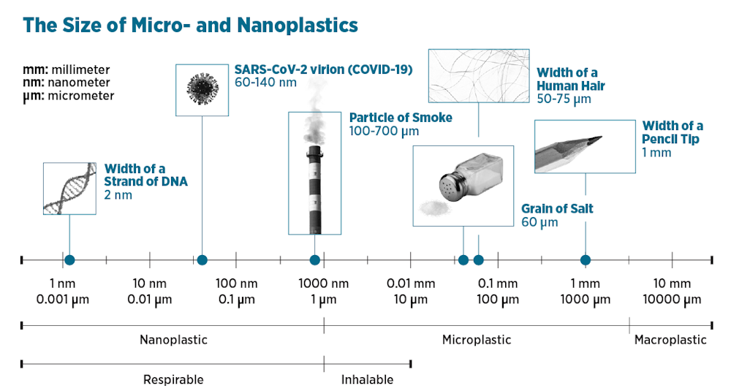

Photo Credit: Center for International Environmental Law, CC BY-ND

Microplastics are small plastic particles with a size of between 5 millimeters (the width of a pencil eraser) and 1 micrometer (one thousandth of a millimeter). Microplastics come from two main sources:
- Microplastics that are intentionally manufactured, such as industrial abrasives or pellets (called “nurdles”) that are used in production of plastic items.
- Microplastics that form when larger plastic products break down.
Microplastics are found in soil, water, and air, and they have also been found in foods that we eat and inside human bodies.

Nanoplastics are smaller than microplastics. Nanoplastics are less than 1 micrometer (1/1,000th of a millimeter) in size and can be as small as 1 nanometer (1/1,000th of a micrometer). Microplastics or other larger plastic products can break down into nanoplastics. Because nanoplastics are so small, they can behave differently from microplastics. Their tiny size means they might move more easily through the environment or interact differently with cells in our body. It also means they are very hard for scientists to study.

Nanoplastics are very tiny! Even the largest nanoplastic particle (1 micrometer) is incredibly small. A strand of hair is about 70 micrometers wide, so 1 micrometer is roughly 1/70th of the width of a strand of hair. The smallest size the human eye can see is about 100 micrometers. Nanoplastics and the smallest microplastics are microscopic and can’t be seen with the naked eye.

This activity will help you to visualize how tiny nanoplastics are.

Part 1: Measuring in nanometers
- Examine the metric ruler. This ruler is 1 meter long. The distance between two of the lines with numbers on this ruler is 1 centimeter.

- How many centimeters long is the ruler? _______________

- Millimeter (mm) A millimeter is 10 times smaller than a centimeter. The distance between the smaller lines (without numbers) is 1 millimeter. 1 centimeter = 10 mm.

- Draw two lines that are 1 mm apart in the box on the right.

- How many millimeters long is the ruler? _______________

- Micrometer (μm) A micrometer (also called a micron) is 1,000 times smaller than a millimeter. 1 millimeter (mm) = 1000 micrometers (μm).

- Can you draw two lines that are 1 micrometer apart? Explain why or why not.
No! A micrometer is 1,000 times smaller than a millimeter. You can’t draw two lines that are that close together. Even the lines would be larger than a micrometer.

- How many micrometers long is the ruler? _______________

- Nanometer (nm) A nanometer is 1000 times smaller than a micrometer. 1 micrometer (μm) = 1000 nanometers (nm).

- How many nanometers long is the metric ruler? _______________

- If a nanoplastic particle is 100 nanometers in diameter, how many nanoplastic particles could you line up along the edge of the ruler? _______________

Remember:
1 meter = 100 centimeters (cm)
1 centimeter (cm) = 10 millimeters (mm)
1 millimeter (mm) = 1000 micrometers (μm)
1 micrometer (μm) = 1000 nanometers (nm)
- One meter = __________________ centimeters (cm)
One meter = __________________ millimeters (mm)
One meter = __________________ micrometers (μm)
One meter = __________________ nanometers (nm)

- Measure the length of this paper in centimeters. __________________ cm
Measure the length of this paper in millimeters. __________________ mm
What is the length of this paper in micrometers? __________________ μm
What is the length of this paper in nanometers? __________________ nm

Part 2: Making a super-sized ruler
To help you visualize how incredibly small a nanoplastic particle is compared to things that you can see, you will create a “super-sized” nanometer ruler using a roll of crepe paper. For your ruler, 1 nanometer will be “super-sized” to equal 1 inch.
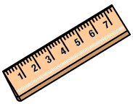
1 Super-sized Nanometer = 1 Inch
- Mark 2 lines on the end of the crepe paper that are 1 inch apart. Label one line “0” and the other line “1 nm”. Imagine that the distance between the two lines represents 1 nanometer.
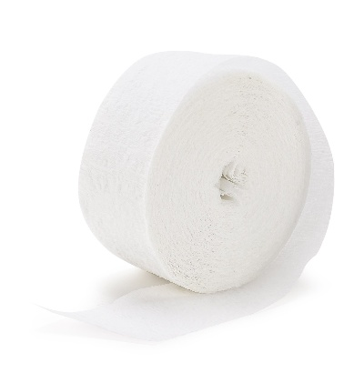
0
1 nm
1 Super-sized Nanometer = 1 Inch

- Draw a third line on the crepe paper in the appropriate location to represent 10 nanometers. Label this line “10 nm.”
- Draw a fourth line on the crepe paper in the appropriate location to represent 100 nanometers. Label this line “100 nm.”
- Draw a fifth line on the crepe paper in the appropriate location to represent 1000 nanometers = 1 micrometer. Label this line “1000 nm or 1 micrometer.”
- Using this scale, 1 crepe paper “super-sized ruler” equals 1000 nanometers. How many of your “super-sized” rulers would it take to represent:
  - 1 millimeter? __________________ super-sized rulers
  - 1 centimeter? __________________ super-sized rulers
  - 1 meter? __________________ super-sized rulers
Part 3: Visualizing nanoplastic particles
The table below gives the approximate sizes of some very tiny things in micrometers (µm) and nanometers (nm).

Object | Size in Micrometers (µm) | Size in Nanometers (nm)
Tree pollen | 40 | 40,000
Human cell | 25 | 25,000
Mold spore | 10 | 10,000
Small microplastic particle | 10 | 5,000
Bacteria | 2 | 2,000
Influenza (flu) virus | 0.1 | 100
Small nanoplastic particle | 0.01 | 10
DNA strand | 0.0025 | 2.5

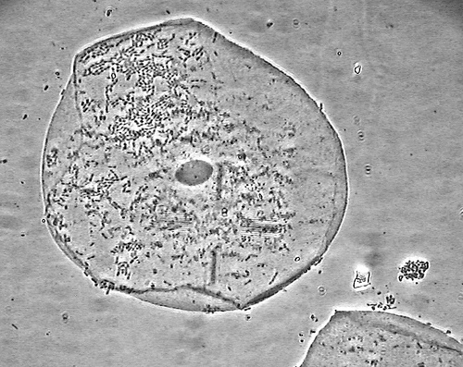
The compound light microscope photo on the right shows a human cell magnified 1,000 times larger than you can see with your eyes. This cell is about 100 micrometers wide. With a compound light microscope, you cannot see things that are smaller than about 200 nanometers.

- Which of the objects listed in the table above is visible with a compound light microscope?

Photo credit: Eric Johnson
- Which of the objects listed in the table above would NOT be visible with a compound light microscope?
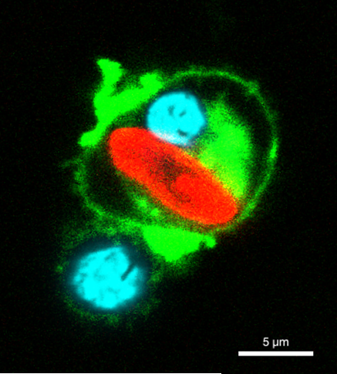

The confocal microscope picture on the right shows a microplastic particle inside a macrophage (a type of white blood cell that engulfs and digests germs and debris). The scientists have used stains to identify different items in the picture. The macrophage cell membrane is green and its nucleus is blue. Confocal microscopes can see similar sizes to a compound light microscope. The microplastic particle (red) is about 10 micrometers long and 3 micrometers wide.

Photo credit: Robert lab, University of Rochester

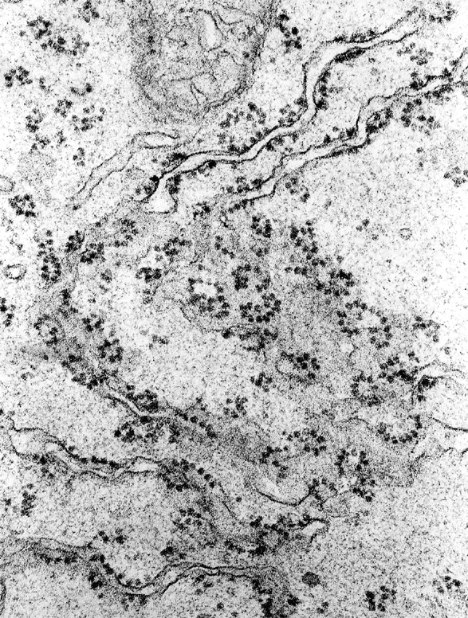
An electron microscope can be used to observe things that are too small to be seen with a compound light microscope. The photo on the right shows a small part of a human cell viewed with an electron microscope. The part of the cell is magnified 100,000 larger than we can see with our eyes. The tiny black dots in this electron microscope image are ribosomes (sites of protein synthesis in cells). Ribosomes are approximately 30 nanometers in size.

- Draw an appropriately scaled small nanoplastic particle on the electron microscope photo above. Explain how you determined how large to make your nanoplastic particle drawing.

- Some scientists are studying nanoplastics. Why do you think this type of research might be difficult?

- Why do you think scientists are studying nanoplastics? Describe one reason why scientists would want to study nanoplastics.

