Microplastics and Nanoplastics:

How Small is Small?
____________________________________________________

Key Concepts:
- Microplastics are small plastic particles between 1 micrometer (μm) and 5 millimeters (mm) in size.
- Nanoplastics are extremely tiny plastic particles that are between 1 nanometer (nm) and 1 micrometer (μm) in size.
- Nanoplastics and some microplastics are so small they require specialized technology to see and study them.

Class time required:
Approximately 60 minutes

Facilitator Notes:
This activity is suitable for a variety of ages. It requires prior knowledge of the metric system and ability to convert between units. It focuses on conceptualizing the scale of very small particles. It is recommended to pair this activity with other activities about microplastics or nanoplastics and their impacts on the environment and health. Additional materials can be found at:
- Lake Ontario MicroPlastics Center - Resources
- University of Rochester Life Sciences Learning Center - Microplastics
- RIT Collaborative for Plastics and the Environment
- New York Sea Grant - Plastic Pollution and You

Materials for each group of students:
- A copy of student handout “Microplastics and Nanoplastics: How Small is Small?” for each student.
- 1 meter metric ruler. If you do not have meter rulers, you can print and tape together the paper meter ruler downloaded from: http://www.vendian.org/mncharity/dir3/paper_rulers/
- A calculator
- Marker or pen
- A large roll of crepe paper from a party or craft store. You may substitute a roll of adding machine paper or plastic flagging tape (from www.uline.com/BL_6423/Flagging-Tape). Note: A roll of crepe paper is approximately 81 feet (972 inches). We use this to approximate 1,000 nanometers for the “super-sized” ruler (1 inch = 1 nanometer).
- Any size ruler with inches. Some meter rulers have inches on the reverse side, or you can also print one from the same site above.
Additional resources and activities:
- Consider a whimsical approach to the concept of size and scale by beginning with reading Horton Hears a Who! by Dr. Seuss or What’s Smaller Than a Pygmy Shrew by Robert E. Wells.
- Purchase copies of Zoom or ReZoom by Istvan Banyai (available at www.amazon.com). Tear out the pages of the book and place them in randomly numbered sheet protectors. Ask students to work to put the pages in order from largest view to smallest view before starting the activity.
- Visit Cell Size and Scale to zoom from objects you can see with the naked eye to the smallest objects in a cell.
- Visit Secret Worlds: The Universe Within to compare the size of the Milky Way to successively smaller things as tiny as an electron.
- For older students, read this article from “The Conversation” to learn more about how and why scientists are studying nanoplastics. What are nanoplastics? An engineer explains concerns about particles too small to see

Suggested Class Procedure:
- Distribute copies of student handout “Microplastics and Nanoplastics: How Small is Small?” to each student.
- Students will work in teams of 2-4.
- Distribute a metric ruler, a calculator, and a roll of crepe paper to each team of students.
- Depending on your students’ math abilities, you may wish to discuss the answers after students complete each part of the activity.

Development of this activity was supported in part by the Lake Ontario MicroPlastics Center (LOMP), which is jointly hosted by the University of Rochester and the Rochester Institute of Technology with funding from NIEHS (P01 ES035526) and NSF (OCE-2418255), and by the University of Rochester Environmental Health Sciences Center (NIEHS P30 ES001247). Learn more at LOMP.urmc.edu.

This activity was adapted from a Life Sciences Learning Center activity about nanoparticles. Find related activities at: Nanoparticles: Benefits and Health Risks.
Microplastics and Nanoplastics: How Small is Small?
____________________________________________________

How small is “small”? It depends on your point of reference. A human is very small compared to the earth. A grain of salt is very small compared to a human. However, a grain of salt is very large compared to a virus.

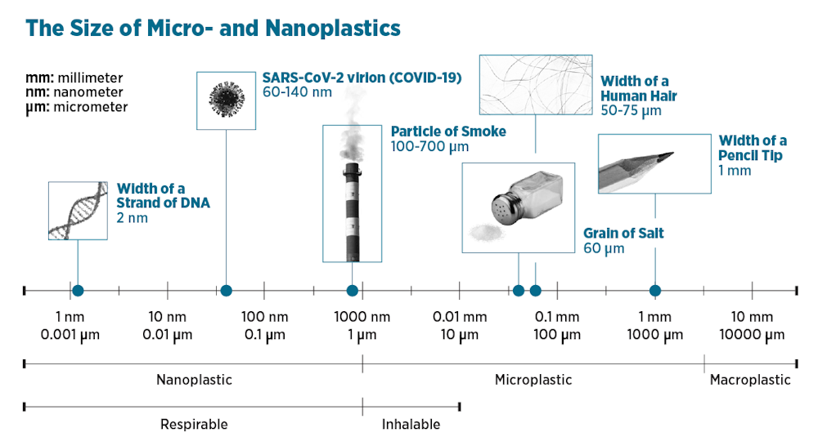

Photo Credit: Center for International Environmental Law, CC BY-ND

Microplastics are small plastic particles with a size of between 5 millimeters (the width of a pencil eraser) and 1 micrometer (one thousandth of a millimeter). Microplastics come from two main sources:
- Microplastics that are intentionally manufactured, such as industrial abrasives or pellets (called “nurdles”) that are used in production of plastic items.
- Microplastics that form when larger plastic products break down.
Microplastics are found in soil, water, and air, and they have also been found in foods that we eat and inside human bodies.

Nanoplastics are smaller than microplastics. Nanoplastics are less than 1 micrometer (1/1,000th of a millimeter) in size and can be as small as 1 nanometer (1/1,000th of a micrometer). Microplastics or other larger plastic products can break down into nanoplastics. Because nanoplastics are so small, they can behave differently from microplastics. Their tiny size means they might move more easily through the environment or interact differently with cells in our body. It also means they are very hard for scientists to study.

Nanoplastics are very tiny! Even the largest nanoplastic particle (1 micrometer) is incredibly small. A strand of hair is about 70 micrometers wide, so 1 micrometer is roughly 1/70th of the width of a strand of hair. The smallest size the human eye can see is about 100 micrometers. Nanoplastics and the smallest microplastics are microscopic and can’t be seen with the naked eye.

This activity will help you to visualize how tiny nanoplastics are.

Part 1: Measuring in nanometers
- Examine the metric ruler. This ruler is 1 meter long. The distance between two of the lines with numbers on this ruler is 1 centimeter.

- How many centimeters long is the ruler? _100__

- Millimeter (mm) A millimeter is 10 times smaller than a centimeter. The distance between the smaller lines (without numbers) is 1 millimeter. 1 centimeter = 10 mm.

- Draw two lines that are 1 mm apart in the box on the right.

- How many millimeters long is the ruler? _1,000__

- Micrometer (μm) A micrometer (also called a micron) is 1,000 times smaller than a millimeter. 1 millimeter (mm) = 1000 micrometers (μm).

- Can you draw two lines that are 1 micrometer apart? Explain why or why not.
No! A micrometer is 1,000 times smaller than a millimeter. You can’t draw two lines that are that close together. Even the lines would be larger than a micrometer.

- How many micrometers long is the ruler? ___1,000,000____

- Nanometer (nm) A nanometer is 1000 times smaller than a micrometer. 1 micrometer (μm) = 1000 nanometers (nm).

- How many nanometers long is the metric ruler? __1,000,000,000___

- If a nanoplastic particle is 100 nanometers in diameter, how many nanoplastic particles could you line up along the edge of the ruler? _____10,000,000___

Remember:
1 meter = 100 centimeters (cm)
1 centimeter (cm) = 10 millimeters (mm)
1 millimeter (mm) = 1000 micrometers (μm)
1 micrometer (μm) = 1000 nanometers (nm)
- One meter = ____100____ centimeters (cm)
One meter = ____100 X 10 = 1,000____ millimeters (mm)
One meter = ____100 X 10 X 1,000 = 1,000,000_____ micrometers (μm)
One meter = ____100 X 10 X 1,000 X 1,000 = 1,000,000,000__ nanometers (nm)

- Measure the length of this paper in centimeters.___ approx 28_____cm
Measure the length of this paper in millimeters.__approx 280___mm
What is the length of this paper in micrometers?_____ approx 280,000__ μm
What is the length of this paper in nanometers? ___ approx 280,000,000___ nm

Part 2: Making a super-sized ruler
To help you visualize how incredibly small a nanoplastic particle is compared to things that you can see, you will create a “super-sized” nanometer ruler using a roll of crepe paper. For your ruler, 1 nanometer will be “super-sized” to equal 1 inch.
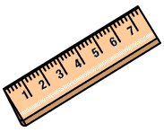
1 Super-sized Nanometer = 1 Inch
- Mark 2 lines on the end of the crepe paper that are 1 inch apart. Label one line “0” and the other line “1 nm”. Imagine that the distance between the two lines represents 1 nanometer.
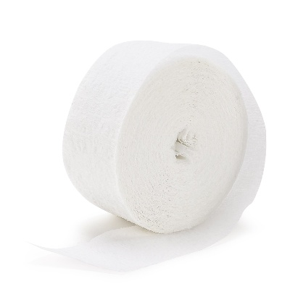
0
1 nm
1 Super-sized Nanometer = 1 Inch

- Draw a third line on the crepe paper in the appropriate location to represent 10 nanometers. Label this line “10 nm.”
- Draw a fourth line on the crepe paper in the appropriate location to represent 100 nanometers. Label this line “100 nm.”
- Draw a fifth line on the crepe paper in the appropriate location to represent 1000 nanometers = 1 micrometer. Label this line “1000 nm or 1 micrometer.”
- Using this scale, 1 crepe paper “super-sized ruler” equals 1000 nanometers. How many of your “super-sized” rulers would it take to represent:
  - 1 millimeter? ___1,000__ super-sized rulers
  - 1 centimeter? ____10,000___ super-sized rulers
  - 1 meter? ______1,000,000__ super-sized rulers
Part 3: Visualizing nanoplastic particles
The table below gives the approximate sizes of some very tiny things in micrometers (µm) and nanometers (nm).

Object | Size in Micrometers (µm) | Size in Nanometers (nm)
Tree pollen | 40 | 40,000
Human cell | 25 | 25,000
Mold spore | 10 | 10,000
Small microplastic particle | 10 | 5,000
Bacteria | 2 | 2,000
Influenza (flu) virus | 0.1 | 100
Small nanoplastic particle | 0.01 | 10
DNA strand | 0.0025 | 2.5

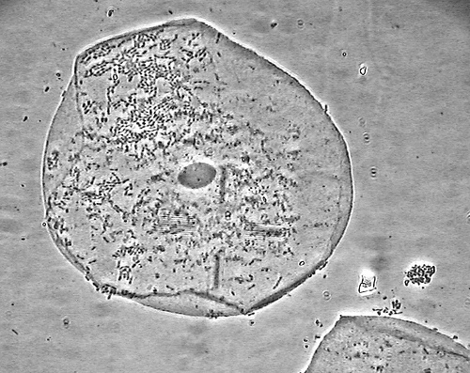
The compound light microscope photo on the right shows a human cell magnified 1,000 times larger than you can see with your eyes. This cell is about 100 micrometers wide. With a compound light microscope, you cannot see things that are smaller than about 200 nanometers.

- Which of the objects listed in the table above is visible with a compound light microscope?

tree pollen, human cell, mold spore, microplastic particle, bacteria
Photo credit: Eric Johnson
- Which of the objects listed in the table above would NOT be visible with a compound light microscope?
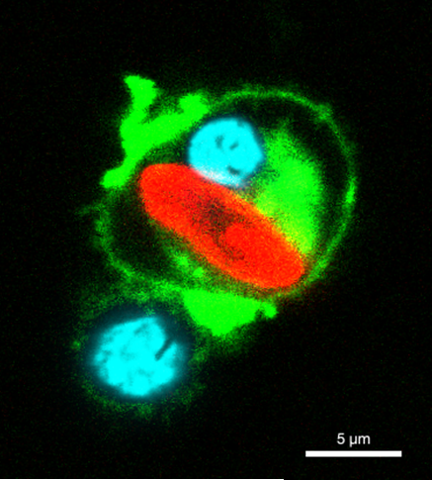
Influenza (flu) virus, nanoplastic particle, DNA
The confocal microscope picture on the right shows a microplastic particle inside a macrophage (a type of white blood cell that engulfs and digests germs and debris). The scientists have used stains to identify different items in the picture. The macrophage cell membrane is green and its nucleus is blue. Confocal microscopes can see similar sizes to a compound light microscope. The microplastic particle (red) is about 10 micrometers long and 3 micrometers wide.

Photo credit: Robert lab, University of Rochester

An electron microscope can be used to observe things that are too small to be seen with a compound light microscope. The photo on the right shows a small part of a human cell viewed with an electron microscope. The part of the cell is magnified 100,000 larger than we can see with our eyes. The tiny black dots in this electron microscope image are ribosomes (sites of protein synthesis in cells). Ribosomes are approximately 30 nanometers in size.
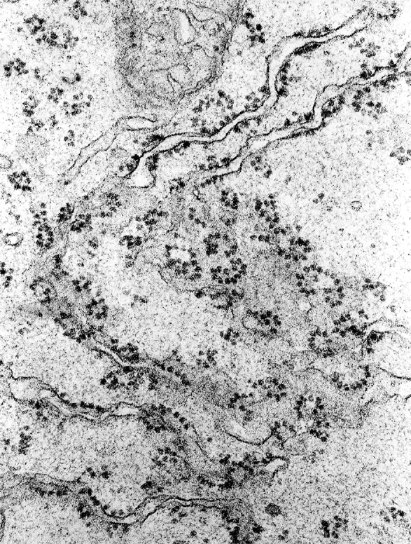

- Draw an appropriately scaled small nanoplastic particle on the electron microscope photo above. Explain how you determined how large to make your nanoplastic particle drawing.

A ribosome is about 30 nanometers and a small nanoplastic particle is about 10 nanometers. So students should draw a dot that is smaller than a ribosome. Here the 10 nm small nanoplastic size is referring back to the table above, but teachers can encourage flexible answers within the nanoplastic size range (1 nm – 1 µm) as long as the explanation is sound.
- Some scientists are studying nanoplastics. Why do you think this type of research might be difficult?

Answers will vary and may include: It would be very difficult to see nanoplastic particles because they are so small; It’s hard to be sure if small particles are actually plastic

- Why do you think scientists are studying nanoplastics? Describe one reason why scientists would want to study nanoplastics.

Answers will vary.

