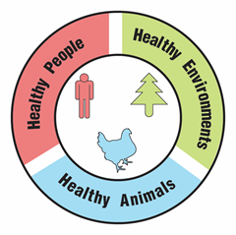
Meet the Billion Dollar Bees

Activity Guide

Overview:
Participants will learn how agriculture in their state or region depends on bees, and they will meet some of the bees that help grow their food. This activity can be used on its own, or as context for a bee-friendly activity such as a native plant giveaway/planting, insect crafts such as bug hotels/bee baths, pesticide awareness/IPM education, events showcasing local food or honey, and more!

Time Needed:
45 minutes. This activity can be adapted for tabling at public events.

Audience:
This activity is recommended for ages 8-adult and for groups of up to 20. It can be adapted for different sized groups and ages.

Objectives: Participants will…
- Classify agricultural products by pollination method.
- Identify the importance of pollinators for human food systems.
- Discuss the impact of pollinators on agriculture and on their local (statewide) economy.
- Identify that different pollinators fill different roles.
- Compare different bees and select the bees needed to produce different agricultural products.
- Discuss the relationship between humans, native pollinators, and domesticated bees.
- Recognize the connected nature of the health and well-being of humans, animals and the environment.

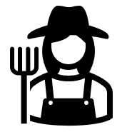
Materials:
- Agricultural Product Cards, labeled with . An example for New York State is provided, which can also be used as a template to make your own cards.
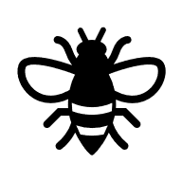

- Bee Cards, labeled with
- Recipe Cards, labeled with

Copyright © 2025 by University of Rochester. All rights reserved. May be copied for educational use. This activity was developed with support from the National Institutes of Health under Award Number R25GM132758. The content is solely the responsibility of the authors and does not necessarily represent the official views of the National Institutes of Health.
- Optional: copies of the How is my Food Pollinated? handout for each participant (recommended for older audiences or as a take-home at public events)
- Optional: index cards or other paper (for thank you notes)
- Optional: colored pencils/markers/pens (for thank you notes)

Preparation:
- Prepare the Agricultural Product Cards. Create your own or print, cut out, and laminate (optional) the provided example.
  - Note: Check your state’s Department of Agriculture or Farm Bureau website to find the top 10 agricultural products list for your state or region. This information may be provided as “top 10” agricultural products in terms of dollar value, acres grown, or amount (e.g., pounds) produced; any of these lists can be used.
  - You could also write the agricultural products on index cards with the name on the front and the pollination method on the back.
- Prepare the Bee Cards and Recipe Cards. Print, cut out, and laminate (optional) the cards.
- Review the How is my food pollinated? handout as background information.
- Note: This activity assumes participants understand what pollination is and why it is important; you may need to prepare your group with background knowledge about pollination.
- Adaptation for outdoor education: If doing this activity outdoors, metal baking sheets and small magnets can be used to keep the cards from blowing away during the sorting.
Optional assessment opportunity:
The One Health as a Tool for Informal Assessment activity can be easily integrated into this activity to provide an informal assessment opportunity. Check out the “One Health Connection” boxes throughout for related discussion prompts.

Description of Activity and Suggested Procedure:
- Remind participants that pollination is needed for plants to make fruits and seeds. Ask participants what they know about pollination and about pollinators and allow a few minutes for sharing responses. Make sure that everyone understands the parts of a plant, how plants reproduce, what a pollinator is and what pollination is before moving on to the next step. A diagram of parts of a plant may be helpful; you can find many free printables online.
- Divide your group into smaller groups of about 5 participants. Pass out one set of the Agricultural Product Cards to each group. Explain that they have the top 10 (in terms of economic value) agricultural products for New York State on them, according to the New York State Farm Bureau.
Note: Ensure that participants do not flip over the cards.
  - If you made your own cards, substitute with your own state/region, top 10, and source here.
- Adaptation for small groups: Work together as one group to sort the cards.
- Ask participants to sort the Agricultural Product Cards into two piles - products that depend on pollinators and products that do not depend on pollinators.
- Quick variation for public events: Arrange the cards in a grid on a poster board. Glue or tape down the left edge of each card. Participants can guess if each card depends on pollinators and fold the card over to check their answer. Or, place the Agricultural Product Cards out on a surface. Have designated spaces for cards that depend on pollinators and those that do not, such as pieces of paper or small containers labeled with “Depend on pollinators” and “Do not depend on pollinators”. Ask participants to sort a few or all the cards, based on interest. Mix up the cards again in between participants.
- Check the answers on the back of the cards. Allow time for discussion; some of the examples may be surprising!
- Animals such as cows and pigs depend on pollinators for the feed crops that they eat (such as alfalfa). Therefore, dairy products and meat depend on pollinators.
One Health Connection:
How might farming practices (for example, monocultures, crop rotation, pesticide/herbicide use) affect humans, animals, and the environment?
- Products made from wheat, rice, and corn do not depend on pollinators. These crops are wind pollinated.
- Root vegetable plants (such as carrots, potatoes and onions) and leafy green vegetable plants (such as lettuce, cabbage, and kale) produce the part of the plant that we eat without pollination. However, pollination may be required to produce seeds to grow additional plants. Facilitators may want to support both “depend on pollinators” and “don’t depend on pollinators” answers for these foods and encourage participants to discuss their answers. Participants may choose to make a third pile of cards.
- Remember, the goal of this activity is to understand that many crops rely on pollinators; it is OK if responses are not exactly correct.
- Remind participants these are just the top 10 products in your region/state, but there are countless other products that depend on pollinators as well. Ask participants to guess what some of those other products might be. Consider taking a local focus here: ask participants to think about how they experience these products. Depending on your audience, ask questions like: “What crops have you seen growing nearby?”, “What foods do you like to buy at the market?”, “Do you eat any of these products often?”, “What other foods that you eat often depend on pollinators?”.
- Ask participants how many bees they think are needed for all of these crops. Collect a few guesses, and then share some of the examples below. Note: One acre is about the size of a football field without the end zones. An acre is 43,560 ft², or 75% the size of a full football field (57,600 ft²).
  - One acre of alfalfa requires 40,000-60,000 alfalfa leafcutting bees (USDA).
  - One acre of apples or cherries requires 250-300 blue orchard bees (a type of mason bee) (USDA) or 1 hive of honey bees (20,000-80,000 bees) (UGA Bee Program).
  - One acre of squash requires 1 hive of honey bees (20,000-80,000 bees) (UGA Extension).
  - One acre of blueberries requires 4 hives of honey bees (80,000-320,000 bees) (UGA Bee Program).
  - One acre of sunflowers requires 1 hive of honey bees (20,000-80,000 bees) (North Dakota State University).
- Collect the Agricultural Product Cards. Explain that to have enough bees to produce enough food for everyone, farmers often rent honey bees. These hives of honey bees are shipped around the country to pollinate different crops. Honey bees are native to Europe, and have been domesticated by humans. Tell participants that honey bees alone contribute more than $15 billion to the US economy through agriculture. The US also has over 4,000 native bee species. Native pollinators contribute another $4 billion dollars to the economy through agriculture.
One Health Connection:
How might moving bees around the country affect other animals?
- Explain that different types of bees have different “superpowers”, and not all bees can pollinate all types of crops. Pass out the Bee Cards (do not pass out the Recipe Cards). You can do this in a few ways: divide participants into groups and give each group a set of cards, or, to incorporate physical movement, pass out cards randomly and instruct participants to move around and get into groups that have one of each type of bee. Give participants a few minutes to read their cards.
  - Note: If your group size is not evenly divisible by 6, you may choose to give some participants more than one card or divide participants into groups first and pass out the cards to the groups.
  - Adaptation for a public event: Place a few Recipe Cards and all the Bee Cards on a table. Individuals or groups can guess which bees contributed to the recipes, either independently or with prompts from the facilitator.
- Explain that to make a meal, like spaghetti and meatballs, you may need more than one type of pollinator. Tell participants that you will name a meal and list the ingredients. Participants will form a team of bees that can pollinate the ingredients needed for the meal. Using the Recipe Cards and the following answer table, call out a meal and hold up the picture of the ingredients (Recipe Card). Ask participants to choose one type of bee for each ingredient (3 types of bees per recipe). Once each team has chosen their bees, call on teams to share their answer and explain their reasoning. Repeat for the rest of the Recipe Cards. Each recipe may have more than one correct answer; see the table below for possible solutions. See if anyone can come up with other recipes to try!
- For younger groups: You may want to do one example together as a group first.
- For older groups: If it works for your group, add a challenge element. Teams might race to assemble a team of bees or have a time limit that decreases for each example.

Meal | Example Bee Combinations
Spaghetti and Meatballs  (beef + tomato + basil) | leafcutter bee (alfalfa/beef)  bumble bee/carpenter bee (tomato)  honey bee (basil)
Yogurt Parfait  (yogurt + blueberries + almonds) | leafcutter bee (alfalfa/dairy)  bumble bee/honey bee (blueberry)  mason bee/honey bee (almond)
Fruit Salad  (apple + melon + berry) | mason bee/honey bee (apple)  squash bee/bumble bee/honey bee (melon)  bumble bee/honey bee (berry)
Trail Mix  (almond + pumpkin seed + cranberry) | mason bee/honey bee (almond)  squash bee/honey bee (pumpkin seed)  bumble bee/honey bee (cranberry)
Veggies and Dip  (bell pepper + cucumber + cheese) | bumble bee (bell pepper)  squash bee/honey bee (cucumber)  leafcutter bee (alfalfa/cheese)

- Ask participants to reflect on what they learned about the different bees. Discussion questions might include: “What might happen if you didn’t have a certain kind of bee?” or “How did you decide which bee to choose?” Participants should recognize that human food supplies depend on the health of multiple kinds of pollinators. Specifically, participants should find that honey bees and bees native to the United States are both important.
One Health Connection:
What effect might transporting bees long distances have on the health of the bees? How do you feel after a long day of travel?
- Wrap-up: As an “exit ticket” or closing discussion prompt, ask participants to share or write a brief thank you note to a bee. Optional: You may want to collect these thank you notes and display them.
- Optional: Send participants home with the How is my Food Pollinated? handout.
Looking for more ideas?
- Consider having some local, bee-pollinated produce or local honey available to taste!
- Instead of the top agricultural products, consider adapting the list to products that are currently in season.
- Explore the role of bees in your own diet with the Do Bees Feed You? activity.
- Explore the role of bees in the ecosystem with the Bees and Biodiversity activity.
- Experience the ups and downs of life as a bee by playing the game A Bee’s Life.
- Deepen your understanding of how bees are important for the health of humans, animals, and the environment with The “One Health” Approach: An Activity Tool.

Agricultural Product Cards

Print the following 4 pages double-sided and then cut to make 10 cards.

(Note: These cards are “top 10” agricultural products from New York State.)

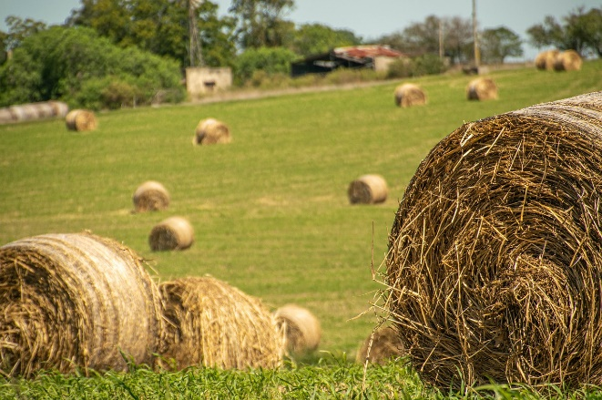
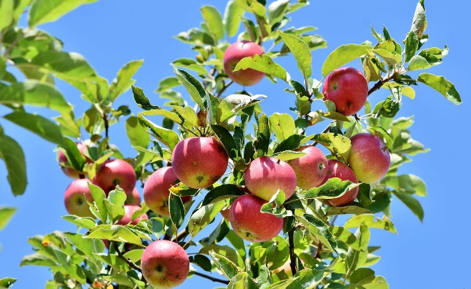
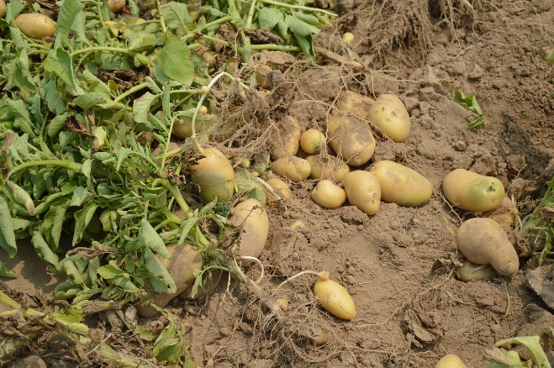
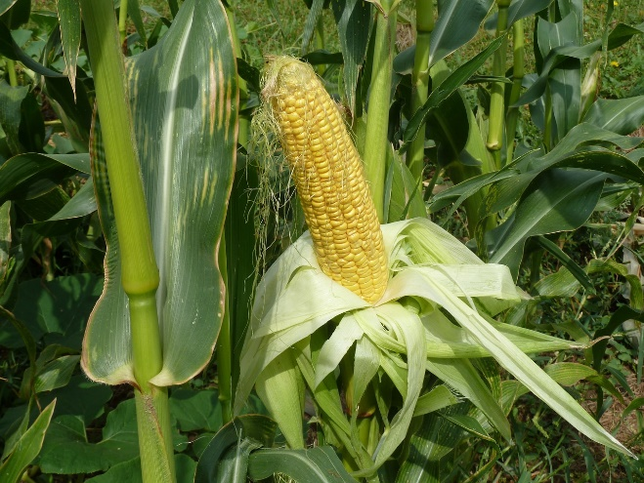
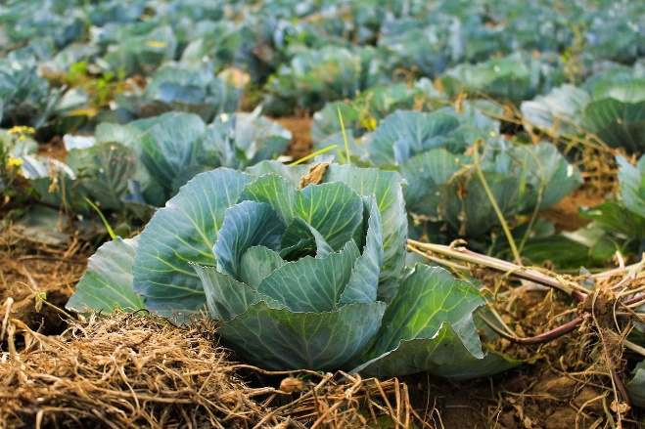
Hay (Alfalfa)
Apples
Potatoes
Sweet Corn
Cabbage
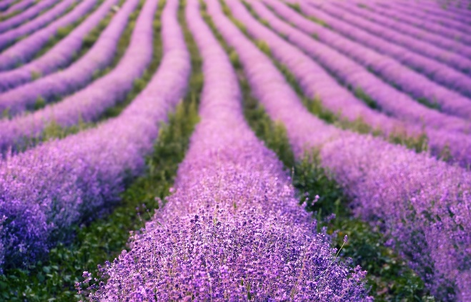
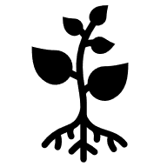
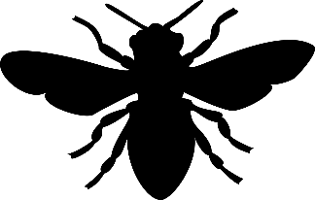

Flowers (Floriculture)
Plants can make flowers without pollination. Bees, butterflies, moths, birds, bats, beetles, wasps and flies all pollinate flowers. Pollination is needed to make seeds.
Alfalfa leafcutting bees are the most common pollinator for alfalfa.
Cabbage is a leaf. Plants can make leaves without pollination. Pollination by bees is needed to make seeds.
Sweet corn is pollinated by the wind.
Potatoes are a root. Plants can make roots without pollination. Potatoes are grown from pieces of other potatoes, not seeds!
Honey bees are the most common pollinator for apples.
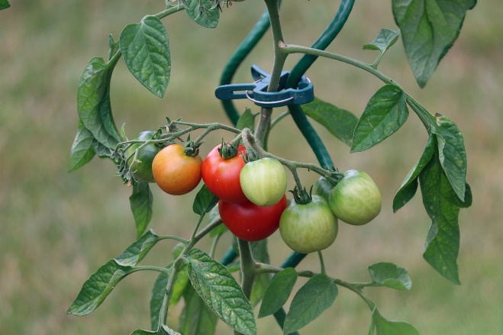
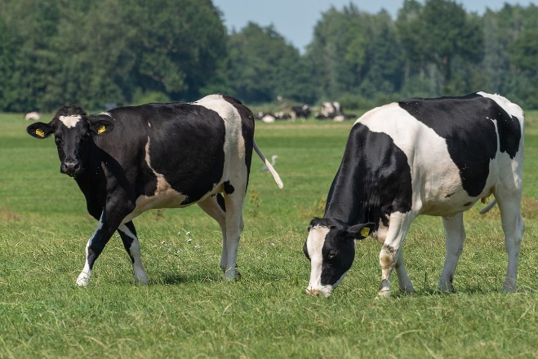
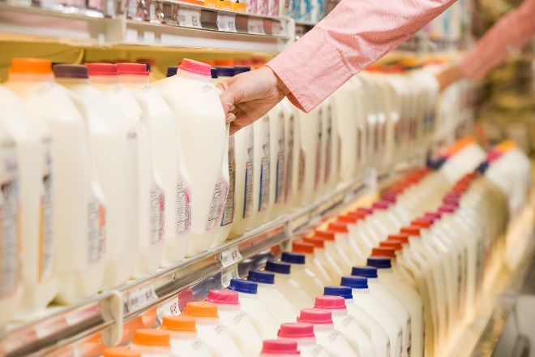
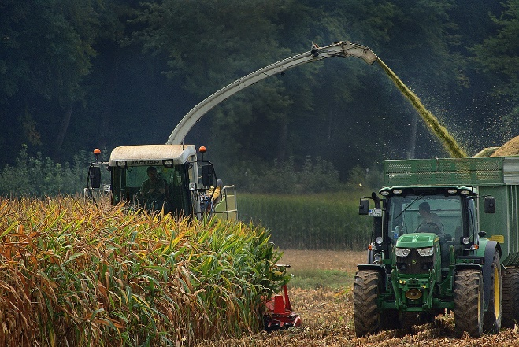
Tomatoes
Cattle
Milk
Corn (for grain)
Tomatoes are pollinated by bumble bees.
Cattle eat hay (alfalfa), which is pollinated by alfalfa leafcutting bees.
Milk comes from cattle, which eat alfalfa pollinated by alfalfa leafcutting bees.
Corn is pollinated by the wind.

Bee Cards
Print these 2 pages and then cut to make 6 cards.

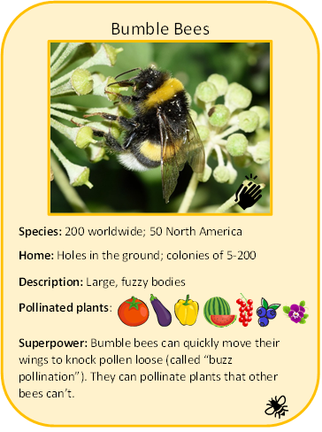
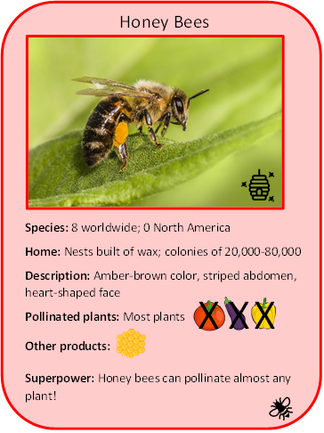

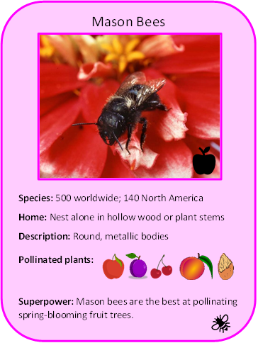
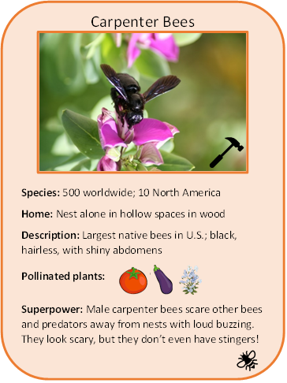
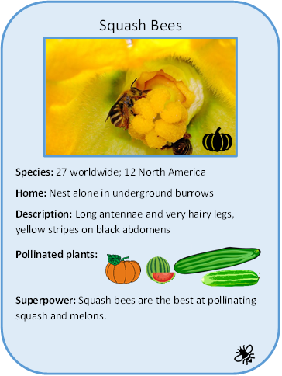
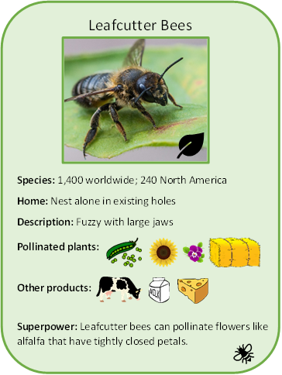

Spaghetti and Meatballs
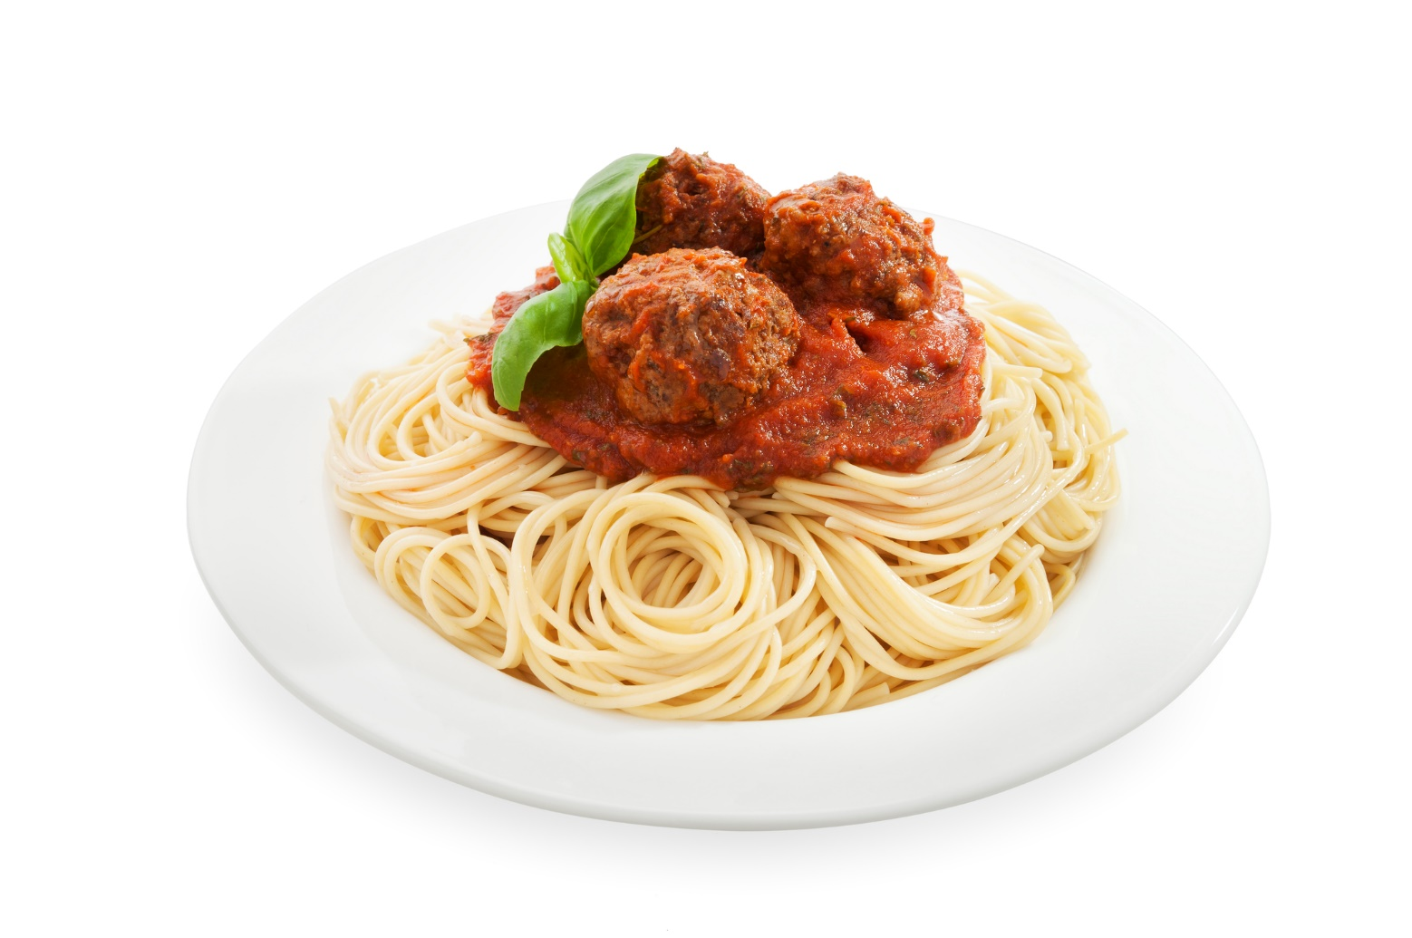

Beef + Tomato + Basil
Yogurt Parfait
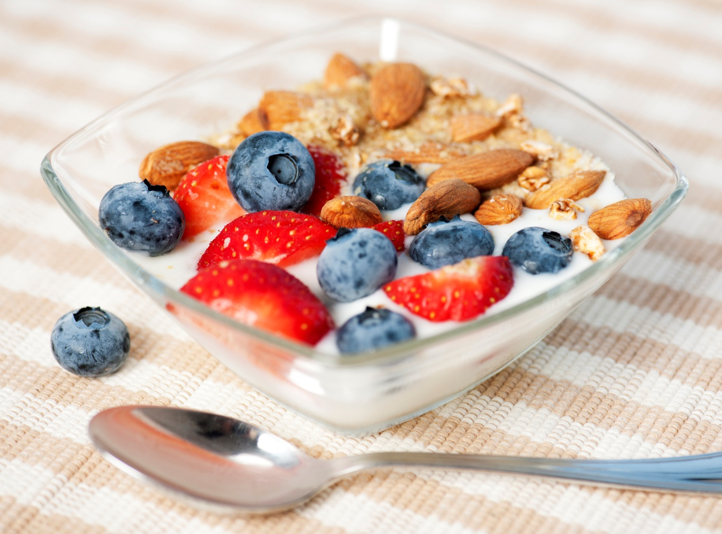

Yogurt + Blueberries + Almond
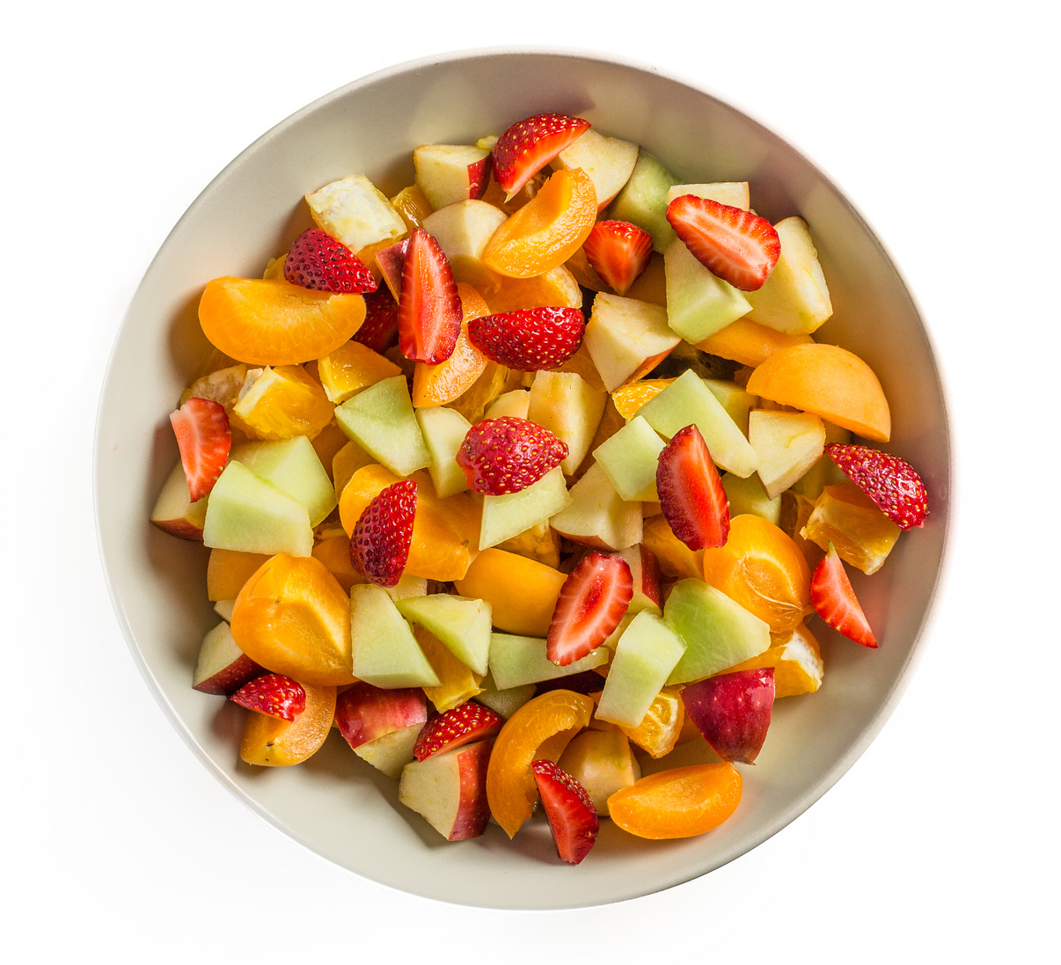
Fruit Salad

Apple + Melon + Berry
Trail Mix
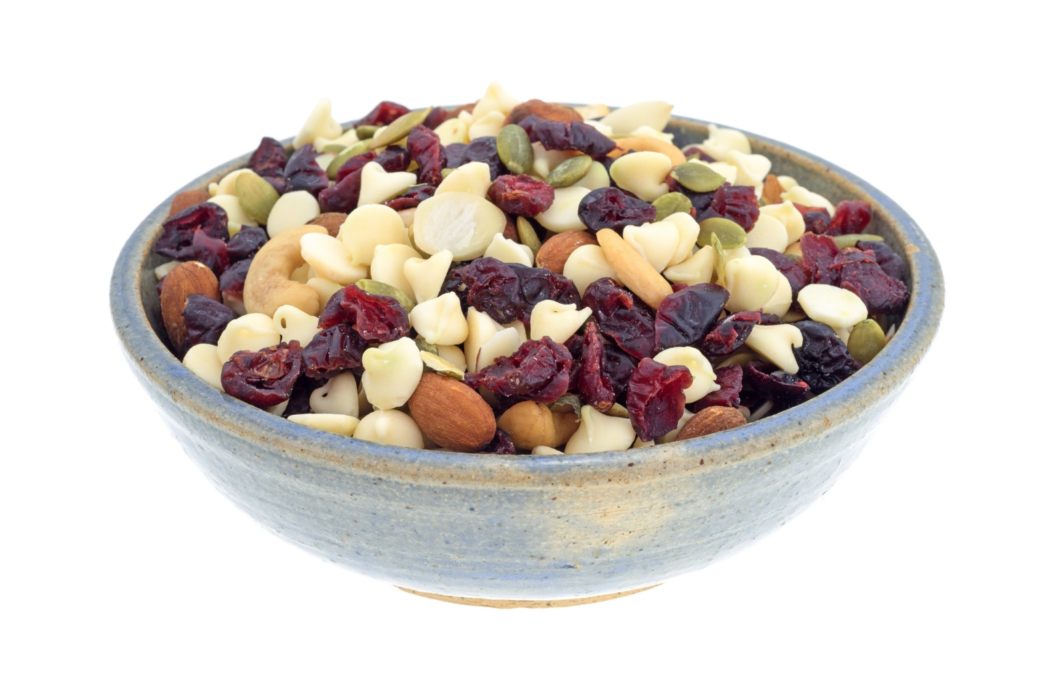

Almond + Pumpkin Seed + Cranberry
Veggies and Dip
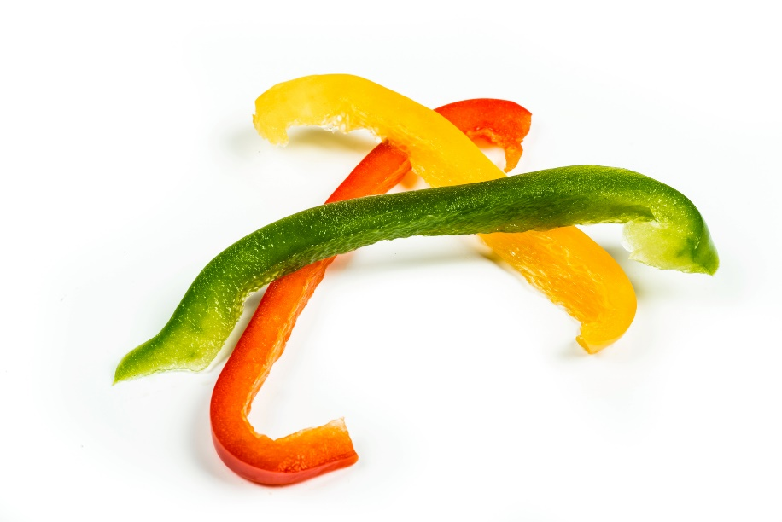
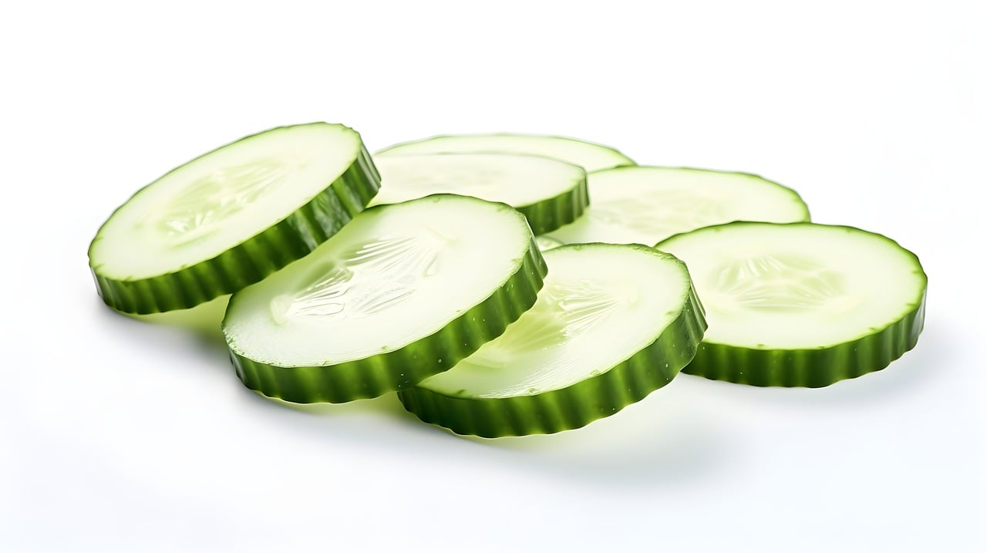
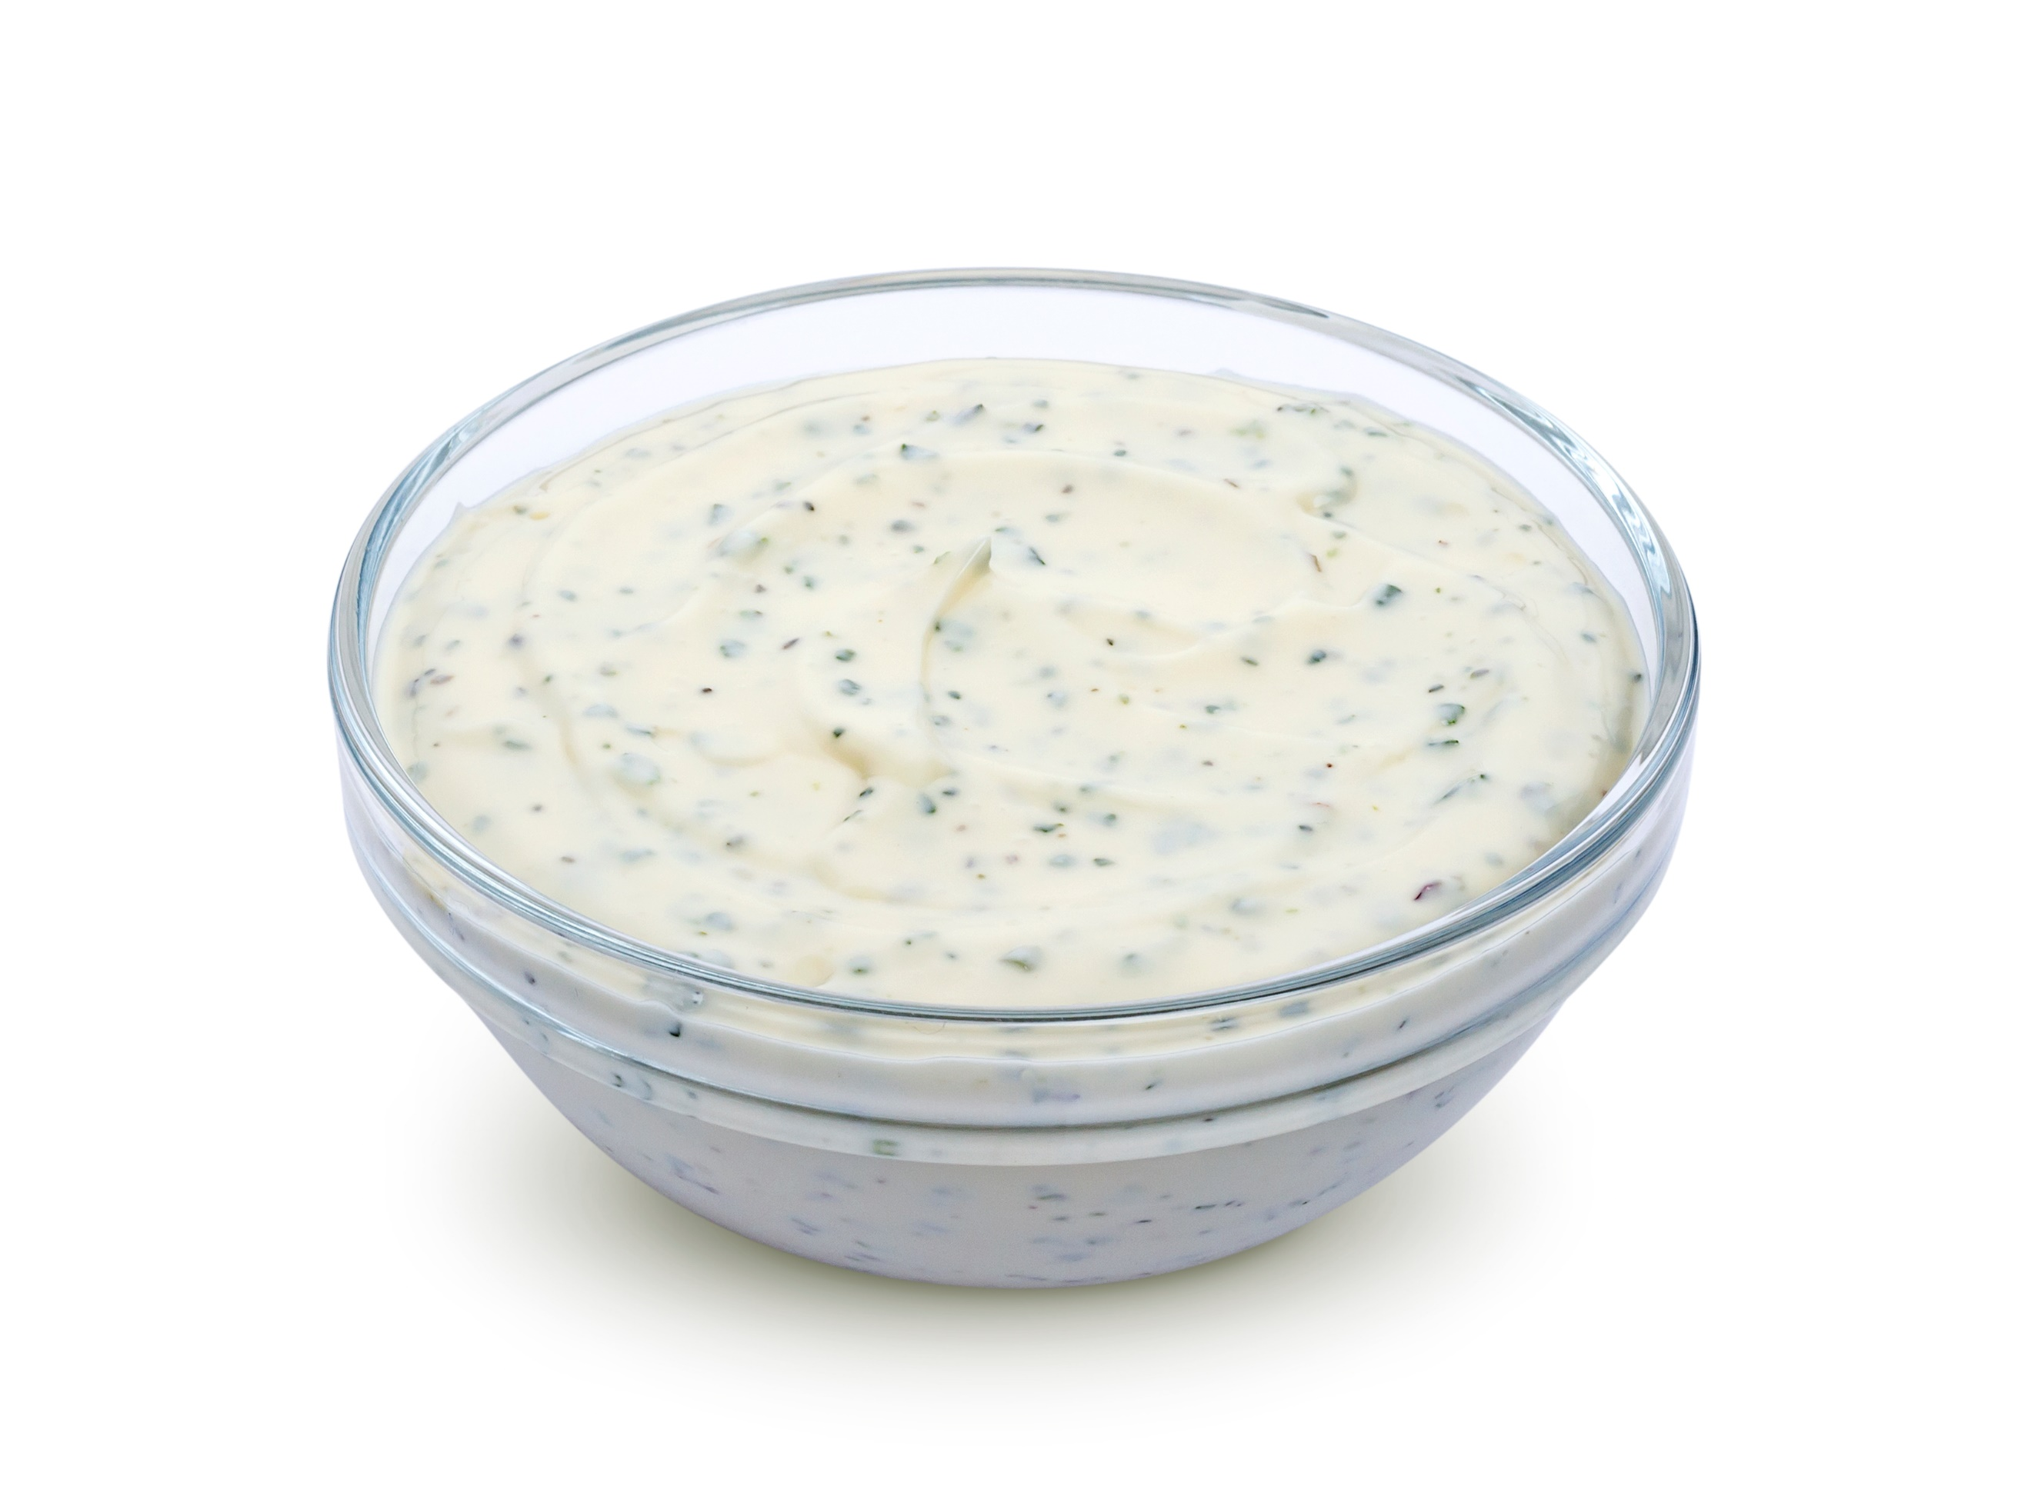

Bell pepper + Cucumber + Cheese

