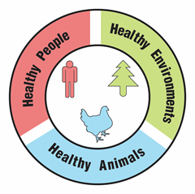
Do Bees Feed You?

Activity Guide

Overview:
Participants will learn what foods rely on pollination. Participants will also learn how they rely on pollinators in their own diets. This activity can be used on its own, or as context for a bee-friendly activity such as a native plant giveaway/planting, insect crafts such as bug hotels/bee baths, pesticide awareness/integrated pest management education, events showcasing local food or honey, and more!

Time Needed:
30-45 minutes. This activity can be adapted for tabling at public events.

Audience:
This activity is recommended for ages 6-adult and for groups of up to 20. It can be adapted for different sized groups and ages.

Objectives: Participants will…
- Classify common foods by pollination method.
- Identify how their own diet relies on pollinators.
- Identify and discuss the importance of pollinators for human food supplies.
- Recognize the connected nature of the health and well-being of humans, animals, and the environment.

Materials:
- Draw your favorite meal handout (or a piece of paper) for each participant
- Pencils with erasers
- Prepared set(s) of Pollination Method Cards
- Optional: Small tokens such as pennies, bingo chips, or erasers
- Optional: Markers, crayons, or colored pencils
- Optional: Copies of How is my Food Pollinated? for each participant (recommended for older audiences or as a take-home at public events)

Copyright © 2025 by University of Rochester. All rights reserved. May be copied for educational use. This activity was developed with support from the National Institutes of Health under Award Number R25GM132758. The content is solely the responsibility of the authors and does not necessarily represent the official views of the National Institutes of Health.

Preparation:
- Print copies of the Draw your favorite meal handout (if you are using it).
- Print and cut out the Pollination Method Cards. Print the cards double-sided. Laminating the cards is recommended if you plan to reuse the cards. You can also cover the cards in clear packing tape to increase longevity.
- Review the How is my food pollinated? handout as background information.
- Note: This activity assumes participants have a general understanding of what pollination is and why it is important. You may need to prepare your group with background knowledge about pollination.
- Adaptation for outdoor education: If doing this activity outdoors, metal baking sheets and small magnets can be used to keep the cards from blowing away during the sorting.
Optional assessment opportunity:
The One Health as a Tool for Informal Assessment activity can be easily integrated into this activity to provide an informal assessment opportunity. Check out the “One Health Connection” boxes throughout for related discussion prompts.

Description of Activity and Suggested Procedure:
    - Ask participants to think about their favorite meal. Provide the Draw your favorite meal handout (or paper) and pencils and ask participants to write a list of the foods or draw pictures of the meal.
- If food is a part of your program or setting, you might ask participants to think about specific foods instead of their favorite meal. For example, if your group has enjoyed a meal or snack together, they can write a list or draw the items in this meal or snack.
One Health Connection:
What do you think might happen to your health if you only ate one type of food?
- You may wish to support participants with additional supplies for drawing their favorite meals, such as markers, crayons, or colored pencils. If so, make sure to collect those supplies before moving on to Step 3.
- Quick variation for public events: You may want to ask participants to close their eyes and visualize their favorite meal instead of writing or drawing.
- Remind participants that pollination is needed for plants to make fruits and seeds. Ask participants what they know about pollination and about pollinators and allow a few minutes for sharing responses. If appropriate for your group, you can have this discussion while participants continue working on their drawings. Make sure that everyone understands the parts of a plant, how plants reproduce, what a pollinator is and what pollination is before moving on to the next step. A diagram of parts of a plant may be helpful; you can find many free printables online.
- Ask participants which of the food items they think depend on pollinators. Ask them to use a pencil to cross out food items on their list/drawing that they think rely on pollinators. Explain that they will be able to change their answers later and encourage them to make their best guess. It is OK if they are not sure. Optional: You can also use small tokens (pennies, bingo chips, erasers, etc.), that can be moved around and reused to place over the food items that depend on pollinators.
  - A note on processed foods: Participants’ favorite meals may include processed foods, and it may be harder to recognize the ingredients. Depending on the age of your group and available time and resources, you may want to support researching the ingredient list. Another strategy is to help participants identify one recognizable ingredient to focus on. For example, is it made of corn or of wheat (flour)? Is there a recognizable flavor, such as chocolate, cheese, or fruit? Is it sweet (does it contain sugar)?
- Pass out the Pollination Method Cards. Ask participants to sort the cards into two piles: foods that depend on pollinators and foods that do not depend on pollinators.
One Health Connection:
What do you notice about the types of foods that depend on pollinators? Are those foods easier or harder to find? Are they more or less expensive?
You can work as a group (recommended for younger audiences) by giving each participant a card to sort and by each person calling out the food listed on their card and having participants vote by giving a “thumbs up” if they think the food depends on pollinators or a “thumbs down” if they do not.
Note: Ensure that participants do not flip over the cards.
- To incorporate physical movement: If your space allows and you are working as a group, the facilitator can read out the food on each card and have participants move to a designated area (such as a corner of the room, either side of a line, or a specific landmark) based on whether they think the food depends on pollinators or not.
- For younger audiences, instead of passing out the cards, the facilitator can read out the food on each card and have participants vote by giving a thumbs up if they think the food depends on pollinators or a thumbs down if they do not.
- Adaptation for larger groups: Divide your group into several smaller groups of about 5 participants. Prepare one set of the Pollination Method Cards for each small group. Have participants work together in their small groups to sort the cards.
- Quick variation for public events: Set the Pollination Method Cards out on a table (or another flat surface). Have designated spaces for cards that depend on pollinators and those that do not, such as small containers labeled with “Depend on pollinators” and “Do not depend on pollinators”. Ask participants to sort some or all of the cards, based on interest. Mix up the cards again in between participants.
- If time permits, discuss the information in this list below with your participants. Some of the information may be surprising to participants!
One Health Connection:
How might wild animals depend on pollinators?
What about plants? Do they need pollinators? What would happen to ecosystems without pollinators?
- Animals such as cows and pigs depend on pollinators for the feed crops that they eat (such as alfalfa). Therefore, dairy products and meat depend on pollinators.
- Products made from wheat, rice, and corn do not depend on pollinators. These crops are wind pollinated.
- Root vegetable plants (such as carrots, potatoes and onions) and leafy green vegetable plants (such as lettuce, cabbage, and kale) produce the part of the plant that we eat without pollination. However, pollination may be required to produce seeds to grow additional plants. Facilitators may want to support both “depend on pollinators” and “don’t depend on pollinators” answers for these types of foods and encourage participants to discuss their answers.
- Ask participants to use what they learned to revise their food lists or drawings. For example: “Are there additional food items that should be crossed out?” and “Did you cross out any food items that don’t depend on pollinators?” Have participants make any necessary updates to their list or drawing. Remember, the goal of this activity is for participants to understand that many foods rely on pollinators; it is OK if their responses are not exactly correct.
One Health Connection:
Do people living in different places have access to the same types of foods? What foods are available where you live?
  - For younger participants, you may want to combine Steps 4-6. Participants can cross off food items that DO depend on pollinators and circle foods that DO NOT depend on pollinators as you go through the cards.
- Wrap-up: As an “exit ticket” or closing discussion prompt, ask participants what food they were surprised to learn did or did not rely on pollination.
- Optional: Send participants home with the How is my food pollinated? handout.

Looking for more ideas?
- Consider having some local, bee-pollinated produce or local honey available for participants to taste!
- Learn about the food system and meet some of the bees that feed us with the Meet the Billion Dollar Bees activity.
- Explore the role of bees in the ecosystem with the Bees and Biodiversity activity.
- Experience the ups and downs of life as a bee by playing the game A Bee’s Life.
- Deepen your understanding of how bees are important for the health of humans, animals, and the environment with The One Health Approach: An Activity Tool.

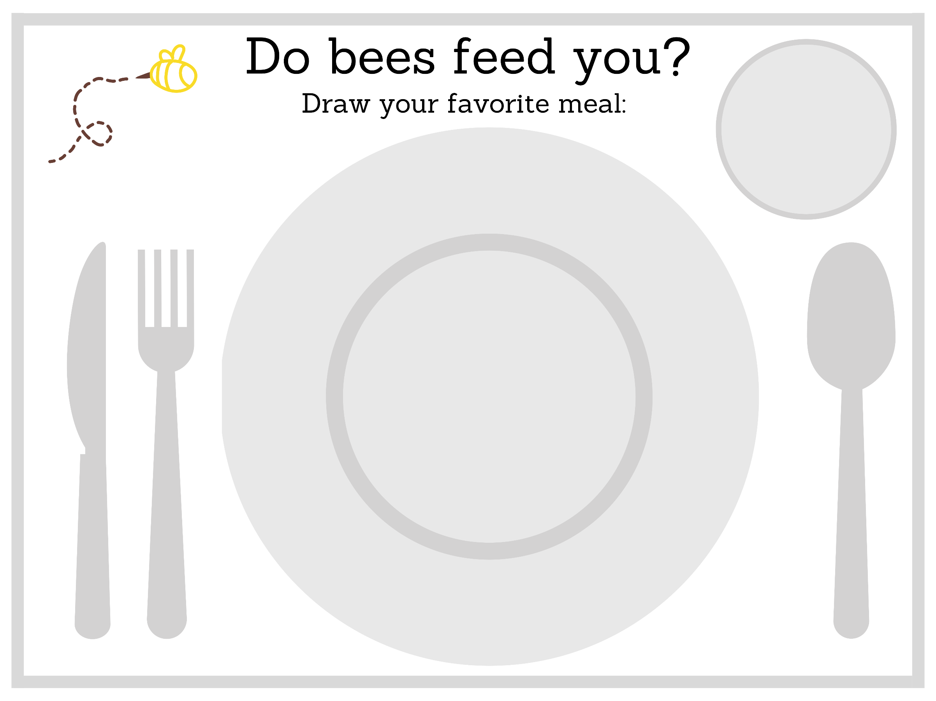

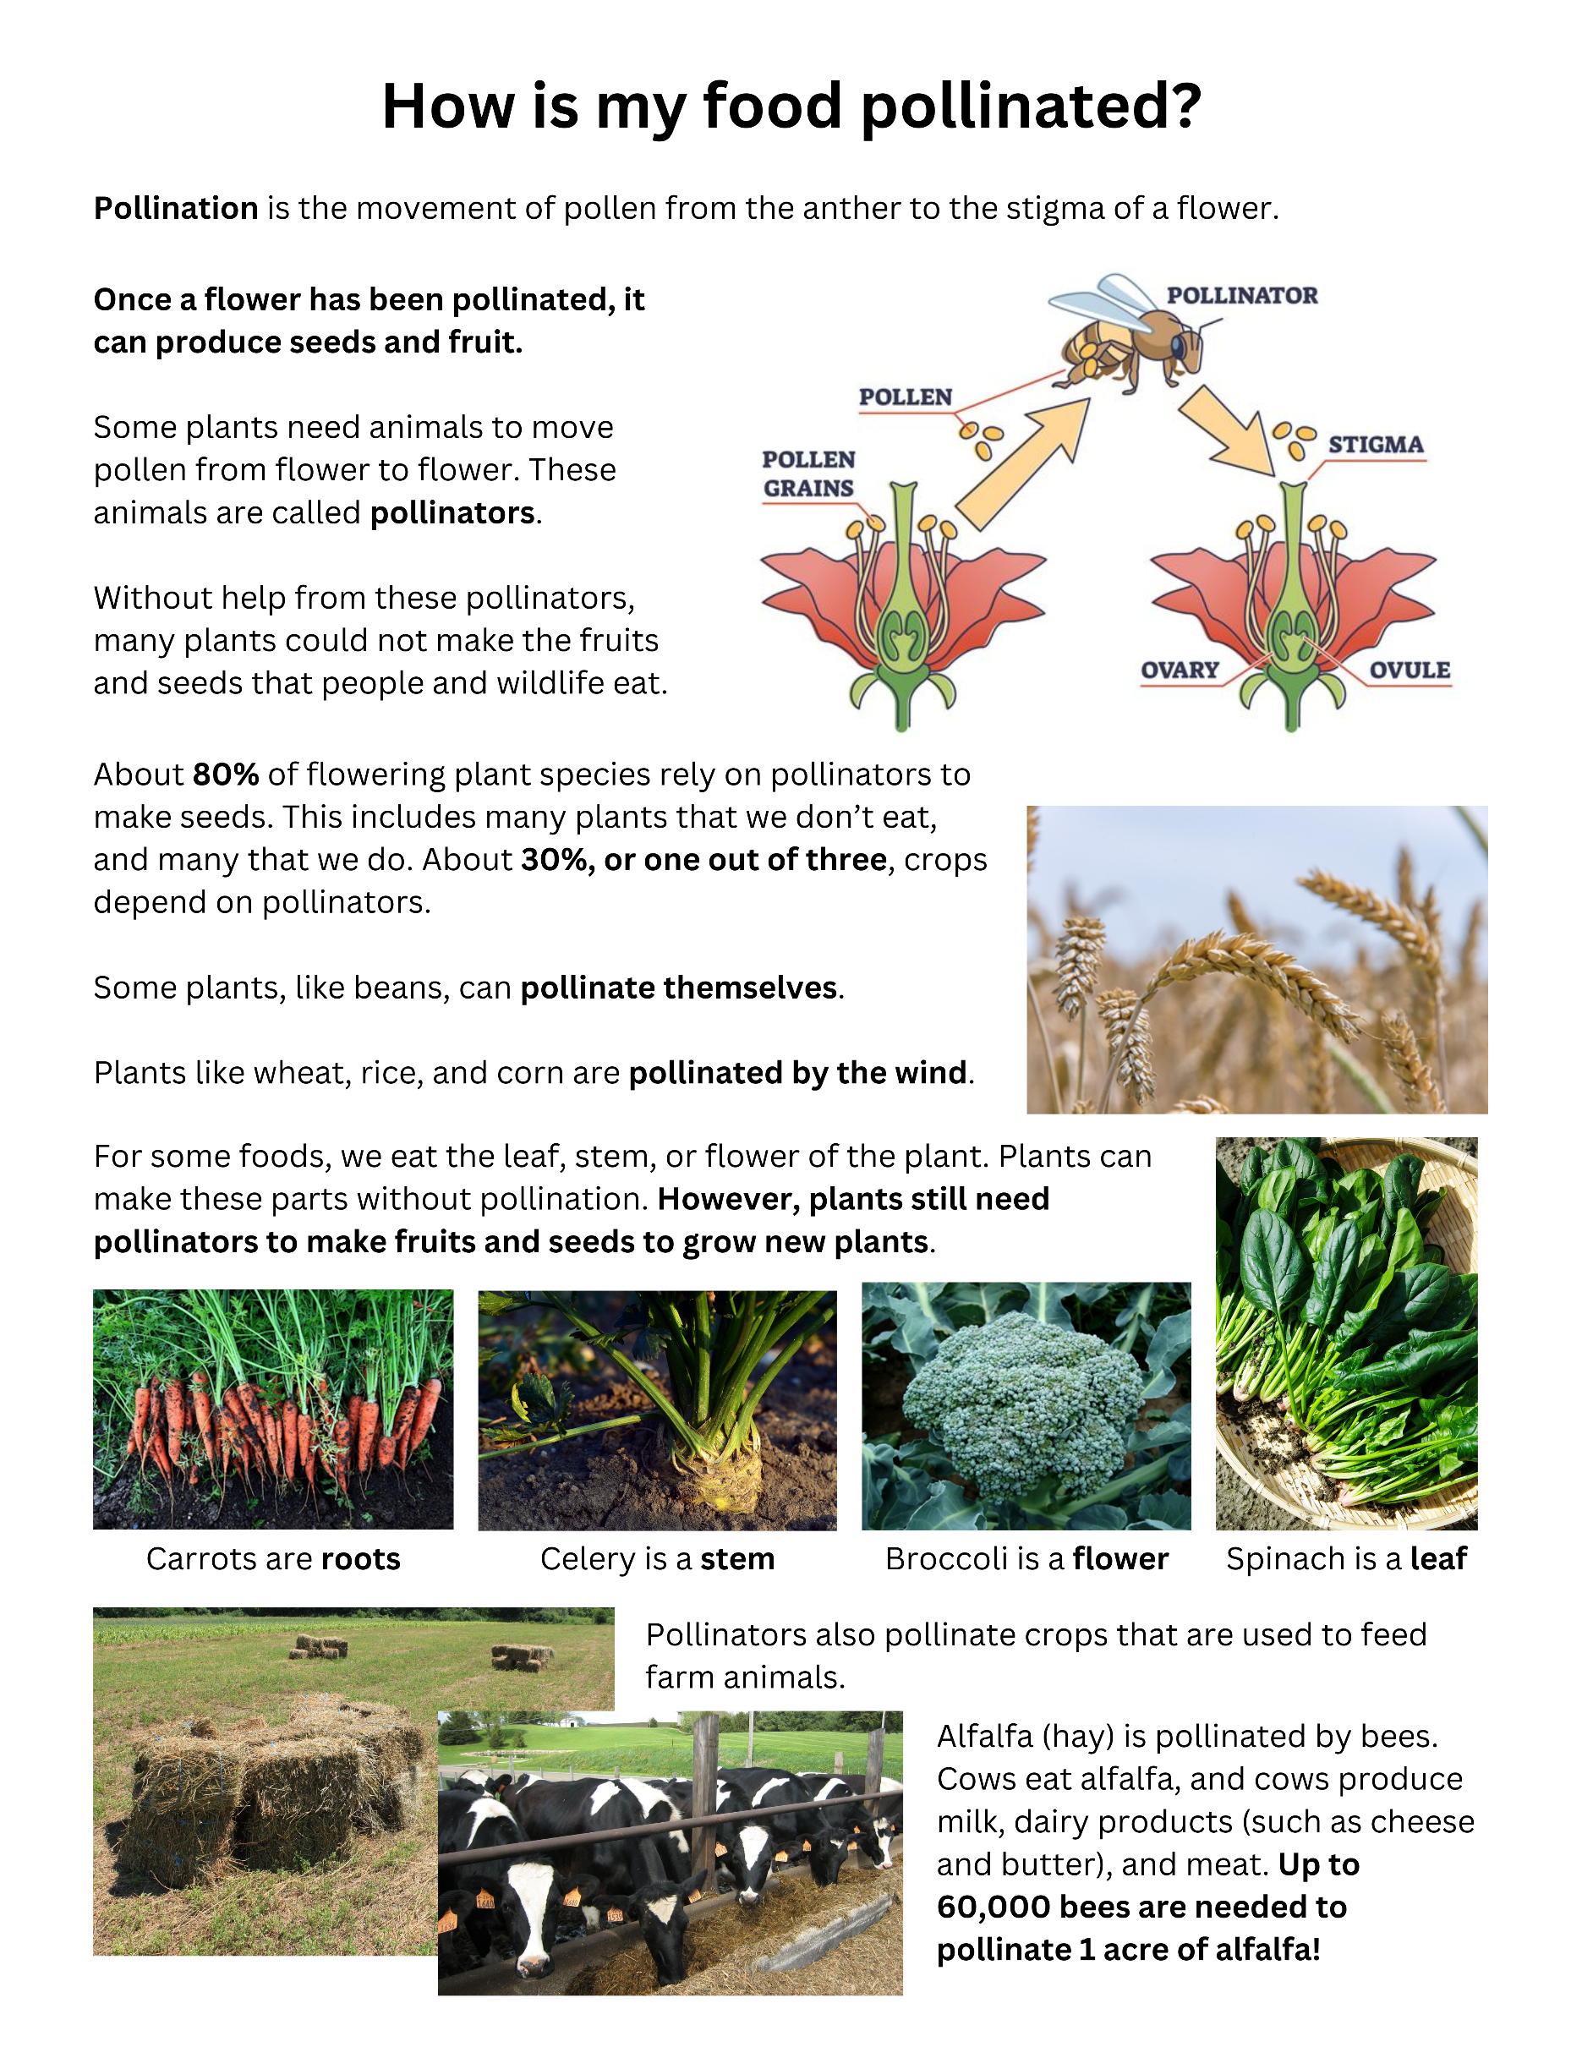
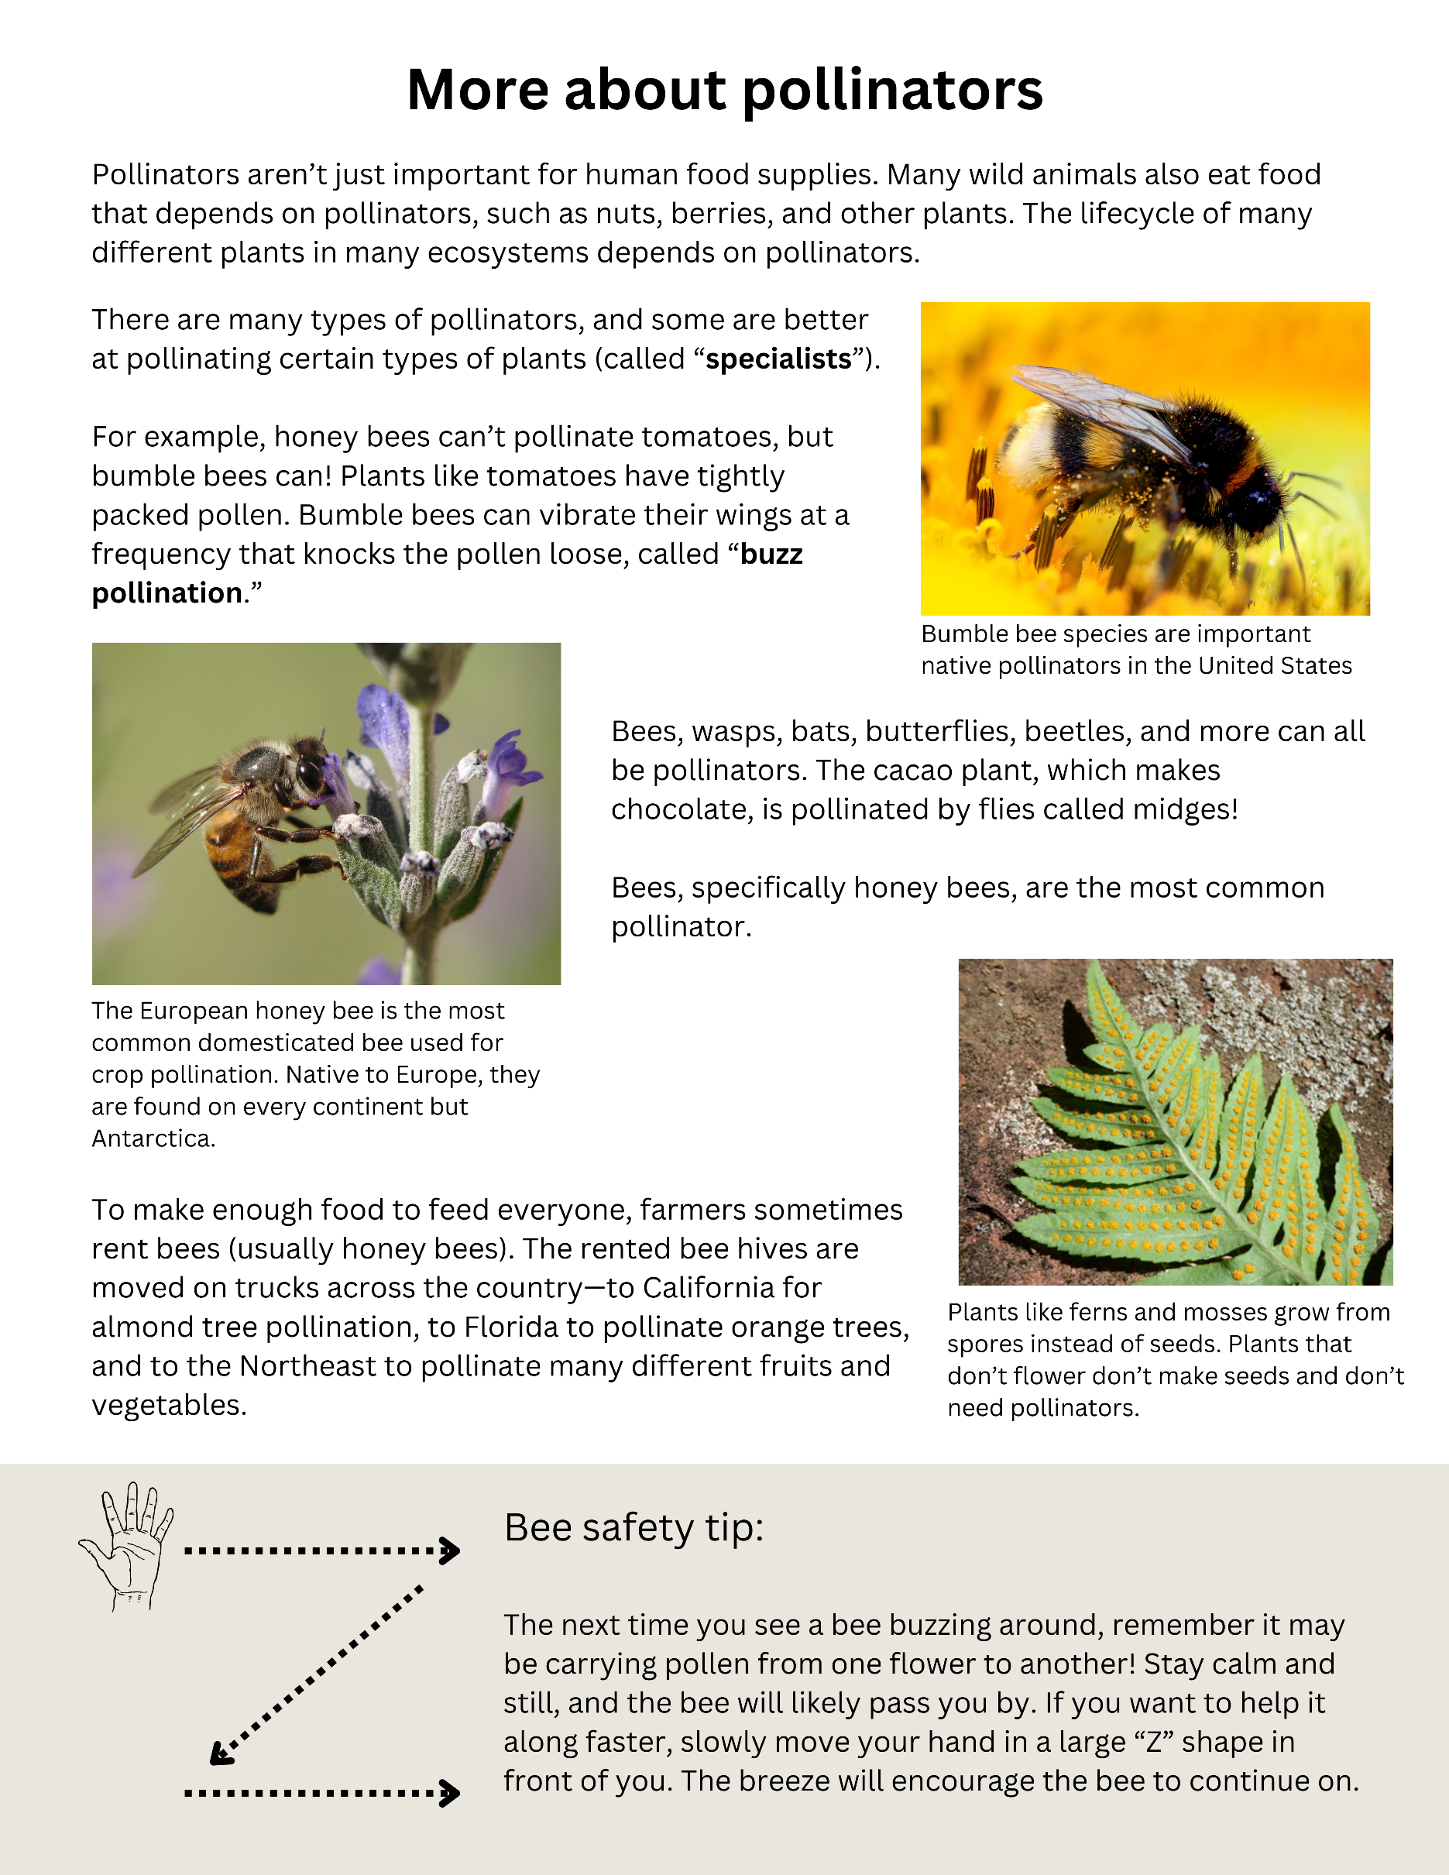

Pollination Method Cards

Print the following 6 pages double-sided and then cut to make 24 cards.
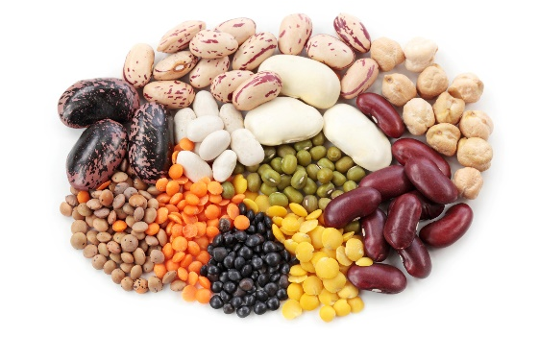
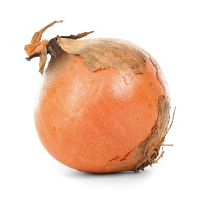
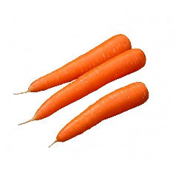
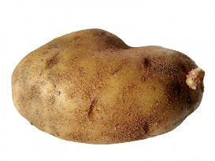
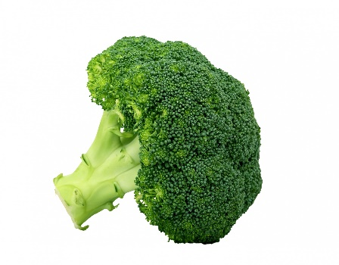
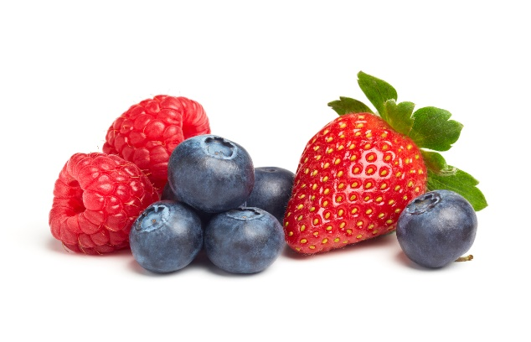
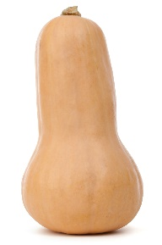
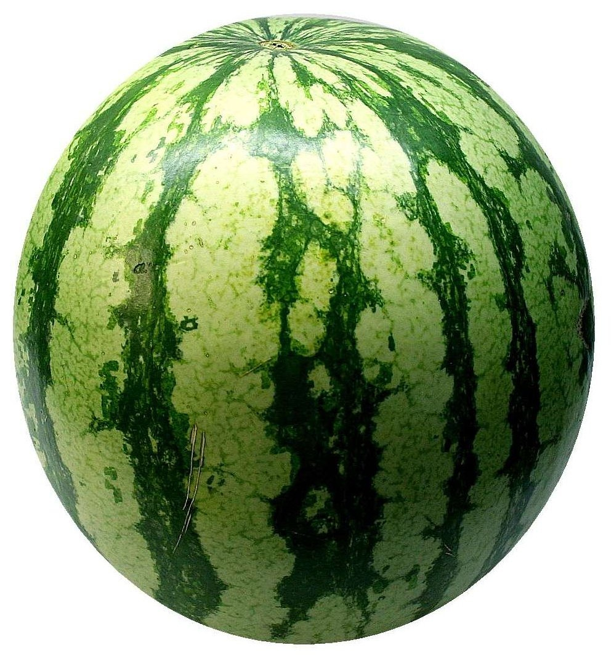
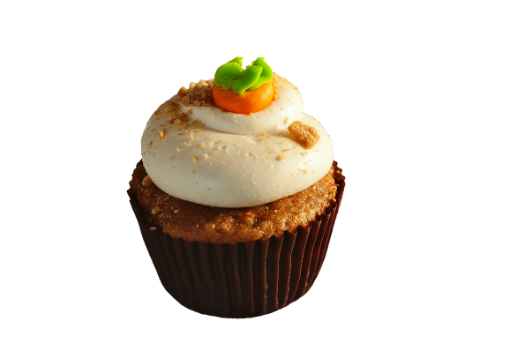
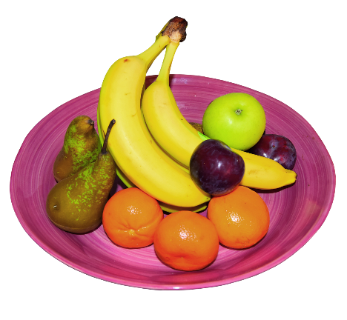
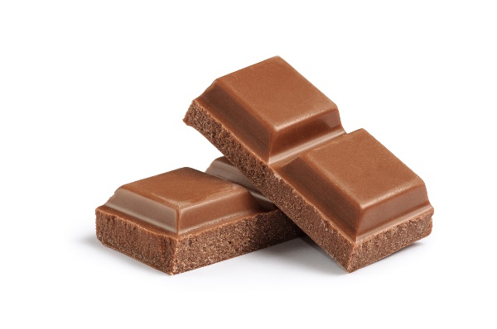
Berries
Squash and Melons
Broccoli
Chocolate
Beans
Root Vegetables
Sugar
Fruit
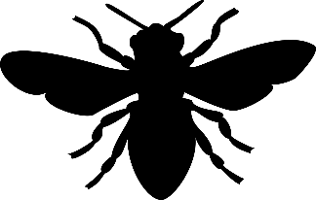
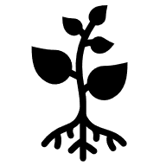
Squash and melon plants are pollinated by bees. There are squash bees that specialize in squash plants!
Fruit trees like apples and oranges are pollinated by bees. Wild bananas are pollinated by bats!
Berry plants are pollinated by bees and other insects.
Sugarcane is pollinated by bees and small insects called thrips.
We eat the root of plants like carrots, potatoes, and onions. Plants can make roots without pollination.
Bean flowers self-pollinate. They don’t need help from pollinators.
Cacao plants are pollinated by bees and small flies called midges.
We eat the flower of the broccoli plant. Plants can make flowers without pollination.
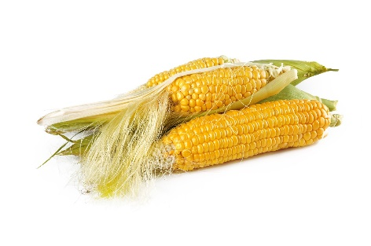
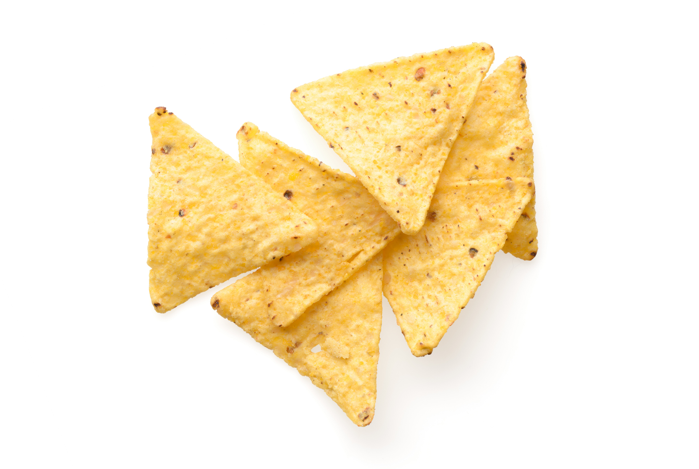
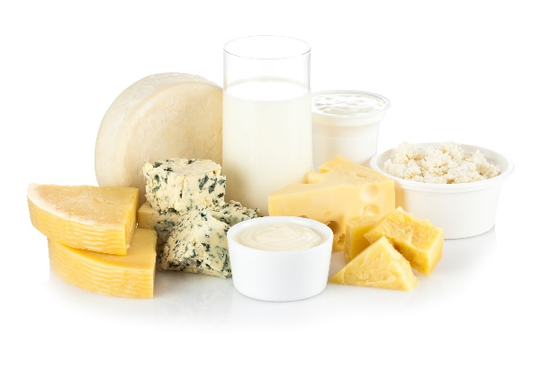
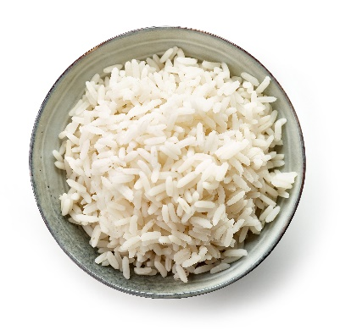
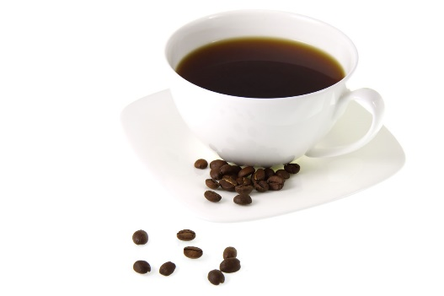
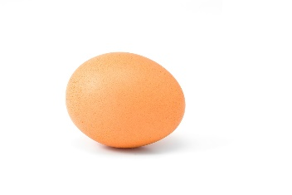
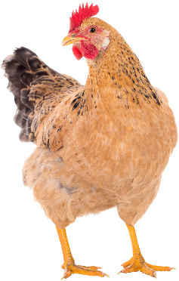
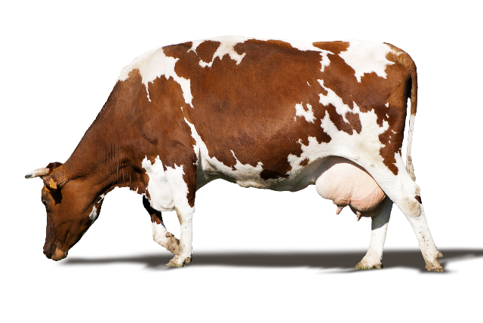
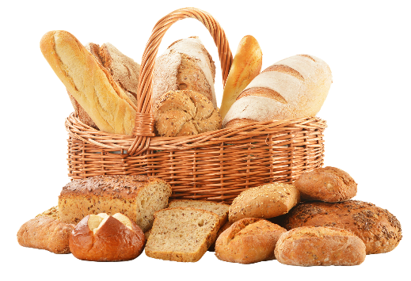
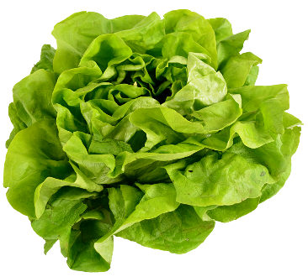
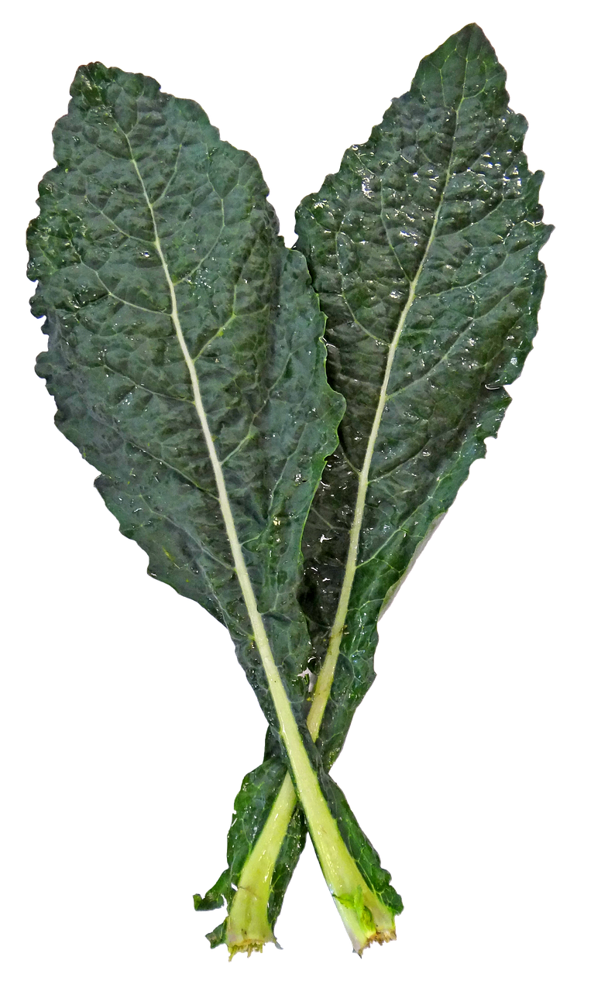
Corn
Dairy
Rice
Wheat
Leafy Greens
Coffee
Chicken/Egg
Beef
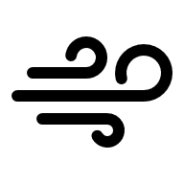
Wheat is pollinated by the wind.
Corn is pollinated by the wind.
Rice is pollinated by the wind.
We eat the leaves of plants like lettuce, spinach, and kale. Plants can make leaves without pollination.
Dairy products come from animals like cows that eat alfalfa. Alfalfa is pollinated by bees.
Chickens eat things like corn, wheat, and soybeans. These are pollinated by the wind.
Cows eat alfalfa. Alfalfa is pollinated by bees. The alfalfa leafcutting bee specializes in pollinating alfalfa!
Coffee plants are pollinated by bees and flies.
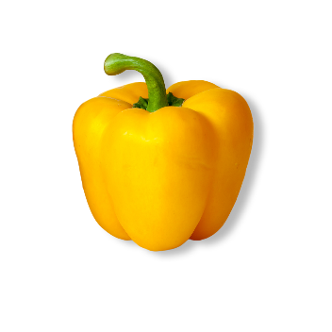
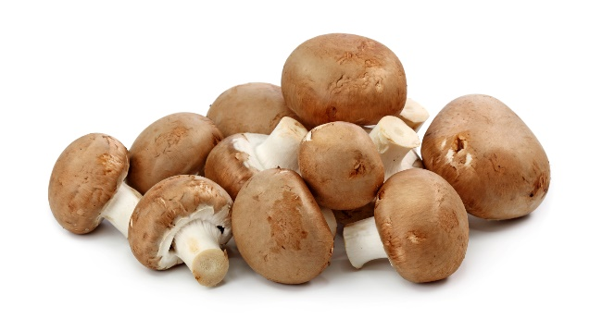
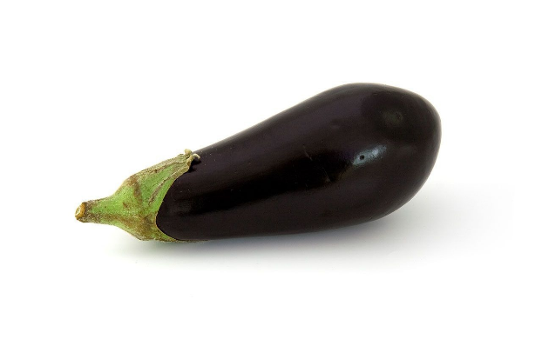
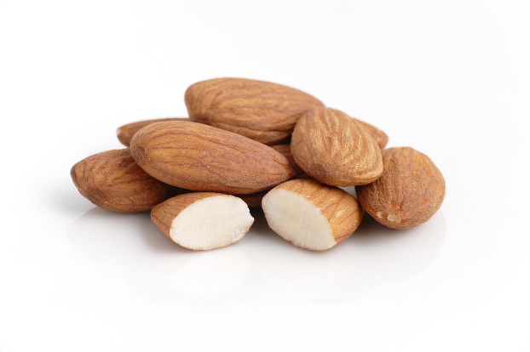
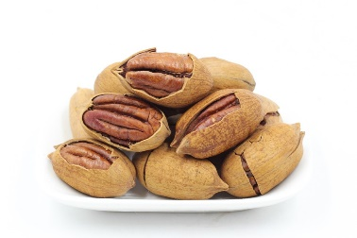
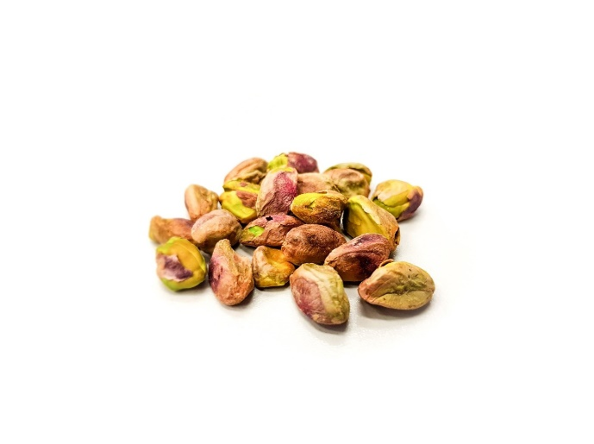
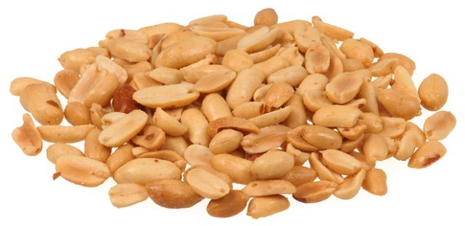
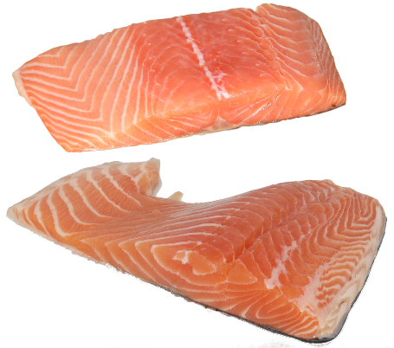
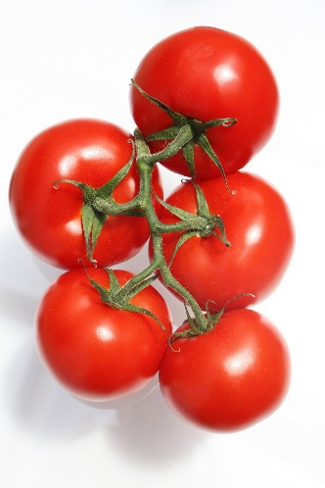
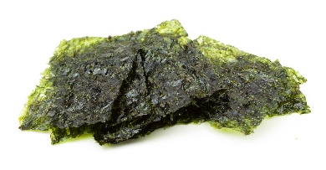
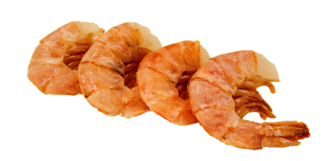
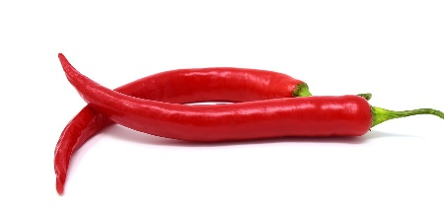
Peppers
Mushrooms
Eggplant
Tomatoes
Almonds, Cashews and Macadamia Nuts
Walnuts, Pecans, Pistachios and Hazelnuts
Peanuts
Seafood
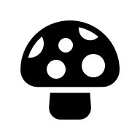
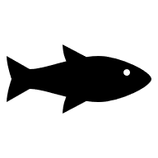
Mushrooms are a fungus, not a plant. Fungi do not need pollinators.
Tomatoes are pollinated by bees.
Peppers are pollinated by bees.
Many tree nuts, like walnuts, pecans, pistachios and hazelnuts, are pollinated by the wind.
A few tree nuts, like almonds, cashews and macadamia nuts, are pollinated by bees.
Peanut flowers self-pollinate. They don’t need help from pollinators.
Seafood does not need pollinators. Seaweed is a type of algae, not a plant. Algae do not need pollinators.
Eggplants are pollinated by bees.

