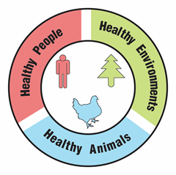
Mosquitoes and a Changing Climate

Activity Guide

Overview:
Participants will examine local climate trends and discuss potential impacts of climate change on mosquito populations and the spread of mosquito-borne disease. This activity can be used on its own, or as context for an activity about climate change (we recommend mitigation and adaptation, extreme heat, or flooding as particularly relevant connections).

Time Needed:
30-45 minutes

Audience:
This activity is recommended for ages 12 and up and for groups of up to 30. It can be adapted for different sized groups and ages, and for tabling at public events.

Objectives: Participants will…
- Describe the climate in their region.
- Interpret trend data in maps (temperature and precipitation change) and graphs (change in mosquito days).
- Analyze and compare information to match trends in mosquito days to known locations.
- Compare maps of climate trends and mosquito distribution.
- Predict trends in mosquito distribution.
- Recognize the connected nature of the health and well-being of humans, animals and the environment.

Materials:
- Change in Annual Precipitation map
- Change in Annual Temperature map
- Distribution of Asian Tiger Mosquitoes map
- Mosquito Days Graphs
- City Climate Descriptions table
- Asian Tiger Mosquitoes: Vectors for Diseases handout
Copyright © 2025 by University of Rochester. All rights reserved. May be copied for educational use. This activity was developed with support from the National Institutes of Health under Award Number R25GM132758. The content is solely the responsibility of the authors and does not necessarily represent the official views of the National Institutes of Health.
- Optional: Mosquito Life Cycle handout - https://www.cdc.gov/mosquitoes/pdfs/AedesLifeCycle-P.pdf
Also available in Spanish - https://www.cdc.gov/mosquitoes/pdfs/AedesLifeCycle_ESP-P.pdf
- Optional: Drought Conditions handout
- Optional: 3 Ways to Reduce Mosquito Bites in Your Yard handout

Preparation:
- Print copies of the 3 maps - Change in Annual Precipitation, Change in Annual Temperature, and Distribution of Asian Tiger Mosquitos
- Print copies of the Asian Tiger Mosquitoes: Vectors for Diseases handout
- Print copies of the Mosquito Days Graphs and cut into 6 cards
- Print copies of the City Climate Descriptions table
- Optional: Print copies of the Mosquito Life Cycle (if you are using it)
- Optional: Print copies of the Drought Conditions handout (if you are using it)
- Optional: Print copies of the 3 Ways to Reduce Mosquito Bites in Your Yard handout (if you are using it)
Optional assessment opportunity:
The One Health as a Tool for Informal Assessment activity is recommended for use along with this activity to provide an informal assessment opportunity. Check out the “One Health Connection” boxes throughout for related discussion prompts.

Description of Activity and Suggested Procedure:
- Ask participants if you have a lot of mosquitoes where you live, compared to other places. Ask participants if they think the number of mosquitoes where they live is changing. Explain that today you will find out the answers to these questions!
- Review the mosquito life cycle by using the Mosquito Life Cycle handout, or by watching this video from HHMI BioInteractive (choose the method most appropriate to your setting, time, and group). The mosquito life cycle depends on warm temperatures and on standing water.
  - Optional: Show this short video from Duke University that discusses climate change, One Health, and malaria.
- Ask participants if they think the weather impacts mosquitoes, and how. In what type of weather do they typically see mosquitoes? Explain that mosquitoes need warm, humid weather.
- Ask participants to describe the typical weather in their local area. Is it often hot? Humid? Is there a lot of precipitation? Explain or remind participants that weather may vary day to day, season to season, or even year to year. An area’s climate refers to the typical weather conditions in that area over a long period of time – the average weather over 30 years or more. Ask participants to describe the climate in their area. Did their responses change?
- Show or give participants the maps of Change in Annual Precipitation and Change in Annual Temperature. These maps show the change in average precipitation and average temperature for the present day (1986-2015) compared to historical data (1901-1960).
One Health Connection:
Are the effects of climate change the same everywhere? Who is most vulnerable?
  - Note: This activity can be done as individuals, pairs, or small groups of up to 4. Divide your group up into the desired group size at this step and make sure each group has at least one copy of each map. For younger audiences, the facilitator can do the activity with the entire group.
  - Data for the Change in Annual Precipitation map compares the average precipitation between 1986-2015 to the average precipitation between 1901-1960, in percent change (0% would be no change). Brown areas are drier and blue-green areas are wetter.
  - Data for the Change in Annual Temperature map compares the average annual temperature between 1986-2016 to the average annual temperature between 1901-1960, in degrees Fahrenheit. Red areas are getting hotter and blue areas are getting colder.
- Ask participants to find their local area on the maps. Is it getting drier or wetter in their local area? Hotter or cooler? Are these changes in climate or weather, and how do they know?
- Have participants set the maps aside. Introduce the idea of “mosquito days”. These are days when the average relative humidity is at least 42% and daily low and high temperatures are between 50- and 95-degrees Fahrenheit. Ask participants if they think their local area has a lot of mosquito days. Do they think the number of mosquito days is changing, and how (more or less)?
  - Optional: Climatecentral.org has mosquito day trend graphics available for many U.S. cities. If one is available for your city or one nearby, look it up to check your prediction.
- Ask participants to imagine that they have been given the opportunity to move to one of 6 cities, but all they know about the cities are the number of mosquito days. Tailor this scenario to your audience. Some example scenarios include:
  - For adults: You have been offered a job at a company with offices in these 6 cities.
  - For older teens: You are considering colleges in these 6 cities.
  - For younger participants: Your family will be moving to one of these 6 cities.
  - Why they should care: Maybe they…enjoy playing outside, working in the garden, have a dog (mosquitoes carry heartworm), play sports outside, etc. You can even source this list with participants!
- Pass out the Mosquito Days Graphs (1 set per group). Review one of these graph cards as a whole group – identify the axis labels, change in number of mosquito days, and city letter (A-F). Challenge participants to choose which city they would like to move to, and discuss their choice and reasoning with their group or partner. Once most people are finished, allow a few volunteers to share their answers with the whole group.
- Pass out the City Climate Descriptions table. Now participants will be able to identify which city they’ve chosen to move to. Challenge participants to match the Mosquito Days Graphs to the cities labeled on the table and on the maps. Have participants write the city letter (City A – City F) on the card in the first column of the table next to the city name they think it matches. See below for the answer key. After the participats make their matches, ask if they still want to move to their chosen city, and why or why not!

Mosquito Days Graph | City | Hints
City A | Phoenix, Arizona (AZ) | Phoenix is getting hotter and drier, so the number of mosquito days is decreasing. Because Phoenix is typically hot and dry, it has few total mosquito days each year.
City B | Rochester, New York (NY) | Rochester is getting hotter and wetter. The number of mosquito days is increasing. Rochester has a colder climate than many of the other cities, which limits the total number of mosquito days each year.
City C | Miami, Florida (FL) | Miami has a warm and wet climate. The number of mosquito days are increasing. Most days of the year are mosquito days in this climate.
City D | Austin, Texas (TX) | Austin is getting hotter and wetter. It is a hot, wet climate so typically has a lot of mosquito days. Many days of the year are now too hot for mosquitoes, so the number of mosquito days is decreasing.
City E | San Francisco, California (CA) | San Francisco has a wet climate. Warming temperatures have allowed for more mosquito days. It has a milder climate than other cities, meaning more possible mosquito days per year than cities like Rochester.
City F | Billings, Montana (MT) | Billings has a dry climate with hot summers and cold winters, so it has few total mosquito days each year. The number of mosquito days has not changed.
  - Note: Participants may need to use all the available information to identify the matches. Encourage them to consider:
    - Change in number of mosquito days.
    - Total number of mosquito days per year (the left axis of the graph).
    - Typical climate of the city and definition of a mosquito day. Remember that very hot summers (days above 95 degrees), long or cold winters, or a dry climate (low humidity) may limit the possible number of mosquito days.
    - Trends in precipitation or temperature on the maps.
    - If participants are stuck, use the hints in the table above to help.
  - Quick variation for public events: Have participants match the city letters to the city name directly on the map, instead of filling out the answer table. You might use moveable tokens such as paper arrows with “City A” (etc.) written on them or laminate the map and write the answers in dry erase marker. Depending on time and interest, you could also have them guess once and then give them the answer.
- Show or give participants the Distribution of Asian Tiger Mosquitoes map. Explain that the Asian tiger mosquito is an invasive species of mosquito originally found in the tropics. They were first introduced in Texas in 1985. Since then, Asian tiger mosquitoes have spread to many parts of the United States. These mosquitoes are active during the day, and bite aggressively. They can spread diseases affecting both humans (like Zika virus) and animals (like heartworm). Ask participants to find their local area on the map again. Do Asian Tiger Mosquitoes live in your area already?
One Health Connection:
Are mosquitoes “bad”? What are some ways that mosquitos serve a role in the environment?
- Ask participants to compare the Distribution of Asian Tiger Mosquitoes map to the maps of temperature change and precipitation change. Ask participants to use what they know about mosquito habitat (hot, humid) and trends in precipitation and temperature in your area to predict whether the distribution of the Asian tiger mosquito species is likely to change. Are these mosquitoes likely to expand into your local area, if they don’t already live there?
One Health Connection:
How might changes in mosquito distribution affect human, animal, and environment health?
Optional extension: As participants to predict if Asian tiger mosquitoes already live or are likely to expand into the city they chose to move to in Step 9.
- Show or give participants the Asian Tiger Mosquitoes: Vectors for Diseases handout. Explain that many mosquito species, including Asian tiger mosquitoes, are expanding their range as climate changes. As the mosquito range expands, this will also expand the range of the diseases carried by mosquitoes. Asian Tiger Mosquitoes are not the only type of mosquito that carries disease, and we can’t usually tell what type of mosquito is biting us, so it is important to protect ourselves from mosquito bites.
One Health Connection:
How might the hazards of climate change and mosquito-borne disease intersect?
Who is the most vulnerable?
- Optional drought add-on: If your area is trending towards a drier climate (decreased rain) or fewer mosquito days, participants may wonder what that means for mosquito populations. Use the Drought Conditions handout to explain that even if mosquito populations decrease due to a drier climate, mosquito-borne disease can still be a risk. As animals (including mosquitoes and their prey) gather around diminishing water sources, the crowding may actually increase the percentage of mosquitoes infected with diseases.
  - Note: This concept could be illustrated with the Mosquito Tag activity, by making the playing area smaller.
- Wrap-up: What can we do? We can take 3 simple steps to protect ourselves from mosquitos! Explain the three steps below (interrupt, attract, protect).
  - Interrupt the mosquito life cycle by removing standing water
  - Attract mosquito predators by providing habitat for bats, birds, and other insects
  - Protect yourself by covering your skin, using insect repellant, and avoiding peak mosquito times to avoid bites.
- Optional: Send participants home with the 3 Ways to Reduce Mosquito Bites in Your Yard handout.
Looking for more ides?
- Learn about the mosquito life cycle and mosquito habitat and make an action plan for managing mosquitos in your outdoor space with the A Mosquito-Friendly Yard? activity.
- Explore how mosquitos spread disease with Mosquito Tag.
- Follow-up with a bat-, bird-, or pollinator-friendly DIY activity to attract mosquito predators.
- Combine this activity with an activity on climate change adaptation and mitigation; themes of extreme heat and flooding are especially relevant.
- Deepen your understanding of how mosquitoes relate to the health of humans, animals, and the environment with The “One Health” Approach: An Activity Tool.

Mosquito Days Graphs
Cut into 6 cards

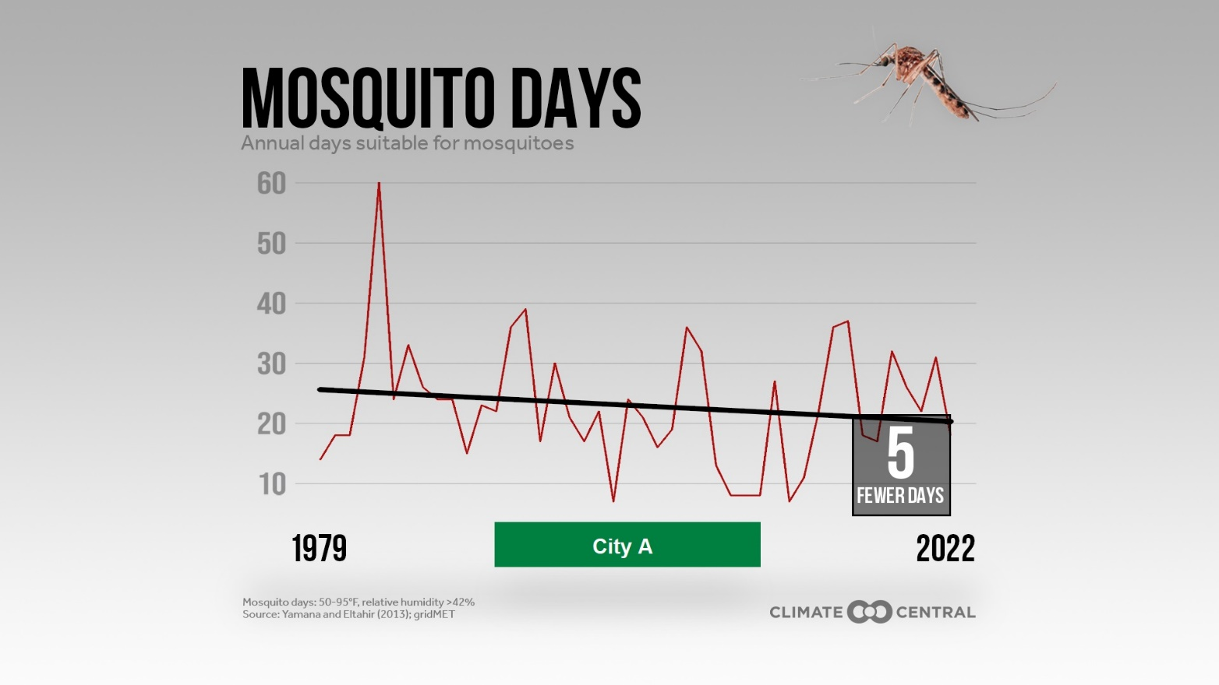
Mosquito days each year

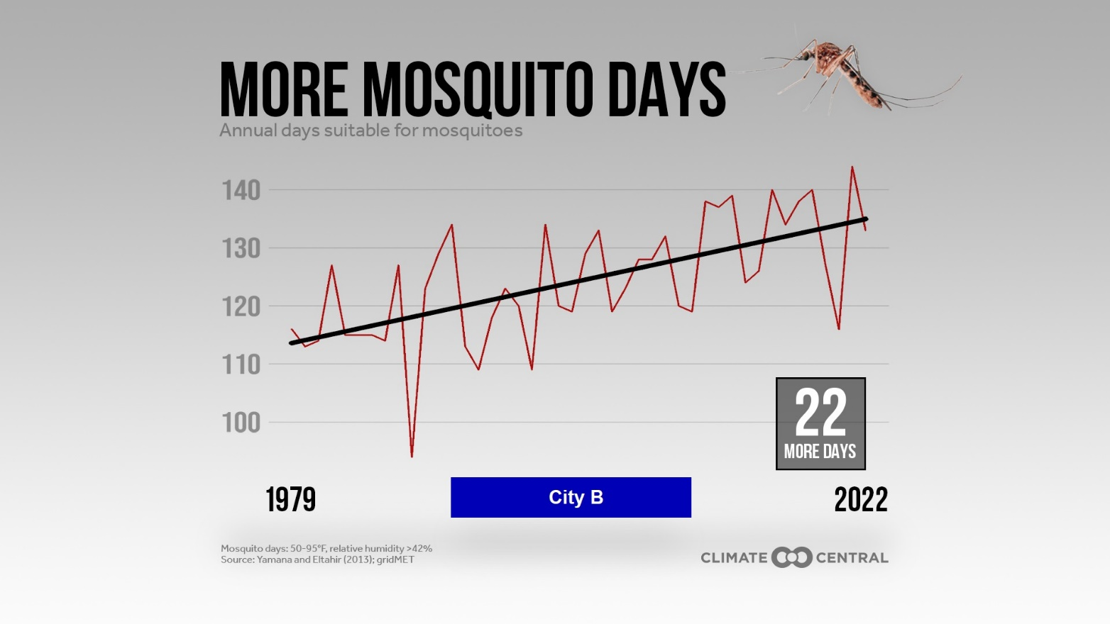
Mosquito days each year

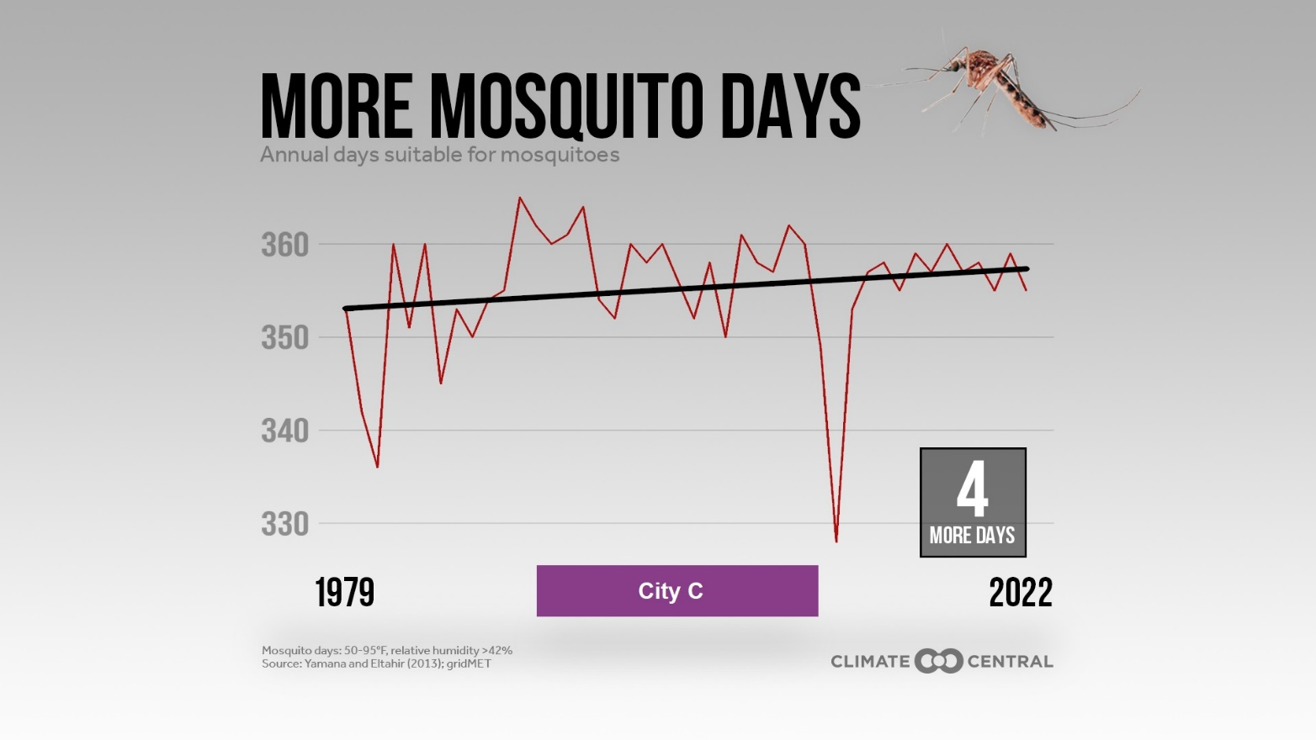
Mosquito days each year

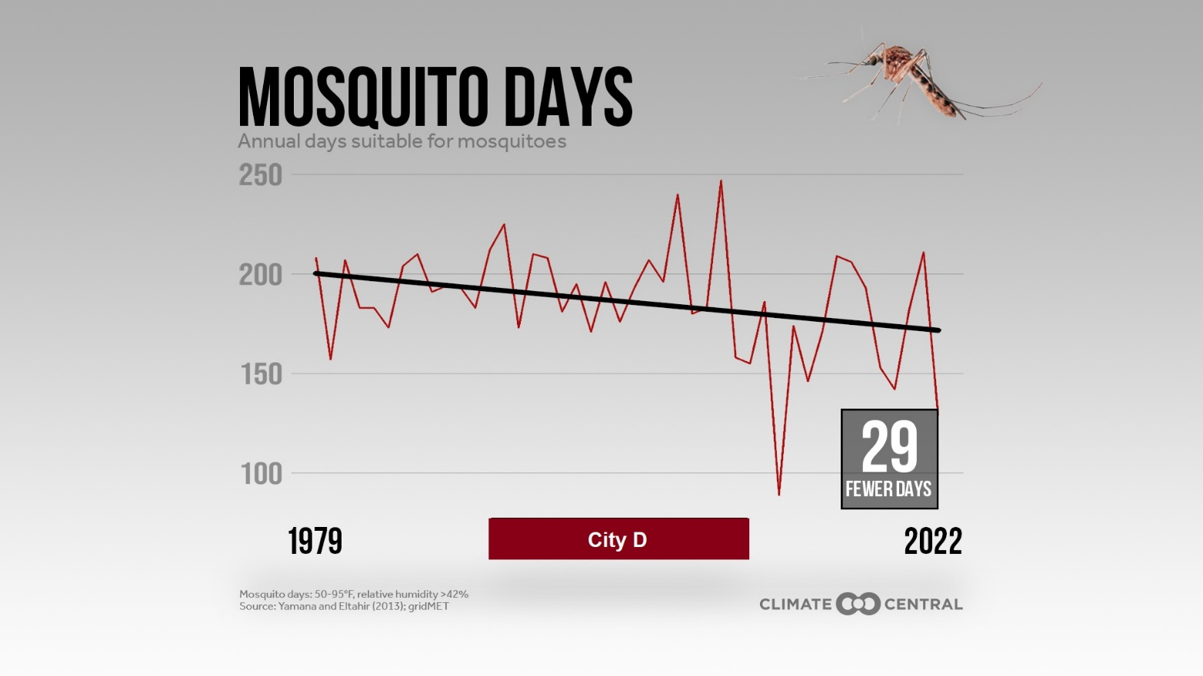
Mosquito days each year

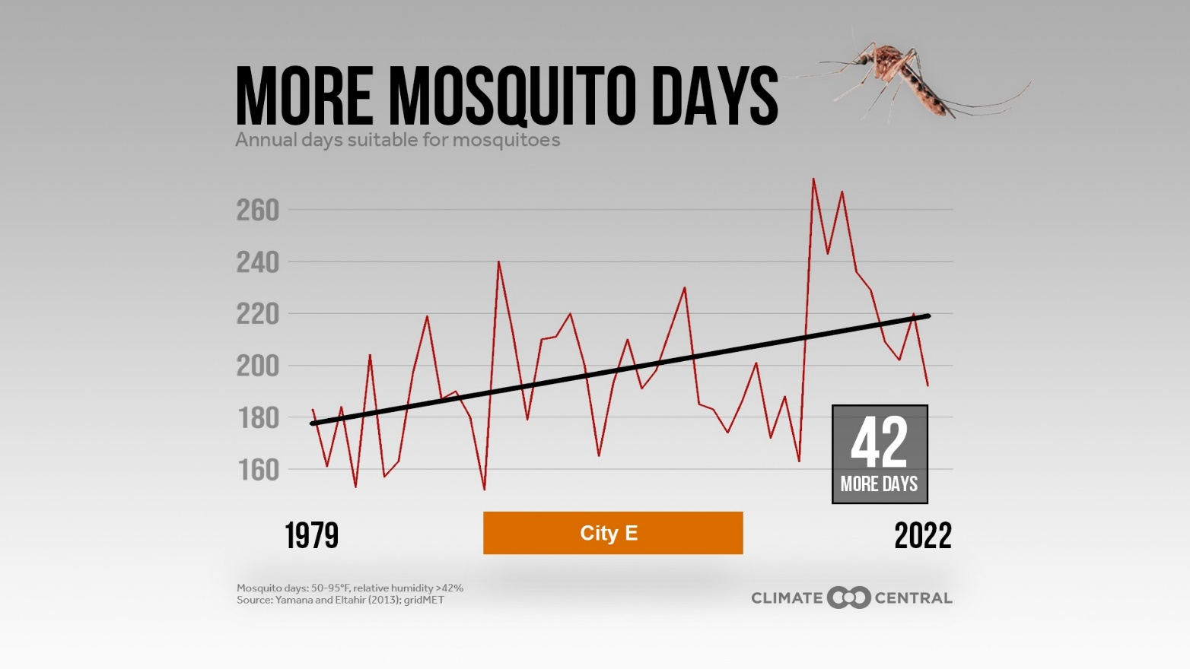
Mosquito days each year

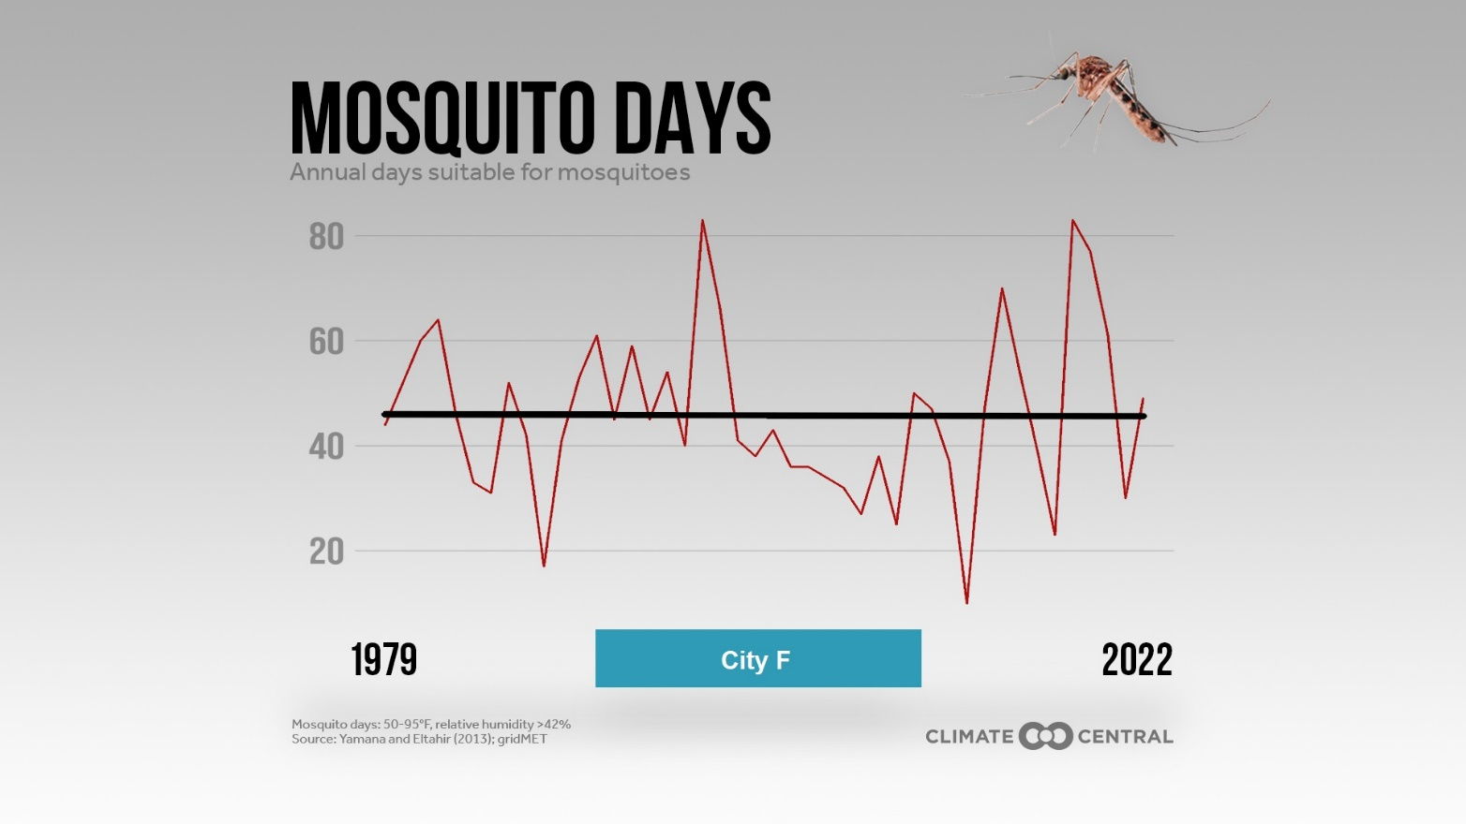
Mosquito days each year

City Climate Descriptions

“Mosquito Days” are days where the high and low temperatures are between 50 °F and 95 °F and the humidity is above 42%.

Match the “Mosquito Days” graphs to the cities below, based on their climate descriptions. Write the letter on the graph (A, B, C, D, E, or F) next to the city you think it matches.

Mosquito Days Graph (letter A-F) | City Name | Biome | Climate | Typical Daily Temperatures  (low-high)
 | Austin,  Texas (TX) | Prairie Grassland | Long, very hot summers and short, mild winters  Can be humid or dry | Summer: 75-95 °F  Winter: 45-65 °F
 | Billings, Montana (MT) | Steppe Grassland | Dry climate with hot summers and cold winters | Summer: 55-90 °F  Winter: 20-40 °F
 | Miami,  Florida (FL) | Tropical Forest | Hot, humid summers and short warm winters | Summer: 80-90 °F  Winter: 45-65 °F
 | Phoenix, Arizona (AZ) | Desert | Long dry, hot summers and short mild winters | Summer: 80-105 °F  Winter: 45-70 °F
 | Rochester, New York (NY) | Temperate Forest | Humid climate with short summers and cold snowy winters | Summer: 60-80 °F  Winter: 20-35 °F
 | San Francisco, California (CA) | Temperate Coastal | Dry summers and wet winters  Similar temperatures year-round | Summer: 55-70 °F  Winter: 45-60 °F

Asian Tiger Mosquitoes: Vectors for Diseases
