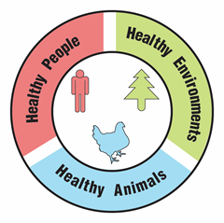
The One Health Approach: An Activity Tool

Activity Guide

Overview:
“One Health” is a globally implemented approach used by experts across disciplines to understand and solve problems affecting the health of humans, animals, and the environment. A key concept of One Health is that people, animals, and the environment are interconnected. Therefore, the health of one can affect the health of the others. This Activity Tool is designed to use the concept of One Health as a lens to deepen participants’ understanding of an environmental or health-related topic. Participants will complete challenge stations, collaborative discussions, and a creative project. Learning about One Health will increase participants' awareness of the impacts of their actions, to empower them to work towards protecting and improving the health of all living beings.

This Activity Tool is designed to build on your group’s learning around another topic. It is recommended to be used to deepen understanding after learning about a topic. For example, groups have used this Activity Tool to deepen understanding of how the health of humans, animals, and the environment are related to ecosystems, chemistry, hurricanes, and pollution.

What is One Health?
“One Health is an integrated, unifying approach that aims to sustainably balance and optimize the health of people, animals and ecosystems. It recognizes that the health of humans, domestic and wild animals, plants, and the wider environment (including ecosystems) are closely linked and interdependent.” - World Health Organization
https://www.who.int/health-topics/one-health
“One Health is a collaborative, multisectoral, and transdisciplinary approach — working at the local, regional, national, and global levels — with the goal of achieving optimal health outcomes recognizing the interconnection between people, animals, plants, and their shared environment.” - CDC
https://www.cdc.gov/one-health/about/

Additional One Health Background Information:
- Infographic from the CDC about the One Health approach
- One Health Linking Human, Animal and Ecosystem Health 3-minute video from Ravenswood Media
- Short article and graphic from Barcelona Institute for Global Health

Copyright © 2025 by University of Rochester. All rights reserved. May be copied for educational use. This activity was developed with support from the National Institutes of Health under Award Number R25GM132758. The content is solely the responsibility of the authors and does not necessarily represent the official views of the National Institutes of Health.

Time Needed:
1.5 – 2 hours (can be broken up into multiple sessions; recommended for younger audiences)

Audience:
This Activity Tool is recommended for ages 6-adult and for groups of 3-18. This activity can be adapted for different size groups and ages, and it can be adapted for tabling at public events.

Objectives: Participants will…
- Explain the concept of One Health
- Identify connections between the health of humans, animals, and the environment
- Examine a specific topic that is relevant to your group, using One Health as a lens
- Create evidence of their understanding of One Health and how it relates to a specific topic that is relevant to your group

Materials:
Part 1 Materials – Hands-on Introductory Activities
Note: Materials listed are for setting up one of each station. You may need to adjust based on your group size. You will need at least one station for each 3 participants.
- Balance the Cup Station
  - 4-5 paper plates
  - 3 pieces of string ~3 ft. long
  - 1 plastic or paper cup
  - Stapler
  - Water or dried beans
  - Water jug (optional)
  - Towels (optional; if using water and the activity takes place inside)
- Draw the Circle Station
  - Clipboard
  - Several pieces of 8.5” x 11” paper (blank, unlined)
  - Packing tape or duct tape
  - 1 Marker
- Stack the Cups Station
  - 1 rubber band
  - 6 plastic or paper cups
  - 3 pieces of string ~3 ft. long
- 1 copy of the instructions for each station (Balance the Cup, Draw the Circle, Stack the Cup)
- One Health Card (1 for each station)

Part 2 Materials – Connect the Concept of One Health to a Selected Topic
- Display board/writing surface for collaborative concept map, for example:
  - Whiteboard, poster board, or cardboard
  - Sticky notes or index cards and tape
- Writing utensils, for example, whiteboard markers, markers, or pencils

Part 3 Materials – Create a Product of Learning
- Supplies for the Product of Learning will vary based on the method you choose; see Part 3 procedure.

Preparation:
- Review the One Health background resources (see the box on Page 1). We recommend reviewing at least 2 of the resources.
- Prepare materials for the Part 1: Balance the Cup station.
  - Staple a stack of 4-5 paper plates together to reinforce them.
  - At three equidistant points around the edge of the plate, staple ~3 ft. long strings and secure with knots.
  - Place the stapled stack of paper plates with strings attached on top of the towel on the ground and extend the strings outward.
  - Fill one paper or plastic cup with water (harder) or dried beans (easier).
  - Place the filled cup on top of the stapled plates, in the center.
  - If using water:
    - If the activity takes place inside, place towels on the ground.
    - Have a jug of water available for refilling the cup.
  - Print and display the Balance the Cup instructions.
  - Note that this challenge station is just that – a challenge! It is expected that participants will spill the water or beans. Have extra beans/water nearby and a plan to clean-up after.
- Prepare materials for the Part 1: Draw the Circle station. See the two photos on the following page.
  - Clip blank paper onto a clipboard.
  - Attach packing tape or duct tape to the marker so that it extends outward from the barrel of the marker (not the cap) in three equidistant directions. Start by sticking one end of the tape to the marker and then carefully fold the tape onto itself the long way (hot-dog style) as you unroll it so that you have a piece extending 2 ft. outward from the barrel of the marker. Cut the tape. Repeat this process two more times so that 3 pieces of tape are extending outwards from the marker in equidistant directions. The folded tape should not expose any sticky surfaces.
  - Place the clipboard with paper on the ground or on a table.
  - Place the marker with attached tape near the clipboard.
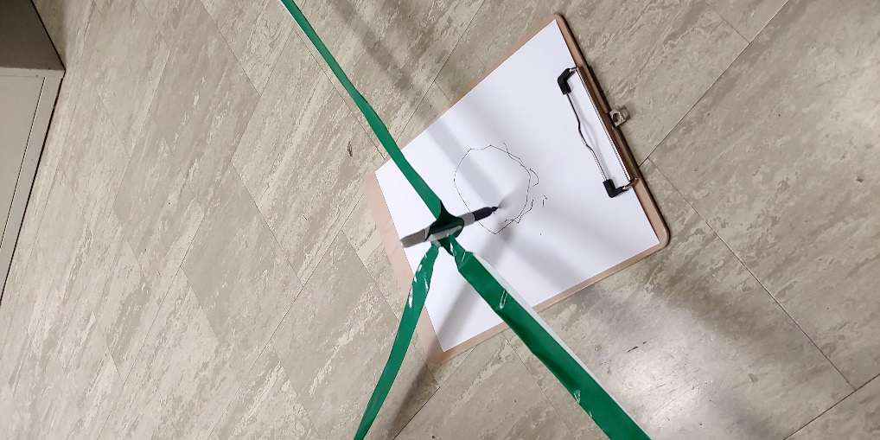
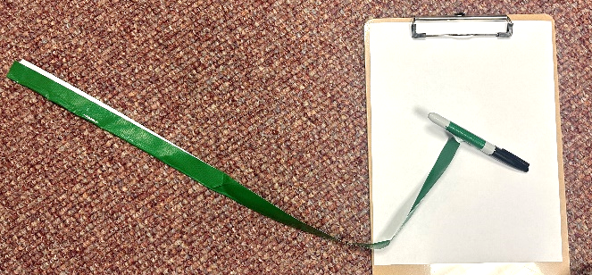
  - Print and display the Draw the Circle instructions.

- Prepare materials for the Part 1: Stack the Cups station.
  - Attach 3 strings to a rubber band, knotting them at 3 equidistant positions along the rubber band.
  - Place the 6 cups and the rubber band with strings attached near each other.
  - Print and display the Stack the Cups instructions.
- Print 1 copy of the One Health Card for each station. Cut along the dashed lines to cut each card into 3 pieces.
- Select a topic to focus on for Parts 2 and 3. The topic should be something your group has prior knowledge of. We recommend using this Activity Tool to finish off a unit, in order to review learning and deepen understanding of the unit’s topic. If you prefer to let participants select their own topic, see adaptation in Part 2 instructions.
- Prepare materials for Part 2, based on the method you choose. If doing the activity across multiple sessions, poster paper or cardboard may be preferred over a whiteboard.
- Prepare materials for Part 3, based on the product you choose to create.

Description of Assessment Activity and Suggested Procedure:

Part 1: Hands-On Introductory Activities (15-30 minutes)

Activity Overview: Participants will be supported to discover the concept of One Health by trying to maintain and/or achieve balance between three components representing humans, animals, and the environment.

- Divide participants into groups of 3.
  - If your group is not divisible by 3, you may want to have a group of 4 that takes turns participating.
  - You may also consider having a group of 1 or 2. Participants can try using both hands for the challenge activities. Note that the challenges may not be able to be completed with only 1 or 2 participants, so you may want to mix up the groups as they rotate stations so that everyone can participate. You can discuss at the end of the activity why it could not be completed without three people.
- Briefly explain the goals of the three challenge stations and show participants the instructions for each challenge station. These activities are designed to be challenges – it may take a few tries to figure it out and they may need to reset the station a few times!
  - Balance the Cup goal: Lift the cup on the stack of plates by pulling the three strings up, without spilling the contents of the cup.
  - Draw the Circle goal: Draw a circle on the paper while only holding the tape connected to the marker.
  - Stack the Cups goal: Create a pyramid of cups by stacking them, only holding on to the strings.
- Allow participants to experiment with the challenge stations. They will observe how coordination of the three connection points is needed to succeed in meeting the common goal of either raising a cup of water, drawing a circle, or stacking cups. Allow participants to attempt the challenges for a few minutes. When several groups have completed their challenge or begin to lose interest, instruct the groups to rotate to the next station.
  - Note: For the Balance the Cup station, if using water, monitor the ground/floor where water spills to ensure it does not become too slippery. Monitor use of the water jug with younger participants.
  - Note: For the Draw the Circle station, monitor use of the marker to ensure marks are not made on unintentional surfaces. Assist very young participants with the clipboard.
- While participants are engaging in the challenge stations, without directly revealing the objective of the challenge stations, encourage participants to begin to understand what the three strings represent by quietly placing one piece of the One Health Card that represents one of the components of One Health (human, animal, environment) next to one of the positions/strings of the challenge stations. Ensure that participants do not move the One Health card pieces from their position or station when they rotate between stations. Note: do not tell participants what the three pieces of the One Health Card represent.
- Observe participants’ conversations. When they have recognized that there is a purpose to the card and have had a chance to brainstorm its meaning, quietly place a second piece of the One Health Card next to one of the positions/strings of the challenge stations. This should prompt further discussion.
- Finally, after a short time for more brainstorming, place the third piece of the One Health Card next to the remaining positions/strings of the challenge stations.
- After participants have completed the challenge stations, facilitate a group discussion. Ask participants what was necessary to complete the challenges. Guide them through understanding the purpose of the cards, and recognizing that humans, animals, and the environment are connected. They may also make connections to concepts such as collaboration, cooperation, and balance that underlie the One Health Approach. If you had a group of 1 or 2, discuss how the challenges went without 3 people. Why could or couldn’t the challenges be completed?

Part 2: Connect the Concept of One Health to a Selected Topic (30 minutes)

Activity Overview: This activity will connect the concept of One Health to a particular topic that your group has previously learned about. Participants and facilitator(s) will work together to use prior knowledge of the selected topic and the knowledge of One Health built in Part 1 to create a concept map of the ways humans, animals, and the environment impact each other, within the context of that topic.
- Explain that you will now be connecting the concept of One Health to your selected topic. Remind the group of the topic.
- If you prefer to let participants select their own topics, do this now. This is only recommended for older participants. Because One Health is a collaborative approach, participants should work in groups, not individually. Each group should have prior knowledge of their selected topic (for example, they might choose one of several topics covered previously or one part of a larger subject area). For the richest experience, chose topics that: 1) are within prior knowledge; 2) not too specific or too broad; and, 3) related in some way to the environment or health. For example, a single species of insect or a particular chemical reaction may be too specific, but “insects” or “chemistry” may be too broad. Aim for something in the middle, like “bees” or “pH/acids and bases”. Each group should complete a concept map (Part 2) and product of learning (Part 3) specific to their selected topic.
- Create the concept map by drawing three circles, connected by lines to create a triangle. Label each circle with one element: “humans”, “animals”, “environment”. In the center of the triangle, write your selected topic. (See example concept map on Page 8.)
  - Note: If using a poster board, consider using sticky notes or index cards instead of writing directly on the poster board, so the concept map is easily adjustable through its development.
- Ask participants to brainstorm how your topic could be connected to human health, animal health, and the health of the environment. Have participants write down or draw pictures representing their responses using the method you selected (either recording their responses directly on the board, or on sticky notes/index cards). Build outward from each of the three initial circles as participants add new ideas by adding new text and/or adding connecting lines to text already on the board. Remind participants there are no right or wrong answers. Take an open approach in the early stages, allowing ideas to flow and not spending too much time evaluating or prioritizing. Avoid providing new information about your topic, but ask open-ended questions as needed to encourage connections, such as “What do you like to do outside?”, “What do you know about [the topic]?”, “What do you remember about when we learned [Z]”, or “How do you think [X] would affect [Y]?”.
  - A note on definitions: Encourage a broad definition of “health” in your discussion. “Health” could include illness/disease, physical fitness, mental health, access to healthcare, physical comfort, food security, biodiversity, available habitat/shelter, pollution, resource scarcity, and more. Similarly, “environment” can mean ecosystems, backyards, forests, parks, farmland, bodies of water, etc. Encourage creative thinking!
  - Adaptation for younger audiences: Consider asking your participants why the topic might matter for or be connected to humans, animals, and the environment, omitting the word “health”.
  - Adaptation for public events: Participants can add to the map throughout the event.
- After initial brainstorming is complete, collaboratively fine-tune the concept map by rearranging, emphasizing, and clarifying to make connections clearly understood by others. Consider adding text to the branches themselves to describe the interactions.
Looking for more?

Consider repeating the stations in Part 1 while representing scenarios related to your topic. For example, what if the person representing the environment was not able to pull their string, demonstrating an unhealthy environment? What are some things that might cause that to happen? What might be some solutions?
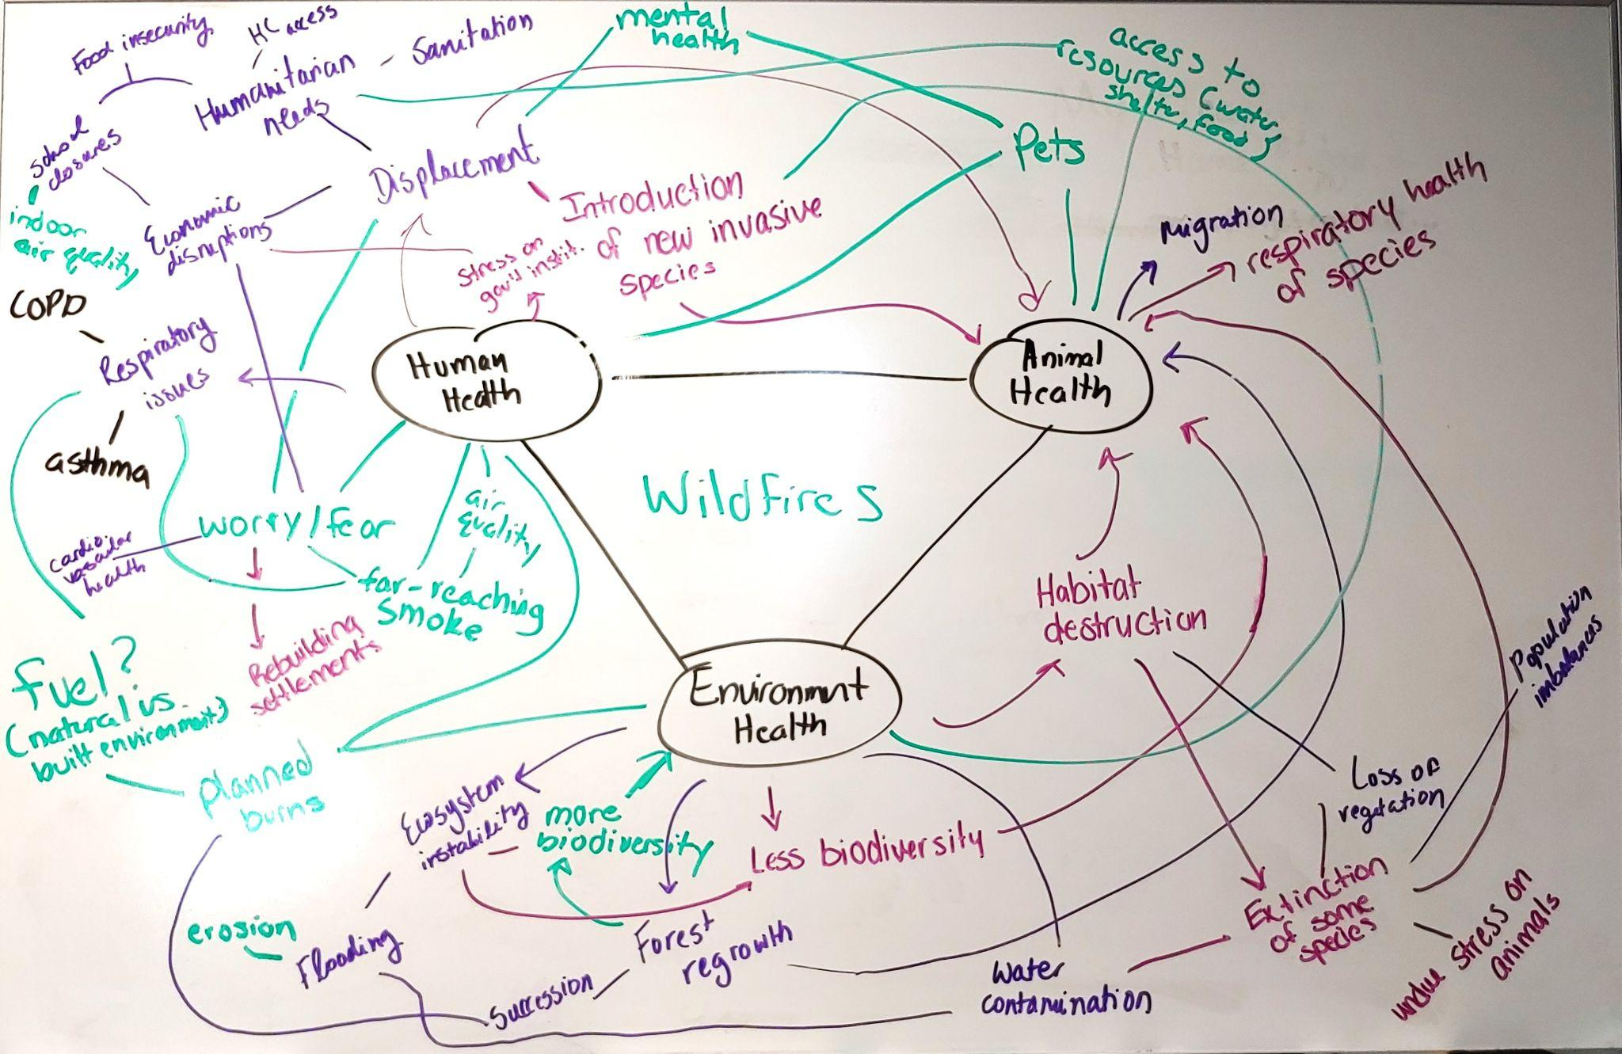
Example concept map by a group learning about wildfires.

Part 3: Create a Product of Learning (45-60 minutes)

Activity Overview: Participants will complete a collaborative project to create evidence of their understanding of One Health and how it relates to the selected topic from Part 2. If used for a public event, participants can contribute to the collaborative project by adding components or information throughout the event.

We have provided some ideas for possible products below, and detailed instructions for a few examples. These are only suggestions; not all examples are appropriate for all settings. We encourage you to be creative about your product of learning and select any medium that inspires your group, even if it is not listed here!

For whatever format you choose the product of learning from this Activity Tool should:
- Clearly communicate the knowledge that has been built.
- Enhance others’ understanding.
- Be created collaboratively.
- Be engaging for the audience.
Collaborative Project Ideas:
- Collage*
- Image-based poster*
Be sure to share your products of learning with us via email and on social media and tag us at @LifeSciencesLearningCenter so we can share them too!
- Graphic for social media*
- Sculpture
- Short informational video
- Slideshow
- Dance
- Comic art
- Poem or song
- Model or diorama
*Detailed instructions below

Example 1: Collage
Description: Based on the concept map created previously, draw lines on a piece of large, sturdy paper to create three sections. Participants then attach clippings from magazines, newspapers, old books, etc., to collaboratively create a large collage that illustrates how interactions between humans, animals, and the environment occur within the context of your topic.
Considerations:
- For younger participants: Provide safety-tipped small scissors, glue sticks, and consider pre-cutting appropriate imagery. Images could be pre-sorted into the three categories, unsorted, or included with unrelated imagery to create an additional challenge. Remember that reading skills will vary, and assistance may be needed with text.
- For older participants: Provide fine-tipped scissors for cutting details, a wider variety of adhesives could be offered, support participants to source and cut imagery themselves.
- For all participants:
  - Use verbal prompts and questions related to your area of focus to promote participants’ reasoning about selection and placement of imagery. Consider posting the questions and prompts somewhere visible so that participants can refer to them throughout their process of creating the collage.
  - Suggest using self-created imagery like arrows and symbols that enhance the clarity of the organization, as needed.
  - Emphasize the artistic purposes of positive and negative space and the intent behind each. Collages are often more aesthetically engaging when blank space is limited or eliminated. Provide guidance on how to overlap imagery so that important elements of the images are not covered.
  - Engage in conversation with participants as they work to assess and guide accuracy and to communicate the intent and design of the layout to others, as needed.

Example 2: Image-based poster
Description: Participants use hand-drawn imagery and text to create a collaborative poster using a facilitator-created template. On a large piece of poster board, use a pencil and straightedge to make light guidelines for the poster title. Partition off three areas of the poster board to correspond with human, animal, and environmental elements of your group’s topic of interest.
Considerations:
- For younger participants: Include more details in the poster template by using simple language to identify the components of your group’s poster (e.g., title, images, text). Use light pencil lines to create guidelines and spaces for information, labeled with the content it should include. Drawings can be made on separate paper, and then glued into place, so that mistakes are fixable prior to adhering. Provide stencils and colored pencils for less confident participants. Monitor younger participants’ use of markers.
- For older participants: Provide rulers, a compass, a square, and other tools for participants to add to and edit (if needed) the poster template created by the facilitator. Consider guiding participants to create a rough draft of potential additions and edits, based on the provided template, and collaboratively agree on the design before proceeding with the final poster. Emphasize the importance of using arrows, bullets, highlighting, fonts/textual alterations, color, shapes, effective fonts, and so on, to create a clear message.
- For all participants:
  - Emphasize the importance of clear titles for the poster and each section.
  - Monitor use of space to be sure contents are appropriate for space allowed.

Example 3: Graphic for social media
Description: Participants use an online design program (such as Canva.com) or PowerPoint to create a piece of graphic art that can be shared on social media to convey ways that humans, animals, and the environment impact each other in the context of your topic. Share the graphics on social media and tag us at @LifeSciencesLearningCenter so we can share them too!
Considerations:
- Use an online design program you feel comfortable navigating or review the tutorial and help resources for the program before using it with participants. Each group of participants will need a device logged in to the program. Alternatively, you can use PowerPoint to create a “slide” with text and graphics.
- For all participants:
  - Form groups of 2-3 participants.
  - Discuss elements of successful social media posts, as age appropriate:
    - They can be understood quickly.
    - The text is clear and concise; limit the number of words so that the text can be read in a few seconds.
    - The font is legible, and any text is large enough to read and stands out from the background.
    - Images are engaging and appropriate; photographs are in focus; use only open-source or personal images.
    - Colors have been selected thoughtfully. Pre-made color palettes can be used, or color selections can be made based on colors in included images. Contrasting colors increase visibility. Colors also have cultural meanings to consider.
    - Simple designs are often more effective. Avoid making the design too crowded.
    - Twitter/X, Facebook, and Instagram have different optimal image sizes. Make sure that your starting template is the correct size for your desired platform.
  - Before beginning work, ask groups to use about 5 minutes to create and write down a 3–10-word message that communicates the concept of One Health as it relates to your topic, and to display it in their workspace.
  - Allow time for the groups to share their work with the whole group to gather feedback and make quick edits.
- For younger participants:
  - Before breaking off into groups, consider showing 5-10 examples of successful and related social media posts to the entire group, on your device. Providing several different examples reduces the likelihood that participants will copy the example.
  - Provide parameters of the design, and list steps on a whiteboard, in simple language:
    - Decide what to say.
    - Add background.
    - Add shapes and pictures.
    - Add text.
    - Make any changes.
  - Add structure to the feedback session. For example, collect only 3 feedback comments from the whole group for each design, or collect feedback only about one element of the design, like the message.
- For older participants:
  - Discuss who the intended audience for the image is, and how it might be best to reach this audience.
  - During the feedback session, participants should focus on being specific and giving reasons for their thoughts. Simple feedback like “I like your design” is more helpful if it is followed by “because…”

