How to Provide Easy to Understand Information

The State Board of Pharmacy created a two-page brochure designed to educate patients about common over-the-counter (OTC) pain medications, including acetaminophen. However, this brochure has a lot of text on it and may be difficult for people to read and understand. The local health department has asked you to design a new brochure that is easier for people to read and understand.

For this activity, you should work with a partner to do two things:

- Use the checklist on page 2 to evaluate the brochure provided on pages 3 and 4. For questions you are not sure how to answer, you can leave those blank.

- Design a completely new one page information sheet that could be handed out to pharmacy patients to help them understand the differences between these 3 medications: acetaminophen, ibuprofen, and aspirin.

You will want to think about how you can use images and diagrams and other design elements to create an easy to follow and interesting document. The checklist on page 2 provides some ideas that you might use to create an easy to understand information sheet (you do not have to use all of them).

Checklist for Easy-to-Understand Print Materials

Message Content
- Have you limited your messages to three to four messages per section?
- Have you taken out information that is “nice to know” but not necessary?
- Is the most important information at the beginning of the document?
- Is the most important information repeated at the end?
- Have you identified action steps or desired behaviors for your audience?
Text Appearance
- Does your document have lots of white space? Are the margins at least ½ inch?
- Is the print large enough (at least 12 points)?
- Have you used bold, italics, and text boxes to highlight information?
- Have you avoided using all capital letters?
- Is text justified on the left only?
- Did you use columns with a line length of 40 to 50 characters of space?
Visuals
- Is the cover attractive to you intended audience? Does it include your main message and show who the audience is?
- Are your visuals simple and instructive rather than decorative?
- Do visuals help explain the messages found in the text?
- Are your visuals placed near related test? Do they include captions?
- If you read only the captions, would you learn the main points?
Layout and Design
- Is information presented in an order that is logical to your audience?
- Is information chunked, using headings and subheadings? Do lists include bullets?
- Have you eliminated as much jargon and technical language as possible?
- Is technical or scientific language explained?
- Have you used concrete nouns, an active voice, and short words and sentences?
- Is the style conversational?

Adapted from:
Simply Put: A guide for creating easy-to-understand materials http://www.cdc.gov/healthliteracy/pdf/Simply_Put.pdf

State Board of Pharmacy Brochure (page 1)
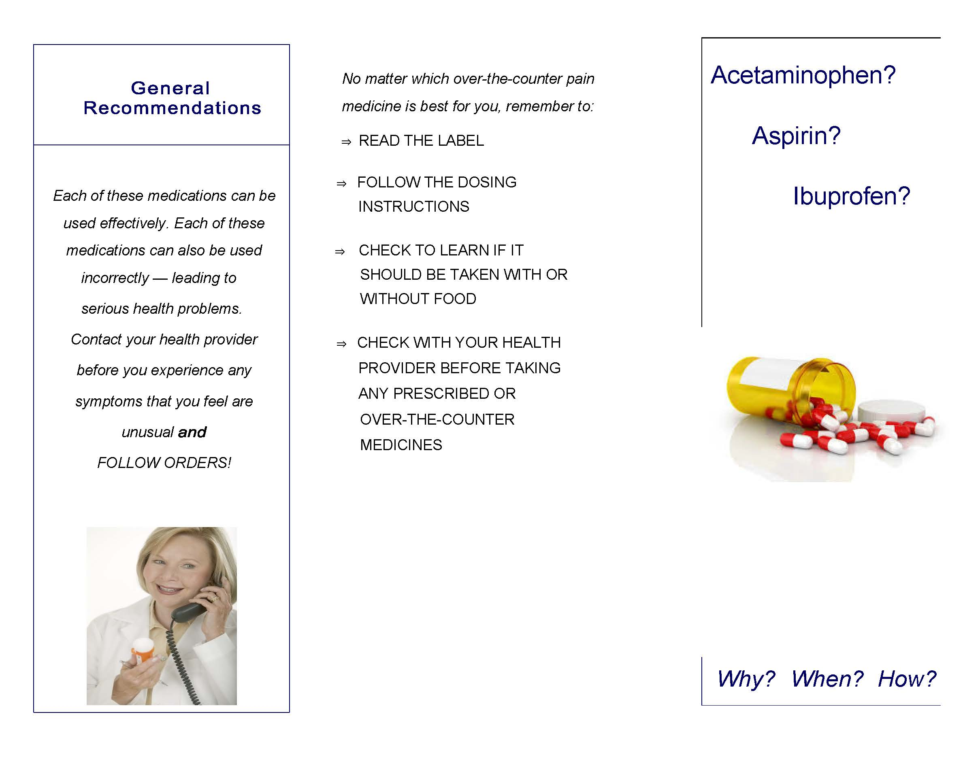
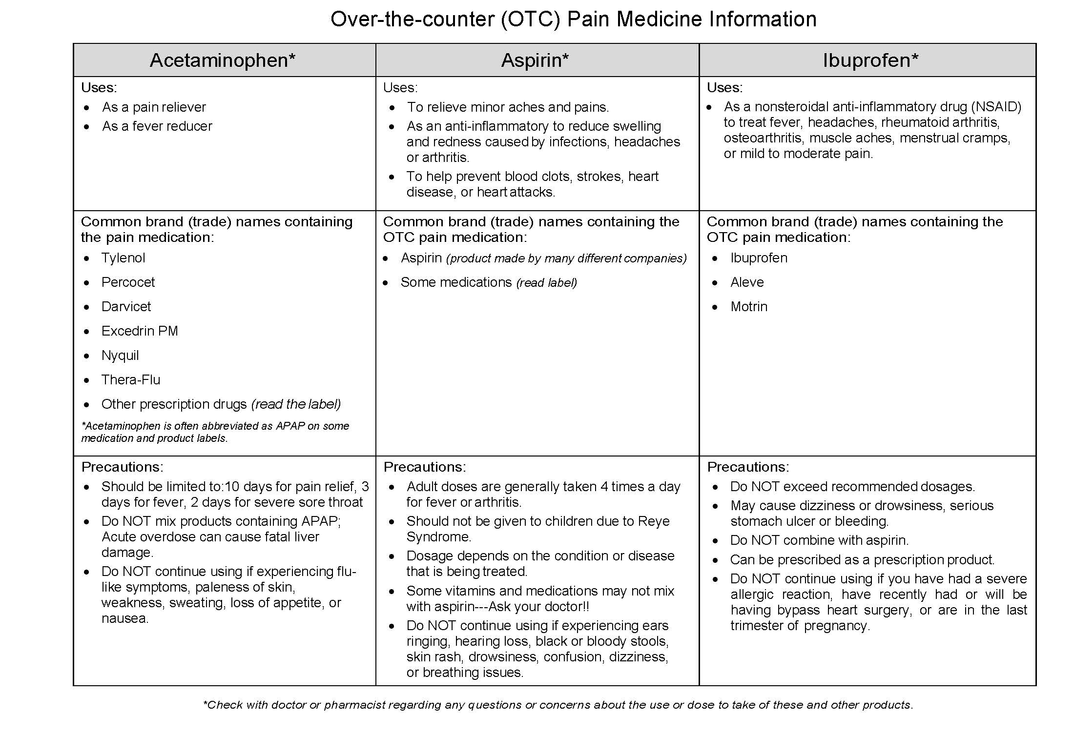
State Board of Pharmacy Brochure (page 2)

