ACTIVITY 3:
Microplastics Messaging

Research indicates that the toxicity and harmful effects of microplastics can vary depending on their size, shape, age, chemical composition, surface charge, and co-contaminants. The information in the box below describes how the characteristics of microplastics might affect how they impact human health.

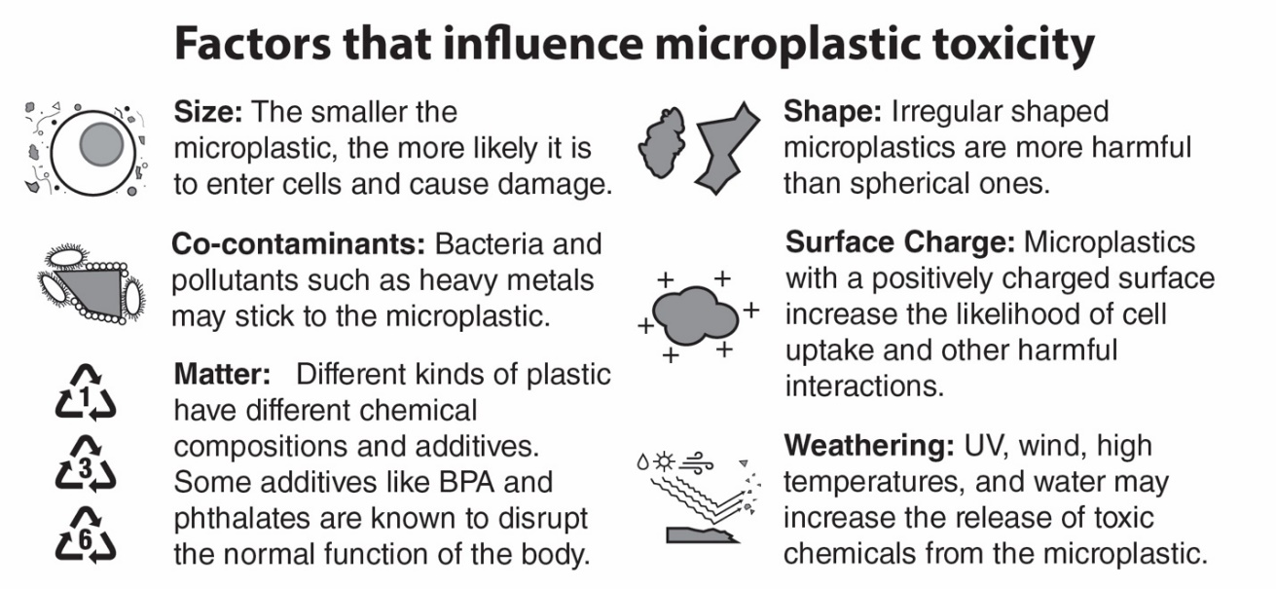

Many researchers have been investigating the possible causes of health problems from microplastics.
  - Some research studies indicate that health problems might be caused by the type of plastic material the microplastic is made of.
  - Some research studies indicate that health problems might be caused by toxic substances that attach to the microplastic.

- Use the Factors that influence microplastic toxicity information above to identify another possible way that microplastics might cause health problems. Explain why that factor might be important for influencing the effect of microplastics on human health. Write your answer in the table below.

Factor | Explanation
Example: Type of plastic material (matter) | Additives are known to impact human health. Different plastics have different additives.
- Some people don’t understand why so many research studies are needed before we can understand how microplastics affect human health. In your own words, explain to someone who is complaining about the number of research studies on microplastics why more research is necessary (or why one research study is not enough).

Once research is published, the news media usually reports the results of the research. The table below lists media headlines and the original research study title.

Original Research Study Title | Media Headline
Bioaccumulation of microplastics in decedent human brains | Your brain is full of microplastics: Are they harming you?
The potential of micro- and nanoplastics to increase the health impacts and global burden of diseases | Microplastics: Are we facing a new health crisis – and what can be done about it?
A global estimate of multi-ecosystem photosynthesis losses under microplastic pollution | Scientists Just Discovered Something Absolutely Horrifying About Microplastics

- Media headlines often use words that create fear or panic – this is called a “sensationalized headline”. What is one advantage of using a sensationalized headline instead of the original study title?

- What is one disadvantage of using a sensationalized headline instead of the original research study title?

- During an interview with a newspaper publishing a story on microplastic research, a scientist involved in the research commented, “I reduced my consumption of bottled water in half. I still drink bottled water, just less.” What impact might this comment have on someone reading the article? Why?

