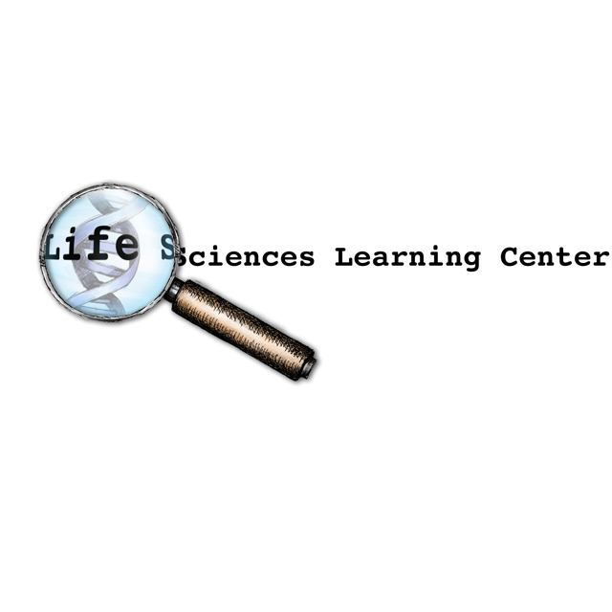

Medicines and Me - Extension Activities

GENERAL TEACHER INFORMATION

Basic literacy, or the ability to read and write, is a common focus of education. However, there are a number of other types of literacy skills that are important for teens to develop, such as digital literacy, information literacy, health literacy, and media literacy.

The Medicines and Me lessons focus on medication literacy—“the ability of individuals to safely and appropriately access, understand, and act on basic medication information.” The Medicines and Me extension activities have been created to help students develop additional literacy skills that are important for medicine use.

The six extension activities can be used to develop additional literacy skills related to medicine use, such as media literacy, eHealth literacy, health literacy, functional literacy, communicative literacy, and research literacy. The teacher information for each of the extension activities identifies and describes the type of literacy developed through the activity.

- Activity 1: Medicine Advertising
- Activity 2: Using the Internet for Health Information
- Activity 3: Public Service Announcements
- Activity 4: How to Provide Easy to Understand Information
- Activity 5: Communicating with Health Care Providers
- Activity 6: Clinical Trials from a Patient’s Perspective

Copyright © 2018 by University of Rochester. All rights reserved. May be copied for classroom use.
This lesson was developed with support from the National Institutes of Health under Award Number R25OD010494.
The content is solely the responsibility of the authors and does not necessarily represent the official views of the National Institutes of Health.

