A Family Medicine Cabinet

What is a medicine? There is no generally accepted definition
for the word “medicine.”
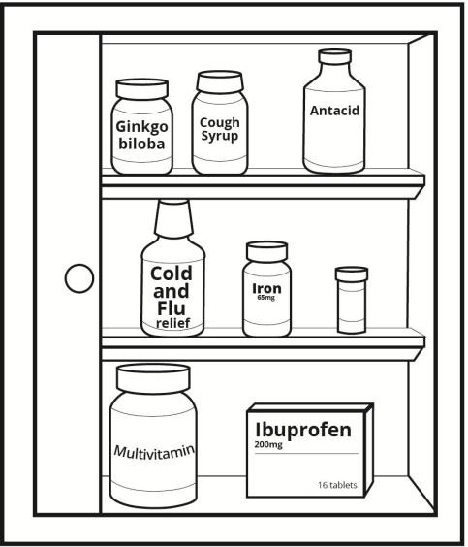
- Most people use the word “medicine” to refer to
products that affect how the body functions.
- Some people only consider prescription drugs and over-the-counter drugs as medicines.
- Other people use the word medicine more broadly to include dietary supplements, some cosmetics, and any health care product that affect how the body functions.

Darla would like to organize her family’s medicine cabinet to separate the three different types of medicines:
- Prescription drugs
- Over-the counter drugs
- Dietary supplements

Part 1: Classifying Medicines
Use the 9 different product labels that your teacher has provided. Help Darla by sorting the labels into the three groups of products.

- Label 1 is a label from a prescription medicine. Write the numbers of the two other labels that are also from prescription medicines.
- Explain how you could tell that the labels are from prescription medicines. Be specific.

- Label 2 is a label from an over-the-counter medicine. Write the numbers of the two other labels that are also from over-the-counter medicines.

- Explain how you could tell that the labels are from over-the-counter medicines. Be specific.

- Label 3 is a label from a dietary supplement. Write the numbers of the two other labels that are from dietary supplements.
- Explain how you could tell that the labels are from dietary supplement. Be specific.

- Which type of product label provides the most detailed information on how to choose and use the product safely?

Over-the-Counter Dietary Supplement Prescription

Part 2: Comparing Medicines
Darla would like to know how over-the-counter drugs are different from prescription drugs and dietary supplements. Help her by completing the comparison chart below.

- Use the information in the Fact Sheet: Drugs and Dietary Supplements to complete the comparison chart below. Write “Yes” or “No” in each of the boxes in the “Over-the-Counter Drug” column.

Criteria | Prescription Drug | Over-the-Counter Drug | Dietary Supplement
1. Affects the way the body functions | Yes |  | Yes
2. Is a drug according to the FDA  definition | Yes |  | No
3. Requires a prescription from a doctor | Yes |  | No
4. Should only be used by person whose name is on the label | Yes |  | No
5. Approved by the Food and Drug Administration (FDA) | Yes |  | No
6. May have potentially harmful side effects or interactions with some  foods, drugs, or dietary supplements. | Yes |  | Yes
7. Includes a Drug Facts Label that provides detailed information on how  to use the drug safely. | No |  | No
8. Scientific research has provided evidence that it is safe and effective  for use by most people. | Yes |  | Usually No There are few that have been tested.
9. Examples include vitamins, minerals, enzymes, herbs, or amino acids | No |  | Yes
10. Be sure your doctor knows that you are taking these products | Yes |  | Yes

Use the Comparing Medicines chart on page 3 and information from the Fact Sheet to answer questions 2 through 5.

- Which product is most likely to have been scientifically tested to provide evidence that it is safe and effective—an over-the-counter drug or a dietary supplement? Explain your answer.

- Explain why it is important that an over-the-counter medicine label include more information than a prescription medicine drug label.

- Why do dietary supplements not meet the FDA’s legal definition for a drug? Support your answer
with evidence from the Fact Sheet.

- Several celebrities endorse a dietary supplement in an advertisement. They claim that the dietary supplement worked for them, is “doctor recommended” and has been “clinically tested.” Do you think these claims mean that the dietary supplement is safe and effective? Explain why or why not.

Part 3: Should Prescription Drugs Become an Over-the-Counter Drug?
Now Available Without Prescription
Blog by Health Policy Analyst
Today's health consumers are taking a more active role in diagnosing and treating themselves. From pain relievers to cough medicines, drugs once available only by prescription are now available as over-the-counter (OTC) drugs on store shelves.
The US Food and Drug Administration (FDA) can approve a prescription drug for OTC sale once it has evidence that the drug’s benefits outweigh the risks, the potential for misuse is low, consumers can self-diagnose the condition, labels can be easily understood, and oversight by doctors is not essential.

Offering OTC drugs without a prescription means that patients can purchase drugs with lower prices, a particularly important factor for people who do not have health insurance. It also eliminates the time and cost involved in visiting a doctor. This allows doctors more time to focus on high-risk patients or patients with more complex conditions.
There is concern that consumers will use OTC drugs instead of seeing their doctor for an appropriate diagnosis and important advice. However, for people who lack health insurance or live in an area where there is a shortage of doctors, OTC medications offer an option for treatment of temporary symptoms.

- Explain the difference between an OTC (over-the-counter) drug and a prescription drug.

- According to the blog by the health policy analyst, what are two advantages to having a prescription medicine become available as an over-the-counter drug?

Prescription Not Required
Blog by Pharmacist
While it’s natural to think that all over-the-counter (OTC) drugs are safe for everyone, that’s a mistake. Every person is different and may react to medications in a different way. Just because a drug is safe for someone else, it may not be safe for you.
Every drug, used improperly, can cause harmful effects. A lot of OTC drugs have the potential to cause harm if users are not aware of the side effects. There is the danger particularly if patients take more than is safe or take them long term. People who choose to use OTC drugs must read and follow the directions and warnings on the label.

People can avoid potential problems by asking a pharmacist or their doctor whether the drug is okay for them to take. A doctor will help patients select the proper dosage and make sure that a patient’s health conditions do not make taking the OTC drugs dangerous. Doctors can also check to be sure that the OTC drug does not interfere with other medications a patient is taking and monitor continuing symptoms to be certain that they are not caused by a more serious illness.

Over-the-counter products can be purchased in retail stores that do not have trained pharmacists. It is always better to purchase OTC drugs from a pharmacist who has the knowledge to provide advice on how to select and use OTC drugs safely.

- According to the blog by the pharmacist, what are two potential problems that may occur from taking an over-the-counter drug?

- According to the blog by the pharmacist, what are two things that people could do to avoid potential problems if they use over-the-counter medicines?

- What do you think? A medicine has been sold as a prescription drug for five years. During that period it has been shown to be safe and effective for many people. Should the medicine be approved for sale as an over-the-counter medicine? Support your answer with pieces of evidence from the blogs or your personal background knowledge.

