How Much and How Often

Part 1: Measuring How Much
Directions from Flu Relief Therapy Label
- Use the measuring device provided with the medicine.
- Do not take more than directed.
- ONLY for adults and children 12 years of age and over. Do not use for children under 12 years of age.
- Take 15 mL (3 teaspoons) every 4 hours while symptoms last.
- Do not take more than 90mL (3 FL OZ) in 24 hours, unless directed by a doctor.

Micah is a 15-year-old boy who has a headache, a bad cough, chest congestion, and a stuffy nose. He wants to take the proper amount of Flu Relief Therapy medicine.

- According to the Directions from Flu Relief Therapy Label to the right, how much Flu Relief Therapy medicine should Micah take?

______ mL or ______ teaspoons

- It is important that Micah measure exactly the right amount of medicine.

- What might happen if Micah took too much medicine?
___________________________________________________________________
___________________________________________________________________

- What might happen if Micah took too little medicine?
___________________________________________________________________
___________________________________________________________________

- A medicine dosing cup was provided with the Flu Relief Therapy medicine. The dosing cup is what should be used to accurately measure the medicine.
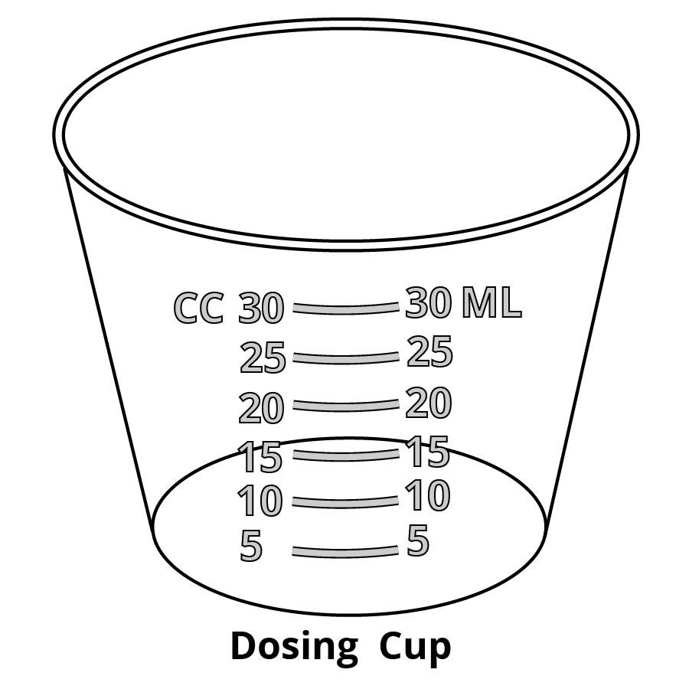
- Pour 15 ml of the simulated medicine into one of the plastic dosing cups. NOTE: It is important to place the dosing cup on a flat surface. The dosing cup should be at eye level when you read the volume!
- Save the dosing cup and its contents by placing it on the box in Row 1 of the Comparing Medicine Measuring Tools sheet.
- Record the volume (in mL) of medicine in the dosing cup in Row 1 on the Comparing Medicine Measuring Tools sheet. Remember to view the cup at eye level to read the volume.
Micah has a problem! He cannot find the dosing (measuring) cup that came with the bottle of Flu Relief Therapy medicine. He wonders if it is OK to estimate (guess) the amount of medicine or if it is OK to use other things to measure liquid medicine such as kitchen silverware (spoons) instead of using the dosing cup that came with the bottle of medicine.

In this lab activity, you will do experiments to determine if using different measuring tools affects the amount of medicine that a person receives.

- Some people think that they can simply estimate (guess) the appropriate dose of medicine. Can you accurately estimate the appropriate dose without using a measuring device?
- Pour what you estimate (guess) would be 15 mL of Flu Relief Therapy medicine into the colored cup (not into a dosing cup). Pour all of the contents from the colored cup into a clean dosing cup. Put this cup in Row 2 of the Comparing Medicine Measuring Tools sheet.

Metal Dinnerware Teaspoon
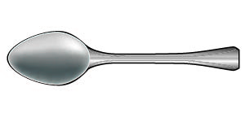

- Sometimes people use a metal dinnerware teaspoon (like the dinnerware teaspoon shown on the right) to measure medicine.
- Refer to the Directions from Flu Relief Therapy Label on the previous page. How many teaspoons of Flu Relief Therapy is the appropriate dose? _______ teaspoons
- Use a metal dinnerware teaspoon to add the appropriate number of teaspoons of Flu Relief Therapy to a clean dosing cup. Put this cup in Row 3 of the Comparing Medicine Measuring Tools sheet.

- Sometimes people use a plastic dinnerware teaspoon (like the dinnerware teaspoon shown on the right) to measure medicine.

Plastic Dinnerware Teaspoon
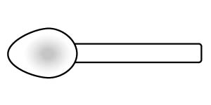

- Use a plastic dinnerware teaspoon to add the appropriate number of teaspoons of Flu Relief Therapy to a clean dosing cup. Put this cup in Row 4 of the Comparing Medicine Measuring Tools sheet.

- Sometimes people use a measuring teaspoon (such as the teaspoon shown on the right). Measuring teaspoons (tsp) are manufactured to more precisely measure teaspoon volumes.

Measuring Teaspoon
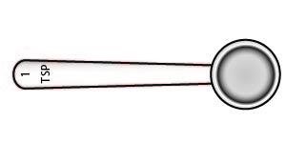

- Use a measuring teaspoon (tsp) to add the appropriate number of teaspoons of Flu Relief Therapy to a clean dosing cup. Put this cup in Row 5 of the Comparing Medicine Measuring Tools sheet.

- Complete the Comparing Medicine Measuring Tools sheet by recording the volumes (in ml) of each of the dosing cups (Rows 1 through 5) in the third column.
- Discard the simulated medicine in each of the dosing cups by pouring it down the drain or into the “Liquid Waste” container. Use a paper towel to dry the dosing cups.
Base your answers to questions 7 and 8 on the data you recorded on the Comparing Medicine Measuring Tools sheet.
- Which measuring device (dosing cup, cup for estimating, metal dinnerware teaspoon, plastic dinnerware teaspoon, or measuring teaspoon) do you think is most accurate for measuring liquid medicine? Explain your choice using the data that you recorded on the Comparing Medicine Measuring Tools sheet.
_________________________________________________________________________
_________________________________________________________________________
_________________________________________________________________________

- Micah could not find the dosing cup provided with the Flu Relief Therapy medicine. Which measuring tool do you suggest that he use instead of the dosing cup? Explain your choice using the data that you recorded on the Comparing Medicine Measuring Tools sheet.
_________________________________________________________________________
_________________________________________________________________________
_________________________________________________________________________

- Calculate: The instructions on the Flu Relief Therapy medicine label say “Do not take more than 90 mL (3 FL OZ) in 24 hours, unless directed by a doctor.” How many teaspoons of the medicine can Micah safely take in 24 hours?
________ teaspoons

Show how you arrived at your answer to question 9 in the space below.

When measuring small doses of liquid medicine, particularly for infants or young children, the recommended dosing device may be either a medicine dosing spoon, an oral syringe, or a medicine dropper.

- For each of the doses indicated on the right, draw an arrow to the point on the medicine dosing spoon that you should fill with the medicine.

- 10 mL of medicine

- 5 mL of medicine

- For each of the doses indicated on the right, draw an arrow to the point on the medicine dropper that you should fill with the medicine.
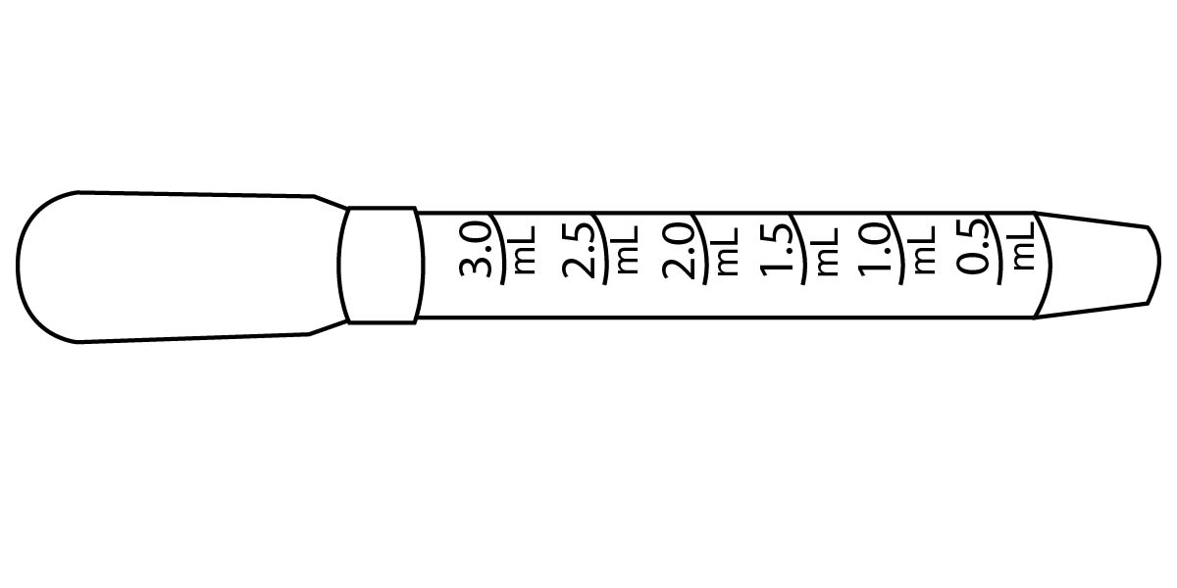

- 2 mL of medicine

- 0.5 mL of medicine

- For each of the doses indicated below, draw an arrow to the point on the medicine syringe that you should fill with the medicine.

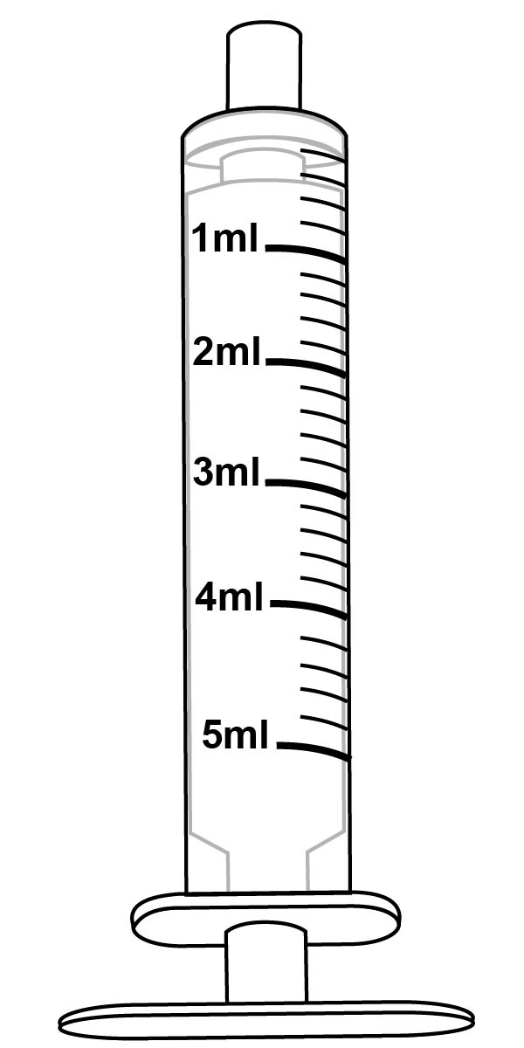

3 mL of medicine 1.5 mL of medicine
Not all liquid medicines come with dosing devices. Some pharmacies will provide free dosing devices. Other pharmacies will sell dosing devices to you. The diagrams below show some different types of dosing devices available in pharmacies.

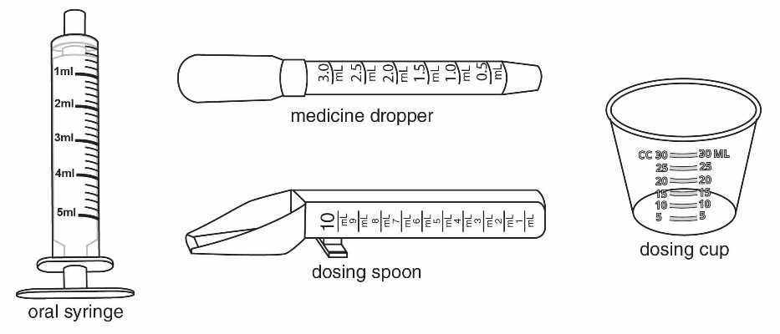

- Which of the dosing devices shown above would best be used to accurately measure:
- 1.5 ml? _____________________________________
- 3.5 ml? _____________________________________
- 9 ml? _____________________________________

Part 2: Determining How Often

Each medicine works in a person's body for a certain length of time. The Drug Facts label tells you how often to use a medicine based on how long the medicine works in people's bodies.
Directions from Flu Relief Therapy Label
- Use the measuring device provided with the medicine.
- Do not take more than directed.
- ONLY for adults and children 12 years of age and over. Do not use for children under 12 years of age.
- Take 15 mL (3 teaspoons) every 4 hours while symptoms last.
- Do not take more than 90mL (3 FL OZ) in 24 hours, unless directed by a doctor.

- Read the Directions from Flu Relief Therapy label (on the right). How often should Micah take the Flu Relief Therapy medicine?

_____________________________________

Micah keeps forgetting to notice the time when he takes the Flu Relief Therapy medicine, so he simply takes more of the medicine when his flu symptoms start reappearing.

You will make a model to represent Micah’s body:
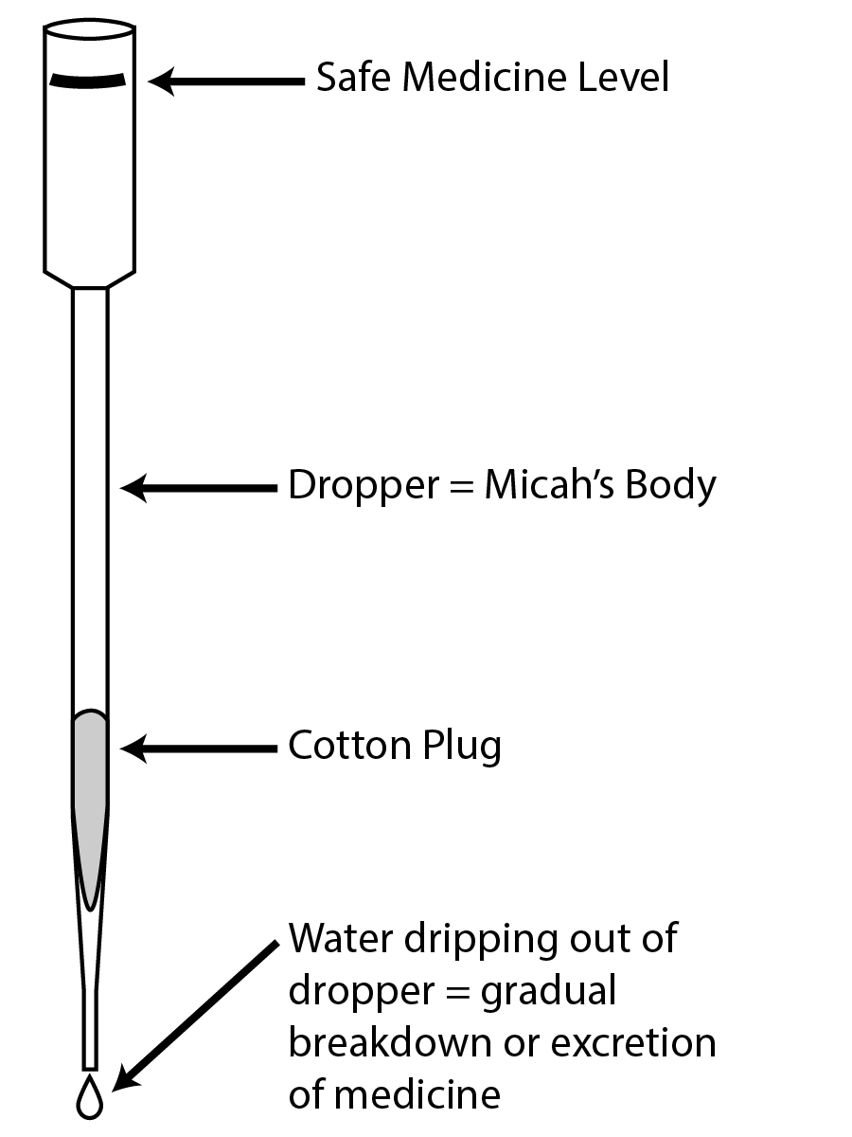
- The long plastic dropper represents Micah’s body.
- The black line at the top of the dropper represents a safe level of medicine in Micah’s body. If the level of medicine in the dropper goes above this line then it is not a safe level of medicine.
- Colored water dripping out of the long plastic dropper represents the gradual breakdown, or excretion, of medicine.

Seeing how the model works.
- You will need a stopwatch for this activity. Practice using the stopwatch if you have not used one before. You will need to know how to start, stop, and reset the stopwatch.
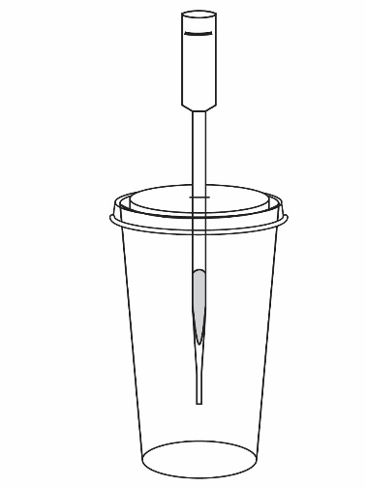
- Put the lid on the large plastic cup. Insert the long plastic dropper into the slit on the top of the lid, as shown in the picture on the right. The dropper should extend to approximately 5 centimeters (2 inches) above the bottom of the cup.
- Use the dosing cup to measure 15 mL of colored water. The colored water will simulate Flu Relief Therapy medicine that Micah will take.
- Start the stopwatch and immediately pour the medicine from the cup into the top of the long dropper.
- The medicine (colored water) will start dripping out of the bottom of the dropper. This represents the gradual breakdown, or excretion, of medicine.
- Stop the stopwatch when the medicine (colored water) stops dripping out of the dropper. Note: Some medicine may remain in the dropper. Look at the time on the stopwatch. How many seconds did it take for the colored water to stop dripping out of the dropper?
________ seconds

Now you will use the model to see what happens when Micah repeats the doses of medicine:
- As shown on the label directions - 15 mL every four hours.
- Sooner than the time directed on the label - after two hours instead of four hours.

Model for taking medicine as shown on the label directions.

- Make a prediction. Would it be safe for Micah to take another 15 mL dose of the medicine after 4 hours?
_________________________________________________________________________
_________________________________________________________________________

- The number of seconds that you recorded above in step 7 represents the 4 hours that Micah should wait before taking another dose of Flu Relief Therapy. How many seconds represent 4 hours?

4 hours would be represented by ___________ seconds

- Use the model to test your prediction.
- Fill two dosing cups with 15 ml of medicine.
- Start the stopwatch and immediately pour a 15 mL dose of medicine into the dropper.
- Wait 4 hours (represented by_____seconds) and pour a second 15 ml dose of medicine into the dropper.
- Did the medicine level in the dropper remain below the safe medicine level (top of the dropper)? ____________

Model for taking medicine sooner than directed on the label - after two hours instead of four hours.

- Make a prediction. Would it be safe for Micah to take a second 15 mL dose of the medicine after 2 hours, instead of after 4 hours? Explain why or why not.
_________________________________________________________________________
_________________________________________________________________________

- Calculate how many seconds it would take to represent waiting 2 hours, instead of 4 hours, before taking another dose of the medicine. Hint: Divide your answer to question 8 by 2.

2 hours would be represented by___________ seconds

- Use the model to test your prediction.
- Fill two dosing cups with 15 ml of medicine.
- Start the stopwatch and immediately pour a 15 mL dose of medicine into the dropper.
- Wait 2 hours (represented by_____seconds) and pour a second 15 ml dose of medicine into the dropper.
- Did the medicine level in the dropper remain below the safe medicine level (top of the dropper)? ____________

- What might happen if Micah continued to take Flu Relief Therapy too soon for the rest of the day?
_________________________________________________________________________
_________________________________________________________________________

- An overdose causes an unsafe level of medicine in the body. Describe one way that people can unintentionally take a medicine overdose.
_________________________________________________________________________
_________________________________________________________________________
_________________________________________________________________________

- Some people may have trouble remembering if and when they took medicines. One strategy that people could use to remember when to take medicine is to write down the name of the medicine and the time it was taken. Describe another strategy that people could use to help them take medicines when they should. Be specific!
_________________________________________________________________________
_________________________________________________________________________
_________________________________________________________________________

