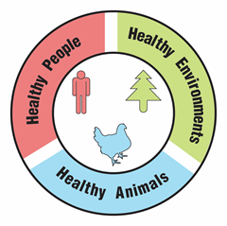
An Outbreak of Antibiotic-Resistant Bacteria

Part 1: A dangerous Salmonella infection

Base your answers to questions 1 through 4 on the information in the text box below.

For 14-year-old Ajay, a case of food poisoning caused by Salmonella bacteria became life threatening. Some of the Salmonella bacteria escaped from his intestine and caused a serious infection in his circulatory and urinary systems. Ajay was treated with azithromycin, a type of antibiotic that doctors usually prescribe for Salmonella infections. Unfortunately, that antibiotic did not work, and Ajay kept getting sicker.

Ajay’s doctors ordered laboratory tests to determine which type of antibiotics might be effective in treating his bacterial infection. For these tests, disks with different antibiotics were placed on a growth medium in a lab dish. Then, a sample of Salmonella bacteria from Ajay was grown on the growth medium. The results of the tests are shown in the diagram below.
- If the Salmonella bacteria are killed by the antibiotic on the disk, a clear ring, called a zone of inhibition, will appear around the disk.
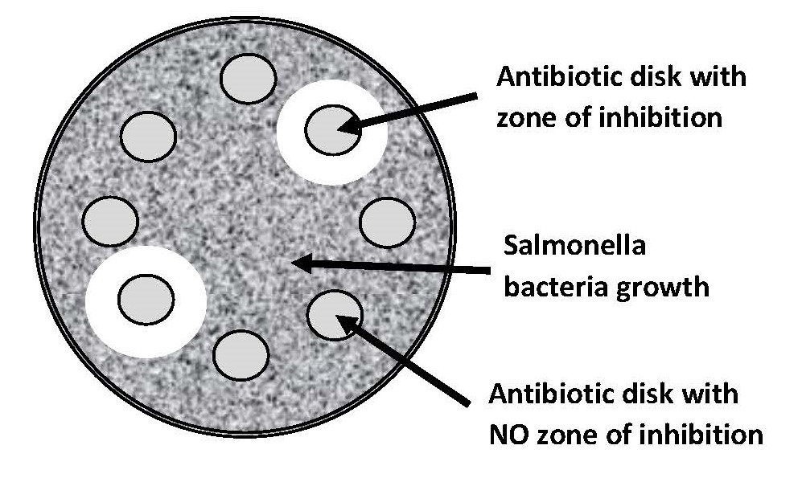
- If the Salmonella bacteria are resistant to (not killed by) the antibiotic on a disk, there is not a zone of inhibition around the disk.

- Each disk contains a different type of antibiotic. Why do six of the antibiotic disks not have a zone of inhibition around them?

- How many of the antibiotics tested would be effective in treating Ajay’s Salmonella infection? Support your answer with information from the diagram above.

- How can you tell that the Salmonella that infected Ajay are antibiotic-resistant Salmonella?

- Explain why the lab report from Ajay’s tests described the Salmonella that affected him as “multidrug-resistant” bacteria.

Part 2: The source of the outbreak

Luckily, doctors found two antibiotics that were effective in killing the Salmonella bacteria that made Ajay so sick. After Ajay was treated with these antibiotics, he slowly recovered and was released from the hospital. Ajay asked his doctors if they knew how he was exposed to the Salmonella that made him so sick. The doctors said that epidemiologists were working to identify the source of the outbreak. About a month after Ajay recovered, his father noticed a news article about a Salmonella outbreak.

- Read the news article below. As you read, underline information that would help Ajay understand how he was exposed to the Salmonella that made him sick.

Salmonella Outbreak Linked to Contaminated Chicken

An outbreak of food poisoning caused by antibiotic resistant Salmonella bacteria has sickened at least 129 people. The Salmonella outbreak is a serious health threat because the antibiotics usually used to treat Salmonella infections are not effective for treating this outbreak.

Epidemiologists from the CDC (Centers for Disease Control and Prevention) conducted interviews with ill people. Most remembered eating different types and brands of chicken products purchased from many different locations.

CDC laboratory scientists conducted tests that identified the multidrug-resistant Salmonella in samples taken from affected humans, affected pets, some live chickens, some raw chicken products, and some raw pet food that contains chicken.

The CDC provided advice to physicians who are selecting antibiotic treatment for suspected cases of Salmonella infection. The CDC also shared this information with veterinarians, farmers, and food processors from the chicken industry. The CDC requested that they take steps to reduce Salmonella contamination.

Because not all chicken was contaminated, the CDC did not advise consumers to avoid eating chicken. They also have not recalled chicken products or advised stores to stop selling or recall chicken products. The CDC recommended that consumers avoid exposure to Salmonella bacteria by handling raw chicken carefully.

Base your answers to questions 2 through 5 on the information in the news article on the previous page.

- Explain why “multidrug-resistant” bacteria are dangerous.

- The news article claims that chickens were the source of Salmonella that caused the outbreak. State two pieces of evidence to support this claim.

- The CDC did not recommend that people stop selling or buying chicken. State two pieces of evidence that support this decision by the CDC.

- Explain why the CDC provided information about the Salmonella outbreak to veterinarians, farmers, and food processors.

Part 3: How do bacteria become resistant to multiple antibiotics?

Ajay knows that mutations could cause new traits to appear. However, he also knows that mutations are rare and random events. He asked his biology teacher “How could Salmonella bacteria become resistant to many different antibiotics?”
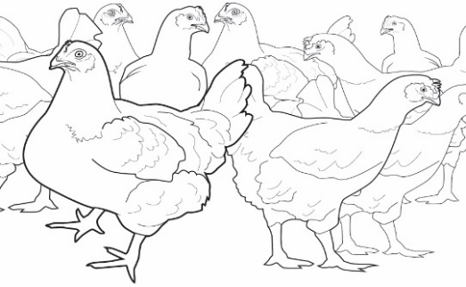
You and your classmates will model how Salmonella living in the intestines of a chicken may acquire antibiotic resistance genes from other bacteria around it.

The intestines of a chicken are crowded with millions of bacteria that may contain different antibiotic resistance genes—genes that enable them to survive exposure to specific antibiotics.

Key for Beads
Blue bead = Tetracycline resistance gene
Black bead = Erythromycin resistance gene
Green bead = Ciprofloxacin resistance gene
Pink bead = Penicillin resistance gene
Red bead = Cephalosporin resistance gene

- The cup provided by your teacher represents a Salmonella bacteria cell living in the intestine of a chicken. Use the Key for Beads on the right. Circle the name of antibiotic resistance gene that is present in your bacteria model?

- You will use dice rolls and beads to model how bacteria can become resistant to multiple antibiotics. The bag labeled Antibiotic Resistance Genes from Other Kinds of Bacteria contains beads that represent antibiotic resistance genes from other bacteria that live in the chicken’s intestines.

- Roll the dice. Follow the instructions on the Key for Dice Roll to determine what happens to the Salmonella bacteria. Did the Salmonella bacteria get a new antibiotic resistance gene?
If NO - Go to question 4.
If YES - Complete the next three bullets:

- Using the Key for Beads, circle the name of the new antibiotic resistant gene that is now present in your model bacteria.

- Using the Key for Dice Roll, name and describe the process by which the bacteria obtained the new gene.

- Go to question 4.
- Roll the dice again. Follow the instructions on the Key for Dice Roll to determine what happens to the Salmonella bacteria. Did the Salmonella bacteria get a new antibiotic resistance gene?

If NO - Go to question 5.
If YES - Complete the next three bullets:
- On the Key for Beads, circle the name of the new antibiotic resistance gene that is now present in your model bacteria.

- Using the Key for Dice Roll, name and describe the process by which the bacteria obtained the new gene.

- Go to question 5.

- Roll the dice again. Follow the instructions on the Key for Dice Roll to determine what happens to the Salmonella bacteria. Did the Salmonella bacteria get a new antibiotic resistance gene?

If NO - Go to question 6.
If YES - Complete the next three bullets:

- On the Key for Beads above, circle the name of the new antibiotic resistance gene that is now present in your model bacteria.

- Using the Key for Dice Roll, name and describe the process by which the bacteria obtained the new gene.

- Go to question 6.

- Roll the dice again. Follow the instructions on the Key for Dice Roll to determine what happens to the Salmonella bacteria. Did the Salmonella bacteria get a new antibiotic resistance gene?

If NO - Go to question 7.
If YES - Complete the next three bullets:

- On the Key for Beads above, circle the name of the antibiotic resistance gene that is now present in your model bacteria.

- Using the Key for Dice Roll, name and describe the process by which the bacteria obtained the new gene.

- Go to question 7.

- Multidrug-resistant bacteria are resistant to more than one antibiotic. Is your Salmonella bacteria model multidrug-resistant? If so, list the antibiotics that it is resistant to.

- If a person becomes infected with Salmonella bacteria like the one that you modelled, what kinds of antibiotics would be effective for treating the infection? Explain how you can tell. Note: Refer to the Key for Beads.

- Observe the bacteria models made by other students in your class. Explain how you would identify the Salmonella bacteria model that would be most likely to survive and reproduce in an environment where multiple antibiotics are present.

- Ajay wanted to know how Salmonella bacteria could become resistant to many different antibiotics. Explain how bacteria could acquire resistance to multiple antibiotics without relying on the rare and random process of mutations.

Part 4: Natural selection and antibiotic-resistant bacteria

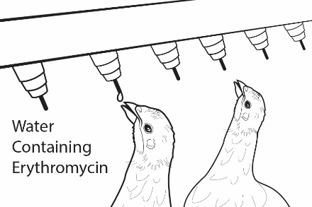
To prevent respiratory diseases in young chickens on his farm, a farmer adds an antibiotic called erythromycin to the water that the chickens drink. When the antibiotic erythromycin is used, only bacteria that have erythromycin resistance genes will survive.

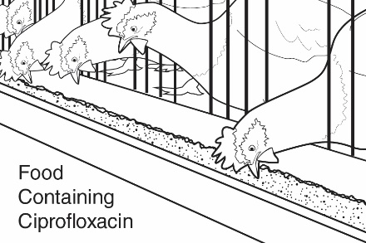
To prevent intestinal diseases in young chickens on the farm, the farmer uses chicken feed that contains an antibiotic called ciprofloxacin. When ciprofloxacin is used, only bacteria that have ciprofloxacin resistance genes will survive.

- What antibiotic resistance genes need to be present in Salmonella bacteria to enable them to survive and reproduce in the chickens that live on this farm?

- Could the Salmonella bacteria that you modeled survive and reproduce in the intestines of chickens that live on this farm? Look at the cup with beads and the key from Part 3. Explain why or why not.

- Did the use of antibiotics on the farm cause your Salmonella bacteria to become antibiotic resistant OR was your Salmonella bacteria resistant to antibiotics before the antibiotics were used on the farm? Support your answer with evidence from the model.

- Natural selection occurs when genes for antibiotic resistance become more common in a population because they increase the organisms’ abilities to survive and reproduce. What genes are likely to become more common in the population of Salmonella bacteria that live on the chicken farm?

- The statements below describe events in the natural selection of bacteria that are resistant to the antibiotic penicillin. Indicate the order in which the events occurred by writing numbers (2, 3 or 4) in front of the statements.

___1___ Bacteria in the chickens’ intestines naturally have a variety of antibiotic resistance genes.

_______ The bacteria are exposed to erythromycin when chickens drink their water.

_______ Erythromycin-resistant bacteria become more common on the chicken farm.

_______ Bacteria that are resistant to erythromycin survive and reproduce.

Animals in large industrial farms produce large quantities of manure - liquid (urine) and solid (feces) wastes. These wastes contain many different kinds of bacteria and viruses. Animal manure is often stored in open pits called “manure lagoons.”

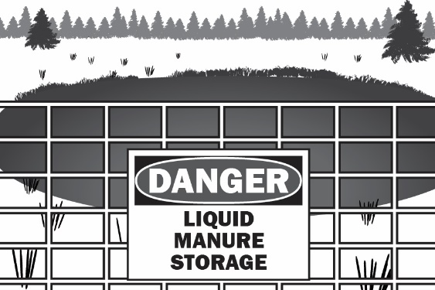
Manure lagoons are ideal places for bacteria reproduction. As the bacteria reproduce, they are exposed to low levels of antibiotics from the feces of animals that were treated with antibiotics. They are also surrounded by sources of antibiotic resistance genes such as viruses, free-floating antibiotic resistance genes, and other types of bacteria that are antibiotic resistant. This can result in new bacteria that are resistant to many different kinds of antibiotics. Wastes from manure lagoons may be used to fertilize fields or may be accidentally released into nearby water sources.

- Describe what conditions in a manure lagoon are likely to result in the evolution (natural selection) of new antibiotic-resistant bacteria.

- Describe two ways that people might be exposed to antibiotic-resistant bacteria from manure lagoons.

Part 5: The spread of antibiotic-resistant bacteria

Ajay claims that banning the sale of animal products from large farms is the best way to prevent outbreaks of diseases caused by antibiotic-resistant Salmonella. One of Ajay’s friends whose parents own a large dairy farm asked him to consider the chart below and rethink his claim.

Some Sources of Salmonella Outbreaks
Animal Products | Pets and Pet Products | Plant Products
Poultry  Beef  Pork  Fish  Milk  Cheese  Eggs  Ice cream | Birds  Reptiles such as turtles  Amphibians such as frogs  Dogs  Cats  Hedgehogs  Pet food  Pet treats | Bean sprouts  Melons  Lettuce  Onions  Tomatoes  Peppers  Spinach  Cucumbers  Cereal  Rice  Nuts  Spices

Modified from:
https://www.researchgate.net/figure/Some-sources-of-Salmonella-outbreaks_tbl1_278793722

- Does the information on the chart support Ajay’s claim that outbreaks of Salmonella could be prevented by banning the sale of animal products from farms that use antibiotics? Support your answer with information from the chart.

There are many ways that Salmonella can spread between humans, animals, and the environment. The six statements (A-F) listed below describe some of the ways that antibiotic-resistant bacteria such as Salmonella can spread between humans, animals, and the environment.

- Antibiotic-resistant bacteria from humans can enter waterways if they are not completely removed by waste sanitation systems.
- Farm animal manure applied to fields spreads antibiotic-resistant bacteria to soil and water.
- Crops can be contaminated by antibiotic-resistant bacteria in soil and water.
- Foodborne transmission of antibiotic-resistant bacteria to humans is a common route the spread to humans.
- Antibiotic-resistant bacteria enter humans when they drink contaminated water.
- Contact with pets and wildlife can transmit antibiotic-resistant bacteria to humans.

- Draw arrows on the How Antibiotic-Resistant Bacteria Spread picture to represent each of the six statements (A-F). Label the arrow with the letter of the statement that it represents. Note: As an example, the first statement has been shown on the picture using a red arrow and red “A”.

- Look at the arrows you drew on the How Antibiotic-Resistant Bacteria Spread picture. These arrows represent processes/routes that spread antibiotic-resistant bacteria. Suggest one way to block a process/route and prevent the spread of antibiotic-resistant bacteria to each of the following:

- Humans:

- Animals (pets or wildlife):

- The environment (soil, water, plants, or air):

Part 6: One Health and antibiotic-resistant bacteria

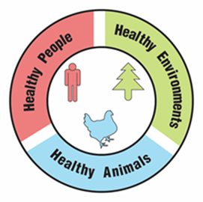
One Health

A university is suggesting that the local government take a One Health approach to solving complex local problems, such as antibiotic-resistant bacteria. A One Health approach uses the idea that complex problems often involve the health of people, animals, and the environment. Therefore, solutions to One Health problems must be designed to protect the health of people, animals, and the environment.

- Use the information in the text box above to explain what must be involved in a complex problem for it to be considered a One Health problem.

To support adoption of a One Health approach, the university officials want to create a series of slides to provide examples of One Health problems in the community. Your team has been hired to create a slide to answer the question, “Why are antibiotic-resistant bacteria a One Health problem?”

Remember how the CDC video used images with captions to help people understand what One Health problems and solutions involve. Using pictures and captions will help people understand and remember what the One Health approach involves.

- Use the information in the text box above and what you learned about antibiotic-resistant bacteria to develop your slide. Use the following template to organize your slide:

Why are antibiotic-resistant bacteria a One Health problem?
Picture and a caption to explain how animals are involved in the problem | Picture and a caption to explain how humans are involved in the problem | Picture and a caption to explain how the environment is involved in the problem

