
Mosquito Invasion

Part 1: A surprising diagnosis

Mario had a mild but annoying cough. His doctor recommended that he have a lung CT scan to screen for lung cancer. His CT scan (Figure 1) revealed a pulmonary (lung) nodule.
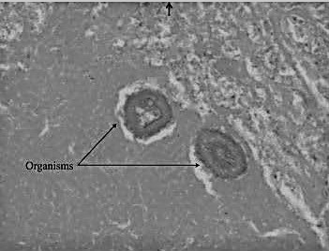
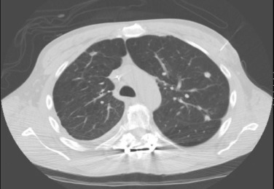
Pulmonary nodule
Dirofilaria immitis worms
cross section
Figure 1: CT scan of Mario’s lungs Figure 2: Biopsy of Mario’s lung

Because pulmonary nodules may be cancerous, the doctor ordered a biopsy. Mario had surgery to remove the pulmonary nodule. Microscopic examination of the biopsy tissue (Figure 2) did not reveal cancer. Instead, the pulmonary nodule tissue from Mario’s lung contained parasitic worms called Dirofilaria immitis. The common name for Dirofilaria immitis is “heartworm.”
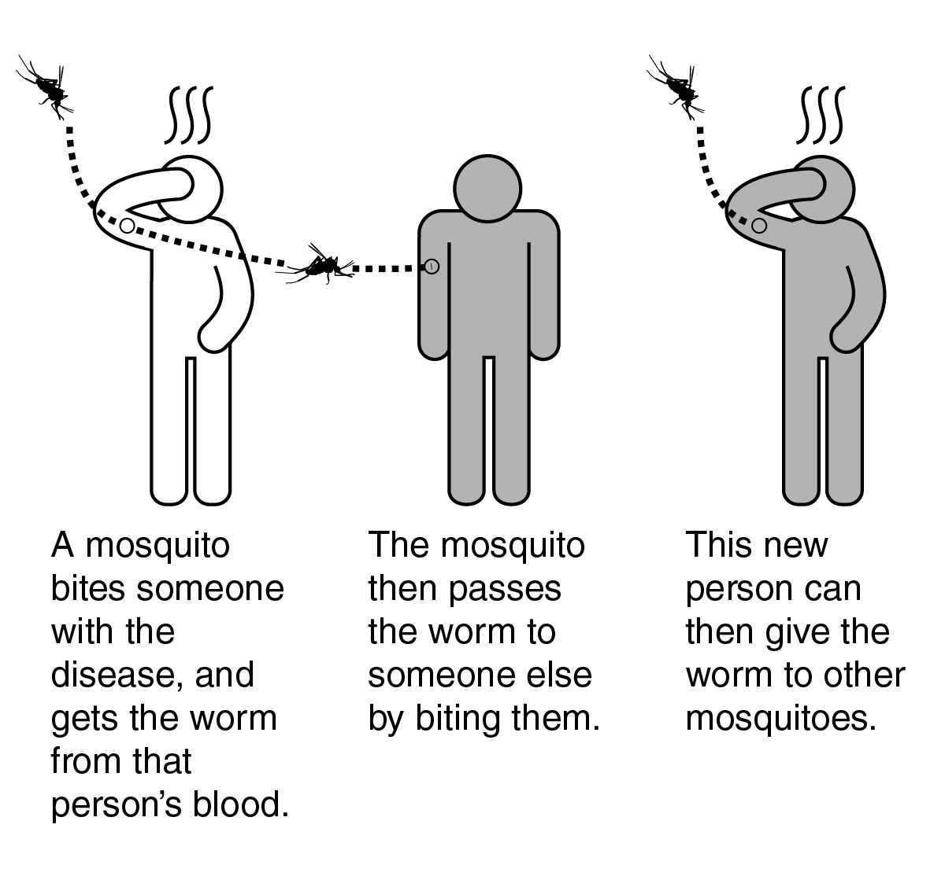
Mario’s doctors explained that mammals, such as humans and dogs, become infected with heartworm when they are bitten by mosquitoes that carry Dirofilaria immitis. Mosquitoes act as vectors (carriers). When they bite one mamma infected with the worm they pick up small worms. They can transfer the worms when they bite another mammal.

Diagnosed cases of Dirofilaria immitis in humans are rare. People infected with Dirofilaria immitis usually experience no symptoms. Inside humans, heartworms grow and then die in blood vessels of the lungs. Treatment is not needed because the worms do not reproduce in humans.

- How did Mario become infected with Dirofilaria immitis?

- Why is Mario’s diagnosis “surprising?”

- Explain why it is likely that there are humans with undiagnosed cases of Dirofilaria immitis.

Part 2: Pets and heartworm

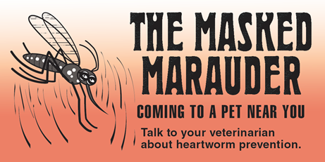
Mario is worried about his dog, Sasha. Sasha has been losing weight. She is not as active as she used to be. Mario took Sasha to a veterinary clinic for a heartworm test.

One poster (shown on the right) in the vet clinic waiting room caught Mario’s attention. He never realized that mosquitoes could bite pets and transmit diseases to them.


- There was a video about dog heartworm playing on the monitor in the waiting room. Watch the video and in the space below write one question you have and one thing that you found interesting about heartworm.
Scan this QR code with your smartphone or tablet camera app to link to the videos and websites used in this lesson.
Click on this link to see the video: https://youtu.be/oy8JwuCIXbY

- One question you have:

- One thing you found interesting about heartworm:

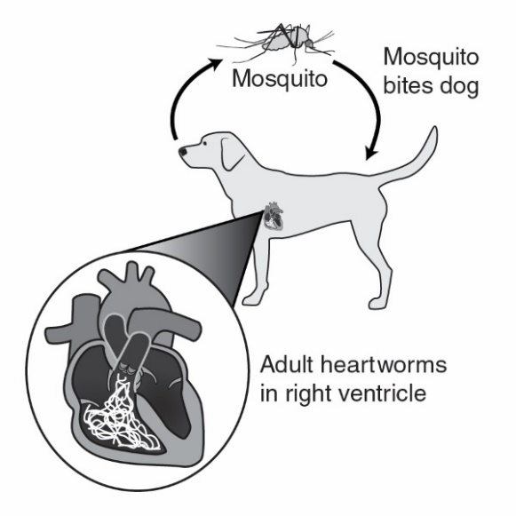
The veterinarian explained that heartworm is caused by a parasitic worm called Dirofilaria immitis. Mosquitoes act as vectors (carriers) to spread heartworm from one dog to another. In a dog, the heartworms cause serious health problems because they live, grow, and reproduce in the dog’s heart.

All dogs should have yearly heartworm tests. Luckily there is a simple and inexpensive test that can be done at the vet clinic to determine if a pet is infected with Dirofilaria immitis worms.

- A veterinary assistant prepared a sample of Sasha’s blood plasma (liquid part of the blood). Follow the instructions below to test the blood plasma sample from Sasha for Dirofilaria immitis.

- Dip the end of the Rapid Test Strip with the black line into Sasha’s Blood Plasma for approximately 5 seconds. Be certain that at least half of the test strip is dipped into the plasma.

Black line inserted into blood plasma

Pink on test strip

- Remove the test strip from the plasma and observe the test strip.
- If there is no pink on the test strip, the result is negative—Sasha does not have Dirofilaria immitis that causes heartworm disease.
- If there is a pink area on the test strip, the result is positive—Sasha has Dirofilaria immitis that causes heartworm disease.

- Does Sasha have heartworm disease? Support your answer with data from the testing.

- Discard the test strip. Close the lid on the tube of Sasha’s Blood Plasma and return it to your teacher.

- Mario had a few questions that are below. Use the resources provided by the American Heartworm Society (https://www.heartwormsociety.org/pet-owner-resources) to answer his questions.

- Is heartworm contagious? Could dogs, cats, or people who are in contact with Sasha get heartworm disease from her?

- The treatment for heartworms is expensive and complex. What will the Dirofilaria immitis worms do to Sasha’s body if I do not have her treated? Be specific.

- I have a cat. Should my cat be tested for heartworm? Explain why or why not.

- What should I do to keep my pets from getting heartworm in the future? Be specific.

- Explain why veterinarians should include information on mosquito control in their advice for pet owners.

Part 3: Mosquitoes and heartworm

Mario lives in Vermont. In the past, mosquitoes were only a problem for him in the early morning or evening. For the last few years, he has noticed a new kind of mosquito that bites aggressively during the day.

Local TV news programs have warnings about the new mosquito in the area. These mosquitoes are called the Asian tiger mosquito. The Asian tiger mosquito (scientific name Aedes albopictus) is an invasive species of mosquito originally found in the tropics. Asian tiger mosquitos were first introduced in Texas in 1985. Since then, they have spread to many parts of the United States.

Adult Aedes albopictus mosquitoes cannot survive cold winter temperatures. However, there is growing evidence that their eggs can survive drying and freezing temperatures and can hatch when temperatures rise in the Spring.

- Asian tiger mosquitoes have characteristics and behaviors that make them excellent vectors (carriers) for heartworm (Dirofilaria immitis). View the animation Tiger Mosquitoes/Seasonal Science at https://www.youtube.com/watch?v=s1ED2eJ4_s0 .

List four reasons why the Aedes albopictus species poses a more serious disease threat than native mosquito species.

Base your answers to questions 2 through 4 on the green map (Distribution of Aedes albopictus Mosquitoes) and the orange map (Distribution of Veterinary Cases of Heartworm).

- Is Aedes albopictus the only type of mosquito that can transmit the heartworm? Support your answer with evidence from the maps.

- Explain why it is possible for Aedes albopictus to move into areas of the United States that are marked “unlikely” on the map.

- Do the two maps support the claim that the spread of Aedes albopictus will result in an increase in the incidence of heartworm cases in the United States? Why or why not?

Part 4: Changing climate and mosquitoes

Mario, his parents and his neighbors have noticed that the climate in Vermont is gradually changing. Due to climate change, the summers in Vermont have been getting longer, warmer, and wetter.

Climate change, which increases the temperature and rainfall, is affecting many areas in the United States. Climate change doesn’t just shift weather patterns. It can change the distribution of plants, people, animals, insects — and disease. Climate change is also making it possible for Asian tiger mosquitoes to move into new areas. It has also led to longer “mosquito seasons.” As mosquito seasons get longer, Asian tiger mosquito populations have more time to reproduce and spread disease.

- Describe two ways that climate change will increase the number of people who are bitten by Asian tiger mosquitoes.

Base your answers to questions 2 through 5 on the illustration entitled Asian Tiger Mosquitoes: Vectors for Diseases.

- Explain why the feeding habits of Aedes albopictus mosquitoes make it likely that they could spread serious diseases from a variety of animals to humans.

- Predict what the future might be like if climate change resulted in large populations of Asian tiger mosquito populations in your community.

- As climate change occurs, it will be important for individuals in many parts of the country to take actions to control mosquitoes in and around their homes. Use information from the website below to identify at least 2 things that individuals could do to control mosquitoes in or near their homes.
https://www.cdc.gov/zika/prevention/controlling-mosquitoes-at-home.html

- As climate change occurs, it will be important that communities use Integrated mosquito management (IMM) methods to develop plans for controlling Asian tiger mosquitoes and preventing outbreaks of diseases that they carry. Use the information at the website below to identify at least 3 things that communities could do to reduce the risks of mosquito-borne diseases.

https://www.cdc.gov/westnile/vectorcontrol/integrated_mosquito_management.html

Part 5: One Health and invasive Asian tiger mosquitoes


One Health

A university is suggesting that the local government take a One Health approach to solving complex local problems, such as invasive Asian tiger mosquitoes. A One Health approach uses the idea that complex problems often involve the health of people, animals, and the environment. Therefore, solutions to One Health problems must be designed to protect the health of people, animals, and the environment.

- Use the information in the text box above to explain what must be involved in a complex problem for it to be considered a One Health problem.

To support adoption of a One Health approach, the university officials want to create a series of slides to provide examples of One Health problems in the community. Your team has been hired to create a slide to answer the question, “Why are invasive Asian tiger mosquitoes a One Health problem?”

Remember how the CDC video used images with captions to help people understand what One Health problems and solutions involve. Using pictures and captions will help people understand and remember what the One Health approach involves.

- Use the information in the text box above and what you learned about invasive Asian tiger mosquitoes to develop your slide. Use the following template to organize your slide:

Why are invasive Asian tiger mosquitoes a One Health problem?
Picture and a caption to explain how animals are involved in the problem | Picture and a caption to explain how humans are involved in the problem | Picture and a caption to explain how the environment is involved in the problem

