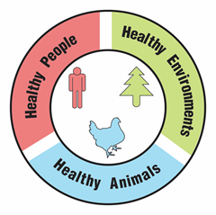
Ticks, Biodiversity, and Climate

Part 1: What kinds of ticks are present in the ecosystem?

Jada’s high school required twenty hours of community service in order to graduate. Jada was interested in a career as a veterinary technician (“vet tech”). As a vet tech, Jada would assist the veterinarian in diagnosing and treating animals. To learn what is involved in the job of a vet tech, Jada decided that she would volunteer at her local veterinarian’s office. Dr. Louis, the veterinarian, encouraged Jada to join her during most pet examinations.


The first patient of the morning was Max, a large sheepdog mix. As Dr. Louis examined Max’s ears, she noticed a small white “bump”. Dr. Louis showed Jada and explained that this bump was actually a tick. Ticks are tiny animals that embed their pointy mouth parts in their host’s skin to feed on blood. Dr. Louis immediately removed the tick from Max’s ear and placed it in a petri dish. Dr. Louis said that the tick could be carrying diseases that could harm Max. In order to find out if the tick was dangerous, they would first need to identify what kind of tick was on Max.

- Use the photograph of the tick found on Max and the Tick Identification Key to identify the tick found on Max. What type of tick was found on Max?

- Support your identification by checking the characteristics the tick had that helped in identification.
____ Festoons
____ Long mouth parts
____ Several silvery markings
____ One single white spot

- Use the Human Diseases Transmitted by Ticks reference page to determine what diseases, if any, this kind of tick is likely to be carrying.

Throughout the course of the day, Dr. Louis examined two more dogs, Lainey and Daisy. Both dogs loved the outdoors and took long walks through the woods with their human companion. Dr. Louis removed ticks from each of these dogs as well!

- Use the Tick Identification Key to identify the tick found on Lainey. What type of tick was found on Lainey?

- Support your identification by checking the characteristics the tick had that helped in identification.
____ Festoons
____ Long mouth parts
____ Several silvery markings
____ One single white spot

- Use the Human Diseases Transmitted by Ticks reference page to determine what diseases, if any, this kind of tick are likely to be transmitted to humans.

- Use Tick Identification Key to identify the tick found on Daisy. What type of tick was found on Daisy?

- Support your identification by circling the characteristics the tick had that helped in identification.
____ Festoons
____ Long mouth parts
____ Several silvery markings
____ One single white spot

- Use the Human Diseases Transmitted by Ticks reference page to determine what diseases, if any, this kind of tick is likely to transmit to humans.

Part 2: What pathogens can ticks carry?

Dr. Louis was concerned that the ticks might be carrying pathogens (viruses and other disease-causing microorganisms) that could harm the dogs. These pathogens would be living inside of the tick’s body and are transmitted to the dog during the bite. Dr. Louis packaged the ticks into sealed plastic bags and sent them to the local veterinary laboratory for analysis.

To test for pathogens, a lab technician places DNA samples from the ticks into different wells on an electrophoresis gel. Gel electrophoresis separates DNA fragments (pieces) on the basis of size. Large DNA fragments move slowly through the gel. Small DNA fragments move quickly through the gel.

Your lab kit contains a simulated paper version of the electrophoresis gel that you will use to test for pathogens in each of the ticks removed from Max, Lainey and Daisy. You can’t see the DNA pieces on this gel because DNA is colorless. In order to see the DNA, you will need to add a DNA stain to the gel. This stain will attach to the DNA fragments on the gel and turn them pink.

- Use the Tick Pathogen Detection Kit to determine if any of the ticks removed from Dr. Louis’ patients were carrying pathogens. Record the banding pattern on the diagram of the simulated electrophoresis gel below.

Simulated Electrophoresis Gel

 | Max |  | Daisy |  | Lainey
13
12
11
10
9
8
7
6
5
4
3
2
1

The Tick Pathogen Standard Key displays banding patterns for common tick-borne pathogens. Compare the banding patterns in the tick samples to the Tick Pathogen Standard Key.

- Complete the laboratory form to return the results to Dr. Louis by placing an “X” in the box where pathogens were detected.

 | Type of Pathogen Detected
Patient’s Name | Borrelia  burgdorferi  (Lyme Disease) | Ehrlichia  chaffeensis (Ehrlichiosis ) | Francisella  tularensis  (Tularemia) | Anaplasma phagocytophilum  (Anaplasmosis)
Max
Daisy
Lainey

- Which pet’s owners should be notified of possible pathogen transmission to their dog?

- During a follow up visit with Lainey, Dr. Louis was informed that Lainey’s owner was walking through the woods with Lainey when she was bitten by the tick. Dr. Louis was concerned that Lainey’s owner may also have been exposed to the pathogen through a tick bite. List some of the symptoms that Lainey’s owner might exhibit if he was exposed to this pathogen.

Part 3: Analyzing patterns in tick-borne diseases

The veterinary lab that Dr. Louis uses participates in a research project that collects data on tick-borne diseases in dogs. The US Centers for Disease Control and Prevention (CDC) collects similar data on tick-borne diseases in humans. Researchers can use this data to recognize patterns in the dog and human tick-borne infections.

Total number of reported tick-borne diseases in humans from 2004-2018

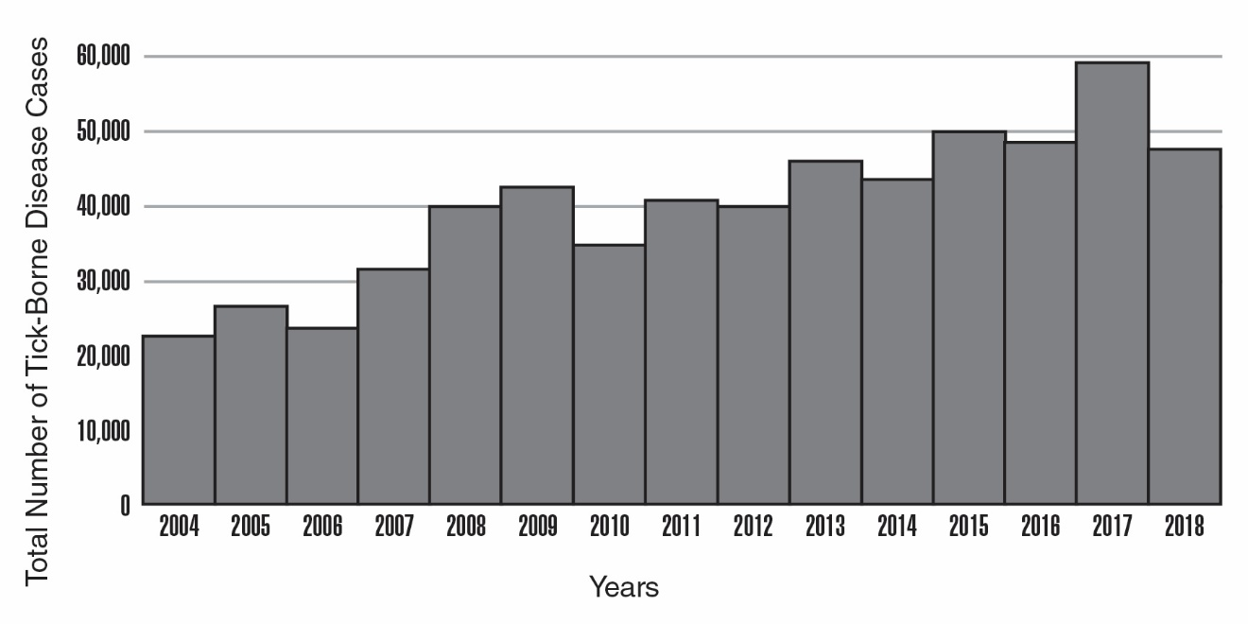
Modified from CDC https://www.cdc.gov/ticks/data-summary/index.html

- Use the graph above to describe the overall trend in the incidence of tick-borne diseases in the United States.

Researchers decided to focus on the blacklegged tick because this tick can carry several diseases that are transmissible to humans, including the pathogen that causes Lyme disease. In 2018, the CDC developed a map to illustrate the geographic distribution of the blacklegged tick in the United States. This map is shown below.

Map of Blacklegged Tick Distribution
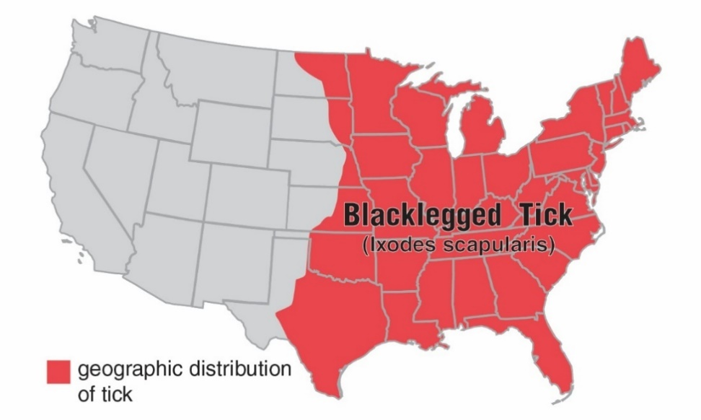

Modified from CDC https://www.cdc.gov/ticks/geographic_distribution.html

- What part of the United States would you most likely find blacklegged ticks?

Red dots on the following maps of the U.S. illustrate the geographic distribution for several blacklegged tick-borne diseases in humans. The data was collected in 2016.

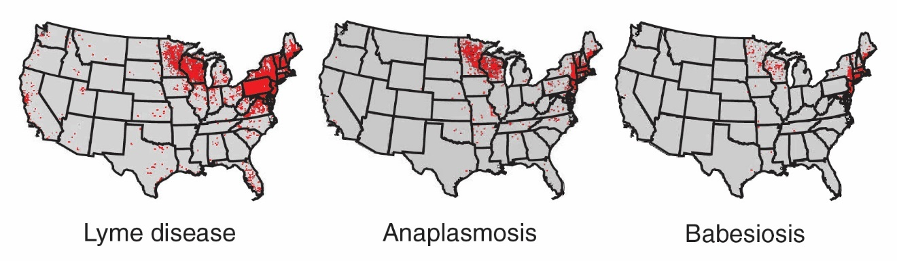
Modified from CDC https://www.cdc.gov/ticks/tickbornediseases/overview.html

- On the map below, circle the region of the country researchers focus on because blacklegged tick-borne diseases are prevalent there.

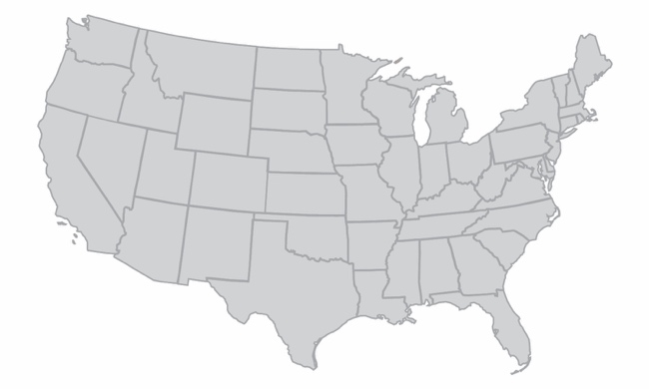

- Does the incidence of these diseases correlate with the entire geographic range of the blacklegged tick? Support your answer.

The first step in determining a cause for the trend in tick-borne diseases is to find non-living, environmental factors (abiotic factors) related to the tick’s life cycle that correlate with the trend. The first data studied by the scientists was temperature data. The scientists wondered if changes in annual average temperature for the region could explain the trend in tick-borne diseases.

Change in Average Annual Temperature
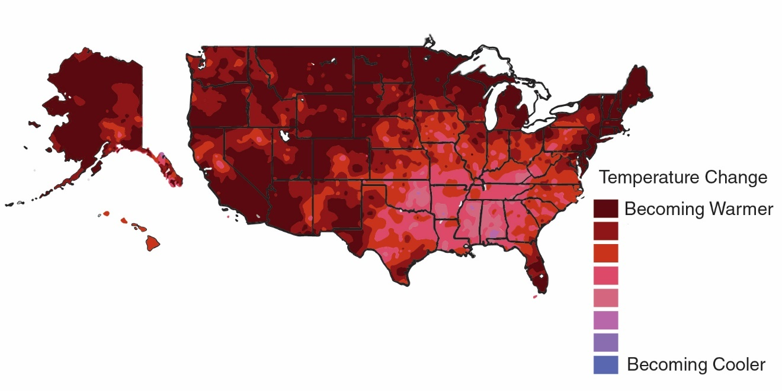
Modified from Climate Science Special Report https://science2017.globalchange.gov/chapter/6/

- What is the trend in annual temperature in the region you identified as important to tick-borne diseases?

- Can this pattern in temperature change provide an explanation for the increase in tick-borne diseases in this entire region? Support your answer with information from the Change in Average Annual Temperature map and the previous maps.

Researchers continued to look at environmental data from this region. This time they focused on changes in annual average precipitation over time.

Change in Average Annual Precipitation
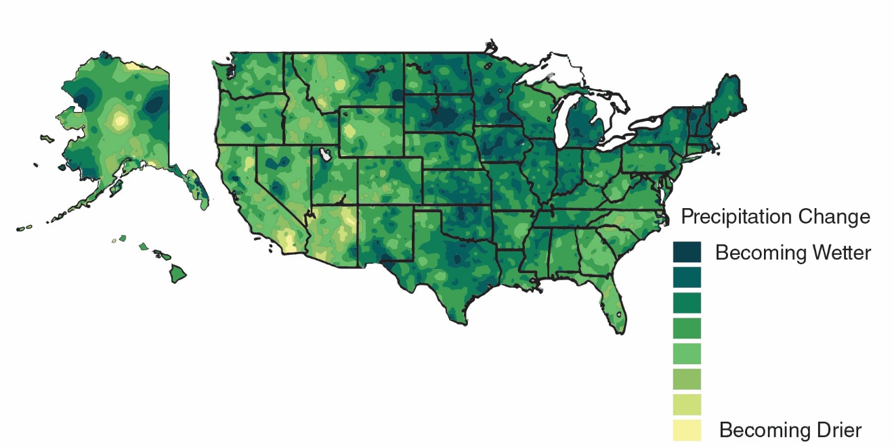

Modified from Climate Science Special report https://science2017.globalchange.gov/chapter/7/

- What is the trend in annual precipitation in the region you identified as important to tick-borne disease?

- Can this pattern in precipitation change provide an explanation for the increase in tick-borne diseases in this entire region? Support your answer with information from this map and the previous maps.

Even though rainfall has increased in the Northeast, the overall relative humidity of the Northeast remains lower than the relative humidity of the Southeast. The researchers hypothesized that this lower relative humidity in the northeast promotes tick survival and reproduction. To test this idea, scientists placed ticks in environments with different humidity levels and monitored their survival rate over time.
Relative Humidity
a measure of the amount of moisture in the air

This graph represents the data that the scientists collected:

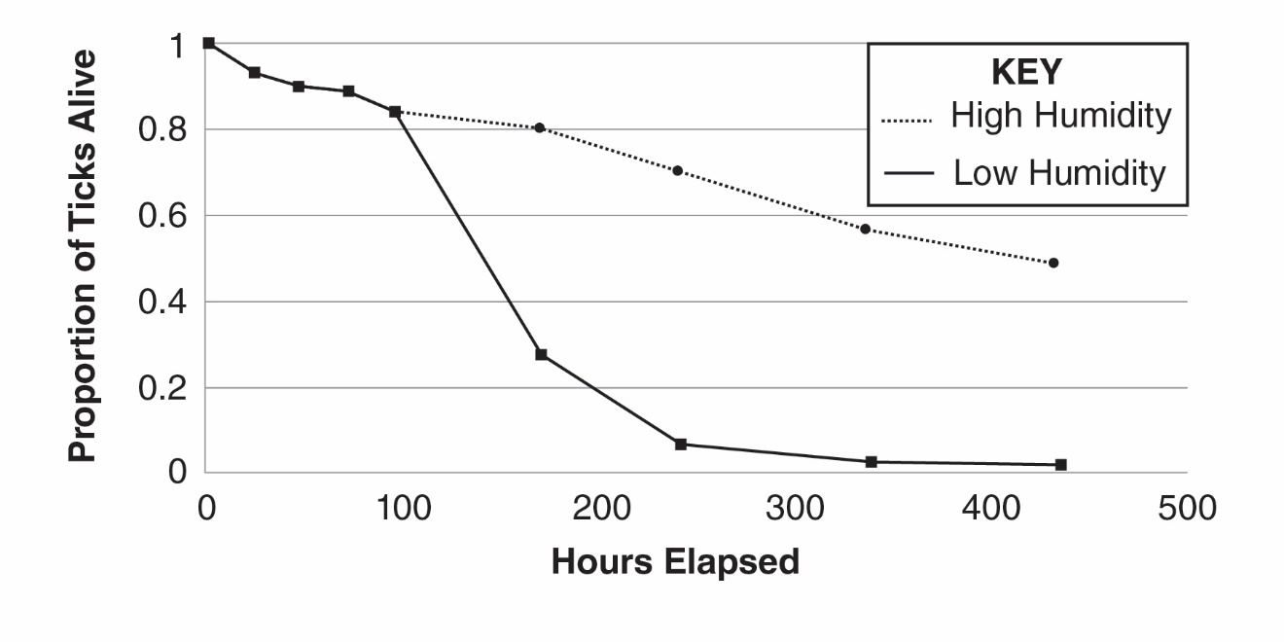
Modified from PLoS ONE https://www.ncbi.nlm.nih.gov/pmc/articles/PMC5226345/

- What effect does relative humidity have on the proportion of ticks alive after 200 hours?

- Does the data support the scientists’ hypothesis? Why or why not?

In addition to abiotic (non-living) factors like temperature, rainfall and humidity, researchers also investigated factors related to living things (biotic factors). The scientists discovered that ticks from the Northeast U.S behave differently compared to ticks in the Southeast U.S. Ticks in the Southeast tend to hide under leaf litter located on the ground. Ticks in the Northeast climb on plant stems.

- Explain how this difference in behavior could lead to more tick-borne pathogens spreading to humans in the Northeast.

Part 4: Do living things influence the pattern of tick-borne diseases?

The researchers involved in the voluntary reporting project studying the patterns in tick-borne diseases realized that this was a very complex problem that may involve even more factors. They decided to enlist the help of an environmental scientist. Environmental scientists use their knowledge of science to protect the environment. They gather data and monitor environmental conditions related to ecosystems, which are an intertwined web of interacting abiotic and biotic factors. The environmental scientist explained that ticks are part of a complex system of interactions. Models are a way to visualize interactions within an ecosystem. Scientists use models to help answer the question, “Are biotic factors in the ecosystem involved in the pattern of tick-borne diseases?”

    - Locate the Complex Interactions Model sheet. According to this model, what organism do immature ticks feed on?

    - What effect would an increase in acorns have on the number of ticks in the environment? Explain.

    - What effect would an increase in the number of small mammal predators have on the number of ticks?

    - Locate the clear plastic overlay sheet called, Steps to Infection. Place this overlay sheet DIRECTLY on top of the Complex Interactions Model sheet. The squiggly arrows represent the movement of ticks through the ecosystem.

    - Using a dry erase marker, draw a circle on the overlay to show where the bacteria that causes Lyme disease is transferred to the tick.

    - Use the information from the two diagrams to explain how Lainey and her owner were most likely exposed to Borrelia burgdorferi, the bacteria that causes Lyme disease. Write numbers (2-8) on the lines to place the events in the correct order.

_____ Immature tick feeds on chipmunk.

_____ Ticks bite Lainey and her owner.

__1__ Adult ticks mate on deer.

_____ Immature ticks leave deer to find a small mammal host.

_____ Tick leaves small mammal host, waits for new host on plants.

_____ Bacteria are transferred from chipmunk to tick.

_____ Immature ticks hatch from eggs on deer.

_____ Ticks leave the plant for a dog or human host.

__9__ Tick bites transfer bacteria to Lainey and her owner.

    - People often read in the newspaper that when deer populations are high, there is an increased risk for tick-borne diseases. Explain why a large deer population may increase the transmission of tick-borne diseases.

The environmental scientist had been monitoring the number of small mammal hosts, acorns and ticks for eight years. Her data are below:

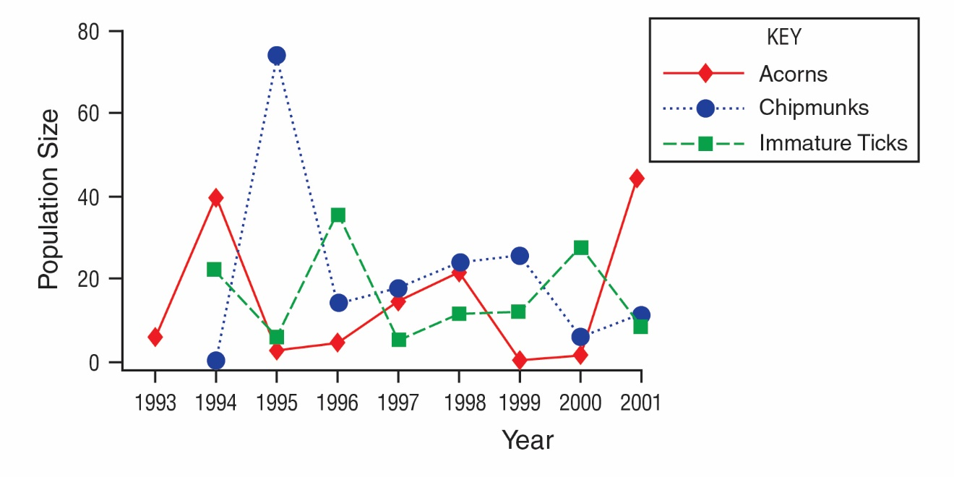
Modified from PLoS Biology https://www.ncbi.nlm.nih.gov/pmc/articles/PMC1457019/

    - Below is a timeline that will help make sense of events in this ecosystem. Use the graph above to:
      - Place a letter A in the box on the timeline below corresponding to each year there was a peak in the number of acorns.
      - Place a letter C in the box on the timeline below corresponding to each year there was a peak in the number of chipmunks.
      - Place a letter T in the box on the timeline below corresponding to each year there was a peak in the number of immature ticks.

1993 | 1994 | 1995 | 1996 | 1997 | 1998 | 1999 | 2000 | 2001

- Describe how the pattern of peaks in the chipmunk population compares to the pattern of peaks in the acorn population.

- Provide an explanation for this pattern.

- Describe how the pattern of peaks in the chipmunk population compares to the pattern of peaks in the tick population.

- Provide an explanation for this pattern.

- In what 2 years (between the years of 1993 and 2011) would you expect to see an increase in tick-borne diseases? Why?

- Assume that 2001 is a peak in the acorn population. What year, following this peak would you warn people about a potential increase in tick-borne diseases? Why?

The environmental scientist explained that increasing the number and kinds of small mammal predators (fox) is important in controlling the transmission of tick-borne diseases. She said that some environmental scientists think that the key to controlling the number of ticks is the size of the population of apex predators such as coyotes and other animals at the top of the food chain.

- Would environmental scientists worried about tick-borne diseases recommend an increase or a decrease in the population of apex predators?

- Explain why environmental scientists would make this recommendation.

- Provide at least two additional actions an environmental scientist might suggest to decrease the number of tick-borne diseases that are transmitted to humans, based on the complex interactions in this ecosystem.

Part 5: What should pet owners know about tick-borne diseases?

Dr. Louis, the veterinarian, was not surprised at the positive results. She has been seeing an increase in tick-borne diseases within the last few years. She keeps a visual reminder in her office to inform her clients about the increase in these diseases. Every time she receives a positive result back, she places a plastic coin in a jar on her office’s welcome counter labeled, “Positive – Tick-borne Disease.” Next to the jar, Dr. Louis posted a statement from the American Veterinary Medical Association:

Because people and their pets often spend time in the same environments where Lyme and other disease-transmitting ticks are found, the American Veterinary Medical Association (AVMA) and the American Academy of Pediatrics (AAP) are working together to offer advice to households with both children and pets. People who have been diagnosed with Lyme disease should consult their veterinarian to determine their pet's risk based on the animal's lifestyle and possible environmental exposures. Likewise, people whose animals have been diagnosed with Lyme disease may want to consult their physician about their own or their children’s risk if they have concerns that the animals and family members might have been exposed to similar environmental risks.

Increasingly, Dr. Louis’s clients have been inquiring about tick-borne diseases because of the doctor’s visual reminder. Dr. Louis asked Jada to develop a FAQ sheet to display on the vet’s website.

- The following questions were identified by Dr. Louis as being most important to address for her veterinary clients.
- What should I do if I see a tick on my pet?
- What kind of precautions can I take to prevent tick bites on me?
- What kind of precautions can I take to prevent tick bites on my pet?
- If my pet is diagnosed with a tick-borne disease, why should I contact my own doctor?

- Use the internet resources provided in the chart on the next page to develop well-written responses to the questions that can be included in the FAQ sheet for Dr. Louis.
Scan this QR code with your smartphone or tablet camera app to link to the websites.



Questions | Answers
What should I do if I see a tick on my pet?
https://www.cdc.gov/ticks/removing_a_tick.html
What kind of precautions can I take to prevent tick bites on me?
https://www.cdc.gov/ticks/avoid/on_people.html

What kind of precautions can I take to prevent tick bites on my pet?
https://www.cdc.gov/ticks/avoid/on_pets.html
If my pet is diagnosed with a tick-borne disease, why should I contact my own doctor?
https://www.avma.org/resources/pet-owners/petcare/lyme-disease-pet-owners-guide

Part 6: One Health and tick-borne diseases

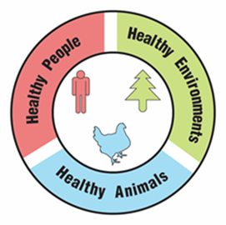
One Health

A university is suggesting that the local government take a One Health approach to solving complex local problems, such as an increase in tick-borne diseases. A One Health approach uses the idea that complex problems often involve the health of people, animals, and the environment. Therefore, solutions to One Health problems must be designed to protect the health of people, animals, and the environment.

- Use the information in the text box above to explain what must be involved in a complex problem for it to be considered a One Health problem.

To support adoption of a One Health approach, the university officials want to create a series of slides to provide examples of One Health problems in the community. Your team has been hired to create a slide to answer the question, “Why is the increase in tick-borne diseases a One Health problem?”

Remember how the CDC video used images with captions to help people understand what One Health problems and solutions involve. Using pictures and captions will help people understand and remember what the One Health approach involves.

- Use the information in the text box above and what you learned about ticks and tick-borne diseases to develop your slide. Use the following template to organize your slide:

Why is an increase in tick-borne diseases a One Health problem?
Picture and a caption to explain how animals are involved in the problem | Picture and a caption to explain how humans are involved in the problem | Picture and a caption to explain how the environment is involved in the problem

