Sampling Protocol

- Pour 50 ml of Tissue Dissolving Solution into the brain tissue sample container.
- Gently stir the Brain Tissue Sample container for 1-2 minutes, or until all the brain tissue is dissolved.
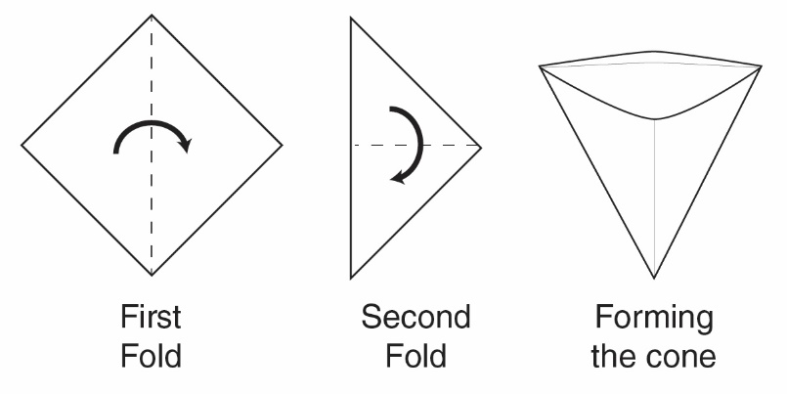
- Fold your square filter paper in half and then in half again.
- Open the folded filter paper so that you have a cone-shaped filter.
- Place the folded filter paper into a beaker or cup.
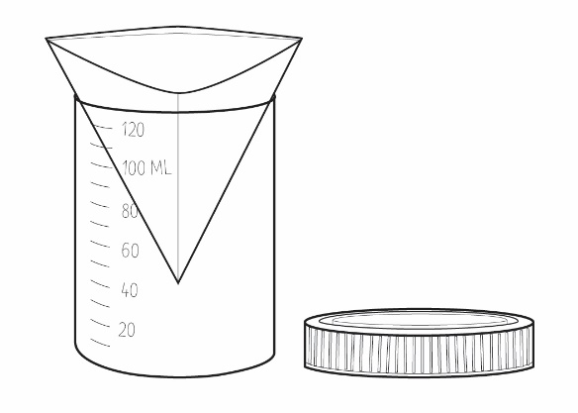
- Pour the dissolved brain tissue sample contents through the filter paper.
- Once all the liquid has passed through the filter, carefully pull out the filter paper.
- Unfold the filter paper and observe any microplastics left on the filter paper.
Note: You may find it useful to observe the microplastics with a hand lens.

