

A Family Medicine Cabinet

Core Concepts:
- Consumers can purchase over-the-counter drugs and dietary supplements without a doctor’s prescription.
- Prescription drugs and over-the-counter drugs have been scientifically tested to provide significant evidence they are safe and effective.

Class time required:
1 – 2 forty-minute class periods

Teacher Provides:
For each student
- Copy of student handout entitled A Family Medicine Cabinet
- Copy of Fact Sheet: Drugs and Dietary Supplements. See page x. Laminate or put it sheet protectors if these will be used by multiple classes.
For each pair of students:
- Product Labels (4 pages with 9 labels) printed in color. Laminate if these will be used by multiple classes. See pages vi through ix. Optional: Make the labels look more realistic by cutting along the dotted lines to remove the white space from around the labels.

Teacher Resources:

- Understanding Over-the-Counter Medicine from the US Food and Drug Administration (FDA) provides a variety of resources including print, video, and audio resources.
https://www.fda.gov/Drugs/ResourcesForYou/Consumers/BuyingUsingMedicineSafely/UnderstandingOver-the-CounterMedicines/default.htm

- Over-the-Counter Medicine Safety by Scholastic provides four lessons, posters, role-playing activity, whiteboard images, a digital flipbook, medicine safety videos, additional resources, and a pre/post-quiz for over-the-counter medicine use. http://www.scholastic.com/otcliteracy/

- FDA: Dietary Supplements provides information on FDA regulation of dietary supplements for https://www.fda.gov/food/dietarysupplements/

- FDA 101: Dietary Supplements provides consumer information on dietary supplements
https://www.fda.gov/ForConsumers/ConsumerUpdates/ucm050803.htm
Copyright © 2017 by University of Rochester. All rights reserved. May be copied for classroom use.
This lesson was developed with support from the National Institutes of Health under Award Number R25OD010494. The content is solely the responsibility of the authors and does not necessarily represent the official views of the National Institutes of Health.
Suggested Class Procedure:

- Prewrite: Ask students write brief answers to the questions “What is a medicine?” and “What is a drug?” Students should save what they have written for use at the end of this lesson.
Warning: It is essential that you maintain families’ legal rights to privacy related to health and medicine use. Do not allow students to provide or discuss examples of medicines or dietary supplement used by their family.

Note: The everyday use of the words “drugs”, “medicines”, and “dietary supplements” is different from the definitions used by the FDA (Food and Drug Administration). The Fact Sheet uses the FDA language. However, to help students relate the activity to their lives, we have used the words “drug” and “medicine” interchangeably.

- Distribute to each student:
  - Fact Sheet: Drugs and Dietary Supplements
  - Student instructions for A Family Medicine Cabinet
- Read the introduction (first two paragraphs on page 1) of A Family Medicine Cabinet aloud to the class. Explain that the purpose for this activity is to help them understand the similarities and differences between the different types of products that they probably call “medicines.”
- Assign students to work with partners.
- Distribute Product Labels (9 labels) to each pair of students. Tell students that they are to use these labels, not the labels in the picture on page 1.
- Ask students to read, follow the instructions, and answer the questions in Part 1: Classifying Medicines
- Check student work for Part 1 by calling on students to read their answers. Ask students to explain how they would tell if a product is a prescription medicine, an over-the-counter medicine, or a dietary supplement.
- Optional: The teacher may wish to collect EMPTY bottles or boxes for dietary supplements and over-the-counter drugs. Students could then classify these samples. BEWARE: It is not wise to ask students to provide samples of medicine containers from home! Student provided samples could pose privacy issues.
- Optional: Show the video Medicines in My Home: The Over-the-Counter Drug Facts Label (approximately 2 minutes) on how to interpret Drug Facts labels.
https://www.youtube.com/watch?v=hT6Th_QfQKE
- Ask students to read, follow the instructions, and answer the questions in Part 2: Comparing Medicines.
- Check student work for Part 2 by calling on students to read their answers.
- Ask students if they have any questions about the differences between prescription drugs, over-the-counter drugs, and dietary supplements.
- Part 3: Should Prescription Drugs become Over-the-Counter Drugs? may be done in class or for homework. If possible, allow class time for students to share their answer to the last question in Part 3.
- Ask students write brief answers to the questions “What is a medicine?” and “What is a drug?” Discuss how their answers to these questions changed after completing this activity.
- Optional: Expand on discussion of clinical trials to test a drug’s safety and effectiveness.
- How should the experiment be designed to be a fair test of the drug?
- Who should pay for the clinical trials—the FDA or drug companies?
- Optional: Expand on discussion of dietary supplements:
- Show the video Dangerous Dietary Supplements (approximately 2 minutes). Be aware that this video focuses on the hazards of dietary supplements without providing information on dietary supplements that are safe and effective. http://www.consumerreports.org/video/view/healthy-living/drugs-medication/605132728001/dangerous-dietary-supplements/
- Ask students to compare and contrast dietary supplements and over-the-counter drugs.
- Discuss the pros and cons of dietary supplements.
- Optional: Discuss how students should define “abuse” of prescription drugs, over-the-counter drugs, and supplements. Why is abuse of legal drugs and supplements potentially dangerous?
- Optional: The multiple choice questions on pages iv-v may be used for homework or as a quiz.

- The FDA (U.S. Food and Drug Administration)
Multiple Choice Questions: A Family Medicine Cabinet
- Approves and regulates the sale of drugs.
- Organizes police action to prevent the sale of illegal drugs.
- Does science research to discover and develop new drugs.

- The FDA (U.S. Food and Drug Administration) defines a drug as
- An illegal substance which may become addictive.
- A harmful substance which affects how the brain works.
- A substance that is used to prevent, treat, or cure diseases.

- Over-the-counter drugs
- Require a prescription from a doctor.
- Can only be purchased at pharmacies or drug stores.
- Have been scientifically tested to determine that they are effective.

- Prescription medicines
- Do not have side effects or drug interactions.
- Contain active ingredients that are natural and organic.
- Should only be used by the person listed on the label.

- A Drug Facts label is found on
- Prescription drugs only
- Over-the-counter drugs only
- Both prescription and over-the-counter drugs

- You can buy over-the-counter medicines without a prescription because they are
- Safe for use by anyone.
- Less expensive than prescription medicines.
- Safe for most people if they follow the label directions and warnings.

- Which type of product label provides the greatest amount of information about how to use the product safely?
- Dietary supplement label
- Over-the-counter medicine label
- Prescription medicine label

- All dietary supplements, over-the-counter medicines, and prescription medicines
- Affect the way the body functions.
- Are safe for all people over the age of 12.
- Have been proven to be effective in treating or preventing disease.

- Which product has a “Warnings” section on the label to help consumers choose and use the product safely?
- Dietary supplements
- Over-the-counter medicines
- Prescription medicines

- The product label shown on the right is
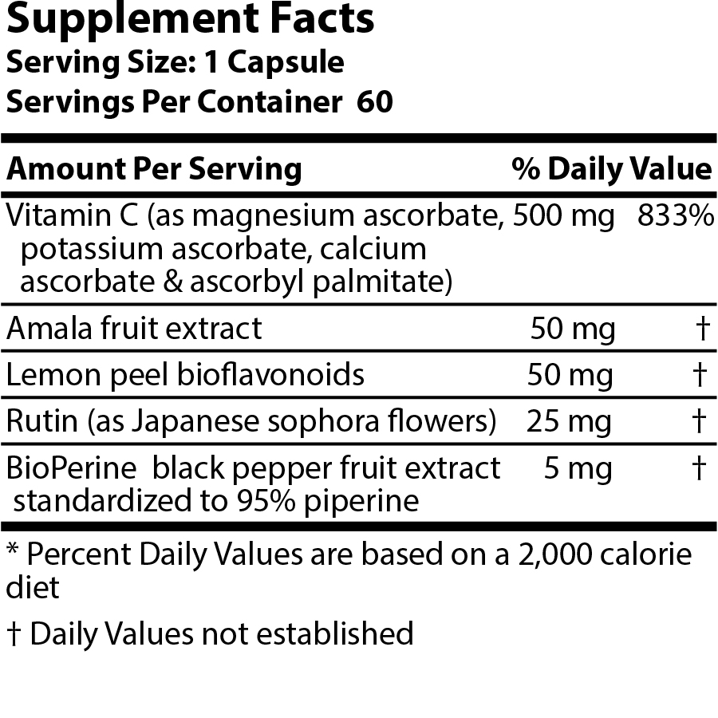
- A dietary supplement label.
- An over-the-counter medicine label.
- A prescription medicine label.

- The product label shown on the right is
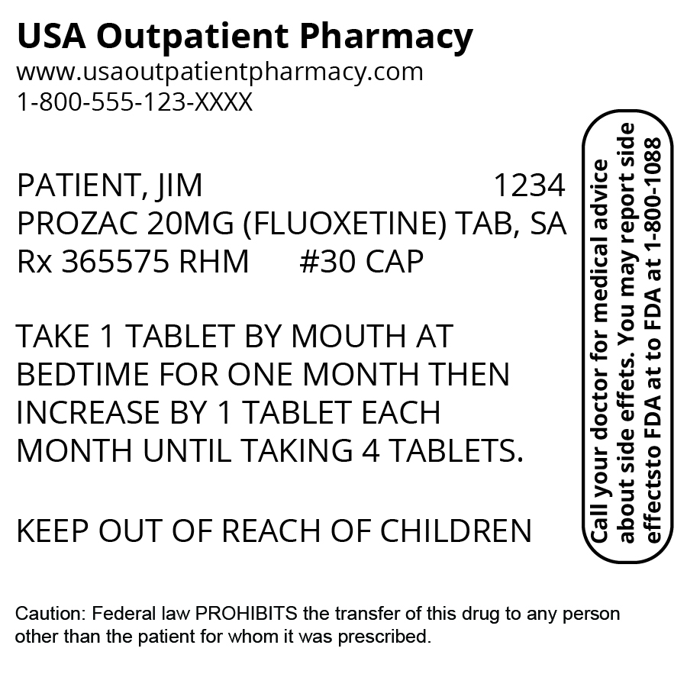
- A dietary supplement label.
- An over-the-counter medicine label.
- A prescription medicine label.

- Both prescription and over-the-counter medicines
- Are only sold in pharmacies (drug stores).
- Have been scientifically tested on a large number of people.
- Are not intended for use in treatment or prevention of disease.

- Both prescription medicines and dietary supplements
- Are classified as drugs by the FDA (Food and Drug Administration).
- Have been approved by the FDA (Food and Drug Administration).
- May result in harmful side effects or drug interactions.

- Both dietary supplements and over-the-counter medicines
- Have been scientifically tested and approved by the FDA.
- Can be purchased without a prescription from a doctor.
- Have a supplement facts label that describes the nutrients in the product.

- Examples of dietary supplements include:
- Antibiotics and antiviral medicines.
- Vitamins, minerals, enzymes, and herbs.
- Antihistamines, decongestants, and pain relievers.

Product Labels (page 1 of 4)

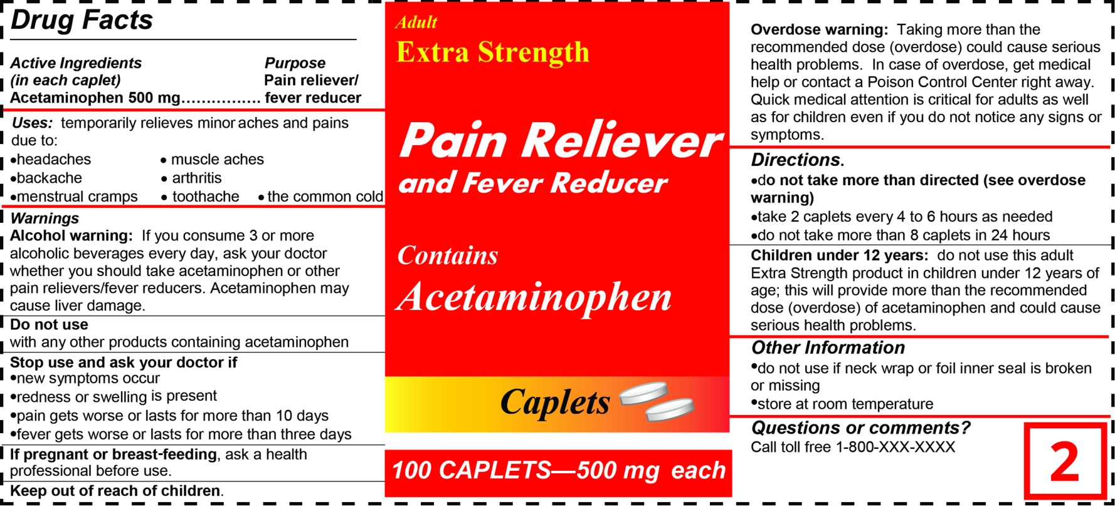
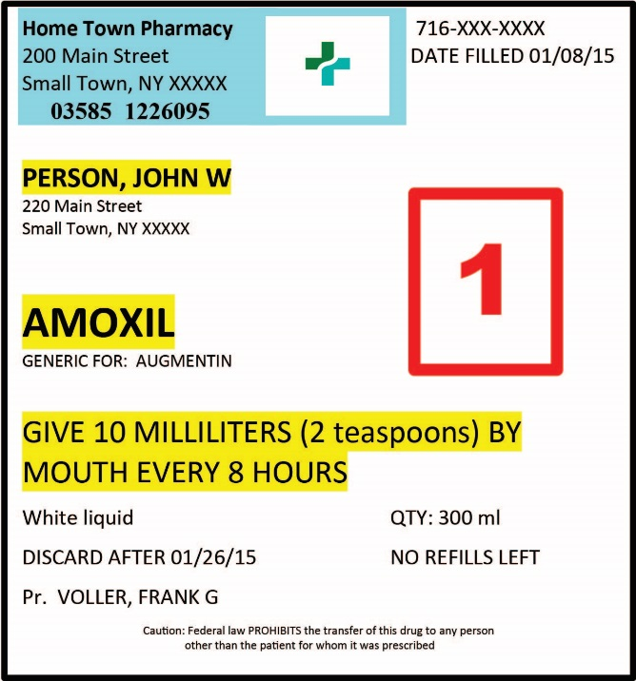

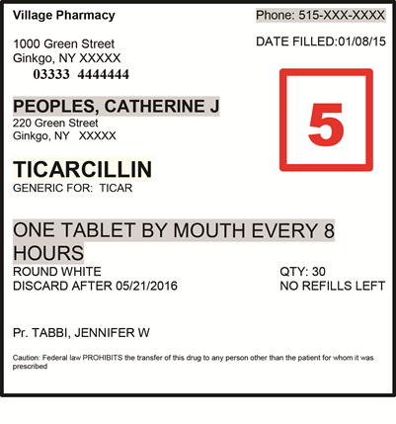

Product Labels (page 2 of 4)
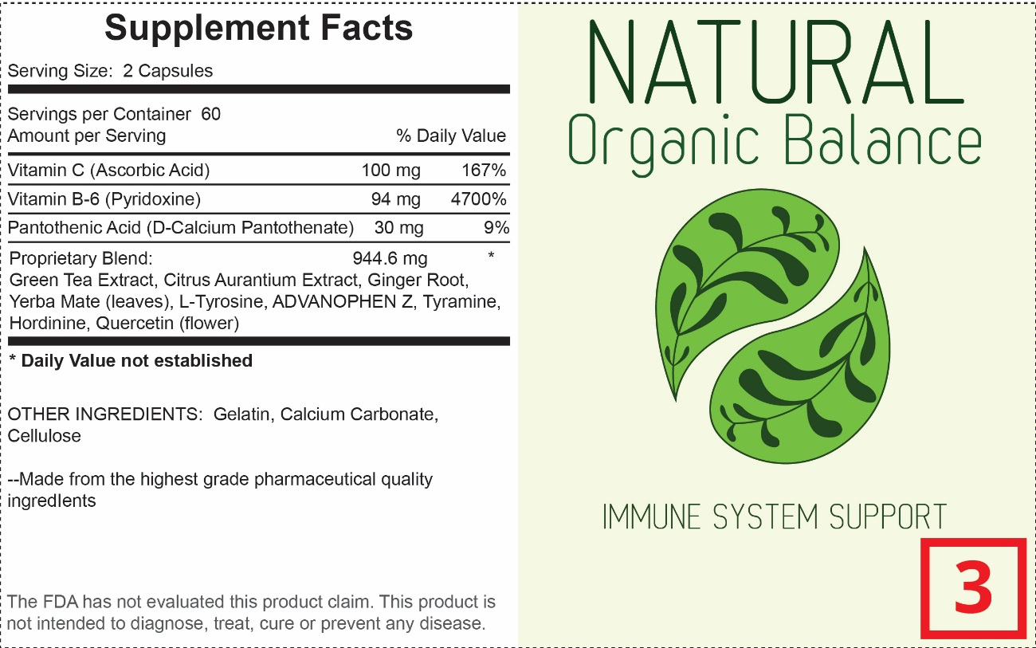

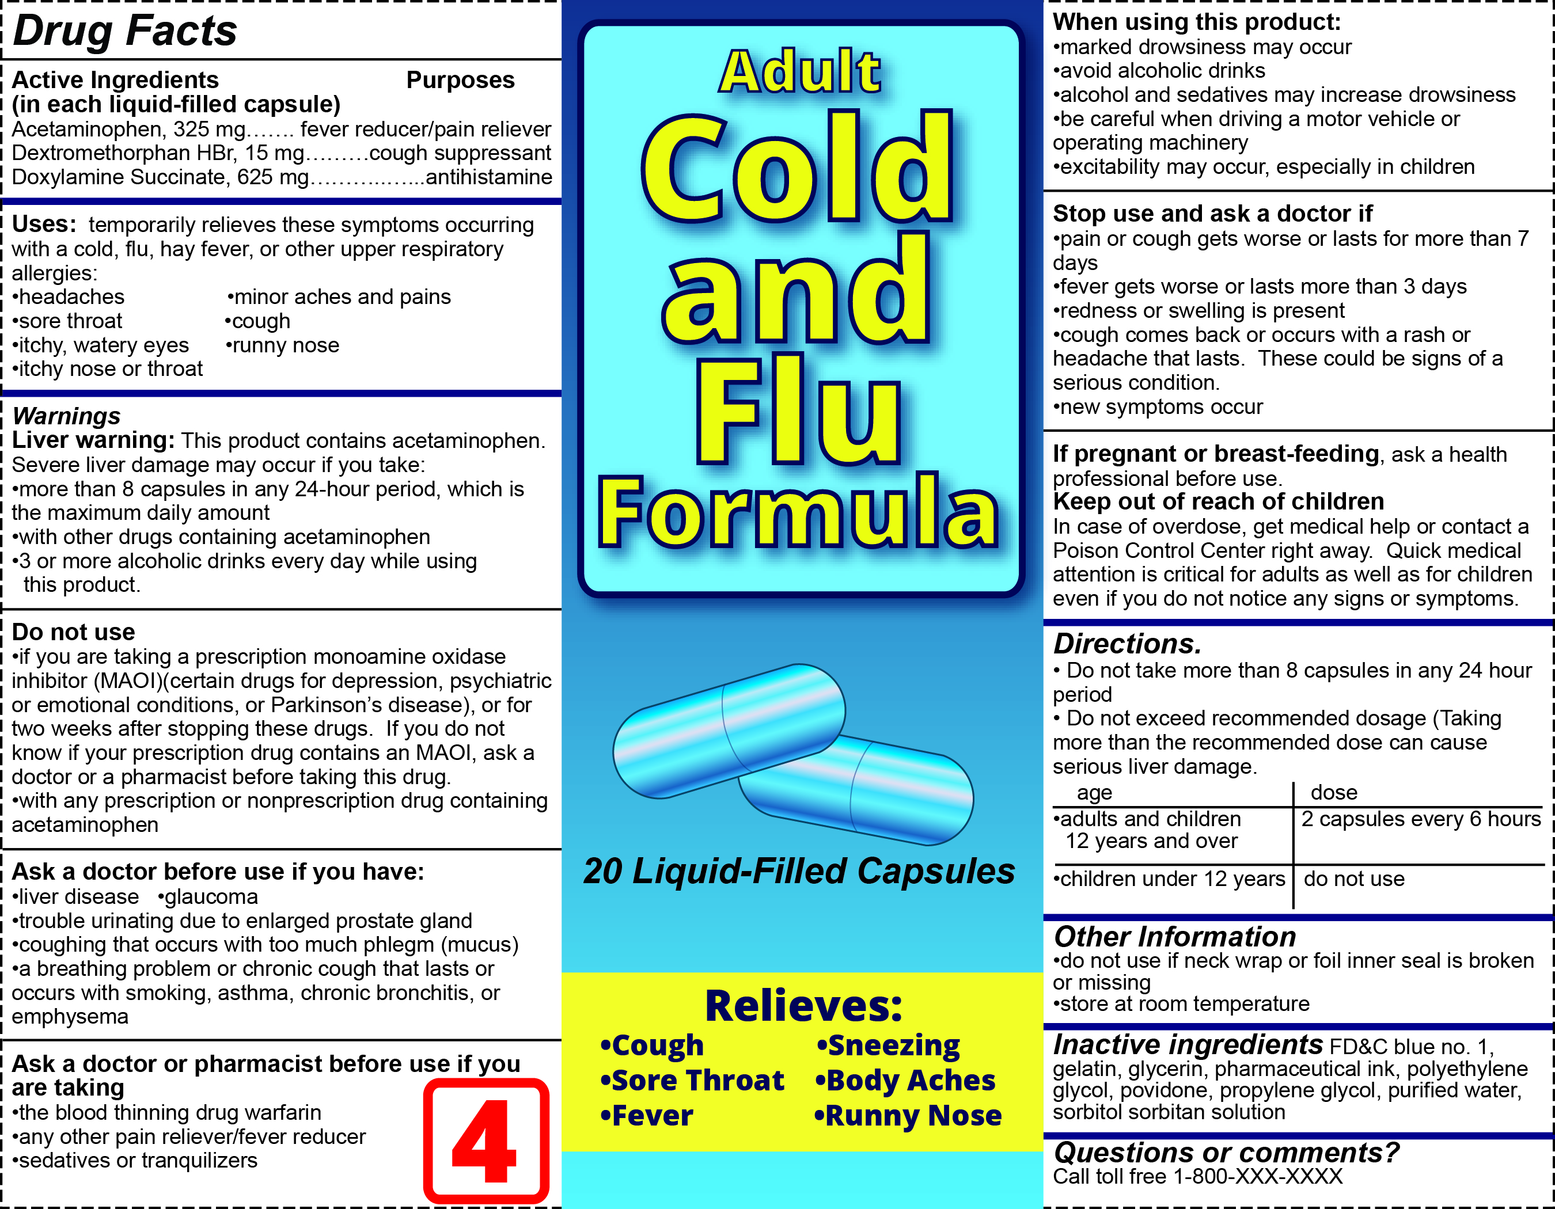
Product Labels (page 3 of 4)
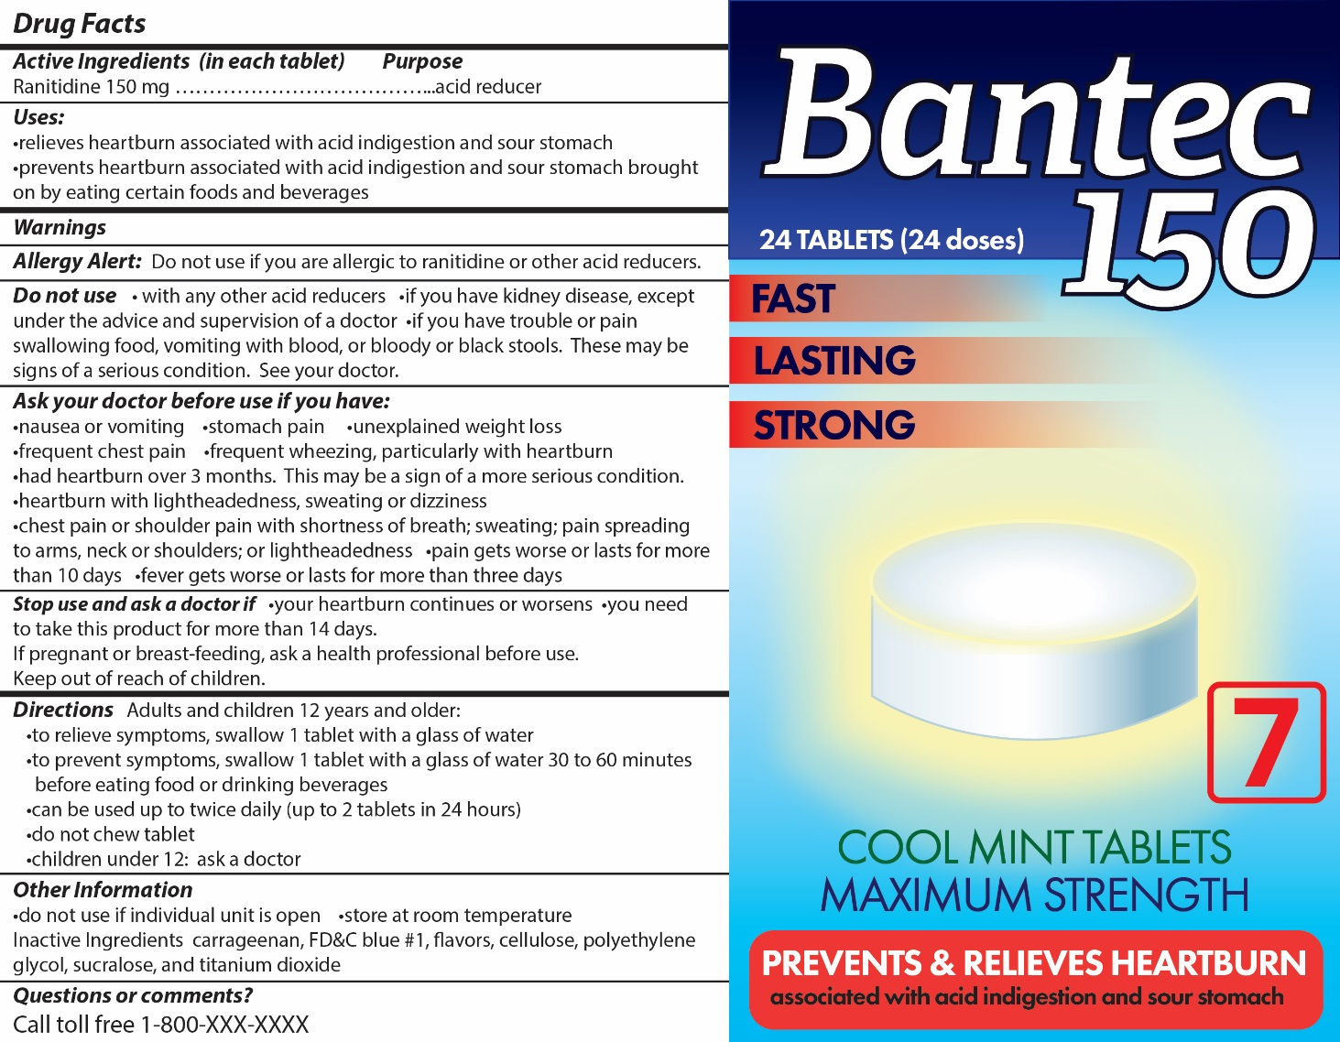
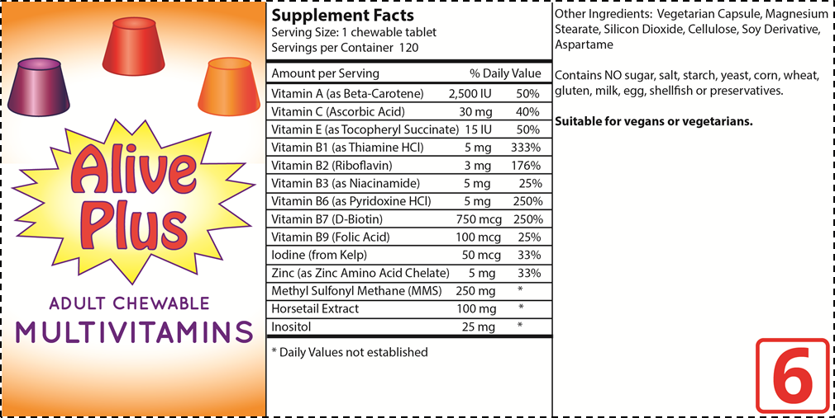

Product Labels (page 4 of 4)

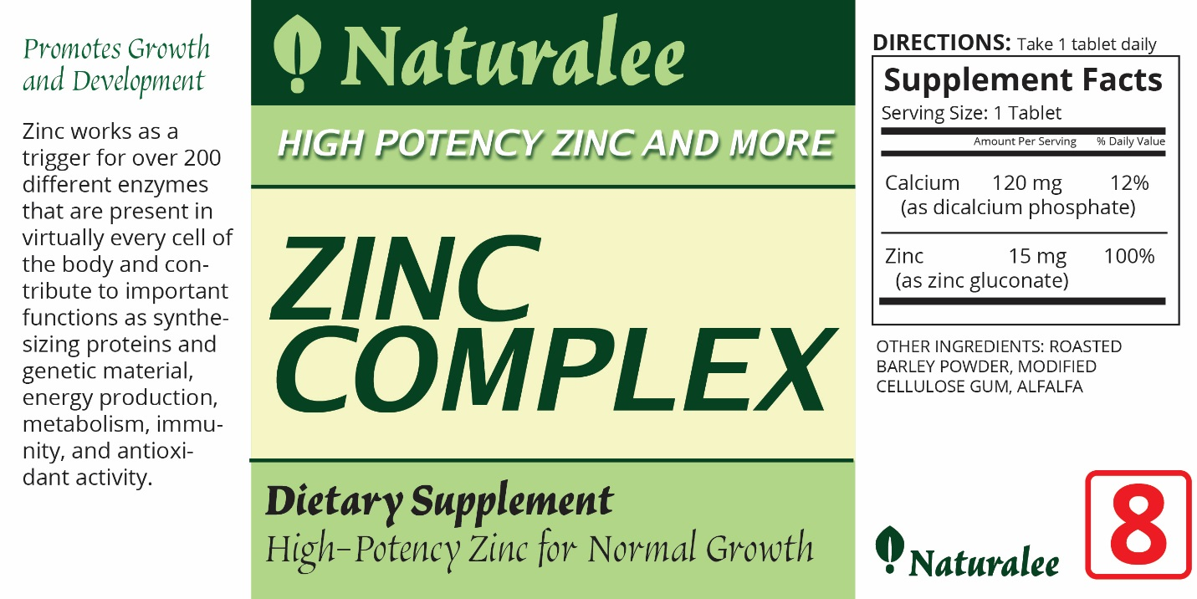

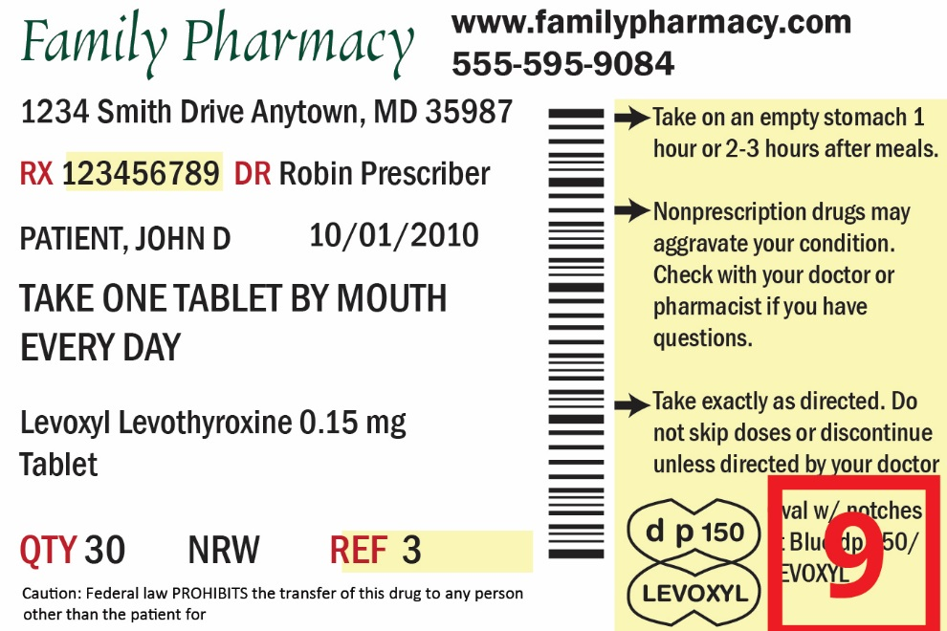

Fact Sheet: Drugs and Dietary Supplements

What is a drug?
According to the FDA (Food and Drug Administration), a drug is defined as a substance intended for use in the diagnosis, cure, symptom relief, treatment, or prevention of disease. Drugs must be approved by the FDA before they can legally be sold to consumers.
Inappropriate use of drugs may result in harm to the body.
Inappropriate uses include:
- Use of illegal or experimental drugs.
- Use of prescription drugs by someone who does not have an appropriate prescription.
- Taking more of a legal drug than called for in the directions for use.

The FDA approval process for a drug requires that it be tested in scientific studies called clinical trials. Clinical trials are scientific experiments conducted under well-controlled conditions with thousands of human volunteers. To be approved by the FDA, the clinical trials must provide clear evidence that a medicine is both safe and effective for its intended use.

What are prescription drugs?
Prescription drugs are prescribed by a doctor and can only be purchased at a pharmacy. They are prescribed for the specific person whose name is on the label and are not supposed to be taken by anyone else. Prescription drugs have been tested through clinical trials, which are scientific research studies. They must be proven to be safe and effective before they are approved by the FDA. The label on a prescription drug identifies the patient’s name, the name of the drug, and directions for using the drug.

What are over-the-counter drugs?
Over-the counter drugs are drugs that have been proven to be safe and effective for use by most people without the supervision of a doctor. Over-the-counter drugs can be purchased without a doctor’s prescription. They can be purchased at pharmacies or other types of stores such as grocery stores and convenience stores. Just like for prescription drugs, over-the-counter drugs must be tested through clinical trials and proven to be safe and effective before they are approved by the FDA. The FDA regulates over-the-counter drugs to be certain that they contain acceptable ingredients, have appropriate dose information, and have label information on how to use them safely and effectively.

What are dietary supplements?
Dietary supplements affect the way the body works but they are not drugs. Dietary supplements have not been approved by the FDA. They can be sold without providing evidence that they are safe or effective in treating or preventing disease. Examples of dietary supplements include things such as vitamins, minerals, herbs, amino acids, and enzymes. Dietary supplements do not require a doctor’s prescription. They can be purchased at pharmacies or other types of stores such as grocery stores, convenience stores, and health food stores. Because dietary supplement labels cannot make any claims about the product that are false or misleading, the label typically includes a statement that the product is not designed to treat or prevent disease.
Side Effect
Any effect of a drug or dietary supplement that is in addition to its intended effect, especially an effect that is harmful or unpleasant.

Drug Interaction
A harmful effect that results when a substance (another drug, food, or a dietary supplement) affects the activity of a drug when both are administered together.
A word of warning!
For some people, drugs and dietary supplements may result in side effects or drug interactions. Always tell your doctor about all the drugs and dietary supplements that you are taking. It is important that you report any unusual reactions to drugs or dietary supplements to your doctor.
A Family Medicine Cabinet

What is a medicine? There is no generally accepted definition for the word “medicine.”
- Most people use the word “medicine” to refer to products that affect how the body functions.
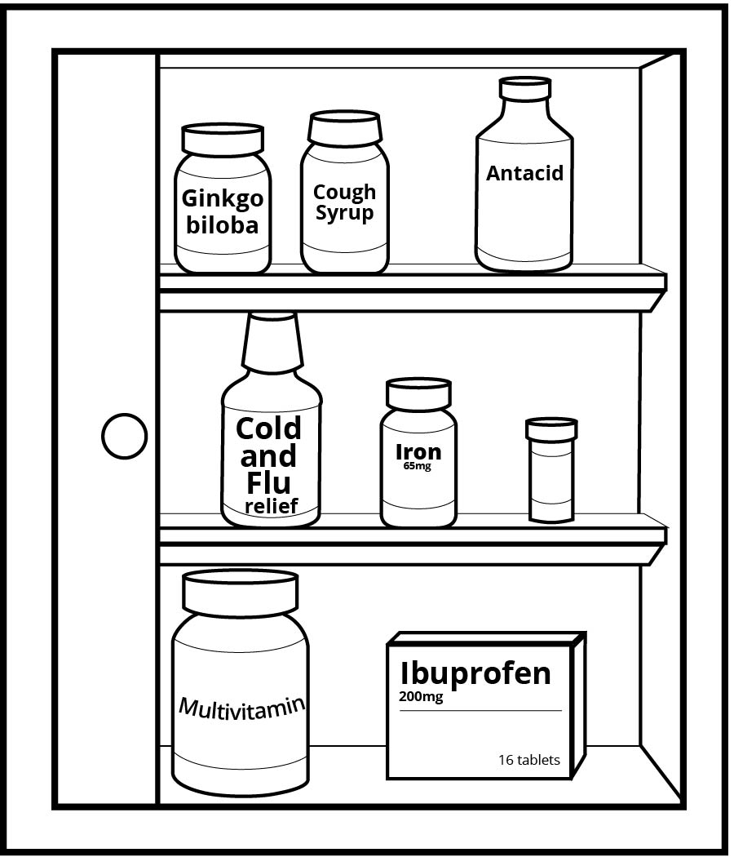
- Some people only consider prescription drugs and over-the-counter drugs as medicines.
- Other people use the word medicine more broadly to include dietary supplements, some cosmetics, and any health care product that affect how the body functions.

Darla would like to organize her family’s medicine cabinet to separate the three different types of medicines:
- Prescription drugs
- Over-the counter drugs
- Dietary supplements

Part 1: Classifying Medicines

Use the 9 different product labels that your teacher has provided. Help Darla by sorting the labels into the three groups of products.

- Label 1 is a label from a prescription medicine. Write the numbers of the two other labels that are also from prescription medicines. ____5_____ ____9_____

- Explain how you could tell that the labels are from prescription medicines. Be specific.

The label has the name of the person for whom the doctor prescribed the drug or the name of the prescribing doctor. Students may also say date, pharmacy address, and quantity.

- Label 2 is a label from an over-the-counter medicine. Write the numbers of the two other labels that are also from over-the-counter medicines. ____4_____ ____7_____

- Explain how you could tell that the labels are from over-the-counter medicines. Be specific.

It has a Drug Facts label that provides very detailed information on use. Students may also answer by describing the different parts of the Drug Facts label such as active ingredients, purpose, uses, warnings, and directions.

- Label 3 is a label from a dietary supplement. Write the numbers of the two other labels that are from dietary supplements. ____6_____ ____8_____

- Explain how you could tell that the labels are from dietary supplement. Be specific.

It has a Supplement Facts label that looks like a nutrition (food label). Students may also answer by describing the different parts of the Supplement Facts label such as serving size and what is in the product.

- Which type of product label provides the most detailed information on how to choose and use the product safely?

Over-the-Counter Dietary Supplement Prescription

Part 2: Comparing Medicines

Darla would like to know how over-the-counter drugs are different from prescription drugs and dietary supplements. Help her by completing the comparison chart below.

- Use the information in the Fact Sheet: Drugs and Dietary Supplements to complete the comparison chart below. Write “Yes” or “No” in each of the boxes in the “Over-the-Counter Drug” column.

 | Prescription  Drug | Over-the-Counter  Drug | Dietary  Supplement
- Affects the way the body functions | Yes | Yes | Yes
- Is a drug according to the FDA definition | Yes | Yes | No
- Requires a prescription from a doctor | Yes | No | No
- Should only be used by person whose name is on the label | Yes | No | No
- Approved by the Food and Drug Administration (FDA) | Yes | Yes | No
- May have potentially harmful side effects or interactions with some foods, drugs, or dietary supplements. | Yes | Yes | Yes
- Includes a Drug Facts Label that provides detailed information on how to use the drug safely. | No | Yes | No
- Scientific research has provided evidence that it is safe and effective for use by most people. | Yes | Yes | Usually No  There are few that have been tested.
- Examples include vitamins, minerals, enzymes, herbs, or amino acids | No | No | Yes
- Be sure your doctor knows that you are taking these products | Yes | Yes | Yes

Use the Comparing Medicines chart on page 3 and information from the Fact Sheet to answer questions 2 through 5.

- Which product is most likely to have been scientifically tested to provide evidence that it is safe and effective—an over-the-counter drug or a dietary supplement? Explain your answer.

An over-the-counter drug because it has been tested and FDA approved.

- Explain why it is important that an over-the-counter medicine label include more information than a prescription medicine drug label.

Because the medicine is not prescribed by a doctor, people need the information to help them select the appropriate medicine and use it safely.

- Why do dietary supplements not meet the FDA’s legal definition for a drug? Support your answer with evidence from the Fact Sheet.

They have not been proven to be effective in diagnosing, curing, treating, or preventing disease.

- Several celebrities endorse a dietary supplement in an advertisement. They claim that the dietary supplement worked for them, is “doctor recommended” and has been “clinically tested.” Do you think these claims mean that the dietary supplement is safe and effective? Explain why or why not.

Student answers will vary. You don’t know how many doctors recommended the product. The product may work for some people but not for others. Or the celebrities could have been paid to give a false testimonial. If the product was only tested on one or a few people, it may not work for most people.

Part 3: Should Prescription Drugs Become an Over-the-Counter Drug?

Now Available Without Prescription Blog by Health Policy Analyst

Today's health consumers are taking a more active role in diagnosing and treating themselves. From pain relievers to cough medicines, drugs once available only by prescription are now available as over-the-counter (OTC) drugs on store shelves.

The US Food and Drug Administration (FDA) can approve a prescription drug for OTC sale once it has evidence that the drug’s benefits outweigh the risks, the potential for misuse is low, consumers can self-diagnose the condition, labels can be easily understood, and oversight by doctors is not essential.

Offering OTC drugs without a prescription means that patients can purchase drugs with lower prices, a particularly important factor for people who do not have health insurance. It also eliminates the time and cost involved in visiting a doctor. This allows doctors more time to focus on high-risk patients or patients with more complex conditions.

There is concern that consumers will use OTC drugs instead of seeing their doctor for an appropriate diagnosis and important advice. However, for people who lack health insurance or live in an area where there is a shortage of doctors, OTC medications offer an option for treatment of temporary symptoms.

- Explain the difference between an OTC (over-the-counter) drug and a prescription drug.

An OTC drug can be purchased without a prescription from a doctor.

- According to the blog by the health policy analyst, what are two advantages to having a prescription medicine become available as an over-the-counter drug?
- Less expensive
- Less time (more convenient)
- Allows doctors more time to focus on patients who need more care
- Allows access to drugs when people do not have health insurance
- Allows access to drugs in areas where there are shortages of doctors.

Prescription Not Required Blog by Pharmacist

While it’s natural to think that all over-the-counter (OTC) drugs are safe for everyone, that’s a mistake. Every person is different and may react to medications in a different way. Just because a drug is safe for someone else, it may not be safe for you.

Every drug, used improperly, can cause harmful effects. A lot of OTC drugs have the potential to cause harm if users are not aware of the side effects. There is the danger particularly if patients take more than is safe or take them long term. People who choose to use OTC drugs must read and follow the directions and warnings on the label.

People can avoid potential problems by asking a pharmacist or their doctor whether the drug is okay for them to take. A doctor will help patients select the proper dosage and make sure that a patient’s health conditions do not make taking the OTC drugs dangerous. Doctors can also check to be sure that the OTC drug does not interfere with other medications a patient is taking and monitor continuing symptoms to be certain that they are not caused by a more serious illness.

Over-the-counter products can be purchased in retail stores that do not have trained pharmacists. It is always better to purchase OTC drugs from a pharmacist who has the knowledge to provide advice on how to select and use OTC drugs safely.

- According to the blog by the pharmacist, what are two potential problems that may occur from taking an over-the-counter drug?
- Just because a drug is safe for some people, it does not mean it is safe for everyone.
- Every drug can have harmful effects. People make take more than is safe or take them for longer than appropriate.

- According to the blog by the pharmacist, what are two things that people could do to avoid potential problems if they use over-the-counter medicines?

- Read the label directions and warnings carefully.
- Talk to their doctor or to a pharmacist.

- What do you think? A medicine has been sold as a prescription drug for five years. During that period it has been shown to be safe and effective for many people. Should the medicine be approved for sale as an over-the-counter medicine? Support your answer with pieces of evidence from the blogs or your personal background knowledge.
Student answers will vary but should be supported with evidences. If possible, take time for students to share their answers with other students.

