

Choosing and Using Medicines Safely

Core Concepts:
- The Drug Facts label on an over-the-counter drug provides directions for safe use including: how much, how often, and for how long.
- The Drug Facts label on an over-the-counter drug provides warnings about people who should not use the medicine until they talk to a doctor.

Class time required:
2 forty-minute class period

Teacher Provides:
For each student
- Copy of student handout entitled Choosing and Using Medicines Safely

For each pair of students:
- Medicine Labels for 7 over-the counter products, printed in color. Laminate if these will be used by multiple classes. See pages vi through xii. Optional: Make the labels look more realistic by cutting along the dotted lines to remove the white space from around the labels.
- Copy of How to Read an Over-the-Counter Drug Facts Label. See page xiii.

Teacher Resources:

- Over-the-Counter Medicine Safety by Scholastic provides four lessons, classroom posters, role-playing culminating activity, whiteboard images, a digital flipbook, medicine safety videos, additional resources, and a pre/post-quiz for over-the-counter medicine use. http://www.scholastic.com/otcliteracy/
- Medicines in My Home is a multimedia educational program to teach consumers how to choose over-the-counter medicines and use them safely. “Rooms” of the program contain presentations, print materials, and resources can be used online or downloaded. http://www.fda.gov/Drugs/ResourcesForYou/Consumers/BuyingUsingMedicineSafely/UnderstandingOver-the-CounterMedicines/ucm092139.htm
- Medicines in My Home: The Over-the-Counter Drug Facts Label is a video (approximately 2 minutes) on how to interpret Drug Facts labels.
https://www.youtube.com/watch?v=hT6Th_QfQKE
Copyright © 2017 by University of Rochester. All rights reserved. May be copied for classroom use.
This lesson was developed with support from the National Institutes of Health under Award Number R25OD010494. The content is solely the responsibility of the authors and does not necessarily represent the official views of the National Institutes of Health.
- Understanding Over-the-Counter Medicine provides a variety of resources including brochures, articles, fact sheets, checklists, print public service announcements, Internet public service announcement banners, audio public service announcements, and television public service announcements.
http://www.fda.gov/Drugs/ResourcesForYou/Consumers/BuyingUsingMedicineSafely/UnderstandingOver-the-CounterMedicines/default.htm

- Checklist for Choosing Over-the-Counter (OTC) Medicine for Adults provides a checklist that helps people choose an appropriate over-the-counter medicine. http://www.fda.gov/downloads/Drugs/ResourcesForYou/UCM133407.pdf
Suggested Class Procedure:
- Distribute a copy of Choosing and Using Medicines Safely student instructions to each student.
Warning: It is essential that you maintain families’ legal rights to privacy related to health and medicine use. Do not allow students to provide or discuss examples of medicines or dietary supplements used by their family.

Note: The everyday use of the words “drugs”, “medicines”, and “dietary supplements” is different from the definitions used by the FDA (Food and Drug Administration). The Fact Sheet uses the FDA language. However, to help students relate the activity to their lives, we have used the words “drug” and “medicine” interchangeably.

- Assign students to work in pairs.
- Distribute a copy of How to Read an Over-the-Counter Drug Facts Label to each pair of students.
- Distribute copies of the seven over-the-counter medicine labels to each pair of students.
- Explain that students should work with their partner to select the medicine that each family member might take for their symptoms.
- The vocabulary in this activity is “real world” language that students will encounter when they read labels. It is important to tell students to ask what words mean if they do not understand them. In a real world situation, they should ask the pharmacist about the meaning of words. In the classroom, you may play the role of pharmacist. Optional: Students could work as a class to make a glossary for Drug Facts label vocabulary words that people may find difficult to understand.
- Consider playing the role of a pharmacist to model how to do the activity. Use Bill Lee as an example.
- Call on students to play the role of “pharmacists” by explaining their answers to one of the first cases (Bill Lee through Kathy Lee).
- Ask students to share their answers to the Andrea Lee and Rick Lee cases. It is important that you make time to discuss these cases during class to be certain that students understand the appropriate actions.
- Optional: The multiple choice questions on pages iv- v may be used for homework or as a quiz.
Alternative Procedure:
- Distribute a copy of Choosing and Using Medicines Safely student instructions and a copy of How to Read an Over-the-Counter Drug Facts Label to each student.
- Split class up into 7 “pharmacist teams”. Each team will research one case. Assign one of the 7 cases (Bill Lee through Kathy Lee) to each team.
- Distribute a set of the seven labels to each team.
- Students work with their team to answer the case assigned to them.
- Pharmacist teams roll play to report their answers to the class.
Note: Do not assign the Andrea Lee and Rick Lee cases to students. Instead, use these two cases during whole class discussions.

Base your answers to the questions on the information in the Medicine Label provided.
Multiple Choice Questions: Choosing and Using Medicines Safely

- What type of health care product is shown on the label?
- Dietary supplement
- Prescription medicine
- Over-the-counter medicine

- An antihistamine is most likely used to reduce
- pain
- a high temperature
- allergy symptoms

- What part of the label describes how much of the product to use?
- Part 4
- Part 5
- Part 6

- What part of the label describes how often to use this product?
- Part 4
- Part 5
- Part 6

- Possible side effects from taking this medicine may include
- drowsiness or excitability
- hay fever or allergy
- emphysema or chronic bronchitis

- For safe use by a five year old child,
- Use 1 tablet every 12 hours
- Avoid an overdose by taking ½ tablet every 4 hours
- Ask a doctor for advice.

- An overdose would occur if an 11 year old girl took more than _____ tablets in a 24 hour period.
- 6
- 12
- 18

- What is the maximum safe amount of the active ingredient in this product that a 13 year old girl could take in a 24 hour period? Express your answer in milligrams.
- 2 milligrams
- 12 milligrams
- 24 milligrams

- What side effect would most likely result if this product is taken with alcohol or sedatives?
- Drowsiness
- Excitability
- Glaucoma

- If a child or adult accidently takes an overdose of this product,
- Contact a Poison Control Center immediately for advice.
- Seek medical help after overdose symptoms appear.
- Reduce the amount the person takes for several days.
Refer to this label when answering the multiple choice questions.
Medicine Label

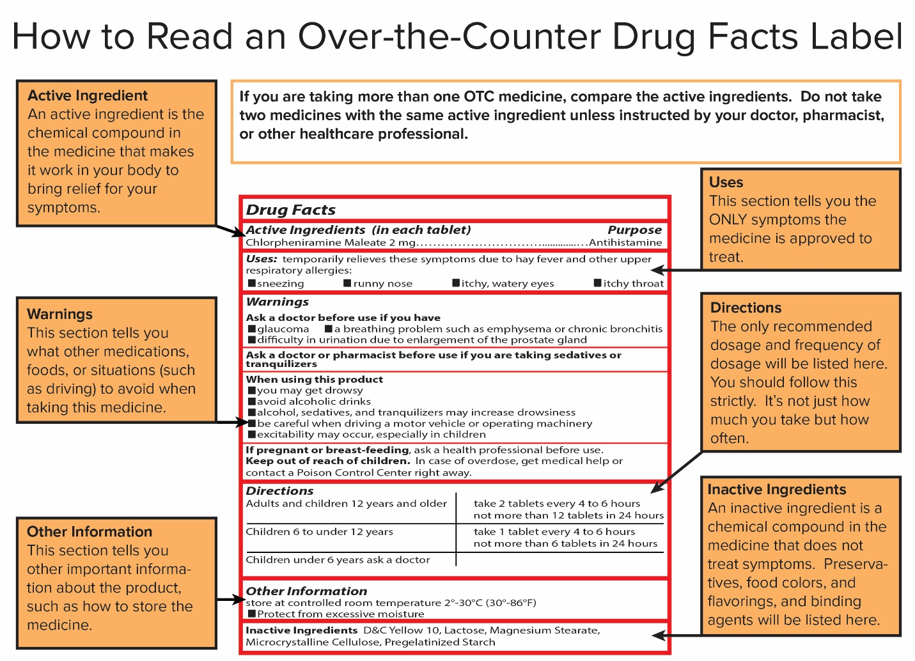

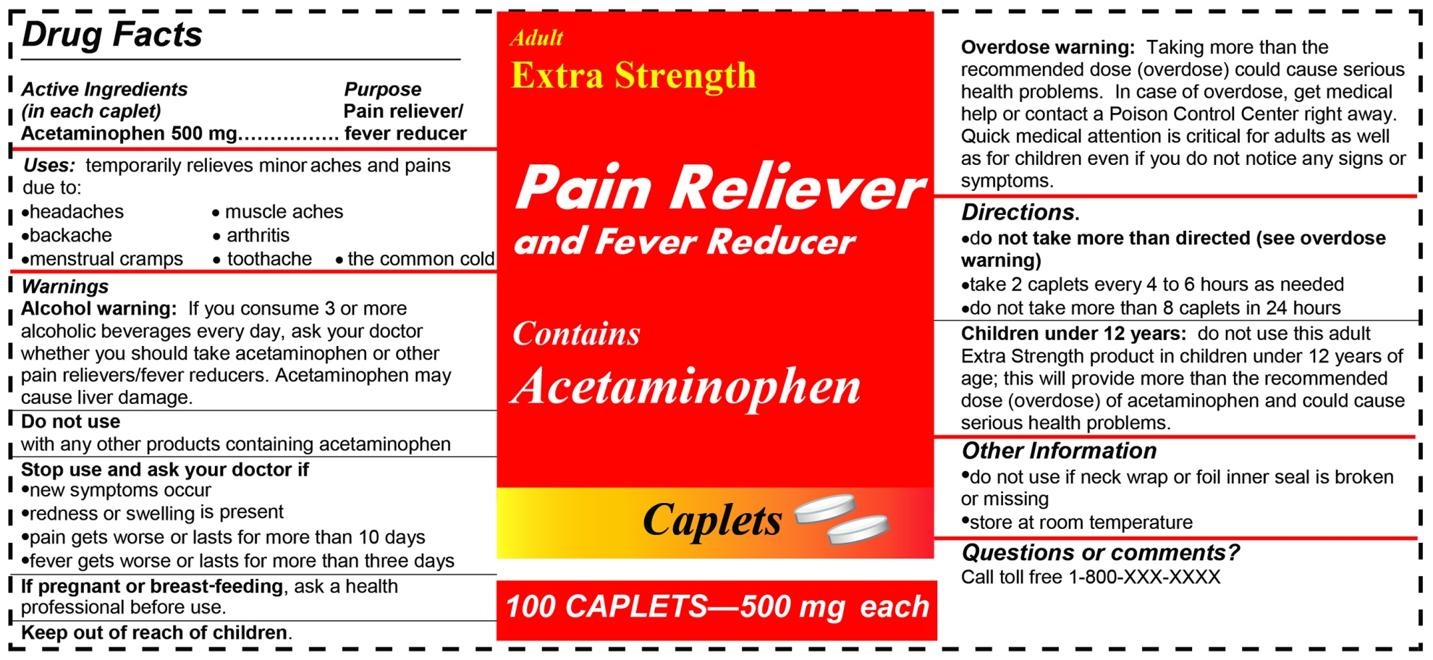

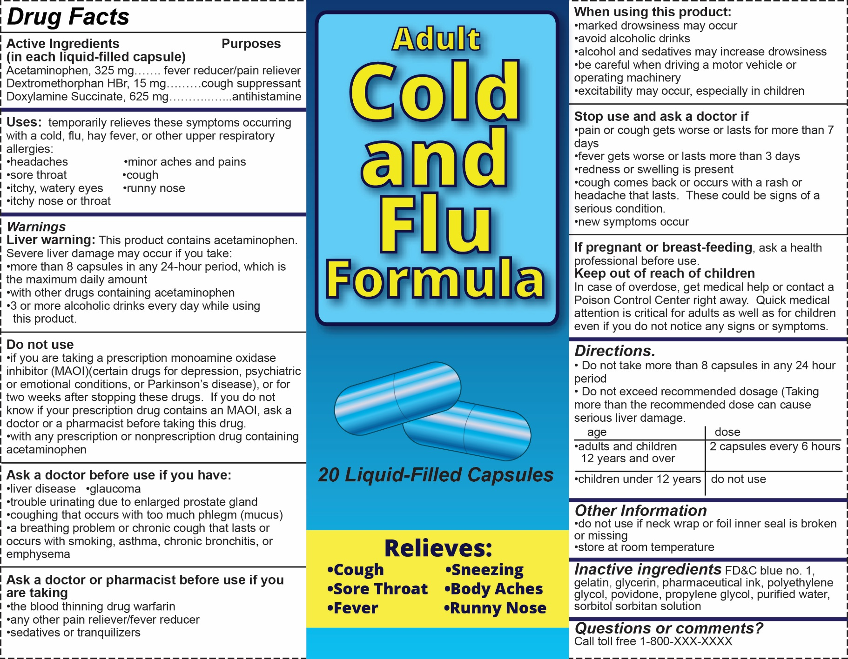
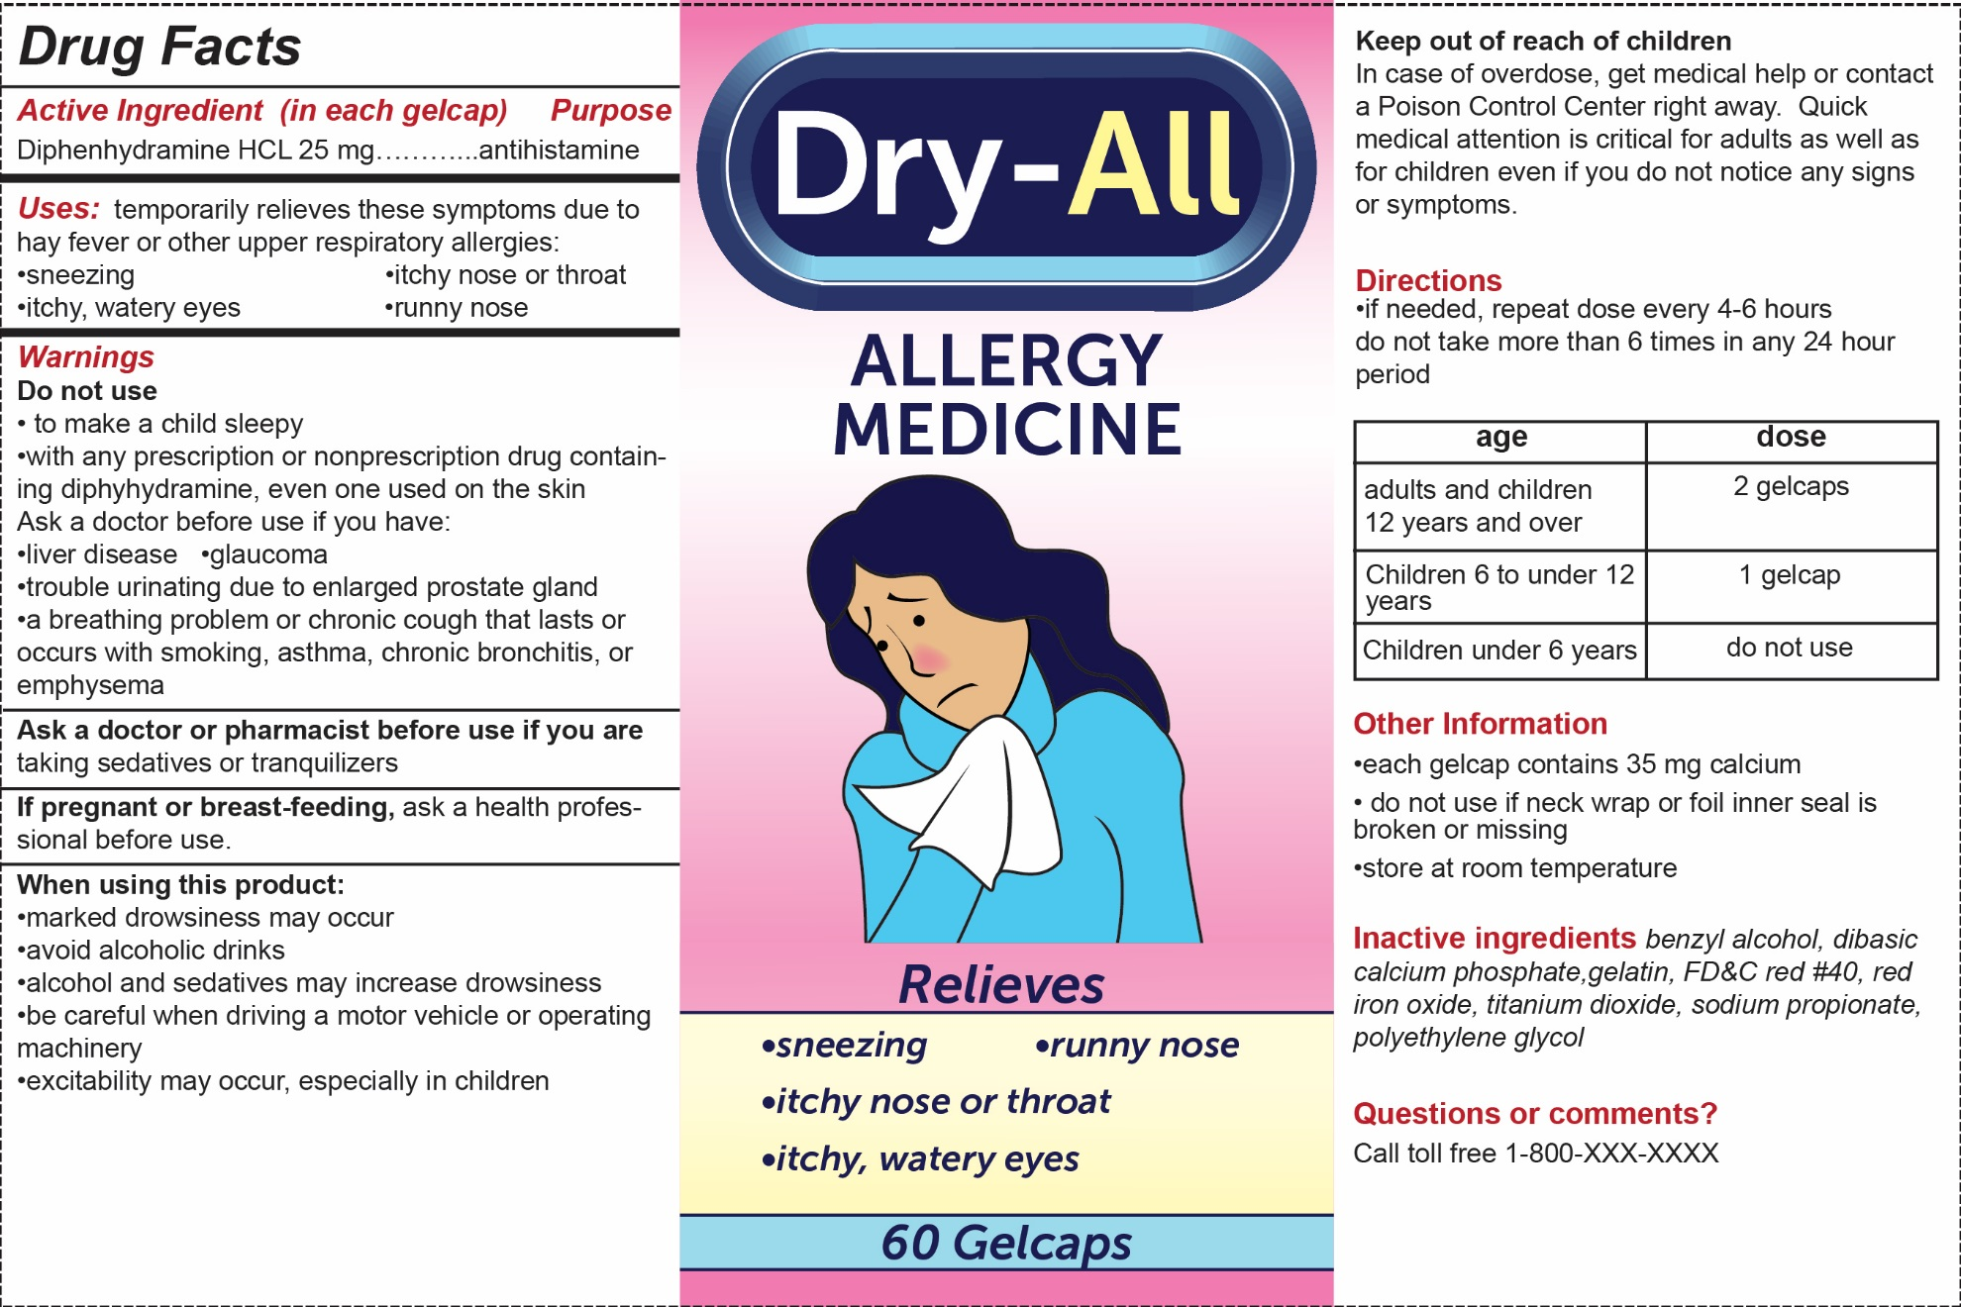

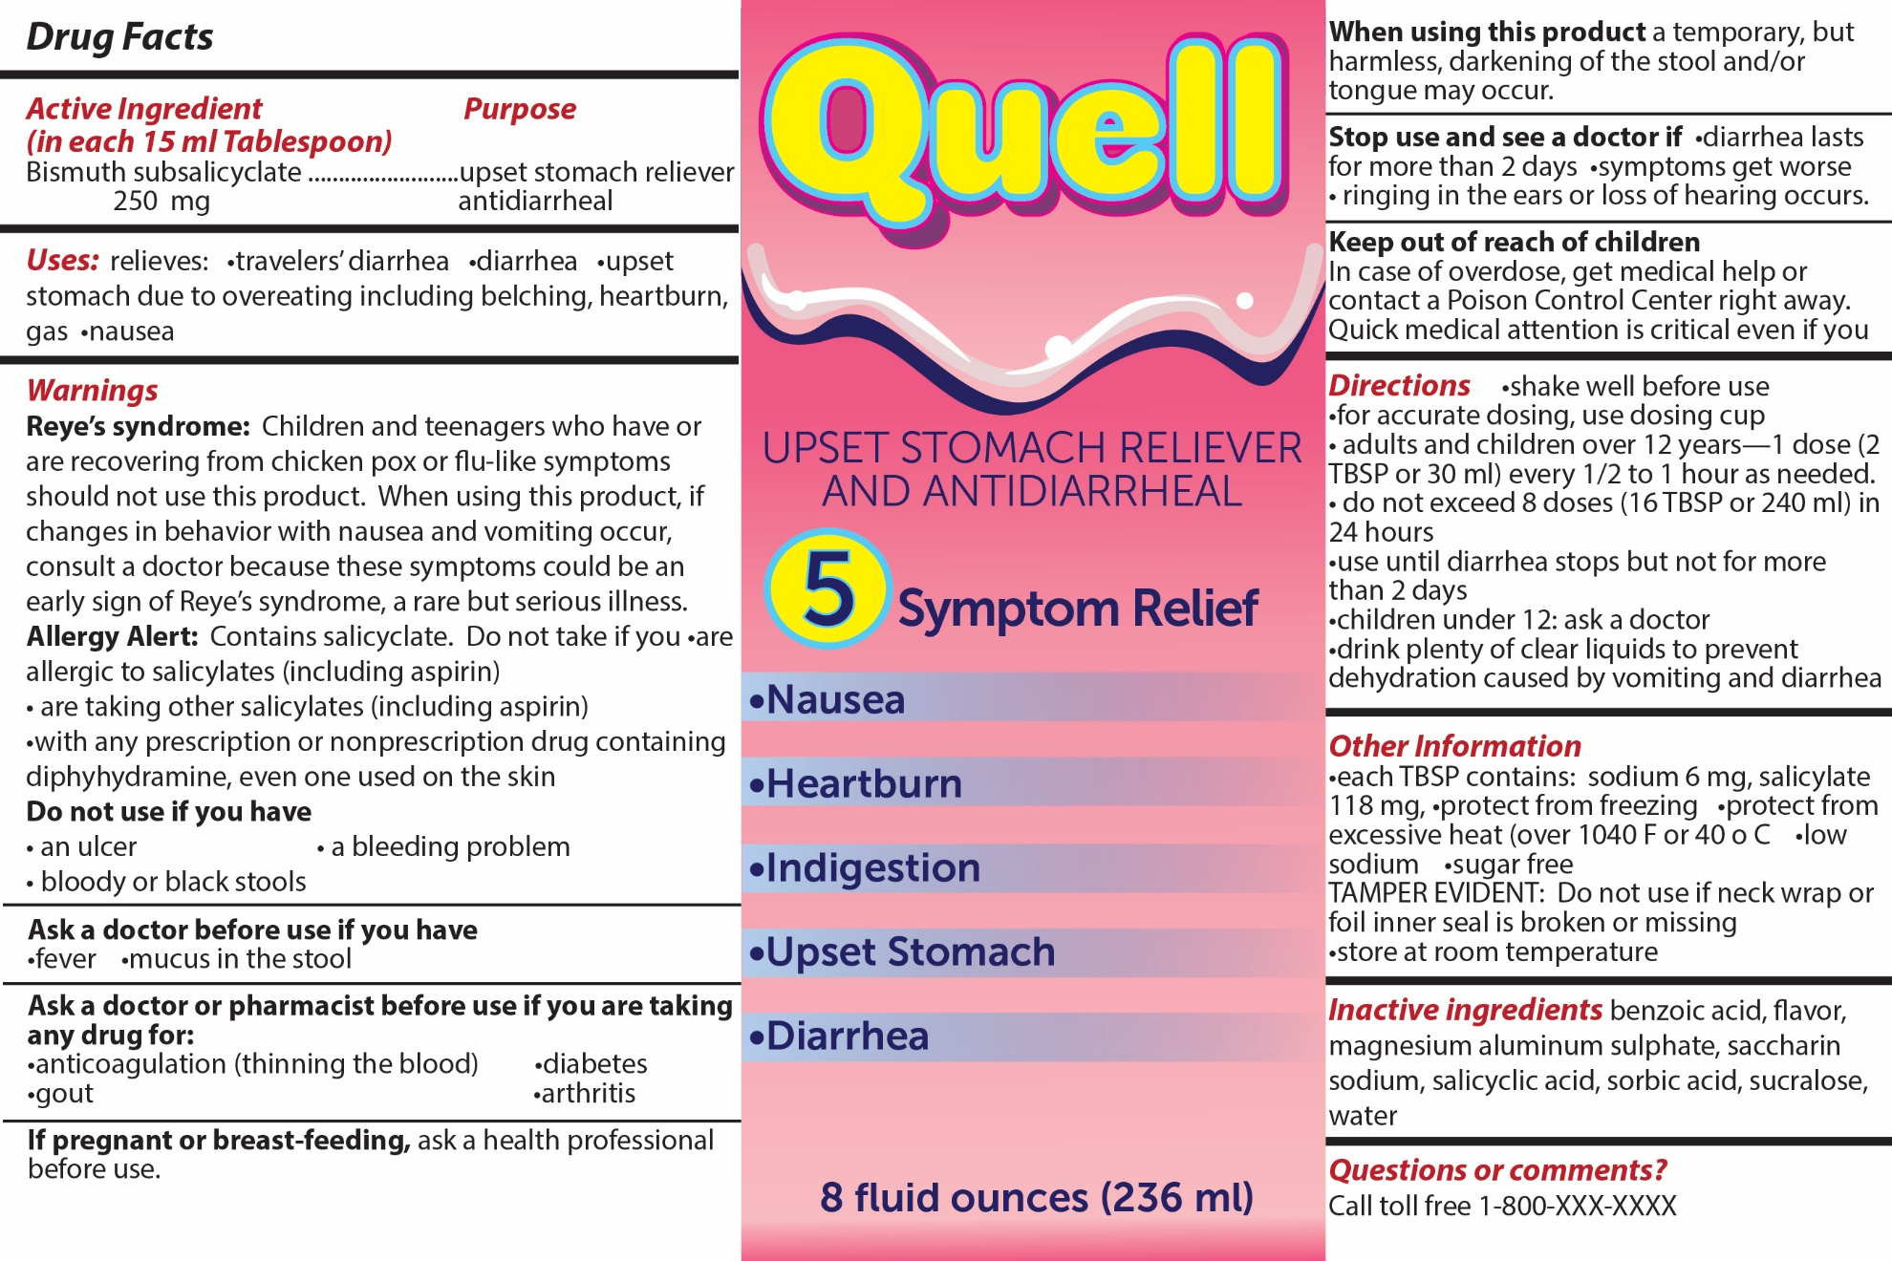

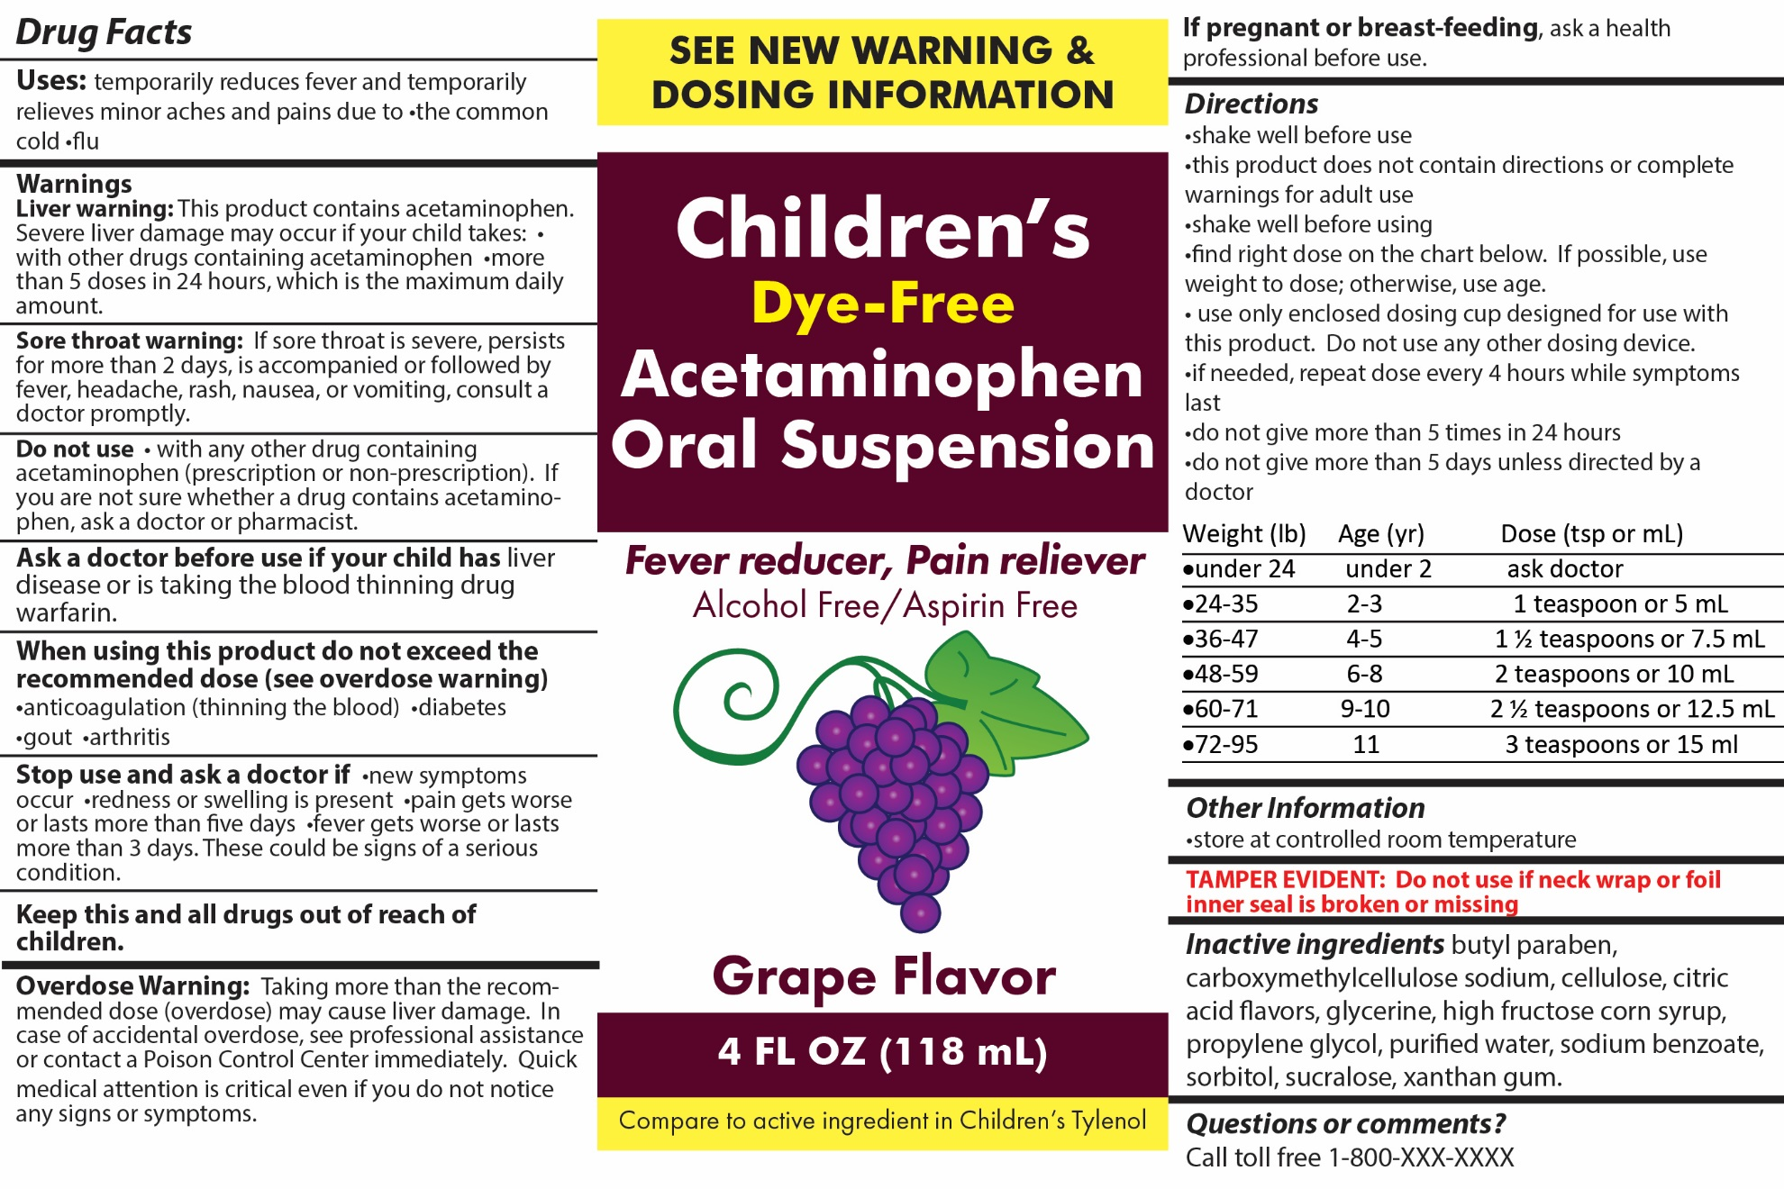

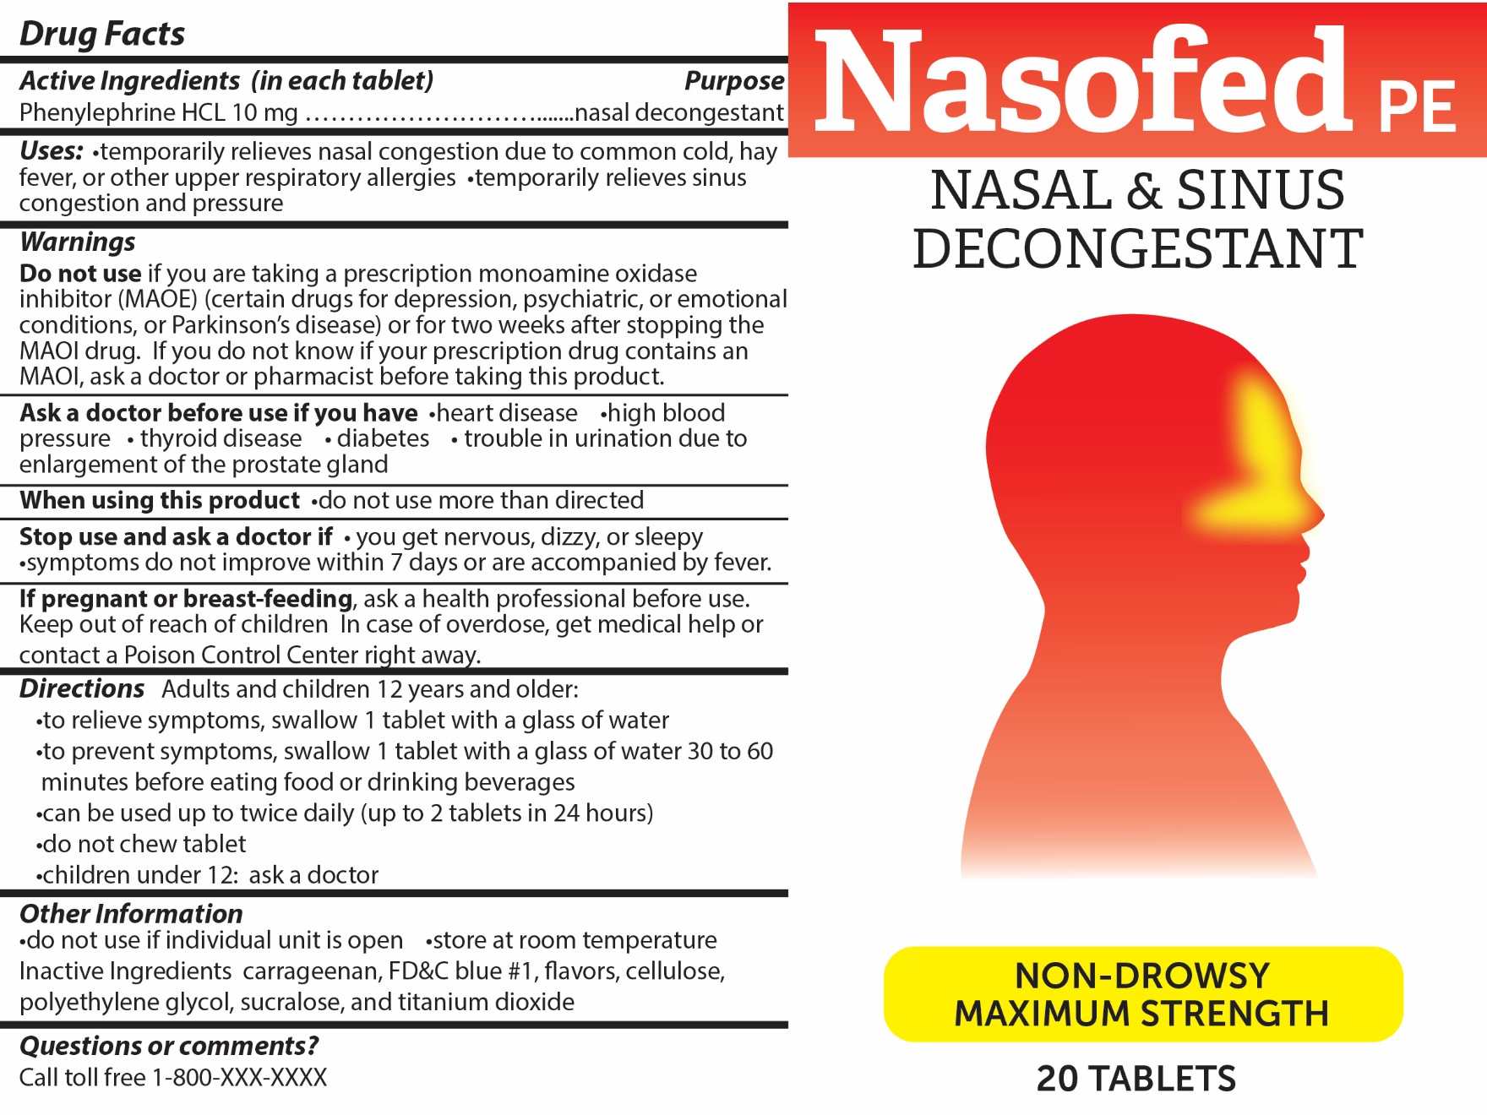

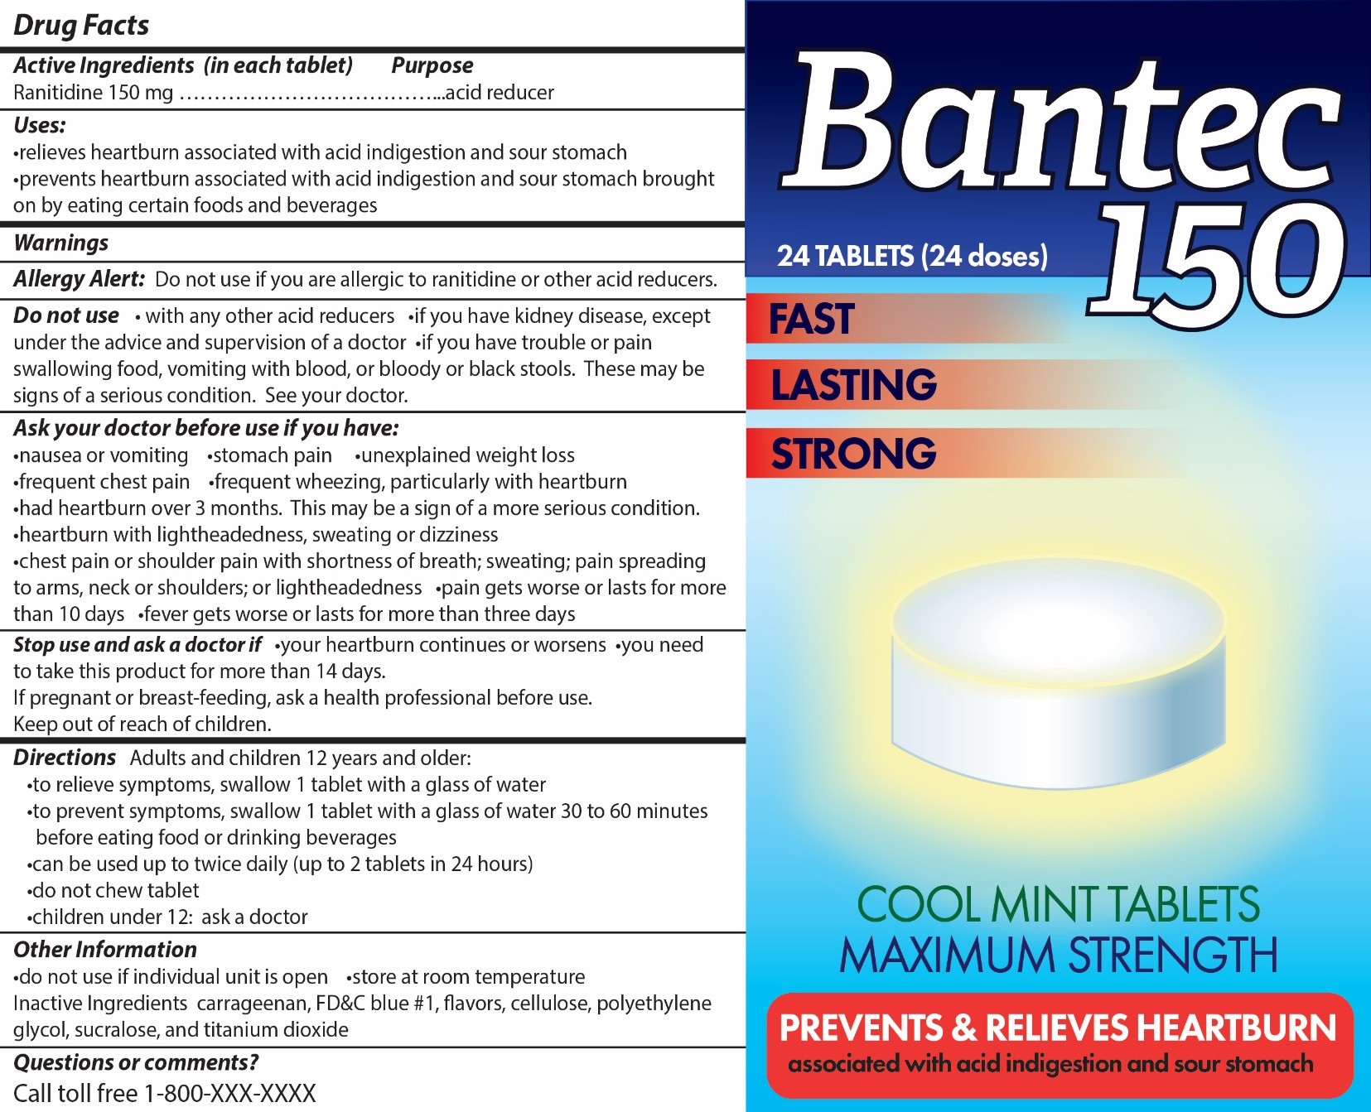

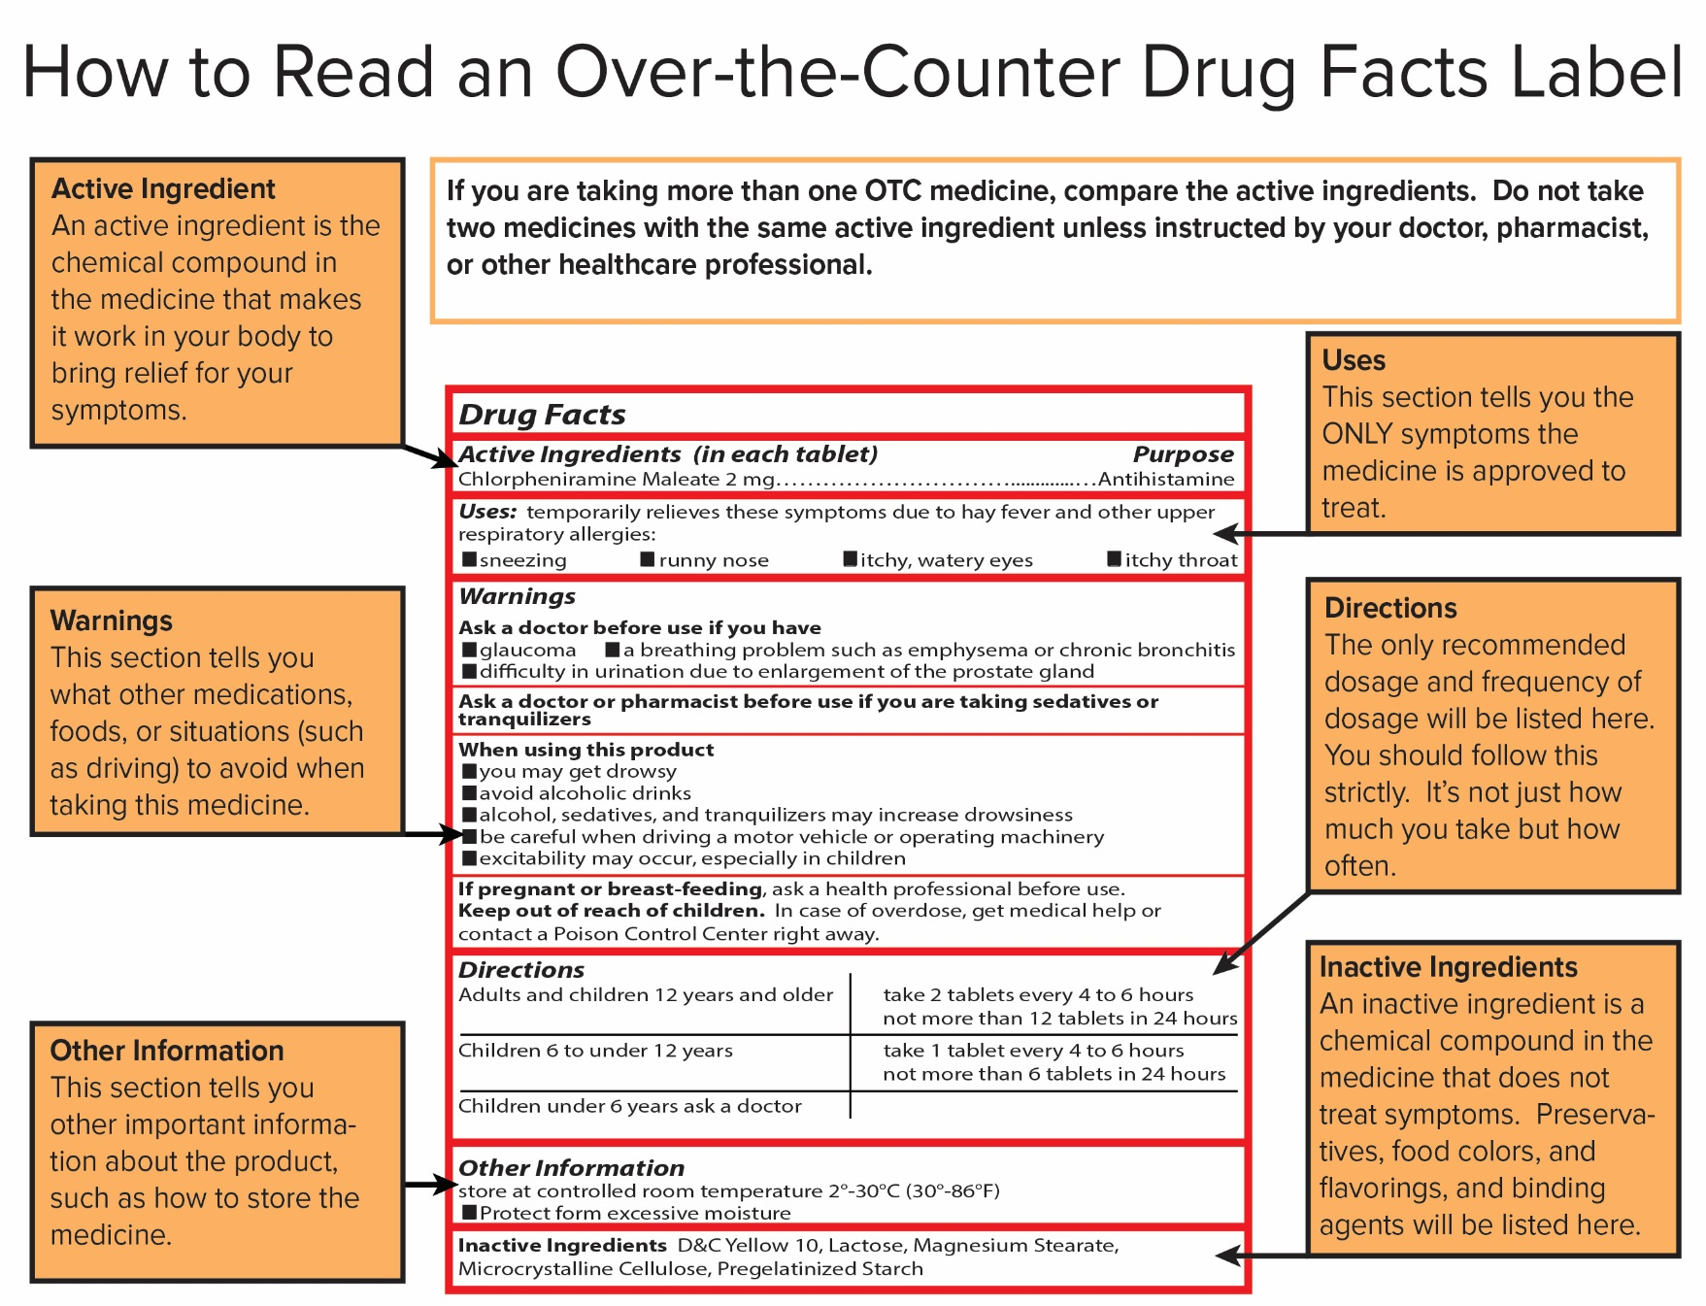

Modified from http://www.intelihealth.com/article/how-to-read-a-drug-label and http://familydoctor.org/content/dam/familydoctor/images/drugs-procedures-devices/drug-facts-label.gif

Choosing and Using Medicines Safely

Members of the Lee family have a variety of health problems. There are many over-the-counter (OTC) medicines that the family members could use. Over-the-counter (OTC) medicines are legal drugs that can be purchased without a prescription from a doctor. However, when people use OTC medicines, they need to be careful to read and follow the instructions on the medicine label to be certain that they use them safely.
Refer to the handout, How to Read an Over-the-Counter Drug Facts Label, to help you understand how to find important information on a medicine label.

You will help members of the Lee family select appropriate over-the-counter medicines. For each family member, you will:

- Read the description of the family member’s symptoms.

- Read the active ingredients, purpose, and uses sections of the Drug Facts label on the medicines. Select one of the medicines that could be used to treat the person’s symptoms. Record the name of the medicine that you selected.

- Read the directions on the Drug Facts label. Record the recommended dose and information on how often the person should take that dose.
Precautions are actions taken in advance to prevent something dangerous, unpleasant, or inconvenient from happening.

- Read the warnings, other information, and inactive ingredients sections on the Drug Facts label. Make notes to explain precautions the person should take to avoid harmful effects from this medicine.

Bill Lee
Age: 40 years

Bill is a long-distance truck driver. He has allergy symptoms (watery eyes, runny nose, and sneezing) that started when the family adopted a dog. Bill has no other health problems.

- Which medicine could be used to treat allergy symptoms? ___Dry-All Allergy Relief______
- What is the correct dose? ___2 gel caps_______
- How often should this medicine be taken? ___every 4-6 hours_______
- Take no more than ____6 times or 12 gel caps______ in a 24 hour period.

- Is it safe for Bill to use this medicine without consulting his doctor? Explain why or why not.

Yes, because he has no other health problems. He might ask his doctor how long it is safe to take this medicine.

- List all of the precautions Bill should take to avoid harmful effects from this medicine.
He should understand that the medicine causes drowsiness and be careful when driving. He should also avoid alcoholic drinks.

Mimi Lee
Age: 39 years

Mimi thinks that she has food poisoning from eating some leftover tacos that she found in the back of the refrigerator. She has both vomiting and diarrhea. She needs to be careful about what medicines she takes because she is pregnant.

- Which medicine could be used to treat vomiting and diarrhea? ________Quell________________
- What is the correct dose? ___30 __ml or__ 2 ___TBSP (tablespoons)______
- How often should this medicine be taken? ____every ½-1 hour as needed __
- Take no more than __8 doses or 16 TBSP or 240 ml_____ in a 24 hour period.

- When should someone stop use of this medicine and see a doctor? __If diarrhea lasts for more than two days, if symptoms get worse, or if ringing in the ears or hearing loss occurs.

- Is it safe for Mimi to use this medicine without consulting her doctor? Explain why or why not.
No, because she is pregnant, she should contact her doctor before taking this medicine.
George Lee
Age: 38 years

Uncle George frequently gets really bad head and jaw aches.

- Which medicine could be used to treat head and jaw aches? _Extra Strength Pain Reliever and Fever Reducer________
- What is the active ingredient in this medicine? ____acetaminophen_________
- What is the correct dose for this medicine?____2 caplets_________

- Because Uncle George is a large man, he thinks it is OK to take two doses of this medicine every 4 hours. Explain how taking too much of this medicine may harm his body. Be specific.

An overdose of acetaminophen may cause liver damage.

- George often drinks more than three beers a day. Explain why it might be dangerous for him to take this medicine.

Combining alcohol and acetaminophen may cause liver damage.

Doug Smith
Age: 70 years

Grandpa Doug thinks he has the flu. He has a fever (101 ºF or 39 ºC), chills, fatigue, muscle aches, headache, cough and stuffy nose. He has arthritis and takes daily doses of a prescription medication that contains acetaminophen. He also has glaucoma, an eye disease that gradually results in blindness.

- Which medicine could be used to treat flu symptoms? ______Adult Cold + Flu Formula_______
- What is the correct dose? ___2 capsules________
- How often should this medicine be taken?___every 6 hours_______
- Take no more than __8 capsules______ in a 24 hour period

- Is it safe for Doug to use this medicine without consulting his doctor? Explain why or why not.

No, because he takes another medicine that contains acetaminophen and he has glaucoma.

Grace Smith
Age: 69 years

Grandma Grace has a runny nose and sinus congestion. She takes a prescription antidepressant. She takes three dietary supplements each day (Ginkgo biloba, Saint John’s wort and Vitamin C).

- Which medicine could be used to treat a runny nose and sinus congestion? ____Nasofed PE_____
- What is the correct dose? ___1 tablet______
- How often should this medicine be taken? ___twice daily_______
- Take no more than __2 tablets___ in a 24 hour period

- Is it safe for Grace to use this medicine without consulting her doctor? Explain why or why not.

No, because she takes an antidepressant that may contain an MAOI inhibitor.

- List all of the medications and supplements Grace should tell her doctor that she takes.

Antidepressant, Ginkgo biloba, Saint John’s wort, and Vitamin C

Laura Lee
Age: 12 years

Laura has problems with stomach pain, heartburn, bloating, and burping. Eating things such as pizza and spicy foods makes her symptoms worse.

- Which medicine could be used to treat acid indigestion? _______Bantec 150__________
- What is the correct dose? __1 tablet 30-60 minutes before meals________
- How often should this medicine be taken? ___up to twice daily______
- Take no more than __2 ____tablets in a 24 hour period
- When should someone stop taking this medicine? _if heartburn continues or after 14 days___

- Is it safe for Laura to use this medicine without talking with her parents or consulting her doctor? Explain why or why not.

No, because she has stomach pain and the medicine says you should ask your doctor if you have stomach pain.
Kathy Lee
Age: 15 months

Kathy is crying because she is teething. Her jaw hurts and she has an ear ache. During the day her temperature is normal, but at bedtime she develops a slight fever (99.5ºF or 37.5ºC).

- Which medicine could be used to treat children’s pain and fever? __ Children’s Dye Free Acetominophen Oral Suspension__

- Kathy is 15 months old. Is it safe for someone to give Kathy this medicine without consulting a doctor? Explain why or why not.

No, she is less than 2 years old.

- The Drug Facts label says, “Use only enclosed dosing cup designed for this medicine.” Explain why you should not use a teaspoon from the kitchen for measuring the medicine.

A teaspoon may not be accurate and it is important to measure the correct dose.

Andrea Lee
Age: 18 years

Andrea is shopping at the mall when she develops a bad headache. One of her friends offers her some pain reliever pills that she had in her wallet.

- List two reasons why Andrea should not take over-the-counter medicines offered by friends.

- It is never safe to take medicine offered by a friend because you cannot be sure of what the medicine is.
- You may have health conditions that make it dangerous to take the medicine.

- What should Andrea do if her headache does not get better?

Andrea could call her parents or talk to a pharmacist about what headache medicine she could purchase.

Rick Lee
Age: 19 years

Rick has a horrible headache and fever. Rick has diabetes and he takes insulin. He also has allergies and takes allergy medicine. He tried to call his mother to find out what medicine he should take, but his calls kept going to voicemail.

- Rick took Extra Strength Pain Reliever but he is still feeling worse. Make a list of three ways that Rick could get reliable health advice.
- Call his doctor
- Talk to a pharmacist
- Go to the emergency room
- Go to a community health clinic
- Talk to a trusted adult family member or friend

- When Rick talks with a health professional, make a list of three things that Rick should be sure to tell them?
The TeensHealth from Nemours website provides information on how to communicate with a doctor.
- Talking to Your Doctor http://kidshealth.org/teen/your_body/medical_care/talk_doctor.html#
- Questions to Ask Your Doctor http://kidshealth.org/teen/your_body/medical_care/questions_doctor.html
- His symptoms—headache and fever
- Medicines that he is taking—insulin and allergy medicine
- Medical conditions or health problems—diabetes and allergies

