
How Much and How Often

Core Concepts:
- The measuring devices provided with liquid medicines should be used to accurately measure the amount of medicine indicated in the directions on the label.
- An overdose may result if someone takes too much medicine or takes the next dose of medicine sooner than they are supposed to according to the directions on the label.

Class time required:
Approximately 2-3 forty-minute class periods

Teacher Provides:
For each student
- Copy of student handout entitled How Much and How Often
- Copy of General Safety Precautions (see page ix)

For Part 1, each team of students will need:
- Paper towel for drying cups and trays
- Comparing Medicine Measuring Tools sheet (see page x).
- Water bottle with label removed and replaced by a label that reads “Flu Relief Therapy (simulated medicine)—DO NOT DRINK.” Fill bottle with at least 125 mL of tap water and add a small amount of red food coloring to turn the water dark pink. Note: If you would like the simulated medicine to be more realistic and “syrupy”, consider adding a viscous liquid such as colorless corn syrup or dish detergent, but be prepared for a messy clean-up process!
- 6 medicine dosing cups (30 mL). These may be purchased at a pharmacy or ordered from http://www.totalpharmacysupply.com/browse.cfm/plastic-medicine-cups-1-oz-graduated/4,324.html
- Small colored cup (1-3 ounce) such as a bathroom cup or a plastic shot glass
- Metal dinnerware teaspoon. Inexpensive metal teaspoons may be purchased at a kitchen supply store, or ordered from http://www.webstaurantstore.com/windsor-flatware-stainless-steel-teaspoon-12-pack/602383TSP.html
- Plastic dinnerware teaspoon. Inexpensive plastic teaspoons may be purchased at a party supply or “dollar store”.
- Measuring teaspoon. May be purchased at a kitchen supply store or “dollar store.” These may be plastic or metal. You may need to purchase an entire set of measuring spoons.
- Optional: cup (12 oz.) labeled “LIQUID WASTE” if students do not have easy access to a sink.
Copyright © 2017 by University of Rochester. All rights reserved. May be copied for classroom use.
This lesson was developed with support from the National Institutes of Health under Award Number R25OD010494. The content is solely the responsibility of the authors and does not necessarily represent the official views of the National Institutes of Health.
For Part 2, each team of students will need:
- A stop watch or clock with a second hand
- 2 medicine dosing cups (30 mL)
- Water bottle with label removed and replaced by a label that reads “Flu Relief Therapy (simulated medicine)—DO NOT DRINK.” Fill bottle with at least 125 mL of tap water and add a small amount of red food coloring to turn the water dark pink.
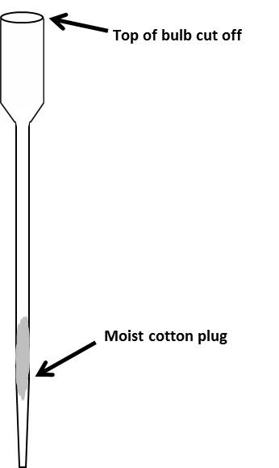
- Extra long transfer pipet. Use scissors to cut off the top of the bulb. Use a permanent marker to draw a line 0.5 centimeters from the top of the cut off bulb.

Line 0.5 cm from the top of bulb
Purchase the pipets from Globe Scientific:
Extra long (23 mL) 300 mm, bulb draw, Item # 139050 http://www.globescientific.com/23ml-c-32_566_568.html
  - Cotton ball. Insert approximately one-half of a cotton ball into the pointed end of the long pipet. Use a skewer, long straw, or plastic stirrer to push the cotton plug almost all the way into the pipet stem as shown on the right. Moisten the cotton by adding tap water to the pipet and letting the excess water drip out.
- Clear 20 ounce plastic cup with lid to support the transfer pipet.
Cup: http://www.webstaurantstore.com/choice-20-oz-clear-pet-plastic-cold-cup-50-pack/999CC20.html
Lid: http://www.webstaurantstore.com/choice-clear-flat-lid-with-straw-slot-50-pack/999LFLAT.html

Optional - Provide examples of other medicine measuring devices such as:

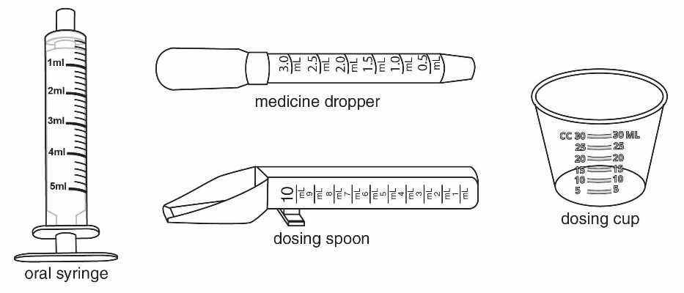

Teacher Resources:

Good Idea, Bad Execution: Dosing Errors, A Preventable Harm blog - http://www.sciencebasedmedicine.org/good-idea-bad-execution-dosing-errors-a-preventable-harm/
- Accuracy of oral liquid measuring devices: comparison of dosing cup and oral dosing syringe article - http://www.ncbi.nlm.nih.gov/pubmed/18056832
- AAP Recommends Using Only Metric Dosing Devices for Children’s Medications article -https://www.aap.org/en-us/about-the-aap/aap-press-room/pages/AAP-Recommends-Using-Only-Metric-Dosing-Devices-for-Children's-Medications-Not-Kitchen-Spoons.aspx

Suggested Class Procedure:
Warning: It is essential that you maintain families’ legal rights to privacy related to health and medicine use. Do not allow students to provide or discuss examples of medicines or dietary supplement used by their family.

Note: The everyday use of the words drugs, medicines, and dietary supplements is different from the definitions used by the FDA (Food and Drug Administration). However, to help students relate the activity to their lives, we have used the words drug and medicine interchangeably.

Part 1
- Distribute and review General Safety Precautions.
- Distribute a copy of How Much and How Often student instructions to each student.
- Assign students to work in pairs.
- Distribute these materials to each pair of students:
- Comparing Medicine Measuring Tools sheet
- Bottle of simulated Flu Relief Therapy medicine
- Small colored cup (1 – 3 oz.) for estimating a 15 mL dose
- 1 Metal dinnerware teaspoon
- 1 Plastic dinnerware teaspoon
- 1 Measuring teaspoon
- 6 Medicine dosing cups
- Optional: cup (12 oz.) labeled “LIQUID WASTE” if students do not have easy access to a sink
- If students are unfamiliar with the measuring tools, you might ask them to arrange them in the proper boxes on the Comparing Medicine Measuring Tools sheet. Check to be certain they have arranged them properly.
- Read the first paragraph in Part 1: Measuring How Much aloud to the class. Ask students to read, follow the instructions, and answer the questions in Part 1: Measuring How Much. Remind students to hold the measuring cups at eye level when reading the medicine volume.
- Discuss student work for Part 1 by having students share their answers to questions 7-9. Note: Student answers may not be consistent. If time permits, discuss reasons for differences and ways to handle these differences.
Part 2
- Distribute to each team:
  - 2 medicine dosing cups
  - Bottle of simulated Flu Relief Therapy medicine
  - Extra long pipet with top of bulb cut off, a line drawn 0.5 centimeters from the top of the cut off bulb, and a moistened cotton plug pushed into the stem
- Clear 20 ounce plastic cup with lid that has a straw slit
- Demonstrate how to set up the plastic cup and lid to support the transfer pipet. Insert the extra long pipet into the slit on the cup lid so that the tip of the pipet is at least 4 centimeters from the bottom of the cup.
- Ask students to read, follow the instructions, and answer the questions in Part 2: Determining How Often. You may want to conduct a demonstration or whole group practice run before they do each model in Part 2.
Note: If you want to encourage inquiry and higher-level thinking, consider substituting this wording for question 13 on page 8. “Describe the steps you would use with the model to test your prediction and show what would happen if Micah took a dose of the medicine every 2 hours instead of every 4 hours. Use the model to follow the steps that you describe.”
- Discuss the answers to the questions in Part 2.
- Optional: The multiple choice questions on pages vi- viii may be used for homework or as a quiz.
- Optional: Ask students to describe how they would make models to illustrate the following scenarios:
- Micah’s younger sister Debra is smaller and weighs less than Micah. How much medicine is appropriate for Debra and how often can Debra safely take the medicine?
- Micah’s older brother Jonathan is a “slow metabolizer.” He does not break down and excrete the medicine as efficiently as most people. How much medicine is appropriate for Jonathan and how often can Jonathan safely take the medicine?

- Taking more medicine in one dose than is directed will
Multiple Choice Questions - How Much and How Often
- Result in a potentially harmful overdose.
- Help you feel better faster.
- Eliminate the need to take multiple doses in the same day.

- Which measurement is the largest?
- One milliliter
- One teaspoon
- One tablespoon
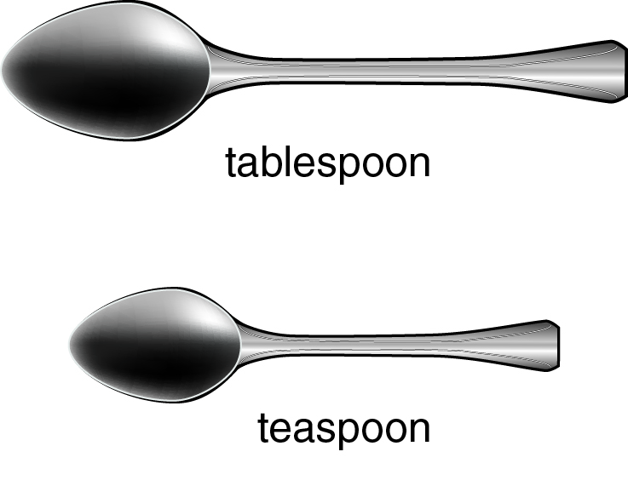

- Which device would most accurately measure a 5 mL dose of a liquid medicine for an infant (young baby)?
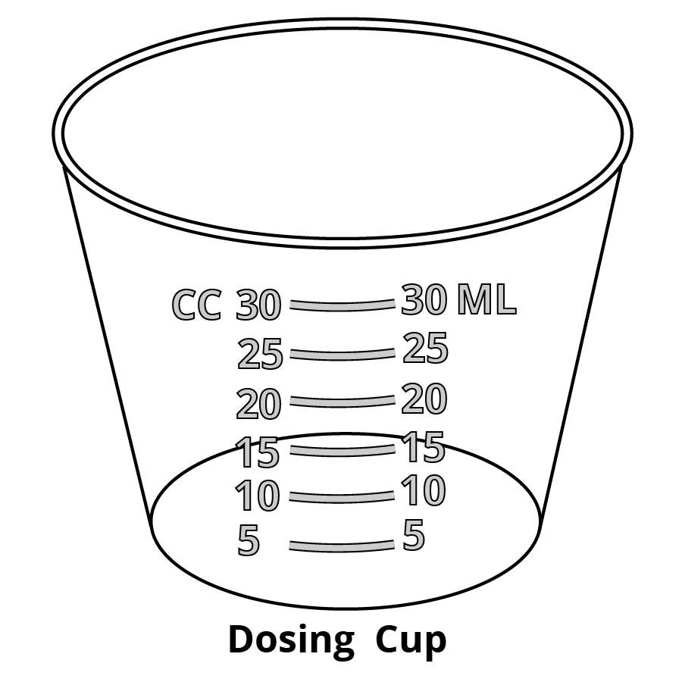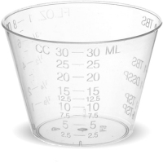
dosing cup
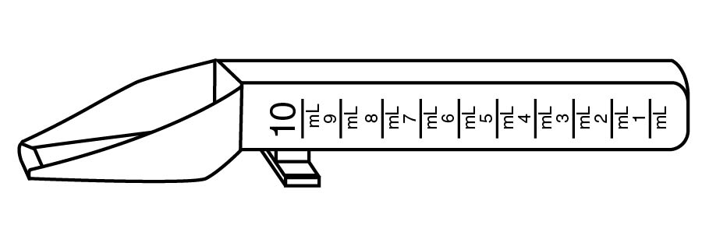dosing spoon

A
C
B

- To prevent an overdose of a medicine, it is important to
- Take more medicine as soon as symptoms return.
- Take medicines with meals.
- Keep a written record of when and how much medicine is taken.

Base your answers to questions 5 and 6 on the diagram on the right that shows a graduated cylinder filled with gray liquid.

- To accurately read the volume of liquid in the graduated cylinder, your eye should be located at
A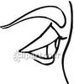
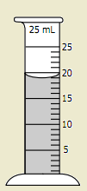

- A
- B
B
- C

- What is the volume of the gray liquid shown in the graduated cylinder on the right?
C
- 19 milliliters
- 20 milliliters
- 20 milligrams

- Which arrow on the diagram best represents the level to which the dosing device should be filled for a 1.5 milliliter dose of liquid medicine?
C
A
B
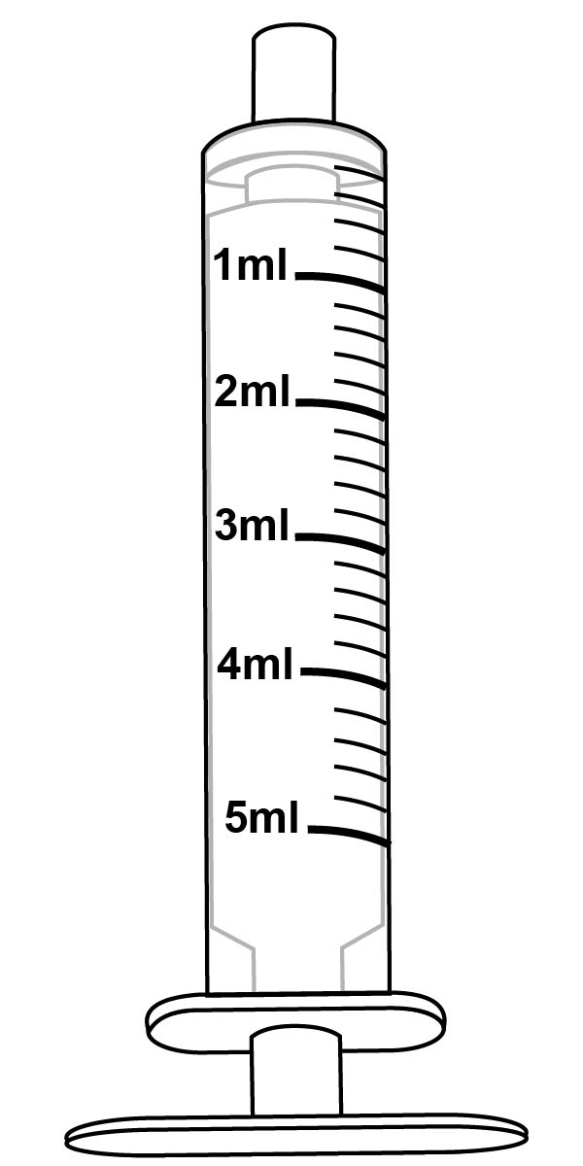

- Which arrow on the diagram best represents the level to which the device should be filled for a 0.5 milliliter dose of liquid medicine?
C
B
A
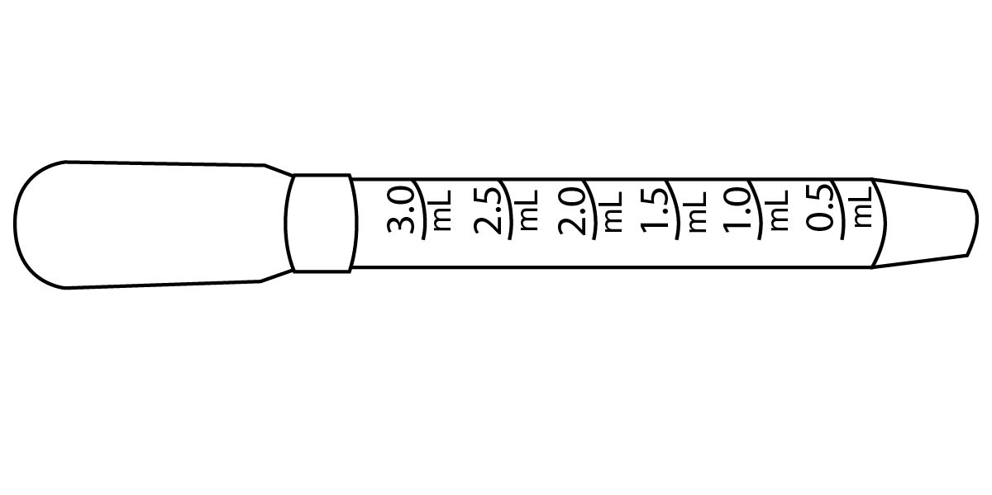

Base your answers to questions 9 through 12 on the Directions from Flu Relief Therapy Label on the right.

Directions from Flu Relief Therapy Label
- Do not use for children under 12 years of age.
- Take 20 mL (4 teaspoons) every 4 hours while symptoms last.
- Do not take more than 150mL (40 teaspoons) in 24 hours, unless directed by a doctor.

- How much Flu Relief Therapy should an adult take for each dose?
- 4 tablespoons
- 40 teaspoons
- 20 mL
- One teaspoon Flu Relief Therapy is approximately equal to
- 5 milliliters.
- One gulp from a bottle.
- 3 tablespoons.

- Which device would most accurately measure the proper dose of Flu Therapy Relief?
dosing cup
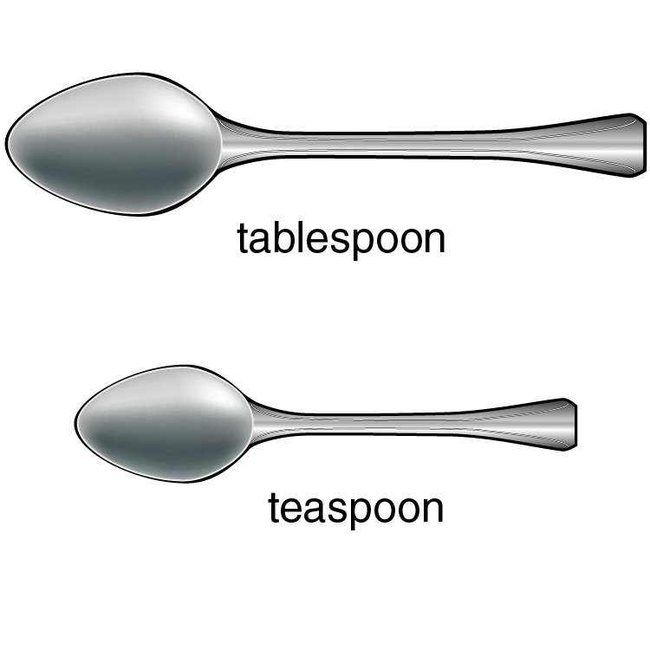
A

C

B

- What would happen to the level of Flu Relief Therapy in a person’s body if they take 20 mL every 2 hours?
- The drug level would remain at or below the safe level.
- The drug level would increase and may reach an unsafe level.
- The drug level would not be high enough to treat a person’s symptoms.

Base your answer to questions 13-15 on the directions in the chart below.

Weight (lb) | Age (year) | Dose (mL or tsp)
Under 24 | Under 2 years | Ask a doctor
24-35 | 2-3 years | 5 mL (1 tsp)
36-47 | 4-5 years | 7.5 mL (1.5 tsp)
48-59 | 6-8 years | 10 mL (2 tsp)
60-71 | 9-10 years | 12.5 mL (2.5 tsp)
72-95 | 11 years | 15 mL (3 tsp)

- What does the abbreviation “tsp” stand for?
- Teaspoon
- Tablespoon
- Both teaspoon and tablespoon

- What is the appropriate dose of this medicine for a 3 year old child who weighs 30 pounds?
- 5 mL
- 7.5 mL
- 2 tsp

- Which arrow best represents the level to which the dosing device should be filled for the proper dose of this medicine for an 11 year-old child.
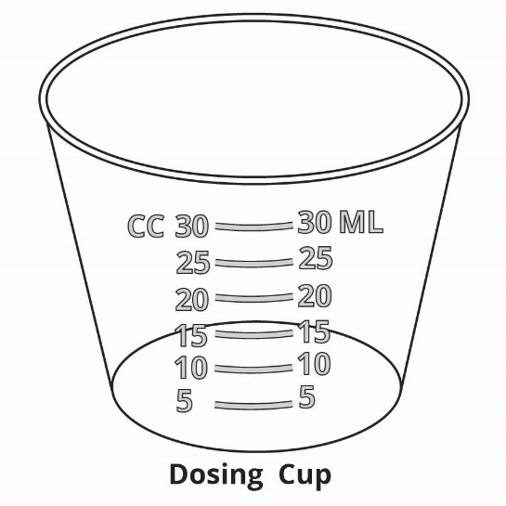
C
B
A
General Safety Precautions
- Work in a clean, uncluttered area. Cover the work area to protect the work surface.
- Read and follow all instructions carefully.
- Pay particular attention to following the specific safety precautions included in the instructions.
- Wear safety goggles while performing experiments using chemicals.
- Do not use droppers as “squirt guns”.
- Never taste or ingest any chemicals used for this activity - they may be toxic.
- Do not eat, drink, or apply make-up or contact lenses while performing experiments.
- Wash your hands before and after performing experiments.
- Chemicals used in experiments may stain or damage skin, clothing or work surfaces. If spills occur, wash the area immediately and thoroughly.
- Follow your teacher’s instructions for end-of-experiment clean-up.

General Safety Precautions
- Work in a clean, uncluttered area. Cover the work area to protect the work surface.
- Read and follow all instructions carefully.
- Pay particular attention to following the specific safety precautions included in the instructions.
- Wear safety goggles while performing experiments using chemicals.
- Do not use droppers as “squirt guns”.
- Never taste or ingest any chemicals used for this activity - they may be toxic.
- Do not eat, drink, or apply make-up or contact lenses while performing experiments.
- Wash your hands before and after performing experiments.
- Chemicals used in experiments may stain or damage skin, clothing or work surfaces. If spills occur, wash the area immediately and thoroughly.
- Follow your teacher’s instructions for end-of-experiment clean-up.

Row | Measuring Tool  Comparing Medicine Measuring Tools | Place dosing cups with medicine below | Volume of medicine in dosing cup
1 | Dosing Cup  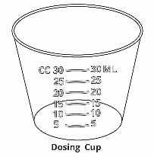 | 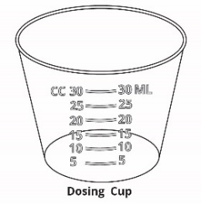 | _______ ml
2 | Cup for Estimating  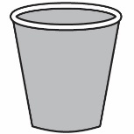 | 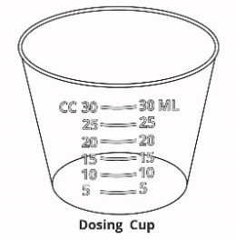 | _______ ml
3 | Metal Dinnerware Teaspoon  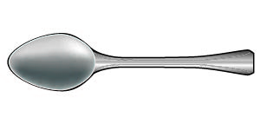 | 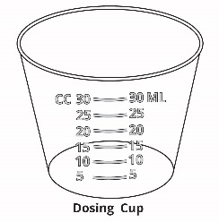 | _______ ml
4 | Plastic Dinnerware Teaspoon  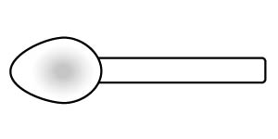 |  | _______ ml
5 | Measuring Teaspoon  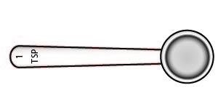 |  | _______ ml

How Much and How Often

Part 1: Measuring How Much
Directions from Flu Relief Therapy Label
- Use the measuring device provided with the medicine.
- Do not take more than directed.
- ONLY for adults and children 12 years of age and over. Do not use for children under 12 years of age.
- Take 15 mL (3 teaspoons) every 4 hours while symptoms last.
- Do not take more than 90mL (3 FL OZ) in 24 hours, unless directed by a doctor.

Micah is a 15-year-old boy who has a headache, a bad cough, chest congestion, and a stuffy nose. He wants to take the proper amount of Flu Relief Therapy medicine.

- According to the Directions from Flu Relief Therapy Label to the right, how much Flu Relief Therapy medicine should Micah take?

___15__ mL or __3___ teaspoons

- It is important that Micah measure exactly the right amount of medicine.

- What might happen if Micah took too much medicine?

Student answers will vary but are likely to include concept of overdose or too much medicine will make Micah sick.

- What might happen if Micah took too little medicine?

Student answers will vary but are likely to include concept that the medicine will not be effective enough.

- A medicine dosing cup was provided with the Flu Relief Therapy medicine. The dosing cup is what should be used to accurately measure the medicine.
- Pour 15 ml of the simulated medicine into one of the plastic dosing cups. NOTE: It is important to place the dosing cup on a flat surface. The dosing cup should be at eye level when you read the volume!
- Save the dosing cup and its contents by placing it on the box in Row 1 of the Comparing Medicine Measuring Tools sheet.
- Record the volume (in mL) of medicine in the dosing cup in Row 1 on the Comparing Medicine Measuring Tools sheet. Remember to view the cup at eye level to read the volume.
Micah has a problem! He cannot find the dosing (measuring) cup that came with the bottle of Flu Relief Therapy medicine. He wonders if it is OK to estimate (guess) the amount of medicine or if it is OK to use other things to measure liquid medicine such as kitchen silverware (spoons) instead of using the dosing cup that came with the bottle of medicine.

In this lab activity, you will do experiments to determine if using different measuring tools affects the amount of medicine that a person receives.

- Some people think that they can simply estimate (guess) the appropriate dose of medicine. Can you accurately estimate the appropriate dose without using a measuring device?
- Pour what you estimate (guess) would be 15 mL of Flu Relief Therapy medicine into the colored cup (not into a dosing cup). Pour all of the contents from the colored cup into a clean dosing cup. Put this cup in Row 2 of the Comparing Medicine Measuring Tools sheet.

Metal Dinnerware Teaspoon

- Sometimes people use a metal dinnerware teaspoon (like the dinnerware teaspoon shown on the right) to measure medicine.
- Refer to the Directions from Flu Relief Therapy Label on the previous page. How many teaspoons of Flu Relief Therapy is the appropriate dose? ___3___ teaspoons
- Use a metal dinnerware teaspoon to add the appropriate number of teaspoons of Flu Relief Therapy to a clean dosing cup. Put this cup in Row 3 of the Comparing Medicine Measuring Tools sheet.

- Sometimes people use a plastic dinnerware teaspoon (like the dinnerware teaspoon shown on the right) to measure medicine.

Plastic Dinnerware Teaspoon

- Use a plastic dinnerware teaspoon to add the appropriate number of teaspoons of Flu Relief Therapy to a clean dosing cup. Put this cup in Row 4 of the Comparing Medicine Measuring Tools sheet.

- Sometimes people use a measuring teaspoon (such as the teaspoon shown on the right). Measuring teaspoons (tsp) are manufactured to more precisely measure teaspoon volumes.

Measuring Teaspoon

- Use a measuring teaspoon (tsp) to add the appropriate number of teaspoons of Flu Relief Therapy to a clean dosing cup. Put this cup in Row 5 of the Comparing Medicine Measuring Tools sheet.

- Complete the Comparing Medicine Measuring Tools sheet by recording the volumes (in ml) of each of the dosing cups (Rows 1 through 5) in the third column.
- Discard the simulated medicine in each of the dosing cups by pouring it down the drain or into the “Liquid Waste” container. Use a paper towel to dry the dosing cups.
Base your answers to questions 7 and 8 on the data you recorded on the Comparing Medicine Measuring Tools sheet.
- Which measuring device (dosing cup, cup for estimating, metal dinnerware teaspoon, plastic dinnerware teaspoon, or measuring teaspoon) do you think is most accurate for measuring liquid medicine? Explain your choice using the data that you recorded on the Comparing Medicine Measuring Tools sheet.
Student answers will vary but they will likely choose either the medicine dosing cup or the measuring teaspoon. Reasons may include: It has precise measuring lines. You know how much to add to it.

- Micah could not find the dosing cup provided with the Flu Relief Therapy medicine. Which measuring tool do you suggest that he use instead of the dosing cup? Explain your choice using the data that you recorded on the Comparing Medicine Measuring Tools sheet.
Student answers will vary but they should answer either the measuring teaspoon or tablespoon. Reasons may include has a better shape for filling without overflowing.

- Calculate: The instructions on the Flu Relief Therapy medicine label say “Do not take more than 90 mL (3 FL OZ) in 24 hours, unless directed by a doctor.” How many teaspoons of the medicine can Micah safely take in 24 hours?
____18___ teaspoons

Show how you arrived at your answer to question 9 in the space below.

15 ml = 3 teaspoons

90 ml/15 ml = X/3

X = 18

When measuring small doses of liquid medicine, particularly for infants or young children, the recommended dosing device may be either a medicine dosing spoon, an oral syringe, or a medicine dropper.

- For each of the doses indicated on the right, draw an arrow to the point on the medicine dosing spoon that you should fill with the medicine.

- 10 mL of medicine

- 5 mL of medicine

- For each of the doses indicated on the right, draw an arrow to the point on the medicine dropper that you should fill with the medicine.

- 2 mL of medicine

- 0.5 mL of medicine

- For each of the doses indicated below, draw an arrow to the point on the medicine syringe that you should fill with the medicine.

3 mL of medicine 1.5 mL of medicine
Not all liquid medicines come with dosing devices. Some pharmacies will provide free dosing devices. Other pharmacies will sell dosing devices to you. The diagrams below show some different types of dosing devices available in pharmacies.

- Which of the dosing devices shown above would best be used to accurately measure:
- 1.5 ml? ____medicine dropper_____
- 3.5 ml? ____oral syringe_____
- 9 ml? ____dosing spoon_____

Part 2: Determining How Often

Each medicine works in a person's body for a certain length of time. The Drug Facts label tells you how often to use a medicine based on how long the medicine works in people's bodies.
Directions from Flu Relief Therapy Label
- Use the measuring device provided with the medicine.
- Do not take more than directed.
- ONLY for adults and children 12 years of age and over. Do not use for children under 12 years of age.
- Take 15 mL (3 teaspoons) every 4 hours while symptoms last.
- Do not take more than 90mL (3 FL OZ) in 24 hours, unless directed by a doctor.

- Read the Directions from Flu Relief Therapy label (on the right). How often should Micah take the Flu Relief Therapy medicine?

Once every 4 hours

Micah keeps forgetting to notice the time when he takes the Flu Relief Therapy medicine, so he simply takes more of the medicine when his flu symptoms start reappearing.

You will make a model to represent Micah’s body:
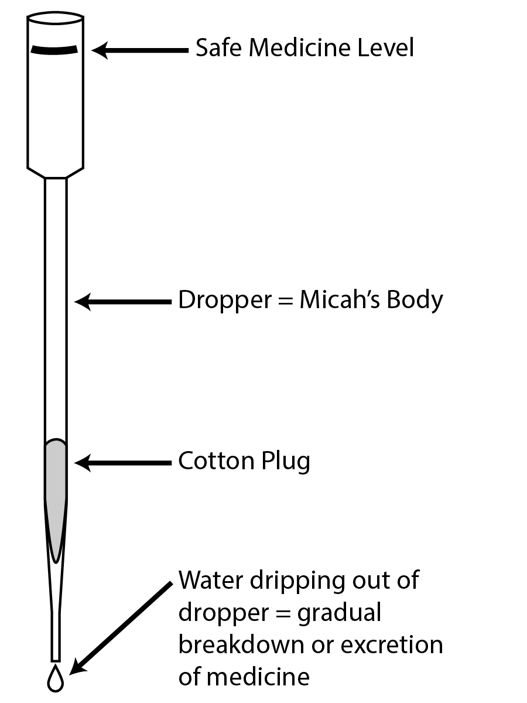
- The long plastic dropper represents Micah’s body.
- The black line at the top of the dropper represents a safe level of medicine in Micah’s body. If the level of medicine in the dropper goes above this line then it is not a safe level of medicine.
- Colored water dripping out of the long plastic dropper represents the gradual breakdown, or excretion, of medicine.

Seeing how the model works.
- You will need a stopwatch for this activity. Practice using the stopwatch if you have not used one before. You will need to know how to start, stop, and reset the stopwatch.
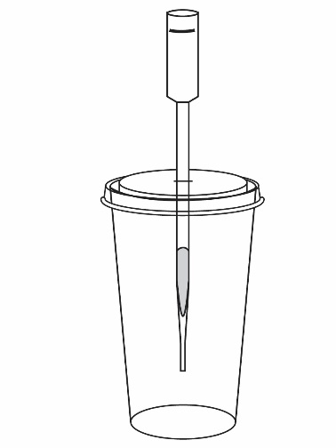
- Put the lid on the large plastic cup. Insert the long plastic dropper into the slit on the top of the lid, as shown in the picture on the right. The dropper should extend to approximately 5 centimeters (2 inches) above the bottom of the cup.

- Use the dosing cup to measure 15 mL of colored water. The colored water will simulate Flu Relief Therapy medicine that Micah will take.
- Start the stopwatch and immediately pour the medicine from the cup into the top of the long dropper.
- The medicine (colored water) will start dripping out of the bottom of the dropper. This represents the gradual breakdown, or excretion, of medicine.
- Stop the stopwatch when the medicine (colored water) stops dripping out of the dropper. Note: Some medicine may remain in the dropper. Look at the time on the stopwatch. How many seconds did it take for the colored water to stop dripping out of the dropper?
________ seconds Times will vary greatly. Typical drip times might be 60 to 240 seconds. You may use the variation in class data to discuss how different individuals may metabolize or excrete medicines at different rates.

Now you will use the model to see what happens when Micah repeats the doses of medicine:
- As shown on the label directions - 15 mL every four hours.
- Sooner than the time directed on the label - after two hours instead of four hours.

Model for taking medicine as shown on the label directions.

- Make a prediction. Would it be safe for Micah to take another 15 mL dose of the medicine after 4 hours?
Student answers will vary.

- The number of seconds that you recorded above in step 7 represents the 4 hours that Micah should wait before taking another dose of Flu Relief Therapy. How many seconds represent 4 hours?

4 hours would be represented by ___________ seconds

- Use the model to test your prediction.
- Fill two dosing cups with 15 ml of medicine.
- Start the stopwatch and immediately pour a 15 mL dose of medicine into the dropper.
- Wait 4 hours (represented by_____seconds) and pour a second 15 ml dose of medicine into the dropper.
- Did the medicine level in the dropper remain below the safe medicine level (top of the dropper)? ____ Yes_____

Model for taking medicine sooner than directed on the label - after two hours instead of four hours.

- Make a prediction. Would it be safe for Micah to take a second 15 mL dose of the medicine after 2 hours, instead of after 4 hours? Explain why or why not.

Student answers will vary.

- Calculate how many seconds it would take to represent waiting 2 hours, instead of 4 hours, before taking another dose of the medicine. Hint: Divide your answer to question 8 by 2.

2 hours would be represented by___________ seconds

- Use the model to test your prediction.
- Fill two dosing cups with 15 ml of medicine.
- Start the stopwatch and immediately pour a 15 mL dose of medicine into the dropper.
- Wait 2 hours (represented by_____seconds) and pour a second 15 ml dose of medicine into the dropper.
- Did the medicine level in the dropper remain below the safe medicine level (top of the dropper)? ____ No______

- What might happen if Micah continued to take Flu Relief Therapy too soon for the rest of the day?
If Micah continued to use the medicine too soon, the medicine can build up in his body to a level that may harm him.

- An overdose causes an unsafe level of medicine in the body. Describe one way that people can unintentionally take a medicine overdose.

Taking more medicine that indicated in the directions. OR
Taking medicines more often (or too soon) than the directions indicate.

- Some people may have trouble remembering if and when they took medicines. One strategy that people could use to remember when to take medicine is to write down the name of the medicine and the time it was taken. Describe another strategy that people could use to help them take medicines when they should. Be specific!

Student answers will vary. If time permits have them share some of their ideas for how to remember if and when people take medicine. Extend the discussion to include ideas that would work for people who take multiple medicines each day and have memory problems. For example, people could set alarms or they could use Smartphone apps.

